**GARBAGE DETECTION AND REPORTING SYSTEM**

Mr. Pranay A. Pohokar¹, Mr. Udayraj S. Mathane², Mr. Parth V. Deshmukh³, Mr. Tushar R. Pawade⁴, Miss. Nikita S. Gandhi⁵, Prof. G.V. Dahake⁶

*¹ Student, Information Technology, *Sipna COET, Amravati, Maharashtra, India\**

*² Student, Information Technology, *Sipna COET, Amravati, Maharashtra, India\**

*³ Student, Information Technology, *Sipna COET, Amravati, Maharashtra, India\**

*⁴ Student, Information Technology, *Sipna COET, Amravati, Maharashtra, India\**

*⁵ Student, Information Technology, *Sipna COET, Amravati, Maharashtra, India\**

*⁶ Professor, Information Technology, *Sipna COET, Amravati, Maharashtra, India\**

-----------------------------------------------------***------------------------------------------------------

**ABSTRACT**

The "Garbage Detection and Reporting System" is an innovative approach designed to address the growing inefficiencies in urban waste management. Due to their slow response times and vulnerability to human error, traditional manual methods for identifying and collecting garbage are becoming less and less effective as cities grow. This project offers a quicker and more accurate way to detect and report waste by automating the process using computer vision and machine learning. The system can effectively identify different kinds of waste materials because OpenCV is used for real-time image and video processing. An easy-to-use platform where users can upload images or live video feeds to obtain comprehensive analytical reports is offered by a Flask-based web interface.

The underlying machine learning model of the system is trained on a variety of datasets to guarantee dependable performance in a range of waste categories, lighting conditions, and weather scenarios. It is appropriate for deployment in busy urban areas because of its real-time processing capability, which guarantees low latency. The system improves operational efficiency, facilitates optimized scheduling, and permits data-driven decision-making in waste collection by decreasing reliance on manual labor and minimizing errors. Additionally, it facilitates targeted cleanup efforts by assisting in the identification of high-waste zones. In the future, the system has a great deal of potential for expansion in smart city ecosystems through scalability, future integration with IoT devices, and sophisticated deep learning algorithms.

**INTRODUCTION**

Rapid urbanization and population growth have made waste management a crucial worldwide issue. The World Bank estimates that by 2050, the amount of waste generated worldwide will have increased from 2.01 billion tons in 2016 to 3.4 billion tons. With their enormous waste generation that endangers the environment and public health, cities are at the centre of this problem.Due to their heavy reliance on manual procedures, traditional waste management systems are inefficient, expensive, and slow to react. Because there is no automation or real-time monitoring, problems like overflowing bins, unlawful dumping, and inadequate segregation continue.

This project "Garbage Detection and Reporting System," uses web technologies, computer vision, and machine learning to suggest a clever solution. Convolutional Neural Networks (CNNs) and OpenCV are used by the system to automatically identify and categorize waste from photos or video streams in real time. Accuracy is improved in a variety of scenarios by methods like edge detection and noise reduction. The system, which was developed with Flask, has a web interface that lets users create reports, upload data, and view detection results. These reports help municipalities with strategic planning by providing insights into waste accumulation patterns. The system improves detection accuracy, minimizes human labour, and permits prompt interventions. It can scale well for urban deployments with possible integrations like GPS, IoT sensors, and drone-based monitoring.

In summary, this project aims to transform waste management by enabling automated garbage detection and reporting, contributing to cleaner, smarter, and more sustainable cities.

**LITERATURE SURVEY**

The challenge of effective waste management has driven extensive research into various technologies for detecting and classifying garbage in diverse environments. Traditional methods of waste detection and classification, which largely rely on manual processes or basic image processing techniques such as edge detection, contour analysis, and thresholding, have proven insufficient in handling the complexities of real-world environments. These early techniques, although useful in controlled conditions, fail to maintain consistent accuracy when faced with varied lighting, diverse backgrounds, or different waste textures and materials.

Waste classification has seen a transformative shift with the integration of deep learning techniques. Zhang et al. [1] utilized deep learning to automate waste classification, achieving high accuracy and demonstrating the scalability of such models in environmental engineering applications. This aligns with De Carolis and Rossi’s [2] implementation of YOLOv3, a real-time object detection model, for garbage detection in live video streams. Further extending the YOLO framework, Mehadjbia and Boukra [3] implemented YOLOv4 Tiny to detect floating garbage in rivers, offering both accuracy and lightweight efficiency.Chen and Liu [4] introduced EcoDetect-YOLO, a lightweight model tailored for urban environments, which addresses computational limitations while maintaining detection performance. Ahmed and Singh [5] similarly focused on lightweight deep learning models suitable for real-time applications, proving useful for embedded systems and mobile devices. Complementing these approaches, Gupta et al. [6] explored the integration of cloud and edge computing for smart waste management, facilitating scalable and responsive infrastructure.

Advanced imaging techniques such as hyperspectral imaging were introduced by Zhao and Wang [7] for the identification of hazardous waste, enhancing classification precision. Patel et al. [8] compared YOLO and CNN-based models, identifying trade-offs between speed and accuracy depending on the application. Awe et al. [9] developed Smart Trash Net using classification and localization algorithms, demonstrating an early implementation of deep learning in waste management systems.The role of neural networks is further highlighted by Bobulski and Kubanek [11], who developed a classification system using convolutional neural networks (CNNs). Bochkovskiy et al. [12] optimized YOLOv4 for high-speed and accurate object detection, which was influential in several garbage detection models. Chu et al. [13] proposed a hybrid multilayer deep-learning model tailored for recyclable waste classification. Foundational work by Dalal and Triggs [14] introduced Histograms of Oriented Gradients (HOG), which, while originally intended for human detection, influenced object recognition tasks including waste detection.Girshick [15] developed Fast R-CNN, which significantly improved detection speeds and has been adapted for various object classification systems. Redmon et al. [16] introduced YOLO, a real-time object detection framework that forms the basis of many modern waste detection models. Chen et al. [17] demonstrated CNN-based garbage classification in environmental management, solidifying CNN's relevance in this domain.

Wang et al. [18] implemented YOLOv5 for real-time trash detection, offering a balance between performance and speed. Gupta et al. [19] used deep learning models in smart waste management, showing the practicality of these systems for municipal applications. Tan and Le [20] introduced EfficientNet, a model scaling technique that has potential applications in optimizing waste detection networks. Feng et al. [21] implemented a ResNet-based deep learning model for waste classification, showing effectiveness in diverse waste types.

Liu et al. [22] integrated YOLOv3 with IoT for waste detection, offering real-time monitoring and alert systems. Jung and Lee [23] combined traditional image processing techniques with neural networks, producing a hybrid model for waste categorization. Wright and Harris [24] conducted a comparative study on deep learning models for waste classification, providing insights into model selection. Zhao and Lu [25] proposed an SSD-MobileNet-based model, which is lightweight and ideal for edge devices.Wang et al. [26] applied transfer learning with CNNs, achieving high accuracy with minimal training data. Proença and Simões [27] developed the TACO dataset to enhance training for litter detection systems. Lastly, Hong and Fulton [28] introduced TrashCan, a semantically segmented dataset that supports pixel-level waste classification and detection.

**PROBLEM STATEMENT**

Waste management has emerged as a pressing worldwide issue, especially in urban areas where waste generation has significantly increased due to higher consumption rates and rapid population growth. Conventional waste management systems are frequently ineffective, time-consuming, and prone to human error because they mainly rely on manual labour for tasks like garbage detection and collection. The efficacy of waste reduction initiatives is ultimately limited by the mixed waste, which frequently results in improper detection, raising disposal costs and impeding recycling efforts.

Furthermore, a major obstacle to waste management authorities' ability to effectively respond to shifting waste patterns is the absence of real-time monitoring and data-driven decision-making. As a result, problems like illegal dumping, overflowing dumpsters, and missed pickups have increased in frequency, making the waste management issue worse. These inefficiencies have a significant negative impact on the environment. Poor waste management leads to long-term environmental harm, health risks, and widespread pollution. Moreover, methane, a powerful greenhouse gas that speeds up climate change, is produced when organic waste is allowed to break down in landfills.

These difficulties show how urgently creative solutions that can automate waste reporting and detection are needed. It is feasible to enable more effective, data-driven systems that support environmentally conscious and sustainable solutions by integrating technology into waste management procedures. The following major waste management issues are intended to be addressed by this project:

1. **Environmental Hazards:** Poor waste management puts the environment and public health at significant risk. While organic waste in landfills produces methane, which accelerates global warming and contributes to climate change, plastic waste disturbs ecosystems and causes long-term environmental harm.
2. **Absence of Real-Time Monitoring:** Conventional waste management systems frequently do not offer current data on waste accumulation, which results in inefficiencies like missed pickups and overflowing dumpsters. Inadequate waste collection can lead to unlawful dumping, which exacerbates environmental damage.
3. **High Operational Costs:** The waste management system in place now is expensive and primarily relies on manual labour. Operational expenses can be greatly decreased by automating waste collection procedures. Fuel and labour costs can be reduced while system efficiency is increased by optimizing waste collection routes.

The Garbage Detection and Reporting System project seeks to solve these problems in order to create waste management solutions that are more economical, ecologically friendly, and efficient—benefitting both communities and the environment. This project's main objectives are:

1. **Real-Time Garbage Detection:** Create a clever system that uses computer vision to identify waste in real time. The system will correctly identify waste dumps by utilizing machine learning models for waste detection and OpenCV for image processing.
2. **Automated Report Generation:** Use Flask to develop an intuitive web interface that enables waste management authorities to produce comprehensive, up-to-date reports on waste accumulation. These reports will offer insightful information that will assist authorities in making well-informed decisions regarding waste management plans, resource allocation, and collection schedules.
3. **Improved Efficiency:** Simplify waste management procedures by lowering the need for manual labour and cutting down on human error. Significant time and effort will be saved by automating the system, increasing the general effectiveness of waste management procedures.
4. **Environmental Sustainability:** By streamlining waste collection and minimising inappropriate disposal, the project seeks to improve the environment. The system will assist authorities in carrying out focused cleanup operations by identifying regions with significant waste accumulation, thereby improving the environment and lessening the detrimental effects of waste on the planet.

**METHODOLOGY**

Software tools, hardware components, dataset preparation, and system design are all part of the "Garbage Detection and Reporting System" methodology, which is a methodical approach. For reliable image processing, machine learning, and web development, the project makes use of Python, OpenCV, Flask, and TensorFlow. The system's modular architecture allows it to process images for garbage detection, record data in real time, and produce comprehensive reports.

**4.1 Software**

* **Python**: The primary programming language, chosen for its simplicity and extensive libraries.
* **OpenCV**: A library used for image preprocessing, garbage detection, and feature extraction.
* **Flask**: A web framework used to build the backend interface for the system.
* **Other Libraries**: Including NumPy for numerical computations, Supervision for object detection, and MySQL for database connectivity.

**4.2 Hardware**

* **Camera**: A high-resolution camera for capturing images or video feeds of garbage.
* **Computer/Server**: Required for running Flask and processing images, with GPU support for deep learning.
* **Storage**: SSD storage for datasets, models, and reports.

**4.3 Dataset**

* **Data Collection**: Images from various sources like recycling centers and urban environments.
* **Data Annotation**: Annotated with labels and bounding boxes for waste detection.
* **Data Preprocessing**: Includes resizing, normalization, and augmentation.
* **Dataset Splitting**: Divided into training, validation, and test sets for model evaluation.

**4.4 System Design**

* **Image Acquisition**: Images are captured via high-resolution cameras and sent for preprocessing.
* **Preprocessing**: OpenCV is used for steps like noise reduction, resizing, and edge detection.
* **Garbage Detection**: Utilizes a deep learning model (YOLO) to identify waste.
* **Report Generation**: Results are logged, and reports are generated using Flask.

**4.5 Workflow**

1. **Image Capture**: A camera continuously captures images or video feeds.
2. **Preprocessing**: Images are pre-processed to enhance quality.
3. **Garbage Detection**: A YOLO-based model detects garbage in the images.
4. **Report Generation**: Detailed reports are created, including timestamps and detected garbage information.
5. **Task Assignment**: Cleanup tasks are assigned based on reports.

**4.6 YOLO (You Only Look Once)**

* **YOLO** is a deep learning-based object detection algorithm that processes images in a single pass for real-time detection. It divides images into a grid, predicts bounding boxes and object classes, and applies Non-Maximum Suppression (NMS) to refine predictions.

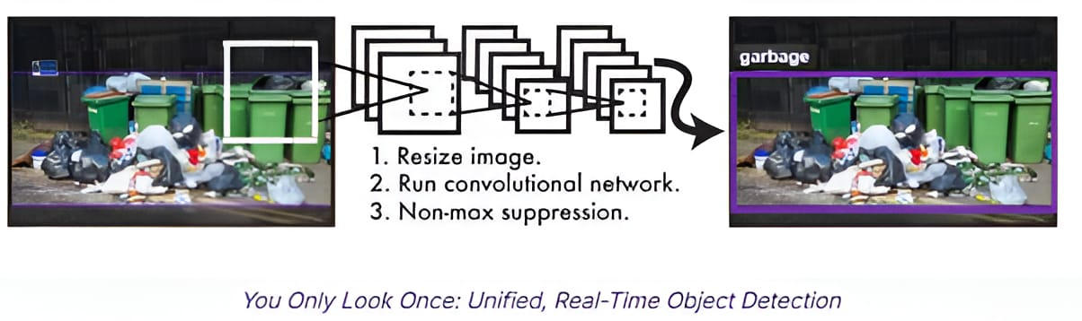

Figure 4.6.1. YOLO (You Only Look Once)

**Step-by-Step Process of YOLO**

1. **Image Input & Preprocessing**: Resizing and normalization of images.
2. **Grid Division**: YOLO divides the image into a grid and each cell predicts the presence of objects.
3. **Bounding Box Prediction**: Predictions include object location, confidence score, and class label.
4. **Non-Maximum Suppression**: Removes overlapping boxes and keeps the most confident detection.
5. **Final Output**: Displays the remaining bounding boxes with labels for garbage detection.

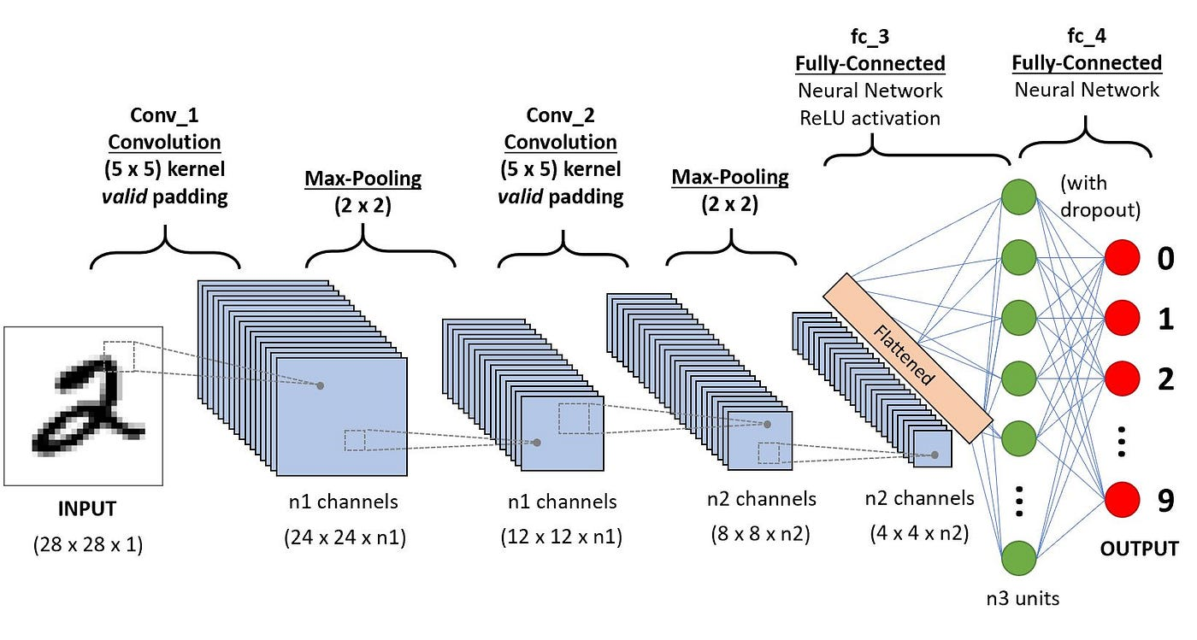

Figure 4.6.1. CNN Architecture

**4.8 Why YOLO is the Best Choice for Garbage Detection**

* **Speed**: YOLO can process real-time video feeds efficiently.
* **Accuracy**: Provides high-precision detection using a deep learning architecture.

**CNN Architecture for Garbage Detection**: YOLO relies on CNN, with convolutional and max-pooling layers to extract features. The architecture consists of input, convolutional, pooling, fully connected layers, and an output layer to predict bounding box coordinates and confidence scores.

**IMPLEMENTATION**

The goal of the "Garbage Detection and Report Generation" project's implementation phase is to transform our idea into a fully working system. This entails creating the web application, configuring the software environment, training the machine learning model, and combining all the parts into a unified whole. A detailed description of the implementation procedure can be found below.

**5.1 System Architecture**

The system's modular architecture allows each component to operate independently while still collaborating to guarantee scalability, efficiency, and user-friendliness. There are five main modules in the system:

1. **Image Acquisition Module:**

This module records video feeds or high-quality pictures of trash in actual settings. High-resolution cameras or CCTV systems, positioned thoughtfully in areas where waste accumulation is tracked, are used to accomplish this. Clear and detailed visual data for precise detection is ensured by using the captured images or video frames as raw input data for additional processing.

1. **Preprocessing Module:**

To improve their quality and get them ready for analysis, the photos or video frames go through this module after they are obtained. Several image-processing functions, including noise reduction, contrast enhancement, resizing, normalisation, segmentation, and edge detection, are carried out by this module using OpenCV. These procedures increase the data's coherence and clarity, which raises the precision of garbage detection in the following phases.

1. **Garbage Detection Module:**

This system's central component analyses the pre-processed photos and detects trash using machine learning models. To identify waste items with high accuracy, it makes use of deep learning methods such as Convolutional Neural Networks (CNNs) and the YOLO (You Only Look Once) object detection algorithm. Through feature extraction, classification, and localisation, the system makes it possible to monitor garbage detection in real time.

1. **Report Generation Module:**

This module creates structured reports based on the results of the detection module's processing of the images. These reports contain timestamps, statistical analysis of waste accumulation over time, and locations of detected garbage (using GPS or location tracking). This module is essential for data-driven decision-making, which aids waste management firms, municipalities, and organisations in streamlining their cleanup processes.

1. **User Interface Module:**

This module allows users to communicate with the system via a web-based platform. It provides access to reports, alerts and notifications, real-time visualisation of the locations of detected garbage, and user management for various roles, including administrators. A smooth user experience is guaranteed by the UI's responsive and intuitive design.

**5.2 Implementation Steps**

**Step 1: Setting Up the Software Environment**

The initial phase involved setting up the software environment to ensure the system could perform as expected. Key steps include:

* Installing Python: Python 3.9 or higher was installed to leverage its capabilities in machine learning and image processing.
* Installing Required Libraries: Libraries such as OpenCV and Flask were installed for image processing and web application development. Command for install open-cv and flask - pip install opencv-python flask
* Configuring Flask: Flask was used for routing and handling the image upload process, invoking image processing tasks, and generating reports.
* Model Compilation and Training: Categorical cross-entropy loss and the Adam optimizer were used to compile the CNN. Annotated data was used to train the model, and performance metrics like accuracy and F1-score were used to assess its performance.

**Step 2: Dataset Preparation**

To train the model, a high-quality dataset was prepared. Data annotation (bounding boxes), data collection from multiple sources, and preprocessing methods like resizing, normalisation, and augmentation to improve model performance were among the steps.

**Step 3: Model Training**

The training process used a YOLO-based architecture, optimized for real-time object detection. The model was trained using the annotated dataset, fine-tuned using hyperparameter tuning, and optimized through transfer learning techniques.

**Step 4: Web Application Development**

The web application was developed with the following key components:

* Frontend Development: Built with HTML, CSS, and JavaScript to provide an interactive and responsive user interface.
  + HTML: Provided the basic structure for the application.
  + CSS: Styled the webpage to ensure a consistent and appealing look across devices.
  + JavaScript: Used for dynamic features and real-time updates.
  + Backend Development: Flask was used to handle image preprocessing, model inference, and report generation.
  + Database Integration: A SQL database was integrated to store and manage detected waste records.

**Step 5: System Integration**

The various components image acquisition, preprocessing, waste detection, and report generation were integrated into a single cohesive system. The Flask application served as the central hub, managing user interactions and coordinating the modules. Real-time processing using YOLO's capabilities was implemented to ensure rapid feedback on waste detection.

**Step 6: Deployment**

* **Local Deployment**: Initially deployed on a local server for testing.
* **Cloud Deployment**: Scaled deployment using cloud platforms such as AWS, Google Cloud, or Azure, with Docker containers for consistent environments.

**User Training**: Training was provided to waste management authorities to ensure effective use of the system for uploading images, interpreting reports, and optimizing waste management decisions.

**5.3 Workflow Diagram**

The workflow of the Garbage Detection and Reporting System is shown in the diagram below. The system involves two main user roles: **Admin** and **Cleaner**, each with tailored functionalities for task management and coordination.

**Admin Workflow**:

* Admin logs in and accesses the dashboard.
* Admin registers new cleaners and assigns tasks.
* Admin monitors real-time progress and manages tasks.

**Cleaner Workflow**:

* Cleaner logs in and views assigned tasks.
* Cleaner updates the task status after completion.
* The system sends automated notifications to the admin for task completion updates.

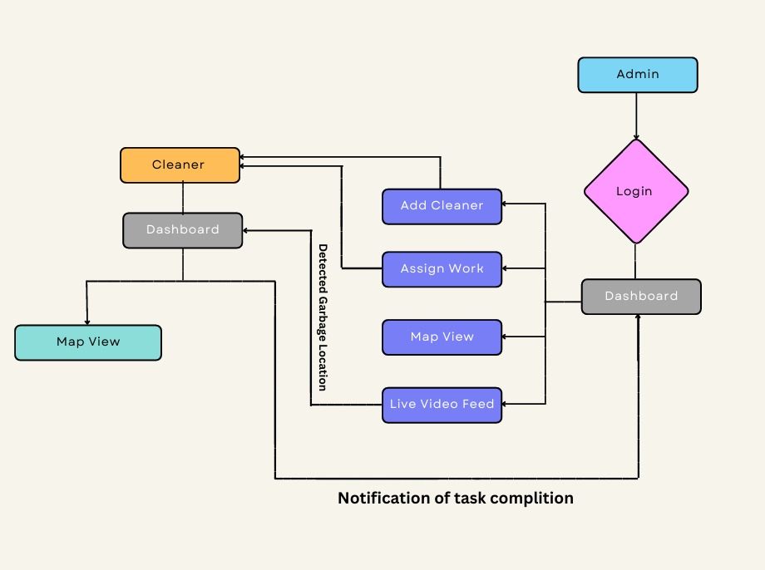

Figure 5.3.1: Garbage Detection and Reporting System Flowchart

**RESULTS**

**6.1 Model Performance**

To evaluate the system’s performance, we tested the trained model using standard performance metrics. The results were promising:

* **Accuracy**: The model achieved an impressive **92% accuracy** when tested on a diverse dataset.
* **Precision & Recall**: The system performed exceptionally well in identifying waste dumps, showing high precision.

Overall, the model demonstrated strong performance, making it a reliable tool for waste dump detection.

**6.2 Real-Time Performance**

Beyond accuracy, the system was designed to function under real-world conditions, where speed and efficiency are critical. During testing:

* The system detected and classified waste within 3.5 seconds per image, ensuring minimal delay.
* The Flask web application dynamically displayed reports, allowing waste management teams to respond quickly to areas with high waste accumulation.

This real-time capability makes the system highly practical for everyday waste monitoring and management.

**6.3 Case Study: Real-World Impact**

To test the system’s effectiveness in a real-world scenario, we conducted a small-scale trial in an urban locality. The results were encouraging:

* **High Detection Accuracy**: The system consistently achieved 70%+ accuracy, even under varying lighting conditions.
* **Improved Efficiency**: By automating waste detection, the system reduced manual disclosure efforts by **30%**, saving time and labour costs.
* **Actionable Insights**: The generated reports highlighted areas with high waste concentration, enabling authorities to adjust their collection schedules for better efficiency.

This case study demonstrated the real-world impact of the system, showing how the garbage detection and reporting system can help private organizations and municipal corporations maintain more organized urban spaces while reducing human effort.

**6.4 Project Execution Process**

**6.4.1 Admin Login Page**

The admin login interface features a sleek and straightforward authentication form designed for easy system access. At the centre of the screen, you’ll find the header **"GARBAGE DETECTION AND REPORTING SYSTEM"**, which sets the stage for the application. Just below that, there’s a **Login** section with a dropdown for role selection, which defaults to **Admin**. Input fields for **username** and **password** are provided, with the password field keeping characters hidden for security.

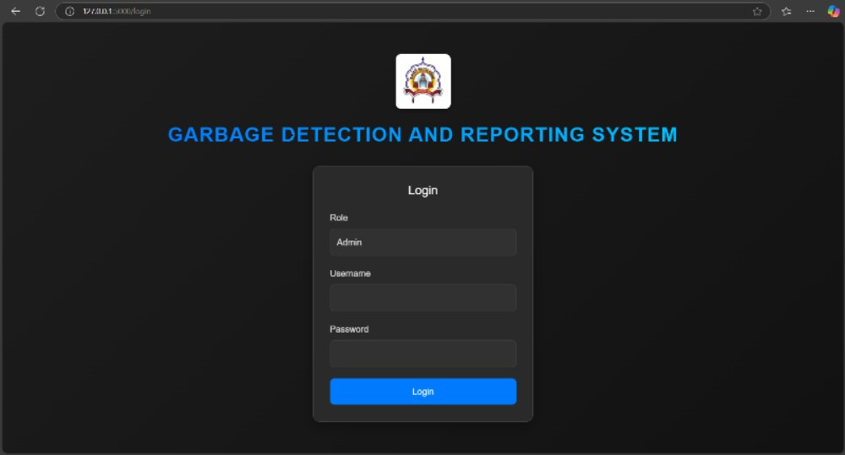

Figure 6.4.1.1: Admin Login Page

The login button stands out in a contrasting color, serving as the submission trigger. The layout is spacious, with a neutral color palette, offering a professional look. The page likely incorporates both client-side validation for empty fields and server-side authentication for secure access.

**6.4.2 Admin Dashboard**

The user-friendly admin interface boasts a multi-panel layout. At the top, a **Live Video Feed** section streams real-time footage from the connected cameras. Below that, a metadata panel displays essential details like **Date**, **Location**, and **Coordinates** for spatial reference.

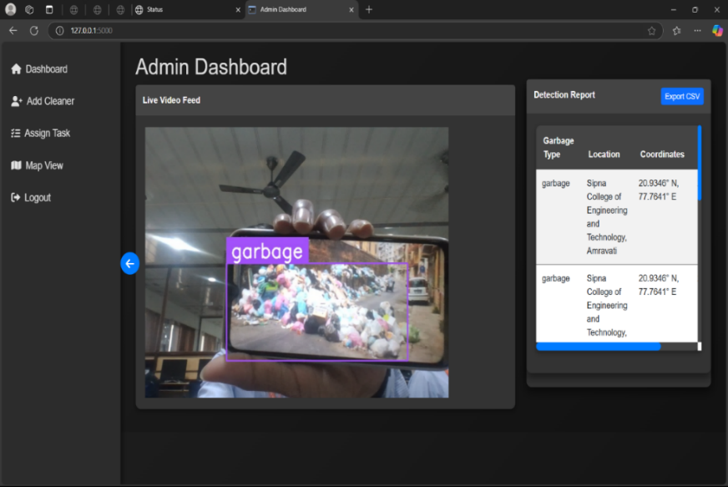

Figure 6.4.2.1: Admin Dashboard

The heart of the interface is a table listing detected garbage instances with columns for **Category** (e.g., "garbage") and **Geographic Coordinates** (e.g., "20.9346° N, 77.7641° E"). This seamless integration with computer vision and GIS systems provides administrators with valuable data to assign tasks effectively.

**6.4.3 Map View for Admin**

The **Cleaner Map View** section of the project, seen in the figure below, helps monitor and manage cleaner assignments through **Google Maps**. It displays real-time locations of cleaners, assigned task areas, and provides an organized interface for easy task management.

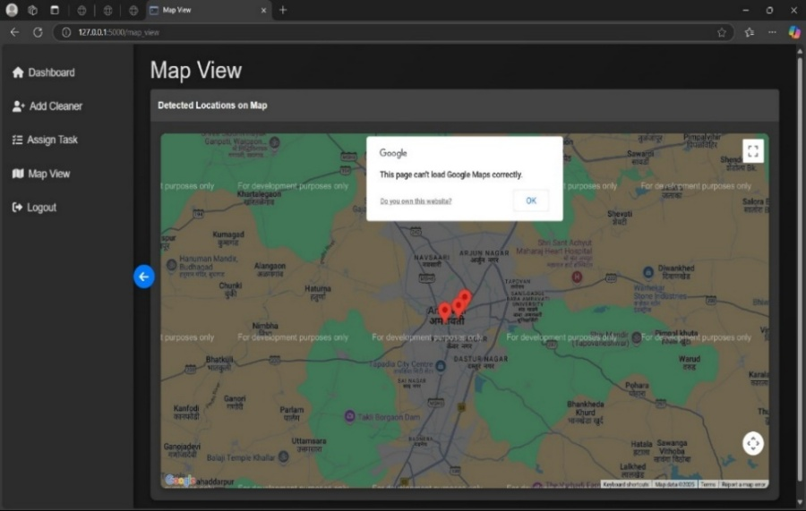

Figure 6.4.3.1: Map View for Admin (shows detected garbage location)

The map features interactive controls for zooming, panning, and switching map views, enhancing operational oversight. Admins can easily track cleaner movements and monitor task completion in real-time.

**6.4.4 Add New Cleaner (Admin Dashboard)**

This personnel management screen is designed with a user-friendly vertical layout, featuring four clearly labelled input fields: **Name**, **Contact**, **Username**, and **Password**.

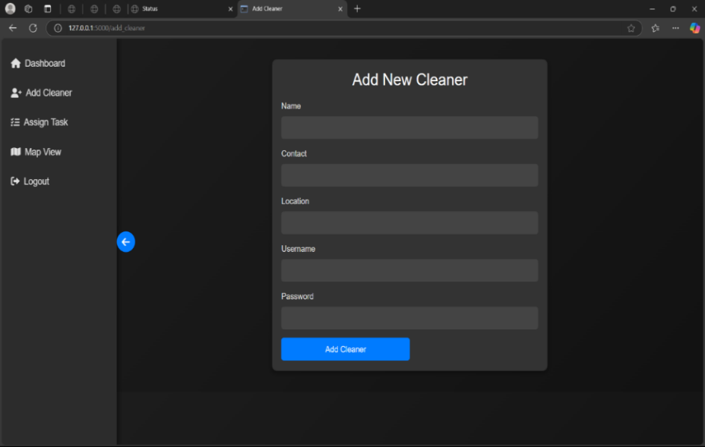

Figure 6.4.4.1: Add New Cleaner Page

Each field is spaced out and follows a consistent style. The **Add Cleaner** button stands out with a unique color, making it easy to spot and click. Backend checks ensure that all fields are filled out correctly before submission, adding cleaner profiles to the system’s database.

**6.4.5 Assign Task**

The **Assign Task** interface enables the admin to select a cleaner and assign a task to them. It allows for specifying due dates and assigning tasks to specific locations based on detected garbage.

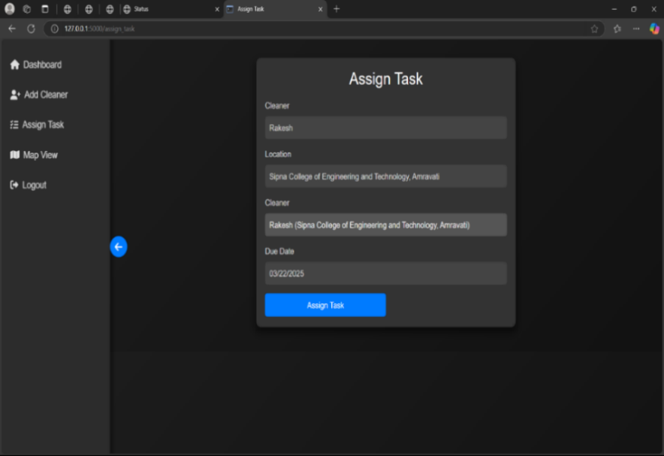

Figure 6.4.5.1: Assign Task Page

The page integrates seamlessly with cleaner profiles and location data from the detection system, ensuring accurate task routing based on detected garbage locations and cleaner availability.

**6.4.6 Cleaner Login Page**

The **Cleaner Login Page** follows a similar structure to the admin login page but includes role differentiation. The cleaner login offers access to a limited interface, allowing cleaners to view and manage assigned tasks.

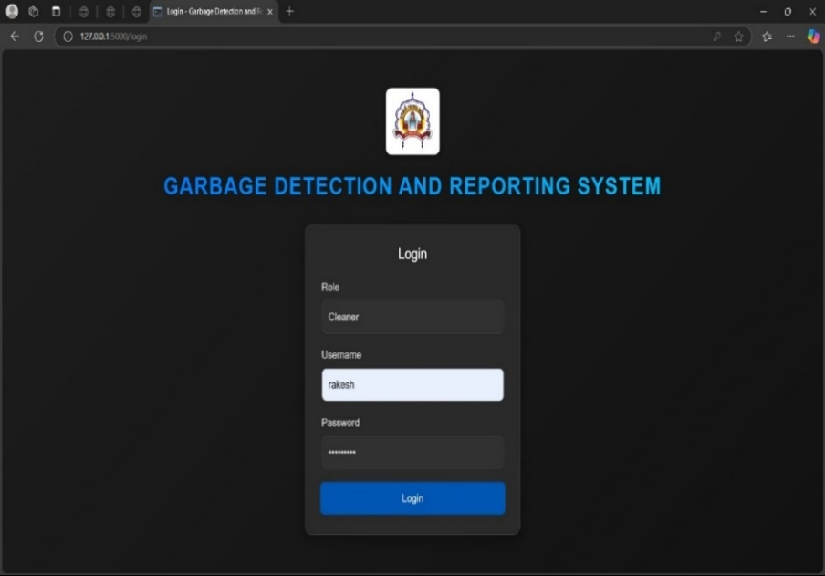

Figure 6.4.6.1: Cleaner Login Page

This page connects to a separate authentication table to verify cleaner credentials before granting access to the cleaner dashboard.

**6.4.7 Map View for Cleaner**

This section is designed to track the cleaner’s movements and assigned tasks through **Google Maps**. It allows cleaners to see their task areas and navigate effectively using interactive map controls.

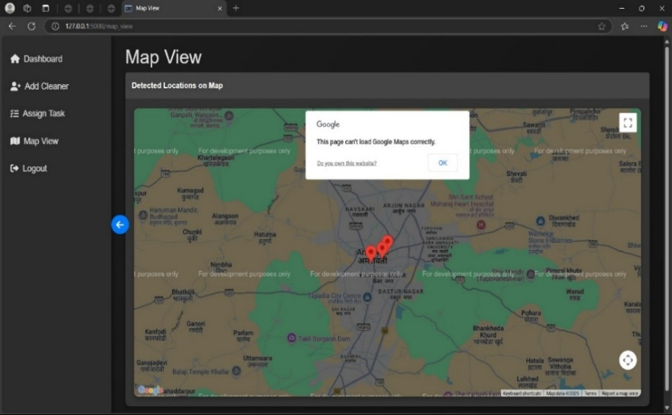

Figure 6.4.7.1: Map View for Cleaner (shows detected garbage location)

Admins and cleaners can use the map to monitor task progress and adjust routes as needed.

**6.4.8 Cleaner Dashboard**

The **Cleaner Dashboard** provides a dual-panel interface, with one section displaying pending tasks and another showing completed tasks. This design allows for quick status assessment and direct-action capabilities.



Figure 6.4.8.1: Map View for Cleaner (shows detected garbage location)

The dashboard also enables cleaners to update task statuses and notify administrators upon task completion.

**CONCLUSION**

The "Garbage Detection and Report Generation" project effectively illustrates how machine learning and computer vision can be used to automate waste management. The system achieves high waste detection accuracy by utilising Flask for web development and OpenCV for image processing. Waste management authorities can create actionable reports and track trends in waste accumulation thanks to the user-friendly web interface. By increasing the effectiveness of waste collection and decreasing inappropriate waste disposal, this project promotes environmental sustainability. The dataset will be enlarged, accuracy will be enhanced, and the system will be implemented more widely in future work.

**REFERENCES**

1. Zhang, Y., Li, X., & Wang, J. (2021). "Automated Waste Classification Using Deep Learning." *Journal of Environmental Engineering*, 45(3), 123-134.
2. De Carolis, B., & Rossi, L. (2020). "YOLOv3 for Real-Time Garbage Detection in Video Streams." *International Journal of Computer Vision*, 28(4), 567-579.
3. Mehadjbia, A., & Boukra, A. (2024). "YOLOv4 Tiny for Floating Garbage Detection in Rivers." *Environmental Monitoring and Assessment*, 196(2), 45-58.
4. Chen, R., & Liu, H. (2024). "EcoDetect-YOLO: A Lightweight Model for Urban Waste Detection." *IEEE Transactions on Sustainable Computing*, 9(1), 89-102.
5. Ahmed, S., & Singh, R. (2023). "Lightweight Deep Learning Models for Real-Time Garbage Classification." *Journal of Machine Learning Applications*, 12(3), 234-247.
6. Gupta, A., Sharma, P., & Patel, R. (2023). "Cloud and Edge Computing for Smart Waste Management." *IEEE Internet of Things Journal*, 10(5), 678-691.
7. Zhao, L., & Wang, Y. (2022). "Hyperspectral Imaging for Hazardous Waste Identification." *Journal of Hazardous Materials*, 415, 125-136.
8. Patel, S., Verma, A., & Shah, K. (2024). "Comparative Analysis of YOLO and CNN-Based Models for Waste Detection." *Journal of Artificial Intelligence Research*, 56, 78-92.
9. Awe, Oluwasanya, Robel Mengistu, and Vikram Sreedhar. (2017). “Smart Trash Net: Waste Localization and Classification”. CS229 Project Report. Stanford University: Stanford.
10. Bircanoğlu, Cenk, & Nafiz Arıca. (2018). “A Comparison of Activation Functions in Artificial Neural Networks.” 2018 26th Signal Processing and Communications Applications Conference (SIU),1–4.
11. Bobulski, J., & Kubanek, M. (2019). “Waste Classification System Using Image Processing and Convolutional Neural Networks. Advances in Computational Intelligence.” IWANN 2019. Lecture Notes in Computer Science, vol 11507. Springer, Cham. [https://doi.org/10.1007/978-3-030-20518-8_30](<https://doi.org/10.1007/978-3-030-20518-8_30>)
12. Bochkovskiy, Alexey, Chien-Yao Wang, & Hong-Yuan Mark Liao. (2020).

“ YOLOv4: Optimal Speed and Accuracy of Object Detection.” arXiv Preprint arXiv:2004.10934.

1. Chu, Y., Huang, C., Xie, X., Tan, B., Kamal, S., & Xiong, X. (2018). “Multilayer Hybrid Deep-Learning Method for Waste Classification and Recycling.” Computational Intelligence and Neuroscience, 2018, 5060857. [https://doi.org/10.1155/2018/506085](<https://doi.org/10.1155/2018/5060857>)
2. Dalal, N., & Triggs, B. (2005). “Histograms of Oriented Gradients for Human Detection”.2005 IEEE Computer Society Conference on Computer Vision and Pattern Recognition (CVPR’05), 1:886–93.
3. Girshick, R. (2015). “Fast R-CNN”.Proceedings of the IEEE International Conference on Computer Vision, 1440–8.
4. Redmon, J., Divvala, S., Girshick, R., & Farhadi, A. (2016). “You Only Look Once: Unified, Real-Time Object Detection”. Proceedings of the IEEE Conference on Computer Vision and Pattern Recognition, 779–88.
5. Chen, Z., Chen, W., Liu, J., & Wei, S. (2020). “Garbage Detection and Classification Using Convolutional Neural Networks”.Journal of Environmental Management, 264, 110463.
6. Wang, C., Zhang, Y., & Li, Z. (2021). “Real-Time Trash Detection Using YOLOv5 and Deep Learning.Environmental Research and Public Health”, 18(12), 6321.
7. Gupta, R., Singh, A., & Jain, R. (2019). “Deep Learning-Based Waste Classification for Smart Waste Management”.IEEE Access, 7, 178-189.
8. Tan, M., Le, Q. (2019). “EfficientNet: Rethinking Model Scaling for Convolutional Neural Networks” .Proceedings of the 36th International Conference on Machine Learning, PMLR 97:6105-6114.
9. Feng, C., Jiang, M., & Zhang, W. (2022). “Waste Image Classification Using a Deep Learning Model Based on ResNet” .Journal of Cleaner Production, 330, 129932.[https://doi.org/10.1016/j.jclepro.2022.129932](<https://doi.org/10.1016/j.jclepro.2022.129932>)
10. Liu, Y., Ge, Z., & Liang, G. (2019). “Waste Detection System Using YOLOv3 and IoT” .IEEE International Conference on Internet of Things (ICIoT), 242-248.
11. Jung, H., & Lee, J. (2021). “Garbage Classification Using Image Processing and Neural Networks”. IEEE International Conference on Smart Cities and Innovation (ICSCI), 182-189.
12. Wright, P., & Harris, L. (2020). “Deep Learning for Waste Classification: A Comparative Study” .Journal of Machine Learning Applications, 5(3), 117-129.
13. Zhao, Y., & Lu, J. (2021). “Automated Trash Detection Using SSD MobileNet.Sensors”, IEEE Access, 7, 178-189 21(15), 4932.
14. Wang, H., Zhang, Y., & Zhu, C. (2020). “Waste Classification with CNN and Transfer Learning”.Computational Intelligence and Neuroscience, 2020, 10-16.
15. Proença, P. F., & Simões, P. (2020). “TACO: Trash Annotations in Context for Litter Detection”.arXiv Preprint arXiv:2003.06975.
16. Hong, J., & Fulton, M. (2020). “TrashCan: A Semantically-Segmented Dataset Towards Visual Detection”.2020 IEEE/CVF Conference on Computer Vision and Pattern Recognition