A Review Article on Hybrid Cyclostationary and energy spectrum sensing and spectrum allocation in cognitive radio.

Dr. G. U. Kharat  Dept. of Electronics &  Telecommunications Engineering  (VLSI & Embedded System)  Sharadchandra Pawar College of Engineering  Otur, India  gukharat@gmail.com | Prof. R. S. Bansode  Dept. of Electronics & Telecommunications Engineering (VLSI & Embedded System)  Shardchandra Pawar college of Engineering  Otur, India  rahulbansodespcoe@gmail.com | Samruddhi Subhash Waje  Dept. of Electronics &  Telecommunications Engineering  (VLSI & Embedded System)  Sharadchandra Pawar College of Engineering  Otur, India  samruddhiwaje44@gmail.com

Abstract
The rapid growth of wireless communication and the increasing demand for efficient spectrum utilization have necessitated advancements in spectrum management techniques. Traditional static spectrum allocation methods often result in underutilization and inefficiencies, creating spectrum scarcity challenges. Cognitive Radio (CR) technology offers a solution by enabling dynamic spectrum access (DSA), allowing secondary users to utilize unused spectrum bands opportunistically. However, effective spectrum sensing remains a critical challenge. This article reviews hybrid spectrum sensing techniques that integrate energy detection and cyclostationary feature detection to enhance spectrum utilization while minimizing interference. On the other hand, cyclostationary feature detection provides improved accuracy and noise resilience but demands significant computational resources. The hybrid spectrum sensing approach combines these two methods, leveraging the strengths of both while mitigating their respective weaknesses. This article further explores the cognitive

cycle, spectrum management functions, and the role of machine learning in improving spectrum sensing performance. Additionally, key challenges such as increased computational complexity, real-time responsiveness, and hardware constraints are discussed. Future research directions emphasize the integration of AI-driven adaptive sensing techniques, cooperative sensing strategies, and hardware-efficient implementations to optimize cognitive radio systems.

Keywords: Hybrid Cognitive Radio Spectrum, Cyclostationary, Cognitive cycle, Sensing Techniques, Cognitive Radio System.
Introduction
The hybrid approach shows promising applications in dynamic spectrum access, public safety communications, IoT, 5G networks, and satellite communications. By improving detection accuracy, reducing false alarms, and enhancing overall efficiency, hybrid cognitive radio spectrum sensing presents a viable solution for modern wireless communication networks. Future advancements in AI and deep learning will further refine spectrum sensing capabilities, ensuring reliable and efficient wireless communication.
Spectrum Sensing Techniques in Cognitive Radio Spectrum sensing is a critical function within cognitive radio networks. Accurate detection of vacant channels is essential to maintain the integrity of the primary user's transmissions and to minimize interference. Among the various spectrum sensing techniques, energy detection and cyclostationary feature detection have received considerable attention.
1. Energy Detection: Energy detection is one of the most commonly used spectrum sensing techniques due to its simplicity and low computational requirements. In energy detection, the CR device measures the energy of a signal within a particular frequency band and compares it to a predefined threshold. If the measured energy is below the threshold, the band is assumed to be idle. However, energy detection has notable limitations, such as its sensitivity to noise uncertainty, which can lead to incorrect decisions about the presence or absence of a primary user. Additionally, energy detection cannot distinguish between noise and signals, which may reduce its accuracy in environments with low signal-to-noise ratios (SNR).

2. Cyclostationary Feature Detection: Cyclostationary detection exploits the unique cyclostationary properties of modulated signals, which exhibit periodicities in their statistical properties. Unlike energy detection, cyclostationary detection can differentiate between noise and primary user signals, making it more robust against noise uncertainty and capable of providing higher detection accuracy. However, this technique is computationally demanding, as it requires complex signal processing to identify and analyze these cyclostationary features, which may limit its practicality in real-time applications or low-power devices. Proposed Hybrid Spectrum Sensing Approach: To mitigate the limitations of energy detection and cyclostationary detection while maximizing their strengths, this project proposes a hybrid spectrum sensing technique that combines both approaches. The hybrid model aims to leverage the simplicity and low computational cost of energy detection with the robustness and noise resilience of cyclostationary detection, creating a more reliable and accurate spectrum sensing solution.

Background
The exponential growth of wireless communication, fueled by technologies like IoT and 5G, has led to increased spectrum demand. Static spectrum allocation methodologies, where bands are permanently assigned to licensed users, result in inefficient utilization. Dynamic Spectrum Access (DSA) and Cognitive Radio (CR) have been introduced to address these inefficiencies by allowing unlicensed users to access idle spectrum dynamically.

Cognitive Radio and Spectrum Sensing
Cognitive Radio networks employ intelligent sensing mechanisms to detect vacant frequency bands and facilitate efficient spectrum utilization. The primary spectrum sensing techniques include:
- Energy Detection: Measures the energy of a signal within a frequency band to determine its availability. It is simple and computationally efficient but suffers from noise uncertainty and inability to distinguish between signals and noise.
- Cyclostationary Feature Detection: Exploits periodicities in modulated signals, providing better noise resilience and accuracy at the cost of high computational complexity.
- Hybrid Spectrum Sensing: Combines energy detection and cyclostationary detection to leverage their strengths while mitigating their weaknesses.
The increasing demand for wireless communication has necessitated efficient spectrum utilization strategies. Traditional static spectrum allocation methods result in underutilization and inefficiencies, leading to spectrum scarcity. Cognitive Radio (CR) has emerged as a promising technology that enables dynamic spectrum access (DSA), allowing secondary users to utilize unused spectrum bands opportunistically. This paper reviews hybrid spectrum sensing techniques that integrate energy detection and cyclostationary feature detection to improve spectrum utilization efficiency while reducing interference. We explore the challenges, advancements, and future directions of hybrid spectrum sensing in cognitive radio networks.

Objectives
1. To develop a hybrid spectrum sensing technique that integrates cyclo-stationary feature detection and energy detection for cognitive radio networks.
2. To analyse the performance of the proposed hybrid technique under different signal conditions, including varying SNR levels and noise uncertainty, and compare it with traditional spectrum sensing methods.
3. To design and implement spectrum allocation mechanisms that utilize the detected spectrum opportunities to achieve efficient spectrum utilization.
4. To validate the proposed hybrid spectrum sensing and allocation approach through simulations and evaluate key performance metrics such as detection probability, false alarm rate, and spectrum utilization efficiency.
Literature Review
The concept of cognitive radio (CR) was introduced in response to inefficiencies in traditional spectrum allocation, where static assignments lead to underutilization despite increasing demands on wireless networks. With the rapid growth in devices and applications, it became evident that fixed spectrum allocations could no longer accommodate evolving needs, driving the development of dynamic spectrum access (DSA) and cognitive radio technologies. Haykin (2005) framed cognitive radio as a "brain empowered" wireless communication system that could sense, learn, and adapt to its environment, optimizing spectrum usage without interfering with primary (licensed) users.
Cognitive radio operates through a “cognitive cycle,” which includes spectrum sensing, decision-making, spectrum sharing, and mobility. The sensing stage is foundational, as it enables CR to identify vacant channels, or "spectrum holes," where it can operate. Studies, including that of Akyildiz et al. (2006), emphasize the role of spectrum sensing in detecting primary users and assessing channel availability, which are essential for ensuring interference-free coexistence with licensed users. Effective sensing, however, remains challenging due to environmental noise, interference, and power constraints, all of which can hinder detection accuracy.
Various spectrum sensing techniques have been explored to improve the efficiency and reliability of spectrum usage. Energy detection is widely used due to its simplicity, but it suffers from poor performance in low signal-to-noise ratio (SNR) conditions and is susceptible to noise uncertainty. Cabric, Mishra, and Brodersen (2004) discuss the limitations of energy detection, noting that while it requires less computational complexity, it struggles to differentiate between noise and primary signals, especially in challenging conditions. To address these limitations, other techniques, such as matched filtering and cyclostationary feature detection, have been developed.
Need for Advancing Cognitive Radio Systems
1. Increasing Spectrum Demand: The explosive growth in wireless devices and applications has intensified the need for efficient spectrum usage, leading to a pressing need for dynamic access solutions like cognitive radio (CR).
2. Inefficiency of Static Allocation: Traditional, static spectrum allocation methods result in significant underutilization, with large portions of allocated spectrum left idle, despite high demand for available frequencies.
3. Spectrum Scarcity: As new wireless applications emerge, there is an apparent scarcity of accessible spectrum, necessitating innovative techniques to maximize available resources.
4. Need for Dynamic Spectrum Access: CR enables secondary (unlicensed) users to access unused spectrum bands opportunistically, improving overall utilization and alleviating the spectrum shortage.
5. Limitations of Existing Sensing Techniques: Current spectrum sensing methods, such as energy and cyclostationary detection, have drawbacks like noise susceptibility and high computational requirements, highlighting the need for more reliable sensing solutions.
6. Enhanced Spectrum Utilization: This project’s hybrid sensing approach seeks to optimize detection accuracy and efficiency, supporting the growth of next-generation networks by facilitating better spectrum allocation and resource management.

Methodology
Block Diagram:
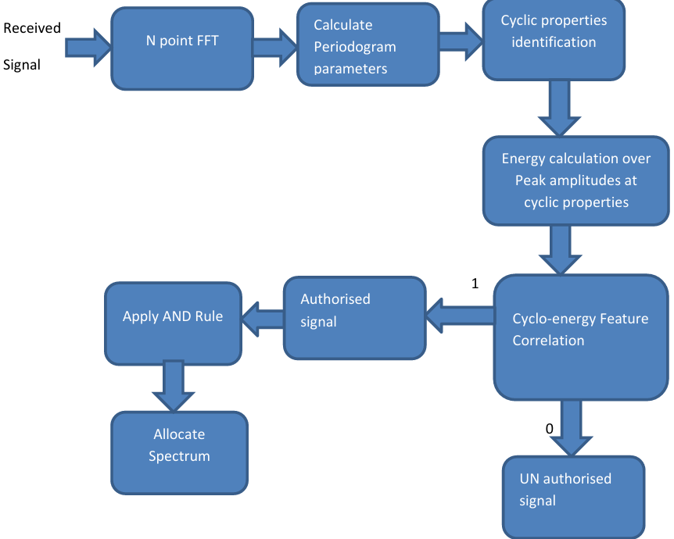

Conclusion
In conclusion, the literature survey reveals that cognitive radio systems and hybrid detection methods, specifically those combining cyclostationary and energy detection, represent significant advancements in wireless communication technologies. Cognitive radios excel in dynamic spectrum management, offering enhanced spectrum utilization and adaptability, particularly in crowded frequency environments and critical communication scenarios such as public safety and IoT applications. On the other hand, hybrid systems leverage the strengths of both detection techniques, providing improved detection performance, robustness against noise, and lower false alarm rates, which are essential for maintaining reliable communication links.

References
[1] ITU Radio Regulations, International Telecommunication Union, Genève, 2008
[2] Federal Communications Commission, "Facilitating Opportunities for Flexible, Efficient and Reliable Spectrum Use Employing Cognitive Radio Technologies", notice of proposed rulemaking and order, FCC 03- 322, December 2003
[3] Federal Communications Commission Spectrum Policy Task Force, "Report of the Spectrum Efficiency Working Group", November 2002
[4] Shared Spectrum Company, "Spectrum Occupancy Measurements", 2005, retrieved from
www.sharedspectrum.com/measurements on 27/10/2009
[5] K. N. Steadman, A. D. Rose, and T. T. N. Nguyen, "Dynamic Spectrum Sharing Detectors", In Proc. of IEEE International Symposium on New Frontiers in Dynamic Spectrum Access Networks (DySPAN 2007), Dublin, Ireland, April 2007, pp. 276-282
[6] M. Wellens and P. Mähönen, "Lessons Learned from an Extensive Spectrum Occupancy Measurement Campaign and a Stochastic Duty Cycle Model", Proc. of TridentCom 2009, Washington D.C., USA, April 2009, pp. 1-9
[7] M. Lopez-Benitez and F. Casadevall, "On the Spectrum Occupancy Perception of Cognitive Radio Terminals in Realistic Scenarios", International Workshop on Cognitive Information Processing, Elba, June 2010, pp. 99-104
[8] V. Valenta, R. Maršalek, G. Baudoin, M. Villegas, M. Suarez and F. Robert, "Survey on Spectrum Utilisation in Europe: Measurements, Analysis and Observations", in Proc. of ICST Conference on Cognitive Radio Oriented Wireless Networks and Communications (CROWNCOM), Cannes, France, June 2010, pp. 1-5
[9] I. F. Akyildiz, W. Y. Lee, M. C. Vuran and S. Mohanty, "NeXt Generation / Dynamic Spectrum Access / Cognitive Radio Wireless Networks: A Survey", Computer Networks, 2006, pp. 2127-2159
[10] S. Haykin, "Cognitive Radio: Brain-empowered Wireless Communications", IEEE Journal on Selected Areas in Commun., Vol. 23, No. 2, February 2005, pp. 201-220
[11] A. L. Drozd, I. P. Kasperovich, C. E. Carroll and A. C. Blackburn, "Computational Electromagnetics Applied to Analyzing the Efficient Utilization of the RF Transmission Hyperspace", In Proc. of IEEE/ACES Conf. on Wireless Comm. and Applied Computational Electromagnetics, Hawaii, USA, April 2000, pp. 1077-1085
[12] J. Mitola and G. Q. Maguire, "Cognitive radios: Making Software Radios More Personal", IEEE Pers. Commun., Vol. 6, No. 4, August 1999, pp. 13-18
[13] J. Mitola, "Cognitive Radio: An Integrated Agent Architecture for Software Defined Radio", PhD thesis, KTH Royal Institute of Technology, Stockholm, Sweden, 2000
[14] M. Matinmikko, M. Mustonen, H. Sarvanko, M. Höyhtyä, A. Hekkala, A. Mämmelä, M. Katz and M. Kiviranta, "A Motivating Overview of Cognitive Radio: Foundations, Regulatory Issues and Key Concepts", First International Workshop CogART, Aalborg, February 2008, pp. 1-5
[15] I. F. Akyildiz, W.-Y. Lee, K. R. Chowdhury: "CRAHNs: Cognitive Radio Ad Hoc Networks", Ad Hoc Networks, Elsevier, Vol. 7, No. 5, July 2009, pp. 810-836
[16] D. Čabrić, S. M. Mishra, D. Wilkomm, R. Brodersen and A. Wolisz, "A Cognitive Radio Approach for Usage of Virtual Unlicensed Spectrum", in Proc. of 14th IST Mobile Wireless Communications Summit 2005, Dresden Germany, June 2005, pp. 1-4
[17] R. V. Prasad, P. Pawelczak, J. A. Hoffmeyer, H. S. Berger, "Cognitive Functionality in Next Generation Wireless Networks: Standardization Efforts", IEEE Communications Magazine, April 2008, pp. 72- 78
[18] C. Clancy, J. Hecker, E. Stuntebeck and T. O'Shea, "Applications of Machine Learning to Cognitive Radio Networks", IEEE Wireless Communications, August 2007, pp. 47-52

