**SECURE HER – AI-ENABLED WOMEN'S SAFETY APPLICATION**

**Arisha khan1, Faizan Mulla2, Fardeen Shaikh3, Sufyan Shaikh4,**

**HOD. NooruSabah Sayed5**

1,2,3,4Student, Head of Department of Artificial Intelligence and Machine Learning, M.H. Saboo Siddik Polytechnic, Mumbai, India.

DOI: https://www.doi.org/10.58257/IJPREMS38900

**ABSTRACT**

"Secure Her" is a women safety app designed to proactively improve the personal safety of women in both public and private spaces. Through AI-driven risk detection, contextual behavioral analysis, and real-time alert systems, the app is meant to offer instant intervention and deterrence in unsafe encounters. The key aim is to provide timely intervention and community-based support and yet preserve the privacy of users. With cutting-edge features such as Smart Contextual Risk Detection and Community Guardian Mode, the app differentiates itself from current solutions. Preliminary testing shows that "Secure Her" has the ability to enhance personal safety perception, real-time response effectiveness, and community mobilization for women's safety.

Keywords: Women Safety, AI Risk Detection, Emergency Alerts, Mobile Security App, Personal Security, Community Support, Real-Time Tracking.

# 1. INTRODUCTION

The growing concern for women’s safety in modern society calls for innovative technological solutions. While many safety apps exist, they often lack intelligent threat detection and contextual responsiveness. "Secure Her" addresses this gap by using artificial intelligence to identify risky environments and behavioral anomalies. Combining GPS tracking, voice analysis, and smart sensors, the app ensures women can receive help quickly, whether from guardians, emergency services, or nearby users. The application supports real-time monitoring, proactive risk alerts, and an intuitive interface for immediate action in high-risk situations.

# 2. PROBLEM STATEMENT

Despite multiple safety apps available today, most rely on manual user input to trigger alerts—often impractical during emergencies. There is a critical need for a smart safety app that can identify and assess threats without user intervention. "Secure Her" uses AI to evaluate contextual clues, detect abnormal patterns, and generate alerts automatically. It empowers women to seek help discreetly and ensures timely action through automated emergency responses and guardian notifications.

# 3. IMPLEMENTATION PLAN

# The use of the "Secure Her" app entails a multi-layered system with emphasis on data protection, artificial intelligence, user interface, and emergency response systems. First, all user information such as location, audio recordings, and emergency contacts will be stored securely and encrypted to meet privacy standards such as GDPR. Sensitive information will only be accessed by authenticated users and approved systems. The risk detection model based on AI will be trained on datasets mimicking actual emergency and non-emergency situations so that the system can detect risky environments or actions in real time. A feedback mechanism will be integrated so that the AI learns from user experience continuously and enhances threat detection efficiency. The user interface shall be minimalist and intuitive with easy access to critical features such as SOS button, sharing of live location, and emergency contact list. The application will also have the capability of voice commands to enable hands-free usage during emergencies. Once a threat is identified—either manually by the user or automatically by the AI engine—the system immediately alerts trusted contacts, shares live location, and initiates ambient audio recording. In risky situations, the app will also show nearby safe areas and directions. Cross-platform compatibility, especially for Android, will make the app available to a large user base. A separate admin dashboard for guardians and emergency services will enable improved monitoring, real-time intervention, and data-driven insights into user safety trends.

# 4. SYSTEM DESIGN

The "Secure Her" application architecture is based on three fundamental modules: the input layer, the processing layer, and the action layer. The input layer gathers real-time information from a variety of sources, such as GPS location, voice commands, motion sensors, and environmental context tags (e.g., time of day or location category). These inputs are passed to the processing layer, which contains the AI model that has been trained to identify patterns of distress or abnormal behavior. The processing layer, through machine learning algorithms, assesses the level of risk based on contextual and behavioral indicators. Upon identifying a potential threat, the action layer is activated. This layer is tasked with triggering safety responses like sending emergency alerts to registered guardians, activating live location tracking, starting audio recording, and optionally alerting local emergency services. The system also makes sure that users are protected not just by manual inputs such as tapping the SOS button but also by smart, automated threat detection and response. The app design balances both user responsiveness and automation to give a complete safety solution.

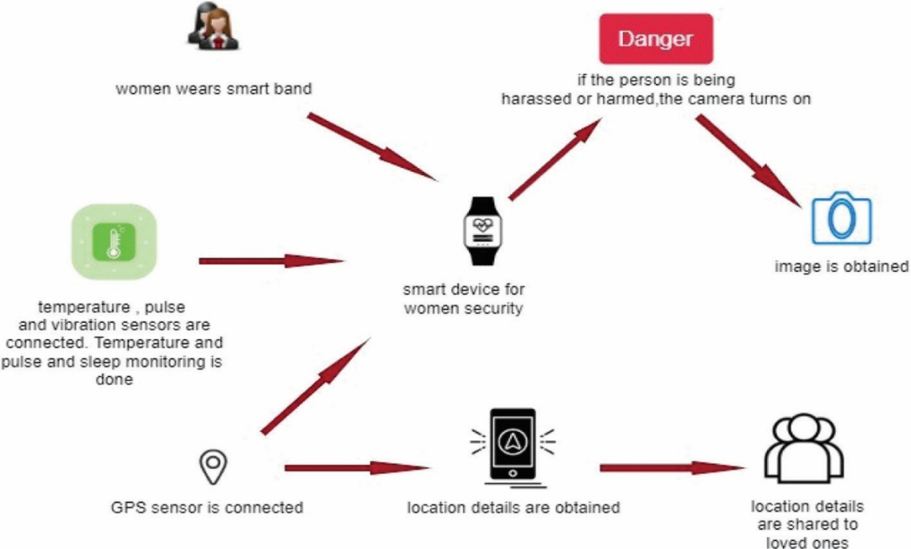

# 5. FUTURE SCOPE

# In the future, "Secure Her" can become a more holistic and smarter safety solution. Some of the upcoming developments are the integration of wearable technology like smart bands and watches, which can trigger silent SOS messages via touch or heart-rate irregularities. The app will also be integrated with local police databases to allow direct emergency contact and quicker rescue operations. In addition, there will be features of anonymous reporting to enable reporting of incidents in a stealth mode, and moderation to confirm and track repeat threats in a certain area. Regional safety data will continue to be used to fine-tune AI models so that hyperlocal detection of risk is enhanced. Another significant addition will be an offline SOS feature utilizing SMS-based communication to exchange location and emergency information, ensuring its functionality in places with limited or no internet coverage. These updates will help to make "Secure Her" an integrated, versatile, and highly dependable companion to women's safety.

# 6. CONCLUSION

# "Secure Her" reimagines personal safety with proactive AI, contextual risk detection, and community support. It minimizes reliance on user input in emergency situations compared to conventional safety apps. Through features such as Smart Contextual Risk Detection and Community Guardian Mode, it enables users with real-time protection and promotes a more secure environment for women. As smart technology continues to grow, the app will be a foundation in improving women's safety.

# 7. REFERENCES

1. 1. C. Yi and Y. Tian Texture string detection in natural scenes via structure-based grouping and partitioning IEEE Conf. Computer. Vis. Pattern Recognition, Jun. 2012, pp. 1083â"1090.
2. 2. Digital Image Processing Rafael C Gonzalez
3. 3. INTERNATIONAL JOURNAL OF TECHNOLOGY ENHANCEMENTS AND EMERGING ENGINEERING RESEARCH, VOL3, ISSUE05122ISSN2347-4289CopyrightÂ c 2015 IJTEEE. Sauver: an Android Application For Women's Safety.
4. 4. Abhaya: an android application for women's safety
5. 5. Report Of The Fourth World Conference on Women. New York, United Nations,1995 (A/CONF.177/20/Rev.1)
6. 6. Doulamis, A.; Pelekis, N.; Theodoridis, Y., âoe Easy Tracker: An Android Application for Capturing Mobility Behavior, â 2012 16th Panhellenic Conference on Informatics (PCI), vol., no., pp.357,362, 5-7 Oct. 2012.
7. 7. Women's Security, Android App developed by App Soft India, December 17, 2013. https://play.google.com/store/apps/details? id=com. Zayan infotech. securityhl=en
8. 8.âoe Life 360 â" FamilyLocatorâ Android App Developed ByLife360, 20 February 2014,
9. 9. Bramarambika Thota, Udaya Kanchana Kumar.P, Sauver: An Android Application For Women Safe-ty, M Tech, Dept. Of ECE,Vignan University, Guntur, India, M.sc, Computer Science, TJPS Co-lege, Guntur, India,IJTEEE,ISSN:2347-4289.VOL 3,ISSUE 05.
10. 10.\tS.Sangeetha1, P.Radhika PG scholar, Application For Women Safety, Department Of MCA, Panimalar Engineering College, IOSR, ISSN:2278-0661, pISSN:2278-8727, Volume17, ISSUE3, Ver. IV(MayJun.2015),pp01-04.
11. 11.\tTracking System using GPS and GSM: Practical Approach, May-2012
12. 12.\tThe Human Positioning System Based on the Wifi Direct and Precision Time Protocol