Sign Language Detection

Omkar Vibhute (Member) Information Technology SVCP, Pune Mr. U. S. Shirshetti (Guide)

**Abstract:** Sign language detection using machine learning aims to bridge the communication gap between deaf and hearing individuals by automatically recognizing hand gestures and translating them into text or speech. This field leverages computer vision and deep learning techniques to analyze video or image sequences, identify hand movements, and classify them according to their corresponding linguistic meaning. The goal is to develop accurate and accessible systems that can facilitate real-time communication for a wider audience. Sign language recognition (SLR) is a growing field with significant potential to improve accessibility and communication for individuals with hearing impairments. Machine learning algorithms, particularly deep learning models like Convolutional Neural Networks (CNNs) and Recurrent Neural Networks (RNNs), are being employed to analyze hand gestures, identify patterns in the movement, and classify them into different signs or words. When a signer interacts with the camera, the system identifies the signer's hand movements and facial expressions, recognizing key markers that represent specific signs. These markers are then translated into sign language vocabulary through the use of advanced machine learning algorithms.

# Keywords :

Sign Language Recognition (SLR), Convolutional Neural Networks (CNNs), Recurrent Neural Networks (RNNs), Machine Learning, Computer Vision, Gesture Recognition, Real-time Translation.

# Introduction :

Sign language detection using machine learning involves developing algorithms that can recognize and interpret hand gestures, facial expressions, and body movements used in sign language, ultimately translating them into text or speech. This technology aims to bridge communication gaps between hearing and non-hearing individuals. Machine learning models learn from vast datasets of sign language videos and images, enabling them to identify patterns and predict the meaning of different signs. Sign Language detection system shows what the position of hands in viewfinder of camera module means with good accuracy. It can then be used to help people who are just beginning to learn Sign Language or those who don't know sign language but have a close one who is deaf. Basic information refers to the fundamental or essential details about someone or something. It typically includes facts such as names, dates, addresses, phone numbers, and other primary identifying information. Basic information can also encompass general knowledge or facts about a particular topic. Sign language is manual communication commonly used by people who are deaf. Sign language is not universal; people who are deaf from different countries speak different sign languages. The gestures or symbols in sign language are organized in a linguistic way. Each individual gesture is called a sign.

Page **1** of **4**

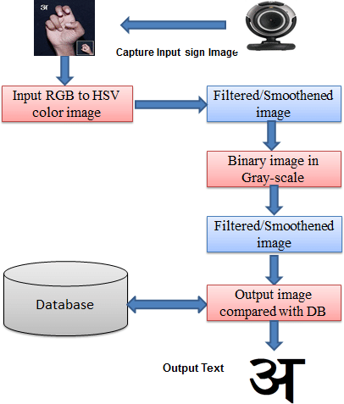

Figure 1 Circuit diagram of Aero-Flap Drone

# Literature Survey

Sign language detection using machine learning involves recognizing hand gestures and movements to understand the meaning conveyed. Literature suggests various approaches, including vision-based systems with cameras, sensor-based methods with wearable devices, and deep learning models. These methods aim to address communication barriers between the deaf and hearing communities. he results show that the system achieves an accuracy of 97.85% for single hand gestures and 94.55% for double hand gestures. The recognition is performed using HMM and bidirectional LSTM neural network (BLSTM-NN) for single and double hand gestures, respectively. Recent works have explored the integration of CNNs and RNNs to capture both spatial and temporal features in sign language videos.

# Background

Sign language serves as the primary mode of communication for millions of individuals with hearing or speech impairments worldwide. However, the lack of widespread understanding of sign language among the general population creates a communication barrier. To address this challenge, researchers have been working on automated sign language recognition systems that can translate signs into text or speech. Initially, sign language detection systems relied on hardware-based solutions like sensor gloves and motion trackers to capture hand movements. While these methods provided high accuracy, they were costly, non-intuitive, and impractical for everyday use. With advances in machine learning and computer vision, camera-based approaches became more viable. These systems use image and video data to detect hand gestures and facial expressions. Machine learning algorithms, especially deep learning models like Convolutional Neural Networks (CNNs) and Recurrent Neural Networks (RNNs), have shown great potential in recognizing and classifying complex gestures.

This shift towards vision-based, AI-driven sign language recognition has opened up possibilities for creating real- time, low-cost, and scalable solutions that promote inclusivity and accessibility in communication. Sign language is a visually-rich, gesture-based language that includes not only hand movements but also facial expressions and body posture to convey meaning. Each region often has its own variation of sign language (e.g., ASL - American Sign Language, ISL - Indian Sign Language), which adds to the complexity of recognition systems. Sign language is a vital mode of communication for individuals with hearing or speech impairments, relying on hand gestures, facial expressions, and body posture to convey meaning. Traditionally, sign language detection systems used hardware-based methods such as data gloves, motion sensors, and accelerometers to capture hand and finger movements. While these methods provided high accuracy, they were expensive, uncomfortable, and impractical for everyday use. With the rise of machine learning and computer vision, there has been a significant shift toward vision-based approaches that use cameras to detect and interpret gestures in real time.

1. **Process Table**

|  |  |  |
| --- | --- | --- |
| Step No. | Action | Description |
| 1 | Data Collection & Preparation | Collect a labeled, diverse sign language dataset; use data augmentation to improve size and variation for better model performance. |
| 2 | Feature Extraction | Use CNNs to extract hand shape, finger positions, and palm orientation from images. |
| 3 | Model Training | Train a model to predict signs with testing sets and hyperparameter tuning. |
| 4 | Refinement & Deployment | Refine the model and deploy it for real-time recognition on devices. |

1. **Methodology**

**Step 1: Importing Libraries**

In the first step we will import all the necessary libraries. Python libraries simplify data handling and machine learning tasks.

# Step 2: Load the Dataset

The dataset is available as two CSV files, sign_mnist_train.csv and sign_mnist_test.csv. Each row in the CSV file is a training sample with the 0th index having the labels from 0-25 and the rest of the row containing the 784-pixel values of a 28 x 28 image. Each pixel value will be in the range [0, 255].

# Step 3: Data Preprocessing

The dataset has been provided in two files one is for training and the other one is for testing. We will load this data and then one hot encode the labels considering the fact we are not building the classifier for ‘J’ and ‘Z’ alphabet.

# Step 4: Data Visualization

In this section, we will try to visualize images for signs of some of the alphabets which have been provided to us to build the classifier for each class.

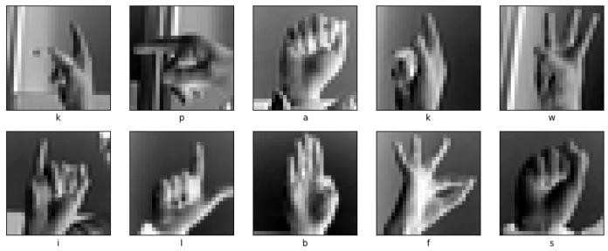

Visualized images of the signs corresponding to various alphabet classes.

# Step 5: Model Development

From this step onward, we use TensorFlow to build our CNN model. The Keras framework of TensorFlow provides all the functionalities needed to define the architecture of a Convolutional Neural Network and train it on the data.

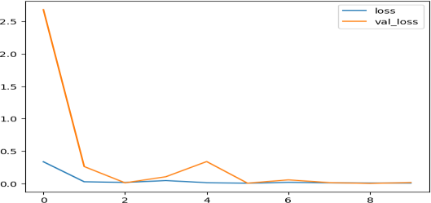

# Step 6: Model Evaluation

After training the model, we will visualize the training and validation accuracy as well as the loss for each epoch. This helps us analyze how well the model is performing.

# Applications

* 1. **Real-Time Communication Tools:** Enables real-time translation of sign language into text or speech, helping deaf or hard-of-hearing individuals communicate with non-signers.
  2. **Assistive Technologies:** Integrates into smartphones, tablets, or wearables to serve as personal communication aids for individuals with hearing or speech disabilities.
  3. **Educational Platforms:** Used in learning apps to teach sign language to students or users interested in learning sign communication.
  4. **Video Conferencing Integration:** Analyzing environmental changes like deforestation, pollution, and climate impact.
  5. **Accessibility in Media:** Helps create subtitles or voiceovers for sign language videos, making content more accessible.
  6. **Surveillance & Security:** Used to recognize hand signals or emergency signs in surveillance footage for safety and security purposes.

# Integration of Technology:

* 1. **Data Collection and Preprocessing:** Gather a diverse dataset of sign language gestures, including various signing styles, lighting conditions, and backgrounds to ensure

the model's robustness.

* 1. **Feature Extraction:** Identify and extract the distinctive characteristics of sign language gestures, such as hand shape, hand movement, facial expressions, and body posture.

# Model Training:

Train a model using the extracted features and labeled data. Common architectures include Convolutional Neural Networks (CNNs) and Recurrent Neural Networks (RNNs), which are often used for sign language recognition and translation.

# Implementation and Deployment:

Refine the model and deploy it for real-time.

# Challenges & Future Scope Challenges:

* 1. Changes in background and lighting can

significantly impact the accuracy of sign detection.

* 1. Systems should be able to recognize signs regardless of who is signing.
  2. Building comprehensive sign language datasets is a major hurdle, especially for less common or regional sign languages.

# Future Scope:

1. **Expanded Datasets:** Creating larger and more diverse datasets with a wider range of signs and signers is crucial.
2. **User-Independent Systems:** Developing systems that can accurately recognize signs regardless of the signer's characteristics.
3. **Sign Language Translation:** Developing systems that can automatically translate sign language into text and vice versa.
4. **Multi-Modal Approach:** Integrating other input modalities like facial expressions and body language to improve recognition accuracy.
5. **Robustness in Various Conditions:** Improving the ability of models to function reliably in different environments and lighting conditions.
6. **Sentence-Level Understanding:**Moving beyond recognizing individual signs to understanding and translating complete sentences.

# Conclusion

Significant progress has been made in the field of hardware-based sign language recognition, however, it is important to acknowledge that this methodology has its limitations and challenges. With this in mind, researchers should explore vision-based techniques, which have not received as much emphasis in the literature. Expanding research efforts in vision-based approaches can help address the limitations of hardware-based methods and contribute to a more comprehensive understanding of sign language recognition. The field of sign language translation is a significant area of study within sign languageliterature.

While there have been advancements in sign language recognition techniques that consider individual modalities (e.g., hand gestures or facial expressions), the exploration of combined sign language techniques incorporating multiple modalities is still relatively limited. Considering that sign language involves various elements, including hand movements, facial expressions, and body postures, it is essential to conduct further research that integrates and analyzes these combined modalities. By focusing on combined modality features, researchers can gain a deeper understanding of sign language communication and develop more accurate and comprehensive recognition techniques.

# References

* 1. Adaloglou N., Chatzis T., Papastratis I., Stergioulas A., Papadopoulos G.T., Zacharopoulou V., *et al.*

A comprehensive study on deep learning-based methods for sign language recognition

IEEE Transactions on Multimedia, 24 (2021),

pp. 1750-1762

* 1. Aditya W., Shih T.K., Thaipisutikul T., Fitriajie A. Gochoo M., Utaminingrum F., *et al.*

Novel spatio-temporal continuous sign language recognition using an attentive multi-feature network Sensors, 22 (17) (2022), p. 6452

* 1. Saha H.N., Tapadar S., Ray S., Chatterjee S.K., Saha S.

A machine learning based approach for hand gesture recognition using distinctive feature extraction Computing and communication workshop and conference (CCWC), 2018 IEEE 8th annual, IEEE (2018), pp. 91-98

* 1. Saxena, S., Paygude, A., Jain, P., Memon, A., & Naik, V. (2022). Hand Gesture Recognition using YOLO Models for Hearing and Speech Impaired People. In 2022 IEEE students conference on engineering and systems (pp. 1–6). Rubber Band Powered Ornithopters at Ornithopter Zone web site
  2. Video provided by Ivan Goncharov:

[https://youtu.be/a99p_fAr6e4?si=GJwHLNi](https://youtu.be/a99p_fAr6e4?si=GJwHLNiREuAAlP64/) [REuAAlP64/](https://youtu.be/a99p_fAr6e4?si=GJwHLNiREuAAlP64/)

* 1. Sharma K., Kumar B., Sehgal D., Kaushik A. A comprehensive analysis on technological approaches in sign language recognition

Emergent converging technologies and biomedical systems: Select proceedings of ETBS 2021, Springer (2022), pp. 349-361

* 1. Tao W., Leu M.C., Yin Z.

American sign language alphabet recognition using convolutional neural networks with multiview augmentation and inference fusion Engineering Applications of Artificial Intelligence, 76 (2018), pp. 202-213