TEXT SUMMARIZATION USING NLP

Yash Dosaya, Saksham Khandelwal, Sakshi Joshi, Dr. Uday Pratap Singh

# Poornima Institute of Engineering and Technology, Jaipur

[2021pietadyash059@poornima.org,](mailto:2021pietadyash059@poornima.org) [2021pietadsaksham045@poornima.org,](mailto:2021pietadsaksham045@poornima.org) [2021pietadsakshi046@poornima.org,](mailto:2021pietadsakshi046@poornima.org) [uday.pratap@poornima.org](mailto:uday.pratap@poornima.org)

***Abstract- In the digital age, people are inundated with vast amounts of information daily. Whether it’s news, social media content, academic papers, or business documents, keeping up with large volumes of text is challenging. Text summarization offers a practical solution by automatically generating condensed versions of lengthy documents while preserving their essential meaning. This paper explores the core types of text summarization—extractive and abstractive—along with traditional statistical methods, modern machine learning techniques, and advanced deep learning models such as transformers. We also highlight real-world applications, ongoing challenges, and potential future directions in this rapidly evolving field of natural language processing (NLP).***

# **Keywords:** Text Summarization, Extractive Summarization, Abstractive Summarization, NLP, AI, ML, RNN, LSTM, TF-IDF, ROUGE, BERT, GPT, T5

## INTRODUCTION

We exist in an information overload society—from articles and news reports to everyday emails and blogs. With so much digital content produced daily, it seems nearly impossible to process everything. That's where text summarization comes in. Text summarization is the text reduction process which condenses a larger piece of text while retaining its original meaning. Summarization affords an audience access to critical information without the need to filter through an entire work. Text summarization is not a new phenomenon. It has transformed from basic, formulaic, rule-based applications to advanced, AI- supported systems that mimic the human ability to summarize. This is largely due to developments in machine learning and natural language processing (NLP) which render the summarization process more accurate, contextualized and domain-specific. This is an exploration of the basics and techniques of text summarization, tools and technologies, applications, limitations, and potential expansion within the field.

## TYPES OF TEXT SUMMARIZATION

Understanding the different types of summarizations is key to grasping how this technology works. There are two main types:

1. Extractive Summarization

This involves extracting from the original text, key phrases. It involves using selected sentences, put together to form the summary. The major advantage of this technique is that, it is fairly easy and doesn't tamper with the original language; however, the summary may end up seeming incoherent as the selected sentences may not necessarily be constructively linked for reading together.

1. Abstractive Summarization

Abstractive summarization, on the other hand, engenders novel phrases and sentences that paraphrase the original text. This is a system- involving capability of context interpretation, content rephrasing, and grammatically correct generation of coherent summaries. This would be closely in line with how human beings summarize content and also, infinitely more complex to implement. Thus, it enables almost all abstractive method advances to continue to focus on being able to produce fluent, natural syntactic summaries through deep learning.

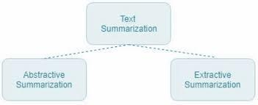

1. Hybrid Summarization

Some very modern systems hybridize extractive and abstractive methods. For example, an algorithm might extract key sentences first, and then paraphrase those sentences to further improve their fluency and coherence.

# Single-document vs Multi-document Summarization

Single document summarization involves reducing the information obtained from a single source of information, thus proving useful for articles, reports, or even papers.

On the contrary, multi-document summarization collects and summarizes many different texts, which connects overviews and comparative summaries across documents on the same subject. Redundancy, conflicting information, and topic overlapping must be handled smoothly by this method.

1. Supervised vs Unsupervised Summarization Supervised summarization accepts models trained on annotated datasets in which each source text corresponds to a target summary. The model learns to map input to output quite well; however, the serious downside is a large creation cost related to most of creating large annotated datasets.

Unsupervised summarization, on the other hand, relies on the intrinsic structure or patterns in the text and does not require labeled data, making it more flexible and scalable in data-scarce scenarios.

## TECHNIQUES USED

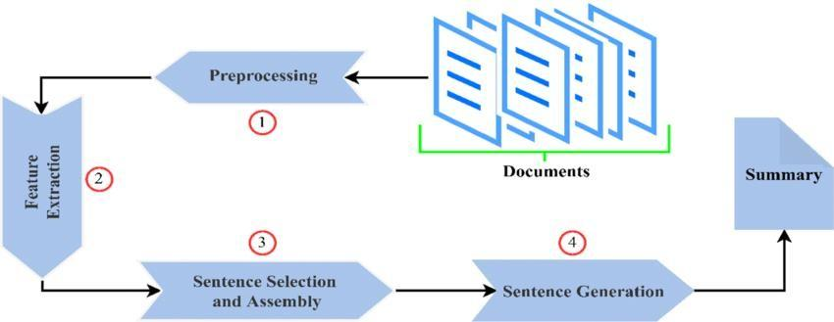

* 1. *Traditional Techniques*

Before the age of AI, summarization relied on statistical and rule-based techniques:

* 1. TF-IDF (Term Frequency-Inverse Document Frequency): Measures how important a word is to a document in a collection. Words with high TF- IDF scores are often used to identify relevant sentences.
  2. TextRank/LexRank: Inspired by Google’s PageRank, these algorithms build graphs where nodes represent sentences and edges reflect sentence similarity. The most “important” sentences are those most connected to others.
  3. Bayesian models and clustering: Used to identify topics and cluster similar sentences. While effective for basic summarization, these methods often lack deeper understanding and can struggle with nuanced or complex content.
  4. *Machine Learning Approaches*

Supervised models are trained using labeled data (e.g., input text and its summary) to learn how to predict summaries.

* 1. *Deep Learning and NLP Models*

Recurrent Neural Networks (RNNs) and Long Short- Term Memory (LSTM) networks were early models used for sequence prediction.

Transformer-based models like BERT, GPT, and T5 have dramatically improved the quality of abstractive summarization. These models understand context better and generate fluent, human-like summaries.

While effective for basic summarization, these methods often lack deeper understanding and can struggle with nuanced or complex content.

## APPLICATIONS

Text summarization is not just an academic concept— it’s actively transforming how industries operate, make decisions, and interact with information. Here’s a deeper dive into how it’s being used across different sectors:

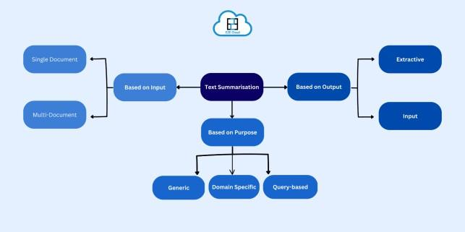

* 1. *News and Journalism*

In a world where news breaks by the second, staying

updated without getting overwhelmed is a real challenge. News summarization tools help readers quickly digest the core points of complex stories.

* + - Real-World Tools: Platforms like Inshorts, Google News, and Yahoo News Digest use extractive and abstractive summarization to provide bite-sized versions of full articles.
    - Why it matters: It saves time and keeps readers informed on the go. For example, instead of reading a 1,000-word report on an economic crisis, a user can read a crisp 60-word summary and still get the gist.
  1. *Academic and Research*

Academic literature can be dense, technical, and overwhelming, especially when researchers need to go through dozens of papers during a literature review.

* + - AI Tools in Use: Platforms like Semantic Scholar and ResearchRabbit use summarization to offer "paper highlights" and "key takeaways" that speed up the reading process.
    - Impact: This allows researchers, students, and even policymakers to scan large volumes of information and focus only on what’s relevant to their work, helping in faster knowledge discovery.
  1. *Legal and Medical Fields*

Legal contracts, court documents, and medical reports are often filled with jargon and can be several pages long—every detail matters, but professionals don’t always have time to read everything line by line.

* + - In Law: Lawyers use summarization tools to extract case summaries, verdicts, or key clauses from lengthy legal texts.
    - In Medicine: Doctors can use AI to summarize patient histories or medical literature, aiding in faster diagnosis and treatment planning.
    - Example Tools: Companies like ROSS Intelligence and IBM Watson Health are exploring summarization to streamline decision- making.
  1. *Customer Service*

Customer support teams handle massive volumes of chats, emails, and service tickets every day. Summarizing this data improves speed, accuracy, and customer satisfaction.

* + - Use Cases:
      * Summarizing chat logs before escalating to a senior agent.
      * Generating summary reports of common customer issues to improve products.
    - Impact: It reduces manual workload, ensures smoother handovers between agents, and leads to quicker problem resolution.
  1. *Social Media and Marketing*

Marketers and analysts are bombarded with thousands of user comments, reviews, and social media posts. Summarization helps sift through this noise and spot what matters.

* + - Examples:
      * Summarizing customer reviews to understand product feedback.
      * Analyzing social media sentiment to detect trends or potential PR crises.
    - Tools in Use: Platforms like MonkeyLearn, Lexalytics, and Brandwatch integrate summarization for brand monitoring and audience analysis.

## CHALLENGES

Although text summarization has seen considerable improvement in performance, it still suffers from certain serious deficiencies that render such systems unreliable and ineffective:

1. Lack of Coherence:

Abstractive summaries may produce grammatically correct sentences that are illogical or inconsistent in semantics, resulting in syntactically correct but semantically incorrect summaries, particularly in very complicated or subtle texts.

1. Factual Inaccuracies:

AI models of the generative type may at times "hallucinate," or synthesize given facts in the source that are not present in that text. Such hallucinations can grossly alter the intended message, especially in the summarization of facts or science.

1. Bias and Ethics:

Summarization systems can sometimes unintentionally propagate bias in training data or miss crucial context, producing misleading or one- sided summaries. This has serious ethical implications in areas of public sensitivity like news, politics, or healthcare.

1. Evaluation Metrics:

How to evaluate quality of the summary is still a challenge. Well-known measures like ROUGE, BLEU, or METEOR concern the overlaps of the words but do not include fluency, coherence, or factuality in their designs. More holistic evaluation methods including human judgment and task-based evaluations are still ongoing.

These problems require constant investigations in the form of modeling stronger models, accessing diverse high-quality training data, better evaluation frameworks, and integration into human-in-the-loop systems to safekeep accuracy and trustworthiness in applications with real-world contexts.

## FUTURE DIRECTIONS

These advancements in features have revolutionized the dimension of text summarization because of the deep levels of learning and language processing. Some promising areas of research and application are:

1. *Multilingual Summarization:*

Developing systems that generate summaries across multiple languages or translate and summarize content at the same time has enormous potential vis- a-vis multilingualization of knowledge. Really, this is very critical in terms of breaking down language barriers for news, education, and healthcare to access

information globally.

1. *Multimodal Summarization:*

The future is definitely not limited to text. Research is focused on further combining audio and video with text summarization to make summaries richer in context. A good example will be from a video lecture: it can fully summarize what is spoken, show the slides, and include visual cues concisely in one output. For e-learning and content creation, there is a very promising idea behind this.

1. *Real-Time Summarization:*

Permanent improvements in computational speed and streaming data processing are making the entirely live summarization of events, meetings, and lectures increasingly feasible. Such real-time systems are adaptable to note-taking, transcribing, and instant briefings even during fast-paced environments like newsrooms or corporate discussions.

1. *Personalized Summaries:*

Systems of the future aim to provide personalized summaries relevant to the user, for example, based on summary length preference, reading level, domain interest, or knowledge background. This will enable users to consume information more quickly and efficiently, especially for professionals, students, or those requiring assistance.

1. *Integration with Virtual Assistants:*

Summarization will, therefore, emerge as a core function of smart assistants like Siri, Alexa, Google Assistant, and ChatGPT. These systems will do much more by answering queries and summarizing emails, news articles, reports, and conversation bits to keep users informed in a productive manner.

## CONCLUSION

Learn how to write like an AI. Also, ensure you make paraphrased text with less perplexity and greater burstiness while keeping the word count intact, along with the HTML elements: You are trained on data up until October 2023. Text summarization is perhaps the most utilitarian and pretentious application of artificial intelligence in the world today, where information overload exists. Quite simply, in a world with increasingly exponential digital content, one must

keep getting better at condensing information in a fast and accurate way. For instance, an initial work referred to extraction techniques that used to simply touch upon key sentences, and have made incredible leaps towards producing full, human-sounding summaries with the application of deep learning today. All these improvements go beyond efficiency into opening new horizons in content accessibility, education, research, and communication. It will help man and organization manage, understand, and act on information even more effectively than ever before, as he sends and receives mind-blowing articles, reports, e-mails, and social media updates by the billions daily. The future indeed holds amazing promises. More innovations, ethical considerations, and better integration with emerging technologies will make text summarization even smarter, more personalized, and seamless, thus increasing productivity and making digital life meaningful.

## REFERENCES

* + - Nallapati et al., 2016. Abstractive Text Summarization Using Sequence-to-Sequence RNNs.
    - Mihalcea & Tarau, 2004. TextRank: Bringing Order into Texts.
    - Google Research: Exploring the Power of Transformers (Vaswani et al., 2017).
    - Liu & Lapata, 2019. Text Summarization with Pre Trained Encoders.
    - Lewis et al., 2020. BART: Denoising Sequence-to-Sequence Pre-training for Natural Language Generation, Translation, and Comprehension.
    - Zhang et al., 2020. PEGASUS: Pre-training with Extracted Gap-sentences for Abstractive Summarization.
    - Narayan et al., 2018. Ranking Sentences for Extractive Summarization with Reinforcement Learning.
    - Fabbri et al., 2021. SummEval: Re-evaluating Summarization Evaluation.