# Analyzing Urban Dynamics: Leveraging CITYINFO for Enhanced Smart City Applications

**Pallavi Sonwane, Gayatri Choudhari, Prof. Pragati Lokhande**

Department of Computer Science and Engineering, Thakur Shiv Kumar Singh Memorial Engineering College Burhanpur(M.P.)

**ABSTRACT**

This project introduces us about City Info Website. Our website has main focus on users who can easily visit this website and can easily access information and services. To create a user-friendly platform that makes exploring and understanding the cities simply and informative. It provide comprehensive, up-to-date information about cities worldwide. User can easily find the common things uses in city and can easily access them. It also contain organized data for the popular & trending basic things that are needed in city.

**Index Terms -** [smart city](https://www.mdpi.com/search?q=smart+city), [real estate](https://www.mdpi.com/search?q=real+estate); [technologies](https://www.mdpi.com/search?q=technologies), [added values](https://www.mdpi.com/search?q=added+values),  [integrative review](https://www.mdpi.com/search?q=integrative+review),CITYINFO,advisorycompany.

**Introduction**

## City Info is a web application that provides users with detailed and organized information about cities, including data on landmarks, transportation, population, and local attractions. It serves as a digital platform where users can search for cities, view relevant data, and contribute their own reviews or updates. Designed for travelers, residents, and researchers, City Info combines dynamic content with a user-friendly interface and asecure login system to deliver an informative and interactive urban exploration experience.

## **OBJECTIVE OF PROJECT**

* Here are the key objectives for the CityInfo website presented in bullet points:
* Centralized Information: Provide a single platform that aggregates all the essential information about cities.
* Comprehensive Coverage: Include diverse categories such as colleges, shopping malls, famous food spots, historical places, home services, rental homes, water services, and travel services.
* Accessibility for All: Cater to both residents and visitors, ensuring that everyone can easily access relevant information.
* User Engagement: Encourage community contributions by allowing users to submit reviews, updates, and recommendations.
* Real-Time Data: Maintain up-to-date and accurate information to support everyday decision making.
* Responsive User Experience: Deliver a clean and intuitive interface that works across multiple devices and platforms.
* Efficient Service Discovery: Help users quickly locate and connect with services and attractions within the city. These objectives are designed to make CityInfo a valuable resource
* for exploring and managing urban life, whether you are a resident or just visiting.

**APPLICATIONS OR SCOPE**

* **City Guide:** Acts as a digital city guide for tourists and newcomers to explore attractions, food, and historical places.
* **Local Service Finder:** Helps residents find nearby home services, rental homes, water suppliers, and essential contacts.
* **Shopping & Lifestyle**: Offers details on shopping malls, local markets, and lifestyle spots within the city.
* **Educational Directory:** Lists local colleges and institutions, useful for students and parents looking for educational options.
* **Food Discovery:** Showcases popular local food joints, restaurants, and street food hubs for food lovers.
* **Travel Assistance:** Provides info on travel services, transportation options, and routes within the city.
* **Community Platform:** Enables users to share reviews, experiences, and suggest updates for public benefit.

**LIMITATION**

Here are some limitations of a blog website project:

* Limited to Burhanpur – Not useful for users outside the city.
* Outdated Data – Hard to keep listings accurate and current.
* No User Interaction – Lacks reviews, ratings, or feedback features.
* Backend Constraints – May face performance issues as user base grows.
* Weak UI/UX – May not be mobile-friendly or easy to navigate.
* Security Risks – Possible vulnerabilities if login system isn’t secured.

## Basic Search – No advanced filters or search options.

## No Real-Time Updates – Doesn’t show live status or availability.

## Language Barrier – Only in English; may exclude local users.

## No Monetization – No way to earn through ads or premium listings.

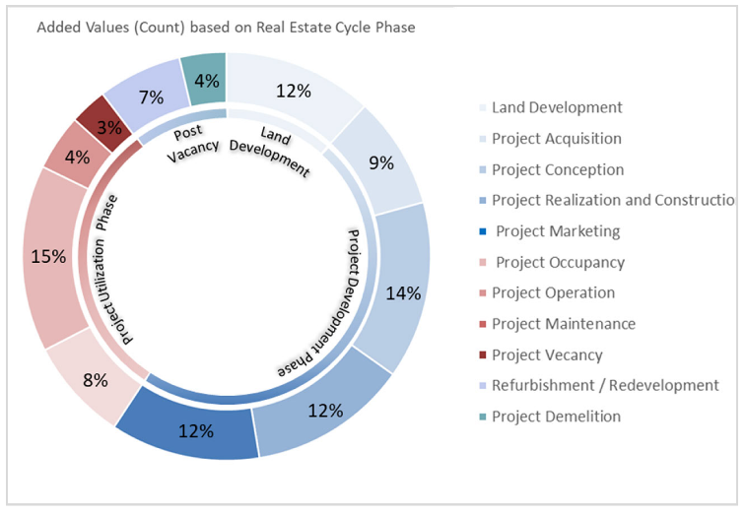

**Figure 1.1** Added values and their percentages based on the phase.

**FUTURE SCOPE**

The CityInfo website is a static, responsive platform developed using HTML, CSS, and Bootstrap, aimed at providing users with essential information about different cities. It successfully delivers a clean user interface, intuitive navigation, and organized city data — all accessible directly through a web browser without needing a backend or database.

**Key Outcomes:** 1. Demonstrated how a city information portal can be built using only frontend technologies.

2. Created a mobile-friendly, easy-to-navigate UI using Bootstrap.

3. Offered a foundation that is simple to maintain and expand.

**CONCLUSION**

The CityInfo website is a static, responsive web application developed using HTML, CSS,JavaScript and Bootstrap to provide an engaging user experience for discovering cityrelated information.

This article explored the added value of smart city technologies in real estate development. An integrative review of 16 technologies: Big Data, artificial intelligence, information and communications technology, Internet of Things, clouds and software as a service, drones, 3D Scanning, wearable technologies, Virtual Reality and Augmented Reality, Geographic Information Systems, Building Information Modeling, Digital Twin, blockchain and smart contracts. The review included 168 publications from the last decade, chosen based on selection criteria.

The publications included scientific articles, conference papers, book chapters, and thesis manuscripts. These technologies were sorted into five function groups: data mining technologies, networking and communication tools, data collection technologies, decision-making and visualization, as well as transaction and trading technologies. The focus was on the added value of these technologies on smart city and real estate levels.

**REFERENCES**

* Mastering HTML, CSS & Bootstrap
* YouTube, ChatGPT.
* l-Rimawi, T.H.; Nadler, M. Evaluating Cities and Real Estate Smartness and Integration: Introducing a Comprehensive Evaluation Framework. Sustainability 2023, 15, 9518. [[Google Scholar](https://scholar.google.com/scholar_lookup?title=Evaluating+Cities+and+Real+Estate+Smartness+and+Integration:+Introducing+a+Comprehensive+Evaluation+Framework&author=Al-Rimawi,+T.H.&author=Nadler,+M.&publication_year=2023&journal=Sustainability&volume=15&pages=9518&doi=10.3390/su15129518)] [[CrossRef](https://doi.org/10.3390/su15129518)]
* Li, W.; Batty, M.; Goodchild, M.F. Real-time GIS for smart cities. Int. J. Geogr. Inf. Sci. 2020, 34, 311–324. [[Google Scholar](https://scholar.google.com/scholar_lookup?title=Real-time+GIS+for+smart+cities&author=Li,+W.&author=Batty,+M.&author=Goodchild,+M.F.&publication_year=2020&journal=Int.+J.+Geogr.+Inf.+Sci.&volume=34&pages=311%E2%80%93324&doi=10.1080/13658816.2019.1673397)] [[CrossRef](https://doi.org/10.1080/13658816.2019.1673397)]
* Girardi, P.; Temporelli, A. Smartainability: A Methodology for Assessing the Sustainability of the Smart City. Energy Procedia 2017, 111, 810–816. [[Google Scholar](https://scholar.google.com/scholar_lookup?title=Smartainability:+A+Methodology+for+Assessing+the+Sustainability+of+the+Smart+City&author=Girardi,+P.&author=Temporelli,+A.&publication_year=2017&journal=Energy+Procedia&volume=111&pages=810%E2%80%93816&doi=10.1016/j.egypro.2017.03.243)] [[CrossRef](https://doi.org/10.1016/j.egypro.2017.03.243)]
* Selvakanmani, S. Smart City—The Urban Intelligence of India. Int. J. Res. Appl. Sci. Eng. Technol. 2015, 3, 302–307. [[Google Scholar](https://scholar.google.com/scholar_lookup?title=Smart+City%E2%80%94The+Urban+Intelligence+of+India&author=Selvakanmani,+S.&publication_year=2015&journal=Int.+J.+Res.+Appl.+Sci.+Eng.+Technol.&volume=3&pages=302%E2%80%93307)]
* Deakin, M.; Al Waer, H. From intelligent to smart cities. Intell. Build. Int. 2011, 3, 133–139. [[Google Scholar](https://scholar.google.com/scholar_lookup?title=From+intelligent+to+smart+cities&author=Deakin,+M.&author=Al+Waer,+H.&publication_year=2011&journal=Intell.+Build.+Int.&volume=3&pages=133%E2%80%93139&doi=10.1080/17508975.2011.586673)] [[CrossRef](https://doi.org/10.1080/17508975.2011.586673)]
* Okoro, C.; Kruger, A.; Booyens, M. Towards Sustainability of Real Estate Development: An Integrative Review of Smart City Planning Considerations. In Proceedings of the Creative Construction e-Conference 2020, Online, 28 June–1 July 2020. [[Google Scholar](https://scholar.google.com/scholar_lookup?title=Towards+Sustainability+of+Real+Estate+Development:+An+Integrative+Review+of+Smart+City+Planning+Considerations&conference=Proceedings+of+the+Creative+Construction+e-Conference+2020&author=Okoro,+C.&author=Kruger,+A.&author=Booyens,+M.&publication_year=2020)]
* Myeong, S.; Jung, Y.; Lee, E. A study on determinant factors in smart city development: An analytic hierarchy process analysis. Sustainability 2018, 10, 2606. [[Google Scholar](https://scholar.google.com/scholar_lookup?title=A+study+on+determinant+factors+in+smart+city+development:+An+analytic+hierarchy+process+analysis&author=Myeong,+S.&author=Jung,+Y.&author=Lee,+E.&publication_year=2018&journal=Sustainability&volume=10&pages=2606&doi=10.3390/su10082606)] [[CrossRef](https://doi.org/10.3390/su10082606)]
* Afaneh, A.; Shahrour, I. Use of GIS for SunRise Smart City project, large scale demonstrator of the Smart City. In Proceedings of the 2017 Sensors Networks Smart and Emerging Technologies, SENSET 2017, Beirut, Lebanon, 12–14 September 2017; IEEE: Piscataway, NJ, USA, 2017; Volume 2017, pp. 1–4. [[Google Scholar](https://scholar.google.com/scholar_lookup?title=Use+of+GIS+for+SunRise+Smart+City+project,+large+scale+demonstrator+of+the+Smart+City&conference=Proceedings+of+the+2017+Sensors+Networks+Smart+and+Emerging+Technologies,+SENSET+2017&author=Afaneh,+A.&author=Shahrour,+I.&publication_year=2017&pages=1%E2%80%934&doi=10.1109/SENSET.2017.8125071)] [[CrossRef](https://doi.org/10.1109/SENSET.2017.8125071)]
* Google Fonts for Typography:

Google Fonts used to enhance the typography of the website. Reference: <https://fonts.google.com/>