##### **ONLINE EXAMINATIONS PORTAL**

**Diksha Bhawsar, Nikita Sonwane, Priyal Jangde,** **Prof. Neha Koge**

Department of Computer Science and Engineering, Thakur Shivkumar Singh Memorial Engineering College, Burhanpur(M.P.)

**ABSTRACT**

The Online Examination Portal is a comprehensive web-based application developed to facilitate the efficient and secure administration of examinations over the internet, aiming to modernize the traditional paper-based assessment approach. By allowing students to take exams remotely at their convenience, the system enhances time management and provides instant evaluation alongside automated results, benefiting both learners and educators. Key features include exam scheduling, dynamic question paper generation, secure login protocols for both students and instructors, real-time performance tracking, and detailed reporting capabilities. This online examination system is tailored to ensure flexibility, user-friendliness, and equity, significantly minimizing human error and improving the overall assessment experience. Additionally, it incorporates administrative functionalities for streamlined management and monitoring of examinations, positioning it as an essential resource for educational institutions.

**INTRODUCTION**

The Online Examination Portal represents a transformative approach to the traditional examination process by migrating it to a digital platform, thereby enhancing the efficiency, security, and accessibility of assessments in educational institutions. This system enables students to undertake exams remotely, significantly reducing the reliance on physical infrastructure while accommodating various question types, including multiple choice, true/false, and descriptive formats. Key features such as secure login, automated evaluation, and real-time result dissemination streamline the examination process, alleviating administrative burdens. The portal's administrative interface supports exam scheduling, monitoring, and reporting, while the student interface ensures straightforward access to exams and performance tracking.

The initiative is driven by the need to overcome limitations of conventional examination methods, including time inefficiencies, manual errors, and logistical complexities. By promoting features like question randomization and immediate grading, this project not only enhances fairness in evaluations but also fosters a more accessible and cost-effective examination environment. The scope encompasses the development of a web-based platform that addresses contemporary educational demands, ultimately facilitating a seamless transition to online assessments.

**LIMITATION**

#### **Internet Connectivity Issues**

Not all students have access to stable internet, especially in rural or semi-urban areas.

#### **Lack of Devices**

Some students may not own personal devices like smartphones, tablets, or laptops.

#### **Cheating Risks in Home-Based Exams**

It's difficult to monitor students during exams taken from home, increasing the chance of cheating.

#### **4. Technical Glitches**

System crashes, login failures, or electricity outages can disrupt the exam process.

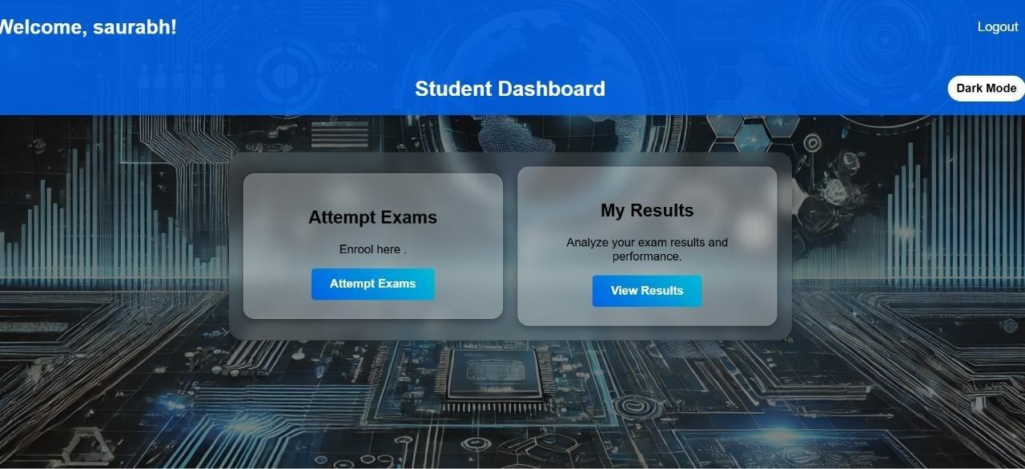 **RESULTS**

**Fig 1.1** Student Dashboard

**APPLICATIONS**

#### Educational institutions

#### Competitive Exams

#### Recruitment Tests

#### Cost and Time Efficiency

#### Instant Results and Analytics

* + This explores the increasing adoption of online examinations across educational institutions, competitive organizations, and corporate hiring processes.

**CONCLUSION**

The online examination portal offers an efficient and secure solution for conducting exams. It simplifies the process for both administrators and students with features like real-time evaluation, automated grading, and secure data handling. The system is user-friendly, reduces administrative effort, and ensures fairness through randomized questions and encrypted data. This portal improves exam accessibility, saves time, and provides a modern, scalable approach to assessments, making it an essential tool for educational institutions.

**FUTURE SCOPE**

#### AI-Based Performance Analysis

Using AI to identify weak areas of students and provide personalized learning suggestions.

#### Voice and Video Proctoring

Implementing webcam and microphone monitoring to prevent cheating during remote exams.

#### Multi-Language Support

Enabling exams in English, Hindi, and other regional languages for better accessibility.

#### Gamified Quizzes

Making learning more engaging by adding fun, timed quizzes and game-based assessments

#### Cloud Backup and Sync

Ensuring automatic data backup and synchronization to prevent data loss.

REFERENCE

1. Web Based online Secured Exam; B.Persis Urbana Ivy, A.shalini, A.Yamuna, International Journal of Engineering Research and Applications (IJERA) ISSN: 2248-9622 www.ijera.com Vol. 2, Issue 1, Jan¬Feb 2012, pp. 943-944.
2. Management System,” International Journal of Electrical & Computer Sciences, Vol. 10, No. 01, pp. 48-55.
3. Downing, D., et al. (2000). Dictionary of computer and Internet.
4. Tallent-Runnels, M. K., et al. (2006). "Teaching courses online: A review of the research." Review of educational research 76(1): 93-135.
5. K. S. Prasad Reddy, Beginning Spring Boot, “RESTful Web Services: Building REST APIs Using Spring Boot.
6. K. S. Prasad Reddy, Beginning Spring Boot, “Working with JPA: BSpring Data JPA, pp. 84-97, 2015.