*Role of CTAC Surfactant in improvement physical and Microstructural Properties of Sustainable Cementitious Pastes*

**Abdel Fattah A. Qaraman\***

* Israa University, Gaza, Palestine.

Email: fatahdeep@gmail.com

Abstract

This study examines how the cationic surfactant cetyltrimethylammonium chloride (CTAC) affects the microstructural and physical characteristics of environmentally friendly, sustainable cementitious pastes. By systematically analyzing the density, air content, water absorption, thermal conductivity, and topography of hardened cementitious pastes, the study assesses the trade-offs between thermal insulation and structural integrity brought about by CTAC Surfactant. The findings indicate that at 2% concentration, CTAC dramatically increases porosity (up to 49.45%) and reduces thermal conductivity (0.24 W•m⁻¹•K⁻¹), but at the expense of compressive strength (79% compared with control). Changes in hydration disruption and pore structure lead to an increase in water absorption from 2.1 to 6.8%. According to the study, the best range for mechanical and insulating viability was between 0.5% and 1.0% CTAC. These findings highlight CTAC's potential for creating lightweight, thermally efficient building materials, but they also highlight the necessity of concentration optimization for performance and durability.

Keywords

Cetyltrimethylammonium Chloride (CTAC), foam cement paste, thermal conductivity, compressive strength, air-entrained porosity, microstructure modification, sustainable construction materials.

Introduction

The efforts of energy-efficient construction practices has enhanced interest in insulating materials, notably for external walls, which account for a significant portion of building envelopes and critically influence thermal performance (Harvey, 2009; Seppälä et al., 2008). Ordinary construction units, such as standard bricks, often exhibit insufficient thermal insulation properties, encouraging researchers to explore advanced materials efficient in reducing energy consumption and environmental footprints (Zhou et al., 2012; Peng et al., 2008). Among these innovations, foam Cementitious Paste has become a promising solution due to its low density, desirable thermal conductivity, and structural versatility, allowing its dual functionality as a thermal insulator and load-bearing component (Bumanis, 2013). Additionally, its cost-effectiveness, ease of Production, and sustainable attributes position it as a viable modern eco-friendly construction.

The efficacy of insulation materials depends on their capacity to diminish heat transfer between outdoor and indoor environments, thereby regulating internal temperatures and preventing condensation (Meletse, 2005). In foam cementitious systems, thermal conductivity is determined by microstructural parameters such as porosity, bulk density, moisture content, and chemical composition (Bremner et al., 2000). Notably, the air content within the cement matrix enhances insulation performance, as air has an inherent low thermal conductivity. Practical studies have further established an inverse correlation between thermal conductivity and porosity, with higher water-to-cement (w/c) ratios increasing porosity and thus improving insulation (Uysal, 2004; Bessenouci, 2011).

To improve mechanical and pore structure performance, surfactants as surface-active agents have been investigated for their ability to modify cementitious matrices. Cetyltrimethylammonium Chloride (CTAC), a cationic surfactant, has attracted attention for its influence on the rate of hydration and the evolution of microstructure. Through the CTAC surfactant adsorption onto cement particles, CTAC affect particle dispersion, hydration product formation (e.g., calcium silicate hydrate (C-S-H) and calcium hydroxide (Ca(OH)₂)), and pore optimization (Snoeck et al., 2017; Zhang et al., 2019). However, the increment of CTAC concentrations may weaken mechanical strength by creating a non-uniform porosity, reinforcing the necessity of accurate dosage adjustment (Jones & McCarthy, 2005).

This study aims to rigorously evaluate the physical and microstructural effects of CTAC blending in sustainable and eco-friendly cementitious pastes. Key behavior parameters, including density, compressive strength, water absorption, thermal conductivity, and microstructure performance, will be analyzed to identify the optimal surfactant concentration that balances enhanced thermal insulation with structural durability and sustainability.

Materials

1. Cement: Ordinary Portland cement (OPC) of grade CEM I 52.5N, compliant with international standards, was sourced from El-Arish Cement Factory. The chemical composition of the cement, as determined by X-ray fluorescence (XRF) analysis, is provided in Table 1.
2. Water: Potable water from local sources, adhering to ASTM C1602/C1602M standards for mixing and curing concrete, was utilized throughout the experiment.
3. Surfactant: Cetyltrimethylammonium chloride (CTAC), a cationic surfactant with the chemical formula C₁₉H₄₂ClN , was procured from Sigma-Aldrich. Key physicochemical properties of CTAC are summarized in Table 2.

Table 1. The chemical composition of the used ordinary Portland cement (OPC).

|  |  |  |  |  |  |  |  |  |  |  |  |
| --- | --- | --- | --- | --- | --- | --- | --- | --- | --- | --- | --- |
| **Oxide** | **SiO2** | **Al2O3** | **Fe2O3** | **CaO** | **Na2O** | **K2O** | **Cl-** | **MgO** | **SO3** | **Free CaO** | **Ignition Loss** |
| **(%)** | 22.12 | 5.56 | 3.69 | 62.87 | 0.26 | 0.11 | 0.02 | 2.36 | 0.91 | 0.92 | 1.22 |

Table 2. Specification of Cetyltrimethylammonium chloride (CTAC) solution

|  |  |
| --- | --- |
| Specification | |
| Chemical formula | CH3(CH2)15N(Cl)(CH3)3 |
| Molar mass | 320.0 g/mol |
| Appearance | Clear colorless liquid |
| density | 0.968 g/mL at 25 °C |
| Active matter | 25 wt. % in H2O |
| Character | cationic surfactant |
| pH at 25C0 | 6-8 |

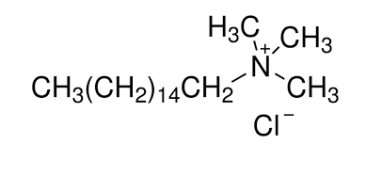

#### Figure 1: Chemical structure of cetyltrimethylammonium chloride (CTAC).

METHODS

1. Paste Preparation

Cement paste samples were prepared by dissolving  CTAC in potable water at concentrations ranging from 0.1% to 2% by weight of cement. A constant water-to-cement (w/c) ratio of 0.43 was maintained for all mixes. The surfactant-water solution was blended with CEM I 52.5N Portland cement using a mechanical mixer under continuous vigorous stirring (approximately 3 minutes) to ensure homogeneity. The resultant paste was cast into cubic molds (10 cm × 10 cm × 10 cm) and cured at 100% relative humidity and room temperature (23 ± 2°C) for 24 hours. After demolding, samples were immersed in water until testing at hydration ages of 3, 7, and 28 days.

2. Compressive Strength Testing

Compressive strength was evaluated using a CEMASCO Controls point-load testing machine (Model 20063, Milano, Italy). For each mix design, three replicates were tested at 3, 7, and 28 day hydration intervals. The mean value of the triplicate measurements was reported as the compressive strength. Loading was applied at a constant rate adhering to ASTM C109/C109M guidelines.

3. Bulk Density and Air Content

Bulk density and air content were determined in accordance with ASTM C138-08. Samples were weighed in air (W air​) and submerged in water (W water​) to calculate density (*ρ*) using the formula:

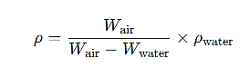

where  *ρ* water​ = g/cm3. Air content (%) was derived from the theoretical density of air-free paste and the measured bulk density.

4. Thermal Conductivity Measurement

Thermal conductivity (k) was assessed via the steady-state guarded hot plate method (ASTM C177). Eight disc-shaped samples (130 mm diameter × 30 mm thickness), two per mix, were prepared. The thermal conductivity coefficient was calculated as:



where:

* k = Thermal conductivity (W·m−1·K−1),
* qx​ = Heat flux (W·m−2),
* x = Sample thickness (m),
* ΔT = Temperature gradient across the sample (°C).

5. Water Absorption Test

Water absorption was quantified following ASTM C642. Samples were oven-dried at 105°C for 24 hours to determine the dry mass (M0​). After immersion in water for 24 hours, surface moisture was removed using a damp cloth, and the saturated mass (M1​) was recorded. Water absorption (WA) was calculated as:

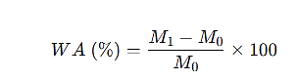

6. Scanning Electron Microscopy (SEM) Analysis

The topography and microstructure of the dried hydrated samples are studied using JEOL JXA 840 an electron Probe micro analyzer SEM. The samples are coated with a thin film of gold, under vacuum evaporator with cathode rays then analyzed.

**Result and discussion:**

Effect of CTAC dose on bulk density and air content

 The insertion of a cationic surfactant, Cetyltrimethylammonium Chloride (CTAC) in the cement paste affects the air content and bulk density of cement pastes, strongly affecting their mechanical and thermal properties. Air content, a key parameter affecting density, compressive strength, and thermal conductivity, is regulated by CTAC’s surfactant concentration. During mixing,  CTAC molecules adsorb at the air-water interface, minimizing surface tension and stabilizing entrapped air bubbles.

As shown in Table 3 and Figure 2, the air content of hydrated samples at 28 day increased progressively with CTAC concentration, peaking at 49.45% for the 2% CTAC mix (M4), compared to 0% in the control sample (M0). This rise in porosity inversely proportioned with bulk density, which decreased from 2.0 g·cm⁻³ (M0) to 1.01 g·cm⁻³ (M4). The relationship conforms with the inverse proportionality between air content and density, in agreement with previous studies (Qaraman et al., 2017 ,Qaraman, & Zuhud, , 2018).

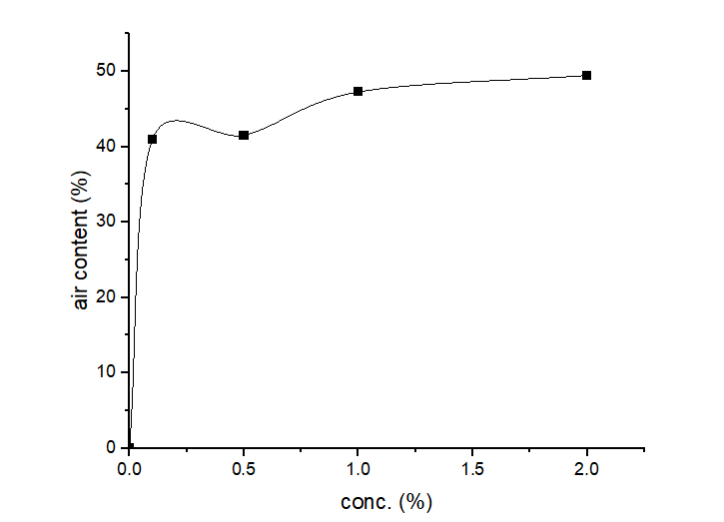

figure (2): Relationship between CTAC concentration and air content in hardened cement paste at 28 days

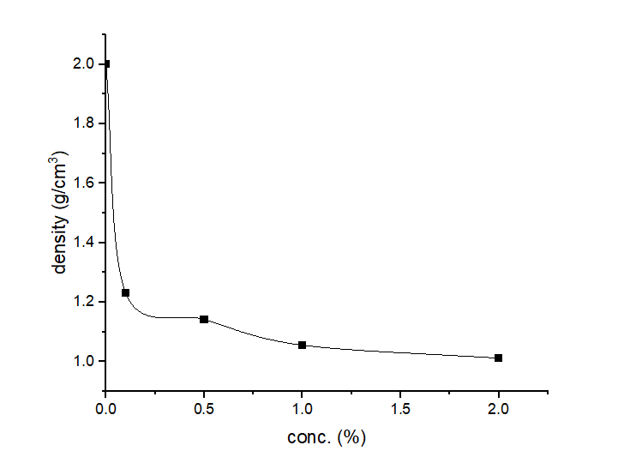

figure (3): Relationship between bulk density and air content in CTAC-modified cementitious pastes at 28 days

Table 3. Composition and properties of foam cement paste mixes

|  |  |  |  |  |  |  |  |  |  |
| --- | --- | --- | --- | --- | --- | --- | --- | --- | --- |
| Mixture | Cement/ water ratio | CTAC  (%) | Density  (gm/cm3) | Air % | Compressive  Strength (N/mm2) | | | Water Absorption % | Thermal conductivity  W•m−1•K−1 |
| 3 days | 7 days | 28 days |
| M0 | 0.43 | 0.0 | 2.0 | 0.0 | 40.42 | 50.38 | 72.7 | 2.1 | 0.72 |
| M1 | 0.43 | 0.1 | 1.181 | 40.95 | 16.04 | 20.03 | 28.90 | 4.5 | 0.30 |
| M2 | 0.43 | 0.5 | 1.170 | 41.50 | 15.93 | 19.65 | 27.70 | 5.9 | 0.28 |
| M3 | 0.43 | 1.0 | 1.055 | 47.25 | 8.66 | 10.81 | 15.60 | 6.6 | 0.25 |
| M4 | 0.43 | 2.0 | 1.011 | 49.45 | 8.21 | 10.23 | 14.99 | 6.8 | 0.24 |

Analysis of Surface Topography and Microstructure

The scanning electron microscope (SEM) is a good tool to investigate the surface topography and microstructure of cementitious materials. Due its high resolution and powerful depth of focus, it analyzes surface roughness and topography of cement pastes hydration products like calcium silicate hydrate (C-S-H) and calcium hydroxide (CH) and microscopic pores in hardened cement pastes.

Figure 4 shows the macroscopic surface topography of hardened cement paste samples at 28 days of hydration, spotlighting the progressive increase in porosity with increasing CTAC concentrations (0% to 2%). It is noticeable that control sample (0% CTAC) revealed a dense, non-porous structure, interconnected with its high bulk density (2.0 g·cm⁻³) and compressive strength (72.7 N·mm⁻²). In contrast, the 2% CTAC specimen shown the highest air content (49.45%) beside the lowest density (1.01 g/cm³), in addition to a uniform distribution of small air voids, resulting in a significantly lower thermal conductivity (0.24 W•m−1•K−1). According to these results, the 2% CTAC concentration—which exhibited the most prominent structural and thermal changes—was selected for a closer microstructural examination using a scanning electron microscope (SEM), shown in Figure 5.

Figure 5 investigate the hydration products and pore structure of the 2% CTAC formulation at 7 and 28 days. At 7 days (Figure 5b), the CTAC-modified cement paste showed a hexagonal CH plates and fibrous C-S-H gels embedded with spherical air voids (average size: 82.3 µm), a characteristic result of surfactant-induced stabilization. At 28 days (Figure 5d), The matrix shown a dense C-S-H network with retention of porosity, consistent with progressive increase in strength (14.99 N•mm⁻²). While the 2% CTAC dose enhanced thermal efficiency, the trade-off between mechanical strength and porosity highlights the importance of balancing surfactant concentration for structural viability in energy-efficient applications. The uniform air void system (82.3 µm) found in modified CTAC pastes contributes to consistent bubble distribution, which enhances insulation but requires careful design to mitigate strength losses.

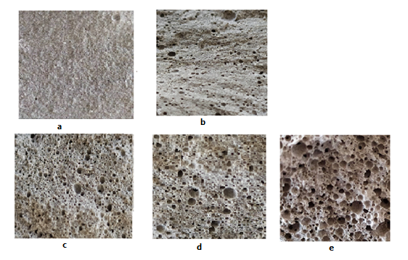

Figure 4. Macroscopic surface topography of hardened cement paste samples at 28 days of hydration (5× magnification):(a) Control sample (0% CTAC) with a dense, non-porous structure. (b) 0.1% CTAC: Initial formation of sparse air voids. (c) 0.5% CTAC: Moderate porosity with distributed air pockets.(d) 1% CTAC: Increased uniformity and density of air voids. (e) 2% CTAC: Highly porous matrix dominated by uniform, spherical air voids.

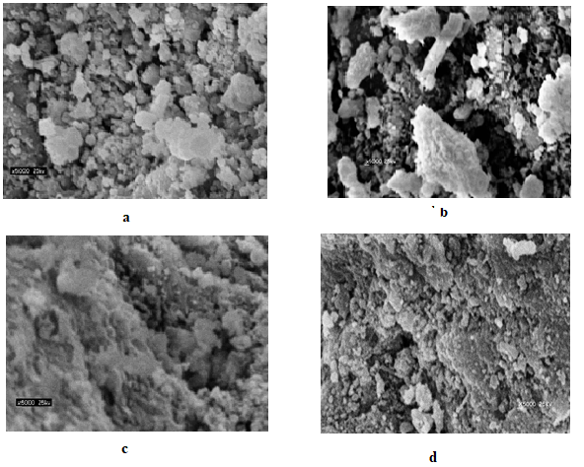

**Figure 5.** Scanning electron microscopy (SEM) images of hardened cement pastes at **5000× magnification**:

**(a)** Control sample (0% CTAC) and **(b)** 2% CTAC after **7 days** of hydration.

**(c)** Control sample (0% CTAC) and **(d)** 2% CTAC after **28 days** of hydration.

*Effect of CTAC on the Compressive Strength of the Hardened cement paste*

Compressive Strength is considered as important a factor as density in evaluating the performance of cement pastes. Due to the time-dependent nature of cement hydration, compressive strength assessments should be performed at standardized hydration ages. In this study, the compressive strength of hardened cement paste specimens—both with and without CTAC—was measured at 3, 7, and 28 days of hydration using triplicate samples for each mix (M0-M4). The average values, shown in Table 3 and represented in Figure 6, showed a consistent increase in compressive strength in all mixes with prolonged hydration, attributing this to progressive cement hydration and C-S-H formation.

Due to the time-dependent nature of cement hydration, compressive strength was evaluated at different hydration ages. In this study, the compressive strength of hardened cement paste samples with and without CTAC was measured at 3, 7, and 28 days of hydration. Table 3 and Figure 6 show the average values ​​for three samples of each mixture (M0-M4). The values ​​showed a steady increase in compressive strength values, which is attributed to the C-S-H growth resulting from the gradual hydration of cement.

Figure 6 shows that the compressive strength peaked at 28 days, with the control sample M0 (0% CTAC) reaching the maximum value (72.7 N⁻mm⁻²). It is also observed that the compressive strength is inversely proportional to the CTAC dosage, reaching the minimum value of 14.99 N•mm⁻² for the 2% CTAC mixture (M4). This inverse relationship between CTAC concentration and compressive strength is due to the surfactant efficiency as an air-entraining agent. This high air content (40.95-49.45% in M1-M4) leads to high porosity, which affects the structural integrity. All cement pastes modified with CTAC maintained acceptable levels of compressive strength. This is attributed to the ability of CTAC to distribute voids in a regular and small manner, with an average void size of 82.3 micrometers as shown by SEM analysis, which maintained the cohesion of the matrix and reduced the stress level (Qaraman, 2016).

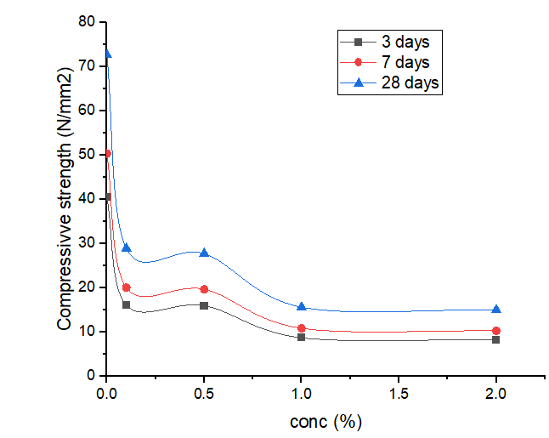

**Figure 6.** Compressive strength development of CTAC-modified cementitious pastes at **3, 7, and 28 days** of hydration.

*Effect of density on thermal conductivity of foam cement paste*

Thermal conductivity, a critical parameter in assessing the insulation efficiency of lightweight cementitious materials, is intrinsically linked to the material’s density and porosity. Foam cement paste derives its insulating capabilities from a cellular structure dominated by air-filled voids, which impede heat transfer. For instance, Chen et al. (2013) highlighted that a foam cement paste with a density of  400 kg·m⁻³ exhibits thermal insulation comparable to a 25 mm-thick cork layer, emphasizing its suitability for energy-efficient construction.

As demonstrated in Figure 7 and Table 3, thermal conductivity decreases proportionally with reduced density across all tested formulations. The control sample (0% CTAC), with a density of 2.0 g·cm⁻³, exhibited a thermal conductivity of 0.72 W·m⁻¹·K⁻¹, while the 2% CTAC-modified paste, with a density of 1.01 g·cm⁻³, achieved a significantly lower conductivity of 0.24 W·m⁻¹·K⁻¹. This inverse relationship stems from the increased air content (49.45%) and porosity in low-density pastes, where entrapped air voids act as thermal insulators by disrupting conductive pathways (Meletse, 2005; Bumanis, 2013).

The underlying mechanism involves the role of porosity in limiting phonon propagation—the primary mode of heat transfer in solid matrices. Higher porosity reduces the continuity of the cementitious framework, thereby diminishing thermal conduction. While CTAC-modified pastes (e.g., 2% CTAC) achieve exceptional thermal performance, the balance between insulation and mechanical integrity must be carefully calibrated for structural applications. These findings underscore foam cement paste’s potential as a dual-function material, offering both thermal efficiency and lightweight properties when optimized with surfactants like CTAC.

The relationship between density and thermal conductivity in CTAC-modified foam cement paste was rigorously analyzed, revealing a strong inverse correlation quantified by a linear regression coefficient of  *R*2=0.98 (Figure 7). This statistical validation confirms that reducing density from 2.0 g·cm⁻³ (control) to 1.01 g·cm⁻³ (2% CTAC) directly lowers thermal conductivity from 0.72 W·m⁻¹·K⁻¹ to 0.24 W·m⁻¹·K⁻¹, aligning with the insulating mechanism of air-entrained porosity. While this performance surpasses traditional dense concrete, the CTAC-modified paste exhibits higher conductivity than specialized insulators like expanded polystyrene (EPS: 0.033–0.040 W·m⁻¹·K⁻¹) or mineral wool (0.030–0.045 W·m⁻¹·K⁻¹) (Jelle, 2011). However, its dual role as a structural and insulating material—retaining 14.99 N·mm⁻² compressive strength—positions it uniquely for applications requiring multifunctionality.

Practically, the 2% CTAC formulation could revolutionize sustainable construction in:

1. Building Envelopes: Replacing conventional blocks in moderate climates (e.g., Mediterranean regions) to reduce thermal bridging.
2. Prefabricated Panels: Streamlining assembly in low-rise structures while minimizing weight.
3. Retrofitting: Enhancing insulation in existing buildings without structural overhauls.

This balance of thermal and mechanical performance underscores CTAC’s potential as a scalable, eco-friendly alternative, bridging the gap between insulation efficiency and structural viability.

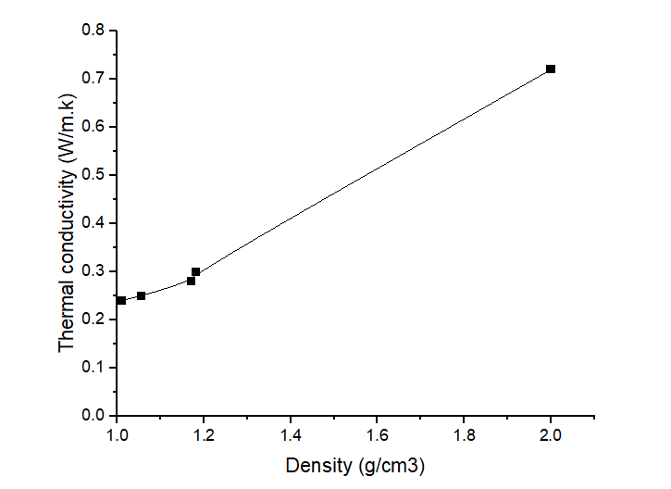

**Figure 7.** Inverse correlation between thermal conductivity and density in CTAC-modified cementitious pastes after 28 days of hydration

*Effect of CTAC on the water absorbance of the Hardened cement paste*

Figure 8 and Table 3 reveal a clear dose-dependent relationship between CTAC concentration and water absorption in hardened cement paste, with values escalating from 2.1% (0% CTAC) to 6.8% (2% CTAC) after 28 days of hydration. This increase is attributed to CTAC’s multifaceted impact on the cementitious matrix. Primarily, CTAC adsorption on cement particles modifies pore structure, creating a more interconnected network that enhances permeability (Zhang et al., 2019). Concurrently, CTAC interferes with hydration kinetics, disrupting the formation of calcium silicate hydrate (C-S-H) and yielding a porous, less dense microstructure (Snoeck et al., 2017). At higher concentrations, surfactant saturation within pores further inhibits hydration, amplifying porosity (Gholizadeh-Vayghan et al., 2020). Additionally, CTAC’s amphiphilic nature alters the water-cement interface, reducing surface tension and promoting uneven water distribution, which exacerbates structural inhomogeneity (Bentz & Ferraris, 2010). Despite this rise in water absorption, the observed range (2.1–6.8%) remains within acceptable limits for foam cement pastes, which typically exhibit 5–15% absorption due to their inherently porous nature (Jones & McCarthy, 2005). To mitigate durability risks—such as freeze-thaw degradation or chemical ingress—while retaining thermal benefits, optimizing CTAC dosage (e.g., 0.1–0.5%) is critical. This balance ensures minimal water uptake without sacrificing insulation efficiency, underscoring the necessity of tailoring surfactant chemistry to harmonize functional performance with long-term resilience in energy-efficient construction materials.

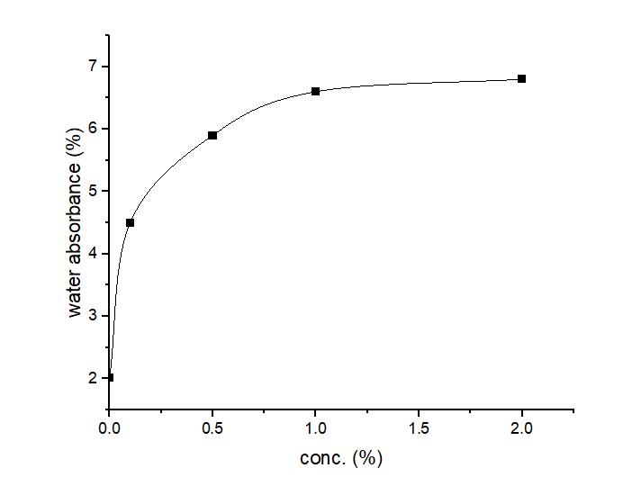

**Figure 8.** Dose-dependent increase in water absorption of CTAC-modified cementitious pastes after 28 days of hydration.

**Conclusion**

The incorporation of CTAC as an air-entraining agent in cementitious pastes demonstrates a transformative capacity to enhance thermal insulation and reduce density through controlled porosity. However, this comes with inherent trade-offs: higher CTAC concentrations (>1%) drastically reduce compressive strength and increase water absorption, posing durability risks. SEM analysis corroborates that CTAC modifies pore architecture, stabilizes air voids, and disrupts hydration kinetics, yielding a lightweight yet mechanically compromised matrix. The optimal CTAC dosage (0.5–1%) achieves a balance, offering 0.25–0.28 W·m⁻¹·K⁻¹ thermal conductivity while retaining 15–28 N·mm⁻² compressive strength—suitable for non-load-bearing insulation applications. Comparatively, CTAC-modified pastes exhibit higher conductivity than traditional insulators (e.g., polystyrene) but excel as dual-function structural-insulating materials. Future work should explore hybrid surfactants or pore-refining additives to mitigate water uptake and enhance durability. This research advances the development of sustainable, energy-efficient cementitious composites, emphasizing the critical role of surfactant chemistry in multifunctional material design.

**References**

1. **ASTM C109/C109M-21**:  
   ASTM International. (2021). Standard test method for compressive strength of hydraulic cement mortars (using 2-in. or [50-mm] cube samples) (ASTM C109/C109M-21).
2. **ASTM C138/C138M-08**:  
   ASTM International. (2008). Standard test method for density (unit weight), yield, and air content (gravimetric) of concrete (ASTM C138/C138M-08).
3. **ASTM C177-19**:  
   ASTM International. (2019). Standard test method for steady-state heat flux measurements and thermal transmission properties by means of the guarded-hot-plate apparatus (ASTM C177-19).
4. **ASTM C642-21**:  
   ASTM International. (2021). Standard test method for density, absorption, and voids in hardened concrete (ASTM C642-21).
5. **Bentz, D. P., & Ferraris, C. F.** (2010). Rheology and setting of high-volume fly ash mixtures. Cement and Concrete Composites, 32(4), 265–270. <https://doi.org/10.1016/j.cemconcomp.2010.03.001>
6. **Bessenouci, H.** (2011). The impact of porosity on the thermal properties of building materials. Journal of Materials Science, 46(15), 5105–5114. <https://doi.org/10.1007/s10853-011-5574-9>
7. **Bremner, T. W., Malhotra, V. M., & Bilodeau, A.** (2000). Thermal conductivity of cementitious materials. Cement and Concrete Research, 30(4), 649–654. <https://doi.org/10.1016/S0008-8846(00)00225-3>
8. **Bumanis, G.** (2013). Lightweight concrete with improved thermal insulation properties. Journal of Civil Engineering and Management, 19(5), 619–626. <https://doi.org/10.3846/13923730.2013.799093>
9. **Gholizadeh-Vayghan, A., Masoumi, S., & Shekarchi, M.** (2020). Effect of surfactants on the hydration and durability of cementitious materials. Construction and Building Materials, 247, 118496. <https://doi.org/10.1016/j.conbuildmat.2020.118496>
10. **Harvey, L. D. D.** (2009). Reducing energy use in buildings: How much, and at what cost? Science and Public Policy, 36(1), 19–28. <https://doi.org/10.3152/030234209X415573>
11. Jelle, B. P. (2011). Traditional, state-of-the-art and future thermal building insulation materials and solutions – Properties, requirements and possibilities. Energy and Buildings, 43(10), 2549–2563. <https://doi.org/10.1016/j.enbuild.2011.05.015>.
12. **Jones, M. R., & McCarthy, A.** (2005). Behavior of foam concrete in structural applications. Materials and Structures, 38(4), 289–300. <https://doi.org/10.1007/BF02479293>
13. **Jones, M. R., & McCarthy, A.** (2005). Behaviour and performance of foam concrete. Cement and Concrete Research, 35(6), 1133–1146. <https://doi.org/10.1016/j.cemconres.2004.11.001>
14. **Meletse, M.** (2005). Thermal insulation principles and applications. Building Science Journal, 18(3), 45–52.
15. **Peng, H., Jiang, Y., & Hu, Y.** (2008). Energy-saving potential of a ventilated cavity structure applied to building envelopes. Energy and Buildings, 40(9), 1645–1655. <https://doi.org/10.1016/j.enbuild.2008.02.016>
16. Qaraman, A. F. A. & Zuhud, A., (2018). The influence of using Cocamidopropyl Betaine as chemical additive on thermal and physical properties of foam mortar. Asian Journal of Natural & Applied Sciences Vol. 7(3), 12-21.‏
17. Qaraman, A. F. A., Musalam, A. M., & El-Hassayna, I. M. (2017), The Behavior of Lauryl Glucoside as cement paste admixture, Israa university journal for applied science,1(1), 7-15.
18. Qaraman، A. F. A., (2016). The efficiency of mixed surfactants as air entraining agents in cement pastes. European Journal of Material Sciences, 3(3), 12-22.‏
19. **Seppälä, J., Heinonen, J., & Junnila, S.** (2008). A review of energy-efficient building materials. Building and Environment, 43(6), 1211–1220. <https://doi.org/10.1016/j.buildenv.2007.04.015>
20. **Snoeck, D., Pel, L., & De Belie, N.** (2017). The influence of surfactants on cement hydration and microstructure. Cement and Concrete Research, 98, 34–44. <https://doi.org/10.1016/j.cemconres.2017.03.012>
21. **Snoeck, D., Pel, L., & De Belie, N.** (2017). The water kinetics of cementitious materials: A review of transport properties and the role of microstructure. Cement and Concrete Research, 97, 136–148. <https://doi.org/10.1016/j.cemconres.2017.03.010>
22. **Uysal, H.** (2004). Effect of w/c ratio on the properties of cementitious materials. Cement and Concrete Composites, 26(6), 773–778. <https://doi.org/10.1016/j.cemconcomp.2004.01.003>
23. **Zhang, J., Wang, Q., & Wang, Z.** (2019). Pore structure and permeability of cementitious materials modified by surfactants. Materials Science and Engineering: A, 759, 152–160. <https://doi.org/10.1016/j.msea.2019.05.022>
24. **Zhang, X., Li, Q., & Ma, H.** (2019). Effect of cationic surfactants on the hydration and durability of cement-based materials. Construction and Building Materials, 215, 440–450. <https://doi.org/10.1016/j.conbuildmat.2019.04.158>
25. **Zhou, Y., Zhang, L., & Zhang, B.** (2012). Influence of lightweight aggregate on the thermal properties of building materials. Construction and Building Materials, 30, 763–768. <https://doi.org/10.1016/j.conbuildmat.2011.12.050>.