**The Future of Supply Chain: How AI and Automation Are Transforming Logistics**

Badhusha Sultan A, Mr. Mohamad Saif

MBA Student & Associate Professor, School of Arts, Humanities and Management, Jeppiaar University, Chennai, India.

[badhushasultan13@gmail.com](mailto:badhushasultan13@gmail.com)

[smileyboysaifu@gmail.com](mailto:smileyboysaifu@gmail.com)

**Abstract**

Fast-forwarding globalisation and rising consumer need for best quality, lower-cost, and accurate delivery of logistics and supply chain are putting more and more pressure at the industry. These demands are no longer met by traditional methods of quality inspection. However, even tougher competition and improved reliability increases the demand for these entities to adapt their supply chains through AI-based tools and automation to heighten efficiency, visibility, and responsiveness. In this article, we will delve into the ways these technologies are revolutionizing logistics operations in various sectors, including the benefits, real-world use cases, challenges, and the future of this landscape.

**1. Introduction**

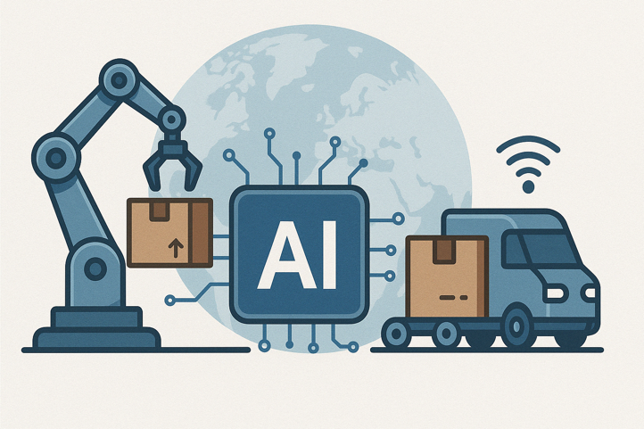The supply chain management world is experiencing a dramatic transition in the digital world. These systems, which historically depended heavily on human judgement and manual work, are today being replaced, or augmented, by intelligent systems. Unlocking new heights of efficiency and insight The advent of Artificial Intelligence (AI) and automation in logistics and supply chain operations

A recent report produced by McKinsey estimates the potential for AI to create up to $1.3 trillion in value annually in supply chain and logistics functions worldwide. From intelligent warehouses to predictive transportation routing, these breakthroughs are enabling organizations to reduce waste, decrease costs, increase customer satisfaction, and stay competitive.

**2. Understanding Traditional Supply Chains**

Before discussing the implications of AI and automation, it is crucial to review the traditional supply chain model. Such systems generally consisted of a number of different stages, from raw material procurement to manufacturing, warehousing, transport and delivery—all executed by manual methods. Coordinating across global suppliers with distributors can be complex and oftentimes led to inefficiencies, such as:

* Poor inventory visibility
* High lead times
* Manual errors in documentation
* Poor response to disruptions like weather or strikes

These constraints became more visible in the context of globalization and of the increasing volatility of demand and the need for “just-in-time.” Toward agility and optimization, companies turned to technological solutions.

**3. Role of AI and Automation in Modern Logistics**

**3.1 Predictive Analytics**

AI-driven predictive analytics tools analyze historical data and real-time market trends to predict customer demand, optimize inventory levels, and prepare for seasonal spikes. For instance, a retail business can ensure that low-demand products are not overstocked during the off-season leading to reduced storage cost and waste.

**3.2 Warehouse Automation**

Modern warehouses employ robotics, AI, and IoT devices to enhance operational speed. Automated Guided Vehicles (AGVs), robotic arms, and smart sorting systems enable faster picking, packing, and shipping. With robotics and AI algorithms to optimize workflows, Amazon’s fulfillment centers are processing thousands of orders per hour.

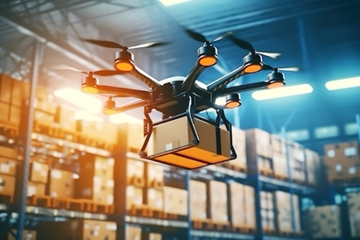**3.3 Smart Transportation & Fleet Management**

AI-powered route planning tools take a handful of data points (traffic data, fuel featured consumption, weather forecast, delivery windows) to eliminate less-expert routes. Fleet managers can monitor the health of vehicles, getting alerts about potential issues before they arise, enabling predictive maintenance and minimizing vehicle downtime.

**3.4 Drones and Autonomous Vehicles**

Still in development and regulatory testing in many countries, drones and autonomous trucks will deliver your stuff to you in the future. In India, startups are investigating last-mile drone delivery for rural healthcare and emergency supplies, and global heavyweights like FedEx and UPS are testing self-driving delivery vans.

**3.5 Real-Time Supply Chain Visibility**

IoT-integrated AI platforms provide end-to-end visibility, enabling managers to monitor product movement in real time, identify bottlenecks, and quickly respond to disruptions. This visibility is vital for managing cross-border shipments, as well as temperature-sensitive products such as vaccines.

**4. Benefits of AI and Automation**

|  |  |
| --- | --- |
| Aspect | Benefit |
| Speed | Faster fulfilment, reduced lead times |
| Accuracy | Minimization of human error in operations |
| Cost Efficiency | Lower labour costs, optimized fuel usage |
| Customer Satisfaction | Real-time tracking, timely delivery |
| Sustainability | Reduced emissions, smarter route planning, less energy usage |

Implementing these technologies not only improves operational efficiency but also aligns with sustainability goals. Companies like **DHL** and **Maersk** report significant drops in fuel usage and carbon emissions thanks to smart logistics.

**5. Real-World Applications**

Let’s look at a few organizations successfully using AI and automation:

* **Flipkart**: Uses AI to predict product demand and automate warehouse management in major cities like Bangalore and Hyderabad.
* **Maersk**: The global shipping giant uses AI for route optimization and fuel efficiency.
* **Zebra Technologies**: Offers real-time inventory management systems using AI and RFID for retail and logistics.

Even government-backed initiatives like India’s **ULIP (Unified Logistics Interface Platform)** are working toward digitizing and integrating national supply chain operations using AI for better visibility.

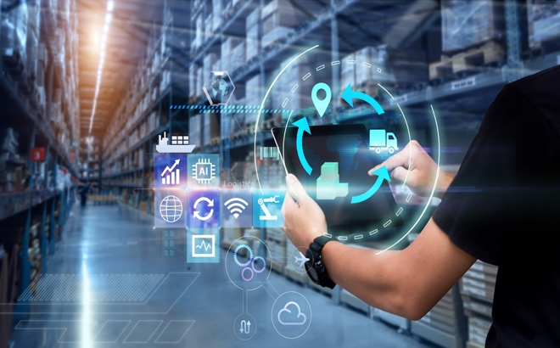

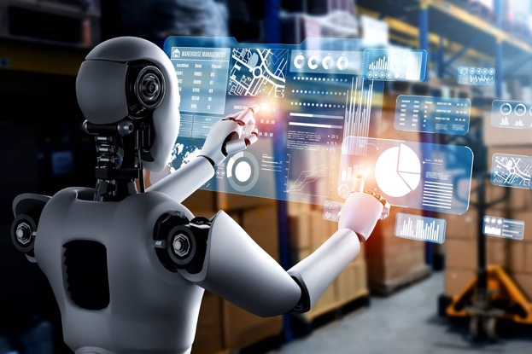

**6. Challenges in Adoption**

Despite its potential, implementing AI and automation in supply chain systems comes with challenges:

* **High Capital Investment**: Robotics, sensors, software, and skilled personnel require significant upfront investment, often difficult for small businesses.
* **Cybersecurity Risks**: As operations become digital and cloud-based, protecting data from breaches is critical.
* **Resistance to Change**: Traditional workforce may resist automation due to fear of job loss or unfamiliarity with new systems.
* **Skill Shortage**: There's a growing demand for professionals skilled in AI, machine learning, and supply chain analytics.

The second challenge is integrating new technologies with existing legacy systems. Most companies especially those with 20+ years of longevity run on legacy systems and manual processes. AI and automation in such settings typically require a total reinvention of workflows and databases and upon even a new organizational culture. This can result in extended migration timelines, surprises on the technology front, and extended downtime. And to layer on what it means to facilitate this change throughout global supply networks — to third-party logistics providers, vendors, partners and others — adds even more complexity. Already, there are enough logistical challenges involved with ensuring that each stakeholder is technically aligned to, and open to, the technological shift. Data is a key ingredient here, but without a clear roadmap and buy-in, transformation may languish in limbo or fall short of its potential.

**7. The Future of AI in Logistics**

The future of AI and automation in logistics holds exciting possibilities:

* **Blockchain Integration** for secure and tamper-proof documentation.
* **AI-powered Chatbots** for customer service and order tracking.
* **Digital Twins** to simulate supply chain models for testing scenarios.
* **Sustainable Logistics** through smart packaging and carbon tracking.

With governments supporting **smart logistics policies** and industries embracing **Industry 4.0**, India is also poised to be a major player in tech-enabled supply chains.

AI powered hyper-personalized logistics is another exciting frontier. As customer demands evolve, logistics providers will need to provide not just speed, but personalized experiences. AI will empower companies to offer personalized delivery options that suit the individual preferences — from selecting time slots and preferred carriers to greener concords. It can also predict customer dissatisfaction based on past behaviour and interactions, so that businesses can address issues proactively. AI will also become more critical in circular supply chains, in which reclaimed items can be rapidly returned to use within the system. Data and Automation will support personalization and sustainability, which are shaping the new ways of engaging with customers and will help us establish stronger and more resilient customer-business relationships.

**Conclusion**

AI and automation are no longer futuristic ideas—they are current realities driving transformation in logistics and supply chain management. By enabling smarter decisions, faster processes, and greater transparency, these technologies are setting new standards across industries. As a logistics student and future industry contributor, understanding and embracing these trends is not just valuable—it’s essential.

The one certainty of the next decades is that fast movers to AI and automation will dominate the next chapter of global commerce. The supply chain isn’t just about moving goods anymore — it’s about moving them intelligently, sustainably, and accurately. However, this process isn't without its struggles but the long-term payoff is worth the upfront investment. This shift is not merely a tech upgrade — it’s a transformation of mindset strategy. It is also the best route to stay relevant in a fast-paced world for students, professionals, and businesses.