**e-ISSN :**

**INTERNATIONAL JOURNAL OF PROGRESSIVE 2583-1062**

**RESEARCH IN ENGINEERING MANAGEMENT**

**AND SCIENCE (IJPREMS) Impact**

|  |  |  |
| --- | --- | --- |
| **www.ijprems.com editor@ijprems.com** | Vol. 04, Issue 01, January 2024, pp : xx-xx | **Factor : 5.725** |

# Pharma Chain Tracker – Identification of Medicine Supply chain using QR code and Blockchain Technology

**Prof. Vaishali Warake1, Sakshi Ovhal2, Sherlin David3 , Madhuri Shinde4 , Saurabh Naikwadi5**

1Professor, Computer Department, P K Technical Campus, Pune, Maharashtra, India

2,3,4,5Student , Computer Department, P K Technical Campus, Pune, Maharashtra, India

**ABSTRACT**

The rise of counterfeit products in the marketplace poses significant challenges to businesses and consumers alike. This paper presents a novel approach for identifying fake products using a QR code-based system integrated with a cloud environment. The proposed solution leverages blockchain technology to ensure product authenticity by storing and validating product information on a decentralized ledger. Each product is assigned a unique QR code at the point of manufacturing, containing essential details such as batch number, production date, and manufacturer credentials. Upon scanning the QR code via a web application, the system cross references the product information with data stored in the cloud. This ensures the product’s legitimacy, providing real-time verification to consumers and reducing the proliferation of counterfeit goods. The cloud environment offers scalability, data redundancy, and secure access, making the system highly efficient and reliable. The system also enables manufacturers to track the product lifecycle and distribution, aiding in supply chain transparency. The proposed system use Custom algorithm to which helps to Identify Fake products. This approach basically deals with QR-code generation for individual accounts and using SCM to provide the secure data distribution to end user.

Keywords: QR, SCM, SHA256, Mining, blockchain

## INTRODUCTION

The global market faces a growing problem of counterfeit products, affecting industries ranging from pharmaceuticals and electronics to fashion and consumer goods. Counterfeit products not only damage brand reputation and lead to financial losses for legitimate manufacturers, but they also pose potential risks to consumers' health and safety. Traditional methods of product authentication, such as holograms and barcodes, are becoming increasingly vulnerable to sophisticated forgeries.

Therefore, a more robust and reliable system is needed to ensure the authenticity of products at every stage of the supply chain. One promising solution is the integration of QR (Quick Response) codes with cloud computing technology. QR codes are widely adopted due to their ability to store substantial amounts of data in a small, scannable format, and they can be easily generated and verified using smartphones. However, on their own, QR codes are not immune to tampering. To enhance their security and reliability, this paper proposes a cloud-based system for fake product identification, leveraging the immutability and transparency of blockchain technology. The system assigns a unique QR code to each product at the point of manufacture, embedding key information such as the product’s origin, batch number, and production date. This data is stored on a secure cloud platform, with a corresponding record on a cloud computing to ensure tamper-proof verification. By scanning the QRcode with a web application, consumers and stakeholders in the supply chain can instantly verify the authenticity of the product against the data stored on the cloud computing.

The use of a cloud environment ensures scalability and provides real-time access to product information from any location. Additionally, cloud computing centralized nature guarantees that no single entity can alter the product information without consensus, thereby safeguarding against tampering or fraud. This paper explores the design and implementation of the fake product identification system, outlining the advantages of combining QR code technology with cloud computing solutions. The proposed system aims to protect brands from counterfeiters, enhance consumer trust, and ensure transparency across the supply chain.

1. **LITERATURE SURVEY**

Patients have authority over their medical records thanks to blockchain [1]. Smart contracts based on the Ethereum blockchain allow patients control over their data in a decentralised, immutable, transparent, traceable, trustworthy, and safe way. To securely collect, store, and exchange patients' medical data, the proposed solution uses decentralised storage of interplanetary file systems (IPFS) and trusted reputation-based re-encryption oracles. Algorithms are presented together with complete implementation information. We assess the suggested smart contracts based on two key performance indicators: cost and accuracy. We also explore the generalisation elements of our technique and give security analysis.

**@International Journal Of Progressive Research In Engineering Management And Science**

**e-ISSN :**

**INTERNATIONAL JOURNAL OF PROGRESSIVE 2583-1062**

**RESEARCH IN ENGINEERING MANAGEMENT**

**AND SCIENCE (IJPREMS) Impact**

|  |  |  |
| --- | --- | --- |
| **www.ijprems.com editor@ijprems.com** | Vol. 04, Issue 01, January 2024, pp : xx-xx | **Factor : 5.725** |

IPFS [2] provides a blockchain-based secure storage and access solution for electronic medical data. We built an attribute-based encryption scheme for safe storage and efficient exchange of electronic medical records in IPFS storage environment based on the ciphertext policy attribute-based encryption system and IPFS storage environment, paired with blockchain technology. Our method is based on ciphertext policy attribute encryption, which effectively regulates access to electronic medical data while maintaining retrieval efficiency. Meanwhile, we store encrypted electronic medical data in the decentralized Interplanetary File System (IPFS), which not only provides storage platform security but also eliminates the single point of failure concern. Furthermore, we use blockchain technology's non-tamperable and traceable characteristics to enable safe storage and search for medical data. Our approach delivers selective security for pick keyword assaults, according to the security proof. Our approach is efficient and viable, according to performance analysis and actual data set simulation studies.

Blockchain technology is being used to handle health records [3]. a patient-centered, entirely decentralized strategy that can detect data theft, prevent data modification, and gives patients control over access. Blockchain technology is the most effective way to solve all issues and meet all demands. As a decentralized and distributed ledger, blockchain has the potential to affect billing, record sharing, medical research, identity theft, and financial data crimes in the future. Smart contracts in health care may help to simplify things even further. On the Blockchain, invocation, record generation, and validation will all take place. on a patient-driven model of record maintenance based on Blockchain technology, with smart contracts to be added in the future, allowing for more data sharing possibilities. Finding its vast reach, I hope that additional study will be conducted and actual applications will be realised.

A medical data exchange and protection method based on blockchain[4]. To enhance the hospital's electronic health system, a medical data exchange and protection strategy based on the hospital's private blockchain was developed. For starters, the system may meet a variety of security requirements, including decentralisation, openness, and tamper resistance. Doctors will be able to retain medical data or retrieve patient history data via a secure approach that respects their privacy. A symptom-matching technique is also provided between patients. It enables patients who have the same symptoms to complete mutual authentication and generate a session key for future disease communication. PBC and OpenSSL libraries are used to implement the suggested approach.

Healthy Block is a blockchain-based IT architecture for electronic medical records that is resistant to network outages. [5]. a patient, posing a direct danger to the person and resulting in large public health expenses for governments. The creation of electronic medical record (EMR) systems using blockchain networks is one of the proposed solutions to this problem; however, most of them fail to account for the occurrence of connectivity failures, such as those found in various developing countries, which can lead to data integrity failures. To address these issues, Healthy Block is described in this paper as a blockchain-based architecture that proposes a unified electronic medical record system that takes into account multiple clinical providers, has data integrity resilience during connectivity failure, and has usability, security, and privacy characteristics. A prototype for patient care in a network of hospitals was developed based on the Healthy Block architecture. The evaluation's findings revealed a high level of efficiency in maintaining patients' EMRs unified, updated, and secure, regardless of which network healthcare provider they contact.

1. **OBJECTIVES**

* To study and analysis the basic execution of blockchain technology in distributed databases environment
* To develop system for supply chain management for medicine using blockchain technology.
* To design and develop an approach for secure medicine transaction system using QR security and blockchain technology.
* To explore and validate the proposed system experimental analyses various existing systems and show the effectiveness of proposed system.

**Problem Statement**

To design and developed a system for supply chain management using blockchain technology, the system will consist of three distinct modules: Supplier, Vendor, and Admin. Each module will facilitate secure transactions and data management, with all transaction details stored in the cloud. The limitations of existing methods and why integrating QR codes with a blockchain technology is a more efficient solution.

**@International Journal Of Progressive Research In Engineering Management And Science Page | 1**

**e-ISSN :**

**INTERNATIONAL JOURNAL OF PROGRESSIVE 2583-1062**

**RESEARCH IN ENGINEERING MANAGEMENT**

**AND SCIENCE (IJPREMS) Impact**

|  |  |  |
| --- | --- | --- |
| **www.ijprems.com editor@ijprems.com** | Vol. 04, Issue 01, January 2024, pp : xx-xx | **Factor : 5.725** |

**4. SYSTEM ARCHITECTURE**

Present the overall architecture of the system. Include diagrams to illustrate how QR code data is processed in the blockchain technology. Explain the process of generating unique QR codes for each product, detailing how it encodes product information like manufacturer, batch, serial number, etc. Discuss how the blockchain technology is used for real-time data storage, processing, and validation of scanned QR codes. Process of embedding product data (manufacturer ID, serial number, batch number, etc.) into QR codes.

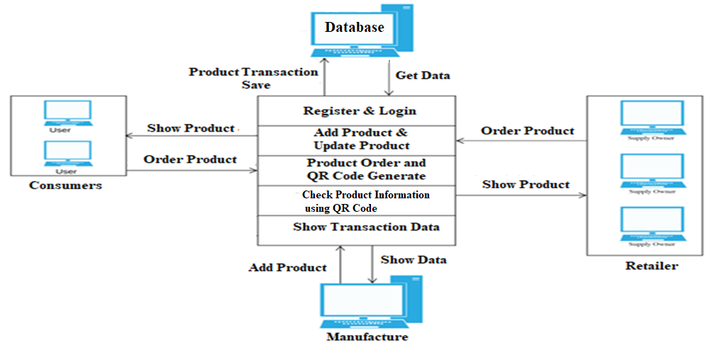

**List of Modules and Functionality**

* **Admin(Manufacturer):** The manufacturer logs into the manufacturer account generates a QR Code for the Product and adds the required details of the product the manufacturer adds a block to customs blockchain.
* **Retailer:** Retailer reads the product's QR code. Manufacturer-entered product data is made available to the retailer. In doing so, he transfers legal ownership of the product to the buyer.
* **Consumers:** Consumers may verify the product's purity by scanning a QR code, which displays a complete record of all purchases made by the product's owner. When a customer checks the product's Genuity, the status will be shown at that moment. If the goods is fraudulent, the buyer will realize that the QR code was likely forged.

1. **IMPLEMENTATION PROCEDURE**
2. We create a multiple Distributed ledger and e-transaction transnational data and stored all transnational data into multiple data nodes.
3. Each node will holds the specific block for each transaction.
4. Same block has replaced for nodes, and generates a valid blockchain technology.
5. System will retrieve data from all data nodes and commit the transaction; it should be any kind of DDL, DML as well as DCL transactional query.
6. If any block chain invalid during the validation of data servers, then system will automatically recover whole cloud environment using majority of servers.
7. We will address and eliminate the runtime server attacks and recover it using own blockchain technology.
8. System will provide the each transactional validation, for all servers

**@International Journal Of Progressive Research In Engineering Management And Science Page | 2**

**e-ISSN :**

**INTERNATIONAL JOURNAL OF PROGRESSIVE 2583-1062**

**RESEARCH IN ENGINEERING MANAGEMENT**

**AND SCIENCE (IJPREMS) Impact**

|  |  |  |
| --- | --- | --- |
| **www.ijprems.com editor@ijprems.com** | Vol. 04, Issue 01, January 2024, pp : xx-xx | **Factor : 5.725** |

1. **SOFTWARE AND HARDWARE REQUIREMENTS**

**Front-End :**

Operating System: -Windows XP/7/8

Programming Language: JAVA/J2EE/

Tools: Net bean or Higher, Heidi SQL, JDK 1.7 or Higher

Database: MySQL 5.1

**Back-End :**

MySQL 5.1

**Hardware Requirements :**

Processor: - Intel Pentium 4 or above

Memory: - 2 GB or above

Other peripheral: - Printer

Hard Disk: - 500gb

1. **OTHER SPECIFICATION** 
   1. **Advantages**

* This guarantees that product authenticity can be traced from the manufacturer to the end customer.
* All transactions and verifications are visible and cannot be altered, improving trust between manufacturers, retailers, and consumers.
* Consumers can scan the QR code to instantly access the blockchain database for real-time verification of the product's origin, batch number, and distribution details.
  1. **Limitations**

If someone has more than 51% computing power, then he/she can find Nonce value quicker than others, means he/she has authority to decide which block is permissible.

What it can do is:

• Modify the transaction data, it may cause double spending attack.

• To stop the block verifying transaction.

• To stop miner mining any available block.

A majority attack was more feasible in the past when most transactions were worth significantly more than the block reward and when the network hash rate was much lower and prone to reorganization with the advent of new mining technologies.

7.**3 Applications**

* Peer to peer communication
* Transaction applications.
* Bitcoin transaction applications.
* Zebpay transaction application
* Bittrex app
* Polonix applications
* Coin exchange applications

**@International Journal Of Progressive Research In Engineering Management And Science Page | 3**

**e-ISSN :**

**INTERNATIONAL JOURNAL OF PROGRESSIVE 2583-1062**

**RESEARCH IN ENGINEERING MANAGEMENT**

**AND SCIENCE (IJPREMS) Impact**

|  |  |  |
| --- | --- | --- |
| **www.ijprems.com editor@ijprems.com** | Vol. 04, Issue 01, January 2024, pp : xx-xx | **Factor : 5.725** |

1. **RESULTS**

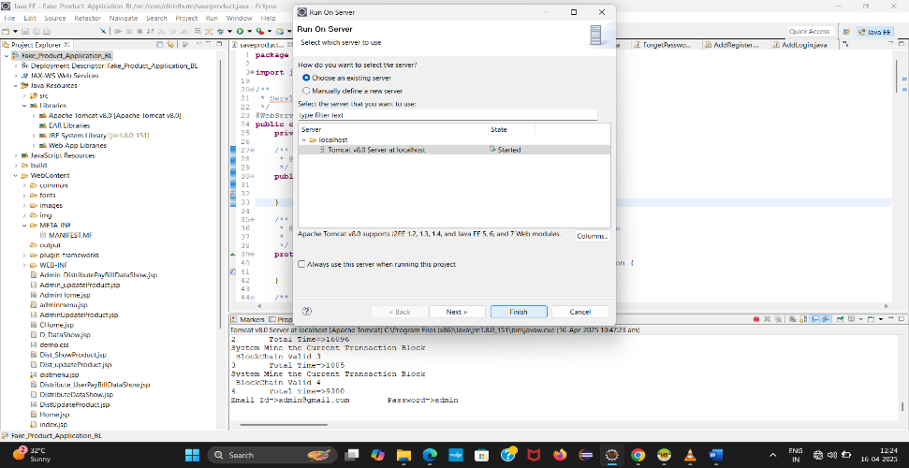

ADMIN INTERFACE :



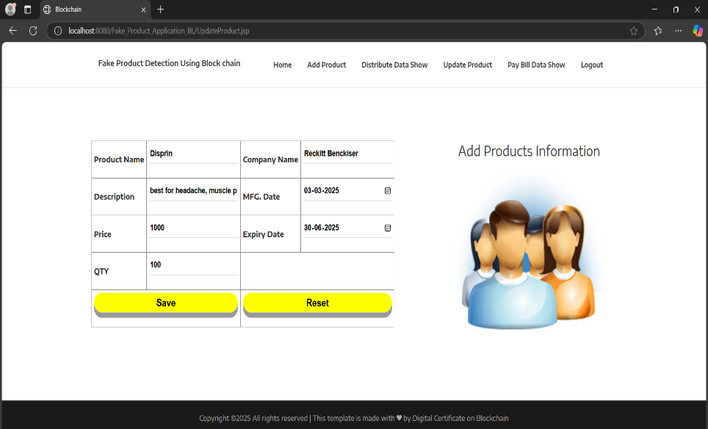

**@International Journal Of Progressive Research In Engineering Management And Science Page | 4**

**e-ISSN :**

**INTERNATIONAL JOURNAL OF PROGRESSIVE 2583-1062**

**RESEARCH IN ENGINEERING MANAGEMENT**

**AND SCIENCE (IJPREMS) Impact**

|  |  |  |
| --- | --- | --- |
| **www.ijprems.com editor@ijprems.com** | Vol. 04, Issue 01, January 2024, pp : xx-xx | **Factor : 5.725** |

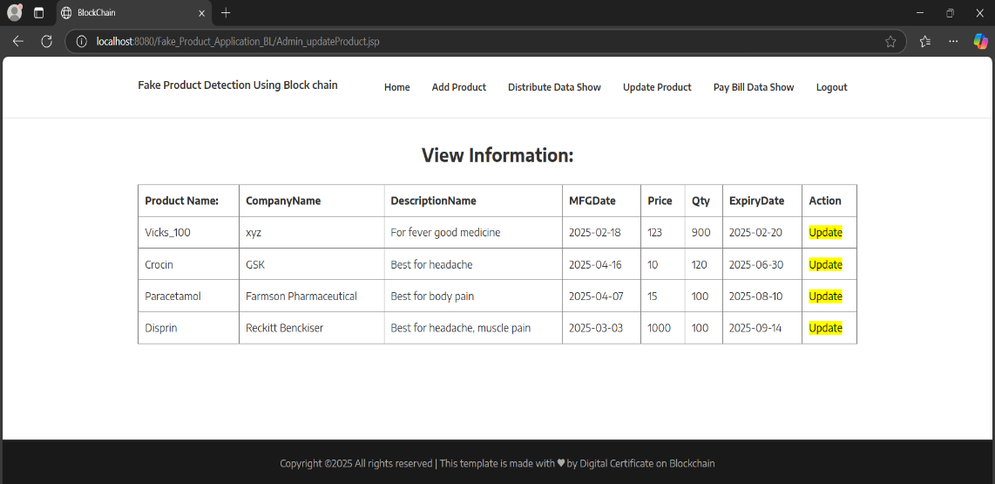

DISTRIBUTER INTERFACE :

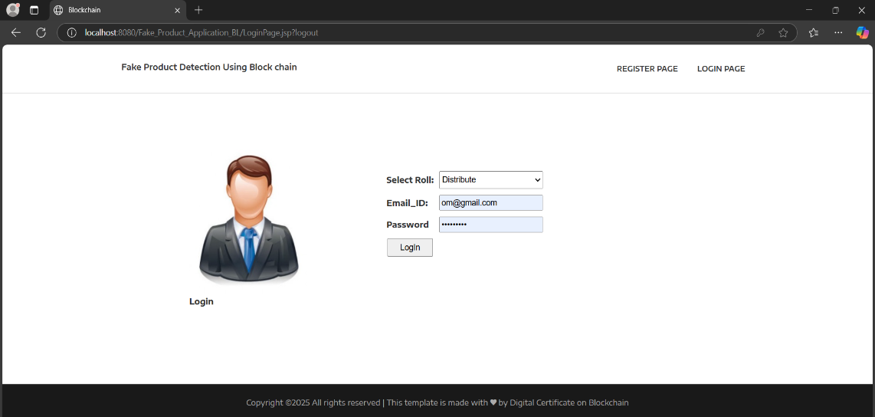

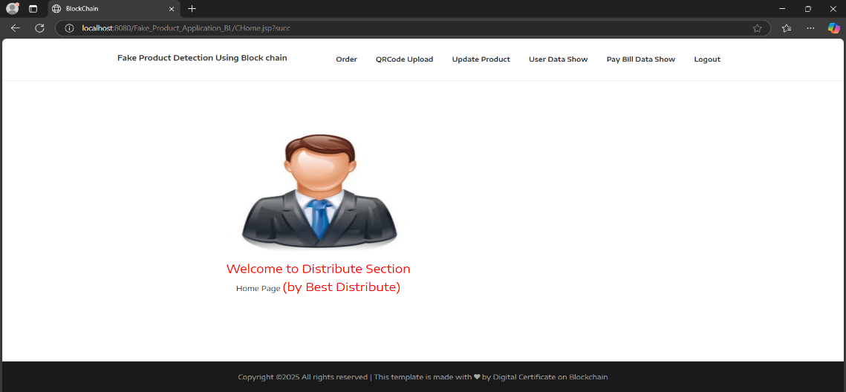

**@International Journal Of Progressive Research In Engineering Management And Science Page | 5**

**e-ISSN :**

**INTERNATIONAL JOURNAL OF PROGRESSIVE 2583-1062**

**RESEARCH IN ENGINEERING MANAGEMENT**

**AND SCIENCE (IJPREMS) Impact**

|  |  |  |
| --- | --- | --- |
| **www.ijprems.com editor@ijprems.com** | Vol. 04, Issue 01, January 2024, pp : xx-xx | **Factor : 5.725** |

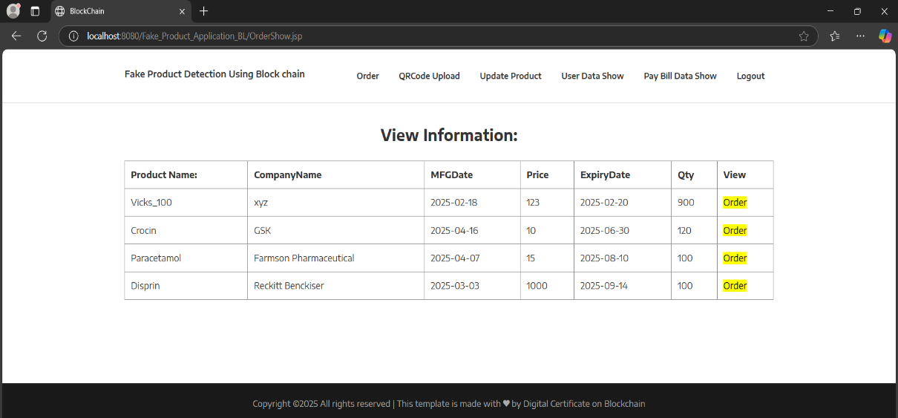

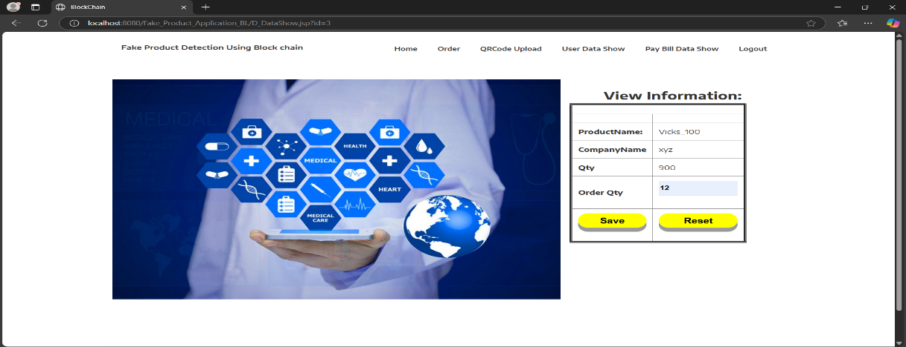

**USER INTERFACE :**

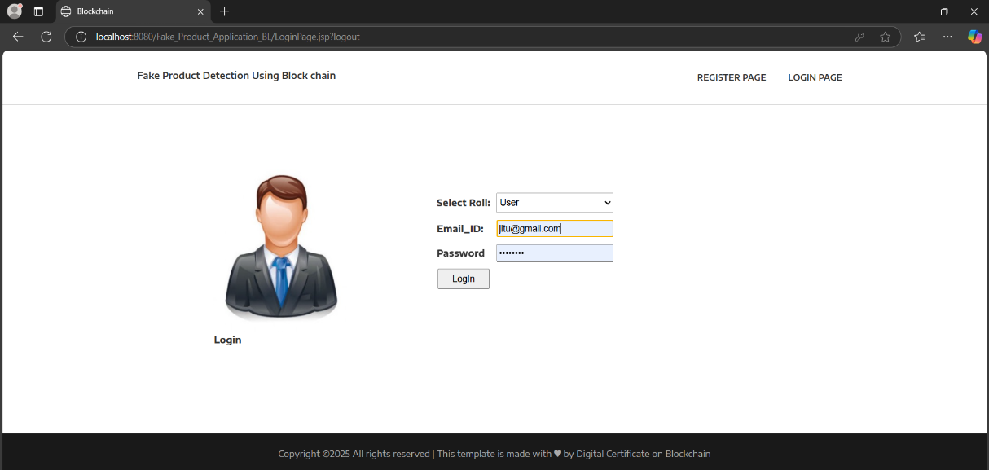

**@International Journal Of Progressive Research In Engineering Management And Science Page | 6**

**e-ISSN :**

**INTERNATIONAL JOURNAL OF PROGRESSIVE 2583-1062**

**RESEARCH IN ENGINEERING MANAGEMENT**

**AND SCIENCE (IJPREMS) Impact**

|  |  |  |
| --- | --- | --- |
| **www.ijprems.com editor@ijprems.com** | Vol. 04, Issue 01, January 2024, pp : xx-xx | **Factor : 5.725** |

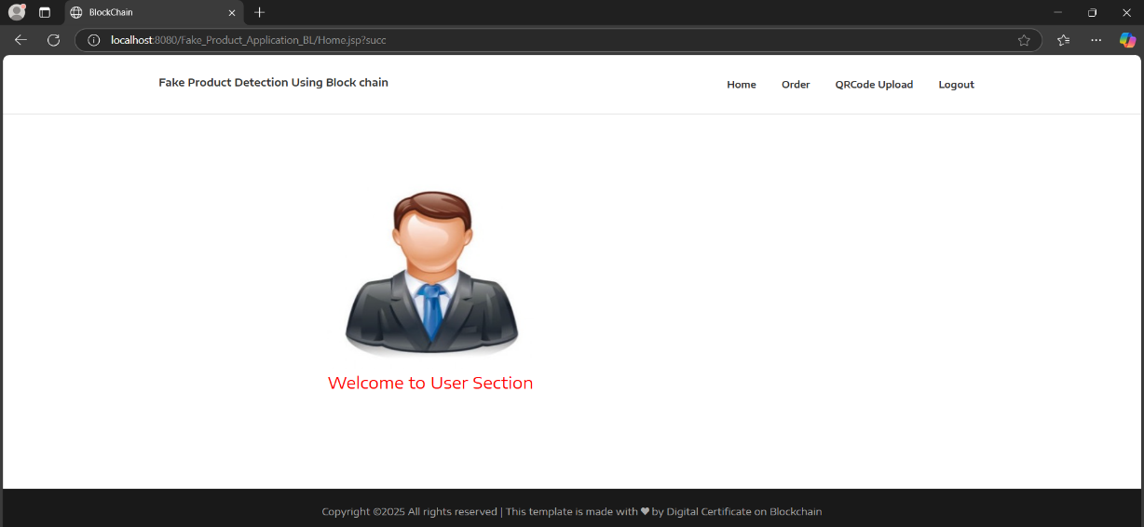

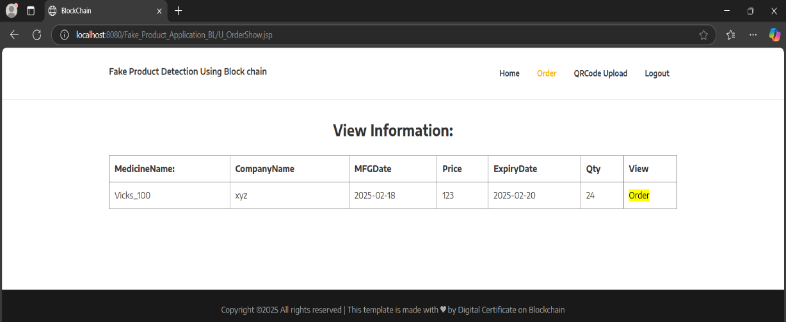

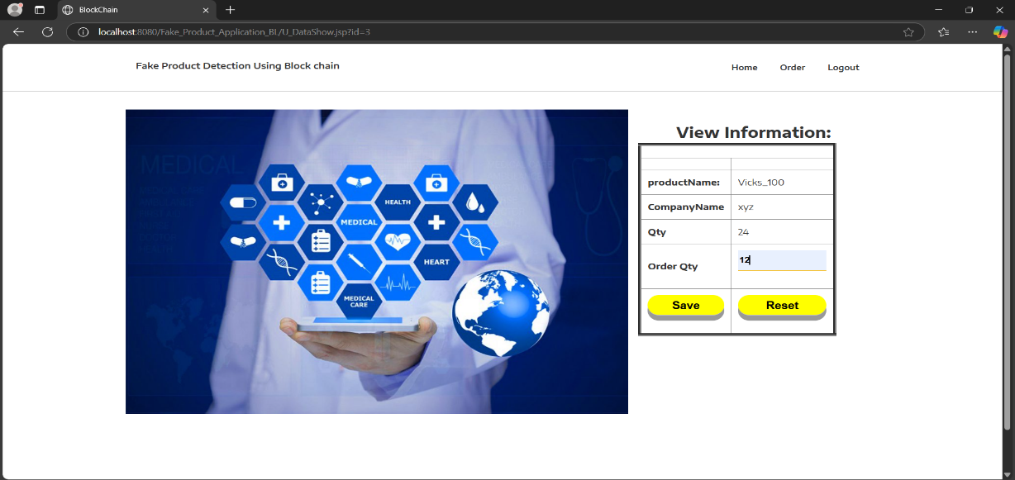

**@International Journal Of Progressive Research In Engineering Management And Science Page | 7**

**e-ISSN :**

**INTERNATIONAL JOURNAL OF PROGRESSIVE 2583-1062**

**RESEARCH IN ENGINEERING MANAGEMENT**

**AND SCIENCE (IJPREMS) Impact**

|  |  |  |
| --- | --- | --- |
| **www.ijprems.com editor@ijprems.com** | Vol. 04, Issue 01, January 2024, pp : xx-xx | **Factor : 5.725** |

FAKE PRODUCT UNABLE TO SCAN :



IN THIS WAY TRANSACTION IS SAVED IN THE BLOCK :

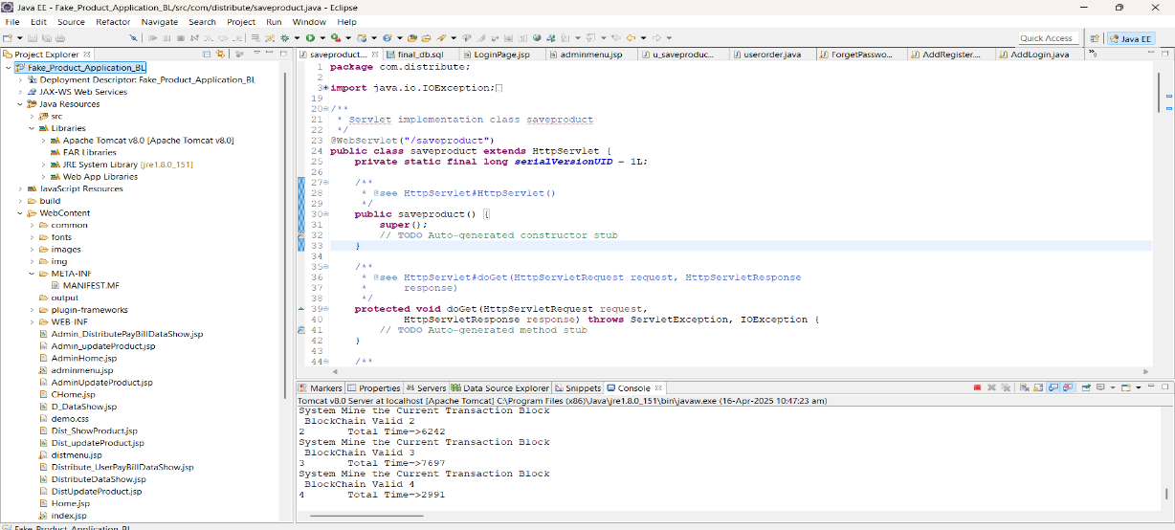

1. **CONCLUSION**

Because of the complexities of this area and the need for more stable and effificient information management frameworks, there are several research directions to apply Blockchain technology to the transaction industry. In several cases of transaction usage that face similar data exchange and communication problems, an interoperable architecture will certainly play a significant role. Further re- search on safe and efficient software practice for the use of Blockchain technology in transactions is also required to educate software engineers and domain experts on the potential and also limitations of this new technology, whether to build a decentralized application using an established Blockchain. The algorithm has chosen the acceptable complexity, efficiency and complexity of implementation to operate the system. Through empirical studies, we have a better understanding of the pace of knowledge creation in the supply chain. There are several important hurdles to getting on the blockchain reaching its full potential and applying it to health is the most important issue technology scalability and data controls

**@International Journal Of Progressive Research In Engineering Management And Science Page | 8**

**e-ISSN :**

**INTERNATIONAL JOURNAL OF PROGRESSIVE 2583-1062**

**RESEARCH IN ENGINEERING MANAGEMENT**

**AND SCIENCE (IJPREMS) Impact**

|  |  |  |
| --- | --- | --- |
| **www.ijprems.com editor@ijprems.com** | Vol. 04, Issue 01, January 2024, pp : xx-xx | **Factor : 5.725** |

1. **REFERENCES**

[1] Madine, Mohammad Moussa, et al. "Blockchain for giving patients control over their medical records." IEEE Access 8 (2020): 193102-193115.

[2]Sun, Jin, et al. "Blockchain-based secure storage and access scheme for electronic medical records in IPFS." IEEE Access 8 (2020): 59389-59401.

[3]Harshini, V. M., et al. "Health record management through blockchain technology." 2019 3rd International Conference on Trends in Electronics and Informatics (ICOEI). IEEE, 2019.

[4] Liu, Xiaoguang, et al. "A blockchain-based medical data sharing and protection scheme." IEEE Access 7 (2019): 118943-118953.

[5] Gutiérrez, Omar, et al. "HealthyBlock: Blockchain-Based IT Architecture for Electronic Medical Records Resilient to Connectivity Failures." International Journal of Environmental Research and Public Health 17.19 (2020): 7132.

[6] Wang, Shangping, Dan Zhang, and Yaling Zhang. "Blockchain-based personal health records sharing scheme with data integrity verifiable." IEEE Access 7 (2019): 102887-102901.

[7] Du, Mingxiao, et al. "An optimized consortium blockchain for medical information sharing." IEEE Transactions on Engineering Management (2020).

[8] Tith, Dara, et al. "Application of blockchain to maintaining patient records in electronic health record for enhanced privacy, scalability, and availability." Healthcare informatics research 26.1 (2020): 3-12.

[9] Houtan, Bahar, Abdelhakim Senhaji Hafid, and Dimitrios Makrakis. "A survey on blockchain-based self-sovereign patient identity in healthcare." IEEE Access 8 (2020): 90478-90494.

[10] Sharma, Yogesh, and B. Balamurugan. "Preserving the privacy of electronic health records using blockchain." Procedia Computer Science 173 (2020): 171-180.

**@International Journal Of Progressive Research In Engineering Management And Science Page | 9**