Review Paper on AI Based Solar Power Vehicle With Ultrasonic Sensors

Department of Mechanical Engineering

Padm. Dr. V. B. Kolte college of Engineering, Malkapur.

**1Gaurao Zambare, 2Shivam Thakur, 3Vivek Kinge, 4Akshay Umale , 5Vaibhav Kolte,**

**6Prof.S. M. Bhole**

12345Students, 6Professor.

# ABSTRACT

This project presents the design and development of an AI-Based Solar Powered Vehicle integrated with Ultrasonic Sensors and an LCD Display. The objective is to create an autonomous, eco-friendly vehicle that can operate on solar power while detecting obstacles in real-time and taking necessary actions to avoid collisions. The vehicle is powered using solar panels that charge a rechargeable battery. The system is equipped with a microcontroller that processes data from ultrasonic sensors to detect any nearby obstacles and alters the path of the vehicle accordingly. Additionally, a voltage measuring circuit is interfaced with the microcontroller to display the real-time voltage from the solar panel on an LCD screen. The project combines renewable energy technology with embedded systems and automation, offering an efficient solution for sustainable transport systems. The model is designed to demonstrate practical integration of clean energy and intelligent sensing technology, with potential applications in smart transportation, agriculture, industrial automation, and disaster management. This report elaborates on the complete system design, hardware and software implementation, testing, and performance evaluation of the solar-powered autonomous vehicle.

**Keywords:** MCU, Controller, Solar Plate, DC Motor, Battery Detector Switches, Remote, Wheel, etc.

# 1 INTRODUCTION

This chapter provides a comprehensive overview of the system design, architecture, and working principles of the AI-based solar-powered vehicle with ultrasonic sensors and LCD display. It describes how various subsystems, including solar energy generation, obstacle detection, AI-based decision-making, and voltage monitoring, are integrated into a single autonomous vehicle system. This chapter covers the detailed circuit design and PCB layout considerations for the AI- Based Solar Powered Vehicle. The success of any embedded system project depends heavily on the accuracy of the circuit design and the quality of PCB layout. This chapter presents the schematic diagrams of the subsystems, describes their interconnections, and discusses PCB design considerations.

# LITERATURE REVIEW

1. The literature review provides a detailed study and analysis of previous research work, technological developments, and innovations in the fields of solar-powered vehicles, autonomous systems, ultrasonic sensor-based obstacle detection, and AI-based embedded systems. This chapter also highlights the gaps in existing technologies that this project aims to bridge through an integrated AI-based solar-powered model.
2. Review of Solar Powered Vehicle Technologies Solar-powered vehicles have gained popularity as sustainable alternatives to conventional fossil-fuel-powered vehicles. Multiple studies and experimental models have been developed over the years to analyze the feasibility and efficiency of solar mobility. The literature review provides a detailed study and analysis of previous research work, technological developments, and innovations in the fields of solar-powered vehicles, autonomous systems, ultrasonic sensor-based obstacle detection, and AI-based embedded systems. This chapter also highlights the gaps in existing technologies that this project aims to bridge through an integrated AI-based solar-powered model.
3. Review of Solar Powered Vehicle Technologies Solar-powered vehicles have gained popularity as sustainable alternatives to conventional fossil-fuel-powered vehicles. Multiple studies and experimental models have been developed over the years to analyze the feasibility and efficiency of solar mobility. Key findings from previous works: Stanford Solar Car Project (2005 - Present): Demonstrated the practical capability of solar- powered race cars using high-efficiency photovoltaic panels and lightweight frames. MIT Electric Vehicle Lab: Explored the integration of solar panels in urban transport vehicles, improving range and reducing energy dependency. ISIE India Solar Vehicle Championship: Focused on encouraging engineering students to develop fully-functional solar vehicles with energy storage systems. These projects focus on high-speed, long-distance travel. However,

limited research has been done on autonomous obstacle-avoiding low-speed solar vehicles, particularly for smaller- scale, application-oriented models

1. Obstacle Detection Techniques in Autonomous Vehicles Obstacle detection is a critical aspect of intelligent autonomous systems. The commonly used sensors and technologies include: Ultrasonic Sensors (HC-SR04): Low-cost, reliable distance measurement in short ranges (2cm–400cm). Infrared Sensors: Effective for line-following and object detection but susceptible to surface reflection issues.

# 2 PROPOSED METHODOLOGIES

The project focuses on the development of an autonomous solar-powered vehicle that utilizes AI-based decision logic and ultrasonic sensors for obstacle avoidance. The power required to operate the motors and electronic components is derived from a solar panel and stored in a rechargeable battery. The vehicle uses ultrasonic sensors to detect obstacles in its path and makes intelligent decisions to change direction. An LCD display is used to show real-time voltage readings from the solar panel.

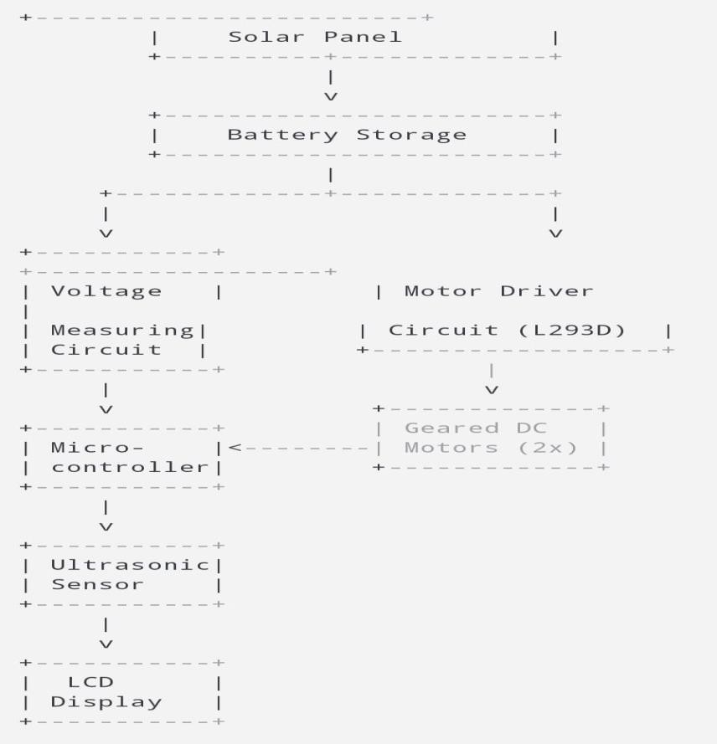

## Majored Components Used:

1. **Solar Panel:**

Solar panel is a photovoltaic (PV) cell device that turns sunlight into electricity. PV cells consist of materials that generate excited electrons when exposed to light. The electrons pass through a circuit and generate direct current (DC) electricity, which can either be used to power devices or stored in batteries. Solar panels are also referred to as solar cell panels, solar electric panels, or PV modules.



Fig. Solar Plate

## Charge Controller:

A charge regulator, charge controller or battery regulator restricts the rate at which electric current is charged to or discharged from electric batteries to avoid electrical overload, overcharging, and can prevent overvoltage. This avoids conditions that decrease battery performance or life and can be a safety hazard. It can also avoid fully draining ("deep discharging") a battery, or carry out controlled discharges, based on the battery technology, to safeguard battery life. “Charge controller" or "charge regulator" can be used to refer to either a stand-alone unit, or to control circuitry embedded in a battery pack, battery-powered equipment, and/or battery charger.

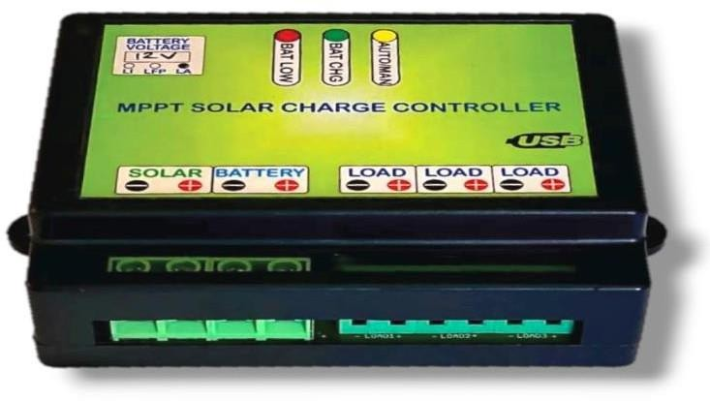

Fig. Charge Controller

## IR Sensor:

Infrared (IR) sensors sense and measure infrared radiation, which is not visible to the human eye, and find application in many applications such as motion detection, security systems, remote controls, and even for meteorological studies, gas detection, and medical applications**.**

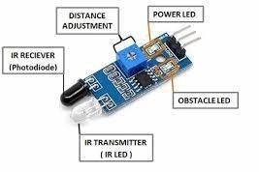

Fig. IR Sensor

## DC Motor Shunt Wound:

DC motor (Direct Current motor) delivers mechanical energy by utilizing the coupling between magnetic field and current-conducting elements. It involves a stator (fixed piece with magnetic field), rotor (moving piece), commutator (switches direction of the current), and brushes (has contact with commutator). When DC voltage is used, the current passes through the rotor, generating a magnetic field that interacts with the stator's field to make the rotor rotate. DC motors find application in equipment such as fans, robots, power tools, and electric vehicles because of their ease of use and speed control.

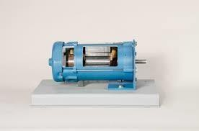

Fig. DC Motor

## MCU Controller:

A MCU (Microcontroller Unit) is a compact, integrated chip with a processor (CPU), memory (RAM and ROM), and input/output peripherals. It is a runs program instructions, devices manage, and performs tasks in embedded systems such as robotics and home automation. Major components are the CPU, memory, I/O pins, timers, and communication interfaces. MCUs are employed in fields such as robotics (e.g., motor and sensor control in a robot), automotive, and consumer electronics. They are low power consumption, cost-efficient, and versatile devices that can be utilized in a broad spectrum of embedded applications.

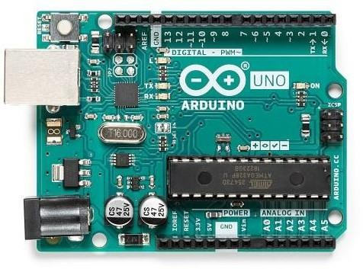

Fig. Arduino

## Battery:

A is a battery houses chemical energy and transfers it into electrical energy. It has an anode, cathode, electrolyte, and separator. Batteries are either primary (one-time use) or secondary (rechargeable). When a battery is discharged, chemical reactions at the anode release electrons, which travel through a circuit to deliver power. Rechargeable batteries, such as lithium-ion or lead-acid, can be used repeatedly. Batteries are employed in items like smartphones, electric cars, and renewable energy storage devices. They provide accessible, portable power for numerous applications.

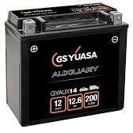

Fig. Battery

# 3 WORKING PRINCIPLE

This chapter explains the practical implementation and functioning of the AI-Based Solar Powered Vehicle with Ultrasonic Sensors and LCD Display. The aim of the working model is to validate the theoretical design through real-time hardware operations and demonstrate the vehicle’s ability to navigate autonomously while being powered by solar energy and displaying real-time voltage data on an LCD. The working model consists of a compact, solar-powered, autonomous robotic vehicle equipped with: Ultrasonic sensors for obstacle detection, DC motors for movement, A solar panel and battery for power supply, A microcontroller unit for processing, LCD display to show solar panel voltage in real time. The model demonstrates the integration of renewable energy with embedded automation, presenting an eco-friendly and intelligent robotic solution.

# PROPOSED CONCLUSIONS

In summary, This project demonstrates the feasibility of combining green energy with smart automation to build efficient, self-sustaining transport solutions. With further development, such systems have the potential to revolutionize fields like smart logistics, campus commuting, agriculture, and more — paving the way for a cleaner and smarter future. The development of an AI-Based Solar Powered Vehicle with Ultrasonic Sensors successfully showcases the integration of renewable energy, smart automation, and intelligent sensing into a single, eco- friendly transportation solution. This project not only addresses the urgent need for sustainable energy alternatives but also demonstrates how artificial intelligence and sensor technologies can significantly enhance the performance, safety, and autonomy of modern vehicles..

# 4 REFERENCES

* 1. Thong-un N, Hirata S, Orino Y, and Kurosaswa M K. 2015. A Linearization-based Method of Simultaneous Position and Velocity Measurement Using Ultrasonic Waves. Sensor and Actuators A. 233, 480-489
  2. Patkar AR, Tasgaonkar PP. 2016. Object Recognition Using Horizontal Array of Ultrasonic Sensors. International Conference on Communication and Signal Processing. 16, 983-986
  3. Zadeh NRN, Dela JC. 2016. Smart Urban Parking Detection System. 6th IEEE International Conference on Control System, Computing and Engineering. 16, 370-373
  4. Hosur P, Shettar RB, and Potdar M. 2016. Environmental Awareness Around Vehicle Using Ultrasonic Sensors. 2016 International Conference on Advance in Computing, Communications and Informatics (ICACCI). 16, 1154-1159