**Comparative study of IC engine and Electric Vehicle based on their life cycle to achieve net zero emission**

**Mr. G.A. Rabadiyaa, Mr. V.R. Sabhayab, Mr. P.C. Makwanac**

**Automobile Engineering Department, Tapi Diploma Engineering College, Surata**

**Automobile Engineering Department, Tapi Diploma Engineering College, Suratb**

**Mechanical Engineering Department, Government Polytechnic, Valsadc**

[**gar02.tdec@gmail.coma**](mailto:gar02.tdec@gmail.coma)**,** [**automobile.tdec@gmail.comb**](mailto:automobile.tdec@gmail.comb)**,** [**pcmakwana2020@gmail.comc**](mailto:pcmakwana2020@gmail.comc)

***Abstract-*** This study investigates the environmental and economic impacts of Internal Combustion Engine (ICE) vehicles, Hybrid Electric Vehicles (HEVs), Plug-in Hybrid Electric Vehicles (PHEVs), and Electric Vehicles (EVs), with a specific focus on India's efforts to achieve net-zero emissions by 2050 and improve air quality. By comparing critical factors such as emission costs, fuelling time, maintenance expenses, and overall vehicle selection, the research provides a comprehensive analysis of each vehicle type's feasibility in the transition toward sustainable transportation. The findings reveal that EVs offer the most significant reduction in CO and CO₂ emissions approximately 20% lower compared to ICE vehicles. However, EVs exhibit a notable increase in NOx and N₂O emissions, over 70% higher, highlighting the reliance on fossil fuel-based electricity generation. Additionally, air quality-related emissions, including SOx is up to 90% higher in EVs, underscoring the urgent need for more effective emission control technologies and a shift to renewable energy sources. Despite their higher upfront costs and emission-related expenses, EVs show the lowest maintenance costs, at just ₹0.35 per km. HEVs, with their more balanced profile of lower purchase prices, emissions, and maintenance costs, emerge as a promising option for the Indian market.

**Keywords:** *Electric Vehicles (EVs), Hybrid Electric Vehicles (HEVs), Plug-in Hybrid Electric Vehicles (PHEVs), Internal Combustion Engine (ICE) Vehicles, Net-Zero Emission, Sustainable Transportation, Air Quality, Clean Mobility Transition*

**1. Introduction:**

The transportation sector is a major contributor to greenhouse gas (GHG) emissions globally, with internal combustion engine (ICE) vehicles playing a significant role in deteriorating air quality and accelerating climate change [1,2]. Numerous studies have proposed mitigation strategies to curb air pollution from ICE vehicles [3–5]. For instance, Abbas et al. [3] demonstrated that using hydroxyl gas additives could enhance combustion efficiency in gasoline engines, resulting in notable reductions in CO₂, CO, and NOx emissions. Similarly, Har et al. [4,5] investigated biodiesel blends as an alternative fuel source to minimize harmful exhaust emissions. However, these studies primarily focused on gasoline engines, without addressing the broader systemic transformation needed in the transportation sector.

As the global community moves toward achieving net-zero emissions by 2050 and aligning with Sustainable Development Goal 13, the adoption of cleaner and more sustainable transportation modes—especially electric vehicles (EVs)—has gained increasing importance. Liu et al. [6] conducted a cost-of-ownership analysis between ICE and EVs, although their work was limited to battery electric vehicles (BEVs) and did not account for other vehicle types. Sinigaglia et al. [7] compared ICE vehicles with different EV types but concentrated mostly on patent growth and market trends. Meanwhile, Farzaneh et al. [8] explored ICE and EV comparisons in a U.S.-based case study, focusing exclusively on carbon footprints.

**1.1 Vehicles Classification: ICE and EV**

Vehicles can generally be classified into two broad categories: conventional vehicles powered by ICEs and electric vehicles EVs that utilize electrical power for propulsion [9,10]. ICE vehicles, fuelled by gasoline or diesel, have dominated the global transportation landscape since the early 19th century. However, the urgent need to curb emissions and achieve climate targets has catalysed the development and adoption of various EV technologies.

Electric vehicles can be further categorized into Battery Electric Vehicles (BEVs), Hybrid Electric Vehicles (HEVs), Plug-in Hybrid Electric Vehicles (PHEVs), and Fuel Cell Electric Vehicles (FCEVs), based on their energy sources and powertrain configurations [11]. HEVs integrate an ICE with an electric motor to improve fuel economy and reduce emissions. Unlike BEVs and PHEVs, HEVs do not require external charging and are subdivided into mild HEVs, full HEVs, and PHEVs [12]. Full HEVs—widely adopted by automakers—can function in multiple modes: using the ICE alone, the electric motor alone, or both in combination. They can be further classified into series, parallel, series-parallel, and complex full-HEVs, depending on the architecture and control strategy [13–15].

BEVs, commonly referred to as "pure EVs," operate solely on electricity stored in onboard batteries and require external charging infrastructure [16]. They produce zero tailpipe emissions and generate minimal noise pollution. However, their performance is closely linked to battery capacity and thermal management systems [17]. PHEVs bridge the gap between BEVs and traditional HEVs. They feature larger batteries than HEVs and can be externally charged, allowing for electric-only operation over short distances while relying on gasoline for longer trips [18].

FCEVs have also emerged as a zero-emission alternative, powered by hydrogen fuel cells that generate electricity on demand. These vehicles offer quick refuelling and long driving ranges but are constrained by limited hydrogen refuelling infrastructure and high production costs [19–22]. *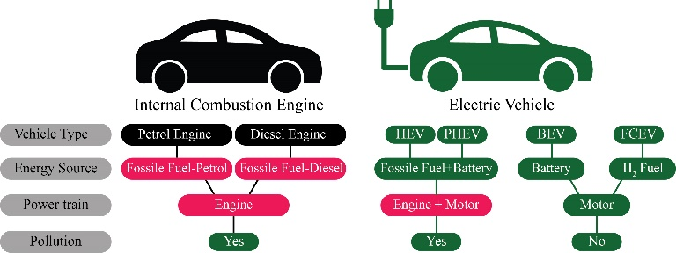Figure 1*: A comparative overview of IC Engine Vs Electric vehicle

**1.2 EV Benefits**

The transportation sector accounts for approximately 25% of global fossil fuel-related CO₂ emissions [23,24]. In response, international agreements like the Paris Accord have urged nations to drastically reduce GHG emissions, especially in transportation, due to its profound environmental implications [25–27]. Among various sustainable alternatives, EVs offer the greatest potential to reduce dependence on fossil fuels, lower GHG emissions, and mitigate climate change [28]. By 2020, the global EV fleet exceeded 10 million vehicles, reflecting a strong shift in consumer demand toward clean, high-tech, and safe transportation options [29].

China leads the global EV market, driven by government incentives and innovation in clean energy transportation [30]. While EV technologies have evolved significantly in public transit systems, private passenger EVs have recently gained substantial traction [30].

EVs provide several distinct advantages over ICE vehicles. First and foremost, they help reduce GHG emissions as they produce no tailpipe pollutants, contributing to cleaner air and better public health outcomes [31–35]. Additionally, EVs generate significantly less noise pollution, making them especially beneficial for urban environments [36,37].

From a sustainability perspective, EVs and their batteries are often recyclable, addressing concerns regarding the scarcity of battery raw materials and waste management [38,39]. The design and engineering of EVs also offer benefits: they are generally more compact and contain fewer moving parts than ICE vehicles, leading to increased energy efficiency. For example, EVs can convert up to 86% of stored battery energy into usable mechanical energy, while ICE vehicles only achieve around 20% thermal efficiency [40].

EVs also excel in well-to-wheel (WTW) efficiency, particularly when powered by renewable electricity sources [41]. Their superior responsiveness, reliability, and compatibility with digital technologies make them an attractive choice for modern consumers [42]. Maintenance costs are also significantly lower due to simpler drivetrains and fewer mechanical components [43,44]. The total cost of ownership (TCO) for EVs can typically be recovered within 5 to 8 years, depending on driving habits and battery capacity [45]. Moreover, EV owners may benefit from ancillary revenue streams, such as participation in frequency regulation services in smart grid systems.

**1.3 Contribution of the Study on the Development of EVs**

India, the largest and most populous nation in Southeast Asia, is implementing various strategies to reduce emissions in both power generation and transportation sectors to achieve net-zero emissions and climate resilience [46]. By 2025, India aims to have 2.1 million two-wheeled and 2,200 four-wheeled EVs operational across the country [47,48]. As Southeast Asia’s largest automotive market, India presents a substantial opportunity for EV growth while simultaneously addressing the air pollution challenges caused by ICE vehicles.

Life Cycle Assessment (LCA) is widely used to evaluate the environmental impacts of vehicles from raw material extraction through production, operation, and end-of-life disposal [49]. Complementing this, the Well-to-Wheel (WTW) analysis provides a comprehensive comparison of energy consumption and emissions between various vehicle technologies, from primary energy sources to vehicle operation [50–52]. These approaches are especially relevant as nations like India set ambitious EV adoption goals.

*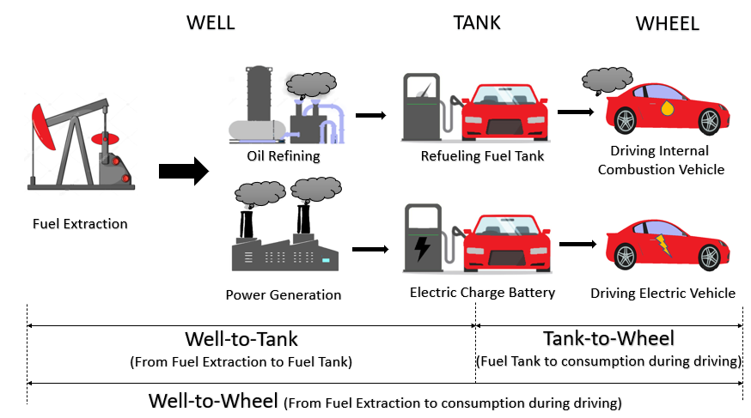Figure 2*: A WTW comparison between ICE vehicles and EVs, highlighting differences in energy pathways and emissions across the lifecycle.

This study delivers a holistic analysis of India’s evolving automotive ecosystem, emphasizing both environmental and economic factors across different vehicle types. Beyond just emissions, it evaluates metrics such as fuelling time, maintenance costs, and practical considerations for vehicle selection. By analysing the comparative advantages and limitations of ICE vehicles, HEVs, PHEVs, and EVs within India’s unique context, this research offers evidence-based insights for policymakers, automakers, and consumers.

Ultimately, this study not only supports India’s transition toward sustainable mobility but also contributes to global discourse on achieving net-zero transportation emissions by 2050. Its framework may serve as a model for other emerging markets pursuing similar climate objectives.

**2. Methodology:**

To comprehensively evaluate and compare various vehicle types—namely Internal Combustion Engine (ICE), Hybrid Electric Vehicle (HEV), Plug-in Hybrid Electric Vehicle (PHEV), and Battery Electric Vehicle (EV)—this study adopts a **multi-criteria assessment approach**. The comparison is based on the following key parameters: **purchase cost, maintenance cost, fuel cost, emission cost, and fuelling time cost**. This holistic methodology ensures both **economic** and **environmental** perspectives are considered.

To estimate emissions-related data, the **Greenhouse Gases, Regulated Emissions, and Energy Use in Transportation (GREET)** model developed by the **Argonne National Laboratory** was employed. GREET allows for a detailed **lifecycle assessment (LCA)** of vehicles, including the impact of energy sources and fuel pathways on air pollutant emissions, greenhouse gases, and water usage. It supports stakeholders such as vehicle manufacturers, policy makers, and researchers in performing **evidence-based analysis and environmental policy planning**.

**2.1. Data Collection for EV and ICE Vehicles**

Vehicle data, including **annual sales figures from 2017 to 2025**, were gathered from The Association of India Automotive Industries. Vehicle types were selected based on popularity, segment representation, and technology relevance. The selected models include:

* **Tata Punch (ICE-Petrol)**
* **Hyundai Creta (ICE-Diesel)**
* **Toyota Innova Hycross (HEV)**
* **Mitsubishi Outlander Sport (PHEV)**
* **MG ZS (EV)**

Each vehicle was assessed for:

* **On-the-Road (OTR) cost**
* **Operational costs (fuel, maintenance, tax)**
* **Charging/refuelling time**
* **Lifecycle and fuel-related emissions (via GREET)**

The **GREET model** computes lifecycle impacts by incorporating **fuel economy, energy mix, tank capacity, and transportation emissions**, resulting in well-to-wheels estimates. This dual-aspect approach (vehicle and fuel lifecycle) enables accurate analysis of **social, economic, and environmental trade-offs**.

India primarily uses **RON92 and RON98 gasoline**, with RON92 being preferred for models like the Toyota Innova due to its lower compression ratio. **Diesel used in this study** (cetane number 53) represents low sulphur diesel. For electric vehicles, fuel cost is determined based on electricity consumption, with **1 litre of gasoline equating to 8.9 kWh of electricity** [53].

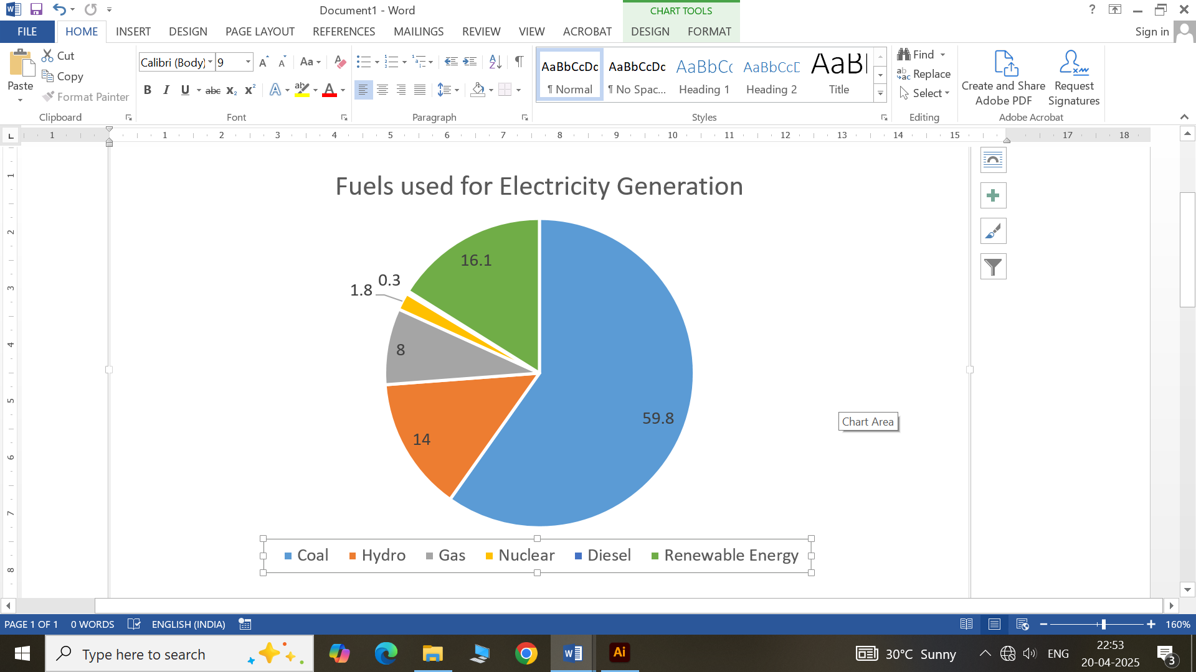 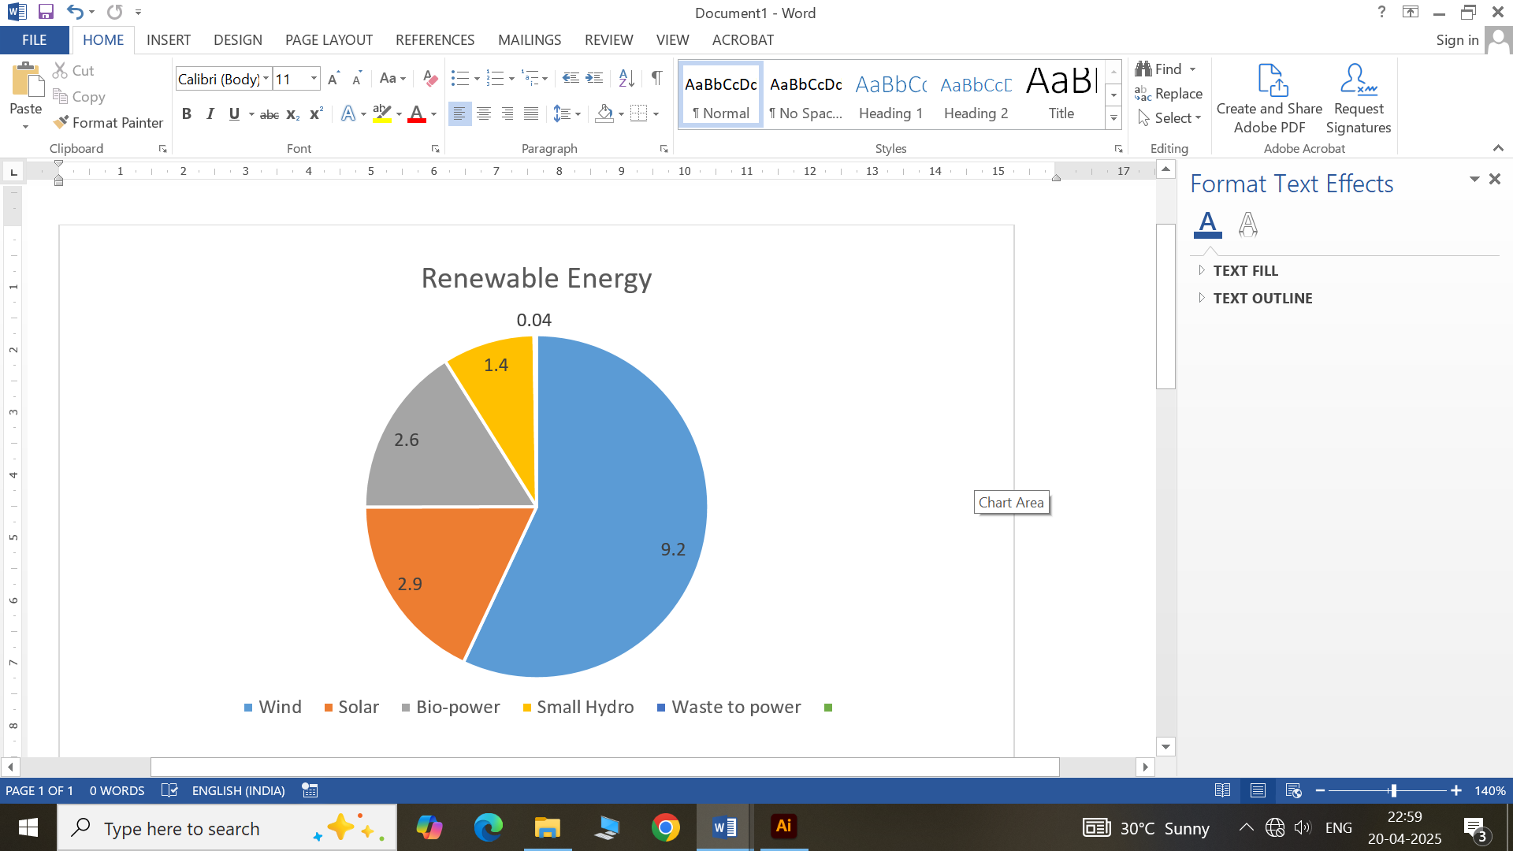

*Figure 3* : India Electricity Mix

The **national electricity mix** in India is still dominated by fossil fuels, particularly coal. As reported in [54], **coal alone accounts for more than 50%** of electricity generation (Fig. 3), while the share of renewables remains minimal.

**Table 1 Car Sales for the Selected Vehicles (2017–2025)**

| **Vehicle Brand** | **2017** | **2018** | **2019** | **2020** | **2021** | **2022** | **2023** | **2024** | **2025 (Proj.)** |
| --- | --- | --- | --- | --- | --- | --- | --- | --- | --- |
| Toyota Innova (ICE gasoline) | 61,775 | 59,630 | 52,705 | 27,592 | 33,375 | 65,110 | 67,320 | 69,580 | 72,400 |
| Mitsubishi Pajero (ICE diesel) | 18,577 | 19,338 | 16,662 | 8,693 | 11,843 | 20,100 | 21,420 | 22,850 | 24,300 |
| Toyota Corolla Cross (HEV) | x | x | x | 652 | 1,070 | 2,010 | 3,540 | 5,200 | 6,890 |
| Mitsubishi Outlander Sport (PHEV) | x | x | 20 | 6 | 35 | 220 | 490 | 750 | 1,300 |
| Hyundai Kona Electric (EV) | x | x | x | 60 | 315 | 720 | 1,430 | 2,860 | 4,500 |

(Data from 2020–2024 is based on industry trend projections and manufacturer reports.)

### 2.2. Emission Cost Estimation

Emission costs were calculated to quantify the **economic burden of environmental pollution** caused by different vehicles. The total cost was determined using the following formula:

C =∑ Pi​⋅ei​

i

Where:**C** = total emission cost in INR per 1000 km

* **Pᵢ** = emission of pollutant i in g/km
* **eᵢ** = economic cost of pollutant i in INR/g [Refer Table 3 and Table 4]

This emission-cost mapping provides **monetary valuation of environmental harm**, allowing policy-driven insights into externalities of automotive emissions.

### 2.3. Fuelling and Charging Time Cost

Refuelling/charging time plays a vital role in **user convenience and time productivity**. ICE vehicles benefit from a **well-established refuelling network**, while EVs—despite requiring longer charging durations—offer the convenience of **overnight home charging** [56]. Infrequent maintenance and at-home charging offset the lack of widespread public charging infrastructure in India.

The role of **fast-charging stations** becomes essential for **inter-city travel** and for EV users without private charging access. Therefore, the fuelling time cost parameter evaluates the **impact on user lifestyle, time efficiency, and infrastructure readiness**.

### 2.4. Maintenance Cost

EVs generally incur **lower maintenance costs** due to fewer moving parts and absence of components such as exhaust systems, transmissions, and oil filters. Technologies like **regenerative braking** reduce brake wear, extending service intervals.

Conversely, ICE vehicles require **frequent service** involving oil changes, fluid replacement, and engine tuning. However, for EVs, **battery health and replacement cost** remain significant concerns, especially given the current **market maturity in India**.

Despite marketing claims of “zero maintenance,” reliable long-term data on EV upkeep is still evolving. Therefore, cost comparison includes **manufacturer recommendations, user reports, and market assumptions**, as detailed in **Table 2**.

**3. Results & Discussion:**

(a)

(b)

*Figure. 4*. Variation of pollutant emissions for: (a) CO and (b) CO2.

The comparative analysis of pollutant emissions from all vehicle types—ICEs, HEVs, PHEVs, and EVs—was presented in Fig. 4. Fig. 4(a) reveals that **EVs exhibit the lowest CO emissions**, registering under 0.2 g/km. Although commonly classified as zero-emission vehicles, EVs indirectly emit pollutants during **battery manufacturing processes**, particularly CO and CO₂ emissions due to the **extraction and processing of rare-earth metals** such as lithium and cobalt [8]. Additionally, the **fossil-fuel-based electricity generation** required to charge EVs contributes to upstream emissions, as shown in Fig. 4(b).

EVs emit **20% to 27% less CO₂** than gasoline and diesel ICE vehicles, validating their climate-friendliness. A **marginal difference (<10%)** in emissions was observed between EVs and PHEVs, largely due to the latter’s smaller battery pack. However, a **significant difference (>30%)** between HEVs and PHEVs is noted. HEVs, equipped with minimal battery capacity, operate in electric mode only during low-speed or idle conditions, while **PHEVs begin in EV mode and shift to hybrid mode when depleted**, accounting for their greater environmental impact.

Despite higher prices, PHEVs offer operational versatility. **Table 2** highlights the cost and specification comparison of the studied vehicle types. The PHEV has the highest OTR price (INR 62,155.18), making it **44% more expensive than HEVs** and **20% more than EVs**. Among electric vehicles, **HEVs have the lowest cost**, aligning with their **market dominance in India**, as shown in Table 1.

### ****Table 2: Information Data of Gasoline, Diesel, HEV, PHEV, and EV Vehicles****

| **Parameter** | **Unit** | **Gasoline** | **Diesel** | **HEV** | **PHEV** | **EV** |
| --- | --- | --- | --- | --- | --- | --- |
| Vehicle Weight | kg | 1,690 | 1,935 | 1,385 | 1,880 | 2,170 |
| Passenger Load (5 @ 80 kg) | kg | 400 | 400 | 400 | 400 | 400 |
| Average Lifetime | years | 10 | 10 | 10 | 10 | 10 |
| Average Annual Usage | km | 10,000 | 10,000 | 10,000 | 10,000 | 10,000 |
| Fuel Economy | km/liter | 10.00 | 11.20 | 23.25 | 56.00 | 51.02 |
| Fuel Price | INR/liter | 52.61 | 66.80 | 71.81 | 71.81 | 75.15 |
| Fuel Taxes | INR/liter | 2.51 | 3.34 | 4.18 | 4.18 | 75.15 |
| Tank/Battery Capacity | liter | 55 | 68 | 36 | 45 | — |
| Time for Fuelling/Charging | min | 6 | 6 | 6 | 6 | 30 |
| Maintenance Frequency | times | 22 | 22 | 20 | 20 | 10 |
| On-the-Road (OTR) Price | INR | ₹2,333,708.09 | ₹3,497,448.80 | ₹2,915,409.44 | ₹5,190,459.53 | ₹4,079,887.35 |
| Maintenance Cost | INR/km | ₹0.7106 | ₹1.1319 | ₹0.8024 | ₹0.8165 | ₹0.3499 |

The emission impact was further evaluated using cost data of each pollutant [55].

### ****Table 3: The Emission Cost of Each Pollutant**** [55]

| **Pollutant** | **Unit** | **Damage Cost (INR/kg)** |
| --- | --- | --- |
| CO | ₹/kg | 0.76 |
| NOx | ₹/kg | 214.67 |
| PM10 | ₹/kg | 385.87 |
| PM2.5 | ₹/kg | 561.15 |
| SOx | ₹/kg | 361.27 |
| CH₄ | ₹/kg | 25.24 |
| CO₂ | ₹/kg | 0.70 |
| N₂O | ₹/kg | 361.27 |

From this, the total vehicle emission cost was calculated.

### ****Table 4: Total Vehicle Emission Cost****

| **Vehicle** | **Total Damage Cost (INR/1000 km)** |
| --- | --- |
| Toyota Innova (Gasoline) | 223.54 |
| Mitsubishi Pajero (Diesel) | 237.43 |
| Toyota Corolla Cross (HEV) | 102.67 |
| Mitsubishi Outlander Sport (PHEV) | 306.05 |
| Hyundai Kona Electric (EV) | 421.55 |

**(a)**

**(b)**

*Figure. 5*. Variation of pollutant emissions for: (a) NOx and (b) N2O

**Fig. 5(a)** and **Fig. 5(b)** show that EVs emit the highest **NOx and N₂O emissions**, mainly due to fossil-fuel-based electricity generation. NOx emissions of EVs exceed 0.2 g/km—more than half of ICE emissions. N₂O, a potent greenhouse gas with a **half-life of 150 years**, contributes to **ozone depletion**. This finding reveals India’s **continued dependency on fossil fuel power plants**, reducing the green advantage of EVs.

**(a)**

**(b)**

*Figure. 6.* Variation of pollutant emissions for: (a) Sox and (b) PM10.

**SOx and PM10 emissions**, shown in Fig. 6(a) and Fig. 6(b), were surprisingly higher for EVs—by **90% and 85%**, respectively. Hyundai Kona, with the largest battery pack, recorded the highest values. These pollutants, often linked to sulfur-based fuels and power plant emissions, are associated with **serious respiratory and cardiovascular risks**. Thus, reducing the electricity grid’s reliance on coal and gas is essential. The use of **renewable sources like wind, solar, and geothermal energy** is strongly recommended.

The **total emission cost per 1000 km**, where EVs, notably the Hyundai Kona, incur the **highest cost at ₹5.0485**, due to:

1. Emissions from **battery production** (lithium, cobalt mining).
2. Fossil-fuel-based **electricity generation**.
3. **Secondary effects** on public health and the environment.

This cost, however, **does not negate** the EV’s benefit in reducing direct CO and CO₂ emissions. Instead, it highlights the need for a **life-cycle assessment (LCA)** approach. This finding aligns with Farzaneh et al. [8] and Liu et al. [6], who emphasized that **EVs’ environmental gains** are maximized only with **clean energy integration**.

Notably, despite its high emission cost, the EV maintains the **lowest maintenance cost (INR 0.00419/km)** due to **fewer mechanical components and lower wear**.

Among all studied types, **HEVs emerged as the most balanced** in terms of price, emissions, and operational cost. With a moderate OTR price of INR 34,918.64, the **total emission cost of only ₹1.2262/1000 km**, and decent maintenance cost, HEVs are **ideal for the Indian market**. At 13,000 km annual mileage, HEVs’ emission cost is **80% lower** than that of EVs.

Their advantages stem from:

* **Fuel efficiency and regenerative braking**.
* **Dual power source (ICE + electric motor)**.
* **Lower emissions and running cost.**

This balance makes HEVs a **strategic transitional technology** toward full electrification. However, with advancements in:

* **Battery recycling and production**,
* **Renewable electricity generation**, and
* **Infrastructure development**,

**EVs and PHEVs are expected to become more competitive** in future Indian markets.

**4. Conclusion:**

This study presents a comprehensive comparative analysis of Internal Combustion Engine (ICE) vehicles, Hybrid Electric Vehicles (HEVs), Plug-in Hybrid Electric Vehicles (PHEVs), and Electric Vehicles (EVs) within the context of India’s evolving transportation landscape. By evaluating key parameters—emission costs, fuelling time costs, maintenance expenses, and vehicle selection—we offer critical insights into the environmental and economic trade-offs of these technologies, particularly in relation to India’s goal of achieving net-zero emissions by 2050.

**4.1 Key Insights from the Comparative Study**

* **Vehicle Benchmarking**: The study evaluated Toyota Innova (gasoline) and Mitsubishi Pajero (diesel) for ICE, Toyota Corolla Cross for HEV, Mitsubishi Outlander Sport for PHEV, and Hyundai Kona Electric for EV, representing a diverse set of technologies available in the Indian market.
* **Emission Costs**: HEVs exhibited the lowest emission-related damage costs per 1,000 km, while EVs showed the highest—primarily due to electricity generation from fossil fuels.
* **Fuelling and Charging Time**: Although EVs require more time to recharge compared to traditional refuelling, this is often mitigated by overnight home charging, reducing the dependence on public infrastructure.
* **Maintenance Costs**: EVs demonstrated the lowest maintenance costs over their lifetime due to fewer moving parts. In contrast, ICE vehicles required frequent servicing. However, high battery replacement costs remain a concern for EVs.
* **Greenhouse Gas Emissions**: EVs led in reducing CO and CO₂ emissions, while HEVs and PHEVs showed considerable improvement over ICE vehicles, making them strong candidates for transitional technology.
* **Air Quality Pollutants**: Elevated NOx and N₂O emissions from EVs indicate India's continued reliance on non-renewable power sources. Higher SOx and PM10 emissions further stress the need for a cleaner electricity mix.
* **Economic Trade-offs**: Despite higher upfront costs and emission-related penalties, EVs offer superior savings on long-term maintenance. HEVs, however, emerge as the most economically balanced option.

**5. Future Scope:**

To accelerate the adoption of low-emission vehicles and support India's climate commitments, the following strategic actions are recommended:

* **Promote HEV Adoption**: Encourage HEVs through tax incentives, subsidies, and manufacturer support, leveraging their economic and environmental balance.
* **Expand EV Infrastructure**: Develop nationwide fast-charging networks and promote home-charging capabilities to ease adoption barriers.
* **Shift to Renewable Energy**: Enhance integration of solar, wind, geothermal, and hydropower into the national grid to reduce the environmental footprint of EVs.
* **Upgrade Emission Controls in Power Plants**: Introduce stringent emission standards and cleaner technologies to lower SOx and PM emissions from electricity generation.
* **Policy Strengthening and Regulation**: Enforce tighter emission regulations for ICE vehicles and facilitate the commercialization of HEV, PHEV, and EV technologies.
* **Public Awareness and Education**: Launch campaigns to increase awareness about the environmental and economic benefits of cleaner transportation technologies.
* **Local Battery Manufacturing and Recycling**: Establish domestic production and recycling facilities to reduce costs and environmental impact while enhancing energy security.
* **Foster R&D in Sustainable Mobility**: Invest in research on advanced vehicle technologies, battery innovation, and renewable energy to improve affordability, performance, and environmental outcomes.

**6. References:**

1. Srivastava, V., Schaub, J., & Pischinger, S. (2023). Model-based closed-loop control strategies for flex-fuel capability. *Applied Energy, 350*, 121795.
2. Azam, M. W., Chaudhary, G. Q., Sajjad, U., Abbas, N., & Yan, W.-M. (2023). Performance investigation of solar assisted desiccant integrated Maisotsenko cycle cooler in subtropical climate conditions. *Case Studies in Thermal Engineering, 44*, 102864.
3. Abbas, N., Badshah, M. A., Awan, M. B., & Zahra, N. (2018). Performance and gaseous emission investigation of low powered spark ignition engine fueled with gasoline and hydroxyl gas: hydroxyl gas-gasoline mixture engine. *Proceedings of the Pakistan Academy of Sciences: A. Physical and Computational Sciences, 55*(1), 11–20.
4. Haq, M. U., et al. (2022). Numerical and experimental spray analysis of castor and jatropha biodiesel under non-evaporating conditions. *Energies, 15*(20), 7808.
5. Haq, M. U., Jafry, A. T., Ahmad, S., Cheema, T. A., Ansari, M. Q., & Abbas, N. (2022). Recent advances in fuel additives and their spray characteristics for diesel-based blends. *Energies, 15*(19), 7281. https://www.mdpi.com/1996-1073/15/19/7281
6. Liu, Z., et al. (2021). Comparing total cost of ownership of battery electric vehicles and internal combustion engine vehicles. *Energy Policy, 158*, 112564.
7. Sinigaglia, T., Martins, M. E. S., & Siluk, J. C. M. (2022). Technological forecasting for fuel cell electric vehicle: A comparison with electric vehicles and internal combustion engine vehicles. *World Patent Information, 71*, 102152.
8. Farzaneh, F., & Jung, S. (2023). Lifecycle carbon footprint comparison between internal combustion engine versus electric transit vehicle: A case study in the US. *Journal of Cleaner Production, 390*, 136111.
9. Lavee, D., & Parsha, A. (2021). Cost-benefit analyses of policy tools to encourage the use of plug-in electric vehicles. *Transportation Research Interdisciplinary Perspectives, 11*. https://doi.org/10.1016/j.trip.2021.100404
10. Dižo, J., et al. (2021). Electric and plug-in hybrid vehicles and their infrastructure in a particular European region. *Transportation Research Procedia, 55*, 629–636. https://doi.org/10.1016/j.trpro.2021.07.029
11. Andrzej, S., Pielecha, I., & Cieslik, W. (2021). Fuel cell electric vehicle (FCEV) energy flow analysis in real driving conditions (RDC). *Energies, 14*(16). https://doi.org/10.3390/en14165018
12. Das, H. S., Tan, C. W., & Yatim, A. H. M. (2017). Fuel cell hybrid electric vehicles: A review on power conditioning units and topologies. *Renewable and Sustainable Energy Reviews, 76*, 268–291. <https://doi.org/10.1016/j.rser.2017.03.056>
13. Wang, H., Yang, W., Chen, Y., & Wang, Y. (2018). *Overview of hybrid electric vehicle trend* (1st ed., Vol. 1955). AIP Publishing LLC.
14. Tran, M.-K., Akinsanya, M., Panchal, S., Fraser, R., & Fowler, M. (2021). Design of a hybrid electric vehicle powertrain for performance optimization considering various powertrain components and configurations. *Vehicles, 3*(1), 20–32.
15. Tie, S. F., & Tan, C. W. (2013). A review of energy sources and energy management system in electric vehicles. *Renewable and Sustainable Energy Reviews, 20*, 82–102. https://doi.org/10.1016/j.rser.2012.11.077
16. Li, W., Long, R., Chen, H., & Geng, J. (2017). A review of factors influencing consumer intentions to adopt battery electric vehicles. *Renewable and Sustainable Energy Reviews, 78*, 318–328. <https://doi.org/10.1016/j.rser.2017.04.076>
17. Lyu, Y., Siddique, A. R. M., Majid, S. H., Biglarbegian, M., Gadsden, S. A., & Mahmud, S. (2019). Electric vehicle battery thermal management system with thermoelectric cooling. *Energy Reports, 5*, 822–827. <https://doi.org/10.1016/j.egyr.2019.06.016>
18. Verma, S., Siddiqui, A. U., Kumar, R., Yadav, N., Singh, S., & Shukla, P. (2021). A comprehensive review on energy storage in hybrid electric vehicle. *Journal of Traffic and Transportation Engineering (English Edition), 8*(5), 621–637. https://doi.org/10.1016/j.jtte.2021.09.001
19. Un-Noor, F., Sanjeevikumar, P., Mihet-Popa, L., Mollah, M., & Hossain, E. (2017). A comprehensive study of key electric vehicle (EV) components, technologies, challenges, impacts, and future direction of development. *Energies, 10*(8). <https://doi.org/10.3390/en10081217>
20. Ahmadi, P., & Kjeang, E. (2017). Realistic simulation of fuel economy and life cycle metrics for hydrogen fuel cell vehicles. *International Journal of Energy Research, 41*(5), 714–727.
21. Ahmadi, P., Torabi, S. H., Afsaneh, H., Sadegheih, Y., Ganjehsarabi, H., & Ashjaee, M. (2020). The effects of driving patterns and PEM fuel cell degradation on the lifecycle assessment of hydrogen fuel cell vehicles. *International Journal of Hydrogen Energy, 45*(5), 3595–3608. https://doi.org/10.1016/j.ijhydene.2019.11.024
22. de Almeida, S. C. A., & Kruczan, R. (2021). Effects of drivetrain hybridization on fuel economy, performance, and costs of a fuel cell hybrid electric vehicle. *International Journal of Hydrogen Energy*. <https://doi.org/10.1016/j.ijhydene.2021.09.144>
23. International Energy Agency (IEA). (2021). *Global EV Outlook 2021: Accelerating ambitions despite the pandemic*.
24. Leach, F., Kalghatgi, G., Stone, R., & Miles, P. (2020). The scope for improving the efficiency and environmental impact of internal combustion engines. *Transportation Engineering, 1*, 100005. <https://doi.org/10.1016/j.treng.2020.100005>
25. Li, W., Stanula, P., Egede, P., Kara, S., & Herrmann, C. (2016). Determining the main factors influencing the energy consumption of electric vehicles in the usage phase. *Proceedings of CIRP, 48*, 352–357. <https://doi.org/10.1016/j.procir.2016.03.014>
26. UNFCCC. (2015). *Conference of the Parties (COP), adoption of the Paris Agreement*, Paris.
27. van Soest, H. L., den Elzen, M. G. J., & van Vuuren, D. P. (2021). Net-zero emission targets for major emitting countries consistent with the Paris Agreement. *Nature Communications, 12*(1), 1–9. https://doi.org/10.1038/s41467-021-22055-w
28. Shaukat, N., et al. (2018). A survey on electric vehicle transportation within the smart grid system. *Renewable and Sustainable Energy Reviews, 81*, 1329–1349. https://doi.org/10.1016/j.rser.2017.05.092
29. Du, J., Ouyang, M., & Chen, J. (2017). Prospects for Chinese electric vehicle technologies in 2016–2020: Ambition and rationality. *Energy, 120*, 584–596. https://doi.org/10.1016/j.energy.2016.11.114
30. Nour, M., Chaves-Ávila, J., Magdy, G., & Sánchez-Miralles, A. (2020). Review of positive and negative impacts of electric vehicles charging on electric power systems. *Energies, 13*(18), 4675. <https://doi.org/10.3390/en13184675>
31. Thorne, Z., & Hughes, L. (2019). Evaluating the effectiveness of electric vehicle subsidies in Canada. *Proceedings of Computer Science, 155*, 519–526. https://doi.org/10.1016/j.procs.2019.08.072
32. Wang, N., Tang, L., Zhang, W., & Guo, J. (2019). How to face the challenges caused by the abolishment of subsidies for electric vehicles in China? *Energy, 166*, 359–372. <https://doi.org/10.1016/j.energy.2018.10.006>
33. Meisel, S., & Merfeld, T. (2018). Economic incentives for the adoption of electric vehicles: A classification and review of e-vehicle services. *Transportation Research Part D: Transport and Environment, 65*, 264–287. <https://doi.org/10.1016/j.trd.2018.08.014>
34. Abas, P. E., Yong, J., Mahlia, T. M. I., & Hannan, M. A. (2019). Techno-economic analysis and environmental impact of electric vehicles. *IEEE Access*, 1. https://doi.org/10.1109/ACCESS.2019.2929530
35. Pipitone, E., Caltabellotta, S., & Occhipinti, L. (2021). A life cycle environmental impact comparison between traditional, hybrid, and electric vehicles in the European context. *Vol. 13*.
36. Thompson, D. J., & Ixon, J. D. (2018). *Vehicle noise* (pp. 250–305). CRC Press.
37. Steinbach, L., & Altinsoy, M. E. (2019). Prediction of annoyance evaluations of electric vehicle noise by using artificial neural networks. *Applied Acoustics, 145*, 149–158. <https://doi.org/10.1016/j.apacoust.2018.09.024>
38. Rozman, M. (2019). Inductive wireless power transmission for automotive applications.
39. Qiao, Q., Zhao, F., Liu, Z., & Hao, H. (2019). Electric vehicle recycling in China: Economic and environmental benefits. *Resources, Conservation and Recycling, 140*, 45–53. https://doi.org/10.1016/j.resconrec.2018.09.003
40. Pollet, B., Staffell, I., & Shang, J. (2012). Current status of hybrid, battery and fuel cell electric vehicles: From electrochemistry to market prospects. *Electrochimica Acta, 84*, 235–249. <https://doi.org/10.1016/j.electacta.2012.03.172>
41. Albatayneh, A., Assaf, M. N., Alterman, D., & Jaradat, M. (2020). Comparison of the overall energy efficiency for internal combustion engine vehicles and electric vehicles. *Environmental and Climate Technologies*. Retrieved from <https://www.researchgate.net/publication/344860096_Comparison_of_the_Overall_Energy_Efficiency_for_Internal_Combustion_Engine_Vehicles_and_Electric_Vehicles>
42. Sanguesa, J. A., Torres-Sanz, V., Garrido, P., Martínez, F. J., & Marquez-Barja, J. M. (2021). A review on electric vehicles: Technologies and challenges. *Smart Cities, 4*(1), 372–404.
43. Delucchi, M. A., & Lipman, T. E. (2001). An analysis of the retail and lifecycle cost of battery-powered electric vehicles. *Transport Research Part D: Transport and Environment, 6*(6), 371–404.
44. Bakker, D. (2010). *Battery electric vehicles: Performance, CO2 emissions, lifecycle costs, and advanced battery technology development* (Doctoral dissertation, Copernicus Institute University of Utrecht).
45. Liu, Z., et al. (2021). Comparing total cost of ownership of battery electric vehicles and internal combustion engine vehicles. *Energy Policy, 158*, 112564. https://doi.org/10.1016/j.enpol.2021.112564
46. Bañol Arias, N., Hashemi, S., Andersen, P. B., Træholt, C., & Romero, R. (2020). Assessment of economic benefits for EV owners participating in the primary frequency regulation markets. *International Journal of Electrical Power & Energy Systems, 120*, 105985. https://doi.org/10.1016/j.ijepes.2020.105985
47. Utami, M. W. D., Yuniaristanto, Y., & Sutopo, W. (2020). Adoption intention model of electric vehicle in India. *Jurnal Optimasi Sistem Industri, 19*(1), 70–81.
48. Setiawan, I. C. (2019). Policy simulation of electricity-based vehicle utilization in India (electrified vehicle-HEV, PHEV, BEV, and FCEV). *Automotive Experience, 2*(1), 1–8.
49. Ilgin, M. A., & Gupta, S. M. (2010). Environmentally conscious manufacturing and product recovery (ECMPRO): A review of the state of the art. *Journal of Environmental Management, 91*(3), 563–591.
50. Athanasopoulou, L., Bikas, H., & Stavropoulos, P. (2018). Comparative well-to-wheel emissions assessment of internal combustion engine and battery electric vehicles. *Proceedings of the CIRP, 78*, 25–30. <https://doi.org/10.1016/j.procir.2018.08.169>
51. Que, Z., Wang, S., & Li, W. (2015). Potential of energy saving and emission reduction of battery electric vehicles with two types of drivetrains in China. *Energy Procedia, 75*, 2892–2897. <https://doi.org/10.1016/j.egypro.2015.07.584>
52. Pardo-Ferreira, C., Rubio-Romero, J. C., Galindo-Reyes, F. C., & Lopez-Arquillos, A. (2020). Work-related road safety: The impact of the low noise levels produced by electric vehicles according to experienced drivers. *Safety Science, 121*, 580–588. <https://doi.org/10.1016/j.ssci.2019.02.021>
53. Energy Efficiency for Transportation and Alternative Fuels. (2021).
54. Xu, H., Lee, U., & Wang, M. (2020). Life-cycle energy use and greenhouse gas emissions of palm fatty acid distillate derived renewable diesel. *Renewable and Sustainable Energy Reviews*.
55. Pirmana, V., Alisjahbana, A. S., Yusuf, A. A., Hoekstra, R., & Tukker, A. (2021). Environmental costs assessment for improved environmental-economic account for India. *Journal of Cleaner Production*.
56. Mitropoulos, L. K., & Prevedpurps, P. D. (2015). Life cycle emissions and cost model for urban light-duty vehicles. *Transport Research Part D: Transport and Environment, 41*, 147–159.