**MENTAL HEALTH AT WORK: BEYOND WELLNESS PROGRAMS TO SYSTEMATIC SUPPORT**

**AISHWARYA.S, MR.N.MOHAMMAD SAIF**

1. MBA student, School of Arts, Humanities and Management, Jeppiaar University, Chennai, India.
2. Associate Professor, School of Arts Humanities and Management, Jeppiaar University, Chennai, India

**ABSTRACT**

Mental health in the workplace is a pressing issue that demands a shift from superficial wellness programs to comprehensive, systematic support. Traditional approaches, such as mindfulness sessions and Employee Assistance Programs (EAPs), often fail to address the root causes of workplace stress, including excessive workloads, poor management practices, and lack of psychological safety. This paper explores the limitations of these fragmented initiatives and advocates for integrated strategies that embed mental health into organizational culture, policies, and leadership practices.

A systematic approach involves implementing structural changes like flexible work arrangements, mental health leave policies, and workload management systems. These measures are complemented by training leaders to recognize and respond to mental health challenges, fostering open dialogue, and reducing stigma through company-wide campaigns. Research shows that organizations adopting such holistic strategies report higher employee engagement, reduced turnover, and improved productivity, underscoring the business case for mental health investment.

Ethical considerations, including privacy, inclusivity, and avoiding tokenism, are critical to ensuring these initiatives are effective and equitable. For instance, marginalized groups often face additional barriers to accessing support, necessitating tailored interventions. Transparency and measurable outcomes are also essential to demonstrate accountability and refine strategies over time.

This paper draws on case studies from companies like Microsoft and Unilever, which have successfully integrated mental health into their operational frameworks. Their experiences highlight the importance of leadership commitment, employee participation, and continuous evaluation in creating sustainable change. By prioritizing mental health as a strategic imperative, organizations can cultivate resilient, high-performing teams.

Ultimately, the transition from standalone wellness programs to systemic support requires a cultural shift—one that values employee well-being as foundational to organizational success. This paper provides actionable insights for businesses aiming to build mentally healthy workplaces, emphasizing the need for policies, education, and ongoing investment to achieve long-term impact.

**Keywords:** Mental health, workplace well-being, systematic support, psychological safety, organizational culture.

**INTRODUCTION**

Mental health in the workplace has become a pressing concern in today’s fast-paced and demanding professional environments. The increasing prevalence of stress, anxiety, and burnout among employees highlights the urgent need for organizations to prioritize psychological well-being. While many companies have introduced wellness programs, such as meditation sessions or fitness challenges, these initiatives often fail to address the systemic issues that contribute to mental health challenges. A more comprehensive approach is required—one that integrates mental health support into the very fabric of organizational culture and policies.

Traditional wellness programs, though well-intentioned, tend to focus on individual behaviors rather than structural factors. For instance, offering yoga classes or resilience workshops does little to mitigate excessive workloads, poor management practices, or a lack of work-life balance. Research shows that employees increasingly view these programs as superficial solutions that ignore the root causes of workplace stress. Without addressing these deeper issues, organizations risk perpetuating cycles of burnout and disengagement, ultimately harming productivity and employee retention.

The consequences of neglecting mental health are far-reaching, affecting not only individuals but also organizational performance. Studies reveal that untreated mental health issues lead to higher absenteeism, reduced productivity, and increased healthcare costs. Furthermore, workplaces that fail to foster psychological safety often experience higher turnover rates, as employees seek environments where their well-being is valued. In contrast, organizations that prioritize mental health report higher levels of engagement, creativity, and loyalty, demonstrating the tangible benefits of a supportive workplace culture.

To create meaningful change, companies must move beyond standalone wellness initiatives and adopt a systematic approach to mental health support. This involves implementing policies such as flexible work arrangements, mental health training for leaders, and transparent communication channels for employees to voice concerns. It also requires measuring outcomes to ensure interventions are effective and inclusive. By embedding mental health into everyday practices, organizations can cultivate environments where employees feel safe, supported, and empowered to thrive.

The shift from reactive wellness programs to proactive systemic support is not just a moral imperative but a strategic one. As the conversation around mental health continues to grow, organizations that lead with empathy and evidence-based strategies will gain a competitive edge in attracting and retaining talent. This paper explores the limitations of current approaches and presents actionable steps for building workplaces where mental health is a cornerstone of success.

**THE LIMITATIONS OF TRADITIONAL WELLNESS PROGRAMS**

While workplace wellness programs have gained popularity in recent years, their effectiveness in addressing mental health challenges remains limited. Below is a detailed analysis of their key shortcomings:

**1. Superficial and Symptom-Focused Approach**

* Most wellness programs (e.g., yoga sessions, meditation apps, or stress management workshops) target surface-level symptoms rather than root causes of mental health struggles.
* They fail to address systemic workplace stressors such as excessive workloads, unrealistic deadlines, poor management practices, or toxic work cultures.
* Example: A company offering mindfulness training while maintaining a high-pressure, always-on work environment sends mixed signals and yields minimal long-term benefits.

**2. Low Employee Engagement and Participation Participation**

* is often voluntary, meaning only employees already inclined toward self-care engage, while those most in need may avoid programs due to stigma or lack of time.
* Studies show that less than 25% of employees consistently participate in corporate wellness initiatives, limiting their overall impact.
* Example: An Employee Assistance Program (EAP) may offer counseling services, but if employees fear judgment or career repercussions for using it, utilization rates remain low.

**3. Failure to Reduce Stigma Around Mental Health**

* Standalone wellness programs do little to normalize mental health discussions or create psychologically safe spaces for employees to seek help.
* Without leadership involvement and cultural shifts, employees may still hesitate to disclose struggles due to fear of being perceived as weak or unreliable.
* Example: A company hosting an annual "mental health awareness day" but discouraging open conversations about stress in team meetings reinforces silence rather than breaking it.

**4. Lack of Personalization and Inclusivity**

* Many programs adopt a one-size-fits-all approach, ignoring diverse employee needs based on roles, demographics, or mental health conditions.
* Marginalized groups (e.g., remote workers, minorities, or employees with disabilities) may find generic initiatives irrelevant or inaccessible.
* Example: A wellness challenge focused on step counts excludes employees with mobility issues, exacerbating feelings of exclusion.

**5. Short-Term Focus Without Measurable Outcomes**

* Programs often lack clear metrics to evaluate effectiveness, making it difficult to assess ROI or justify continued investment.
* Temporary boosts in morale (e.g., after a wellness workshop) rarely translate to sustained improvements in mental health or productivity.
* Example: A company surveys employees after a meditation session but fails to track long-term changes in stress levels or job satisfaction.

**6. Disconnected from Organizational Policies**

* Wellness initiatives frequently operate in silos, unrelated to broader HR policies (e.g., workload distribution, performance reviews, or leave systems).
* Without alignment with structural changes, employees perceive these programs as performative rather than transformative.
* Example: A firm promotes "work-life balance" through wellness seminars but rewards employees who consistently work overtime, undermining the message.

**7. Overemphasis on Individual Responsibility**

* By framing mental health as a personal issue (e.g., "practice self-care"), these programs absolve organizations of accountability for creating stressful work conditions.
* This "band-aid" approach shifts blame onto employees rather than addressing systemic contributors like poor leadership or inadequate resources.
* Example: A company advises employees to "manage stress better" while ignoring complaints about unmanageable project timelines.

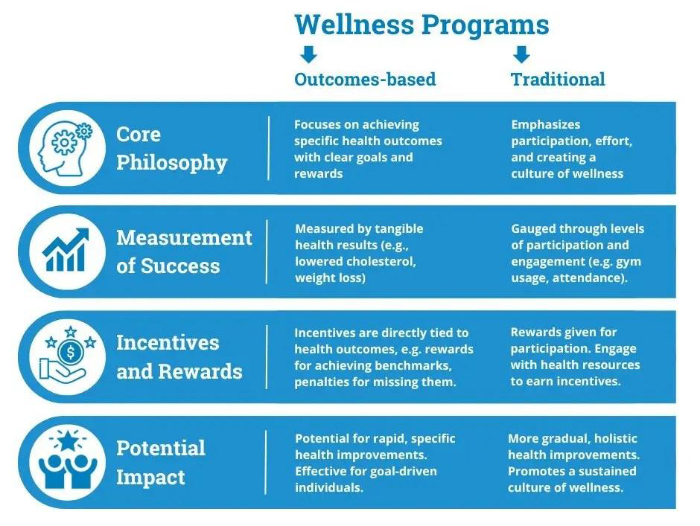

**TOWARD SYSTEMATIC SUPPORT: KEY STRATEGIES**

To create a workplace that genuinely supports mental health, organizations must implement comprehensive, systemic strategies that go beyond superficial wellness programs. Below are detailed, actionable approaches:

**1. Policy Integration: Embed Mental Health into Organizational**

* **Frameworks Flexible Work Arrangements:**
* Offer remote/hybrid work options to reduce commute stress and improve work-life balance.
* Implement adjustable working hours (e.g., compressed workweeks, staggered shifts) to accommodate personal needs.
* Establish "core hours" for collaboration while allowing flexibility for deep work or personal commitments.
* **Mental Health Leave Policies:**
* Provide dedicated paid mental health days separate from sick leave.
* Normalize taking mental health leave by encouraging leaders to model this behavior.
* Ensure policies are clearly communicated and free from stigma or penalty.
* **Workload Management:**
* Set realistic deadlines and distribute tasks evenly to prevent burnout.
* Introduce "right to disconnect" policies to discourage after-hours communication.
* Regularly review workloads with employees to identify and address excessive demands.

**2. Leadership Training: Equip Managers to Support Mental Health Mental Health**

* Awareness Programs:
* Train managers to recognize signs of distress (e.g., changes in behavior, productivity dips).
* Teach active listening skills and how to approach conversations about mental health empathetically.
* **Psychological Safety Training:**
* Encourage leaders to foster open dialogue by sharing their own experiences with stress or mental health challenges.
* Provide tools for managers to create inclusive, non-judgmental team environments.
* **Accountability Measures:**
* Tie leadership performance metrics to employee well-being outcomes (e.g., team engagement scores).
* Conduct 360-degree feedback to assess how well leaders support mental health.

**3. Stigma Reduction: Normalize Mental Health Conversations**

* **Awareness Campaigns:**
* Host regular workshops, talks, or storytelling sessions featuring employees and leaders discussing mental health.
* Share anonymized success stories of employees who utilized mental health support.
* **Visible Leadership Commitment:**
* Have executives openly advocate for mental health initiatives in company-wide communications.
* Appoint "Mental Health Champions" across departments to promote resources and reduce stigma.
* **Regular Surveys and Feedback:**
* Use anonymous surveys to measure psychological safety and track progress over time.
* Act on feedback to demonstrate that employee input drives change.

**4. Accessible Professional Support: Provide Practical Resources**

* **Counseling Services:**
* Partner with mental health platforms (e.g., BetterHelp, Lyra) to offer subsidized therapy.
* Provide on-site or virtual counseling sessions for immediate support.
* **Crisis Resources:**
* Establish 24/7 anonymous helplines for employees in distress.
* Train HR teams to guide employees to appropriate resources during crises.
* Peer Support Networks:
* Create employee-led support groups (e.g., for parents, caregivers, or stress management).
* Foster mentorship programs to connect employees with colleagues who can offer guidance.

**5. Measurement and Continuous Improvement**

* **Track Key Metrics:**
* Monitor absenteeism, turnover rates, and utilization of mental health resources.
* Use engagement surveys to assess changes in psychological safety and well-being.
* **Evaluate Program Effectiveness:**
* Conduct regular audits of mental health initiatives to identify gaps or areas for improvement.
* Benchmark progress against industry standards or best practices.
* Iterate and Adapt:
* Adjust strategies based on data and employee feedback.
* Scale successful pilots (e.g., department-specific programs) company-wide.

**Implementation Roadmap Assess Needs:**

1. **Secure Leadership Buy-In:** Present a business case linking mental health support to productivity and retention.
2. **Pilot Programs:** Test strategies in specific teams or departments before rolling them out organization-wide.
3. **Communicate Transparently:** Regularly update employees on new initiatives and their impact.
4. **Review and Refine:** Use data to refine approaches and ensure long-term sustainability.

**ETHICAL CONSIDERATIONS IN WORKPLACE MENTAL HEALTH INITIATIVES**

Implementing mental health support systems in the workplace requires careful attention to ethical principles to ensure programs are effective, inclusive, and respectful of employee rights. Below are key ethical considerations organizations must address:

**1. Privacy and Confidentiality**

* **Secure Data Handling:** Ensure all mental health data (e.g., counseling records, survey responses) is stored securely and accessible only to authorized personnel.
* **Informed Consent:** Clearly communicate how employee data will be used, who will have access, and the purpose of collection. Employees must voluntarily opt into sharing sensitive information.
* **Anonymity in Surveys:** Aggregate data to prevent identification of individuals in mental health assessments or feedback tools.

**2. Avoiding Discrimination and Stigma**

* **Equal Access:** Ensure mental health resources (e.g., counseling, leave policies) are available to all employees, regardless of role, tenure, or background.
* **Non-Punitive Policies:** Guarantee that disclosing mental health struggles does not lead to retaliation, biased performance evaluations, or career limitations.
* **Language Matters:** Train leaders and teams to use destigmatizing language (e.g., avoid terms like "crazy" or "unstable").

**3. Transparency and Trust**

* **Clear Communication:** Disclose the scope and limitations of mental health programs (e.g., "Our EAP provides short-term counseling but not long-term therapy").
* **No Coercion:** Participation in wellness activities (e.g., mindfulness sessions) should be optional, not tied to performance metrics or incentives.
* **Honesty About Outcomes:** Share data on program efficacy (e.g., "Our stress-reduction workshops reduced burnout reports by 20%") without exaggerating results.

1. **Bias and Cultural Sensitivity**

* Inclusive Design: Tailor programs to diverse needs (e.g., accommodate religious practices, language barriers, or disabilities).
* Address Systemic Inequities: Recognize that marginalized groups (e.g., BIPOC, LGBTQ+ employees) may face higher stigma and barriers to care.
* Algorithmic Fairness: If using AI tools (e.g., mental health chatbots), audit for biases in language or recommendations.

**5. Balancing Organizational and Employee Needs**

* Avoid Surveillance: Mental health tools (e.g., mood-tracking apps) should not be used to monitor productivity or punish employees.
* Sustainable Commitments: Ensure mental health budgets and policies persist beyond short-term "awareness campaigns."
* Employee Autonomy: Respect individual choices (e.g., opting out of programs) while providing accessible alternatives.

**Case Example:** A company implementing AI-driven stress monitoring software must:

* Disclose how data is collected and used.
* Allow employees to opt out without penalty.
* Regularly audit the tool for racial/gender bias in its assessments.

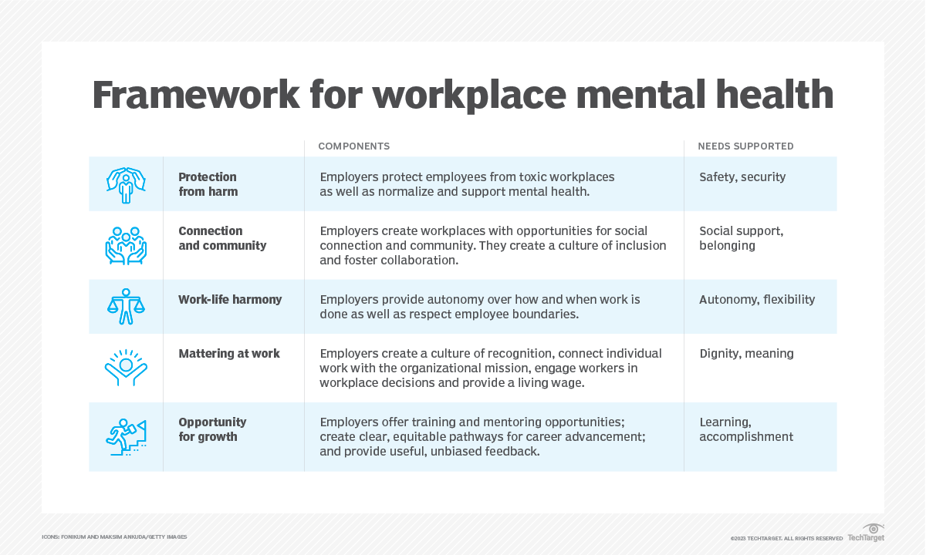

**CONCLUSION**

Mental health in the workplace is no longer a peripheral issue but a fundamental aspect of organizational success. As businesses navigate the complexities of modern work environments, the need for systematic mental health support has become undeniable. Traditional wellness programs, while beneficial, are insufficient to address the deep-rooted challenges employees face daily. A more holistic approach—one that integrates mental health into the very fabric of organizational culture—is essential to foster resilience, productivity, and employee satisfaction.

The transition from isolated wellness initiatives to comprehensive systemic support requires deliberate action. Organizations must prioritize policies that promote work-life balance, equip leaders with the skills to support their teams, and create environments where mental health conversations are normalized. By embedding these practices into everyday operations, companies can move beyond reactive measures and build proactive strategies that address the root causes of workplace stress and burnout.

Leadership plays a pivotal role in this transformation. When executives and managers champion mental health through transparency and empathy, they set a powerful example for the entire organization. Training programs that teach leaders to recognize signs of distress and respond appropriately can significantly reduce stigma and encourage employees to seek help without fear of judgment. This cultural shift not only enhances individual well-being but also strengthens team cohesion and organizational performance.

However, systemic change must be measured and accountable. Regular assessments, such as employee surveys and mental health audits, can help organizations track progress and identify areas for improvement. Transparent reporting on mental health initiatives ensures that efforts are not merely performative but lead to tangible outcomes. By committing to continuous evaluation, businesses can refine their strategies and demonstrate a genuine dedication to employee well-being.

Ultimately, the future of work depends on creating environments where mental health is valued as much as physical health and productivity. Organizations that embrace systematic support will not only attract and retain top talent but also cultivate a culture of trust, innovation, and long-term success. The journey toward a mentally healthy workplace is ongoing, but with intentional effort and collaboration, it is a goal within reach for every forward-thinking company.

**REFERENCE**

[1] World Health Organization. (2022). Mental health at work. WHO Press.

[2] Deloitte. (2022). Workplace Mental Health Trends Report.

[3] Harvard Business Review. (2023). "Why Microsoft's Mental Health Strategy Works."

[4] American Psychological Association. (2021). Guidelines for Organizational Mental Health Programs.

[5] Goh, J., Pfeffer, J., & Zenios, S. (2022). The Relationship Between Workplace Stressors and Mortality. Journal of Occupational Health Psychology.

[6] Mind Share Partners. (2023). Mental Health at Work Report.

[7] National Institute for Occupational Safety and Health (NIOSH). (2021). Total Worker Health® Framework.

[8] World Economic Forum. (2023). The Future of Work and Mental Health.

[9] Sorenson, S. (2021). How Google Builds Psychological Safety. Gallup Press.

[10]International Labour Organization. (2022). Convention 190 on Violence and Harassment.