**HYBRID WORK CULTURE BUILDING CONNECTION ACROSS DISTANCE**

**MALAISELVI M, DR.N.PADMAVATHY**

1. MBA student, School of Arts, Humanities and Management, Jeppiaar University, Chennai, India.
2. Associate Professor, School of Arts Humanities and Management, Jeppiaar University, Chennai, India

**ABSTRACT**

The evolution of hybrid work culture has reshaped organizational operations worldwide. With employees splitting time between working remotely and from the office, companies are navigating a new model that balances flexibility, productivity, and collaboration. While hybrid work offers significant advantages, such as improved work-life balance, reduced commuting time, and access to a global talent pool, it also introduces complex challenges, especially in building and maintaining employee connection across physical distances.

One of the primary concerns in hybrid environments is the weakening of interpersonal bonds that traditionally develop in shared physical workspaces. In a hybrid setup, spontaneous interactions, informal conversations, and face-to-face collaboration are significantly reduced, potentially leading to feelings of isolation, disengagement, and misalignment among teams. To counter this, organizations must proactively cultivate a culture of connection that transcends location.

Digital tools have emerged as essential enablers in fostering virtual collaboration. Video conferencing platforms, team messaging apps, and project management software provide the foundation for remote communication. However, technology alone is insufficient. Organizations must also focus on inclusive leadership practices, regular team check-ins, virtual team-building activities, and open communication policies to ensure that every employee, remote or in-office, feels equally engaged and valued.

Moreover, hybrid work requires a shift in managerial mindset. Leaders must move from traditional supervision methods to trust-based performance evaluation. They must create equitable opportunities for participation and growth for both remote and on-site employees. By doing so, they promote a sense of belonging and strengthen the organizational culture, even when teams are not physically co-located.

This paper explores how companies can effectively bridge the connection gap in hybrid work models. By combining technological tools with empathetic leadership and inclusive practices, organizations can build resilient, connected, and high-performing teams across distances. The article also discusses the benefits, potential drawbacks, and ethical considerations involved in managing a hybrid workforce, offering a comprehensive understanding of the modern workplace.

**Keywords:** Hybrid Work, Remote Teams, Organizational Culture, Employee Engagement, Virtual Collaboration.

**INTRODUCTION**

The workplace has experienced a dramatic transformation over the past few years, primarily driven by advancements in technology and the global COVID-19 pandemic. As organizations adapted to lockdowns and restrictions, remote work quickly became a necessity rather than an option. Once seen as a temporary solution, remote work has evolved into a long-term strategic approach, leading to the widespread adoption of hybrid work models. Hybrid work combines the flexibility of remote work with the structure and social benefits of in-person office environments, allowing employees to divide their workweek between home and the office.

This hybrid model has proven beneficial for both employers and employees. For organizations, it helps reduce operational costs, allows access to a broader talent pool, and increases employee satisfaction and retention. For employees, it offers greater autonomy, improved work-life balance, and reduced commute times. However, despite these benefits, hybrid work culture introduces new challenges, particularly around maintaining strong connections among team members who are not consistently working in the same physical space.

Traditionally, workplace relationships and collaboration flourished through informal interactions such as hallway conversations, team lunches, and spontaneous brainstorming sessions. In a hybrid setup, such interactions are limited, often replaced by scheduled virtual meetings that can feel impersonal or transactional. This reduction in organic communication can lead to weakened team cohesion, reduced trust, and a diminished sense of belonging. Employees who spend more time working remotely may feel isolated or disconnected from the organization’s mission and culture.

Therefore, fostering connection in a hybrid work environment is not just an HR function—it is a strategic necessity. Companies must develop intentional practices and adopt innovative tools to ensure that distance does not become a barrier to collaboration, creativity, or inclusion. Building connections in a hybrid workplace requires rethinking how teams communicate, how culture is maintained, and how leaders engage with employees across different settings. This article explores these aspects and provides insights into how organizations can create meaningful connections regardless of where their employees are located.

**IMPORTANCE OF CONNECTION IN HYBRID WORK**

Connection plays a central role in ensuring the success of hybrid work environments. It helps employees feel engaged, valued, and included, regardless of their work location. In the absence of daily in-person interactions, organizations must develop systems and strategies that keep all team members aligned and emotionally connected. These are the most important elements that define the role of connection in hybrid work

**1. Digital Communication Tools**

Digital communication tools are the foundation of connection in hybrid work. They help replicate face-to-face interactions and keep teams updated and collaborative. The use of video conferencing, instant messaging, and shared workspaces has become essential in managing daily communication and long-term projects.

* Promote real-time conversations across locations
* Enable document sharing and task tracking
* Facilitate virtual team meetings and brainstorming sessions
* Reduce communication delays and misunderstandings
* Maintain visibility of work progress
* Build a routine for both remote and on-site employees

With proper digital communication tools, hybrid teams stay informed, productive, and engaged.

**2. Leadership and Team Engagement**

In a hybrid model, leadership must go beyond task delegation—it must involve empathy, clarity, and constant engagement. Leaders play a vital role in shaping how connected and motivated their teams feel.

* Encourage open-door policies (virtually and in-person)
* Conduct regular one-on-one check-ins and team updates
* Offer support for mental health and work-life balance
* Create an inclusive space for remote voices
* Recognize individual and team achievements
* Lead with transparency and consistency

Engaged leaders foster loyalty and help bridge the emotional and communication gap between remote and in-office employees.

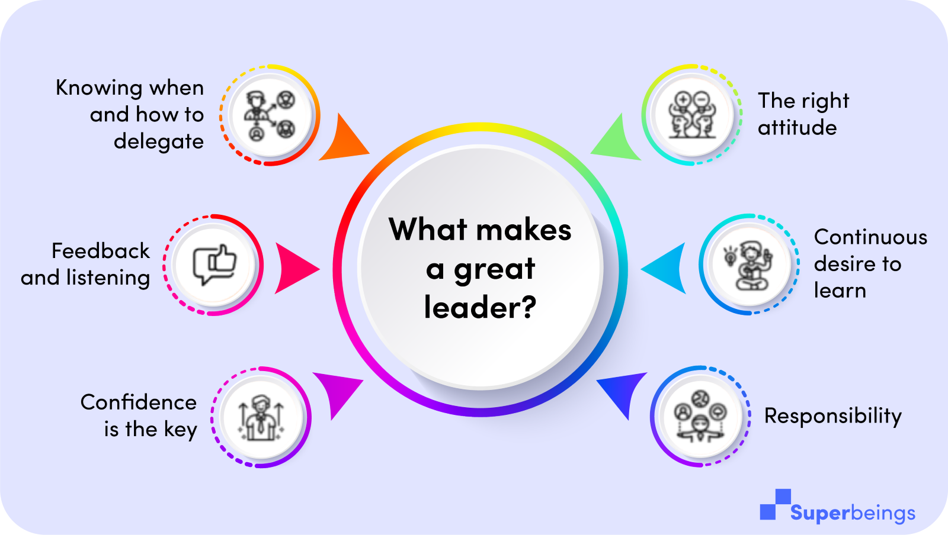

**3. Hybrid Collaboration Practices**

Collaboration in hybrid settings must be intentional. Structured processes and flexible workflows help teams work together effectively, no matter where they are located.

* Use shared documents and cloud-based project boards
* Establish common goals and timelines
* Assign roles clearly across locations
* Create synchronous and asynchronous collaboration options
* Organize hybrid brainstorming sessions
* Promote cross-functional interactions.

These practices ensure balanced participation and eliminate the feeling of being "left out" among remote workers

**4. Culture and Social Connection**

A connected workplace is not just about productivity—it’s also about belonging. In hybrid environments, maintaining organizational culture and providing social connection opportunities is essential.

* Organize virtual team-building activities and celebrations
* Encourage casual check-ins and “coffee chats.”
* Offer hybrid-friendly cultural programs
* Promote peer recognition programs
* Align everyone with the organization’s vision and values
* Create digital spaces for informal interaction (e.g., chat groups)

Fostering human connection beyond work builds morale, strengthens loyalty, and supports mental well-being.

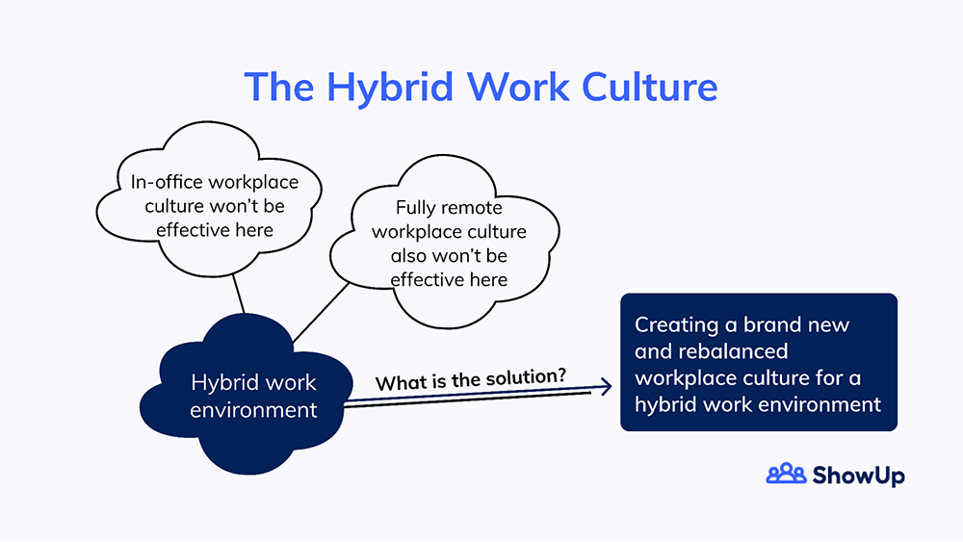

**BENEFITS OF CONNECTION IN HYBRID WORK CULTURE**

**1. Increased Employee Engagement**

When employees feel connected, whether they are working remotely or in the office, they are more likely to be engaged in their work. Regular communication and interaction foster a sense of belonging, leading to higher job satisfaction and productivity.

* Enhances motivation and commitment to work
* Reduces feelings of isolation and disengagement
* Strengthens team collaboration across different locations
* Boosts morale and job satisfaction

**2. Improved Communication and Collaboration**

Connection through digital tools and effective collaboration practices ensures clear communication. This reduces misunderstandings and enhances the sharing of ideas, leading to better decision-making and problem-solving.

* Ensures timely sharing of information
* Encourages effective problem-solving
* Promotes knowledge sharing and innovation
* Helps in maintaining alignment on projects and goals

**3. Better Work-Life Balance**

Maintaining a strong connection in a hybrid work culture helps employees manage their time more efficiently. With digital tools and supportive leadership, employees can achieve a healthy work-life balance while staying connected to their teams.

* Allows for flexible work schedules
* Reduces burnout through better mental health support
* Supports employees’ personal and professional well-being
* Provides an option for work-life integration

**4. Stronger Company Culture**

Building a sense of connection even in hybrid settings helps maintain a strong organizational culture. It ensures that employees, regardless of location, are aligned with company values, feel appreciated, and share common goals.

* Fosters inclusivity and belonging
* Promotes company values consistently
* Encourages peer recognition and support
* Strengthens team loyalty and retention

**5. Enhanced Innovation and Creativity**

Regular interaction, collaboration, and engagement among teams help in generating new ideas and innovative solutions. The blend of remote and on-site perspectives can lead to more diverse and creative approaches to problem-solving.

* Sparks innovation through diverse perspectives
* Encourages creative brainstorming sessions
* Enables cross-functional collaboration for holistic solutions
* Improves problem-solving efficiency with collective input

**CHALLENGES OF CONNECTION IN HYBRID WORK CULTURE**

**1. Communication Barriers**

While digital tools enable communication, they can’t fully replicate the nuances of face-to-face interaction. Remote workers may feel disconnected or overlooked, especially if not all communication is inclusive

* Misunderstandings due to a lack of non-verbal cues
* Remote workers feel excluded from informal conversations
* Over-reliance on written communication leads to misinterpretation
* Delays in response due to time zone differences

**2. Maintaining Team Cohesion**

In a hybrid model, it can be difficult to maintain a sense of unity and camaraderie among team members. Without in-person interactions, employees might feel like they belong to different teams, which can reduce collaboration.

* Lack of team bonding in remote environments
* Increased silo mentality among departments
* Difficulty in fostering trust and transparency remotely
* Unequal access to opportunities for remote workers

**3. Technology Limitations**

Digital tools and platforms are vital for hybrid work, but not all tools are designed to support effective collaboration. Poor technology can create barriers to seamless communication and reduce productivity.

* Dependence on unreliable or complex technology platforms
* Limited access to high-quality tools for some employees
* Difficulty in managing multiple digital tools for different purposes
* Technical issues that disrupt meetings or communication

**4. Leadership Challenges**

Leading hybrid teams requires more effort and understanding from leaders. Without regular face-to-face interactions, leaders may struggle to gauge employee engagement, provide timely feedback, or recognize emotional signals.

* Difficulty in building relationships with remote employees
* Challenges in ensuring consistent leadership presence across locations
* Increased workload for leaders in managing hybrid dynamics
* Risk of leadership disconnect from on-site or remote employees

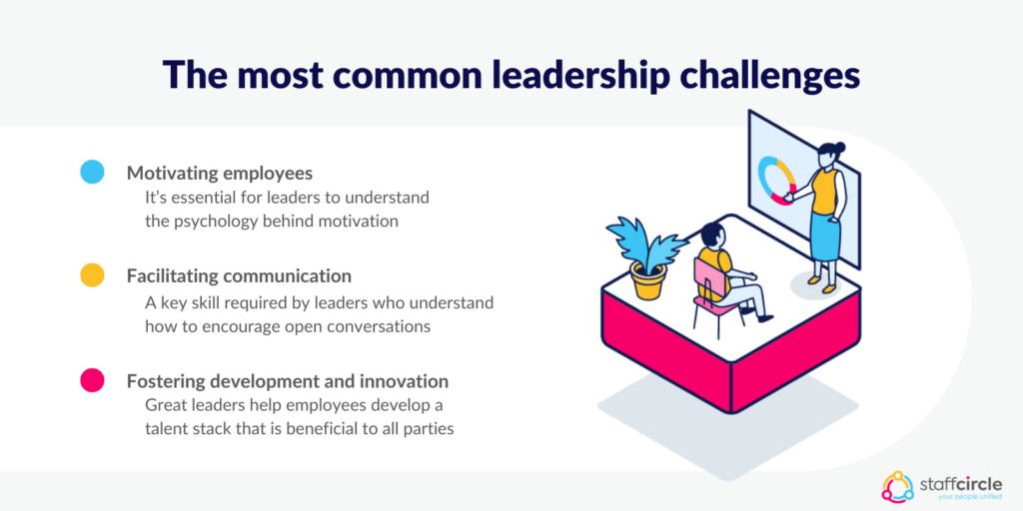

**CONCLUSION**

Hybrid work is not merely a trend but a strategic evolution in how modern organizations operate. It blends flexibility with responsibility, offering employees the freedom to choose their workspace while maintaining accountability. However, its success hinges on more than just logistics—it requires a conscious investment in connection, culture, and communication.

Connection serves as the backbone of hybrid work, keeping teams aligned, engaged, and emotionally grounded regardless of physical location. Organizations must go beyond just implementing tools; they must build systems that support regular, meaningful interactions. This includes both professional collaboration and informal social touchpoints that replicate the bonding that naturally occurs in physical offices.

Leadership plays a crucial role in this transformation. Leaders must actively cultivate trust, inclusivity, and psychological safety across all teams. From recognizing achievements to ensuring transparent communication, strong leadership bridges the gap between remote and on-site teams and builds a sense of belonging for all.

Ultimately, a connected hybrid culture doesn’t just improve productivity—it nurtures loyalty, supports mental well-being, and creates a workplace where people feel seen and valued. By placing human connection at the heart of their hybrid strategies, companies can future-proof their operations and create thriving, resilient workforces for years to come.

**REFERENCE**

[1] Microsoft Work Trend Index Report (2023)

[2] Harvard Business Review: “Reinventing the Workplace for a Hybrid Future” (2022)

[3] McKinsey & Company: “The Future of Work After COVID-19” (2021)

[4] Forbes: “How to Build Culture in a Hybrid Team” (2022)

[5] Deloitte Insights: “Navigating the Future of Hybrid Work” (2023)

[6] Gallup: "The Advantages and Challenges of Hybrid Work." (2022)

[7] PwC: "Future of Work: What Employers Need to Know About Hybrid Work Models." (2021)

[8] Buffer: "State of Remote Work." (2023)

[9] CIPD (Chartered Institute of Personnel and Development): "Embedding Hybrid Working." (2022)

[10] MIT Sloan Management Review: "Why Remote Work Makes Teamwork Harder." (2021)