**FROM RETENTION TO BELONGING: RETHINKING EMPLOYEE ENGAGEMENT STRATEGIES**

**SUVALAKSHMI.V, DR.N.PADMAVATHY**

1. MBA student, School of Arts, Humanities and Management, Jeppiaar University, Chennai, India.
2. Associate Professor, School of Arts Humanities and Management, Jeppiaar University, Chennai, India

**ABSTRACT**

Employee engagement has traditionally been measured through retention rates and job satisfaction, but these metrics often fail to capture the deeper emotional and psychological needs of employees. In today’s evolving workplace, fostering a sense of belonging—where employees feel valued, included, and connected—has emerged as a critical driver of long-term engagement and organizational success. This article explores the shift from retention-focused strategies to belonging-centric approaches, highlighting the limitations of conventional methods and the transformative potential of creating inclusive, purpose-driven workplaces.

Belonging goes beyond superficial perks and addresses fundamental human needs for acceptance and meaningful contribution. Research shows that employees who experience belonging are more productive, innovative, and loyal, directly impacting organizational performance. By leveraging data-driven insights, inclusive leadership, and targeted cultural initiatives, companies can cultivate environments where employees thrive. This paper examines key strategies such as sentiment analysis, bias mitigation, and community-building programs that enhance belonging while addressing challenges like privacy concerns and scalability.

The transition from retention to belonging requires a rethinking of traditional HR practices. Case studies from industry leaders like Salesforce and Microsoft demonstrate how intentional efforts—such as inclusivity training, transparent communication, and mentorship programs—can foster a culture of belonging. These examples underscore the importance of leadership commitment and continuous feedback loops in sustaining engagement. Additionally, the article discusses the ethical considerations of using employee data to measure belonging, emphasizing the need for transparency and consent.

Despite its benefits, implementing belonging-focused strategies presents challenges, including resistance to change and the difficulty of quantifying intangible outcomes. Organizations must balance data analytics with human-centric approaches, ensuring that technology enhances rather than replaces genuine connection. Practical recommendations include piloting small-scale initiatives, training managers in empathetic leadership, and integrating belonging metrics into performance evaluations.

**Keywords:** Employee engagement, belonging, retention, inclusivity, organizational culture, data-driven strategies.

**INTRODUCTION**

Employee engagement has long been a cornerstone of organizational success, traditionally measured through retention rates, job satisfaction surveys, and productivity metrics. While these indicators provide a snapshot of employee stability, they often fail to capture the deeper emotional and psychological connections that drive true commitment and performance. In today’s rapidly evolving workplace, where remote work, diversity, and generational shifts are redefining norms, organizations must move beyond mere retention and focus on fostering a sense of belonging. This shift is not just a moral imperative but a strategic one, as research consistently shows that employees who feel they belong are more innovative, collaborative, and loyal.

The concept of belonging goes beyond superficial perks or policy compliance; it is about creating an environment where employees feel valued, heard, and empowered to bring their authentic selves to work. Studies reveal that when employees experience belonging, they are more likely to go above and beyond their job descriptions, contribute innovative ideas, and advocate for their organizations.

Conversely, a lack of belonging can lead to disengagement, quiet quitting, and high turnover—issues that no amount of retention strategies can fully address. This paradigm shift calls for a reevaluation of traditional engagement tactics, emphasizing cultural and emotional alignment over transactional benefits.

Several factors are driving this transformation, including the rise of remote and hybrid work models, which challenge traditional notions of workplace connection. Additionally, younger generations, such as Millennials and Gen Z, prioritize purpose, inclusivity, and psychological safety in their careers, demanding more from employers than just financial stability. Organizations that fail to adapt risk losing top talent to competitors who understand the value of belonging. By integrating data-driven insights, inclusive leadership practices, and intentional community-building initiatives, companies can create workplaces where employees don’t just stay—they thrive.

This article explores the critical transition from retention-focused strategies to belonging-centric approaches, examining the tools, metrics, and cultural shifts required to make this change. From leveraging predictive analytics to identify at-risk employees to designing inclusive leadership training programs, the strategies discussed here offer a roadmap for organizations aiming to build resilient, engaged, and high-performing teams. The ultimate goal is to redefine employee engagement as a holistic experience that nurtures both individual fulfillment and organizational success.

**THE LIMITATIONS OF TRADITIONAL RETENTION STRATEGIES**

Traditional employee retention strategies have long focused on quantitative metrics like turnover rates, tenure, and satisfaction surveys. While these approaches provide measurable data, they often fail to address the deeper, more nuanced aspects of employee engagement. Below are the key limitations of conventional retention strategies:

**1. Overemphasis on Surface-Level Metrics**

Many organizations rely heavily on retention rates and annual engagement surveys to gauge employee satisfaction. However, these metrics can be misleading because:

* **Lagging Indicators:** Retention rates only show outcomes (e.g., who left) rather than predicting or preventing disengagement.
* **Survey Fatigue:** Employees may disengage from frequent surveys, leading to inaccurate or rushed responses.
* **Lack of Context:** High retention doesn’t always mean high engagement—employees may stay due to convenience (e.g., job market conditions) rather than loyalty.

**Example:** A company with a 90% retention rate may still have a disengaged workforce if employees stay solely for financial stability but lack motivation or connection to the organization’s mission.

**2. One-Size-Fits-All Approaches**

Traditional retention tactics often rely on generic perks and incentives, such as:

* **Monetary Rewards:** Bonuses and raises may boost short-term morale but don’t address long-term engagement drivers like career growth or meaningful work.
* **Standardized Benefits:** Free snacks, gym memberships, or flexible hours are appreciated but don’t necessarily foster a sense of belonging or individual recognition.
* **Lack of Personalization:** Employees have diverse needs—what motivates one person (e.g., public recognition) may overwhelm another (e.g., introverts who prefer quiet acknowledgment).

**Example:** A tech firm offering unlimited PTO (Paid Time Off) might assume it’s addressing burnout, but if employees fear stigma for taking time off, the policy becomes ineffective.

**3. Ignoring Psychological Safety and Inclusion**

Retention strategies often overlook the importance of psychological safety—the belief that employees can speak up, take risks, and be themselves without fear of punishment or humiliation. Key gaps include:

* **Fear-Based Cultures:** Employees stay silent about issues (e.g., discrimination, inefficiencies) to avoid retaliation, leading to passive disengagement.
* **Lack of Inclusive Practices:** Homogeneous leadership teams or exclusionary social dynamics can make underrepresented employees feel like outsiders, even if they remain with the company.
* **Tokenism:** Diversity hires who aren’t given meaningful roles or voice may leave despite "diversity initiatives."

**Example:** A study by Google found that teams with high psychological safety outperformed others by 25% because members felt safe to contribute ideas without judgment.

**4. Short-Term Fixes Over Long-Term Culture Building**

Many retention strategies prioritize quick wins over systemic change:

* **Exit Interviews as Afterthoughts:** Conducting exit interviews too late (or not acting on feedback) misses opportunities to address root causes of turnover.
* **Reactive vs. Proactive Measures:** Offering counteroffers to resigning employees is a band-aid solution rather than addressing why they considered leaving in the first place.
* **Neglecting Middle Managers:** 70% of engagement variance stems from managers (Gallup), yet many retention programs focus on organizational perks rather than leadership training.

**Example:** A sales team with high turnover might invest in retention bonuses instead of fixing toxic management practices driving attrition.

**5. Failure to Measure Qualitative Factors**

Traditional metrics often ignore intangible elements critical to engagement:

* **Emotional Connection:** Employees may stay for a beloved team or mission, even if pay is below market.
* **Sense of Purpose:** A Deloitte study found that 73% of employees who feel their work has meaning are more engaged, yet few companies track this.
* **Belonging:** Feelings of isolation or exclusion (e.g., remote workers, minority groups) aren’t captured in turnover stats.

**Example:** A remote employee may log in daily (high retention) but feel disconnected due to lack of virtual community-building efforts.

**MOVING BEYOND RETENTION: THE PATH TO BELONGING**

To overcome these limitations, organizations must shift from retention-centric tactics to strategies that foster belonging:

* **Replace annual surveys** with continuous listening tools (e.g., pulse surveys, AI-driven sentiment analysis).
* **Personalize engagement** by tailoring recognition, career paths, and benefits to individual needs.
* **Train leaders** to build psychological safety and inclusive team cultures.
* **Measure belonging** through qualitative feedback (e.g., storytelling, focus groups) alongside quantitative data.

By addressing these gaps, companies can create environments where employees don’t just stay—they thrive.

**Key Takeaway:** Retention is the floor; belonging is the ceiling. Organizations that prioritize the latter will outperform those stuck in outdated retention paradigms.

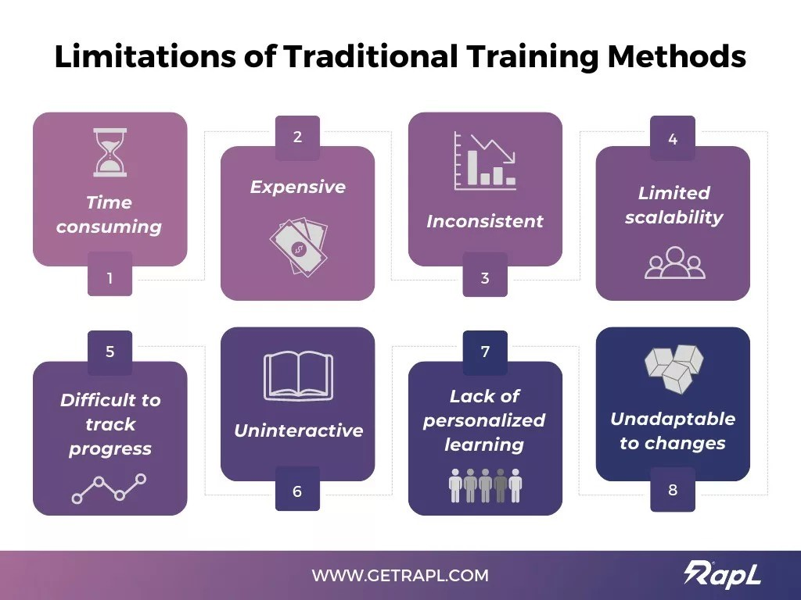

**THE POWER OF BELONGING**

part of a team or organization. Unlike traditional retention strategies that focus on keeping employees through extrinsic rewards (e.g., salaries, benefits), belonging taps into intrinsic human needs—connection, purpose, and identity. Research shows that when employees feel they belong, they are more engaged, innovative, and committed to their organization’s success.

**Why Belonging Matters**

1. **Boosts Employee Engagement**

* Employees who feel a sense of belonging are 3.5 times more likely to be engaged at work (Harvard Business Review).
* Engagement translates to higher productivity, better customer service, and lower absenteeism.

1. **Enhances Retention & Reduces Turnover**

* A study by BetterUp found that employees with a strong sense of belonging are 50% less likely to leave their jobs.
* High belonging correlates with lower burnout and higher job satisfaction.

1. **Drives Innovation & Collaboration**

* Diverse teams with high belonging outperform others by 30% in innovation (McKinsey).
* Psychological safety (a key component of belonging) encourages risk-taking and idea-sharing.

1. **Improves Organizational Performance**

* Companies with inclusive cultures (where belonging thrives) are 1.7 times more likely to be market leaders (Deloitte).
* Employees who belong are more likely to advocate for their company, improving employer branding.

**Key Drivers of Belonging**

1. **Inclusive Leadership**

* Leaders set the tone by modeling inclusive behaviors—actively listening, acknowledging biases, and fostering open dialogue.
* Example: Microsoft’s "Model, Coach, Care" framework trains managers to create psychologically safe environments.

1. **Authentic Recognition & Feedback**

* Employees need personalized, meaningful recognition—not just generic praise
* Tools like 15Five or Bonusly help managers give real-time, specific feedback.

1. **Community & Connection**

* Employee Resource Groups (ERGs), mentorship programs, and team rituals (e.g., virtual coffee chats) strengthen bonds.
* Example: Google’s "gPause" program promotes mindfulness and connection among employees.

1. **Transparent & Empathetic Communication**

* Regular check-ins (not just annual surveys) and open forums where employees voice concerns without fear.
* Example: Salesforce’s "Ohana Culture" emphasizes open dialogue and mutual respect.

1. **Equitable Opportunities**

* Fair access to promotions, projects, and learning opportunities ensures employees feel valued.
* Pay equity audits (like Adobe’s) reinforce fairness.

**Measuring Belonging**

Belonging is qualitative but can be assessed through:

* **Surveys:** Questions like, "Do you feel your unique background is valued here?"
* **Sentiment Analysis:** AI tools (e.g., IBM Watson) analyze employee feedback for emotional tone.
* **Behavioural Metrics:** Participation in ERGs, mentorship uptake, and retention rates among diverse groups.

**Challenges in Fostering Belonging**

1. **Overcoming Unconscious Bias**

* Even well-intentioned policies can exclude marginalized groups. Regular bias training is crucial.

1. **Remote & Hybrid Work Barriers**

* **Virtual employees may feel isolated. Solutions:**
* Virtual "watercooler" chats (e.g., Slack channels for hobbies).
* Inclusive meeting practices (e.g., rotating speaking turns).

1. **Scaling Personalization**

* Large organizations struggle to tailor experiences. Technology (e.g., AI-driven engagement platforms) can help.

**Case Study: Airbnb’s "Belong Anywhere" Approach**

* **Inclusion Labs:** Employee-led workshops on diversity and belonging.
* **Unconscious Bias Training:** Mandatory for all hiring managers.
* **Belonging Metrics:** Tracked via surveys and tied to leadership bonuses.
* **Result:** 90% of employees reported feeling a strong sense of belonging, contributing to higher innovation and retention.

**Actionable Steps for Organizations**

1. **Start with Listening:** Conduct anonymous pulse surveys to gauge belonging.
2. **Train Leaders:** Equip managers with skills to foster inclusivity.
3. **Celebrate Differences:** Highlight diverse employee stories in internal communications.
4. **Iterate & Improve:** Use data to refine strategies continuously.

**DATA-DRIVEN STRATEGIES FOR BELONGING**

In today’s workplaces, fostering a sense of belonging requires more than intuition—it demands evidence-based strategies. Data-driven approaches enable organizations to measure, analyze, and enhance belonging systematically. Below are key methodologies, tools, and actionable steps to integrate data into belonging initiatives:

**1. Measuring Belonging: Key Metrics**

To improve belonging, organizations must first quantify it. Relevant metrics include:

* **eNPS (Employee Net Promoter Score):** “How likely are you to recommend this workplace to a friend?” (Indicates emotional connection.)
* **Belonging-Specific Survey Questions:**
* “I feel my unique background is valued here.” (5-point scale)
* “My voice is heard in team decisions.”
* “I have meaningful relationships with colleagues.”
* **Participation Rates:** Engagement in ERGs (Employee Resource Groups), mentorship programs, or DEI (Diversity, Equity, Inclusion) events.
* **Turnover by Demographic:** Analyze attrition rates among underrepresented groups to identify belonging gaps.

**Tool Example:** Platforms like Culture Amp or Qualtrics customize surveys and track trends over time.

**2. Predictive Analytics for Early Intervention**

**Approach:**

* Correlate belonging metrics with performance/retention data to predict at-risk employees.
* Example: Employees who skip ERG events for 3+ months are 40% more likely to leave within a year.

**Actionable Steps:**

* **Identify Patterns:** Use historical data to model risk factors (e.g., lack of 1:1s with managers).
* **Trigger Alerts:** HR systems flag employees showing disengagement signals for timely check-ins.
* **Personalize Outreach:** Offer tailored resources (e.g., mentorship, flexible work options).

**Tool Example:** Workday People Analytics or Visier for predictive modeling.

**3. Network Analysis for Inclusion**

**Concept:**

* Map employee interactions using email/chat metadata to assess inclusion.

**Measure:**

* **Centrality:** Are certain groups (e.g., women, remote workers) excluded from key communication networks?
* **Cross-Team Collaboration:** Silos reduce belonging; diverse interactions strengthen it.
* **Intervention:** If data shows underrepresented employees are periphery nodes, launch cross-functional projects or “coffee chat” algorithms (e.g., Donut for Slack).
* **Tool Example:** Sociometric Solutions or Cognito by Humanyze.

**6. Real-Time Feedback Loops**

**Strategy:** Replace annual surveys with pulse checks (e.g., weekly 1-question polls via TINYpulse or Glint).

**Benefits:**

* Rapid response to belonging crises (e.g., post-merger integration).
* Track impact of initiatives (e.g., “After launching ERGs, belonging scores rose 15%”).

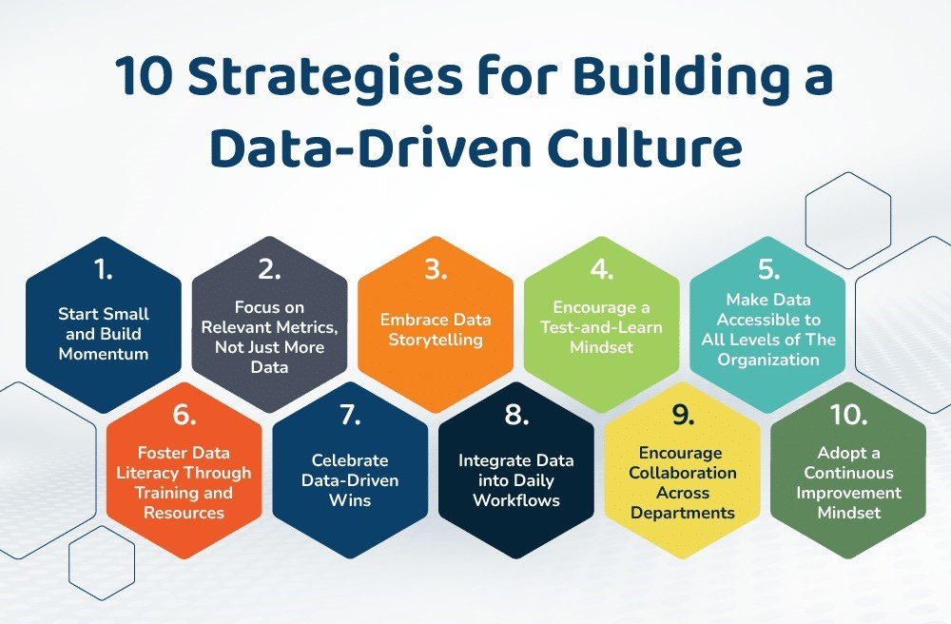

**CHALLENGES AND ETHICAL CONSIDERATIONS**

1. **Privacy Concerns:** Balancing data collection with employee consent and anonymity.
2. **Measuring Intangibles:** Belonging is subjective; qualitative methods (e.g., storytelling, focus groups) complement quantitative data.
3. **Scalability:** Tailoring strategies to global teams while maintaining cultural relevance.

**CASE STUDY: TECH INDUSTRY INNOVATORS**

Companies like Salesforce and Microsoft have pioneered belonging-centric strategies

* **Salesforce:** "Ohana Culture" emphasizes family-like support, with mandatory inclusivity training and pay equity audits.
* **Microsoft:** "Model, Coach, Care" framework trains managers to foster psychological safety and growth.

**RECOMMENDATIONS**

1. **Start Small:** Pilot belonging initiatives (e.g., monthly "listening circles") before scaling.
2. **Train Leaders:** Equip managers with skills to cultivate inclusivity and empathy.
3. **Leverage Technology:** Use platforms like LinkedIn Glint or Culture Amp to track belonging metrics.
4. **Celebrate Progress:** Share success stories to reinforce commitment

**CONCLUSION**

The shift from retention-focused strategies to fostering a deep sense of belonging represents a transformative approach to employee engagement. By prioritizing belonging, organizations can cultivate environments where employees feel genuinely valued, connected, and empowered. This not only enhances individual well-being but also drives collective success, fueling innovation, resilience, and long-term loyalty. The integration of data-driven strategies—such as sentiment analysis, predictive modeling, and bias audits—provides a roadmap to measure and achieve these outcomes systematically.

However, the journey toward belonging is not without challenges. Organizations must navigate ethical considerations, such as data privacy and algorithmic bias, while ensuring that quantitative insights are balanced with qualitative human experiences. Tools and metrics are invaluable, but they must be paired with empathetic leadership and inclusive practices to create meaningful change. The goal is not merely to collect data but to translate it into actionable strategies that resonate with employees on a personal level.

Case studies from industry leaders demonstrate that belonging-centric cultures are not only possible but also profitable. Companies like Salesforce and Microsoft have shown that intentional efforts—such as inclusivity training, transparent communication, and community-building initiatives—yield measurable improvements in engagement and performance. These examples underscore the importance of commitment at all organizational levels, from leadership to frontline managers, in sustaining a culture of belonging.

Ultimately, the future of work hinges on creating environments where employees thrive because they feel they truly belong. By leveraging data to inform decisions, addressing systemic inequities, and fostering authentic connections, organizations can move beyond retention metrics to build workplaces where every individual can contribute their best. The path forward requires both technological sophistication and human compassion, proving that the most successful workplaces are those where data and empathy go hand in hand.

**REFERENCE**

[1] Edmondson, A. C. (2018). The fearless organization: Creating psychological safety in the workplace for learning, innovation, and growth. Wiley.

[2] Brown, B. (2018). Dare to lead: Brave work. tough conversations. whole hearts. Random House.

[3] Gallup. (2021). Employee engagement 3.0: The evolution of workplace dynamics and performance. Gallup Press.

[4] Gartner. (2023). People analytics in the era of belonging: Measuring what matters in the human workplace. Gartner Research.

[5] McKinsey & Company. (2020). Diversity wins: How inclusion matters [Report].

[6] Harvard Business Review. (2020). The value of belonging at work.

[7] Deloitte Insights. (2021). Inclusive leadership analytics: Measuring the intangible drivers of performance.