LIBRARY MANAGEMENT SYSTEM

**Charushila Patil1, Adan Shaikh2, Murtuza Shaikh3**

1Assistant Professor, Artificial Intelligence & Data Science, Guru Gobind Singh College of Engineering & Research Center, Nashik, Maharashtra, India

2,3,Student, Artificial Intelligence & Data Science,Guru Gobind Singh College of Engineering & Research Center, Nashik, Maharashtra, India

**ABSTRACT**

The Library Management System is a software application designed to automate and streamline the operations of a library. It provides a comprehensive solution for managing books, users, and library transactions efficiently. The system enables users to register, log in, search for books, borrow and return books, and view their transaction history. Librarians and administrators can add new books, update book details, manage user accounts, and monitor issued and returned books.

The system is developed using Python with a MySQL database for backend data storage, ensuring data integrity and quick access. A user-friendly graphical interface enhances usability, making the system accessible even to users with minimal technical knowledge.

Keywords: Authentication, Book Management, Database, Library System

1. **INTRODUCTION**

Libraries play a vital role in the educational and cultural development of any community. They serve as a repository of knowledge and offer a structured way to store, manage, and disseminate information. Traditionally, library operations such as book issuance, returns, and record-keeping were handled manually, leading to errors, inefficiencies, and significant time consumption.

The objective of this project is to develop a user-friendly, reliable, and secure Library Management System using Python and MySQL. This system will allow users to register, search for books, borrow or return them, and manage their accounts conveniently. Librarians will benefit from simplified book management and automated tracking, enhancing overall operational efficiency.

In recent years, the need for digital transformation in libraries has grown exponentially. With the increasing volume of books and users, manual systems have proven to be inadequate for maintaining accurate records, handling user queries efficiently, or scaling up to meet modern demands. As a solution, a computerized Library Management System (LMS) is not only a necessity but also a cornerstone for creating a smarter academic environment.

This project aims to bridge that gap by providing an interactive and dynamic Library Management System built with Python for the front-end and logic layer, and MySQL as the back-end database. The system leverages PyMySQL for database connectivity, ensuring seamless integration between the application and the database. The GUI is developed using Tkinter, Python’s standard GUI toolkit, making it accessible even to users with minimal technical expertise.

Building upon this foundation, the system incorporates role-based access to differentiate functionalities available to users and librarians. Librarians can add new books, update book details, manage user records, and monitor transactions in real time, while general users are allowed to search the library catalog, borrow and return books, and view their borrowing history. This division of privileges ensures operational control while maintaining ease of access for all users. The system also includes validation checks and user feedback mechanisms to reduce input errors and guide users through various processes effectively.

One of the notable features of the system is its real-time synchronization with the MySQL database, which ensures that all records—such as issued books, returned books, and newly added inventory—are immediately updated and reflected in the system. This eliminates redundancy and ensures consistency across the platform. Moreover, the system can be deployed over a local network, allowing multiple terminals to access the library data simultaneously.

1. **METHODOLOGY**
2. *Review Stage*

In the review stage, the Library Management System was subjected to internal evaluation and verification processes. The initial version of the project was tested for basic functionalities such as user registration, login authentication, book addition, issuance, and return operations. Bugs identified during unit testing and integration testing were documented.

The testing phase played a crucial role in ensuring the reliability, accuracy, and stability of the Library Management System. After completing the initial development cycle, the system underwent a comprehensive internal review that included unit testing, integration testing, and user acceptance testing (UAT).

1. *Final Stage*

The final version was organized into a two-column format for documentation, including relevant figures and tables to illustrate system architecture and database design. All components — user interface, backend logic, and database interactions — were thoroughly validated for consistency . The project was then submitted for evaluation, complete with proper documentation, screenshots, ER diagrams, and sample outputs to demonstrate the functionalities.

The final version of the Library Management System was systematically documented and formatted to ensure clarity, professionalism, and ease of understanding for evaluators and future developers. The project documentation was structured in a two-column format, aligning with academic and institutional standards, and included a comprehensive collection of visuals and structured data representations.

1. *Figures and Tables*

|  |  |  |
| --- | --- | --- |
| Figure No. | Figure Title | Description |
| Fig. 1 | GUI Screenshot - Home Page | Display of the login/registration interface developed using Tkinter. |

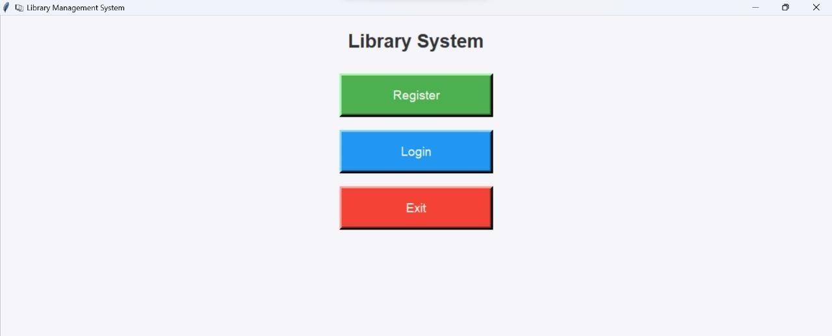

|  |  |  |
| --- | --- | --- |
| Figure No. | Figure Title | Description |
| Fig. 2 | GUI Screenshot - Book Management | Interface to add, update, delete books. |

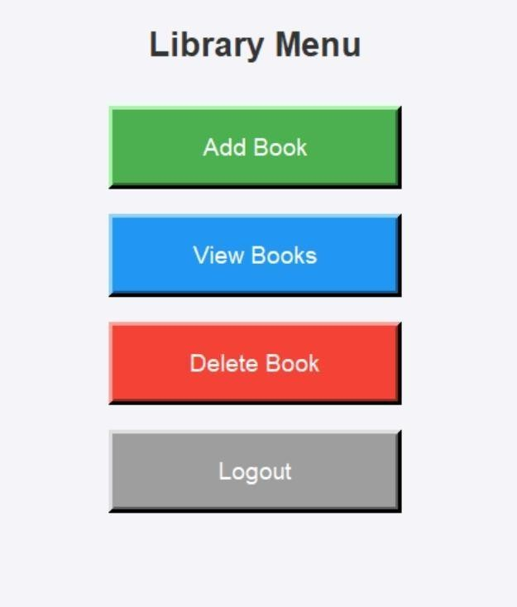

|  |  |  |
| --- | --- | --- |
| Figure No. | Figure Title | Description |
| Fig. 3 | System Architecture Diagram | Shows the three layers: Presentation |

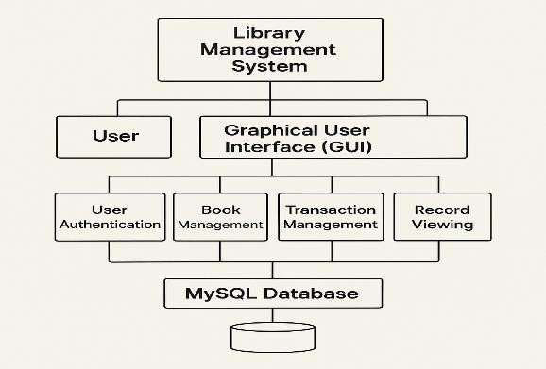

1. **Acknowledgment**

Department of Artificial Intelligence and Data Science, [Your College/University Name], for their valuable guidance, support, and encouragement throughout the development of this project. We also thank our peers and reviewers for their insightful feedback, which helped improve the quality and functionality of the Library Management System.

1. **REFERENCES**
2. Python Software Foundation, Python 3 Documentation. [Online]. Available: <https://docs.python.org/3/>
3. TkDocs, Tkinter GUI Programming. [Online]. Available: <https://tkdocs.com/>
4. Stack Overflow, Community Forums for Developers. [Online]. Available: <https://stackoverflow.com/>
5. GitHub, Code Repositories and Educational Content on Library Management Systems. [Online]. Available:https://github.