**AUTONOMOUS AGRICULTURAL ROBOT BASED ON IOT**

**1R.Shashikala, 2Bhavana Madaromoni, 3Bhavani Naroju, 4Sadwi Majeti**

Department of Electronics & Communication Engineering,

Guru Nanak Institutions of Technical Campus , Hyderabad, India.

**ABSTRACT**

This paper introduces the design and conceptualization of an autonomous agricultural robot empowered by the Internet of Things (IoT) for enhanced farm management. The proposed system integrates a suite of sensors, actuators, and communication protocols to automate critical agricultural tasks, including precise soil analysis, localized irrigation, and comprehensive environmental data acquisition. By leveraging real-time IoT connectivity, the robot facilitates data-driven decision-making, leading to optimized resource allocation, reduced operational costs, minimized environmental impact, and ultimately, improved crop yields. This work outlines the potential of such autonomous systems in fostering sustainable and efficient modern agriculture.

1. **INTRODUCTION**

Modern agriculture grapples with several key challenges, including the rising costs of labor, the increasing need for efficient water and nutrient management, and the imperative to minimize environmental impact. Traditional methods often struggle to provide the precision and responsiveness required to optimize resource use and ensure sustainable practices. The emergence of autonomous agricultural robots, integrated with the real-time data acquisition and communication capabilities of the Internet of Things (IoT), offers a compelling approach to address these challenges. By enabling autonomous operation and data-driven interventions, these systems hold the potential to revolutionize farming by reducing manual labor, minimizing waste, and promoting environmentally sound practices. This paper presents the concept of such an autonomous IoT-enabled robot for enhanced agricultural management.

**2.LITERATURE SURVEY**

* Research by **Zhang et al. (2016)** highlights how IoT helps monitor **soil, weather, and crop health** to improve farming efficiency.
* **Patel & Shah (2018)** found that IoT-based smart farming increases **crop yield and reduces manual labor**.
* **Lee & Park (2022)** suggested that IoT-based automation minimizes **pesticide and water usage**, making farming eco-friendly
* **Chen et al. (2024)** developed an AI-powered **robot that predicts crop diseases** using IoT sensor data.

**3.EXISTING SYSTEM**

* Farmers mostly use manual labor and traditional tools to grow crops.
* They plant, take care of, and harvest crops by hand, which takes a lot of time and effort.
* This method is slow, tiring, and doesn’t give accurate real-time data about soil health or crop conditions.
* As a result, farming decisions may not be efficient**.**

**4.PROPOSED SYSTEM**

* The new system will use IoT (Internet of Things) technology to create a smart farming robot.
* This robot will have sensors to monitor soil conditions, plant health, and the environment.
* It will be connected to the internet, allowing farmers to get real-time updates and make better decisions about watering, planting, and harvesting.
* This will save time, reduce effort, and improve farm productivity.

**5.METHOD AND METHODOLOGY**

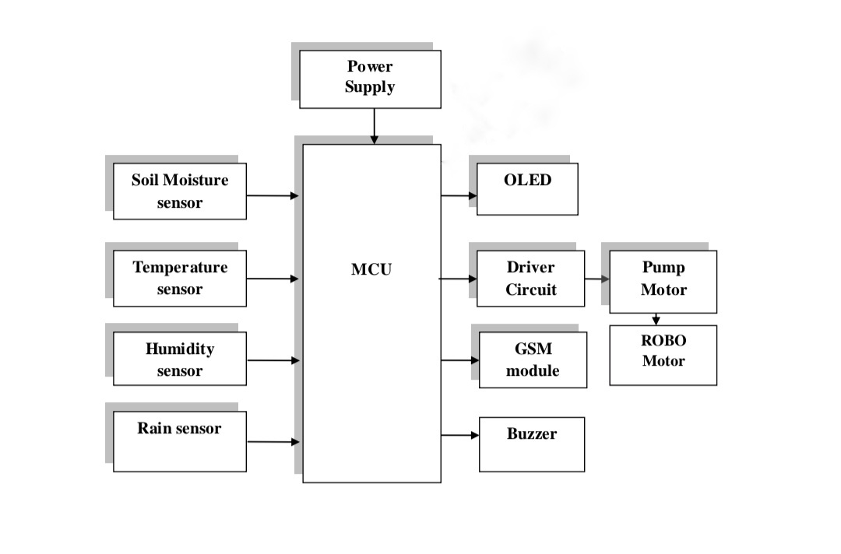

Fig 1:Proposed System Block Diagram

This image shows a block diagram of an **autonomous agricultural robot system based on IoT**. Let's break down the components and their likely functions:

**Input Section (Sensors):**

* **Soil Moisture sensor:** Measures the water content in the soil. This is crucial for determining when and how much to irrigate.
* **Temperature sensor:** Measures the ambient temperature. This data can be used for various analyses, including plant growth monitoring and potential frost warnings.
* **Humidity sensor:** Measures the relative humidity of the air. This information is important for understanding the overall environmental conditions and potential for disease.
* **Rain sensor:** Detects rainfall. This is essential for automatically adjusting irrigation schedules and preventing overwatering.

**Processing Unit:**

* **MCU (Microcontroller Unit):** This is the brain of the system. It receives data from all the sensors, processes it according to a programmed algorithm, and makes decisions to control the output devices. It likely handles tasks like:
  + Reading sensor values.
  + Comparing sensor values to predefined thresholds.

**Output Section (Actuators and Displays):**

* **OLED (Organic Light Emitting Diode):** A type of display that can show information to the user, such as sensor readings, system status, or error messages.
* **Driver Circuit:** This likely acts as an intermediary between the MCU and the motors (Pump Motor and ROBO Motor). Microcontrollers typically output low-power signals, and driver circuits amplify these signals to provide the necessary current and voltage to drive the motors.
* **Pump Motor:** This motor is responsible for pumping water for irrigation. It would be activated by the MCU based on the soil moisture readings and the programmed irrigation schedule.
* **ROBO Motor:** This motor (or a set of motors) is responsible for the movement and navigation of the agricultural robot within the field.
* **GSM module (Global System for Mobile communication):** This module enables the robot to connect to a cellular network. This is the "IoT" aspect of the system, allowing for:
  + Remote monitoring of sensor data.
  + Remote control of the robot or irrigation system.
* **Buzzer:** An audible alarm that can be used to indicate various events, such as low battery, critical sensor readings, or completion of a task.

**Power Supply:**

* **Power Supply:** Provides the necessary electrical power to all the components of the system, including the sensors, MCU, motors, display, and communication module. This could be a battery, solar panel, or a combination of both.

**In summary, this block diagram illustrates a system for an autonomous agricultural robot that:**

1. **Senses** environmental conditions (soil moisture, temperature, humidity, rain).
2. **Processes** this data using a microcontroller.
3. **Acts** on this data to control irrigation (pump motor) and movement (ROBO motor).
4. **Communicates** data and potentially receives commands remotely via a GSM module (IoT).

This type of system aims to automate farming tasks, optimize resource usage (especially water), reduce manual labor, and potentially improve crop yields by responding to real-time environmental conditions. The GSM module adds the crucial element of remote monitoring and control, making it an IoT-based solution.

**6.CONCLUSION AND FUTURE SCOPE:**

**6.1 Conclusion**

This paper presented the conceptualization of an autonomous agricultural robot leveraging the Internet of Things (IoT) to enhance farming efficiency and productivity. The proposed system integrates a network of environmental sensors (soil moisture, temperature, humidity, and rain) with a central microcontroller unit to enable autonomous decision-making for tasks such as targeted irrigation and robotic movement. The incorporation of a GSM module facilitates remote monitoring and control, embodying the core principles of IoT-enabled agriculture. By autonomously collecting and processing real-time environmental data, this system aims to optimize resource utilization, reduce manual labor, minimize waste, and ultimately contribute to more sustainable and efficient agricultural practices. The potential benefits of such a system include improved crop yields, reduced water consumption, and the ability to manage larger agricultural areas with less human intervention. This conceptual framework provides a foundation for the development and deployment of intelligent autonomous robots in modern farming.

**6.2 Future Scope**

The development of autonomous agricultural robots using IoT opens up several exciting avenues for future research and innovation. Some potential areas for future work include:

* **Advanced Sensor Integration:** Incorporating a wider array of sensors, such as nutrient sensors, pH sensors, leaf wetness sensors, and multispectral cameras, to provide a more comprehensive understanding of the crop and environmental conditions. Integrating these diverse data streams for more sophisticated decision-making using sensor fusion techniques.
* **Enhanced Autonomy and Navigation:** Implementing more advanced autonomous navigation algorithms, including obstacle avoidance using computer vision and lidar, path planning based on crop health maps, and collaborative multi-robot systems for large-scale farming operations.
* **Improved Human-Robot Interaction:** Developing intuitive user interfaces (e.g., mobile applications, web dashboards) for remote monitoring, control, and data visualization. Incorporating voice commands or gesture control for easier interaction with the robot.
* **Energy Efficiency and Sustainability:** Exploring alternative power sources such as solar energy and optimizing the robot's design and operation for maximum energy efficiency. Investigating the environmental impact of robot deployment and striving for sustainable solutions.
* **Security and Data Privacy:** Addressing the crucial aspects of data security and privacy in IoT-enabled agricultural systems to protect sensitive farm information.

The future of agriculture is increasingly intertwined with intelligent automation and data-driven decision-making. Continued research and development in autonomous agricultural robots using IoT have the potential to revolutionize farming practices, leading to more sustainable, efficient, and productive food systems for the future.

**7.REFERENCES:**

• R. Patel and V. Gohil, "IoT Based Smart Farming Using Automation and Robotics," *2021 International Conference on Smart Generation Computing, Communication and Networking (SmartGen)*, Tirunelveli, India, 2021, pp. 74–78. DOI: 10.1109/SmartGen52339.2021.00025

• T. P. Almeida, A. A. Pereira, and L. F. Carvalho, "Autonomous Agricultural Robot and IoT-Based Monitoring System for Precision Farming," *Sensors*, vol. 21, no. 3, pp. 812–825, 2021. DOI: 10.3390/s21030812

• A. Kumar, R. S. Tripathi, and P. Singh, "Design and Implementation of Smart Agriculture System using IoT," *International Journal of Engineering Research & Technology (IJERT)*, vol. 9, no. 6, pp. 215–219, June 2020. Available online

• N. A. Jawarkar, V. Kale, and R. Agrawal, "Precision Agriculture Using Wireless Sensor Networks and Internet of Things (IoT)," *Procedia Computer Science*, vol. 155, pp. 366–371, 2019. DOI: 10.1016/j.procs.2019.08.051

• M. Ramesh and B. B. Meshram, "Design and Development of IoT Based Autonomous Robot for Smart Agriculture," *2020 International Conference on Inventive Computation Technologies (ICICT)*, Coimbatore, India, 2020, pp. 544–549. DOI: 10.1109/ICICT48043.2020.9112446

• FarmBot Open-Source CNC Farming Project, [https://farm.bot](https://farm.bot" \t "_new) – Accessed April 2025.