Smart Farming: An Integrated Approach Using IoT and AI

Ganesh Chate,Hitesh Bhosale,Sairaj Bhagat,Sucheta Chaudhari Dept of Computer Engineering

AISSMS Institute of Technology [bhosalehitesh4552@gmail.com](mailto:bhosalehitesh4552@gmail.com)

***Abstract*— Smart farming is a paradigmatic change in agri- cultural practice through the application of state-of-the-art technologies like the Internet of Things (IoT) and Artificial Intelligence (AI) towards productivity, efficiency, and sustain- ability. In this research study, an intelligent farm system is exemplified that aims to address some of the most significant challenges in conventional agriculture, like water shortage, pest control, and unforeseen climatic conditions. The system uses IoT sensors such as temperature, humidity, and soil moisture sensors through a NodeMCU microcontroller to obtain real- time environmental and soil conditions. The information is sent to a cloud platform and displayed on a responsive web applica- tion developed using the MERN stack (MongoDB, Express.js, React.js, Node.js), allowing farmers to monitor field conditions remotely from anywhere. To further complement crop health management, the system includes AI-based predictive models that examine past and real-time sensor data to predict future plant diseases. Additionally, image processing is used for early blight and late blight detection in plant leaves so that farmers can implement effective preventive measures at the right time. An automated irrigation system is utilized to ensure maximum use of the available water, which only switches on when the water level in the soil drops below a set limit, thus conserving water. The system also gives computerized advice on the maximum application of fertilizers and pesticides, aimed at the precise needs of specific crops. Besides on-field monitoring and automation, the system also comprises an AI-driven market price analysis module through which farmers are able to make well-decided choices about selling crops so as to bring maxi- mum profitability. Through IoT-based automation, AI-driven analytics, and cloud-based monitoring, the system promotes precision farming, minimizes the reliance on human resources, and saves resources. The paper thoroughly discusses the system architecture, implementation issues, and major advantages like increased crop yield, minimizing cost, and encouraging sustainable agricultural practices. Future expansion of the system includes drone field monitoring for bulk monitoring, blockchain for supply traceability, and extending AI models to include other crops. This project shows how applications of smart farming technologies can transform conventional farming to provide scalable and efficient solutions to farming challenges today with environmental sustainability and economic viability to farmers.**

trend of the modern era with IoT, AI, and cloud computing together in an attempt to optimize farm output. Real-time data on soil moisture, temperature, and humidity using IoT sensors are processed by AI algorithms in a bid to foretell diseases, automate irrigation, and give actionable insights. It is this change from reactive to proactive farming that reduces wastage of resources and increases sustainability.

According to this research, a smart integrated farming system consisting of

1. IoT-environmental monitoring (NodeMCU, DHT11, soil moisture sensors).
2. AI-disease prediction (LSTM for environmental mon- itoring, CNN for image-based blight).
3. Irrigation management with automation to save water.
4. A cloud dashboard (MERN stack) for real-time farm management. and monitor their patterns of consump- tion, allowing further optimization of efficiency.
5. Market price prediction to maximize profitability.

It aims to minimize man-involvement, minimize cost of operations, maximize crop yields while ensuring sustainable cultures. Operational issues (dependency on use, networking issues) as well as potential future developments (drone technology for monitoring and blockchain technologies) are also mentioned in the story. Through the use of smart farming systems, farmers would be able to make a transition away from backward guesswork to evidence-based decision- making towards long-term farm resilience.

# HARDWARE REQUIREMENTS

1. *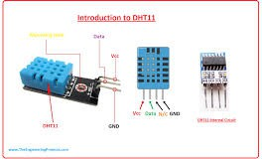DHT SENSOR*

# INTRODUCTION

Agriculture is still the back bone of most economies, which ensures food security, employment opportunities, and materials for industrial processing. Yet conventional agricul- ture is still vulnerable to impending dangers like scarcity of water, infestation, unpredictable weather patterns, and suboptimal usage of resources. These dangers jeopardize crop yield, farmers’ livelihoods, and international food sup- ply chains. To tackle such issues, smart farming is also a

A DHT sensor (DHT11 or DHT22) is a digital tem- perature and humidity sensor consisting of a thermistor

to sense temperature and a capacitive sensor to sense humidity, offering precise environmental information. Used extensively in home automation and weather sta- tions, it has low power consumption and offers consis- tent performance.

1. *Moisture Sensor*

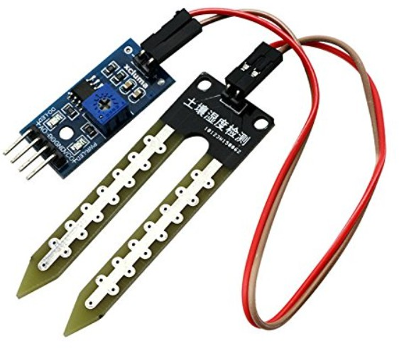

A moisture sensor is a device used to measure the water content in soil. It helps farmers, gardeners, and researchers monitor soil moisture levels to ensure plants receive the right amount of water. The sensor typically works by measuring electrical resistance or capacitance, providing accurate data for better irrigation manage- ment.

1. *NODE MCU*

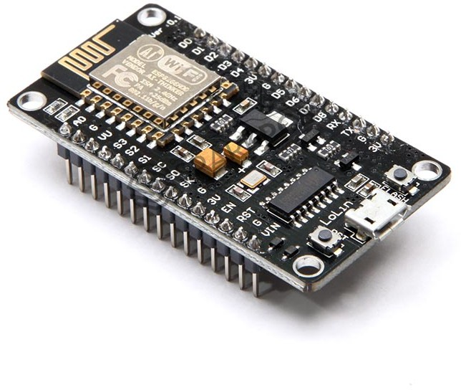

The NodeMCU is a free IoT development board that operates on the ESP8266 Wi-Fi module and supports wireless connection for smart purposes. It allows Lua and Arduino programming, with which it’s perfect for

use in home automation and IoT developments. It incorporates Wi-Fi integration and GPIO pins, making sensor and other electronics easy to connect.

# SOFTWARE REQUIREMENTS

1. Android Studio
2. C++,MERN STACk
3. NodeMCU ESP8266
4. Arduino and sensor coding

# WORKING PROJECT MODEL

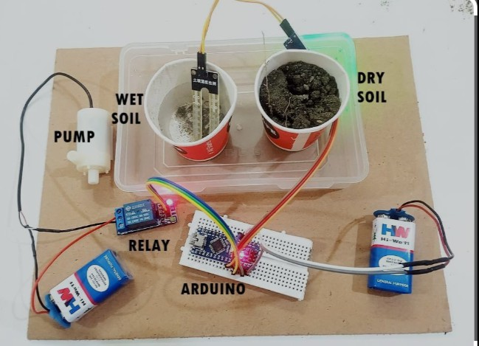

* 1. Functional blocks

A functional block diagram visually represents the work- ing of the smart farming system using sensors, NodeMCU, server, and database connectivity. Below are the key func- tional blocks:

1. Measures soil parameters like moisture, tempera- ture, or humidity. Sends real-time sensor data to the NodeMCU for further processing.
2. Collects sensor data and connects to the server through Wi-Fi. Sends sensor readings to the server and receives actions (e.g., pump ON/OFF) based on server instruc- tions.
3. Receives sensor data from NodeMCU. Stores data into the database. Processes information and sends action commands back to NodeMCU. Also makes data available for user interface display.
4. Saves all incoming sensor data through the server for future analysis, tracking, and decision-making in farming operations.
5. Displays real-time sensor data to users via a webpage or app. Allows users to check plant disease status and manually or automatically control the water pump.

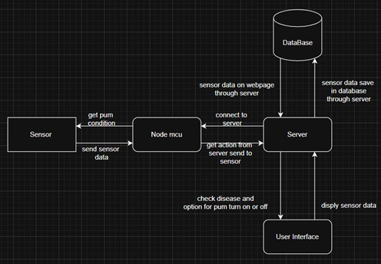

* 1. Functionality of Automation System
     + Cloud-Connected Moisture Monitoring
     + Alert System for Incorrect Conditions
     + Remote Motor Control via Web Interface
     + Automatic Motor Activation

# CONCLUSIONS

The integration of IoT and AI in this smart farming system marks a significant advancement in agricultural technology. It addresses traditional farming challenges and promotes sustain- able practices.

Real-time monitoring enables farmers to instantly assess crop and soil health, allowing for quick, informed decision- making that reduces risks and maximizes productivity.

The system’s AI-driven disease prediction offers a proac- tive approach to crop protection. By analyzing patterns in environ- mental data, it forecasts potential outbreaks, en- abling early interventions and reducing the need for reactive pesticide use. This precision supports both yield protection and environmen- tally conscious farming.

Automated irrigation is completely based on continuous monitoring of soil moisture and weather conditions, ensures optimal water delivery in terms of timing and quantity. This not only conserves water but also provides crops with exactly what they need—an essential benefit in areas facing water scarcity.

Additionally, expert recommendations generated through data analysis help even novice farmers optimize planting schedules, nutrient application, and harvesting times, further enhancing productivity.

Looking ahead, the focus will be on improving energy effi- ciency and system scalability. Scalability will allow adaptation to larger farm areas and evolving technologies, while energy- efficient innovations will reduce the system’s carbon footprint, ensuring long-term sustainability.

Together, these innovations will further solidify the role of smart farming in creating a more efficient, productive, and environmentally sustainable agricultural future.

References

1. Nikesh Gondchawar and Dr. R. S. Kawitkar, ”IoT Based Smart Agriculture,” International Journal of Advanced Research in Computer and Communication Engineer- ing (IJARCCE), Vol. 5, Issue 6, June 2016, DOI: 10.17148/IJARCCE.2016.56188
2. S. P. Mohanty, D. P. Hughes, and M. Salathe´, ”Using Deep Learning for Image-Based Plant Disease Detec- tion,” Frontiers in Plant Science, vol. 7, p. 1419, 2016.
3. Ms. Sinchana H N and Mr. Nithin Kumar, ”Smart Automated Irrigation System with Disease Detection using IoT,” Proceedings of the Inter- national Conference on Power, Control, Signals and Instrumentation Engi- neering (ICPCSI), 2017.
4. E. Ahmed et al., ”IoT-enabled edge computing model for smart irrigation system,” IEEE Internet of Things Journal, vol. 8, no. 6, pp. 4294–4303, Mar. 2021.
5. S. Olawepo et al., ”An Overview of Smart Garden Automation,” in International Conference in Mathe- matics, Computer Engineering and Computer Science (ICMCECS), IEEE, 2020.
6. L. Perera, V. Gayantha, and A. Wanniarachchi, ”A Smart Solution for Plant Disease Detection Based on IoT,” in Proceedings of the International Conference on Advances in Computing and Technology (ICACT–2020), pp. 121–123, Nov. 2020. ISSN 2756-9160.
7. M. Seelye et al., ”Plant Disease Detection using Internet of Things (IoT),” International Journal of Advanced Computer Science and Applications, vol. 11, no. 5, pp. 567–573, 2020.
8. R. Pandey, S. Verma, “A Study on Wireless Home Automation Tech- nologies,” Journal of Emerging Technologies and Innovative Research (JETIR), vol. 6, no. 4, 2021.
9. A. Alheraish, “Design and Implementation of a Microcontroller Based Wireless Home Automation System,” IEEE Transactions on Consumer Electronics, vol. 50, no. 4, pp. 1087-1092, 2020.
10. M. Patel, K. Shah, “Implementation of IoT-Based Smart Home Au- tomation System,” International Journal of Computer Science and Mobile Computing (IJCSMC), vol. 8, no. 2, pp. 56-62, 2022.