**DESIGN AND ANALYSIS OF LOAD CARRYING CHASSIS STRUCTURE OF ROBOTICS TANK SYSTEM**

**Shilpa S. Gajbhiye1, Dr. I.A. Khan2**

*M.Tech. Student of Defence technology, M.E. Department & Priyadarshini College of Engineering, Nagpur, India*

*Faculty of Department of Mechanical Engineering*,

**ABSTRACT**

The chassis of a robotic tank system plays a vital role in supporting essential components such as motors, sensors, and payloads while ensuring the system’s performance, stability, and durability. The design of the chassis is critical, as it directly impacts the robot's ability to bear loads, withstand environmental conditions, and maintain reliable mobility. This paper discusses the importance of chassis design, focusing on load-bearing capacity, structural integrity, mobility, stability, durability, and cost-effectiveness. Key considerations include material selection, design configuration (tracked or wheeled), load distribution, environmental resilience, and integration with other system components. Analytical tools such as Finite Element Analysis (FEA) and Computer-Aided Design (CAD) are employed to simulate and optimize the chassis structure. A review of related literature highlights recent developments in battle tanks and robotic vehicle simulations. The paper aims to design and analyze a chassis structure that ensures enhanced structural integrity, optimized load distribution, material efficiency, improved mobility, and cost-effectiveness, while considering future upgrades and maintenance. The expected outcomes include a robust, efficient design that meets performance criteria and enhances operational effectiveness in various terrains. The study also provides a framework for conducting comprehensive load analysis and design optimization to ensure the chassis's longevity and adaptability.

**Keywords:** chassis design, mobality, stability,cost effectiveness, environmental resilience,optimized load distribution.

1. **INTRODUCTION**

## A machine, often referred to as its "skeleton." Chassis is the foundational structure of a vehicle or provides the framework on which all other components like the engine, suspension, wheels, body, and various systems are mounted[1]. The design and construction of the chassis play a crucial role in determining the durability, performance, and safety of the entire machine. A well-designed chassis provides rigidity and strength to withstand various forces, such as road impacts, vibrations, and loads during operation. The chassis is often designed to absorb and distribute energy during collisions, enhancing the safety of occupants by reducing impact forces[2]. A good chassis ensures better handling, stability, and overall performance of the vehicle by providing a balanced and robust foundation. In the design and manufacturing of vehicles, the chassis serves as a platform where other systems and components are integrated, making it a key factor in customization and innovation. Robotic tanks are expected to operate on rough, uneven terrains (mud, rocks, slopes, debris). The chassis must provide rigid support and ground clearance while maintaining mobility and balance[3].

1. **METHODOLOGY**
2. Work and Work Material

Static Structural Analysis of robot chassis which includes total deformation, equivalent elastic strain, equivalent

Stress, etc has been carried out. Analysis has been performed using materials for chassis: Structural steel.

1. Software Used

For CAD modelling of chassis of robotics tank whereas for CAE Analysis of Chassis of robotic tank Ansys R2 were used.

1. Methodology:

Every research follows certain desired methodology based upon which the research aim is achieved. This is automobile-oriented research which will eliminate shape defect occurring in chassis though suitable design analysis. Data analysis of the process will be done to find severity in reduction of unstrung weight leads to more precise running and minimizing the fuel consumption. Based on analysis, the problem will be defined and a through review of literature related to the problem will be done. 3D Model of Load Carrying Chassis Of robotics tank system will be prepared using CAD software followed by detailed analysis of the cause behind the issue by using Ansys software. Later, compatibility of the design modification will be checked using the software tool followed by investigating in line enhancement in term of quality. Based on the finding, suitable conclusion will be presented at the end of the research.

In this Catia based 2D CAD Model of chassis of robotics tank system with suitable dimension. Dimensions: Length of Chassis 825.02 mm Width of Chassis 790 mm Height of Chassis 180 mm Fig.1. Shows Top View of Chassis Of Robotics Tank System. Fig.2. Shows Views of Chassis Of Robotics Tank System with Dimension.

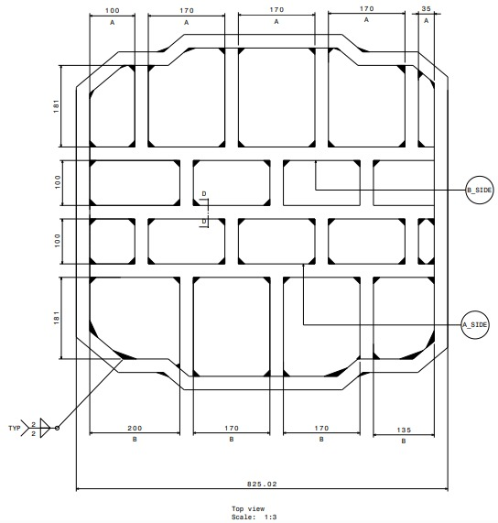

**Fig. 1. Top View of Chassis Of Robotics Tank System**.

3D CAD MODEL OF CHASSIS OF ROBOTICS TANK SYSTEM Dimensions: Length of Chassis 825.02 mm Width of Chassis 790 mm Height of Chassis 180 mm

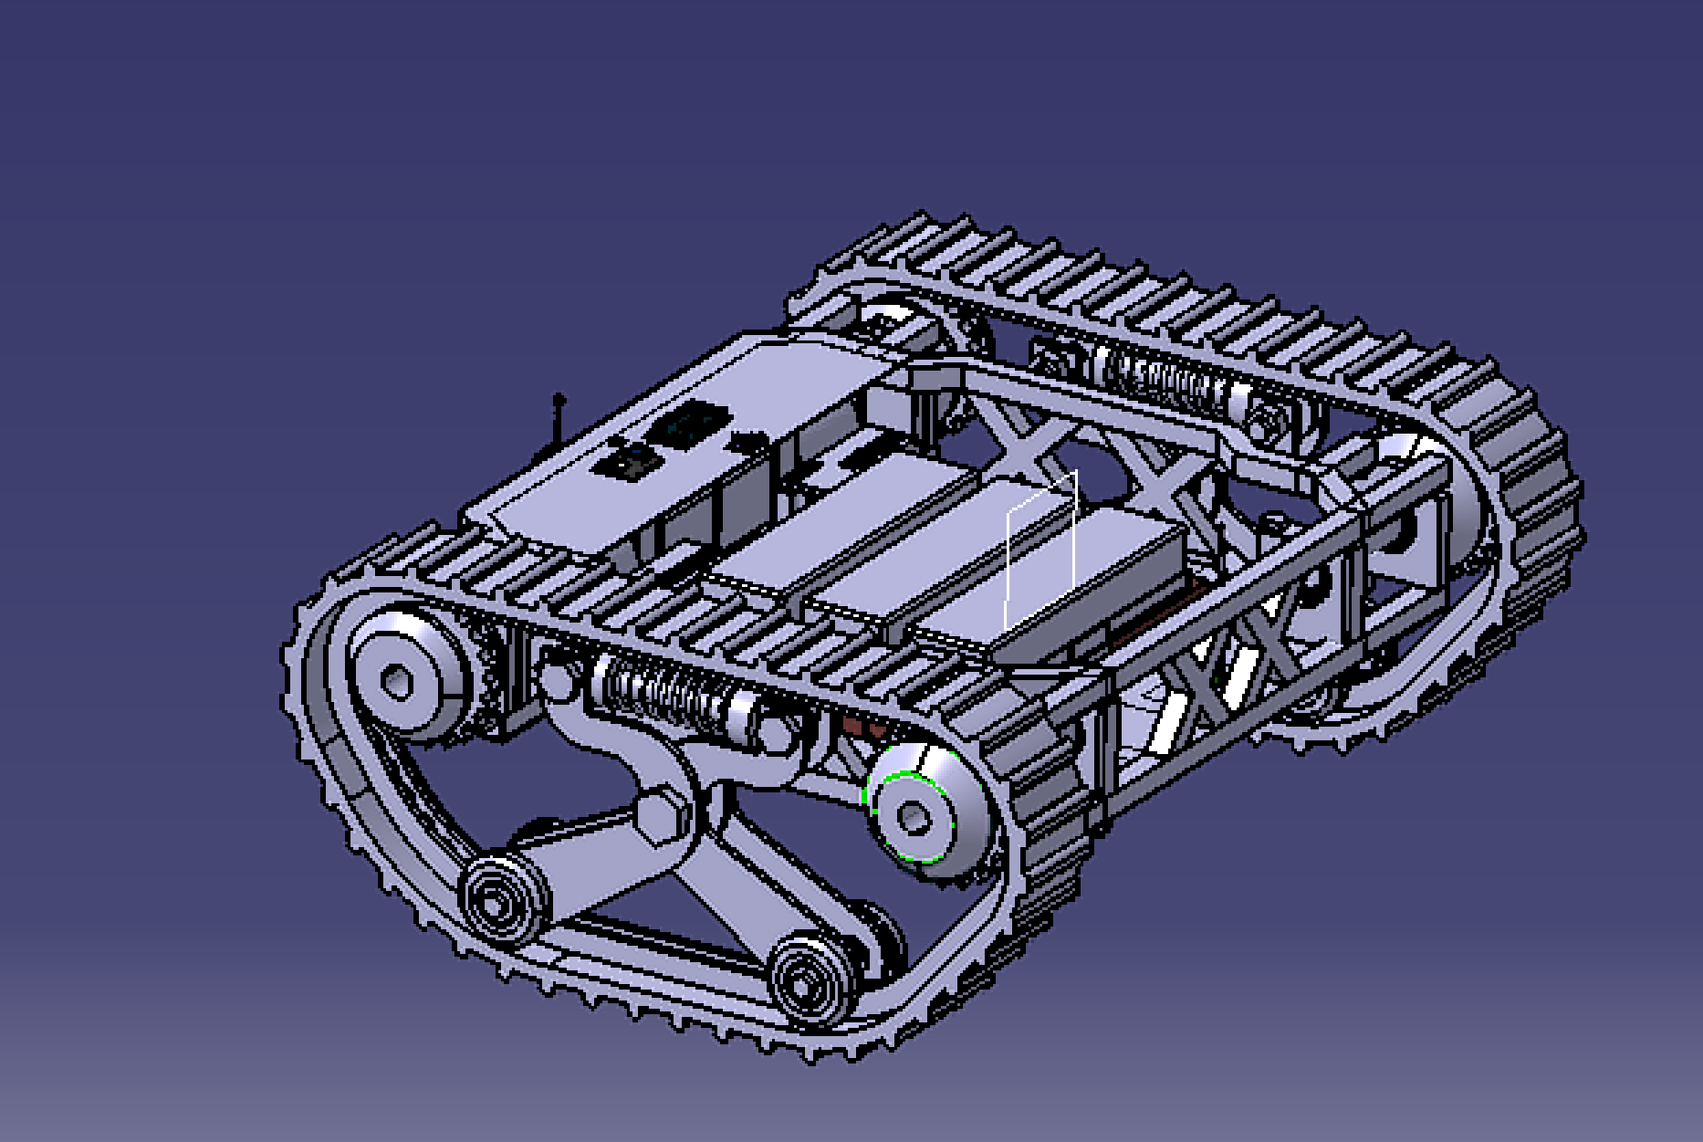

**Fig.2.Views of Chassis Of Robotics Tank System**

1. **RESULTS AND DISCUSSION**

“The trickle of water in terms of droplets converts into the water fall then it gains the form of a river, at the last the river converts into an ocean”. The former lines are best suited for the present work. Because, the genesis of work took place with a new thinking process in terms of droplets then it converted into the literature survey in terms of water fall. The experimentation for the validation of new technique is just like a river, which helps to gain experiences and at last the things and facts generated from the present work are just like an ocean of acquired knowledge. As every start has its end, hence through this chapter it is inevitable to sum up the present work in terms of results and discussions. This chapter detailed established the result of the present research where taking comparison of three aspect total deformation, equivalent elastic strain and elastic stress with its difference of maximum and minimum deformation for selecting the proper material for chassis taking analysis as a reference.

1. TOTAL DEFORMATION STRUCTURAL STEEL:

After the analysis of materials the table of total deformation is formed in which minimum and maximum value of all material is mentions, for the material structural steel the minimum total deformation obtained is 0 and maximum value obtained is 8.992e-5.

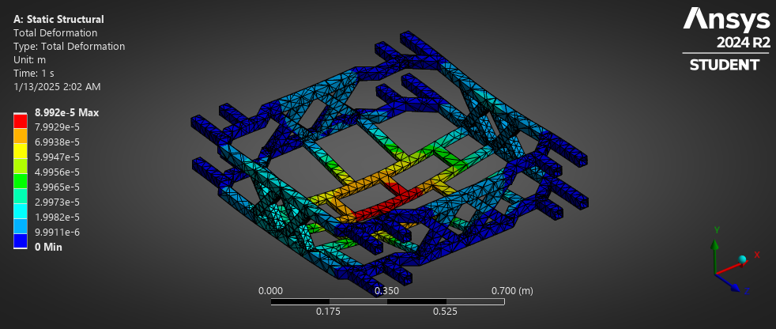

**Fig 3. Total deformation structural steel**

1. **CONCLUSION**

## Based on the present work the following some important conclusions have been drawn. 1. The analysis of the chassis structure, designed with a brick-like arrangement, reveals that it can withstand forces greater than 500 N. Specifically, the maximum total deformation observed under an applied load of 500 N is 8.992 × 10⁻⁵, which is within the acceptable limits for structural integrity. 2. Based on these findings, it can be concluded that the chassis structure exhibits sufficient durability to sustain loads exceeding 500 N. 3. However, the analysis report suggests that the center of the chassis would benefit from the addition of additional ribs or a more distributed load approach to further enhance the structural performance. This modification would help ensure optimal rigidity and reduce the risk of excessive deformation in critical areas under various loading conditions.

1. **REFERENCES**
2. Aditya Sadhukhan, G. Srinivas & G. T. Mahesha. Recent Developments of Battle Tanks Used in Defence Applications. In: 2024 International Conference on Modern Research in Aerospace Engineering.
3. Stavrev S, Ginchev D (2020) Towards a cost-efficient gunner controller for a modular battle tank simulator. In: Gate—Conference paper, Oct 2020.
4. Rahman, A., Malik, A., Kumar, J., Balaguru, V., & Sivakumar, P. (2017). Design Configuration of a Generation Next Main Battle Tank for Future Combat. Defence Science Journal, 67(4), 343-353.
5. Kumar G, Tiwari PY, Marcopoli V, Kothare MV. A study of a gun-turret assembly in an armored tank using model predictive control. In: 2009 American control conference Hyatt regency riverfront
6. Naraimhan G. Sivaprasad N (1989) FEM analysis of gun tank turret. Def Sci J 39(3): 257-268:
7. Chassis Design and Analysis of an Autonomous Ground Vehicle (AGV) using Genetic Algorithm Chassis Design and Analysis of an Autonomous Ground Vehicle (AGV) using Genetic Algorithm: Taher Deemyad, Ryan Moeller, Anish Sebastian
8. Design and Development of a Mobile Robotic System for Aircraft Wing Fuel Tank Inspection Manpreet Kaur Dhoot and Ip-Shing Fan Cranfield University
9. Comparative Chassis Finite Element Analysis Of A Novel Robot Chassis Using Structural Steel And Aluminium Alloy Materials: Avadhoot Rajurkar, Kunal Dangra, Aryan Deshpande, Madhav Gosavi, Tejas Phadtare, Gajanan Gambhire.
10. DESIGN AND CONSTRUCTION OF TANK-CHASSIS AND LIFTING STRUCTURE FOR CENTRIFUGAL PUMP HL260 M POWERED BY A DIESEL ENGINE Cristian A. Pedraza-Yepes1, Jorge E. González-Coneo1, Carlos A. Mancera-Trejos1, Luis E. Florez-Sarmiento1, Gabriel Torres- Diaz2 and Camilo González-Olier3
11. Design and Analysis of Chassis for SAE BAJA Vehicle Shiva Krishna J, Ambesh Shetye, Prabhudev Mallapur
12. Design and development of chassis for formula student vehicle : Ameya Dabbade, Khizar A. Pathan, Sher A. Khan, Akash Jadhav
13. Chassis Design & Analysis p-ISSN: 2395-0072 Ansari Mohd Abuzar Mohd Naeem1, Ghulam Tausif Ghulam Younus2, Mohd Ismail Zainulabedin3, M Tausif M Sharif4, Tanveer Baig Naseer Baig5, M Z Khan6
14. Automotive Chassis Frame Structural Analysis and Design Modification for Weight Reduction. K.MOUNIKA, Dr.B.James Prasada RAO, P.SRIKANTH, Sura LingaReddy, S SANGEETHA, B.VENKATES
15. Structural Analysis of Different types of the changes design for the multi- Axle heavy commercial vehicle Aziz Başdemir, Zeki Can Kaynak, Emre Tekin
16. Ilie CO, Barothi L, Marinescu M, Giurgiu IT (2022) Aspects of electric transmission implementation on a battle tank. AITS 2021, IOP conference series: materials science and engineering, vol 1220, p012017.