**Feigning Illness and School Phobia in a Child: A Case Report with Homeopathic Management Using Tarentula Hispania**

**Corresponding Author – Dr. Dipika Velkar**

**Dr. Dipika Velkar1**Assistant Professor in Department of Homeopathic Materia Medica,   
Smt. C.M.P Homeopathic Medical College, Mumbai, India

Keywords: School Phobia, Feigning Illness, Psychosomatic Disorders, Pediatric Anxiety, Homeopathy, Tarentula Hispania, Individualized Medicine, Mind-Body Connection, Childhood Behavioral Disorders, Homeopathy

Abbreviations: OPD – Outpatient Department, SL – Saccharum Lactis (Placebo), I P – I powder/Single dose Prescription, 3 P- 3 powder/doses, ICD – International Classification of Diseases

**Abstract**

School phobia in children often presents alongside psychosomatic symptoms, including feigned illness. Such conditions reflect deeper emotional conflicts or traumatic triggers. (JV, 2012).This paper presents the case of an 8-year-old boy with school phobia who exhibited dramatic psychosomatic behavior, including threats of self-harm. The homeopathic remedy Tarentula Hispania was prescribed based on individualized case analysis. The case demonstrates the importance and relevance of qualified mental symptoms in remedy selection and the effectiveness of Tarentula Hispania. It helps in corroborating the importance of Organon of Medicine to highlight the role of qualified mental symptoms in the selection of remedy. (Hahnemann, 1994); (Kent J. T., 1999)

1. **Introduction**

School phobia is a significant psychosocial issue affecting children and adolescents, often marked by fear, anxiety, and somatic complaints without clear pathology. (Kearney and Albano, 2000). Research suggests that such presentations may be underpinned by trauma, attachment insecurity, or learned behavioral responses to stress. Feigning illness is often a coping strategy in children experiencing psychological discomfort, rather than an act of deception. Homeopathy, with its individualized approach, provides an effective framework for understanding and addressing such psychosomatic phenomena.(Boericke, 2007)

**2. Literature Review**

**2.1 Psychosomatic Expressions in Children:**Psychosomatic symptoms such as abdominal pain and headaches are common among school-aged children and frequently correlate with school-related stress or emotional trauma. Studies report that these expressions serve as non-verbal cues to internal psychological conflict.  
  
**2.2 School Phobia and Behavioral Avoidance:**School refusal and related disorders are well-documented in child psychology literature. Kearney et al. emphasize the need for therapeutic approaches that consider the emotional and environmental triggers.

**2.3 Symptoms of feigning sickness and treatment:**Clinical Presentation of feigning symptoms in the context of Factitious Disorder imposed on self usually presents with deceptive behavior by presenting themselves as ill, impaired or injured even in the absence of any pathological disease and the deception should not be explained by any other mental disorder. They also exaggerate the symptoms they don’t actually have. Treatment usually includes medication for co-occurring symptoms such as anxiety or depression, personalized cognitive behavior therapy, psychotherapy and avoiding confrontation. (American Psychiatric Association, 2013)

**2.4 Homeopathy and Psychodynamic Interpretation:**Classical homeopathic literature highlights the role of mental symptoms and causation in remedy selection. As per Hahnemann (Organon, Aphorism 213), the mind must be the primary focus of attention in chronic cases. Boericke describes Tarentula Hispania as suitable for states of restlessness, feigning illness, and violent emotional outbreaks. Kent further identifies the remedy as indicated in manipulative and attention-seeking behavior, often accompanied by dramatic gestures. (Hahnemann, 1994)

**3. Case Presentation**

A 8 years old male came to OPD with complaints of fear and aversion to school, Feigning abdominal pain, threatening self-harm with a butter knife, temper tantrums, particularly on Sunday evenings since 6 months. He heard a bad news of bereavement of an extended relative and an episode of admonition by the teacher due to his tardiness in copying notes off the blackboard. This triggered humiliation and behavioral regression. On observation, he complained of severe abdominal pain (rated 10/10 by the child), but said he was seen actively playing football shortly afterward. Restless, mischievous, and dramatic behavior without actual pathology.

**Family history:** Nothing specific  
**Past history:** Nothing specific  
  
**Personal History:**

**Appearance:** Lean, tall, athletic built, fair complexion  
Appetite: Good, eats well  
Veg/Non veg: Vegetarian  
Thirst: Profuse  
Likes: Dal, rice  
Dislikes: Nothing Specific  
Perspiration: Profuse all over the body  
Stool: Normal  
Sleep: Good  
Dreams: Nothing specific

**Mind:**Lean, athletic build, good appetite. Emotionally sensitive, craves attention. Attachment to mother and jealousy towards elder sibling. He loves karate, music, football. Teacher has noted on previous occasions that he is distractive in class.  
  
  
**Diagnosis: School Phobia with psychosomatic symptoms (presenting with feigning symptoms)(ICD-11: 6B00)**

**Hahnemannian Classification:** Dynamic chronic miasmatic with fully developed symptoms

**4. Homeopathic Totality and Repertorization- Kent’s Method** (Kent J. T., 2008)

1. Mind: Feigning sick, children, in
2. Mind: Threatening to kill
3. Mind: Admonition aggravates
4. Ailments from: Hearing bad news

Repertorization was done using Synthesis Repertory App  
  
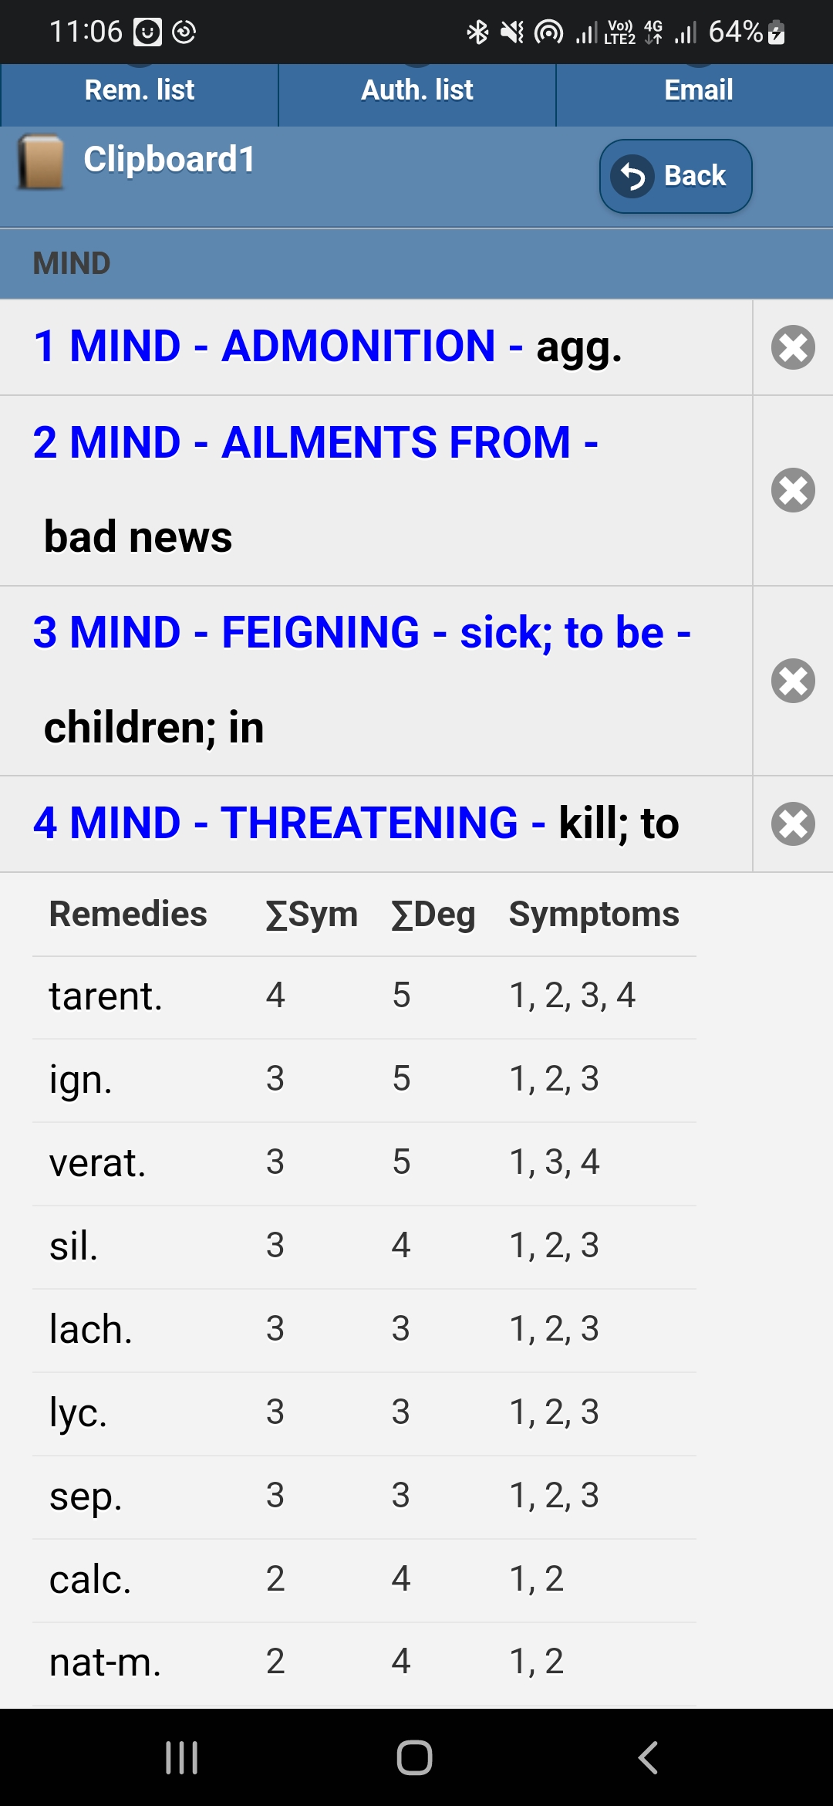

1. **Remedy Justification**Boericke notes Tarentula as suitable for excitable, mischievous children, with a tendency to act dramatically and manipulate their environment through exaggerated complaints. Kent corroborates these observations with mental symptoms such as affectation, destructiveness, and desire to attract attention. Tarentula tends to avoid blame and punishment when admonished and as an escape mechanism will turn on the blame to others. Also, with threatening behavior, the intention is only to threaten but not harm, especially not to oneself.

6**. Treatment Course and Follow-Up**

|  |  |  |
| --- | --- | --- |
| **Date** | **Follow up** | **Prescription** |
| 17. 7.2024 | First prescription | Tarentula Hispania 30 (3P)  SL tds x 7 days |
| 18.7.2024 | Mother reported:  He passed plenty of stools and soiled his pants. Developed a fever of 99.20F. Not gone to school. | SL tds x 7 days |
| 21. 7.2024 | Parents took him to school but he started screaming at the gate itself. After a lot of difficulty he went in. Mother was standing outside school until it got over. He attended but was very angry with parents for sending him. | SL tds x 7 days |
| 27.7.2024 | Child has been going to school since then, but with a lot of coaxing from parents. Sits for a few classes and then parents have to get him home since he starts screaming during the classes. | Tare ntula Hispania 200 (IP)  SL tds x 7 days |
| 3.8.2024 | His temper has reduced. He went to school, sat for the entire length of his classes and came out smiling. | SL tds x 7 days |
| 18.8.2024 | He is able to go to school without much difficulty, gets apprehensive on Sunday evenings occasionally. Tantrums---0--- | Tarentula Hispania 200 (IP) |
| 2.9.2024 | He is able to go to school, no tantrums noted. Enjoys his classes now. | No medicine given. |

SL: Sac Lac

**7. Discussion**

The case illustrates how homeopathy, through individualization and psychological insight, can resolve complex emotional patterns. Tarentula Hispania was not chosen for school phobia per se but for the behavioral portrait—feigning illness, dramatic threats, and emotional lability. The effectiveness of the remedy reaffirms Kent’s emphasis on peculiar and qualified mental symptoms in remedy selection. Feigning behavior was an emotional defense and cry for security which was addressed through homeopathy and restoring emotional balance.  
  
This outcome is consistent with findings from Indian Journal of Research in Homoeopathy, where individualized treatment showed positive outcomes in anxiety-related pediatric cases. Ignatia was ruled out due to lack of threatening symptoms.

**8. Conclusion**

Homeopathy offers a unique and effective approach in managing school phobia with psychosomatic overlay when remedies are selected based on mental and causative characteristics. Tarentula Hispania, in particular, can be a potent choice for children displaying dramatic, attention-seeking behavior, restlessness, and feigned symptoms.

9. **Acknowledgement**

I would like to thank teachers, staff and management of Smt. Chandaben Mohanbhai Homeopathic Medical College, Vile Parle (W), Mumbai, Principal Dr. Parizad Damania, Vice- Principal, Dr. Jenil Panthaki, Head of Department of Homeopathic Materia Medica, Dr Vanita Johari, and Associate professor, Dr.Abhinandan Hulamani for their support.

**References**

1. Association, A. P. (2013). *Diagnostic and Statistical Manual of Mental Disorders 5th Edition.* Washington DC: American Psychiatric Publishing.
2. Boericke, W. (2007). *Pocket Manual of Homeopathic Materia Medica.* New Delhi: B. Jain Publishers.
3. Hahnemann, S. (1994). *Organon of Medicine, 6th edition.* New Delhi: B. Jain Publishers.
4. JV, C. (2012). Functional somatic aymptoms and associated anxiety and depression- develeopmental psychopathology in pediatric practice. . *Journal of Child Psychology and Psychiatry*, 575-592.
5. Kaerney CA, A. A. (2000). *When Children Refuse School: A Cognitive- Behavioral Therapy Approach.* Oxford University Press.
6. Kent, J. T. (1999). *Lectures on Homeopathic Materia Medica.* New Delhi: B. Jain Publishers.
7. Kent, J. T. (2008). *Repertory of the Homeopathic Materia Medica.* New Delhi: B. Jain Publishers.