Evaluation of Mortar by addition of Limestone to Enhance Self Compacting Nature in Structural Application

**ROMIL SHRIVASTAVA**1, **RAGINI MISHRA**2

1, 2 BABULAL TARABAI INSTITUTE OF RESEARCH AND TECHNOLOGY, SAGAR (M.P.), India

**Abstract.** It is crucial to comprehend the durability element of self-compacting concrete with a filler waste in order to more easily use marble and lime waste and to cautiously avoid any constraints in a practical application. Two industrial by-products from the non-pozzolanic group foam (FM) and limestone powder waste (LP)—are selected for this experimental effort. It was investigated how filler waste behaved in mortar, cement paste, and concrete. Experimental research was done on the characteristics of the marble and lime filler waste in SCC that was subjected to sulfate and acid attack solutions. In order to assess the impact of filler types on the early and mature properties of SCC, M-20 concrete was created. Three distinct cement replacement levels—0%, 10%, 15%, and 20% of employment—as well as five different compositions were examined. To assess the young and hardened properties of SCC, several experiments were conducted utilizing three replacement levels of cement and fine aggregate, resulting in a total aggregate ratio of 0.54. The test findings demonstrated that improved deformability was achieved in SCC samples and that filler types and contents had a considerable impact on flow behavior.

**Keywords:** Self-compacting mortar; Limestone powder waste; Foaming Agent.

# Introduction

Researchers are working on alternative materials, such as industrial byproducts, to replace natural aggregates in order to get over these limitations. These days, solid or hollow concrete masonry blocks are utilized in place of clay bricks as the brick-making process shatters soil. The commercially available clay bricks, solid concrete blocks, and hollow concrete blocks are depicted in Fig. 1.1(a), (b). However, a significant amount of cement, together with river sand and coarse aggregate, is needed for the construction of these blocks also. Therefore, in order to minimize the use of cement and other materials, it became necessary to continue research into the creation of some other alternative building blocks that would replace all of the masonry units mentioned above in practical application.

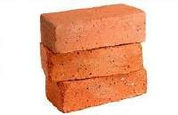

**Fig1:** Commercially available brick sand blocks

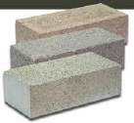

# Lightweight Concrete

Concrete that includes stable foam or lightweight particles as one of its constituents is referred to as lightweight concrete. The concrete is referred to as lightweight aggregate concrete if lightweight aggregates are utilized, and foamed concrete or foamcrete if stable foam is used. In most cases, foamed concrete (FC) has at least 20% of foam mixed with the plastic mortar. The stable foam settles around the foam bubbles when it is added to the prepared cement mortar, and the paste will be strong enough to hold its form around the gaps even as the foam starts to degenerate. Lightweight Foamed Concrete (LFC) has a low density, which makes it an excellent choice for infills in reinforced concrete buildings will lead to thinner beam and column sections, which will increase economy. Additionally, a significant volume of industrial wastes may be used to produce LFC, providing a long-term solution to the wastes' disposal problems.

# Limestone

Limestone, which is made up of CaCO3 in the form of the mineral calcite, is the most valuable sedimentary rock. Roughly 10% of all sedimentary rocks are limestone. Limestone is a non-metallic mineral that is required as a raw ingredient to make cement, a crucial building material. The two primary components of limestone are dolomite and calcite. The majority of limestone used by companies is sedimentary limestone, also known as bedded limestone. Lime shells are another form of calcareous material used by industry. This lime shell may be found in the shallow sea and bed of an old lake. 338.55 million tonnes of limestone were produced in 2017–18, an increase of around 7.59% over 2016–17. 711 mines out of 832 were reported to have grown in 2017–18. Three million tonnes of limestone were produced by twenty-nine mines, accounting for 43% of the total production in 2017–18. Additionally, 20 mines contributed 24% of the overall production, producing 2 to 3 million tonnes of limestone. About 97% of the limestone produced in 2017–18 was used to make cement, with the remaining 3% going toward other uses.

# OBJECTIVES OF THE STUDY

Utilization of concrete for construction shall not only solve waste problems, but also provide a new resource for construction purposes. In this research, use of Foam agent and Limestone powder as partial replacement of cement has been tried. The specific objectives of the investigation are as follows

* To examine the current test procedures used to assess the strength and durability of mixed cement.
* To determine the appropriate proportion of Foam and LP in the concrete mix that would meet the plastic state's criteria and yield the maximum strength of concrete in compression stability.
* To assess the durability and mechanical qualities of concretes containing cement matrix.
* Examine the self compacting of the concrete mixtures and confirm the outcomes of tests for durability and strength.
* To promote the use of waste to wealth mixed cement in general building and to acknowledge the mix's possible advantages for the economy and environment.

# Methodology & Results of concrete containing Lime powder and Foam

The latest type of concrete is called self-consolidated concrete. It compacts itself, creates a free flow of concrete without the need for external energy (vibration), fills in all of the voids in the formwork, and consolidates by its own weight with the help of superplasticizer, viscosity-modifying agents, and filler materials as an admixture.

The S/a ratio (fine aggregate to total aggregate ratio), coarse aggregate size (< 16 mm), superplasticizer, and additive are the main distinctions between SCC and ordinary concrete. SCC was utilized for a twenty-eight-day underwater curing process to provide more gratifying workability and strength.

The present study aims to investigate the potential use of two waste products, foam and lime powder, as fillers in SCC. It also looks at how these fillers impact the young and hardened qualities of the SCC in terms of mechanical and physical strength. The physical and chemical properties of each ingredient are analyzed first in order to make the concrete self-compacting; adding, removing, or altering any component will alter the behavior and usefulness of SCC. Two fillers are used in SCC in place of cement; the precise chemical and physical composition of foam and lime powder is also investigated. The details of each component utilized to construct the M20 grade—which was made in the current study using different combinations

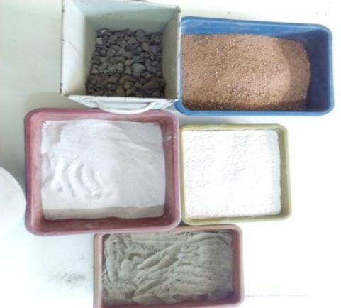

Fig 2: Ingredients for SCC mixes

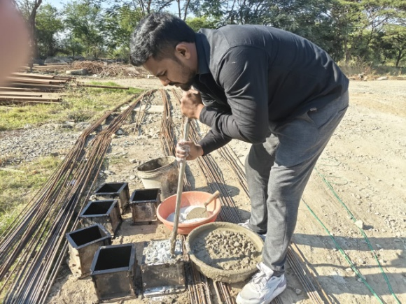

Fig 3: Tamping of batched material

All substances underwent various laboratory testing in accordance with Indian standards (IS) and EFNARC recommendations. Because SCC is a sensitive concrete, attention was made while choosing materials that were readily available in the area, and the same sources were used for all testing. The selection of materials from the local market was done with the intention of balancing the cost of the superplasticizer and lowering the production cost of SCC, which is now marketable. The characteristic of the component is used for designing the SCC mix and for understanding the overall behavior of SCC. It also helps interpret the performance of SCC with lime and foam in the mortar test.

Table 1 Physical Properties of Ultratech 53 grade OPC for the present study

|  |  |  |  |  |
| --- | --- | --- | --- | --- |
| Type | Specific  Gravity (gm./cm3) | Mean  grain size (μm) | Fineness  passing 45μm (%) | Specific surface area (m2/kg) |
| Ultra tech OPC-53 grade | 3.11 | 21.63 | 86 | 316 |

Table 2: Mechanical Properties of Ultra tech 53 grade OPC: As per IS 4031 (Part 2):1999, (Part 3, 4, 5, and 6):1988

|  |  |  |  |  |  |  |
| --- | --- | --- | --- | --- | --- | --- |
| **Consistency**  **(%)** | **IST**  **(min)** | **FST**  **(min)** | **Soundness**  **(mm )** | **Average Compressive Strength (MPa)** | | |
| **3 days** | **7 days** | **28 days** |
| 29 | 184 | 314 | 1.00 | 32.54 | 38.43 | 54.10 |

Table 3: Chemical Properties of Ultratech 53 grade OPC

|  |  |  |  |  |  |  |  |  |  |
| --- | --- | --- | --- | --- | --- | --- | --- | --- | --- |
| **Type** | **CaO** | **SiO2** | **Al2O3** | **Fe2O3** | **SO3** | **Na2O** | **K2O** | **MgO** | **LOI** |
| Ultra  tech OPC- 53  (%) | 63.60 | 20.35 | 5.78 | 3.52 | 2.62 | 0.58 | 0.72 | 0.41 | 1.37 |

Table 4 Physical properties of fine Aggregates confirming to IS- 383:1970.

|  |  |  |
| --- | --- | --- |
| **Sr. No** | **Property** | **Results** |
| 1. | Particle Size & Shape | Rounded, Below 4.75mm |
| 2. | Grading Zone | Zone II |
| 3. | Fineness Modulus(FM) | 2.68 |
| 4. | Specific Gravity(Gs) | 2.62 |
| 5. | Surface moisture | Nil |
| 6. | Water Absorption | 1.0% |
| 7. | Silt content | 2.45% |

**Water: (IS 456: 2000)** Water is an essential component for a chemical process that forms concrete and mortar. It actively participates in the hydration of cement to provide the required strength and workability. Cement is an anhydrous substance that instantly combines with water to generate C-S-H gel, which is what gives SCC its strength. The C-H-S gel, or cement hydration binding process, is primarily responsible for the strength of concrete. According to IS 456: 2000, drinkable water that is pure and devoid of salt, oils, and alkalis should be used to produce mortar and concrete. In the current experiment, all samples have been produced and cured by combining drinking-quality tap water.

# Test procedure selected for cement paste and mortar with LP and FOAM

Table 5 Different mixes of powder used for making cement paste and mortar

|  |  |  |  |  |  |  |  |
| --- | --- | --- | --- | --- | --- | --- | --- |
| Powder Content | % Replacement of cement by LP and FOAM | | | | | | |
| 0 | 10 | | 15 | | 20 | |
| LP | √ | √ | √ | √ | √ | √ | √ |
| FOAM | √ | √ | √ | √ | √ | √ | √ |

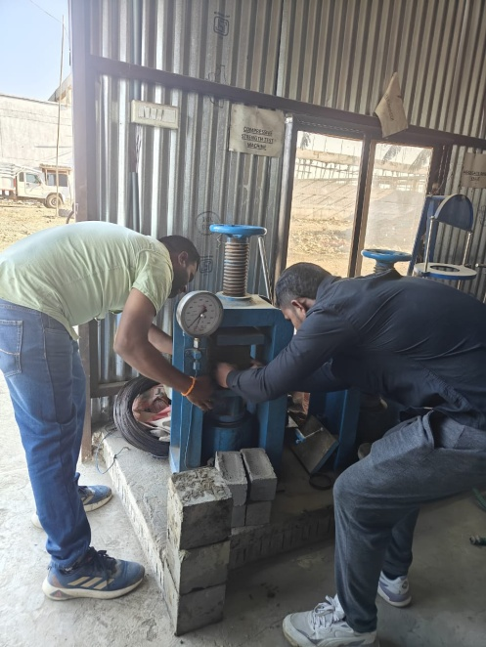

Fig 4: Compression test of Mortar cube

|  |  |  |  |  |  |  |  |  |  |
| --- | --- | --- | --- | --- | --- | --- | --- | --- | --- |
| Water cement ratio = 0.50 (normal),0.40 (filler), S.P= Superplasticizer 1.0% | | | | | | | | | |
| Mix | Name  of Mix | %  Replace | Cement (g) | Sand (g) | Water (ml) | Lime (LP) | Foam (FM) | 28 days comp. strength (Mpa) | SAI (%) |
| 1 | SCC0 | 0 | 450 | 1350 | 225.0 | 0.0 | 0.0 | 55.10 | - |
| 2 | 0LP-100FM | 10 | 405 | 1350 | 180.0 | 0.0 | 45.00 | 51.35 | 93.19 |
| 3 | 25LP-75 FM | 405 | 1350 | 180.0 | 15.0 | 30.00 | 49.37 | 89.56 |
| 4 | 50LP-50 FM | 405 | 1350 | 180.0 | 22.50 | 22.50 | 47.58 | 86.35 |
| 5 | 75LP-25 FM | 405 | 1350 | 180.0 | 45.0 | 15.00 | 46.10 | 83.67 |
| 6 | 100LP-0 FM | 405 | 1350 | 180.0 | 45.00 | 0.00 | 44.68 | 81.08 |
| 7 | 0LP-100 FM | 15 | 382.0 | 1350 | 180.0 | 0.0 | 68.0 | 48.55 | 88.11 |
| 8 | 25LP-75 FM | 382.0 | 1350 | 180.0 | 17.0 | 51.0 | 45.35 | 82.30 |
| 9 | 50LP-50 FM | 382.0 | 1350 | 180.0 | 34.0 | 34.0 | 43.65 | 79.21 |
| 10 | 75LP-25 FM | 382.0 | 1350 | 180.0 | 51.0 | 17.0 | 43.10 | 78.22 |
| 11 | 100LP-0 FM | 382.0 | 1350 | 180.0 | 68.0 | 0.0 | 40.55 | 73.59 |
| 12 | 0LP-100 FM | 20 | 360 | 1350 | 180.0 | 0.0 | 90.0 | 42.50 | 77.13 |
| 13 | 25LP-75 FM | 360 | 1350 | 180.0 | 30.0 | 60.0 | 41.05 | 74.68 |
| 14 | 50LP-50 FM | 360 | 1350 | 180.0 | 45.0 | 45.0 | 40.10 | 72.77 |
| 15 | 75LP-25 FM | 360 | 1350 | 180.0 | 60.0 | 30.0 | 38.90 | 70.59 |
| 16 | 1 00LP-0 FM | 360 | 1350 | 180.0 | 90.0 | 0.0 | 37.65 | 68.33 |

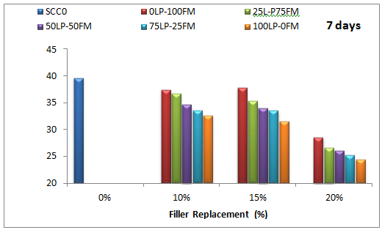

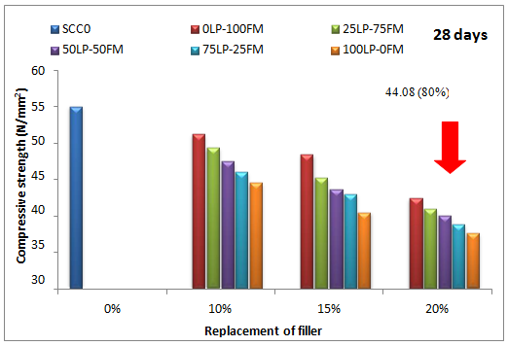

Fig.5: Strength of mortar cube for 7 and 28 days for different replacement of LP & FM

# CONCLUSION

* It was found that as the percentage replacement increases, so do the cement paste matrix's standard consistency and setting time. Water and lime dissolve to generate Ca(OH)2, which slows down the pace of setting and hydration. Additionally, the low pozzolanic reactivity of the silica concentration in foam initially causes a delay in the setting time.
* The SCC mix's total powder content increased by 1.5% in the compatibility test for superplasticizer dosages.The low water-cement ratio (0.43) necessitated greater dosages of SP for high replacement, and the two additives (LP & FM) boost the paste volume of the mix.

# References

1. Al-Dulaijan, S. U., Maslehuddin, M., Al-Zahrani, M. M., Sharif, A. M., Shameem, M., & Ibrahim, M. (2003). Sulfate resistance of plain and blended cement exposed to varying concentrations of sodium sulfate. Cement and Concrete Composites, 25(4-5), 429-437.
2. Al-Tamimi, A. K., & Sonebi, M. (2003). Assessment of Self-Compacting Concrete Immersed in Acidic Solutions. Journal of Materials in Civil Engineering, 15(4), 354–357.
3. Ali, M. B., Saidur, R., & Hossain, M. S. (2011). A review on emission analysis in cement industries. Renewable and Sustainable Energy Reviews, 15(5), 2252–2261.
4. Alghazali, H. H., & Myers, J. J. (2017). Performance Study of Ecological Self-Consolidating Cement Mixtures. Journal of Materials in Civil Engineering, 29(12), 04017239.
5. Alyamaç, K. E., & Ince, R. (2009). A preliminary concrete mix design for SCC with marble powders. Construction and Building Materials, 23(3), 1201–1210.
6. Anjos, M. A., Camões, A., Campos, P., Azeredo, G. A., & Ferreira, R. L. (2020). Effect of high volume fly ash and metakaolin with and without hydrated lime on the properties of selfcompacting concrete. Journal of Building Engineering, 27, 100985.
7. Arel, H. S. (2016). Recyclability of waste marble in concrete production. Journal of Cleaner Production, Vol. 131, pp. 179–188.
8. Ashish, D. K. (2019). Concrete made with waste marble powder and supplementary cementitious material for sustainable development. Journal of Cleaner Production, 211, 716–729.
9. Assié, S., Escadeillas, G., & Waller, V. (2007). Estimates of self-compacting concrete “potential” durability. Construction and Building Materials, 21(10), 1909–1917.
10. ASTM(2006). Standard test method for evaluating plastic shrinkage cracking of restrained fiber reinforced concrete (using a steel form insert).
11. ASTM C-1579-06.ASTM, USA ASTM (2015). Standard Specification for Coal Fly Ash and Raw or Calcined Natural Pozzolan for Use in Concrete. C618-15.Annual Book of ASTM Standard Vol. 04.02.