**Innovative Controller Designs for Custom Power Devices in Renewable Energy-Driven Distribution Systems**

**Abstract –** Due to the intermittent and nonlinear properties of renewable energy sources (RES), the increasing integration of RES into power distribution networks has brought substantial issues in the maintenance of power quality. These challenges have contributed to the preservation of power quality. The objective of this paper is to investigate the difficulties associated with the integration of distributed generation systems that utilise renewable energy sources into distribution networks, to identify power quality issues that arise as a consequence of this integration, and to propose the development and implementation of sophisticated control strategies for custom power devices that significantly improve power quality. The objective of this project is to improve the control strategies for custom power devices (CPDs), such as Distribution Static Compensators (D-STATCOMs), and Unified Power Quality Conditioners (UPQCs), Dynamic Voltage Restorers (DVRs), in order to effectively address power quality challenges, including voltage sags, swells, harmonics, and unbalanced loads. Advanced controllers utilising methodologies such as Model Predictive Control (MPC), Adaptive PI control, and Artificial Intelligence (AI)-based algorithms are developed and assessed. The efficacy of these controllers is evaluated via simulation in Simulink across several grid scenarios featuring substantial integration of renewable energy sources (RES). The results indicate substantial advancements in voltage regulation, harmonic suppression, and overall system stability, validating the effectiveness of the suggested method in improving power quality in contemporary distribution systems.

**Keywords:** Renewable Energy Sources (RES), Distributed Generation (DG), Power Quality (PQ), Solar Photovoltaic (PV).

**1. Introduction**

The integration of Renewable Energy Sources (RES) and Distributed Generation (DG) systems into electrical power distribution networks has garnered significant momentum in recent years as a result of the global initiative to develop sustainable, low-carbon energy solutions [3] [6]. The transition of conventional power systems, which were previously distinguished by centralised generation and unidirectional power fluxes, into more intricate, decentralised structures has presented both substantial opportunities and obstacles [1]. Ensuring power quality, voltage stability, reliability, and system protection in distribution networks has become a critical area of research and development as the penetration of distributed renewable sources, including solar photovoltaic (PV) systems, wind turbines, biomass generators, and small-scale hydro power units, increases [] [2]. Four. the decentralised production of electricity, which is typically connected at the distribution level or near the site of consumption, is referred to as Distributed Generation. This decentralisation provides benefits such as the potential for localised energy autonomy, improved grid resilience, enhanced energy efficiency, and reduced transmission losses. Nevertheless, the power output of the majority of renewable energy sources is uncertain due to their intermittent and non-linear nature, which can result in negative consequences such as harmonic distortion, voltage fluctuations, frequency deviations, flicker, and unbalance in the power system [11]. The efficacy of both the grid and the connected loads can be impacted by these challenges, which can deteriorate the overall power quality (PQ).

CPDs act dynamically to compensate for voltage sags, swells, harmonics, and unbalance, thus ensuring the delivery of high-quality electric power to consumers, even under adverse grid conditions. Nevertheless, the effectiveness of CPDs heavily depends on the quality of their control systems [8]. Traditional controllers, typically based on proportional-integral (PI) schemes or other linear control methods, often fall short when dealing with the non-linear, fast-varying dynamics induced by high RES penetration [9]. Therefore, there is a growing need for the development of advanced and improved control algorithms that can enhance the responsiveness, adaptability, and robustness of CPDs in modern distribution systems. These improved controllers should be capable of handling multi-variable system interactions, parameter variations, non-linearities, and unbalanced load conditions, while also ensuring real-time operation with high accuracy [10].

Recent advances in nonlinear control theories, adaptive control, fuzzy logic, neural networks, and model predictive control (MPC) have shown considerable promise in this direction [15]. These techniques can be employed to design intelligent control strategies for CPDs that dynamically respond to power quality issues, adapt to changes in operating conditions, and learn optimal control actions over time [5]. Furthermore, the integration of communication technologies and real-time monitoring systems enables coordinated control schemes among multiple CPDs and distributed energy resources (DERs), paving the way for smart distribution networks [8]. In this context, the development of improved controllers for CPDs in distribution systems with high renewable energy penetration is not merely a technical enhancement—it is a necessity for the sustainable evolution of modern power systems [12]. This research area not only contributes to improving the power quality and reliability of electricity supply but also supports the larger vision of smart grids, net-zero energy systems, and climate-resilient infrastructures [14] [16].

**2. Literature Review**

Distribution system reliability and power filtering using specialized power devices were two topics of conversation. Electricity of a better quality maybe provided via the application of many evolutionary processes in combination with targeted power devices. The current is controlled by this regulator. Mosaad & Ramadan (2018) look at the potential for creating a single, standard power quality conditioner. The nine-stage framework serves as the basis for this inquiry. The thermostat is linked to both a solar array and a smart grid. A new modulation approach has been introduced for generating switching signals for the switches of series and parallel converters. Fuzzy logic is employed to build an adaptive hysteresis band, which is then combined with the modulation process to provide an accurate and clean output voltage. If you're looking for a renewable energy option that can be wired into the national grid, this article has you covered (Nagaraj & Sharma 2021). Harmonic distortions from the interface of non-linear power are a common problem for renewable energy sources that are linked to the grid. Losses rise due to the many load-demand-dependent conversion processes included in microgrids. Therefore, a hybrid microgrid system that can switch between using AC and DC was created.

When it comes to controlling the power quality of Renewable Energy Sources (RES) in a microgrid system, Rajesh et al. (2021) provide a novel control strategy. The suggested IBSMFO technique is one such strategy; it incorporates the enhanced BAT search algorithm as well as the moth flame optimization procedure. The bats' foraging habits were modified as a result of the genetic crossover technique used to introduce mutations and other forms of genetic drift. To mitigate the consequences of its mistake functions, MFOA regulates IBSA's search behavior in this way. The proposed objective is to enhance power quality by lowering active variation in combination with reactive power. This enhanced the non-linear solar-wind hybrid micro-grid's voltage stability and responsiveness. Wind turbines, solar PV plants, and STATCOM are all represented in the system-wide simulation model. It has been shown that compared to using a regular PI controller, employing a GA-based PI controller reduces voltage fluctuations at the bus bar end by about 10%, and employing a BFA-dependent PI controller reduces them by about 15%. It was shown that the standard controller couldn't compete with the improved results gained via BFA and GA-dependent PI controller optimization.

Sarkar and Gupta 2021 describe a microgrid that employs photovoltaic arrays as the primary generation unit, a three-phase induction generator to augment the arrays' variable output, and a battery bank to offload the microgrid during peak demand. Nateesan et al. (2014) and Raman et al. (2017) have proposed comparable designs. The process is maintained with the requisite stability, reliability, and flexibility by the power electronic interface that connects the distribution grid to the renewable energy generators. A comprehensive micro-grid survey was conducted to introduce a suitable hybrid optimisation strategy, harmonic filters, battery storage, and controllers in order to enhance power quality characteristics, including Total Harmonic Distortion (THD). Wind, PV array, and storage battery were all components of the hybrid microgrid system (GOUD & Rao 2020) managed, designed, and modeled to optimize power quality. An ESA implementation was used to create a hybrid system once the concept was proposed. Power quality was defined in this ESA by considering voltage, actual current, reactive current, and power. The completed data collection will be used by the European Space Agency (ESA) to provide the most efficient control signals possible. Simulations of the planned system were run in MATLAB/SIMULINK, and the resulting software was integrated with existing technologies like PI.

In order to enhance the quality of power in the power network, a conventional PI controller was integrated with FC (Mosaad & Ramadan 2018). This treatment was administered to both the voltage converter and the chopper. The two PI controllers were improved by employing three distinct modern evolutionary computing techniques: the Harmony Search (HS), the Modified Flower Pollination Algorithm (MFPA), and the Electromagnetic Field Optimisation (EFO) approach. It is imperative to employ both PI controllers to monitor the PCC voltage between the power grid and the FC when the FC is operating the grid-connected inverter. The current and power regulators were operated by these two controllers in a variety of conditions, including wave height, wavelength, and voltage. Runtime, power quality, and Voltage Profile (PSO) are all areas in which Particle Swarm Optimization (PSO) interacts with the other two optimization methods.

**3. Proposed Methodology**

The present subsection provides a comprehensive analysis of the suggested system. The suggested system's entire process is shown in Figure 1.

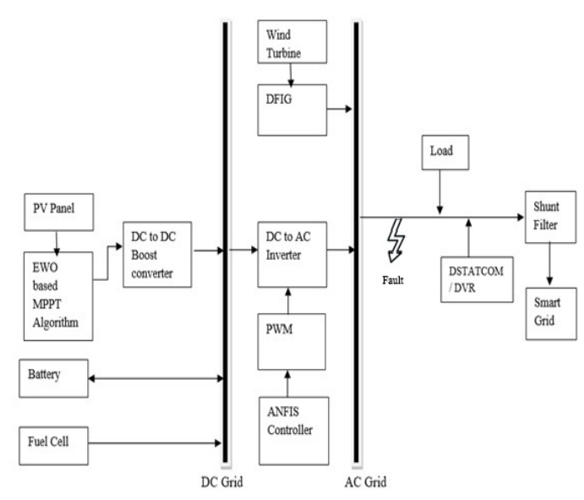

Figure 1 Block diagram of the proposed ANFIS controller-based system

Photovoltaic cells within a module are electrically interconnected in both series and parallel configurations to produce the output voltage and current of a photovoltaic array. Given that the PV array constantly delivers a uniform DC voltage, it is essential to regulate the output voltage for best performance. The Maximum Power Point Tracking (MPPT) approach is employed for this purpose. This approach allows for the optimisation of PV module output under any situations. The photovoltaic cell comprises 66 parallel strings, each containing five modules arranged in series. The Photovoltaic (PV) cell serves as the fundamental component of a PV module, responsible for converting solar radiation into useful energy. The following is the typical equation for the current drawn by a PV cell:

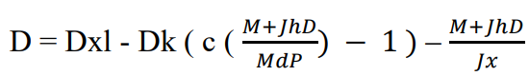

where,

Dxl = Current generated by incoming solar radiation

Dk represents the reverse saturation or leakage current of the diode.

Md = Thermal voltage of a solar module including Ns photovoltaic cells arranged in series = NsKT/Q

K = Boltzmann constant = 1.3806503 × 10^-23 J/K

Q = Electron Charge = 1.60217646 x 10^-19 C d = Temperature expressed in Kelvin

P = Diode ideality factor (1 < P < 1.5)

The voltage increases when PV cells are linked in series, whereas the current increases when the cells are connected in parallel. The peak power output (Pmax, c) and the open-circuit and short-circuit temperature coefficients (KV and KI, respectively) are determined in this lab exercise. The typical test settings for reporting this information are 250 degrees Celsius and 1000 watts of light per square meter. The saturation current, diode ideality constant, parallel resistance, and series resistance of the light-producing diode may be evaluated in the simulation to see whether they fall within the acceptable ranges specified by the manufacturer. As a function of temperature, the following equation explains the connection between sun irradiation and the resultant current.

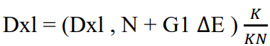

where,

Dxl, N denotes the light-induced current under standard conditions, specifically at 25°C and 1000 W/m².

∆E = Actual temperature - Nominal temperature expressed in Kelvin

K = Irradiance on the surface of the device

KN = Irradiance at standard levelsIt is possible to express the saturation current Dk in a diode and its temperature dependence.

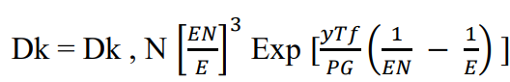

It is possible to express the saturation current Dk in a diode and its temperature dependence.

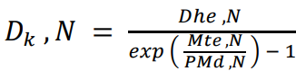

where, Voc, N = Nominal open-circuit voltage of the photovoltaic module.

**Fuel Cell Module**

The fuel cell's module is determined by the electrolyte employed in the device. It is suggested that you use a Proton Exchange Membrane (PEM) fuel cell, which consists of an anode, a cathode, and an electrolyte membrane. The PEMFC's adaptable design allows it to produce 45 V at the fuel cell's output and 6 kW of electricity. This adds to the fuel cell's excellent efficiency.

**Wind Source**

Wind speed (Mu) is defined as the mean velocity across the area traversed by the blades.

The power equation generated by the wind turbine is presented below.



The amount of aerodynamic torque in Nm is given below



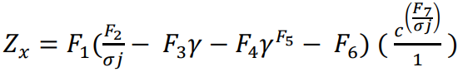



**Battery Storage**

System Innovation is crucial because of the ongoing disparity between supply and demand. The battery may be utilized to store excess energy for later use. The proposed microgrid employs a VSC connected to a battery to control active and reactive power adjustment. The control algorithms are continually being executed to maintain a steady State of Charge (SOC) in the batteries.

**Controller Mechanism based on ANFIS Controller and PWM Generation**

The combination of a wind turbine with a Doubly-Fed Induction Generator (DFIG) results in the generation of Alternating Current (AC) at the output. The Direct Current (DC) generated by the photovoltaic system is converted into Alternating Current (AC) by the use of a controller mechanism. The structural foundation for PWM pulse converters is a two-level Pulse Width Modulation (PWM) generating block. The pulses in this signal are created using a triangular waveform, in contrast to the sinusoidal waveform used in the modulation signal. In the operational mode when the system is linked to the grid, the secondary switches are regulated by a Pulse Width Modulation (PWM) signal. The PWM generator is designed to closely mimic the frequency of the gridline. The generation of modulation signals may occur internally via the PWM generator or externally through the input block by connecting to external signal vectors. The generation of pulses is contingent upon the utilization of a solitary reference signal. The voltage at the terminals of the AC inverter connected to the PWM-generating block regulates the amplitude, frequency, and phase of the reference signal. The DPQC uses a synchronous reference frame to manage the operation of two voltage source inverters. The selection of this approach aligns with contemporary practices in reference signal generation methods, while the experimental setup is powered by a signal conditioning board and a Central Processing Unit (CPU). The DPQC-P-DVR is a command that is used to control and manage various aspects of a system or process. Hall effect sensors are used for the measurement of supply voltages (𝑉𝑜𝑥, 𝑉𝑜𝑦,) and the load terminal voltages (𝑉𝑀𝑥, 𝑉𝑀𝑦,𝑧) To provide gating signals for the Insulated Gate Bipolar Transistors (IGBTs) in the series inverter, it is necessary to align them using the Sinusoidal Pulse Width Modulation (SPWM) technique for signal creation. Both inverters calculate reference values and then compare them to the measured values. Therefore, it is feasible to compute the required injection voltage and current. The reference voltages used in series voltage source inverters are derived from the common-coupling voltages of the three phases. (𝑉𝑜𝑥, 𝑉𝑜𝑦,𝑉𝑜𝑧). The voltages in question are obtained via the use of Hall effect sensors. The signal conditioning board uses Band Pass Filters (BPFs) to eliminate ripple information from the signals before transforming. The experiment was conducted via a first-order filter. The voltages corresponding to the t-axis and the B-axis are expressed as





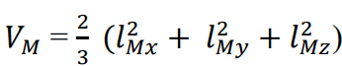

As previously stated, Pr and ripple contents were filtered through a low-pass filter to get the reference signals. To maintain the Pr bus voltage and compensate for losses, a PI controller was implemented at the Pr bus voltage, with the controller's output providing the current component (jloss) necessary to address these losses. Therefore, the amplitude of the reference supply current is expressed as



This indicates that a finely calibrated fuzzy controller may be employed in the development of a current regulator, AC voltage regulator, or DC voltage regulator. The current regulator of the D-STATCOM control system is analysed in relation to the system's inner loop, while the DC and AC voltage regulators are evaluated concerning the system's outer regulatory loop.

**4. Result and Discussion**

The effectiveness of the suggested system's use of DSTATCOM is verified by examining the achieved results. The following are the expected results, based on the estimated performance of the DSTATCOM device application:

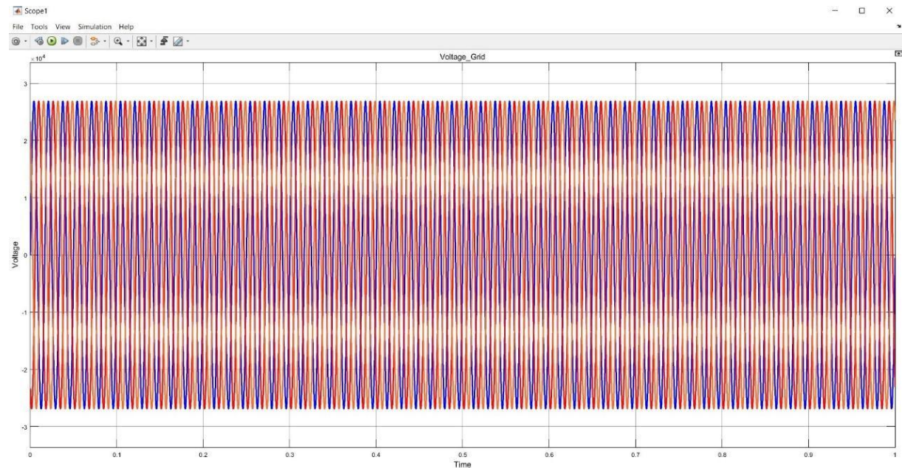

Figure 2 Performance analysis of grid voltage using DSTATCOM for the ANFIS controller

The results of the grid voltage investigation conducted using the DSTATCOM are shown in Figure 2. The phenomenon of oscillation is visually represented via a spectrum of colors, enabling a clear observation of the deviation and oscillatory behavior in the flow of electricity. To maintain voltage stability, power variations are rectified

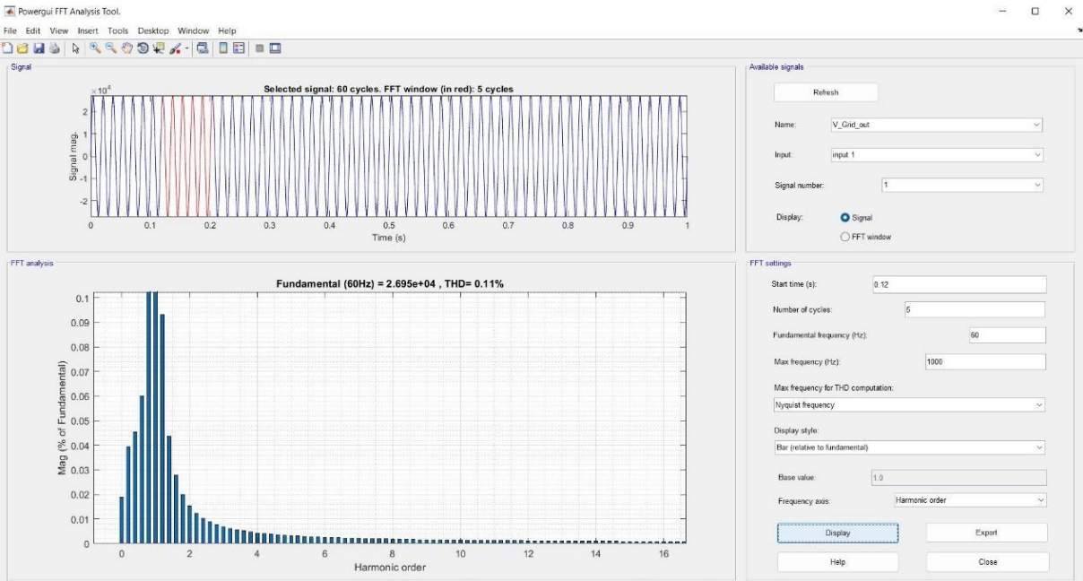

Figure 3 THD analysis of grid voltage using DSTATCOM for the ANFIS controller

Figure 3 illustrates the overall harmonic distortion performance of the grid voltage according to the suggested approach for the DSTATCOM apparatus. With a 0.12-second rise-to-basics frequency and a 60-hertz fundamental frequency, the THD obtained is around 0.11%.

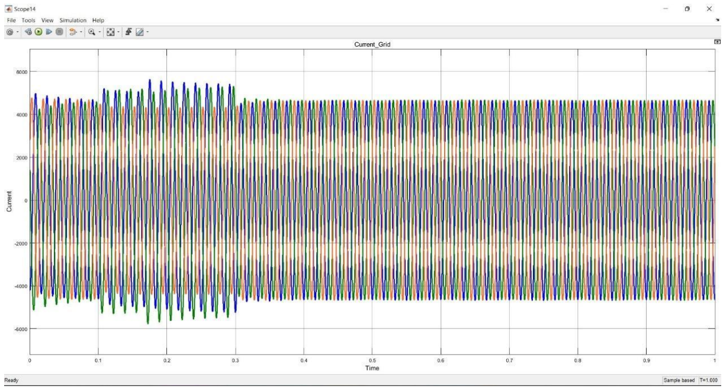

Figure 4 Performance analysis of grid current using DSTATCOM for the ANFIS controller

The efficacy of the proposed system's use of the customized power device DSTATCOM is validated by an examination of the grid current outcomes shown in Figure 4. The current flow exhibits a diverse range of changes and oscillations, which are visually represented by a spectrum of colors like a rainbow. Based on the findings of the research, it is evident that there are variations in the current, which need rectification to maintain uninterrupted current flow inside the grid.

**5. Conclusion**

The integration of Distributed Generation (DG) and Renewable Energy Sources (RES) into distribution networks introduces significant power quality challenges due to their intermittent and non-linear nature. Custom Power Devices (CPDs) such as DVRs, D-STATCOMs, and UPQCs are essential in mitigating these issues, but their effectiveness largely depends on the sophistication of their control systems. This work highlights the need for and advantages of developing improved, intelligent controllers—such as adaptive, nonlinear, and AI-based approaches—that can respond swiftly and accurately to dynamic power quality disturbances. Implementing such advanced control strategies not only enhances the performance of CPDs but also supports the broader goals of reliable, efficient, and sustainable power delivery in modern, renewable-rich distribution systems.

**References**

1. Mosaad, MI & Ramadan, HS 2018, ‘Power quality enhancement of grid-connected fuel cell using evolutionary computing techniques’, International Journal of Hydrogen Energy, vol. 43, no. 25, pp. 11568-11582.
2. Nagaraj, C & Sharma, KM 2021, ‘Bi-directional power flow control with improved power quality using intelligent controller for AC-DC coupled hybrid micro-Grid system’, International Journal of Power Electronics, vol. 14, no. 2, pp. 156-179.
3. Rajesh, P, Shajin, FH & Umasankar, L 2021, ‘A novel control scheme for PV/WT/FC/battery to power quality enhancement in micro grid system: A Hybrid Technique’, Energy Sources, Part A: Recovery, Utilization, and Environmental Effects, pp. 1-17.
4. Sarkar, DD & Gupta, CJIJ 2021, ‘YYPO-PSO Algorithm Based Power Quality Control in a Grid-Connected Hybrid System’, International Journal of Advanced Trends in Computer Science and Engineering, vol. 10, no. 2, pp. 781-786.
5. Raman, G, Raman, G, Peng, JC-H & Xiao, W 2017, ‘Bridging the transition to DC distribution: A hybrid microgrid for residential apartments’, 2017 IEEE Innovative Smart Grid Technologies-Asia (ISGT-Asia), pp. 1-6.
6. Goud, BS & BLJIJ, O & Rao, RER 2020, ‘An intelligent technique for Optimal Power Quality Enhancement (OPQE) in an HRES grid connected system: ESA technique’, International Journal of Renewable Energy Research, vol. 10, no. 1, pp. 317-328.
7. Mosaad, MI & Ramadan, HS 2018, ‘Power quality enhancement of grid-connected fuel cell using evolutionary computing techniques’, International Journal of Hydrogen Energy, vol. 43, no. 25, pp. 11568-11582.
8. Ansari, J, Abbasi, AR & Firouzi, BB 2022, ‘Decentralized LMI-based event-triggered integral sliding mode LFC of power systems with disturbance observer’, International Journal of Electrical Power & Energy Systems, vol. 138, P. 107971.
9. Ansari, J, Abbasi, AR, Heydari, MH & Avazzadeh, Z 2022, ‘Simultaneous design of fuzzy PSS and fuzzy STATCOM controllers for power system stability enhancement’, Alexandria Engineering Journal, vol. 61, no. 4, pp. 2841-2850.
10. Saradha Devi, A & Karpagam, N 2023, ‘Power quality improvement of hybrid distributed system using MGWO technique-based DVR and DSTATCOM’, Electric Power Components and Systems, vol. 52, no. 01, pp. 99-119.
11. Dong, L, Zhang, T, Pu, T, Chen, N & Sun, Y 2019, ‘A decentralized optimal operation of AC/DC hybrid microgrids equipped with power electronic transformer’, IEEE Access, vol. 7, pp. 157946-157959.
12. Hossain, MA, Pota, HR, Hossain, MJ & Blaabjerg, F 2019, ‘Evolution of microgrids with converter-interfaced generations: Challenges and opportunities’, International Journal of Electrical Power & Energy Systems, vol. 109, pp. 160-186.
13. Jumani, TA, Mustafa, M, Anjum, W & Ayub, SJP 2019, ‘Salp swarm optimization algorithm-based controller for dynamic response and power quality enhancement of an islanded microgrid’, Processes, vol. 7, no. 11, P. 840.
14. Li, P & Zheng, M 2019, ‘Multi-objective optimal operation of hybrid AC/DC microgrid considering source-network-load coordination’, Journal of Modern Power Systems and Clean Energy, vol. 7, no. 5, pp. 1229-1240.
15. Malik, SM, Sun, Y, Ai, X, Chen, Z & Wang, K 2019, ‘Cost-based droop scheme for converters in interconnected hybrid microgrids’, IEEE Access, vol. 7, pp. 82266-82276.
16. Naderi, Y, Hosseini, SH, Zadeh, SG, Mohammadi-Ivatloo, B, Savaghebi, M & Guerrero, JM 2019, ‘An optimized direct control method applied to multilevel inverter for microgrid power quality enhancement’, International Journal of Electrical Power & Energy Systems, vol. 107, pp. 496-506.