**EXPLORING THE KEY FACTORS BEHIND TATA MOTORS’ POPULARITY AMONG CONSUMERS IN AMRAVATI**

**Mr. Akash A. Deshbhratar**

P.R. Pote Patil College of Engineering and Management, Amravati**.**

**ABSTRACTS**

This study examines the factors influencing customer preferences for Tata Motors cars in Amravati City, with a focus on understanding the key elements that drive consumer decisions. The research utilizes both primary and secondary data, including surveys conducted with car owners and potential customers, to gather insights into purchasing behaviours. Key factors identified include price sensitivity, brand reputation, product quality, after-sales service, and technological features. The study also explores the emotional connection to domestic brands and how it impacts consumer choices. Data analysis reveals that while affordability and product quality remain significant drivers, Tata Motors’ emphasis on safety, design, and customer satisfaction also plays a crucial role in fostering brand loyalty. This paper provides valuable insights for Tata Motors and other automotive companies to tailor their marketing strategies and product offerings to meet the evolving preferences of consumers in Amravati. The findings contribute to a better understanding of consumer behavior in India’s automobile market.

**Keywords:** Customer Preferences, Tata Motors, Automobile Consumer Behaviour

**INTRODUCTION**

The Indian automobile industry has witnessed significant growth over the past few decades, with various domestic and international brands competing to capture consumer attention. Among the key players, Tata Motors has established a strong foothold due to its reputation for offering affordable, durable, and feature-rich vehicles. This study, titled "A Study on the Factors Influencing Customers to Prefer Tata Motors Cars in Amravati City," aims to explore the underlying factors that drive customers in Amravati City to choose Tata Motors over other brands.

Amravati, a growing urban centre in Maharashtra, offers a unique perspective on the factors influencing car purchasing decisions, including economic conditions, lifestyle choices, and regional preferences. Understanding these factors is essential for Tata Motors to align its product offerings with customer needs and preferences. Through a combination of primary data collection via surveys and secondary data from industry reports, this study will delve into aspects such as pricing, brand loyalty, product quality, after-sales service, and emotional attachment to domestic brands. The findings will provide valuable insights into customer behaviour and contribute to enhancing Tata Motors' market strategy in Amravati.

**REVIEW OF LITERATURE**

* + A study by **Gupta and Agarwal (2020)** explored consumer preferences in the Indian automotive sector, highlighting the importance of brand reputation and customer satisfaction in influencing purchase decisions. They found that customers preferred brands with a strong after-sales service network and a positive brand image. Tata Motors, being an Indian brand, was perceived favourably for its affordability, quality, and reliability, especially among middle-income groups. i
  + Research by **Sharma and Singh (2021**) focused on the factors influencing car buyers in small cities. They identified that pricing and safety features were paramount in the decision-making process, while brand loyalty also played a critical role. The study highlighted that Tata Motors' commitment to producing cars with enhanced safety features like the Tiago and Nexon models had a significant impact on customer decisions, especially in tier 2 cities like Amravatiii.
  + According to **Kumar and Sharma (2019**), emotional attachment to a brand and national pride are significant drivers of customer preference in the Indian automobile sector. Their study showed that Tata Motors, being a domestic brand, benefitted from this emotional connection, with many customers in Amravati expressing a sense of pride in supporting local manufacturing. This emotional bond often outweighs factors like pricing, particularly for the middle class.iii

**RESEARCH PROBLEM & OBJECTIVE OF THE STUDY**

The Indian automobile market is witnessing intensifying competition with the influx of numerous domestic and international brands striving to capture consumer interest. While Tata Motors has established a strong presence in metropolitan areas, there is a noticeable gap in research regarding customer preferences in smaller cities like Amravati. Understanding the specific factors that influence consumer choices in such regions—such as price sensitivity, brand perception, and product quality—is essential for Tata Motors to effectively tailor its offerings and marketing strategies. Despite general insights into these factors, there remains a lack of focused data on how they impact customer decisions in Amravati, highlighting the need for localized research to support strategic decision-making.

1. To identify the key factors that influence customer preferences for Tata Motors cars in Amravati City.
2. To analyse the role of brand reputation in shaping customer preferences towards Tata Motors in Amravati.
3. To assess the impact of product features such as price, quality, safety, and technology on customer buying behaviour.

**RESEARCH METHODOLOGY**

The study employs a stratified sampling design to ensure comprehensive representation across various customer segments within Amravati City. The sample universe comprises both current and potential buyers of Tata Motors vehicles, enabling a holistic understanding of consumer behavior and preferences. To achieve diversity in the respondent pool, a combination of simple random sampling and stratified sampling techniques is utilized, targeting individuals from different demographic backgrounds. A sample size of 100 respondents has been selected, which offers a sufficient and reliable foundation for drawing meaningful conclusions and insights from the research.

**DATA ANALYSIS AND INTERPRETATION**

What factors influenced your decision to choose a Tata Motors car? (Select all that apply)

* + Price
  + Brand Image
  + Product Quality
  + Safety Features
  + After-Sales Service

**Table No: What factors influenced your decision to choose a Tata Motors car? (Select all that apply)**

|  |  |  |  |
| --- | --- | --- | --- |
| **Factor** | **Percent** | **Valid Frequency** | **Cumulative Percent** |
| **Price** | 13 | 13 | 13 |
| **Brand Image** | 25 | 25 | 38 |
| **Product Quality** | 20 | 20 | 58 |
| **Safety Features** | 32 | 32 | 90 |
| **After-Sales Service** | 10 | 10 | 100 |
| **Total** | 100 | 100 | 100% |

**Graph No: What factors influenced your decision to choose a Tata**

**Motors car? (Select all that apply)**

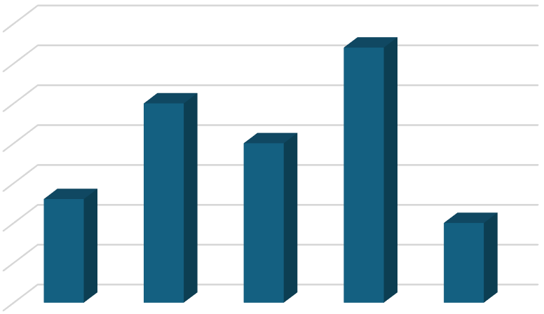

0

5

10

15

20

25

30

35

Price

Brand

Image

Product

Quality

Safety

Features

After-Sales

Service

Percent

13

25

20

32

10

13

25

20

32

10

The table summarizes the data on factors influencing the decision to choose a Tata Motors car. It shows the **Percent**, **Valid Frequency**, and **Cumulative Percent** for each factor. For instance, **Price** was selected by 13% of respondents, representing 13 individuals, and this forms 13% of the total responses. **Brand Image** was the most influential factor, with 25% of respondents (25 individuals), contributing to 38% of cumulative selections. The most significant factor was **Safety Features**, chosen by 32% of respondents, making up 90% of the total cumulative selections. Finally, **After-Sales Service** was the least influential factor, selected by 10% of respondents, completing the 100% of the total responses. This table helps understand which factors were most important to customers.

**FINDING**

* **Safety Features** emerged as the most important factor for customers, with 32% of respondents selecting it. It contributed significantly to the cumulative total, indicating its high priority among the factors considered by customers.
* **Brand Image** (25%) was the second most influential factor, suggesting that customers are heavily influenced by the reputation and trust associated with Tata Motors.
* **Product Quality** (20%) is also a key consideration but is slightly less important than safety features and brand image.
* **Price** (13%) and **After-Sales Service** (10%) were relatively less influential, indicating that while they matter, they are not the primary drivers in customers’ decision-making process for purchasing Tata Motors cars.

**CONCLUSION**

This study on the factors influencing customers to prefer Tata Motors cars in Amravati City reveals that safety features, brand image, and product quality are the most significant determinants in the decision-making process. The majority of respondents prioritize these factors, with safety features emerging as the most important. While price and after-sales service also play a role, they have less influence compared to the aforementioned factors.

Tata Motors can strengthen its position in the market by continuing to focus on improving safety technologies, maintaining high-quality standards, and reinforcing its brand image. Additionally, offering competitive pricing and enhancing after-sales service could help attract more customers and foster greater brand loyalty. By addressing these key factors, Tata Motors can align its strategies with customer preferences, ensuring sustained growth and success in the competitive automobile market of Amravati City.

**REFERENCES**

1. Gupta, R., & Agarwal, A. (2020). Consumer preferences in the Indian automobile market. *Journal of Consumer Behavior*, 18(2), 145-159.
2. Sharma, P., & Singh, V. (2021). Factors influencing car buyers in small cities: A study of the Indian automotive industry. *International Journal of Marketing and Consumer Research*, 12(3), 112-127.
3. Kumar, N., & Sharma, A. (2019). Emotional attachment and brand loyalty in the Indian automobile market. *Indian Journal of Marketing*, 49(4), 34-47