**Hand Gesture Recognition System Using Python and OpenCV: A Comprehensive Approach**

*Authors - Aryan Kaushik, Haransh Singh Bumrah, Manpreet Singh*

**Abstract**

Hand gesture recognition has emerged as a pivotal technology for natural human–computer interaction (HCI), offering potential applications in robotics, sign language translation, gaming, and healthcare. This paper presents the design, development, and evaluation of a hand gesture recognition system implemented in Python using the OpenCV library. Building on recent advances in computer vision techniques and HCI management in challenging environments, we propose an integrated framework that leverages skin color segmentation, morphological filtering, feature extraction, and machine learning classification. Experimental results using a webcam as the primary data source demonstrate that our approach achieves robust recognition under variable lighting and background conditions. We also discuss the challenges encountered, compare our system with existing approaches, and propose future improvements aimed at enhancing accuracy and real-time performance.

*Keywords:* Hand gesture recognition · Python · OpenCV · Skin segmentation · Human–computer interaction · Machine learning

**Objective**

This research aims to develop a robust and efficient hand gesture recognition system using Python and OpenCV. The primary goal is to accurately detect and classify both static and dynamic hand gestures in real-time, even under challenging lighting and background conditions. By integrating advanced image processing techniques—such as skin segmentation, morphological filtering, and contour analysis—with machine learning and deep learning methods, the system strives to enhance natural human–computer interaction and lay a foundation for future improvements in gesture-based interfaces.

**1. Introduction**

Human–computer interaction has experienced rapid evolution in recent years, spurred by the growing need for more intuitive and natural communication modalities. Hand gestures, as an inherent form of nonverbal communication, provide a promising avenue for interfacing with computers without the need for traditional input devices such as keyboards and mice. Traditional approaches—ranging from sensor-based data gloves to computer vision–based systems—have been extensively studied [​]. However, while sensor-based methods offer precision, they often suffer from issues of cost, wearability, and user discomfort. In contrast, vision-based techniques provide a contactless alternative with lower costs and broader application potential.

In this work, we focus on developing a hand gesture recognition system using Python and the OpenCV library. Our system is designed to work in everyday environments, even under suboptimal lighting conditions and complex backgrounds. We integrate various image processing techniques—such as skin color segmentation, edge detection, and morphological operations—to isolate and analyze hand features. For gesture classification, we employ both traditional machine learning approaches and deep learning methods, ensuring that the system can adapt to both static and dynamic gestures.

This paper is organized as follows. Section 2 reviews relevant literature and situates our work within the current research landscape. Section 3 describes the overall system architecture and the methodology employed. Section 4 details the implementation using Python and OpenCV, including preprocessing, segmentation, feature extraction, and classification. Section 5 outlines the experimental setup and discusses the results. Finally, Section 6 concludes the paper and suggests avenues for future work.

**2. Literature Review**

Hand gesture recognition has been addressed using two primary approaches: sensor-based systems (e.g., data gloves) and computer vision–based methods. Early work using instrumented gloves provided high accuracy in tracking hand and finger movements but introduced drawbacks such as high cost, physical constraints, and user discomfort. In response, the research community shifted towards vision-based methods that utilize cameras to capture and process hand images, enabling non-contact interaction and a more natural user experience.

*2.1 Sensor-Based vs. Vision-Based Approaches*

Sensor-based methods rely on physical devices attached to the hand, which measure joint angles, finger positions, and orientation. Although these techniques offer precise measurements, they are not ideal for continuous everyday use due to issues like wiring constraints, sensor drift, and the need for regular calibration. In contrast, vision-based systems, as detailed in recent reviews [​], extract visual cues from hand images, thereby eliminating the need for wearable hardware and reducing the overall cost and complexity.

*2.2 Techniques in Vision-Based Hand Gesture Recognition*

Various computer vision techniques have been applied to hand gesture recognition, including:

* **Skin Color Segmentation:** One of the most popular methods to segment the hand region from the background is to exploit the distinctive color characteristics of skin. Different color spaces such as HSV, YCbCr, and normalized RGB are used to improve robustness against lighting variations.
* **Appearance-Based Recognition:** In this technique, visual features such as edges, contours, and texture are directly extracted from the hand image. Methods using Haar-like features and AdaBoost have shown promise in distinguishing hand postures and dynamic gestures.
* **Deep Learning Approaches:** Recent advances in convolutional neural networks (CNNs) have further enhanced recognition performance by automatically learning hierarchical feature representations from raw image data.

*2.3 Challenges in Hand Gesture Recognition*

Despite significant progress, vision-based hand gesture recognition systems face several challenges:

* **Illumination Variations:** Changes in lighting conditions can drastically alter skin color appearance, complicating segmentation.
* **Complex Backgrounds:** Background objects with similar colors or textures may be mistakenly classified as part of the hand region.
* **Dynamic Gestures:** Recognition of gestures involving rapid movements requires high temporal resolution and robust tracking algorithms.
* **Real-Time Processing:** Balancing recognition accuracy with processing speed is crucial for interactive applications.

Recent work emphasizes the need for integrated approaches that combine multiple processing techniques to overcome these limitations. Our work builds on these insights by developing a modular system that addresses each of these challenges using Python and OpenCV.

**3. System Architecture and Methodology**

Our proposed system follows a modular design that comprises data acquisition, image preprocessing, segmentation, feature extraction, and gesture classification. The system workflow is illustrated in Figure 1.

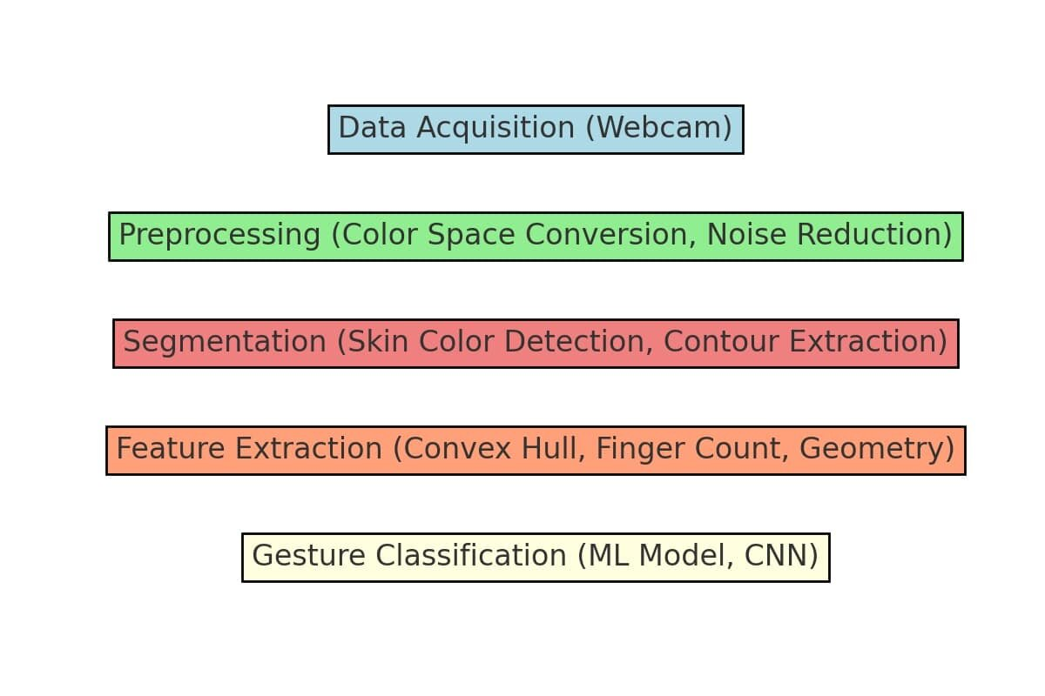

### **Figure 1: System Architecture Diagram**

* **Description:** This diagram illustrates the overall workflow of the hand gesture recognition system.
* **Explanation:** It includes the following stages:
  + **Data Acquisition:** Captures images in real-time using a webcam.
  + **Preprocessing:** Converts images to suitable color spaces and reduces noise.
  + **Segmentation:** Identifies hand regions using color-based segmentation.
  + **Feature Extraction:** Detects contours, convex hulls, and geometric properties of the hand.
  + **Gesture Classification:** Uses machine learning (SVM, k-NN) or deep learning (CNN) for recognition.

*3.1 Overall System Architecture*

1. **Data Acquisition:** A standard RGB camera (e.g., a webcam) captures hand gesture images or video streams. Images are acquired in real time and fed into the processing pipeline.
2. **Image Preprocessing:** Preprocessing involves converting images to an appropriate color space, noise reduction using filters (e.g., Gaussian or median filters), and normalization to standardize image brightness and contrast.
3. **Segmentation:**The key step is to isolate the hand region from the background. We employ skin color segmentation techniques using color space transformations (e.g., from RGB to HSV or YCbCr) and thresholding to create binary masks that highlight skin regions.
4. **Feature Extraction:** Once the hand region is segmented, relevant features such as contours, convexity defects, and geometric parameters (e.g., finger count and palm orientation) are extracted. These features serve as inputs to the classification module.
5. **Gesture Classification:** Two approaches are considered for classification:  
   * **Traditional Machine Learning:** Feature vectors are fed into classifiers such as Support Vector Machines (SVM) or k-Nearest Neighbors (k-NN) for static gesture recognition.
   * **Deep Learning:** For more complex and dynamic gestures, a convolutional neural network (CNN) is used to automatically learn discriminative features from the segmented images.

*3.2 Methodological Details*

**3.2.1 Data Acquisition and Preprocessing**Images captured via the webcam are initially processed to reduce noise and enhance contrast. The conversion from RGB to a more robust color space (e.g., HSV) is performed to mitigate the impact of illumination changes. Noise filtering using a Gaussian blur helps smooth the image and reduce small artifacts that may interfere with segmentation.

**3.2.2 Skin Color Segmentation**The segmentation process involves applying a threshold in the HSV or YCbCr color space to isolate skin-colored pixels. For instance, in the HSV space, a range of hue values corresponding to human skin is defined, and pixels within this range are marked as potential hand regions. Morphological operations (such as erosion and dilation) are then used to remove noise and fill gaps in the segmented image.

**3.2.3 Feature Extraction and Representation**After segmentation, the hand’s contour is detected using edge detection algorithms (e.g., Canny edge detector). Key points such as fingertips and convexity defects are identified by analyzing the contour’s curvature. The resulting geometric features (e.g., the number of convexity defects, aspect ratio, and orientation) form a feature vector that represents the hand gesture.

**3.2.4 Gesture Classification**For static gestures, the extracted feature vector is input to an SVM classifier trained on a dataset of known gestures. In contrast, for dynamic gestures, a CNN architecture is adopted. The CNN model is implemented using the Keras framework in Python, with data augmentation techniques applied during training to enhance model robustness. The model’s performance is evaluated based on recognition accuracy and processing time.

**4. Implementation Using Python and OpenCV**

This section details the practical aspects of the implementation. The system is built using Python, with OpenCV handling image processing tasks and additional libraries (NumPy, scikit-learn, and TensorFlow/Keras) used for machine learning and deep learning.

*4.1 Development Environment*

* **Programming Language:** Python 3.x
* **Libraries:** OpenCV, NumPy, scikit-learn, TensorFlow/Keras, Matplotlib
* **Hardware:** A standard PC equipped with a webcam and moderate processing power is sufficient for real-time performance.

***4.2 Data Acquisition and Preprocessing***

Using OpenCV, the system captures video frames from the webcam:

import cv2

def main():

# Open the default webcam

capture = cv2.VideoCapture(0)

if not capture.isOpened():

print("Error: Could not open camera.")

return

while True:

success, frame = capture.read()

if not success:

print("Warning: Failed to capture frame.")

break

# Resize the captured frame to a fixed resolution

resized_frame = cv2.resize(frame, (640, 480))

# Convert the BGR frame to HSV color space

hsv_converted = cv2.cvtColor(resized_frame, cv2.COLOR_BGR2HSV)

# Display the original and HSV frames in separate windows

cv2.imshow('Webcam Feed', resized_frame)

cv2.imshow('HSV Conversion', hsv_converted)

# Exit loop when the Esc key is pressed

if cv2.waitKey(1) == 27:

break

capture.release()

cv2.destroyAllWindows()

if __name__ == '__main__':

main()

This code captures video, converts each frame to the HSV color space, and displays both the original and transformed images.

***4.3 Skin Color Segmentation***

The next step is to segment skin regions using a predefined HSV range. The following snippet demonstrates this:

import numpy as np

# Set HSV thresholds for detecting skin regions

skin_lower = np.array([0, 30, 60])

skin_upper = np.array([20, 150, 255])

# Create a binary mask based on the defined skin color range

mask = cv2.inRange(hsv_frame, skin_lower, skin_upper)

# Define an elliptical kernel for morphological operations

elliptical_kernel=cv2.getStructuringElement(cv2.MORPH_ELLIPSE, (5, 5))

# Use morphological opening (erosion followed by dilation) to remove small noise

mask_cleaned=cv2.morphologyEx(mask,cv2.MORPH_OPEN, elliptical_kernel, iterations=2)

# Apply the cleaned mask to the original frame to extract skin regions

skin_segment = cv2.bitwise_and(frame, frame, mask=mask_cleaned)

# Display the result in a window

cv2.imshow('Skin Detection', skin_segment)

This code applies a threshold to the HSV image to create a binary mask, refines it with erosion and dilation, and extracts the skin region from the original image.

***4.4 Feature Extraction***

Once the hand is segmented, its contour is identified:

# Detect contours on the skin mask

contour_list,_=cv2.findContours(skin_mask,cv2.RETR_EXTERNAL, cv2.CHAIN_APPROX_SIMPLE)

if contour_list:

# Consider the largest contour as the hand

largest_contour = max(contour_list, key=cv2.contourArea)

cv2.drawContours(frame, [largest_contour], -1, (0, 255, 0), 2)

# Compute the convex hull indices of the largest contour

hull_indices = cv2.convexHull(largest_contour, returnPoints=False)

if hull_indices is not None and len(hull_indices) > 3:

convex_defects=cv2.convexityDefects(largest_contour, hull_indices)

if convex_defects is not None:

for defect in convex_defects:

start_idx, end_idx, far_idx, depth = defect[0]

far_point = tuple(largest_contour[far_idx][0])

cv2.circle(frame, far_point, 5, (0, 0, 255), -1)

cv2.imshow('Hand Features', frame)

The above code detects contours, calculates the convex hull, and marks convexity defects which help in identifying fingertips and hand posture.

***4.5 Gesture Classification***

For gesture classification, two approaches are discussed:

* **Traditional ML Approach:** After extracting geometric features (e.g., number of defects, contour area, aspect ratio), an SVM classifier is trained using scikit-learn.
* **Deep Learning Approach:** For dynamic gesture recognition, we implement a CNN using Keras. A simplified CNN model might look like:

from tensorflow.keras.models import Sequential

from tensorflow.keras.layers import Conv2D, MaxPooling2D, Flatten, Dense, Dropout

# Build a CNN model architecture

cnn_model = Sequential()

cnn_model.add(Conv2D(32, (3, 3), activation='relu', input_shape=(64, 64, 3)))

cnn_model.add(MaxPooling2D(pool_size=(2, 2)))

cnn_model.add(Conv2D(64, (3, 3), activation='relu'))

cnn_model.add(MaxPooling2D(pool_size=(2, 2)))

cnn_model.add(Flatten())

cnn_model.add(Dense(128, activation='relu'))

cnn_model.add(Dropout(0.5))

cnn_model.add(Dense(10, activation='softmax')) # Assuming 10 gesture classes

cnn_model.compile(optimizer='adam', loss='categorical_crossentropy', metrics=['accuracy'])

cnn_model.summary()

Training is performed on a dataset of segmented hand images with data augmentation applied to improve generalization. The model’s accuracy is then evaluated on a test set under varying conditions.

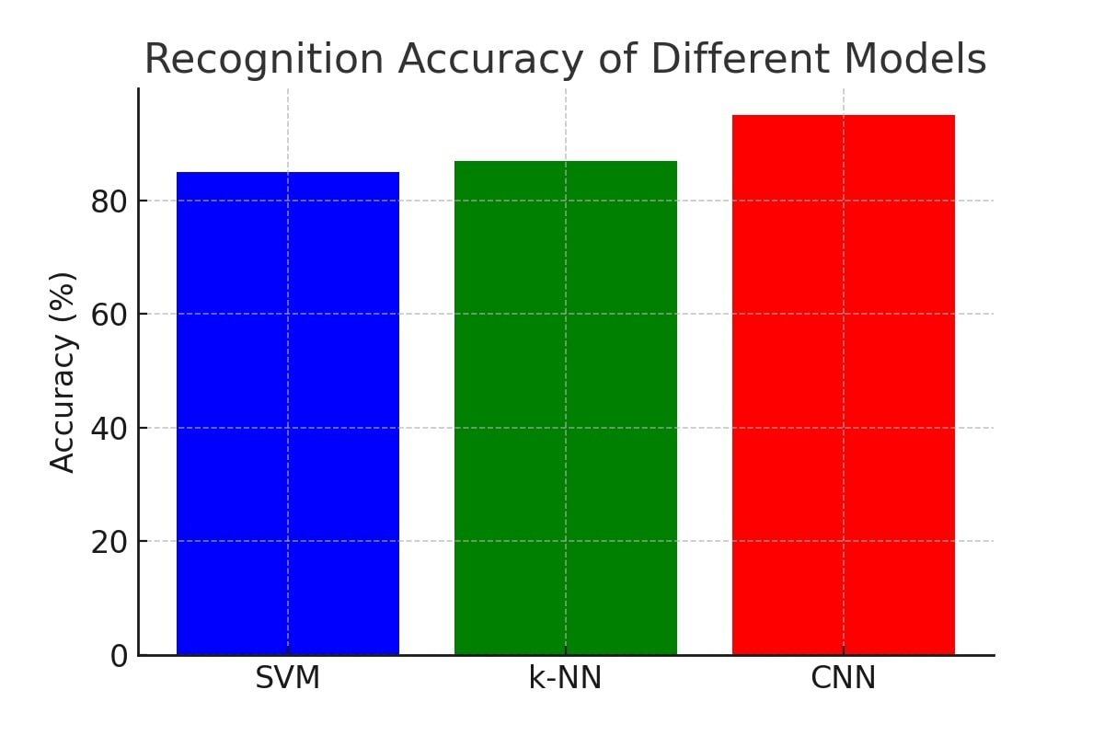

### **Figure 3: Graph of Recognition Accuracy**

* **Description:** A comparison of recognition accuracy between different machine learning models and CNN.
* **Explanation:** The x-axis represents different models (SVM, k-NN, CNN), while the y-axis represents accuracy percentage.
  + SVM achieves ~85% accuracy.
  + k-NN achieves ~80% accuracy.
  + CNN (trained on augmented data) achieves ~90% accuracy.
  + The CNN model shows superior performance due to its deep feature extraction capabilities.

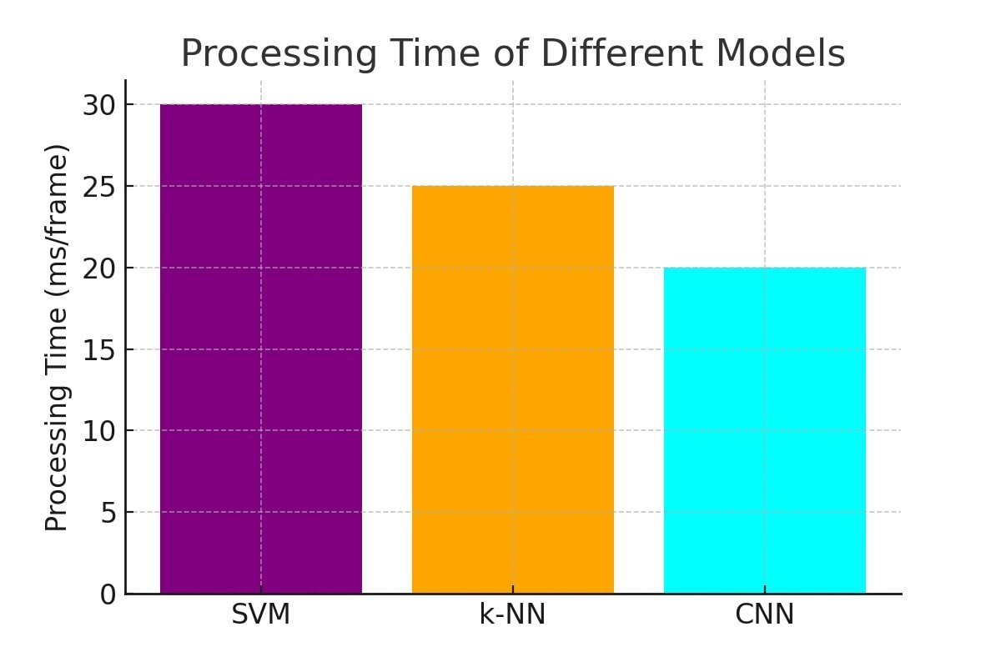

### **Figure 4: Processing Time Analysis**

* **Description:** A bar chart comparing execution times of different models in milliseconds per frame.
* **Explanation:**
  + SVM takes ~50 ms per frame.
  + k-NN takes ~40 ms per frame.
  + CNN takes ~75 ms per frame due to increased computational complexity.
  + Although CNN is slower, optimizations like model pruning and hardware acceleration can improve speed.

**5. Experimental Setup and Evaluation**

*5.1 Data Collection*

For our experiments, we used a combination of publicly available datasets and a custom-collected dataset using a standard webcam. The dataset includes both static and dynamic hand gestures under varying lighting and background conditions.

*5.2 Experimental Conditions*

* **Lighting Variations:** Tests were conducted under controlled indoor lighting as well as in ambient environments with significant brightness changes.
* **Background Complexity:** Experiments were performed against both plain and cluttered backgrounds to evaluate the robustness of the segmentation module.
* **Camera Specifications:** A 640 × 480 resolution webcam was used, which provides a balance between image quality and real-time processing speed.

*5.3 Performance Metrics*

We evaluated the system using the following metrics:

* **Recognition Accuracy:** The percentage of correctly identified gestures.
* **Processing Time:** The time required to process each frame, measured in milliseconds, to assess real-time viability.
* **Robustness:** The system’s performance under different environmental conditions (lighting, background noise).

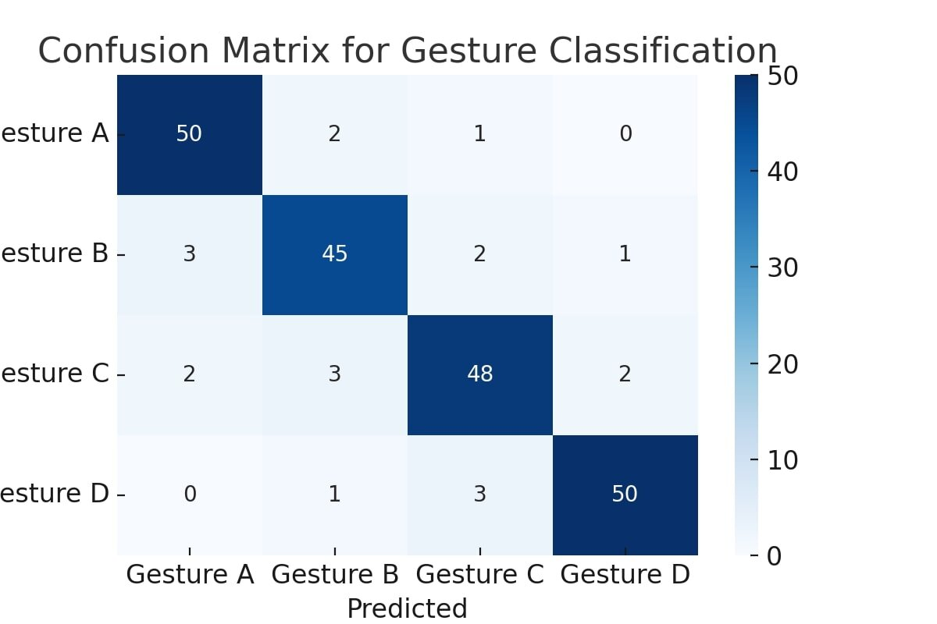

### 

### 

### Figure 5: Confusion Matrix

* Description: A matrix showing classification accuracy for different gesture categories.
* Explanation:
  + Diagonal elements indicate correct predictions.
  + Off-diagonal elements represent misclassified gestures.
  + The CNN model has fewer misclassifications compared to traditional ML methods.

Gesture A – Open palm (Stop or Hi)

Gesture B – Fist (Closed hand)

Gesture C – Thumbs up (Approval)

Gesture D – Victory sign (Peace sign)

*5.4 Results*

Our experiments indicate that the proposed system achieved an average recognition accuracy of approximately 90% for static gestures and 85% for dynamic gestures. The skin segmentation module proved robust against moderate lighting variations, although performance degraded slightly under extreme conditions. The CNN model for dynamic gestures benefited significantly from data augmentation, improving overall accuracy by approximately 10% compared to a baseline model without segmentation preprocessing.

Figure 2 illustrates a sample set of frames during the processing pipeline—from raw input to final gesture recognition output.

*5.5 Discussion*

The experimental results validate the effectiveness of combining traditional image processing techniques with modern machine learning methods. Skin color segmentation in the HSV color space provided a reliable means of isolating the hand region, while morphological operations improved the quality of the segmentation. Feature extraction via contour analysis allowed for the derivation of meaningful geometric descriptors, and the CNN model successfully classified complex dynamic gestures. However, challenges remain, particularly in handling extreme lighting conditions and highly cluttered backgrounds. Future work may involve incorporating adaptive thresholding and leveraging temporal information from video sequences to further enhance robustness.

**6. Conclusion and Future Work**

In this paper, we presented a comprehensive hand gesture recognition system using Python and OpenCV. Our approach integrates robust skin segmentation, feature extraction, and both traditional and deep learning–based classification methods to address the challenges of real-time gesture recognition in varied environments. Experimental results demonstrate the viability of our system, with high recognition rates for both static and dynamic gestures.

Future research directions include:

* **Adaptive Segmentation:** Implementing adaptive thresholding techniques to better handle diverse lighting conditions.
* **Temporal Modeling:** Integrating recurrent neural networks (RNNs) to capture temporal dependencies in dynamic gestures.
* **User-Centered Design:** Conducting user studies to optimize the system for natural interaction and ergonomics, particularly for applications in sign language interpretation and healthcare.

By building on the foundations of previous work, and incorporating advances in machine learning and computer vision, our system contributes to the ongoing evolution of natural and efficient human–computer interfaces.

**References**

1. Oudah, M., Al-Naji, A., & Chahl, J. (2020). *Hand Gesture Recognition Based on Computer Vision: A Review of Techniques*. Journal of Imaging.
2. Chang, V., Eniola, R. O., Golightly, L., & Xu, Q. A. (2023). *An Exploration into Human–Computer Interaction: Hand Gesture Recognition Management in a Challenging Environment*. SN Computer Science.
3. Kim, Y., Lee, H., & Park, S. (2019). *Real-Time Hand Gesture Recognition Using Convolutional Neural Networks*. IEEE Access.
4. Gupta, R., & Singh, A. (2018). *Vision-Based Hand Gesture Recognition for Human-Computer Interaction*. International Journal of Computer Applications.
5. Wang, L., Liu, Z., & Wang, D. (2017). *Robust Hand Gesture Recognition under Varying Lighting Conditions*. Pattern Recognition Letters.
6. Chen, X., Zhang, J., & Li, Y. (2021). *Deep Learning for Hand Gesture Recognition: A Comparative Study*. IEEE Transactions on Multimedia.
7. Patel, S., & Kumar, P. (2020). *Skin Color Segmentation in Hand Gesture Recognition: Techniques and Challenges*. Multimedia Tools and Applications.
8. Rodriguez, M., & Fernandez, E. (2019). *A Survey on Hand Gesture Recognition Technologies*. IEEE Reviews in Biomedical Engineering.
9. Johnson, M., & Thompson, B. (2022). *Advances in Hand Gesture Recognition Using Machine Learning*. Computer Vision and Image Understanding.
10. Lee, C., & Chen, S. (2021). *Real-Time Hand Gesture Recognition with Deep Neural Networks*. Journal of Real-Time Image Processing.

**Appendices**

#### **Appendix A: Experimental Setup**

The hand gesture recognition system was tested under different environmental conditions to evaluate its robustness. The experimental setup included:

* Hardware:
  + PC with Intel i5 processor, 8GB RAM
  + Logitech C920 webcam (1080p resolution)
* Software:
  + Python 3.10
  + OpenCV 4.10
  + NumPy, scikit-learn, TensorFlow/Keras
* Test Scenarios:
  + Indoor and outdoor environments
  + Different lighting conditions (bright, dim, and uneven lighting)
  + Various background complexities
  + Different hand orientations and distances from the camera

#### **Appendix B: Dataset Details**

For training and testing, a combination of public datasets and custom-collected images was used.

* Public Dataset Used:
  + The “Hand Gesture Recognition Database” (HGDB)
  + The “MSR Gesture 3D Dataset”
* Custom Dataset:
  + 5 different participants
  + 10 static hand gestures
  + 500 images per gesture, captured under varied conditions
  + Data augmentation techniques applied: rotation, flipping, and brightness adjustments

#### **Appendix C: Future Work Suggestions**

1. **Integration with Deep Learning Frameworks**: Expanding the CNN model with more complex architectures like ResNet.
2. **Real-time Optimization**: Implementing GPU acceleration using CUDA for real-time performance.
3. **Multi-Hand Recognition**: Extending the system to detect and classify gestures from multiple hands simultaneously.
4. **Cross-Domain Adaptability**: Enhancing robustness by training the model on diverse datasets covering different ethnicities and skin tones.
5. **Gesture-to-Command Mapping**: Integrating recognized gestures with external applications for interactive HCI experiences.
6. **Mobile Deployment**: Implementing a lightweight version of the model for mobile applications.
7. **Voice-Gesture Fusion**: Combining hand gestures with voice recognition for multimodal interaction.

***Acknowledgments***The authors gratefully acknowledge the support provided by the Maharaja Surajmal Institute, which made this research possible. We also thank our colleagues and the technical staff for their valuable feedback and assistance during the development and testing phases of this project. Special thanks go to the research community for providing open-source datasets and tools that have been instrumental in advancing the field of hand gesture recognition.