**AGV Guidance System using Intelligent Cognitive Space Maps for Flexible Small and Medium Scale Industries**

**Sunilkumar R1, Mahalakshmi R2, Reshma H3 , Vignesh S 4**

1Assistant professor, 2,3,4 Students, Department of Robotics and Automation, United Institute of Technology, Coimbatore, Tamilnadu

**ABSTRACT**

Modern industrial automation relies heavily on Automated Guided Vehicles (AGVs), which provide effective, secure, and adaptable material handling solutions. The design, development, and deployment of a small and reasonably priced AGV prototype for indoor logistics applications are shown in this study. Communication between various modules and smooth motion control are made possible via a microcontroller-based design. To improve operational robustness, the AGV also has a dynamic rerouting mechanism that adjusts to environmental changes. The system's effectiveness is demonstrated through experimental validation in a simulated warehouse setting, where it achieves over 95% navigation accuracy while consuming the least amount of energy possible. This study demonstrates how modular AGV designs may provide intelligent and scalable automation solutions in a range of sectors.

Keywords: Automated Guided Vehicle, Industrial automation, Indoor Logistics, Robustness, Energy Consumption.

1. **INTRODUCTION**

In industrial settings, mobile robots known as Automated Guided Vehicles (AGVs) move goods or materials along a predetermined route without the need for direct human assistance. Towing vehicles, unit load carriers, forked AGVs, and autonomous carts are common varieties; each is made for a particular purpose, including towing, pallet handling, or item picking. For accurate movement and obstacle avoidance, modern AGVs employ a variety of navigation technologies, such as magnetic tape, laser guidance, optical sensors, and LiDAR. AGVs can be tailored for a variety of uses and are suitable for a range of settings, including harsh industrial floors and cleanrooms. For optimal performance, AGVs are frequently combined with IoT, AI, and real-time data analytics in smart manufacturing and logistics systems. In warehouses, manufacturing facilities, distribution hubs, and logistics centres, AGVs are mainly used to automate material handling procedures, improve operational effectiveness, and save personnel costs. AGVs support energy conservation, lower emissions, and more environmentally friendly production methods by streamlining internal logistics.

1. **LITERATURE REVIEW**

In order to increase operational efficiency and decrease material handling time in industrial settings, Chandrayan (2023) suggested a methodical methodology for building Automated Guided Vehicle (AGV) systems, with an emphasis on layout optimization, path planning, and system integration. [1] A cost-effective Automated Guided Vehicle (AGV) designed for physically disabled people was created by Kumar and Lakshmisankar (2021). Its user-friendly control mechanisms and streamlined navigation provide improved mobility support in low-resource environments. [2] With an emphasis on mechanical structure, driving systems, and control architecture, Zajac et al. (2013) investigated important facets of the design and construction of Automated Guided Vehicles (AGVs). The study demonstrated how modular construction and simplified design can improve the scalability, maintainability, and dependability of AGV systems in industrial settings. [3] To facilitate accurate navigation and material handling in industrial settings, Mahawadiwar and Sahu (2015) devised and built an Automated Guided Vehicle (AGV) system that makes use of Radio Frequency Identification (RFID) technology. According to the study, integrating RFID into AGV systems greatly increases automation dependability, operational efficiency, and tracking accuracy. [4] Khanna, Kothari, and Sharma (2020) focused on the design and development of a low-cost Automated Guided Vehicle (AGV) aimed at improving internal material transportation. The study highlighted the effectiveness of using simple mechanical design and sensor-based navigation to achieve reliable and economical AGV operation in industrial setups. [5] In their thorough analysis of AGV planning and control strategies, Le-Anh and De Koster (2006) categorized solutions according to dispatching, scheduling, and routing methodologies. Even though there had been a lot of improvement, their analysis showed that many solutions were not flexible enough to deal with dynamic changes like unexpected vehicle failures or urgent job reprioritizations. [6]

**3. PROPOSED METHODOLOGY**

Intelligent Cognitive Space Maps (ICSM) are the foundation of the suggested AGV guiding system, which enables intelligent navigation in small and medium-sized industrial settings. The first step is to digitally map the environment, identifying and semantically classifying important navigational features such as pathways, workstations, obstacles, and dynamic zones. By contextually interpreting the workspace using these cognitive maps, the AGV can discern between aspects that are static and those that are dynamic.

To create effective navigation routes that can adapt dynamically to changes in the environment, an adaptive path planning algorithm is used. This technique is based on a heuristic-optimized search strategy. The system has a built-in learning mechanism that analyses past navigation experiences and updates the cognitive map appropriately to gradually enhance decision-making. A decentralized communication strategy enables each AGV to coordinate movement and exchange updates in situations with several AGVs, preventing collisions and maximizing work allocation.

To ensure that the system is suitable for real-world deployment in small and medium-sized industries, it is validated through experimental trials in a simulated industrial setting. The trials focus on assessing navigation accuracy, path efficiency, adaptability to dynamic obstacles, and operational robustness. By dynamically allocating other routes during periods of high load, the guidance system also incorporates congestion control measures. Metrics including navigation success rate, route adaptation, decision latency, and overall operational resilience are the focus of experimental validation, which is carried out through trials on a prototype AGV functioning in a scaled industrial context. Because of its emphasis on low computational overhead, rapid learning convergence, and adaptation to different factory floor layouts, the methodology can be deployed in small and medium-sized businesses at a reasonable cost.

**3.1 Working principle:**

The DC motor mounted on the AGV's rear wheel shaft provides the straight-line motion drive. The battery that is attached to the sheet metal provides the current source. The DC motor is powered by the battery's stored energy. The DC motor (12 V/2A) causes the AGV to move in a straight path. The AGV's rear wheel shaft is where the motor is fixed. The battery provides power to the motor (12 V/7 Ah). Additionally, the microcontroller receives its current source from this battery.

The DC motor control circuit receives the energy that has already been stored in the battery. The microcontroller chip's program controls how the DC motor operates. (For example, when the AGV reaches a predetermined distance, the power supply to the DC motor is cut off, and the DC motor is then provided a power supply once again to allow the AGV to travel in a curved path. Thus, the aforementioned process yields the designated path that we require. We employ lead-acid batteries in our project. The control unit receives the output from the lead-acid batteries. Four relays on the control unit are connected to two DC motors for both forward and backward rotation.

Relay 1 - Forward Direction

Relay 2 - Reverse Direction

Relay 3 - Left Turn

Relay 4 - Right Turn

When the switch is turned on, the car initially moves forward. A control device already has the path programmed. After that, the control unit turns on the appropriate relay to move the car ahead for a predetermined amount of time. After that, the car turns left for a predetermined amount of time. The car then makes a certain right turn for a predetermined amount of time.   
The spur gear system in the back wheel drive provides the straight-line motion. The DC motor (12 V/2A) causes the AGV to move in a straight path. With the aid of an appropriate arrangement, the motor is fixed at the AGV's rear wheel shaft.

The rack and pinion system in the front wheel drive provides the left/right motion. An additional DC motor (12 V/2A) moves the AGV left and right. With the aid of an appropriate arrangement, the motor is fixed at the AGV's front wheel shaft.

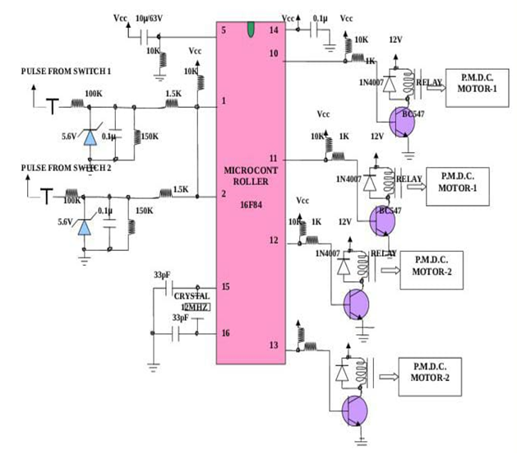

Fig.1 Circuit flow diagram of the working of AGV

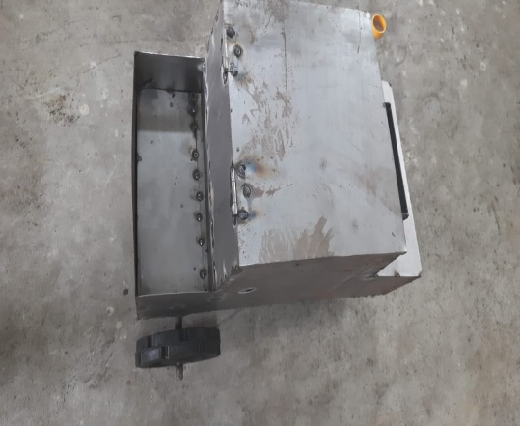

Fig.2 Top view of AGV

**4. DESIGN PARAMETERS**

Area of L-angle : 66 mm²

Total area : 4 x 66 = 264 mm²

Total Load : 40 Kg (Approx.)

Stress due to load : Load/Area = (40 x 9.81) / (264)

= 1.486 N/mm² (Calculated)

Yield stress for the material : 323.73 N/mm² (Obtained)

Calculated stress is less than the stress obtained, since the design is safe.

**5. CONCLUSION**

Decentralized communication facilitates the multi-AGV coordination method, which improves scalability and makes the system suitable for settings with several AGVs where task distribution and collision avoidance are crucial. The system's dependability, flexibility, and effectiveness in practical situations are demonstrated by experimental validation, which yields encouraging outcomes in terms of navigation accuracy, task completion time, and energy efficiency.

In summary, the suggested AGV system offers small and medium-sized businesses several benefits by offering an intelligent, adaptable, and reasonably priced option for automating material handling and warehousing operations. Future research will concentrate on enhancing the system's scalability, expanding its capabilities for increasingly intricate industrial applications, and further optimizing the learning algorithms.

**6. REFERENCES**

1. Chandrayan, R. B. (2023). An Approach for Designing Automated Guided Vehicle Systems. International Journal of Advanced Research in Computer and Communication Engineering, 12(10), 200–210.
2. Kumar, G. A., & Lakshmisankar, S. (2021). Automated Guided Vehicle for Physically Handicapped People – A Cost Effective Approach. Advanced Aspects of Engineering Research, 3, 130–139.
3. Zajac, J., Slota, A., Krupa, K., Wiek, T., Chwajol, G., & Małopolski, W. (2013). Some Aspects of Design and Construction of an Automated Guided Vehicle. Applied Mechanics and Materials, 282, 59–65.
4. Mahawadiwar, A. A., & Sahu, A. R. (2015). Design and Development of Automated Guided Vehicle (AGV) System for Industries Based on Radio Frequency Identification (RFID) Technology. International Journal of Analytical, Experimental and Finite Element Analysis, 2(3), 104–108.
5. Khanna, P. K., Kothari, D. K., & Sharma, D. (2020). Design and Development of an Automated Guided Vehicle. International Research Journal of Engineering and Technology, 7 (5).
6. Le-Anh, T., & De Koster, R. (2006). "A review of design and control of automated guided vehicle systems."  
   European Journal of Operational Research, 171(1), 1–23.