**ANALYSIS OF EXPORT DOCUMENTATION OF TRUCK MANUFACTURING COMPANY BEYOND CHALLENGES**

**1, Second Author2, Third Author3 (Font-Times New Roman, Bold, Font Size -12)**

1Designation, Department, Institute, City, State, Country (Font Size -11)

2Designation, Department, Institute, City, State, Country

3Designation, Department, Institute, City, State, Country

**ABSTRACT**

In today’s competitive global market, efficient export documentation plays a critical role in ensuring the smooth movement of goods across international borders, particularly in capital-intensive industries like truck manufacturing. This study delves into the export documentation practices of a truck manufacturing company, analyzing the processes, regulatory requirements, and document flow across departments. While export operations are often hindered by common challenges such as documentation errors, compliance issues, and interdepartmental coordination this research goes a step further by exploring the hidden operational inefficiencies and missed opportunities for optimization that lie beyond these surface-level problems. By combining qualitative insights from company personnel with a detailed review of existing documentation workflows, the study identifies root causes and offers practical recommendations to enhance accuracy, reduce delays, and improve overall export performance. The findings aim to support manufacturers and logistics managers in strengthening their export capabilities amid evolving global trade dynamics.

**INTRODUCTION**

As a legal framework to guarantee adherence to trade laws, customs rules, and contractual responsibilities, export paperwork is an essential part of international trade. This paperwork helps with logistics and inventory management, ensures payment, and speeds up customs clearance. Commercial invoices, packing lists, bills of lading, certificates of origin, insurance certificates, and regulatory permissions are important papers. Each has a distinct function in confirming shipping information, ownership, origin, and adherence to national regulations.

This study examines a truck manufacturer's whole documentation process, revealing operational obstacles that go beyond typical compliance issues. In addition to highlighting the need of industry-specific paperwork like sanitary certifications or hazardous products declarations, it looks at how poor documentation affects payment cycles, logistics, and incentive claims. The scope also includes the digitization of export documents through customs e-filing, e-invoices, and e-certificates of origin, which expedite procedures and cut down on delays.

In order to increase productivity, guarantee regulatory compliance, and boost worldwide competitiveness in the truck manufacturing industry, the research ends with recommendations for optimizing documentation procedures through digital integration and interdepartmental collaboration.

**PROBLEM OF THE STUDY**

Despite the critical role export documentation plays in facilitating smooth international trade, truck manufacturing companies often face persistent inefficiencies, delays, and compliance risks due to outdated processes, manual handling, and lack of integration across departments. While many firms address surface-level challenges such as incomplete paperwork or delayed approvals, deeper systemic issues such as poor coordination between logistics, finance, and compliance teams; limited adoption of digital solutions; and insufficient training remain largely unaddressed. These hidden challenges can lead to shipment delays, penalties, loss of export incentives, and reputational damage. This study aims to investigate not only the apparent obstacles in export documentation but also the underlying structural and process-related inefficiencies that hinder effective export operations in a truck manufacturing company.

**NEED FOR THE STUDY**

This study aims to understand the complexities of export documentation for truck manufacturing companies, identify common challenges, ensure compliance with regulations, improve document accuracy, streamline workflow, evaluate the impact of errors on export performance, explore technology's role, benchmark practices against global best practices, recommend strategies for optimization, and enhance competitiveness in the international market.

**3. OBJECTIVE OF THE STUDY**

This study explores the export documentation process in the truck manufacturing industry, identifying key documents needed for successful international exports, analyzing challenges, evaluating legal, regulatory, and compliance requirements, and examining the impact of inaccurate or incomplete documentation on operations. It also explores technology and digitalization's role in improving documentation accuracy and efficiency, highlighting the importance of coordination between internal and external departments.

**SCOPE OF THE STUDY:**

This study explores the export documentation processes for international truck shipment, analyzing challenges faced by truck manufacturers, the impact of errors, delays, and non-compliance on timelines, costs, and customer satisfaction, regulatory frameworks, customs policies, and international trade agreements, digital tools, automation, and technology platforms, and best practices adopted by leading manufacturers. It emphasizes collaboration with freight forwarders, customs brokers, and government agencies for efficient documentation.

**4. LITERATURE REVIEW**

• **Smith and Patel (2023)** "Export Documentation: Navigating Legal Hurdles in International Trade"  
 discuss the legal challenges in export documentation for manufacturing companies, particularly truck exports.  
• They highlight the need for firms to stay informed about trade agreements and international law to avoid penalties.  
• They recommend strategies for developing strong legal teams and timely document submissions to prevent shipments delays.  
  
• **Kumar and Singh (2023)** "Innovative Solutions to Reduce Export Documentation Errors"  
discuss the use of automated systems to reduce errors in export documentation.  
• They highlight the role of artificial intelligence in verifying documentation and flagging discrepancies.  
• They suggest creating a digital database of frequently used documents for quick access.  
  
• **Hassan and Roberts (2023)** "Understanding the Challenges of Exporting Commercial Vehicles"  
 highlight the importance of detailed export documentation to meet international safety standards and product certifications.  
• They propose improving communication between manufacturers, freight forwarders, and customs officers.  
• They suggest incorporating sustainability certifications in export documents to meet global environmental standards.  
  
• **Martin and Zhao (2023)** "Logistics Management and Export Documentation in the Automotive Industry"  
 analyze the complexities of managing freight documents across multiple borders and regulatory systems.  
• They emphasize the role of specialized software in managing the growing volume of export paperwork.  
  
**• Sampath and Kumar (2023)** "The Role of Digitalization in Simplifying Export Documentation"  
 discuss the benefits of transitioning from paper-based to digital documentation systems.  
• They argue that digital records enhance transparency and traceability, making it easier to comply with international regulations.  
  
• **Barker and Lee (2023)** "Automation of Export Documentation in the Truck Manufacturing Sector"  
 focus on the automation of export documentation in the truck manufacturing sector.  
• They suggest integrating automation into the end-to-end export process.

**5. RESEARCH METHODOLOGY**

Research is a systematic process aimed at solving problems, confirming knowledge, or uncovering new information. It can be categorized into applied, basic, qualitative, and quantitative research. Research methodology is the framework that ensures the research is rational, trustworthy, and legitimate. It includes sample strategy, data collection techniques, study design, and data analysis. A well-structured methodology ensures accurate, repeatable, and useful findings, reduces biases, enhances reliability, and ensures effective and moral research.

**METHOD OF DATA COLLECTION**

Data collection techniques are systematic procedures used for research, analysis, and informed decision-making. They help identify trends, predict outcomes, and solve complex problems. The choice of data collection method depends on study objectives, information type, time availability, and precision. Correct data collection strengthens research validity and reliability, while poor collection can lead to false findings.

**SECONDARY DATA**

Secondary data, gathered from government documents, research studies, and industry reports, is a cost-effective alternative to primary data in situations where primary data is unavailable. It aids in examining past trends, assessing market trends, and aiding decision-making. However, its reliability depends on the legitimacy of the original source.

**RESEARCH DESIGN**

Research design is a crucial framework in the research process, ensuring a methodical approach and reliable findings. It guides researchers in choosing the best techniques for data collection, analysis, and interpretation. Research designs can be quantitative, qualitative, mixed-methods, exploratory, descriptive, experimental, or correlational. The validity of a study is affected by design decisions, enhancing credibility and impacting academic contributions, policy formation, and informed decision-making.

**SWOT ANALYSIS**

**SWOT Analysis of Ashok Leyland**

### **Strengths**

* **Strong Manufacturing Base in Chennai:** High production capacity and efficient supply chain for both domestic and export markets.
* **Established Distribution Network in Nepal:** Long-term partnership with **IME Motors,** the official distributor, ensuring brand presence and local service support.
* **Diverse Product Portfolio:** Customizable trucks and buses suited for multiple terrains, including hill-friendly variants for Nepal.
* **Quick Adaptability:** Shifted to **multimodal transport**, border warehousing, and digital documentation quickly during the pandemic.

### **Weaknesses**

* **Overdependence on Road-Based Border Crossings:** No direct access to seaports in Nepal makes Ashok Leyland vulnerable to border closures and policy changes.
* **Limited Control Over Nepali Market Regulations:** Import restrictions, changing duties, and foreign currency shortages in Nepal impact order flow.
* **Inventory Build-Up Risk:** Lockdowns and unpredictable transit times led **to parking shortages and warehousing costs** in Chennai.
* **Inadequate Real-Time Communication Early On:** During early stages of COVID, lack of synchronized updates with border officials and partners created confusion.

### **Opportunities**

* **Expansion into Alternative Markets:** Learning from Nepal’s volatility, Ashok Leyland can increase focus on Africa, Latin America, and Southeast Asia.
* **Digitization of Supply Chain:** Invest further in **real-time tracking, customs e-clearances, and AI-based logistics forecasting.**
* **Local Assembly Possibility in Nepal:** Setting up **semi-knocked down (SKD) or CKD assembly** units in Nepal could reduce dependency on border logistics.
* **Government Partnership for Export Facilitation:** Leverage **EXIM Bank and Ministry of Commerce** support to establish smoother Indo-Nepal export corridors.

### **Threats**

* **Pandemic and Geopolitical Disruptions:** Any future pandemic, natural disaster, or political unrest could again halt operations without warning.
* **Competition from Chinese and Local Brands:** Cheaper alternatives from China and growing local assemblers in Nepal may capture market share.
* **Policy Instability in Nepal:** Frequent changes in vehicle import laws, green tax regulations, and customs duties affect long-term planning.
* **Currency Volatility:** Nepalese importers depend on stable INR/NPR/USD dynamics, and shortages of foreign exchange continue to be a risk.

**SWOT Analysis of Daimler**

* **Strengths**
* **Strong Brand Reputation:** Backed by Daimler AG and known for reliability and engineering excellence.
* **Product Quality:** Focus on fuel efficiency, durability, and safety features.
* **Proactive Strategic Response:** Swift upgrades to meet regulatory norms and adapt to local needs.
* **Expanding Service Network:** Strengthening local partnerships improved after-sales service and brand trust.
* **Weaknesses**
* **High Initial Cost:** Premium pricing compared to local and Chinese competitors made market penetration harder.
* **Limited Flexibility Pre-Crisis:** Initial lack of local adaptation led to clearance delays and customer dissatisfaction.
* **Regulatory Misalignment:** Early exports failed to fully align with updated Bangladeshi import norms.
* **Opportunities**
* **Growing Infrastructure Sector in Bangladesh:** Rising demand for commercial vehicles in logistics and construction.
* **Training & Financing Models:** Leveraging driver training and financing options to demonstrate long-term value.
* **Policy Influence:** Continued engagement with local authorities can secure favorable trade terms and clarity in customs classifications**.**
* **Threats**
* **Aggressive Chinese Competition:** Lower-priced Chinese trucks with financing benefits pose a constant market threat.
* **Regulatory Instability:** Sudden changes in customs classification or emission norms can affect profitability.
* **Import Tariff Risks:** Unpredictable import duties could increase costs and reduce competitiveness.

**SWOT Analysis of TATA**

#### **Strengths**

* **Strategic Location**: Located near Ennore port and major highways, enabling multimodal connectivity for domestic and export markets.
* **Advanced Manufacturing**: Modern facility with automation, lean practices, and green initiatives enhances product quality and production efficiency**.**
* **Strong Brand & Dealer Network**: Established brand presence in Nepal with trusted dealerships boosts customer confidence.
* **Digital & Process Improvements**: Real-time shipment tracking, pre-clearance verification, and digital coordination with Nepalese dealers increase efficiency and reduce delays.

#### **Weaknesses**

* **Long Land Distance to Nepal**: Over 2,000 km from Chennai to Nepal border causes time delays and increased logistics complexity.
* **Border Bottlenecks**: Manual customs processes, congestion, and inadequate border infrastructure cause long wait times.
* **Vulnerability to Documentation Errors**: Manual documentation and emission norm mismatches often delay clearance and lead to shipment rejections.

#### **Opportunities**

* **Growing Demand in Nepal**: Nepal’s infrastructure and transport sectors offer increasing demand for commercial vehicles.
* **Rail Logistics Expansion**:  
  Use of containerized rail movement through CONCOR and ICDs reduces road dependency and improves reliability.
* **Policy Harmonization**: Active engagement through SIAM and trade bodies can influence smoother trade policies and faster regulatory alignment.
* **Strategic Buffer Zones**: Development of staging facilities (e.g., Kolkata) allows flexible dispatch and quicker turnaround during customs clearance.

#### **Threats**

* **Political & Bilateral Tensions**: India-Nepal disputes or treaty changes can suddenly impact transit routes and permissions.
* **Natural Disasters & Road Conditions**: Flooding and poor road maintenance in eastern India disrupt transit schedules.
* **Nepal’s Import Restrictions**: Forex-related bans or quotas (e.g., 2022) can halt imports and cause inventory pileups.
* **FISHBONE ANALYSIS**

**Fishbone analysis of Ashok Leyland**

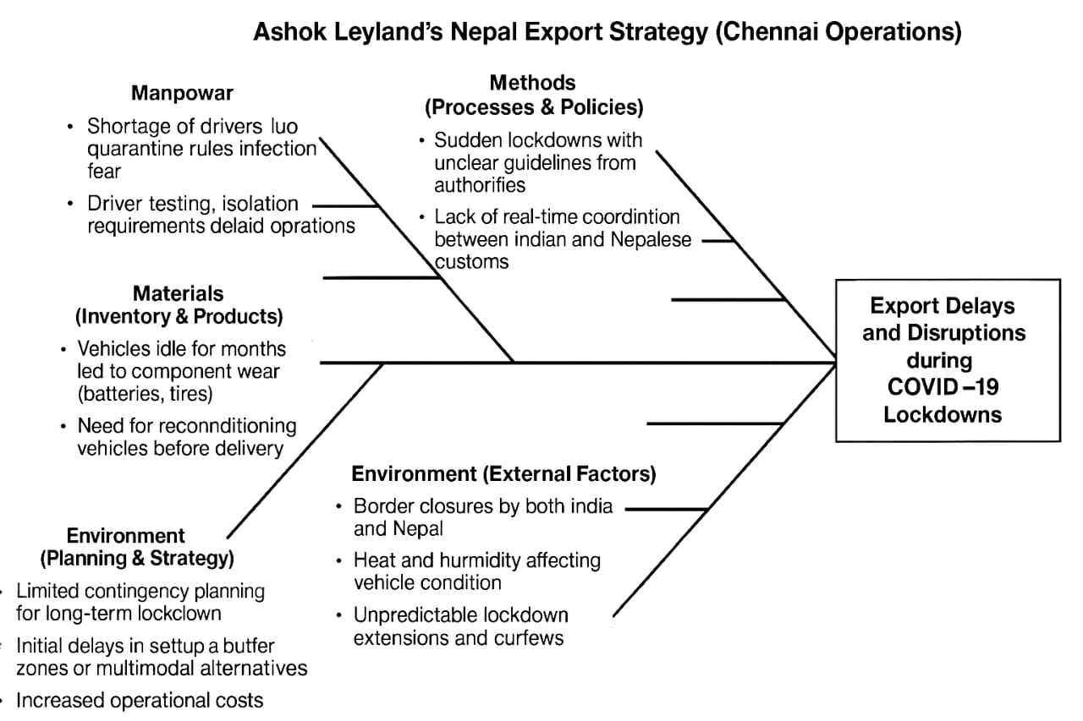

**Fishbone Analysis of Daimler**

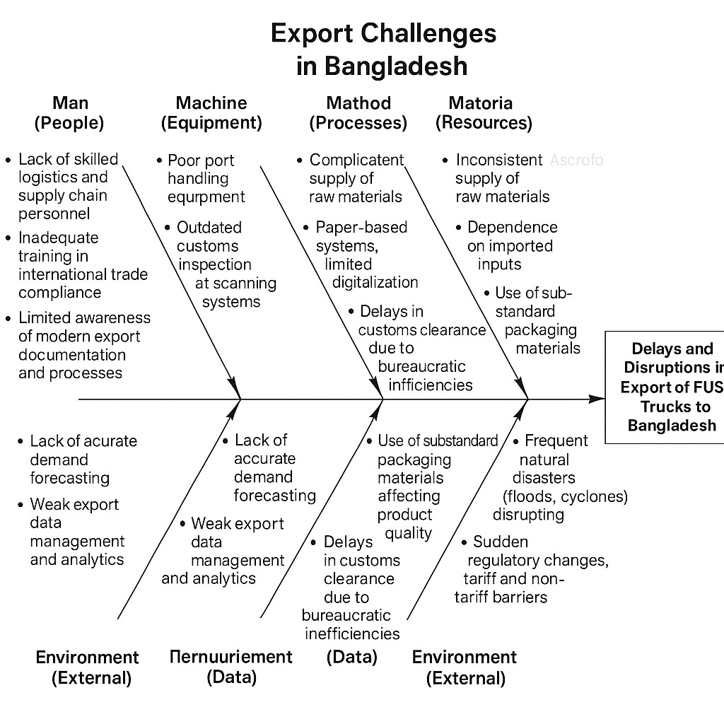

**Fishbone Anlysis of Tata**

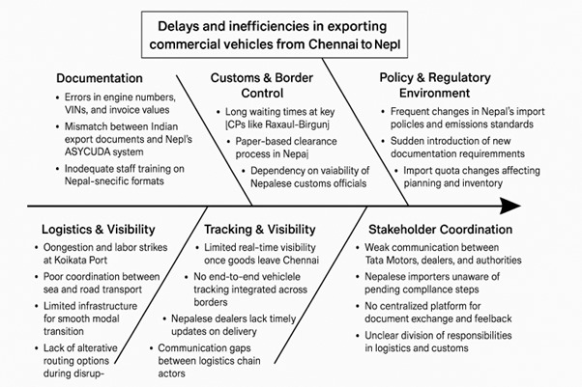

**COMPARITIVE ANALYSIS**

**Comparitive analysis of (Ashok Leyaland, Daimler, Tata)**

Tata Motors, a subsidiary of Daimler India Commercial Vehicles (DICV), is based in Chennai and has a major facility in Hosur and Pune. The company produces commercial trucks, light trucks, heavy-duty trucks, and BharatBenz brand trucks for India and exports. It exports to markets such as Africa,

SAARC, Middle East, Latin America, and some EU markets. The company focuses on offering affordable trucking solutions, with a special focus on premium trucks optimized for tropical conditions and ruggedness and fuel efficiency for emerging markets.  
  
Tata Motors has a global sales contract with Daimler group terms, which includes export order acceptance and Proforma Invoice. The company also has a separate export production line and separate SKUs for export and domestic use. The company conducts internal and buyer inspections, including commercial invoices, packing lists, bills of lading, certificates of origin, insurance certificates, and export declaration forms. The company also provides vehicle homologation certificates, which are subject to GCC Standards and Euro Norm compliance documents.

**SUGGESTIONS**

To streamline the export documentation process, adopt electronic solutions such as electronic export declarations, certificates of origin, and bills of lading. Conduct a comprehensive pre-shipment audit to ensure all documentation meets national and international regulations. Regular training for employees handling export documentation is crucial. Standardized templates can reduce human error and maintain uniformity across shipments. Collaborate with customs brokers and freight forwarders to ensure proper paperwork submission. Prepare early documents like packing lists, certificates of origin, and business invoices to prevent last-minute issues. Create a risk management framework to identify potential areas for documentation errors, such as prohibited items needing special permits. By being proactive, problems can be minimized before they start.

**CONCLUSION**

Export paperwork is crucial for efficient product movement across borders, ensuring compliance with legal and regulatory standards. Simplifying documentation procedures through digital solutions, document verification, employee training, and logistics partnerships can lead to faster customs clearance, reduced delays, and increased operational efficiency in global trade. A well-run export documentation process also enhances the exporter's reputation and ensures reliable, on-time delivery.

**REFERENCES**

1. **"Export–Import Procedures and Documentation" by Thomas E. Johnson & Donna Bade**
   * Comprehensive guide on export documentation including invoices, LCs, compliance, HS codes, and INCOTERMS.
2. **"International Trade and Export Management" by Francis Cherunilam**
   * Covers documentation, export strategies, and trade regulations, with an Indian context.
3. **"Logistics and Supply Chain Management" by Martin Christopher**
   * Offers insights into logistics systems, documentation flows, and trade facilitation.
4. **"Export Documentation and Procedures" by M.I. Mahajan**
   * Indian-focused guide to documentation like ARE-1, shipping bills, and customs processes.
5. **"International Business: Competing in the Global Marketplace" by Charles W. L. Hill**
   * Discusses global trade strategies, regulatory challenges, and market entry.
6. **"Managing Global Supply Chains" by Ron Basu**
   * Detailed look into documentation, digital transformation, and global SOPs.

### ****Reliable Websites****

1. **Directorate General of Foreign Trade (DGFT), India**  
   https://dgft.gov.in
   * Key source for Indian export documentation rules, AEO status, EPCG, and FTAs.
2. **Indian Customs – CBIC (Central Board of Indirect Taxes and Customs)**  
   https://www.cbic.gov.in
   * Detailed information on export formalities, HS codes, and documentation formats.
3. **India Trade Portal (FIEO)**  
   https://www.indiantradeportal.in
   * Export documentation requirements, market access details, and compliance norms.
4. **Society of Indian Automobile Manufacturers (SIAM)**  
   https://www.siam.in
   * Truck industry export performance and regulatory developments..
5. **UN/CEFACT (United Nations Centre for Trade Facilitation and Electronic Business)**  
   https://unece.org/trade/uncefact
   * Guidance on electronic trade documents and harmonized trade procedures.
6. **World Customs Organization (WCO)**  
   https://www.wcoomd.org
   * Global HS code classifications, trade compliance tools, and AEO standards.
7. **Automotive Component Manufacturers Association (ACMA)**  
   https://www.acma.in
   * Export trends, compliance documentation, and digitalization efforts.