**Evaluation of Lean Construction Practices for Improving Construction Projects Delivery in Anambra State, Nigeria: A Review**

Dominic Anosike Obodoh1, Justin Blessing Onwuliri2, Chijioke Steven Umeokana3 and Nwannadi James Makuochukwu4

1, 2, 3, 4 Department of Building, Nnamdi Azikiwe University, Awka Nigeria.

Corresponding Author’s Email: [cs.umeokana@pg.unizik.edu.ng](mailto:cs.umeokana@pg.unizik.edu.ng)

**Abstract:** The construction industry in Anambra State, Nigeria, continues to face persistent challenges, including significant project delays, cost overruns, and quality deterioration, largely due to traditional construction methods, inadequate training, poor stakeholder collaboration, and adverse weather conditions. This review critically evaluates Lean construction practices as an innovative approach aimed at addressing these inefficiencies. It systematically examines Lean principles such as Value Stream Mapping (VSM), Last Planner System (LPS), Just-In-Time (JIT), and Continuous Improvement (Kaizen), assessing their potential benefits and implementation barriers within the Anambra State context. The analysis reveals that while Lean practices could significantly enhance cost management, reduce timelines, and improve quality, awareness and adoption remain limited due to inadequate training, cultural resistance, and lack of supportive regulatory frameworks. The paper recommends targeted capacity-building initiatives, active stakeholder engagement, governmental policy incentives, and pilot project demonstrations to facilitate effective Lean adoption.

**Keywords:** Lean Construction, Construction Management, Construction Efficiency, Lean Principles, Construction Industry Optimization

**1. Introduction**

The construction industry in Nigeria, particularly in Anambra State, faces numerous challenges that undermine project delivery, including significant delays, cost overruns, and deteriorating quality of work. Studies reveal that underlying issues such as late material deliveries, poor decision-making and adverse weather conditions significantly contribute to these project delays. These factors have been shown to be consistent with issues observed in construction sectors of similar regions, including Jordan and Iran [1]. Furthermore, the lack of suitable technologies and insufficient training in modern construction methods exacerbates these problems, hampering the industry's overall progress [2]. These inefficiencies inflate costs and lead to wasteful resource utilization, which is a critical factor affecting sustainability in construction projects. The adverse effects of these challenges echo throughout the economy, stifling infrastructure development and ultimately impeding national economic growth [3]. Lean construction practices could offer a potential remedy by promoting waste reduction, enhanced efficiency, and improved project delivery timelines, which may be particularly beneficial in addressing these prevalent challenges in Nigeria’s construction sector [4],[5].

The construction sector in Anambra State, Nigeria, continues to face significant inefficiencies despite advancements in technology and various initiatives. A primary issue is reflected in the persistent delays, cost overruns, and compromised quality associated with construction projects. These challenges are largely attributed to a lack of systematic approaches and structured methodologies in project delivery. Studies have indicated that traditional project delivery methods frequently contribute to these inefficiencies within the sector [6]. Furthermore, research has highlighted that ineffective communication and poor collaboration among stakeholders exacerbate these challenges, leading to an adversarial environment that hinders project success [7],[8]. The necessity to evaluate innovative strategies such as Lean construction emerges from the urgent need to enhance project delivery outcomes in Anambra State. Lean construction principles emphasize minimizing waste and maximizing value, which could effectively address the inefficiencies present in conventional practices [9]. Recent investigations suggest that integrating Lean methodologies may provide essential frameworks to overcome barriers to effective project delivery, ultimately leading to improved performance and sustainability in the construction industry [7].

The purpose of this review is to critically evaluate Lean construction practices as a viable solution to the challenges in construction project delivery within Anambra State. At the of this study, the following objectives will be achieved; comprehensively examine key Lean construction principles and methodologies, evaluate the current state of awareness and adoption of Lean construction practices in Anambra State, identify the benefits and barriers associated with the implementation of Lean construction practices locally, comparatively assess Lean construction effectiveness against traditional construction methods and propose actionable recommendations for stakeholders and policymakers to improve Lean adoption.

The paper is structured as shown in figure 1 below.

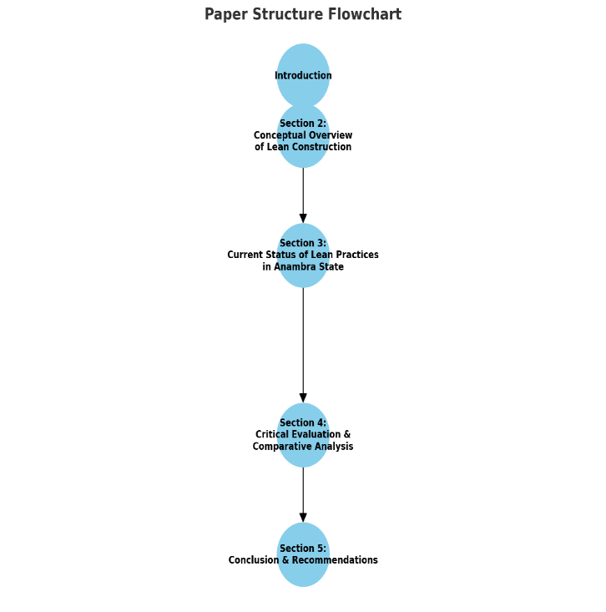  
Figure 1: Paper Structure Flowchart

**2 Origin and Principles of Lean Construction**

Lean construction is derived from the Lean production system initiated in the automotive industry, particularly through the Toyota Production System (TPS). The principles of Lean construction focus on the elimination of waste, promotion of continuous improvement, and the creation of value through effective collaboration and transparency among project stakeholders [10]. This conceptual foundation emerged in the mid-20th century, with the TPS implementing methodologies aimed at optimizing production efficiency by identifying and removing non-value-adding activities [11].

Lean construction extends these principles into the construction domain, where traditional paradigms often lead to inefficiencies such as delays and cost overruns due to siloed work processes. Core aspects of Lean construction include the management of workflow through techniques such as Just-In-Time delivery, value stream mapping, and the Last Planner System, which collectively aim to enhance productivity and responsiveness to client needs. In essence, Lean construction is about transforming construction processes into more efficient, client-focused operations by fostering a culture of continuous improvement and collective responsibility among all parties involved in a project [12].

**Core Lean Construction Tools and Techniques**

**Value Stream Mapping (VSM):** VSM is a fundamental tool within Lean construction practices, providing a systematic approach to visualize workflows and identify non-value-adding activities. Originating from Lean manufacturing principles, VSM allows construction professionals to map the entire value stream of a project, effectively highlighting areas of waste and inefficiency that can be improved [13]. By visually representing both the current and desired future states of project workflows, VSM enhances decision-making and encourages collaboration among stakeholders focused on continuous process improvement. The application of VSM in construction projects is critical for driving productivity and minimizing delays, as it helps teams streamline operations and improve communication [13]. Research indicates that VSM not only facilitates the identification of inefficiencies but also fosters a culture of continuous improvement by involving all project participants in the optimization process [6],[7]. Consequently, implementing VSM is vital for construction firms seeking to adopt Lean principles, ultimately improving project delivery performance in complex and dynamic environments [14].

**Last Planner System (LPS):** The LPS is a cornerstone of Lean construction, designed to foster a collaborative planning approach that enhances workflow reliability and accountability among project participants. By focusing on the management of constraints and commitments during the planning process, the LPS encourages team members to collaborate and make real-time decisions that positively impact construction outcomes [15]. The system is built around weekly work planning meetings where last planners—those responsible for executing tasks—commit to what they can accomplish, thereby ensuring that resources are effectively utilized and workflow is maintained [16].

Research indicates that the implementation of LPS promotes greater predictability in project schedules, as it helps identify and mitigate potential bottlenecks and eliminates inefficiencies rooted in traditional construction methodologies [17]. By emphasizing accountability, LPS enhances communication among stakeholders, leading to improved trust and coordination throughout the project lifecycle [17],[18]. This collaborative framework not only reduces waste but also aligns with the core objectives of Lean construction, which seeks to deliver projects on time and within budget while maintaining high quality [15].

**Just-In-Time (JIT):** JIT is a foundational tool in lean construction that enhances project delivery by ensuring timely material and resource availability, ultimately reducing inventory waste and boosting efficiency. JIT emphasizes minimizing waste along the supply chain by synchronizing the arrival of materials with production schedules, which is critical in the construction industry, where project timelines are often tight and resource allocation must be optimal [19],[20].

The integration of JIT practices in construction promotes environmental sustainability by decreasing excess inventory and associated waste, aligning with broader lean construction goals [20],[21]. Research has shown that JIT contributes positively to operational efficiency, which is essential for meeting project deadlines and minimizing costs [21],[22]. Furthermore, the successful implementation of JIT depends on various critical factors, including effective communication and collaboration among project stakeholders, which enhances supply chain responsiveness [19],[22]. Incorporating JIT within construction practices not only fosters productivity and sustainability but also impacts financial performance, making it an essential consideration for project managers in Anambra State, Nigeria, as they seek innovative techniques to improve overall construction delivery [22].

**Continuous Improvement (Kaizen**): Continuous Improvement, or Kaizen, is a pivotal principle in lean construction that emphasizes ongoing, incremental enhancements involving all project stakeholders to optimize construction processes. This approach fosters a culture of continuous review and improvement, which is imperative for increasing efficiency and reducing waste within construction projects [23],[24]. In lean construction contexts, engagement from all team members—ranging from management to on-site workers—ensures that improvements are practical, well-informed, and effectively implemented [25].

Additionally, Kaizen utilizes the Plan-Do-Check-Act (PDCA) cycle, facilitating systematic iteration and assessment of processes. This cyclical nature allows construction teams to address inefficiencies and establish a feedback loop that promotes sustainable improvements over time [26]. The Kaizen philosophy has demonstrated substantial benefits in various industries and is increasingly recognized in construction, as it aligns closely with the lean objectives of reducing waste and enhancing value delivery [27]. By integrating the Kaizen methodology, construction companies in Anambra State, Nigeria can build resilience and adaptivity into their project delivery, fostering a competitive edge in a challenging market environment [23].

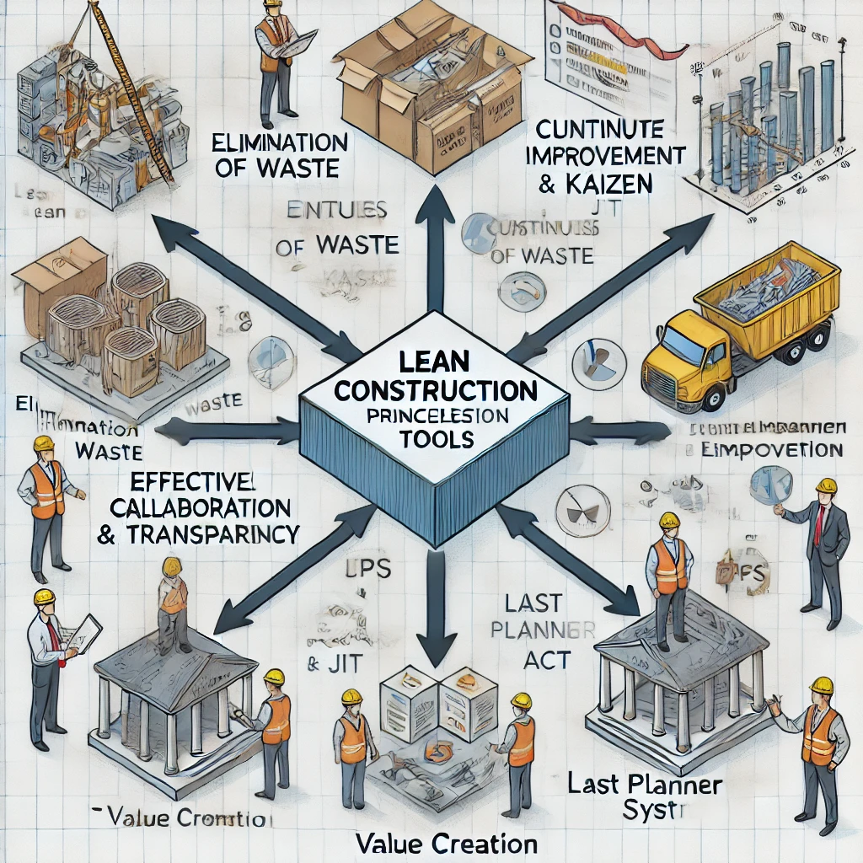

Figure 2: Conceptual Framework of Lean Construction Principles and Tools (Author’s Simulated Design)

Figure 2 is the conceptual diagram visually representing the structure and relationships among the core Lean Construction principles and tools as outlined in this study.

**3. Current Status of Construction Project Delivery in Anambra State**

The current status of construction project delivery in Anambra State, Nigeria, is notably characterized by inefficiencies such as budget overruns, delayed timelines, and substandard quality outcomes. Traditional construction practices continue to dominate, significantly impeding progress in project execution and overall delivery effectiveness. A review of the relevant literature suggests that these traditional methods are often burdened with rigid planning and execution frameworks, which struggle to accommodate the dynamic challenges of construction environments [28].

Budget overruns are prevalent, often resulting from poor cost estimation and inadequate financial controls during project planning and execution phases. Evidence indicates that many construction projects exceed their initial budget due to unforeseen challenges, lack of proper risk management frameworks, and inefficient resource use [29]. Additionally, project delays are commonly linked to inadequate project management practices, including poor communication among stakeholders and a lack of modernized methodologies that could enhance coordination and efficiency.

Moreover, the quality of deliverables in construction projects has been compromised, reflecting a need for enhanced standards and compliance oversight. Existing literature indicates that a shift towards embracing innovative practices and technologies, such as Building Information Modelling (BIM) and lean construction principles, could remedy these issues by facilitating better planning, communication, and resource allocation [30]. However, the uptake of such innovations remains slow, indicating a significant gap between current practices and potential improvements in project delivery effectiveness in Anambra State, Nigeria [30].

**Awareness and Adoption of Lean Construction Methods**

The awareness and adoption of lean construction methods in Anambra State, Nigeria, is relatively low, with only a limited number of construction firms actively engaging in these practices. This situation contrasts with the global trend where lean principles have gained substantial traction in improving project delivery effectiveness. Research reveals that most local firms still rely heavily on traditional construction methods, which contribute to inefficiencies and suboptimal outcomes, such as budget overruns and project delays [20].

While notable exceptions exist among larger firms involved in high-profile projects, their implementation of lean techniques remains limited and often lacks the comprehensive integration necessary for significant performance improvement [31]. Studies indicate that a primary barrier to broader adoption is the insufficient knowledge among smaller contractors regarding lean practices, leading to a general reluctance or inability to shift from established methodologies to more modern, efficient ones [31],[32]. Furthermore, active promotion and education regarding the benefits of lean construction are crucial, especially as middle-tier construction firms dominate the market landscape [33].

For Anambra State to leverage lean construction principles effectively, there is an urgent need for structured training and awareness programs to elucidate the potential advantages of lean methods, therefore fostering an environment conducive to innovation and improved project delivery performance.

**Identified Benefits and Barriers to Implementation Lean Construction**

In Anambra State, Nigeria, the limited implementation of lean construction practices has demonstrated several observable benefits, including cost reduction, improved scheduling, better resource utilization, and higher quality deliverables. These benefits arise from the core lean principles seeking to minimize waste and optimize efficiency throughout the construction processes. Specifically, the application of lean methodologies has shown potential to enhance project delivery by streamlining workflows and fostering collaboration among stakeholders involved in construction projects [34].

However, several significant barriers inhibit broader adoption of these lean practices in Anambra State. One of the most critical barriers is the lack of comprehensive training for practitioners and stakeholders on lean principles and techniques [6]. This knowledge gap contributes to cultural resistance to change, as many construction firms are entrenched in traditional methods that prioritize established practices over innovative approaches. Additionally, limited technical knowledge about lean methodologies further hampers effective implementation, resulting in misunderstandings of these techniques [7]. Lastly, the absence of regulatory encouragement, including policies that promote lean adoption in the construction industry, creates a challenging landscape for the integration of lean practices [9].

Addressing these barriers through structured training and regulatory frameworks could pave the way for leveraging lean construction benefits more effectively in Anambra State, ultimately leading to improved overall project delivery [7].

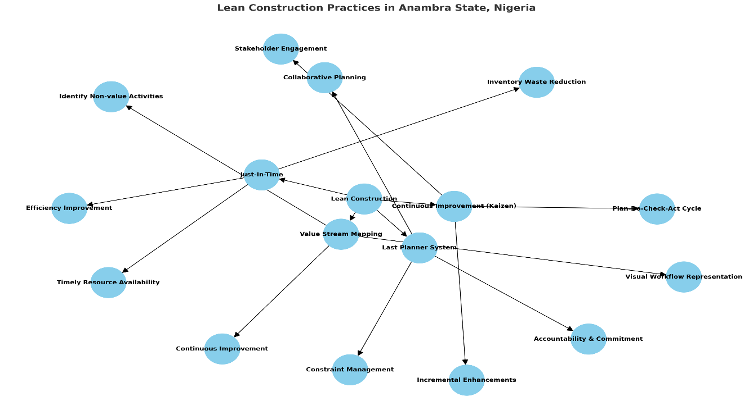

Figure 3: Case Diagram of Lean Construction Practices in Anambra State (Author’s Design)

Figure 3 is the pictorial diagram clearly illustrating the structure and key elements of Lean Construction Practices in Anambra State, Nigeria.

**4. Evaluation and Discussions**

**Assessment of Impact on Project Delivery (Cost, Time, Quality)**

Lean construction practices have the potential to significantly impact project delivery in terms of cost, time, and quality when effectively implemented. Research indicates that the adoption of lean principles typically results in enhanced cost management by minimizing waste and optimizing resource allocation. For instance, studies reveal that projects employing lean methodologies can achieve up to 30% reductions in project costs due to improved efficiencies in material use and labour productivity. The concept of waste reduction, central to lean practices, emphasizes eliminating non-value-adding activities, which directly contributes to overall cost savings.

In terms of time management, lean construction has been associated with reduced project durations. By streamlining processes through tools such as JIT delivery and Kaizen, projects can experience decreased lead times and enhanced scheduling flexibility. Previous research highlights that project utilizing lean techniques often complete within predetermined schedules, significantly improving time efficiency compared to traditional construction methods.

Moreover, lean construction positively influences quality outcomes. By promoting a culture of continuous improvement and involving all stakeholders in process optimization, projects demonstrate higher quality standards in deliverables. This emphasis on quality is corroborated by findings that indicate lean-adopting projects have lower defect rates and greater compliance with specifications, leading to increased stakeholder satisfaction. Ultimately, the successful implementation of lean construction practices fosters an environment conducive to achieving superior project delivery outcomes in Anambra State, Nigeria.

**Comparative Analysis with Traditional Construction Methods**

Lean construction represents a paradigm shift from traditional construction methods, characterized by its structured approach to process optimization and collaborative project management. Unlike conventional practices, which often operate in silos and lead to fragmented communication, lean construction fosters collaboration among all stakeholders, enhancing project efficiency. This collaborative environment enables timely decision-making, reduces misunderstandings, and ultimately enhances overall project coordination.

One of the most significant advantages of lean construction over traditional methods is its effectiveness in mitigating project delays. Traditional construction often experiences delays due to unclear roles, lack of accountability, and inefficient resource allocation, resulting in missed deadlines. In contrast, lean principles, such as JIT manufacturing and continuous flow, streamline processes and improve scheduling accuracy, reducing idle time and enhancing productivity.

Moreover, cost overruns are a prevalent issue in traditional construction practices due to unpredictable changes, poor cost estimation, and excessive waste. Lean construction methodologies directly address these challenges through waste reduction and improved resource management, leading to more accurate budgeting and reduced overall project costs. Studies have shown that projects utilizing lean practices consistently achieve better cost performance compared to their traditional counterparts, with reductions of up to 20-30% in total project costs.

Additionally, lean construction enhances quality by embedding quality management practices within the workflow, establishing quality as a primary project objective rather than as an afterthought. Traditional methods often compromise quality due to rushed timelines and insufficient communication. In contrast, lean practices promote a culture of continuous improvement and emphasize proactive quality management, leading to fewer defects and superior deliverables.

In conclusion, the comparative analysis highlights that lean construction methodologies significantly outperform traditional construction practices in reducing project delays, minimizing cost overruns, and ensuring higher quality outcomes. The adoption of lean principles in Anambra State could thus foster more efficient, cost-effective, and high-quality construction projects.

**Challenges and Limitations in the Practical Implementation of Lean Construction**

Despite the proven advantages of lean construction methodologies, various challenges and limitations hinder their practical implementation in Anambra State, Nigeria. One of the foremost obstacles is the inadequacy of capacity building within the construction workforce. Many professionals lack sufficient training in lean principles and methodologies, which undermines their ability to implement such practices effectively [33],[35]. This gap in knowledge results in a slow transition from traditional construction methods to lean approaches and inhibits organizational adoption of innovative techniques.

Another significant barrier is the cultural resistance to change prevalent in the construction industry. This resistance often stems from entrenched practices and the apprehension of stakeholders toward adopting new processes that lean construction entails [35]. Moreover, securing stakeholder buy-in can prove challenging; while benefits are recognized, stakeholder engagement and collaboration are imperative for successful implementation. The need to align various stakeholders around a common vision for lean practices can lead to conflicts or misunderstandings, further complicating the implementation process.

Additionally, the absence of robust regulatory frameworks that encourage and incentivize lean adoption in Anambra State presents a critical limitation. Current regulations may not sufficiently support innovative practices, leaving construction firms without adequate motivation to engage with lean methodologies [36]. Establishing supportive policies and frameworks could not only enhance awareness and knowledge of lean construction but also provide the necessary incentives for construction companies to pursue process improvements.

In summation, while lean construction offers numerous benefits such as enhanced project efficiency and effectiveness, the challenges of capacity building, change management, stakeholder engagement, and the need for supportive regulatory frameworks must be meticulously addressed to facilitate wider adoption in Anambra State, Nigeria.

**Strategies for Effective Adoption in Anambra State**

For the effective adoption of lean construction practices in Anambra State, a multifaceted strategy is essential, which includes targeted capacity-building programs, governmental policy support, active stakeholder engagement, incentives for innovation adoption, and pilot projects that demonstrate measurable success.

1. Targeted Capacity-Building Programs: There is a critical need for structured capacity-building initiatives to enhance the knowledge and skills of construction professionals regarding lean principles. Such programs can facilitate the transformation of how construction is approached within the region, particularly for small and medium contractors who are often underrepresented in capacity development initiatives. It is important to include practical implementation projects to translate theoretical knowledge into actionable skills in real-world contexts. This reflects findings that emphasize the relevance of hands-on experiences in capacity building.

2. Governmental Policy Support: To promote the adoption of lean practices, government policies should be designed to encourage innovation in the construction industry. This includes frameworks that incentivize firms to adopt lean methodologies through grants, tax reductions, or subsidies for training programs. Leadership support alone is insufficient; comprehensive policy backing is necessary to ensure sustained growth and acceptance of new practices [37].

3. Active Stakeholder Engagement: Stakeholder engagement is crucial for successful lean implementation. Involving a diverse range of stakeholders fosters a collaborative environment conducive to sharing best practices and overcoming implementation challenges. Creating forums for dialogue among stakeholders can enhance buy-in and commitment to lean principles [2].

4. Incentives for Innovation Adoption: Establishing incentives for firms that adopt innovative construction practices can drive interest in lean methodologies. Incentives could include financial rewards for demonstrating measurable improvements or offering public recognition for successful projects. Supporting innovation through such incentives can catalyse the shift toward lean approaches in construction.

5. Pilot Projects Demonstrating Measurable Success: Implementing pilot projects that utilize lean construction practices can provide tangible evidence of the benefits, thus encouraging wider acceptance. Successful pilot projects can serve as case studies for other firms, showcasing how lean methods can lead to reduced costs, enhanced quality, and timely project delivery. Well-documented pilots can function as powerful tools for advocacy and education.

In conclusion, a collaborative approach that incorporates capacity building, supportive governmental policies, active stakeholder participation, incentives, and pilot project demonstrations is essential for effectively adopting lean construction practices in Anambra State. This structured strategy not only aligns with current implementation science frameworks but also addresses the specific challenges faced by the construction industry in the region.

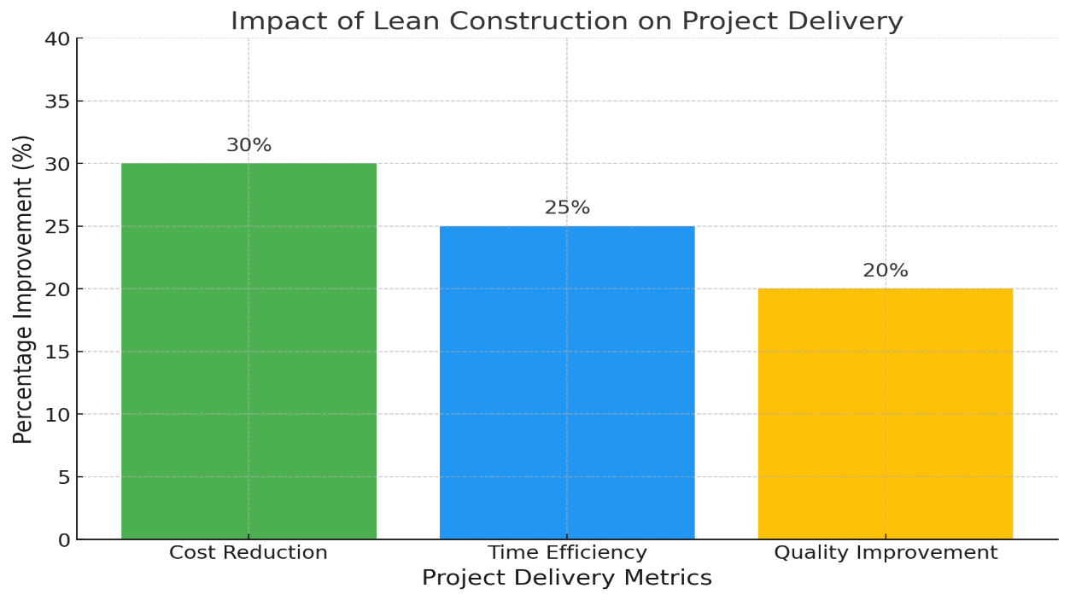

Figure 4: Impact of Lean Construction on Project Delivery

Figure 4 is a chart representing the significant positive impacts of Lean Construction practices on project delivery, highlighting improvements in Cost Reduction, Time Efficiency, and Quality Improvement as detailed in the discussion.

**5. Conclusion and Recommendations**

This review has identified critical challenges facing the construction industry in Anambra State, Nigeria, including substantial project delays, cost overruns, and quality deterioration. Underlying factors include delayed material deliveries, poor decision-making, inadequate training, and adverse weather conditions, compounded by ineffective communication and collaboration among stakeholders. Lean construction, originating from Lean manufacturing principles, emphasizes waste elimination, resource optimization, continuous improvement, and collaborative stakeholder engagement, offering a viable solution to these challenges.

Despite potential benefits, the current awareness and adoption of Lean construction methods in Anambra State remain low, limited primarily to large construction firms engaged in high-profile projects. Key Lean techniques such as VSM, the LPS, JIT, and Kaizen have demonstrated notable advantages, including improved cost management, reduced project durations, enhanced quality outcomes, and efficient resource utilization.

However, significant barriers impede broader implementation. These include limited training and awareness of Lean principles, resistance to change, absence of regulatory incentives, and insufficient knowledge among smaller contractors. Effective adoption strategies identified involve targeted capacity-building programs, governmental policy support, active stakeholder engagement, incentives for innovation, and demonstration pilot projects. Addressing these areas is crucial for overcoming current implementation challenges and achieving meaningful improvements in project delivery within Anambra State’s construction sector.

Based on the evaluation of construction project delivery challenges in Anambra State, Nigeria, and the potential advantages offered by Lean construction practices, the following actionable recommendations are proposed for stakeholders and policymakers:

* **Targeted Capacity-Building Programs:** Construction professionals in Anambra State lack sufficient training in Lean principles and methodologies, limiting effective implementation. Structured capacity-building initiatives that include practical training and hands-on experience should be introduced to enhance professional competencies in Lean construction. Special attention should be given to small and medium-sized enterprises that may not currently have access to comprehensive training resources.
* **Governmental Policy Support:** Policymakers should develop and implement policies that actively encourage the adoption of Lean construction practices. These policies could include incentives such as tax benefits or subsidies for construction companies that successfully integrate Lean methodologies into their operational frameworks. Establishing regulatory frameworks that encourage innovation and process improvement will significantly motivate firms toward embracing Lean practices.
* **Active Stakeholder Engagement:** Effective implementation of Lean construction requires collaborative participation among various stakeholders, including construction firms, clients, consultants, and regulatory bodies. Policymakers should facilitate the creation of forums or platforms to encourage open dialogue, cooperation, and knowledge-sharing among stakeholders. Enhancing communication and trust through structured engagement strategies will support the sustainable adoption of Lean methodologies.
* I**ncentives for Innovation Adoption:** To drive interest and motivate firms to adopt innovative construction practices, policymakers should consider providing incentives such as tax breaks, grants, or public recognition for firms demonstrating successful implementation of Lean methodologies. These incentives could significantly encourage broader adoption and mitigate resistance to innovative construction practices.
* **Implementation of Pilot Projects:** Policymakers should support and fund pilot projects to demonstrate the tangible benefits of Lean construction practices. Successfully executed pilot projects, thoroughly documented and publicly disseminated, will serve as powerful examples and case studies, encouraging more widespread adoption. Such case studies can also inform ongoing training and serve as educational benchmarks for other firms.

Implementing these recommendations collectively can foster an environment conducive to Lean construction practices, addressing current challenges and significantly enhancing construction project delivery in Anambra State, Nigeria.

**Acknowledgement**

The authors acknowledge the efforts of the management of the Nnamdi Azikiwe University Akwa in stimulating this research.

**References**

1. Egwim, C., Alaka, H., Toriola-Coker, L., Balogun, H., Ajayi, S., and Oseghale, R. (2021). Extraction of underlying factors causing construction projects delay in Nigeria. Journal of Engineering Design and Technology, 21(5), 1323-1342. <https://doi.org/10.1108/jedt-04-2021-0211>
2. Ebekozien, A., Aigbavboa, C., Aigbedion, M., Ogbaini, I., and Aginah, I. (2022). Integrated project delivery in the Nigerian construction sector: an unexplored approach from the stakeholders’ perspective. Engineering Construction and Architectural Management, 30(4), 1519-1535. https://doi.org/10.1108/ecam-09-2021-0823
3. Ajayi, S. and Oyedele, L. (2018). Critical design factors for minimising waste in construction projects: a structural equation modelling approach. Resources Conservation and Recycling, 137, 302-313. https://doi.org/10.1016/j.resconrec.2018.06.005
4. Ogunmakinde, O., Sher, W., and Maund, K. (2019). An assessment of material waste disposal methods in the Nigerian construction industry. Recycling, 4(1), 13. https://doi.org/10.3390/recycling4010013
5. Eze, E., Sofolahan, O., and Omoboye, O. (2023). Assessment of barriers to the adoption of sustainable building materials (sbm) in the construction industry of a developing country. Frontiers in Engineering and Built Environment, 3(3), 153-166. <https://doi.org/10.1108/febe-07-2022-0029>
6. Ahmed, S. and El-Sayegh, S. (2020). Critical review of the evolution of project delivery methods in the construction industry. Buildings, 11(1), 11. https://doi.org/10.3390/buildings11010011
7. Moradi, S. and Sormunen, P. (2022). Lean and sustainable project delivery in building construction: development of a conceptual framework. Buildings, 12(10), 1757. https://doi.org/10.3390/buildings12101757
8. Okeagu, N., Nwamekwe, C., and Nnaman B. (2024). Challenges and Solutions of Industrial Development in Anambra State, Nigeria. Iconic Research and Engineering Journals, 7(11) | ISSN:2456-8880
9. Daniel, E. and Pasquire, C. (2019). Creating social value within the delivery of construction projects: the role of lean approach. Engineering Construction and Architectural Management, 26(6), 1105-1128. https://doi.org/10.1108/ecam-06-2017-0096
10. Bocquet, R., Dubouloz, S., and Chakor, T. (2019). Lean manufacturing, human resource management and worker health: are there smart bundles of practices along the adoption process? Journal of Innovation Economics and Management, n° 30(3), 113-144. https://doi.org/10.3917/jie.pr1.0050
11. Vaagen, H. and Ballard, G. (2021). Lean and flexible project delivery. Applied Sciences, 11(19), 9287. https://doi.org/10.3390/app11199287
12. Koskela, L., Ferrantelli, A., Niiranen, J., Pikas, E., and Dave, B. (2019). Epistemological explanation of lean construction. Journal of Construction Engineering and Management, 145(2). https://doi.org/10.1061/(asce)co.1943-7862.0001597
13. Ramani, P. and KSD, L. (2019). Application of lean in construction using value stream mapping. Engineering Construction and Architectural Management, 28(1), 216-228. https://doi.org/10.1108/ecam-12-2018-0572
14. Herrera, R., Mourgues, C., Alarcón, L., and Pellicer, E. (2019). An assessment of lean design management practices in construction projects. Sustainability, 12(1), 19. https://doi.org/10.3390/su12010019
15. Shehab, L., Hattab, M., Khalife, S., Samad, G., Abbas, Y., and Hamzeh, F. (2023). Last planner system framework to assess planning reliability in architectural design. Buildings, 13(11), 2684. https://doi.org/10.3390/buildings13112684
16. Power, W., Sinnott, D., and Lynch, P. (2021). Evaluating the efficacy of a dedicated last planner® system facilitator to enhance construction productivity. Construction Economics and Building, 21(3). https://doi.org/10.5130/ajceb.v21i3.7640
17. Madushanka, T. and Ranadewa, K. (2022). Challenges for last planner system implementation; Sri Lankan construction industry perspective., 196-204. https://doi.org/10.31705/faru.2022.22
18. Perez, A. and Ghosh, S. (2018). Barriers faced by new-adopter of last planner system®: a case study. Engineering Construction and Architectural Management, 25(9), 1110-1126. <https://doi.org/10.1108/ecam-08-2017-0162>
19. Hussein, M. and Zayed, T. (2021). Critical factors for successful implementation of just-in-time concept in modular integrated construction: a systematic review and meta-analysis. Journal of Cleaner Production, 284, 124716. https://doi.org/10.1016/j.jclepro.2020.124716
20. Babalola, D., Ibem, E., and Ezema, I. (2019). Implementation of lean practices in the construction industry: a systematic review. Building and Environment, 148, 34-43. https://doi.org/10.1016/j.buildenv.2018.10.051
21. Garza‐Reyes, J., Kumar, V., Chaikittisilp, S., and Tan, K. (2018). The effect of lean methods and tools on the environmental performance of manufacturing organisations. International Journal of Production Economics, 200, 170-180. https://doi.org/10.1016/j.ijpe.2018.03.030
22. García-Cutrin, J. and Rodríguez-Garcia, C. (2024). Enhancing corporate sustainability through just-in-time (jit) practices: a meta-analytic examination of financial performance outcomes. Sustainability, 16(10), 4025. <https://doi.org/10.3390/su16104025>
23. Omotayo, T., Kulatunga, U., and Bjeirmi, B. (2018). Critical success factors for kaizen implementation in the Nigerian construction industry. International Journal of Productivity and Performance Management, 67(9), 1816-1836. https://doi.org/10.1108/ijppm-11-2017-0296
24. Okpala, C., Ezeanyim O., and Nwamekwe C. (2024). The Implementation of Kaizen Principles in Manufacturing Processes: A Pathway toContinuous Improvement. International Journal of Engineering Inventions,13(7),116-124.
25. Vieira, J., Etges, B., Pellegrino, R., Lins, M., and Costa, L. (2022). Kaizen as an improvement method for concrete walls construction in social housing project. <https://doi.org/10.24928/2022/0136>
26. Nwamekwe, C., Ewuzie, N., Igbokwe, N., Okpala, C., and U-Dominic, C. (2024). Sustainable Manufacturing Practices in Nigeria: Optimization and Implementation Appraisal. Journal of Research in Engineering and Applied Sciences, 9(3). https://qtanalytics.in/journals/index.php/JREAS/article/view/3967
27. Muniz, J., Ribeiro, V., Hong, J., Wintersberger, D., and Salomon, V. (2024). Enabling knowledge sharing in a production context in China. Knowledge and Process Management, 31(3), 207-220. https://doi.org/10.1002/kpm.1774
28. Shehu, S. (2021). A review of time management factors in construction project delivery. Journal of Project Management Practice, 1(2), 34-45. https://doi.org/10.22452/jpmp.vol1no2.3
29. Umeokafor, N., Windapo, A., Manu, P., Diugwu, I., and Haroglu, H. (2022). Critical barriers to prevention through design in construction in developing countries: a qualitative inquiry. Engineering Construction and Architectural Management, 30(7), 3014-3042. https://doi.org/10.1108/ecam-04-2021-0304
30. Ukochi, G. and Oguaju, K. (2023). An investigation into implementation of project quality management plan on building projects in Awka, Anambra state, Nigeria. IJGEM, 9(3), 1-7. https://doi.org/10.56201/ijgem.v9.no3.2023.pg1.7
31. Pan, W. and Pan, M. (2022). Rethinking lean synergistically in practice for construction industry improvements. Engineering Construction and Architectural Management, 30(7), 2669-2690. https://doi.org/10.1108/ecam-04-2021-0346
32. Nwamekwe, C., Ewuzie, N., Igbokwe, N., U-Dominic, C., and Nwabueze, C. (2024). Adoption of Smart Factories in Nigeria: Problems, Obstacles, Remedies and Opportunities. International Journal of Industrial and Production Engineering, 2(2). Retrieved from https://journals.unizik.edu.ng/ijipe/article/view/4167
33. Sifa, P. and Mbatta, G. (2023). Adopting a lean construction wheel (lcw) to Tanzanian construction firms. a case of class i building contractors in dar es salaam. AJCET, 4(1). https://doi.org/10.47604/ajcet.1820
34. Hamzeh, F., Rached, F., Hraoui, Y., Karam, A., Malaeb, Z., Asmar, M., … and Abbas, Y. (2019). Integrated project delivery as an enabler for collaboration: a middle east perspective. Built Environment Project and Asset Management, 9(3), 334-347. <https://doi.org/10.1108/bepam-05-2018-0084>
35. Nwamekwe, C. O., Chinwuko, C. E. and Mgbemena, C. E. (2020). Development and Implementation of a Computerised Production Planning and Control System. UNIZIK Journal of Engineering and Applied Sciences, 17(1), 168-187.
36. Khah, F., Rybkowski, Z., Pentecost, A., Smith, J., and Muir, R. (2019). Development and testing of an innovative architectural programming simulation as a precursor to target value design. <https://doi.org/10.24928/2019/0221>
37. Martín, E., Fisher, O., Merlo, G., Zardo, P., Barrimore, S., Rowland, J., … and Davies, J. (2022). Impact of a health services innovation university program in a major public hospital and health service: a mixed methods evaluation. Implementation Science Communications, 3(1). https://doi.org/10.1186/s43058-022-0029
38. 3-3