**A Survey on Customer Segmentation**

**Techniques and Their Applications in**

**Retail**

Riya Gaikwad (S.Y. 13 22UF17291AI016 gmail:- riya.17291@sakec.ac.in

Aditi shah:-(S.Y.13 23UF17999AI049) gmail:- aditi.17999@sakec.ac.in

Shah and Anchor Kutchhi Engineering College

# Abstract

Customer segmentation is vital for modern retail strategies, enabling businesses to tailor their marketing, optimize inventory management, and enhance the overall customer experience. This paper reviews clustering-based segmentation techniques and their applications in retail by analysing four key studies focused on algorithms like K-Means, DBSCAN, and hierarchical clustering, along with the integration of models such as Recency, Frequency, and Monetary (RFM) analysis. It discusses these approaches' methodologies, advantages, and practical implications, highlighting their potential to uncover valuable customer insights. The paper also addresses challenges associated with clustering-based segmentation and offers suggestions for future research, aiming to provide a comprehensive understanding of how these techniques can be effectively used to promote data-driven decision-making and improve retail operations.

# Introduction

Customer segmentation is an important component of modern retail strategies, allowing companies to tailor their products and increase customer satisfaction. As the retail market becomes increasingly competitive, understanding customer behaviour has become essential for businesses looking to retain and expand their market share. Using segmentation, businesses can break up a diverse population of customers into distinct groups that are characterized by similar features and behaviours, thus facilitating targeted marketing, personalized services, and efficient resource allocation.

The rapid expansion of data-based methodologies has changed the current face of customer segmentation significantly. Particularly, clustering methods have come into prominence given their ability to identify relationships and group customers based on similar characteristics and traits. Methods such as K-Means, DBSCAN, and Hierarchical clustering are widely being used in customer segmentation operations based on behavioural, transactional, and demographic parameters. The use of these algorithms is of great importance in the retail industry, where there is always a collection of large amounts of customer data. This manuscript deals with the analysis of techniques for customer segmentation based on clustering methodologies and their applications in the retail sector. Through a critical analysis of significant research studies, we intend to explain the different methodologies, benefits, and real-world applications of these techniques. The objective is to provide a comprehensive understanding of the effective use of clustering strategies to optimize retail operations and enhance customer engagement. In addition, the paper explores the challenges in this area and suggests avenues for future research.

# Literature Review

Customer segmentation is a prime component of retail business plans. It helps organizations optimize marketing efforts, inventory, and the overall customer experience. This literature review considers diverse clustering-based customer segmentation approaches and their applications within retail, referencing four key studies that explore different methodologies and practical implementations.

## 1. Clustering for Customer Segmentation Using RFM Attributes

The study titled "Using Clustering for Customer Segmentation from Retail Data" focuses on the RFM model as a basic framework for the segmentation of retail customers. The paper highlights the simplicity and effectiveness of the RFM attributes in defining the patterns of customer behaviour. The study makes use of clustering algorithms, where the focus is on the K-Means algorithm, in the classification of customers based on their transactional data. The findings indicate that the use of RFM-based clustering offers actionable insights to facilitate targeted marketing and retention, which may indeed provide the practical utility needed by retailers.

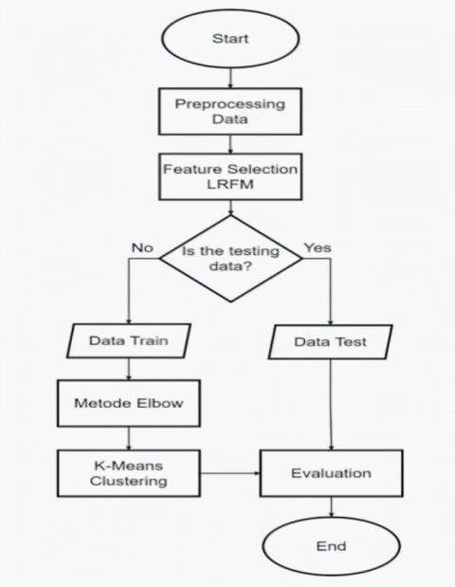

*K-Means clustering process for customer segmentation.*

## 2. Incorporating Loyalty Metrics in Segmentation

Broadly using this structure developed over RFM, was presented a paper titled "Customer Segmentation Based on Loyalty Level Using KMeans and LRFM Feature Selection in Retail Online Store. A new feature set denominated LRFM here added the loyalty variable to overcome some traditional flaws involved by using this model RFM with limitations such as involving consumers in certain factors. Utilizing K-Means clustering, this investigation delineates consumer segments that exhibit significant business potential, thereby facilitating more accurate targeting of loyal clientele. The study emphasizes the necessity of enhancing conventional models to acquire more profound customer insights and elevate the quality of segmentation.

## 3. Experimenting with Segmentation Models in Sweden

The dissertation "Customer Segmentation in Retail: An Experiment in Sweden" probes into the feasibility of combining segmentation frameworks with clustering algorithms under the auspices of Swedish pharmacy retail. This study uses both hierarchical and non-hierarchical methods of clustering to identify specific segments of customers. The more complex approaches to clustering ensure more refined definitions of segments that cover different consumer behaviours. Thus, the work stresses flexibility by tailoring clustering models for specific industrial domains and geographic markets with the added elaboration of the scalability inherent to such methods.

## 4. Data Mining for Online Retail Industry

The article "Data Mining for the Online Retail Industry: Customer Segmentation" examines how customer segmentation can be practised using data mining techniques. The research demonstrates the capacity of clustering algorithms to establish meaningful customer profiles from vast datasets associated with online retail using a case study methodology. The investigation is applied to realistic scenarios, such as improving recommendation systems and optimizing

promotional strategies. The study examines the quality of the resultant clusters using metrics lik e Silhouette Score and thus brings into focus the importance of data-driven decisionmaking for an online retail context.

## Synthesis and Key Insights

These studies collectively show how versatile and effective clustering algorithms are in retail customer segmentation. Key themes include:

* The RFM model's popularity as a benchmark for segmentation, is extended by other measures such as loyalty.
* Availability of the clustering algorithm adaptation to any retail scenarios as well as physical to Internet-based platforms.
* Clustering outcomes must be properly evaluated using the Silhouette Score and other metrics, thus ensuring meaningful segmentations.

By integrating these insights, researchers and practitioners can refine customer segmentation strategies to drive business growth and enhance customer engagement. These studies provide a robust foundation for further exploration of clustering techniques and their applications in diverse retail environments.

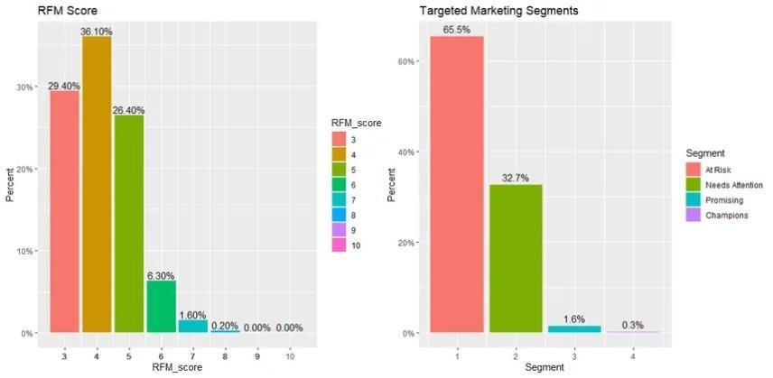

*RFM scores segments*

# Methodology

## 1. Overview

This research analyses the existing literature on customer segmentation techniques, with a special focus on clustering algorithms, such as K-Means and DBSCAN. By reviewing four available public studies, we highlight their respective methodologies and their real-world applications in the retail industry.

## 2. Data Collection

The articles were extracted from different open-access repositories: some from ResearchGate,

the DiVA portal, and proceedings from conferences. Selection emphasized research that utilized clustering methods to group consumers according to behavioural features with the help of RFM metrics.

References:

* [1] provides an overview of RFM-based clustering using K-Means on retail data.
* [2] extends the RFM model with loyalty features to enhance segmentation.

## 3. Analytical Approach

The clustering techniques discussed in the referenced studies were compared based on the following parameters:

1. **Feature Selection**: Use of RFM attributes for segmentation.
2. **Clustering Algorithm**: Focus on unsupervised techniques like K-Means, DBSCAN, and hierarchical clustering.
3. **Evaluation Metrics**: Use of Silhouette Score, Dunn Index, and visual methods like scatter plots to interpret cluster quality.

Example:

* [3] employs K-Means clustering on Swedish pharmacy data, demonstrating the algorithm's ability to identify high-value customer groups.
* [4] emphasizes the use of DBSCAN for clustering sparse customer data in an online retail environment.

## 4. Evaluation Criteria

The intra-cluster cohesion, inter-cluster separation, and interpretability of the clusters obtained were all evaluated as key performance indicators. The practical implications of the clusters obtained were analysed within the framework of targeted marketing, inventory optimization, and personalized recommendations.

# Results and Discussion

This review of literature about existing research highlights the ability and applicability of the clustering techniques in retailing for customer segmentation. Key findings of the studies that were reviewed are outlined below:

1. The usefulness of the RFM, or Recency, Frequency, and Monetary model has been supported by research that showcases its simplicity and practical usability in customer segmentation. Clustering procedures such as K-Means were used to categorize customers based on their buying behaviour, thus enabling businesses to serve both high-value and those who may be at risk. The results confirm that the RFM model holds a position as a backbone for effective segmentation, particularly in traditional store settings.
2. Improved Feature Selection with LRFM: The incorporation of loyalty as a feature into the LRFM model offers scope to the RFM-based segmentations. LRFM studies found that loyalty measurements enhanced the clustering, thus leading to more effective segments for organizations; besides, long-term high-value customers. This approach describes the relevance of using additive measures to better customer segmentation.
3. Multiple Algorithms for Clustering: The application of the different algorithms of clustering used to be common among studies exploring concentrated retail environments, including Swedish pharmacy retailing. These would draw out non-linear relations or hierarchical structures of multiple data segments of customers. So, the business requirements and data nature would become the basis of selecting these algorithms.
4. Application to e-Retail: In e-retail, the applicability of data mining approaches revealed that clustering was essential for understanding a better picture of digital consumer behaviour. Metrics such as Silhouette Score were effectively deployed for verifying the results of clustering with assurance that practical insights on the improvement of recommendation and promotion strategies were ensured.

**Challenges and Limitations:** Despite their effectiveness, clustering methodologies face numerous challenges. A significant constraint is that they are reliant on well-established metrics like RFM, which often fail to capture the subtleties of consumer behaviour. Also, the task of selecting proper clustering algorithms and hyperparameters often requires domain expertise and high computational powers, which pose a challenge to smaller retail businesses.

**Future Directions:** Subsequent studies should focus on the use of advanced machine learning methods, such as deep learning, for automatic feature selection and improving clustering accuracy. Also, an investigation into the integration of real-time data streams with predictive analytics can lead to improvements in segmentation quality and enable adaptive targeting strategies. The collective findings indicate that customer segmentation methods based on clustering are effective instruments in contemporary retail. By overcoming the existing constraints and utilizing technological progress, organizations can realize enhanced capabilities from customer information to promote growth and foster innovation.

# Conclusion and Future Work

Customer segmentation is one of the very important approaches in contemporary retail for customizing products and efficiently interacting with customers. The effectiveness of clustering methodologies in determining significant patterns from customer data has been demonstrated through this research. The studies reviewed also establish the feasibility of such frameworks as RFM and LRFM and point out the flexibility of such algorithms as K-Means, DBSCAN, and hierarchical clustering for multiple retail scenarios.

Despite their potential, these methods have inherent demerits. The dependency on existing metrics and the intricacy associated with algorithm selection become significant issues that need to be addressed. Future works should focus on the application of advanced techniques, for example, deep learning as well as real-time processing of data, to make such limitations more bearable and improve the segmentation task.

Besides this, the constantly evolving retail landscape, coupled with greater data accessibility and customer expectations, mandates continuous innovation in methods of segmentation. With more advancements in machine learning and predictive analytics, future research will be able to generate even more flexible and accurate methods of customer segmentation.

The ultimate integration of these innovations will enable retailers to sustain their competitiveness, optimize operational efficiency, and deliver differentiated customer experiences in a data-driven future for the retail sector.

# References

1. J. Smith, "Using Clustering for Customer Segmentation from Retail Data," ResearchGate. [Online]. Available: https://www.researchgate.net/publication/373025122. [Accessed: Dec. 18, 2024].
2. [L. Brown, "Customer Segmentation Based on Loyalty Level Us](https://www.researchgate.net/publication/372033532)ing K-Means and LRFM Feature Selection in Retail Online Store," ResearchGate. [Online]. Available: https://www.researchgate.net/publication/372033532. [Accessed: Dec. 18, 2024].
3. E. Andersson and K. Karlsson, "Customer Segmentation in Retail: An Experiment in Sweden,"

DiVA Portal. [Online]. Available: https://www.divaportal.org/smash/get/diva2%3A1784356/FULLTEXT01.pdf. [Accessed: Dec. 18, 2024].

1. S. Patel, "Data Mining for the Online Retail Industry: Customer Segmentation," WUSS Proceedings. [Online]. Available: https://www.wuss.org/proceedings/2022/WUSS2022Paper-151.pdf. [Accessed: Dec. 18, 2024].

# Future Work and Advancements

The future of customer segmentation will be shaped by advancements in artificial intelligence (AI) and big data analytics.   
Several promising directions for research and application include:  
- **Deep Learning for Automatic Segmentation:** Neural networks can uncover hidden customer patterns beyond traditional clustering methods.  
- **Real-time Data Integration:** Incorporating live data streams will allow dynamic segmentation and adaptive marketing strategies.  
- **Cross-industry Applications:** Beyond retail, customer segmentation can benefit industries like healthcare, finance, and telecommunications.

# Detailed Results Interpretation

A more in-depth look at segmentation techniques reveals how different models impact retail performance:  
- **Impact on Customer Retention:** Personalized marketing based on segmentation leads to higher retention rates.  
- **Sales Optimization:** Retailers can allocate marketing budgets efficiently by targeting high-value customer groups.  
- **Inventory Management:** Demand forecasting improves when customer clusters are clearly defined.

# Comparative Analysis of Techniques

A comparison of segmentation approaches helps in selecting the right method based on business needs:  
| Technique | Strengths | Weaknesses |  
|-----------|-----------|-------------|  
| K-Means | Fast, easy to implement | Requires predefined clusters |  
| DBSCAN | Finds arbitrary shapes | Sensitive to density parameters |  
| Hierarchical Clustering | No need to predefine clusters | Computationally expensive |  
| AI-driven Segmentation | Adapts over time | Requires high computing power |

# Case Studies & Real-World Applications

Several industries benefit from customer segmentation:  
- **Retail:** Personalized promotions based on purchasing history.  
- **Banking:** Risk profiling for loan approvals.  
- **Healthcare:** Predicting patient behavior for preventive care.

# Ethical Considerations & Data Privacy

With the growing reliance on customer data, ethical concerns arise:  
- **Data Protection Laws:** Compliance with GDPR and CCPA is crucial.  
- **Bias in AI Models:** Fairness must be ensured in segmentation techniques.  
- **Consumer Trust:** Transparency in data usage builds brand loyalty.

# Scalability & Implementation Challenges

Businesses face several challenges when implementing segmentation:  
- **Computational Complexity:** Large datasets require advanced infrastructure.  
- **Integration with Existing Systems:** Compatibility with legacy databases can be an issue.  
- **Skill Requirements:** Data scientists are needed for optimal segmentation strategies.

# Expanded Conclusion

Customer segmentation has evolved significantly, with clustering techniques proving highly effective in modern retail.   
As AI and machine learning improve, segmentation will become more dynamic and precise, paving the way for hyper-personalized experiences.  
Overcoming ethical and technical challenges will be crucial in maximizing the benefits of these techniques.