**REVIEW ON FLOATING TABLET**

Likitha3 ,C. Priyanka1 , D.Nikitha4 , K.Dhana shree2, Ch.Shanthipriya5, S. Rohini Reddy6

1,2,3,4 Student, Department of Pharmaceutics, Sarojini Naidu Vanita Pharmacy Maha Vidyalaya, Tarnaka, Hyderabad, India.

5,6Associate Professor, Department of Pharmaceutics, Sarojini Naidu Vanita Pharmacy Maha Vidyalaya, Tarnaka, Hyderabad, India.

**ABSTRACT**

A major development in oral controlled-release formulations, floating drug delivery systems (FDDS), especially floating tablets, are intended to improve the bioavailability of medications with site-specific absorption in the upper gastrointestinal tract. Because of their low density, these systems are made to float in gastric fluid, extending the duration of gastric residence and enhancing drug absorption, particularly for substances that have unstable intestinal environments , poor solubility at higher pH values. The mechanics, elements, and several formulation methods—such as solvent evaporation, ionotropic gelation, and emulsion solvent diffusion methods—involved in creating floating tablets are described in this article. Evaluation characteristics such tablet hardness, friability, buoyancy, swelling index, and density are also included. Clinical uses for floating tablets are found in many different therapeutic domains, such as the treatment of Helicobacter pylori infections, diabetes, cardiovascular illnesses, and gastrointestinal disorders. Not with standing certain drawbacks, floating tablets offer a viable method for site-specific, prolonged medication administration that may have applications in both human and veterinary medicine.

Keywords:- FDDS , Controlled released ,Buoyancy ,Solvent Evaporation Method ,Ionotropic Gelation ,Emulsion Solvent Diffusion method.

**1.INTRODUCTION**

Floating tablet is a class of gastro retentive drug delivery system. Gastro retentive systems are able to increase residence time of dosage forms in the stomach there by increases the bioavailability of drugs with narrow absorption window, drugs Which contain less water solubility in alkaline pH of small intestine or drugs with poor stability in the intestinal or colonic environment. The drug is administered by oral route is increasingly being used for the delivery of therapeutic agents because the low cost of the therapy and ease of administration lead to high levels of patient compliance. The design of floating tablets and floating drug delivery Systems (FDDS) should be primarily aimed to achieve more predictable and increased bioavailability. Floating systems or hydro-dynamically controlled systems are low-density systems that have sufficient buoyancy to float over the gastric contents and remain buoyant in the stomach without affecting the gastric emptying rate for a prolonged period of time. This results in an increased GRT and a better control of the fluctuation in the plasma drug concentration.

**1.1TYPES:**FDDS are drug delivery forms designed to prolong the time a dosage form stays in the stomach by making it float over gastric contents is classified as follow as-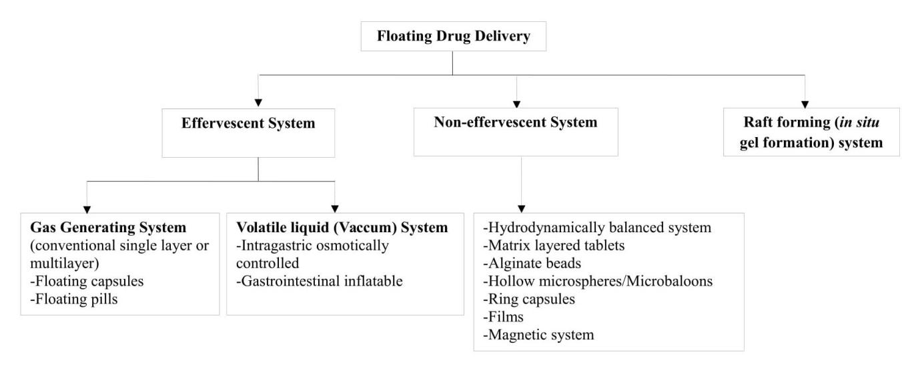

Fig 1: Types of Floating Drug Delivery Systems

The polymers used in preparations of floating drugs - HPMC K4, HPMC K4 M, HPMC K15, Calcium alginate, , Polyethylene oxide, HPMC 4000, HPMC 100, CMC, Polyethylene glycol, polycarbonate, PVA, Sodium alginate, HPC-L, CP 934P, HPC, HPMC, Metolose S.M. 100, Propylene foam, Eudragit RS, ethyl cellulose, PVP, HPC-H, HPC-M, Acrylic polymer, etc. The polymers which are used for sustained release action are- HPMC K100M, HPMC K15M, HPMC ELV, Polycarbonate, Polyethylene glycol, Sodium alginate, etc . Effervescent generating system: Citric acid, Tartaric Acid, Sodium Bicarbonate, citroglycrine,etc.

**Advantages**

* Simple and conventional technique for formulation.
* Site-specific drug delivery.
* In treating gastro esophageal reflux disorders (GERD).
* Improved drug absorption with increased GRT and excess duration of contact of dosage regimen at its target site.

**Disadvantages**

* The major disadvantage of a floating system is due to the necessity of a sufficient level of gastric fluids to float without a sink. However, this limitation can be overcome by coating the dosage form with bio adhesive polymers that easily adhere to gastric mucosa.
* The drugs those get significantly absorbed through out gastrointestinal tract, with significant first-pass metabolism, are desirable candidate predominantly.
* Certain drugs present in the floating system may causes irritation to gastric mucosal linings.

**1.2 COMPONENTS OF FDDS**

1. **Polymers:** Types Hydrophobic : ethyl cellulose, eudragit RL/RS,

Hydrophilic : HPMC,Carbopol

1. **Gas-Generating Substances** (For Effervescent FDDS Buoyancy)

acidic citric, sodium bicarbonate

1. **Excipients with a low density** (to improve floating ability) powdered polypropylene foam, 4. **Surfactants:** For Stability and Drug Solubility, eg: Sulfate of sodium lauryl (SLS), Poloxamer.

**5.Additional Excipients**

**Binders:** starch and polyvinylpyrrolidone (PVP).

**Lubricants:** Talc and magnesium stearate.

**Diluents:** Microcrystalline cellulose (MCC) and lactose

**1.3 PREPARATION METHODS**

* The method of solvent evaporation:

Solvent diffusion and evaporation techniques were used to construct a hollow inner core in the floating multi-particulate dose form. Following the dissolution of the polymer in an organic solvent, the drug is dissolved in the polymer organic solution. To produce an O/W emulsion, the drug solution is further emulsified into an aqueous phase containing Polyvinyl alcohol (PVA). Next, by raising the temperature or stirring constantly, the organic solvent is evaporated. • When the solvent is removed, a polymer precipitates at the droplets' oil-in-water (O/W) interface, creating a cavity and hollowing them out so they can float. Chitosan, Acrycoat, Eudragit, Methocil, Polyacrylate, Polyvinyl Acetate, and Cellulose Acetate.Among the polymers under consideration for the development of such floating systems are carbopol, polyethylene oxide, and agar. Using an O/W solvent evaporation procedure, floating microparticles were created using theophylline (as the model drug), polypropylene foam powder and Eudragit RS, ethyl cellulose, or polymethylmethacrylate (PMMA). The rate-controlling polymer and medication were dissolved using methylene chloride. The produced organic phase was then covered with the polypropylene powder. After that, an aqueous polyvinyl alcohol (PVA) solution was used to emulsify the final suspension. The macroparticles, which have a porous structure and are all irregular in size and shape, were sieved, rinsed in cold water, and then dried in a desiccator with enough silica gel.Generally speaking, the drug combination efficiency was high and almost unaffected by the method's theoretical drug loading assumption. A variety of drug release patterns will be provided by the formulation evaluation. • This new production method has the following benefits: high drug combining efficacy (almost 100 percent), quick preparation time, no exposure of the product to high temperatures, and a tendency to avoid harmful chemical solvents. A floating microparticle framework is composed of polymer foam powder, a secondary polymer (polymethyl methacrylate), and a model drug (such as chlorpheniramine maleate). Microporous foam particles were soaked in an organic solution containing the polymer and the medicine to create them. An easily administered oral dosage can be produced by compressing the low-density microparticles into quickly dissolving capsules.

* Inotropic Gelation Method for Floating Tablets :

The medication is combined with a natural polymer, such as alginate. dropped into a solution containing calcium or other cross-linking ions. uses ionic interaction to create gel beads. Tablets are created by drying the beads. It will float in the stomach if you add a gas-forming substance. used to release drug gradually into the stomach.

* The diffusion method of emulsion solvent :

A novel emulsion solvent diffusion procedure is used to create micro-balloons, or hollow microspheres, with a medicine inside their outer polymer shell. An agitated aqueous polymer solution (vinyl alcohol) is mixed with a polymer and drug solution in ethanol methylene chloride. When the trapped methylene chloride evaporates, interior holes are formed inside the microparticles.

**1.4 MECHANISM OF FLOATING DRUG DELIVERY SYSTEMS**

Floating drug delivery systems (FDDS) have a lower bulk density than gastric fluids, they stay afloat in the stomach for an extended amount of time without influencing the rate at which the stomach empties. The medicine is gradually removed from the system at the appropriate pace while the system is floating on the stomach contents (Fig. 4). The residual system is drained from the stomach following medication release. As a result, the GRT rises and the variations in the drug concentration in plasma are better managed. However, to maintain the dosage form's consistent buoyancy on the meal's surface, a minimal amount of floating force (F) is also necessary, in addition to a minimal stomach content that permits the correct realization of the buoyancy retention principle. An apparatus for determining the resultant weight has been reported in the literature to measure the kinetics of the floating force. The device works by continually measuring the force equal to F (as a function of time) needed to keep the submerged object in place. If F is on the upper positive side, the object floats more easily. This device aids in the stability and stability optimization of FDDS. longevity of floating forces generated to avoid the negative effects of unpredictable intra-gastric buoyancy capability fluctuations 25,

**F=F buoyancy- F gravity =(Df-Ds)gv**

where g is the acceleration caused by gravity, V is the volume, Df is the fluid density, Ds is the object density, and F is the total vertical force. 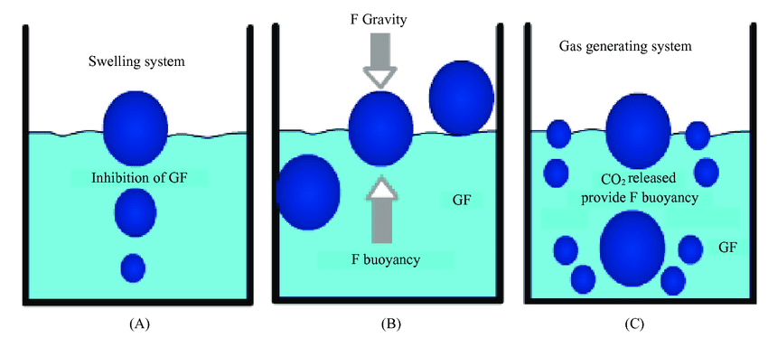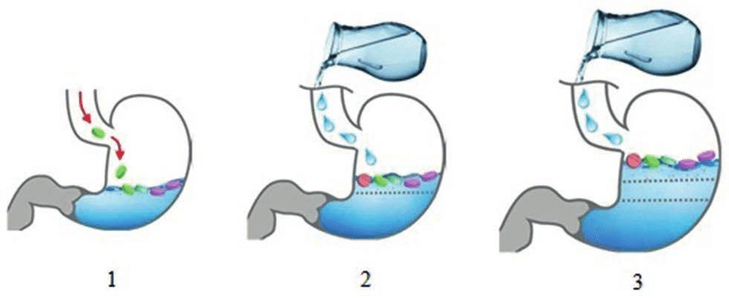

Fig 2: Mechanism of Floating

**2. EVALUATION OF FLOATING TABLET**

* Weight variation :- To check for weight differences, twenty pills were randomly selected from each batch and measured individually. The USP permits a slight variance in pill weight. The following is the permitted percentage deviation in weight variance. All formulations had tablet weights larger than 324 mg, allowing for a maximum variation of 5%.
* Hardness :- A tablet's resistance to mechanical shocks during treatment depends on its hardness. The tablet's hardness (kg/cm2) was evaluated using the Monsanto tester. In every instance, the average of five replication determinations was employed.
* Friability:- In accordance with Indian Pharmacopoeia (IP), this was ascertained by weighing 26 tablets after they had been dusted, putting them in the Roche friabilator, and spinning the plastic cylinder vertically at 25 rpm for four minutes. Following dusting, the total weight of the tablets that remained was recorded, and the following formula was used to determine the percentage of friability. Tablets with adequate friability are less than 1%.

**% Friability = Initial Tablet Weight - Final Tablet Weight / Initial Tablet Weight × 100%**

* Study of buoyancy in vitro Measurements :- They were made of the dose form's buoyancy on the SGF after it was introduced, as well as how long it remained buoyant. Total Floating Time (TET) is the amount of time the dosage form remains buoyant, whereas Floating Lag Time (FLT) or Buoyancy Lag Time (BLT) is the amount of time it takes for the dosage form to emerge on the medium's surface. In order to replicate in vivo conditions, a floating behavior investigation was conducted in a USP XXIII dissolving apparatus type II (Paddle) at a speed of 50 RPM in 900 ml SGF at 37±0.50C for 12 hours30.
* Index of swelling:- The measurement device's swelling activity is determined by the weight assignment. The tablet site in the dissolution tool basket (type 1) correlates with the tablet swelling index while utilizing a pH 6.8 buffer dissolution media at 370.5 °C. The trials were conducted three times at each time point31.
* Tablet Dimension:- The diameter and thickness were measured using a calibrated vernier calliper. Each formulation's three tablets were selected at random, and their thicknesses were measured.
* Tablet density:- Tablet density is considered as an important parameter for floating tablets. The tablet will float only when its density is less than that of gastric fluid (1.004)It can be determine as density using following formula

**3. APPLICATIONS**

* Drugs with Narrow Absorption Window

Use: These are medications that are mostly absorbed in the upper small intestine (duodenum, jejunum) or stomach. Examples include furosemide, riboflavin, and levodopa.

Benefits of FDDS include increased stomach residence time, improved absorption, and increased bioavailability.

* Drugs Unstable in Intestinal or Colonic pH

Use: medications that break down in the intestinal alkaline pH.

Benefit of FDDS : that it prolongs the drug's exposure to the stomach's acidic environment.

* Local Action in the Stomach

Use: Medication designed to treat stomach conditions locally, such as ulcers and H. pylori infections. Examples include antacids and antibiotics such as clarithromycin or amoxicillin.

Benefit of FDDS: Extended local action due to stomach retention.

* Use of Sustained Release Formulations

Use: Medicines that gain from gradual, regulated release.

Benefits ofFDDS include slower transit and more consistent stomach discharge**.**

* Low Solubility Drugs at Higher pH

**Use**: These medications dissolve more readily in acidic conditions. Examples include diazepam and verapamil.

**Benefit of FDDS**: Extended exposure to stomach pH results in improved solubility and bioavailability.

* Reducing Variations in Plasma Drug Concentrations

**Use**: medications that need constant blood levels or have short half-lives.

**Benefit of FDDS**: Offers a more reliable profile of medication release and absorption.

* Improved Patient Compliance

Use: Long-term treatments or situations when taking medication frequently is difficult.

**Benefits of FDDS** include improved convenience, compliance, and a decrease in dosage frequency.

* To treat gastroesophageal reflux disease (GERD)

**Use:**Drugs that reduce stomach acid or protect the gastric mucosa.

**Benefit of FDDS**: Floating systems provide a sustained release of acid suppressants like famotidine or ranitidine by remaining in the stomach longer.

* Handling Infections with Helicobacter pylori

**Use:** It is difficult to get rid of H. pylori since it lives in the stomach mucosa.

**Benefit of FDDS:** Preserves a high local concentration of antibiotics (such as amoxicillin and clarithromycin) in the stomach, increasing their efficacy.

* Chronotherapy

**Use:** Certain disorders, such as cardiovascular problems, arthritis, and asthma, have a circadian cycle.

**Benefits of FDDS:** For optimal treatment, timed and sustained release in the stomach can synchronize with the body's circadian clock.

* Post-Operative Pain Management

**Use:** Careful management of medication distribution is necessary following GI surgery.

**Benefits of FDDS:** Safer drug levels and fewer frequent dose requirements are guaranteed via controlled release in the stomach.

* Diabetes Management

**Use:** The upper gastrointestinal system is where medications like metformin are primarily absorbed.

**Benefits of FDDS:** Long-term absorption in the targeted area improves glycemic control.

* Use of Cardiovascular Drugs

**Use:** Short gastric residence reduces the bioavailability of medications such as propranolol, verapamil, or nifedipine.

**Benefits of FDDS :**increased bioavailability and a longer-lasting therapeutic effect through prolonged stomach retention.

* Better Peptide and Enzyme Utilization

**Use:** Certain peptides break down rapidly in the gastrointestinal system.

**Benefits of FDDS:** FDDS can help preserve the active substance and enhance absorption by prolonging its presence in the stomach's acidic environment.

* Application in Veterinary Care

**Use:** Localized stomach delivery and regulated release are advantageous for animals such as ruminants or dogs.

**Benefit of FDDS:** Floating dosage forms can improve the way that GI disorders are treated in animals.

**4.CONCLUSION**

By extending stomach retention, floating pills, a form of gastro retentive medication delivery technology, improve drug bioavailability. In addition to sophisticated methods like solvent evaporation and ionotropic gelation, they employ polymers and gas-generating agents. Diabetes, heart disease, H. pylori infections, and GERD can all be effectively treated using these systems. Notwithstanding many drawbacks, they continue to show promise as a sustained and targeted drug delivery system, and further developments are anticipated to expand their application, notably in veterinary medicine.

**5. REFRENCES**

1. Dey S, Singh PK. Bilayer and Floating-Bioadhesive Tablets: Innovative Approach To Gastroretension.) Drug Deliv Ther. 2011; 1(1):32-5.
2. Patil P, Baviskar P, Saudagar RB. Floating Drug Delivery System: A comprehensive review. J Drug Deliv Ther. 2019; 9(3-5):839-46. <https://doi.org/10.22270/jddt.v9i4-s.3384>
3. Chandel A, Chauhan K, Parashar B, Kumar H, Arora S. Floating drug delivery systems: A better approach. Int Curr Pharm J. 2012; 1(5):119-27. <https://doi.org/10.3329/icpj.v115.10283>
4. Saikrishna K, Rao VUM, Kiran RS, Raju B, Keerthi LM, Dutt AG, et al. Floating Bilayer Drug Delivery Systems - A Review of Novel Approach. Pharmanest [Internet]. 2014; 5(4):2237-41. Available from: <http://linkinghub.elsevier.com/retrieve/pii/S02715309140008>
5. Sabale V, Sakarkar SN, Pund S, Sabale PM. Formulation and evaluation of floating dosage forms: An overview. Syst Rev Pharm. 2010; 1(1):33-9. <https://doi.org/10.4103/0975-8453.59510>
6. Mayavanshi AV, Gajjar SS. Floating drug delivery systems to increase gastric retention of drugs: A Review.Research Journal of Pharmacy and Technology. 2008 Oct; 1(4):345-8.
7. Datir SK, Patil PB, Saudagar RB. Floating type drug delivery system: a review. | Drug Deliv Ther. 2019; 9(2):428-32. <https://doi.org/10.22270/jddt.v9i2.2492>
8. Chawla G, Gupta P, Koradia V, Bansal AK. Gastroretention: a means to address regional variability in intestinal drug absorption. Pharm Tech 2003;27:50-68.
9. Chandel A, Chauhan K, Parashar B, Kumar H, Arora S. Floating drug delivery systems: a better approach. Int Curr Pharm J 2012;1:110-8.
10. Rubinstein A, Friend DR. Specific delivery to the gastrointestinal tract. In: AJ Domb. (Ed.). Polymeric site-specificpharmacotherapy, Wiley, Chichester; 1994. p. 282-3.