**FAIRNESS IN MACHINE LEARNING: DETECTING AND MITIGATING ALGORITHMIC BIAS IN PREDICTIVE MODELS**

**Ms. Charushila Patil1, Ms. Jasleen Kaur Palaya2, Ms. Sanjana Kulkarni3, Ms. Kumkum Chavan4**

1Head of Department, AI&DS, Guru Gobind Singh College of Engineering and Research Centre, Nashik, Maharashtra, India

2Student, AI&DS, Guru Gobind Singh College of Engineering and Research Centre, Nashik, Maharashtra, India

3Student, AI&DS, Guru Gobind Singh College of Engineering and Research Centre, Nashik, Maharashtra, India

4Student, AI&DS, Guru Gobind Singh College of Engineering and Research Centre, Nashik, Maharashtra, India

**ABSTRACT**

The rapid integration of machine learning models into critical decision-making processes has raised concerns about algorithmic fairness and bias. Predictive models trained on historical data can inadvertently perpetuate or amplify societal biases, leading to unfair outcomes in areas like hiring, credit scoring, and law enforcement. This paper explores the root causes of bias in machine learning, methodologies for detecting such biases, and current strategies for mitigation. We discuss fairness metrics, debiasing algorithms, and the trade-offs between accuracy and fairness. Real-world case studies and experimental results using open-source datasets are used to demonstrate practical applications. The paper concludes with recommendations for building more equitable machine learning systems.

**Keywords:** Data Science, Machine Learning, AI, Algorithms

**1. INTRODUCTION**

The increasing reliance on machine learning in decision-making has brought algorithmic fairness to the forefront of ethical AI research. Bias in predictive models can lead to discriminatory outcomes, often reflecting historical inequalities embedded in the training data. This paper aims to provide a comprehensive understanding of algorithmic bias, its detection, and mitigation strategies.

**2. METHODOLOGY**

**2.1 Understanding Algorithmic Bias:**  
Bias in machine learning can arise from various sources, including biased data collection, skewed labelling, or model assumptions. We classify bias into several types:

* **Historical bias**: Inherent in the data due to past societal inequalities.
* **Representation bias**: Occurs when certain groups are underrepresented in the data.
* **Measurement bias**: Arises from flawed labels or proxies.
* **Aggregation bias**: When models fail to account for subgroup variations.

**2.2 Detecting Bias in Predictive Models**  
Several fairness metrics are used to identify bias, such as:

1. **Demographic parity**
2. **Equalized odds**
3. **Predictive parity**
4. **Disparate impact**  
   We explain these metrics and demonstrate their application using tools like AIF360 and Fairlearn.

**3. MODELING AND ANALYSIS**

**3.1 Mitigation Strategies**  
Bias mitigation can be applied at different stages:

* **Pre-processing**: Data cleaning and rebalancing techniques (e.g., re-weighting, sampling).
* **In-processing**: Fairness-aware algorithms (e.g., adversarial debiasing, fairness constraints).
* **Post-processing**: Adjusting model outputs (e.g., threshold optimization).  
  Each method is evaluated for its effectiveness, limitations, and trade-offs.

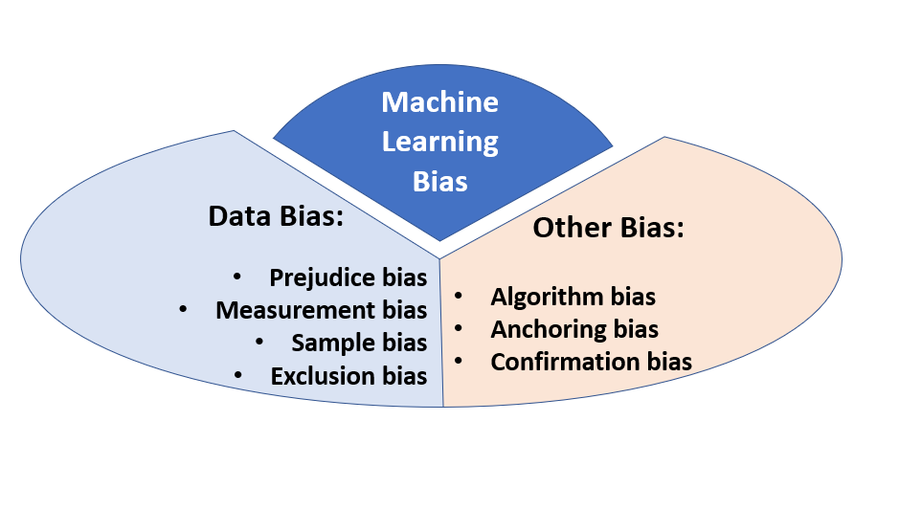

**Figure 1:** Mitigating Models in ML

**4. RESULTS AND DISCUSSION**

Using the COMPAS and Adult Income datasets, we apply various detection and mitigation techniques. Results show significant improvements in fairness metrics, with a detailed discussion on the impact on model performance. We explore the trade-off between model accuracy and fairness, the importance of context in fairness evaluation, and the role of human oversight. We also touch on regulatory and ethical considerations.

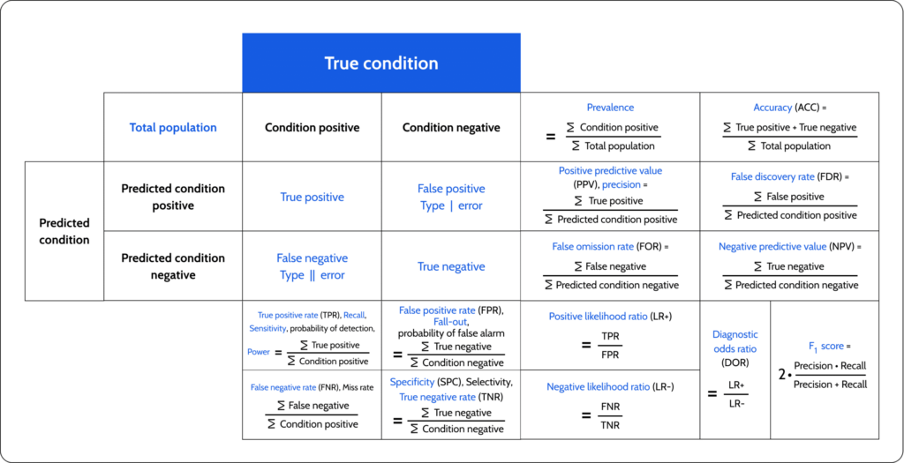

**Figure 2:** Machine Learning Fairness Metrics

1. **CONCLUSION**

Ensuring fairness in machine learning is essential for ethical and responsible AI deployment. The complexity of bias—ranging from its origin in historical data to its reinforcement through algorithmic decisions—demands a multi-layered approach to both detection and mitigation. Through an in-depth study of fairness metrics, debiasing strategies, and practical implementations, this paper emphasizes the importance of embedding fairness at every stage of the machine learning pipeline.

1. **REFERENCES**

[1] T. Mohana Priya, et al., “Machine Learning Algorithm for Enhanced SVM to Predict Stress,” Global Journal of Computer Science and Technology, Vol. 20, Issue 2, 2020, pp. 12-20.

[2] Ganesh Kumar, P. Vasanth Sena, “Novel Neural Networks for Detecting Credit Card Deceit,” IJCSNS, Vol. 15, Issue 9, Sep. 2015, pp. 222–234.

[3] IBM AIF360 Toolkit. https://aif360.mybluemix.net

[4] Fairlearn Documentation. <https://fairlearn.org>

[5] Berk et al., “Fairness in Criminal Justice Risk Assessments,” Science Advances, 2018.