**Experimental investigation on pulp and paper based concrete to study its properties**

**Sonal Kumar Soni1, Bhojram Sahu2**

1MTech Scholar, Civil Engineering, Bharti Vishwavidyalaya, Durg, Chattisgarh, India

2Assistant Professor, Civil Engineering, Bharti Vishwavidyalaya, Durg, Chattisgarh, India

**ABSTRACT**

The use of Paper Pulp in concrete is relatively a new development in the world of concrete technology and lot of research must go in before this material is actively used in concrete construction. The previous studies suggested that Paper Pulp used in concrete is perfect example of make best from waste; the waste papers are fully utilized. In this study the various properties of Concrete made by Paper pulp based is done like Workability, W/C Ratio, Compressive strength, Tensile strength, Flexural Strength etc. for different grades of concrete. The investigation is based in the laboratory results obtained during the studies and the laboratory equipments and tools used are as per Indian Standard Provision and certified by the university which is used for consultancy purpose too. The locally available (near by the research Area) Paper Pulp used in this study which is found from the wastage. The Conclusion is further made after the study and graphs are drawn for two comparative grades of concrete.

Keywords: Workability, W/C Ratio, Compressive strength, Tensile strength, Flexural Strength.

**INTRODUCTION**

Nowadays concrete plays a major role in the development of any country. It has become in such a way that the usage of concrete became second only to water around the world. In the last two decades environmental issues in the concrete industry have been paid a lot of attention, aiming at reducing the total environmental impact of concrete structures to a minimum, without compromising on their performance. A lot of different tools have been developed in order to reduce the environmental impact of concrete.

Over 300 million tons of industrial wastes are being produced per annum by chemical and agricultural process in India. These materials possess problems of disposal problem. Paper fibers can be recycled only a limited number of times because the fibers become too short to make high quality paper. It means low- quality paper fibers are separated out to become waste sludge. Paper sludge has properties like cement because of the presence of silica and magnesium which improve the workability of theconcrete. The amount of sludge generated by a recycled paper mill is greatly dependent on the type of furnish being used and end product being manufactured. Paper sludge can be used as an alternative for the partial replacement of fine aggregates in production of concrete.

About 300 kg of sludge is produced for each tone of recycled paper. This is an enormous volume of sludge produced every day that makes landfill decomposition uneconomical. By using the right proportion of mixes, concrete mixtures containing the paper sludge can be produced that are equivalent in slump and strength with respect to concrete without paper sludge.

In 1995, the U.S. pulp and paper industry generated about 5.3 million metric tons of mill wastewater-treatment residuals (on oven-dry), which is equal to about 15 million metric tons of dewatered residuals. Half of this was disposed in landfills, a quarter was burned, one-eighth was applied on farmland/forest, one sixteenth was recycled in mills, and the rest, one sixteenth, was used in other ways. Pulp and paper mill residual solids (also called sludge) are composed mainly of cellulose fibers, moisture, and papermaking fillers (mostly kaolinitie clay and/or calcium carbonate).

Use of the industrial wastes in the construction work might lead to a finding the possibility to decrease theenvironment pollution by paper industry wastes and it will also bring down the cost of construction.The use of paper sludge in concrete used as an alternative to landfill disposal.

The dry paper sludge mainly contains silica and calcium oxide, followed by alumina and magnesium oxide. Cement mixed with 10% and 20% calcined paper sludge exhibits a small decrease in compressive strength than the ordinary Portland cement. A study on the reuse of paper de-inking sludge, undertaken in Spain, shows its potential as raw material for yielding a product with pozzolanic activity.

The compressive strength and drying shrinkage of concrete containing paper sludge were also comparable to the ordinary Portland cement when the proper amount of super plasticizer is mixed. Concrete containing an average of 15% paper sludge as fine aggregates had a lower 28-days compressive strength than the reference ordinary Portland cement.

Although there are potential advantages of including paper-mill residuals in a concrete mixture, such as cost savings in both waste management and concrete production, to date still lot of work has to be done on the utilization of paper pulp in concrete production. This thesis work summarized the behavior of concrete with the waste paper sludge by replacement of cement in the range of 5%, 10%, 15% and 20% which may helps to reduce the disposal problem of sludge and enhance the properties of concrete.

In 1987, Thomas,in his paper he made an attempt to prepare the composite concrete using the Portland cement and fibrous sludge from paper recycling plant. These composites were studied for potential use of wall boards, fire retarders and insulations. The paper sludge used in the experiment contained 55% cellulose fibres, 44% Kaolinitic clay and 1% ink and dyes.

Two methods of concrete mixing were devised. One method involved mixing the cement with dewatered sludge with 35% solid content. The other method was mixing the cement with wet sludge with 5% solid content. In both methods, the mixes were vacuum dewatered. Then it was filled in the 2 inches diameter pipe and was compacted with the vibration. For the compression test the specimen was cut into 4 inches length. The compressive strength was about four times. This was due to the improved dispersion of fibres.

For the flexural strength 2 inches deep and 1.5 inches wide beams were casted and tested under centre point flexural loading on a 10 inches span. The flexural strength was lower than the conventional mortar. The composite of cement and wet sludge showed a considerable load carrying capacity beyond cracking.

In 1997, Naik et. all,It was an attempt to study the use of pulp and paper mill residuals in concrete. In this study three sources of dewatered residuals were used. The two sources contained virgin cellulose fibres and one source was from recycled de-ink mill. The residuals were composed of moisture, wooden fibers, kaolin type clay, calcium carbonate and carbon. For the preparation, tilting mixer was used for mixing the ingredients. Pea gravel of 3/8 inches maximum size were used as a coarse aggregates and regular sand as a fine aggregate.

Before mixing, the paper residuals were deflocculated. The amount of paper pulp residuals required for each concrete mixes were immersed in a high range water reducing admixture and water in a plastic bucket. It was assumed that the high range water reducing admixture would help deflocculate wooden fibres in the residuals. The slump of all the mixes falls between the 2.5 to 6.5 inches. The water cement ratio ranged between 0.39 to 0.52. The density of mixes containing residuals are equivalent to the mixes without containing residuals. The density of the residual concrete decreased with the increase of the residuals.This research was therefore dedicated to the development, the manufacture, and the engineering properties of the fresh and hardened paper pulp-basedconcrete.

**METHODOLOGY**

## 2. GENERAL

Based on the extensive literature an attempt has been made to verify the possibility of preparing waste paper pulp-based concrete economically to suit our country conditions.

In order to develop the waste paper pulp based concrete technology, therefore, a meticulous trial and error process was adopted. In order to simplify the development process, the compressive strength was selected as the datum. The aim of the study was mainly on the engineering properties of the waste paper pulp-based concrete and also for maximum substitution of paper pulp with cement. The current practice used in the manufacturing and testing of ordinary Portland cement concrete was followed, even for paper pulp-based concrete. It is ease the promotion of this ‘new’ material to the construction industry.

Waste paper pulp-based concrete can be made from various source materials, in the present study only dry paper pulp was used, as it easily available at economical price in the country. Also, as in the case of this in the case of OPC, even in the paper pulp-based concrete, the aggregate occupies 75-80% of the total volume of the matrix. In order to decrease the effect of the properties of the aggregates on the properties of the waste paper pulp-basedconcrete the study was done using the aggregates from single place.

Waste paper pulp-based concrete with different combinations are casted and tested for Compressive strength, Split Tensile strength, and Flexure strength.

## 2.1 MATERIALS

### 2.1.1 Paper Pulp:

In this thesis work an attempt is made to produce the concrete specimens constituting calcined source material (waste paper pulp). Curing for the specimens is carried out at room temperature.Thepaper pulp used in the experiment is taken from Dhanlakshmi paper mill, Dongargaon, Rajnandgaon, Raipur and Bilspur.

### 2.1.2 Fine Aggregate and Coarse Aggregate

Zone-II sand was considered for work and the properties of zone-2, fine aggregate was shown in table and machine crushed stone used as coarse aggregate. The size of aggregate varies from 20mm to 4.75mm. The physical properties of coarse aggregate are shown in table.

**Table 2.1 Sieve Analysis of Fine Aggregate and Coarse Aggregate**

|  |  |  |  |  |
| --- | --- | --- | --- | --- |
| **Sieve size(mm)** | **Percentage passing** |  | **Sieve size(mm)** | **Adopted Grading** |
| 40 | 100 |  | 10 | 100 |
| 20 | 100 |  | 4.75 | 100 |
| 16 | 70 |  | 2.36 | 85 |
| 12.5 | 45 |  | 1.18 | 70 |
| 10 | 30 |  | 600µ | 45 |
| 4.75 | 0 |  | 300µ | 10 |
|  |  |  | 150µ | 0 |

Fineness modulus of fine aggregate: 3.10

Fineness modulus for Coarse aggregate: 7.15

Specific gravity for fine aggregate: 2.62

Specific gravity for Coarse aggregate:2.8

### 

### 2.1.3 Water

Portable water supplied by the college was used in the work. The pH of water around 6.5-7.

**Table 2.2 Number of specimens casted for OPC and PPC M20& M25 grade concrete**

|  |  |  |  |  |  |  |
| --- | --- | --- | --- | --- | --- | --- |
| Specimens | Dimensions (mm) | Number of specimens casted for OPC M20 & M25 | | | | Purpose |
| Cubes | 150x150x150 | 3+3 | | | | Compressive strength, Durability |
| Cylinders | 150 ɸ and 300 height | 3+3 | | | | Splitting tensile strength and determining the Modulus of Elasticity. |
| Prisms | 100x100x500 | 3+3 | | | | Flexural strength |
|  | | | | | | |
| Specimens | Dimensions (mm) | Number of specimens casted for PPC M20 grade of concrete | | | | Purpose |
| 5 | 10 | 15 | 20 |
| Cubes | 150x150x150 | 3 | 3 | 3 | 3 | Compressive strength, Durability |
| Cylinders | 150 ɸ and 300 height | 3 | 3 | 3 | 3 | Splitting tensile strength and determining the Modulus of Elasticity. |
| Prisms | 100x100x500 | 3 | 3 | 3 | 3 | Flexural strength |
|  | | | | | | |
| Specimens | Dimensions (mm) | Number of specimens casted for PPC M25 grade of concrete | | | | Purpose |
| 5 | 10 | 15 | 20 |
| Cubes | 150x150x150 | 3 | 3 | 3 | 3 | Compressive strength, Durability |
| Cylinders | 150 ɸ and 300 height | 3 | 3 | 3 | 3 | Splitting tensile strength and determining the Modulus of Elasticity. |
| Prisms | 100x100x500 | 3 | 3 | 3 | 3 | Flexural strength |

**Figure 2.1 Scheme of Experimental Programme**

## 2.2 MIX DESIGN

M20 & M25 Grades of Concrete were considered. Mix of M25 were designed by using IS 10262.The mix proportions corresponding to M20 are 1:1.40:3.20:0.45 and M25 are 1:1.26:2.80:0.45. The constituents of mix proportion were shown in the Table.4.4

**Table 2.2 Showing Mix proportions and quantity of materials used for M20 Mix ‘A’**

|  |  |  |  |
| --- | --- | --- | --- |
|  | **Material** | **Quantity**  **kg/m3** | **Quantity for** |
| **6 cubes in Kg** |
| 1 | Cement | 365.94 | 7.41 |
| 2 | Fine Aggregate | 539.28 | 10.92 |
| 3 | Coarse Aggregate | 1232.64 | 24.96 |
| 4 | Waste Paper Pulp | 19.26 | 0.39 |
| 5 | Water | 173.34 | 3.51 |
|  | **Density** | **2332** |  |

**Table 2.4 Showing Mix proportions and quantity of materials used for M25 Mix ‘A’**

|  |  |  |  |
| --- | --- | --- | --- |
| **S.No.** | **Material** | **Quantity**  **kg/m3** | **Quantity for** |
| **6 cubes in Kg** |
| 1 | Cement | 405.17 | 8.20 |
| 2 | Fine Aggregate | 537.39 | 10.90 |
| 3 | Coarse Aggregate | 1194.20 | 24.20 |
| 4 | Waste Paper Pulp | 21.33 | 0.431 |
| 5 | Water | 191.92 | 3.89 |
|  | **Density** | **2372** |  |

**Table 2.5 showing Mix proportions and quantity of materials used for M20 Mix ‘B’**

|  |  |  |  |
| --- | --- | --- | --- |
| **S.No.** | **Material** | **Quantity**  **kg/m3** | **Quantity for** |
| **6 cubes in Kg** |
| 1 | Cement | 346.68 | 7.02 |
| 2 | Fine Aggregate | 539.28 | 10.92 |
| 3 | Coarse Aggregate | 1232.64 | 24.96 |
| 4 | Waste Paper Pulp | 38.52 | 0.780 |
| 5 | Water | 173.34 | 3.51 |
|  | **Density** | **2332** |  |

**Table 2.6 Showing Mix proportions and quantity of materials used for M25 Mix ‘B’**

|  |  |  |  |
| --- | --- | --- | --- |
| **S.No.** | **Material** | **Quantity**  **kg/m3** | **Quantity for** |
| **6 cubes in Kg** |
| 1 | Cement | 383.85 | 7.77 |
| 2 | Fine Aggregate | 537.39 | 10.90 |
| 3 | Coarse Aggregate | 1194.20 | 24.20 |
| 4 | Waste Paper Pulp | 42.65 | 0.863 |
| 5 | Water | 191.92 | 3.89 |
|  | **Density** | **2372** |  |

**Table 2.7 showing Mix proportions and quantity of materials used for M20 Mix ‘C’**

|  |  |  |  |
| --- | --- | --- | --- |
| **S.No.** | **Material** | **Quantity**  **kg/m3** | **Quantity for** |
| **6 cubes in Kg** |
| 1 | Cement | 327.42 | 6.63 |
| 2 | Fine Aggregate | 539.28 | 10.92 |
| 3 | Coarse Aggregate | 1232.64 | 24.96 |
| 4 | Waste Paper Pulp | 57.78 | 1.17 |
| 5 | Water | 173.34 | 3.51 |
|  | **Density** | **2332** |  |

**Table 2.8 Showing Mix proportions and quantity of materials used for M25 Mix ‘C’**

|  |  |  |  |
| --- | --- | --- | --- |
| **S.No.** | **Material** | **Quantity**  **kg/m3** | **Quantity for** |
| **6 cubes in Kg** |
| 1 | Cement | 362.52 | 7.34 |
| 2 | Fine Aggregate | 537.39 | 10.90 |
| 3 | Coarse Aggregate | 1194.20 | 24.20 |
| 4 | Waste Paper Pulp | 63.98 | 1.30 |
| 5 | Water | 191.92 | 3.89 |
|  | **Density** | **2372** |  |

**Table 2.9 showing Mix proportions and quantity of materials used for M20 Mix ‘D’**

|  |  |  |  |
| --- | --- | --- | --- |
| **S.No.** | **Material** | **Quantity**  **kg/m3** | **Quantity for** |
| **6 cubes in Kg** |
| 1 | Cement | 308.16 | 6.24 |
| 2 | Fine Aggregate | 539.28 | 10.92 |
| 3 | Coarse Aggregate | 1232.64 | 24.96 |
| 4 | Waste Paper Pulp | 77.04 | 1.56 |
| 5 | Water | 173.34 | 3.51 |
|  | **Density** | **2332** |  |

**Table 2.10 Showing Mix proportions and quantity of materials used for M25 Mix ‘D’**

|  |  |  |  |
| --- | --- | --- | --- |
| **S.No.** | **Material** | **Quantity**  **kg/m3** | **Quantity for** |
| **6 cubes in Kg** |
| 1 | Cement | 341.20 | 6.91 |
| 2 | Fine Aggregate | 537.39 | 10.90 |
| 3 | Coarse Aggregate | 1194.20 | 24.20 |
| 4 | Waste Paper Pulp | 85.30 | 1.72 |
| 5 | Water | 191.92 | 3.89 |
|  | **Density** | **2372** |  |

## 2.3 MOULDS AND EQUIPMENTS:

### 2.3.1 Moulds

To determine the compressive strength of a waste paper pulp concrete, cubes of 150mm×150mm×150mm size were used. Cylinders are used to determine split tensile strength, having the dimension 150mm diameter and 300mm. For flexure test Prisms of 100mm×100mm×400mm size were used.

### 2.3.2 Equipment’s

**2.3.2.1 Vibrator**

Table vibrator was used to compact the cubes, cylinders and prisms.

## 2.4 Casting

The moulds were tightly fitted and the inner sides of the moulds were thoroughly oiled. First all the required quantities of materials cement, waste paper pulp, fine and coarse aggregate were batched. During the preparation, first coarse aggregate and fine aggregate were poured and mixed thoroughly for some time then the waste paper pulp and cement were added to the mix and rotate the machine for some time so that the uniform mix was prepared. Then the prepared concrete was placed in the moulds in three layers. Each layer was thoroughly compacted by a tamping rod by giving 25 blows. The process was continued for all the specimens. Finally, the mould was compacted with the help of table vibrator and after compaction the top surface was levelled with a trowel.

## 2.5 Curing

The cubes were removed from the mould after the 48hrs. Then the specimens were cured for 14 days and 28 days.

## 2.6 Testing of specimens

### 2.6.1 Compressive Strength

The cube specimens were tested on compression testing machine of capacity 1000kN. The bottom surface of the compression testing machine was cleaned and loose fine particlesremoved from the surface of the cubes.The mould was placed on the bottom surface of machine in such a way that the load was applied to opposite sides of the cubes as cast that is not top and bottom. The axis of the specimen was aligned in the centre of the loading frame. The load was applied on the specimen and it was increased continuously at a constant rate until the resistance of the specimen to the increasing load breaks down and no longer cubes can sustain. Then, the maximum load applied on the specimen was recorded. The detail of a cube specimen under test is shown in Figure 4.4.

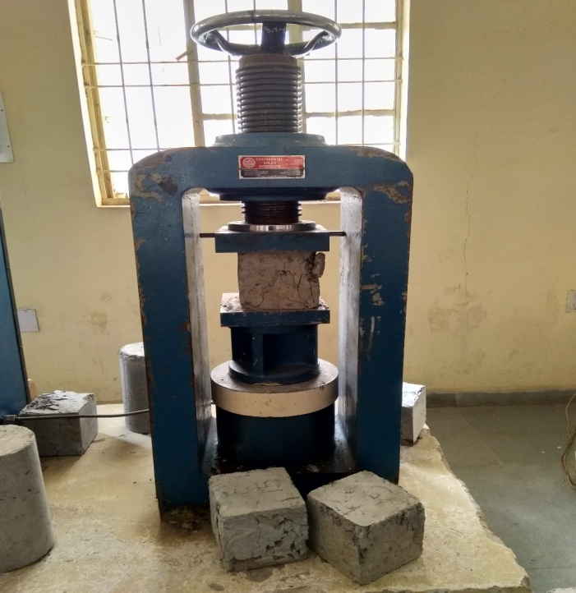

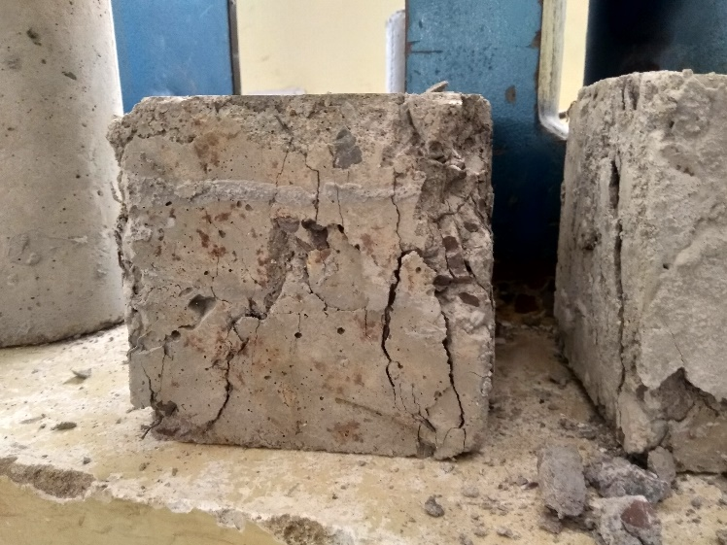

**Figure 2.3 Testing of cubes for compressive strength**

### 

### 2.6.2 Split Tensile Strength

The cylindrical specimens were tested on compression testing machine of capacity 3000kN for getting the tensile strength. The bottom surface of the machine was cleaned off and in case of cylindrical specimen the test was carried out by placing the specimen horizontally between the loading surfaces of the compression testing machine for split tensile strength and the axis of the specimen was aligned at the centre of loading frame. The load applied was increased continuously at a constant rate until the resistance of the specimen to the increasing load breaks down and no longer can be sustained. The maximum load applied on the specimen was noted. The details of a cylinder specimen under test are shown in Figure 4.5.

The Split Tensile Strength is obtained for

$$fst=2P/(п LD)$$

Where, P is the maximum load carried by the cylinder

L is the length of the cylinder

D is the diameter of the cylinder

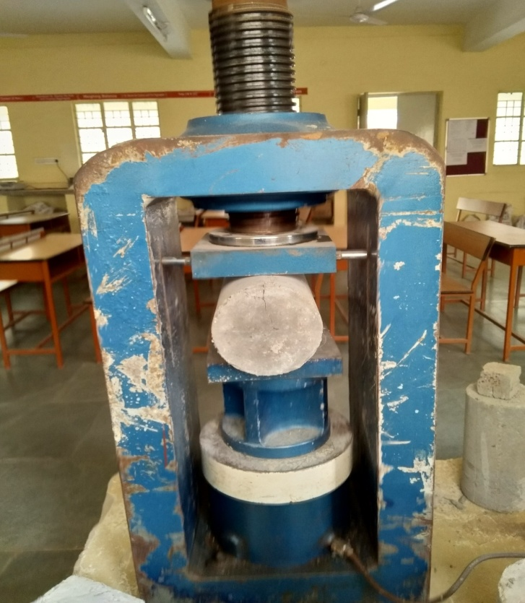

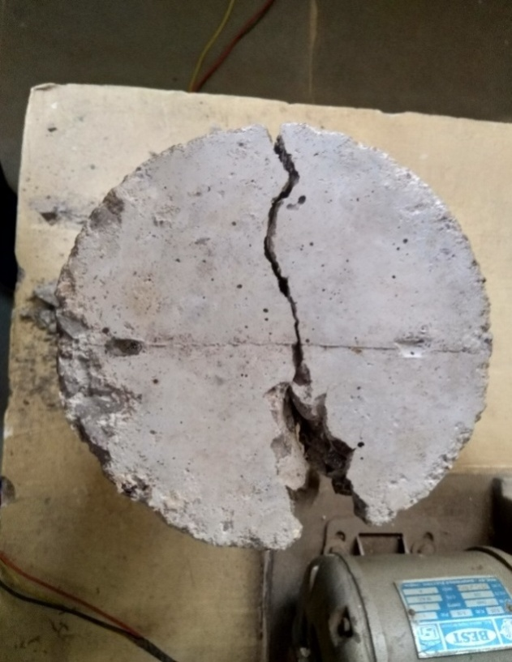

**Figure 2.3 Testing of cylinder for split tensile strength**

### 2.6.3 Flexural Strength

Flexural strength of the specimen was determined with the help of universal testing machine of 1000 KN capacity and +80mm stroke (displacement).

The flexural strength of the prism specimen is expressed as the modulus of rupture. The two point loading method is used for the testing.The test specimen should be turned its sides with respect to its portion moulded and cantered on bearing blades. The load applied as shown in Figure 4.6. All the tests were performed under vertical displacement control. The load deflection curves were continuously recorded for each prisms of all four different percentages of crumb rubber If “a” equals the distance between the line of fracture and the nearer support measured on the cantered line of the tensile side of the specimen, in cm, is calculated to the nearest 0.05 M pa as follows.

$$F=Pl/(bd^{2})$$

When “a” is greater than 20.0 cm for 15cm specimen or greater than 13.3 cm for a 10.0cm specimen or

$$F=3Pa/({bd}^{2})$$

When “a” is less than 20.0cm but greater than 17cm for 15cm specimen or less than 13.3cm but greater than 11cm for a 10cm specimen

Where, b = measured width of the specimen

d = measured depth of the specimen at the point of failure

l = length of span on which the specimen was supported

P = Max. Load in kg applied to the specimen upto failure.

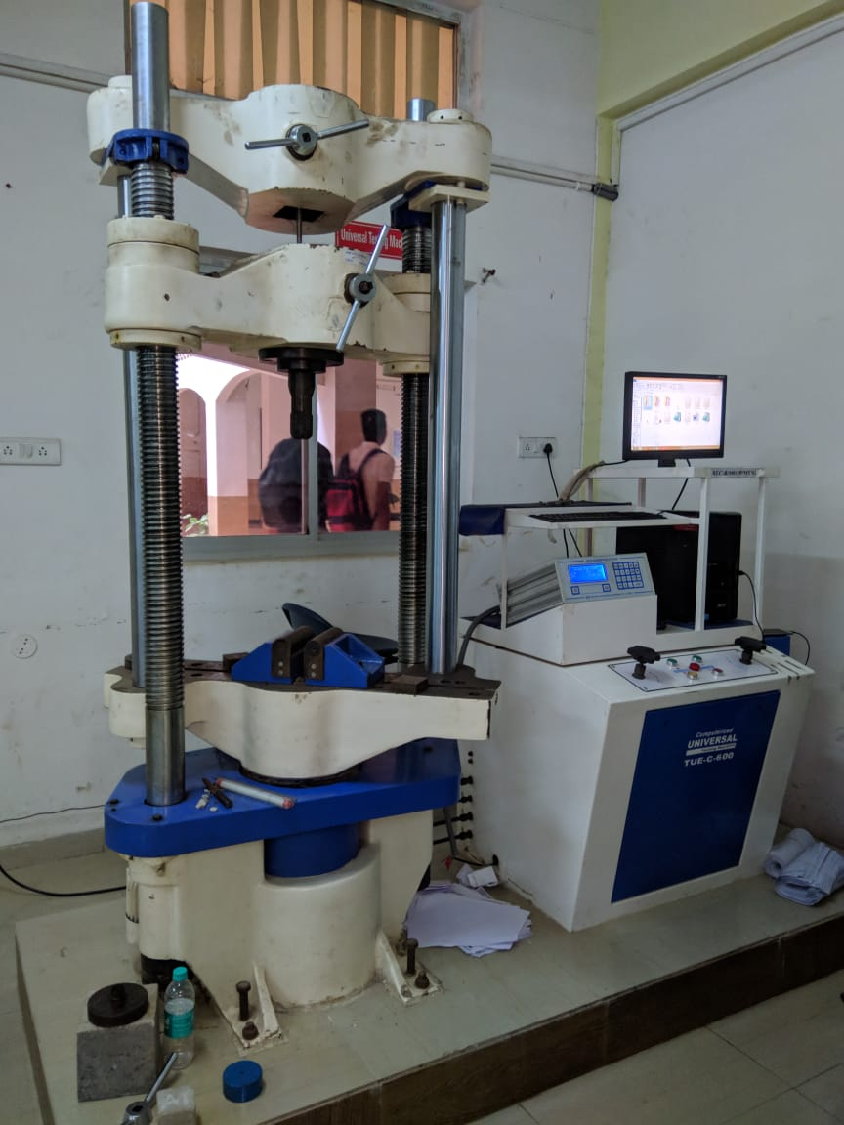

**Figure 2.4 Test setup for Flexural Testing in Dynamic Testing Machine of Capacity 1000KN**

### 2.7.4 Sorptivity Study:

The sorptivity tests were carried out on all batches of Paper Pulp based Concrete with size of 15x15 x15cm. The preparation of samples also included water impermeability of their lateral faces, reducing the effect of water evaporation. The test started with the registration of samples weight and afterwards they were placed in a recipient in contact with a level of water capable to submerge them about 5 mm . After a predefined period of time, the samples were removed from the recipient to proceed to weight registration. Before weighing, the samples superficial water was removed with a wet cloth. Immediately after weighting, the samples were replaced in the recipient till reach the following measuring time. The procedure was repeated, consecutively, at various times such as 15 min, 30 min, 1 h, 2 hrs, 4 hrs, 6 hrs, 24 hrs, 48 hrs ,72 hrs, 7days, 14days and 28days.

Because of a small initial surface tension and buoyancy effects, the relationship between cumulative water absorption (kg/m2) and square root of exposure time (t0.5) shows deviation from linearity during first few minutes. Thus, for the calculation of sorptivity coefficient, only the section of the curves for exposure period from 15 min to 72 hrs, where the curves were consistently linear, was used.

1. **RESULTS AND DISCUSSION**

## WORKABILITY OF CONCRETE

### Effect of Paper pulp on workability of concrete

**Table 5.1 Slump Value of M20 of different mixes.**

|  |  |  |
| --- | --- | --- |
| **S.No** | **Waste paper pulp %** | **Slump Value (mm)** |
| Mix1 | 0 | 70 |
| Mix2 | 5 | 70.5 |
| Mix3 | 10 | 57 |
| Mix4 | 15 | 51 |
| Mix5 | 20 | 41 |

**Figure 5.1 Variation of M20in slump value with variation of paper pulp**

**Table 5.2 Slump Value of M25 of different mixes.**

|  |  |  |
| --- | --- | --- |
| S.No | Waste paper pulp % | Slump Value (mm) |
| Mix1 | 0 | 52 |
| Mix2 | 5 | 53 |
| Mix3 | 10 | 46 |
| Mix4 | 15 | 34 |
| Mix5 | 20 | 31 |

**Figure 5.2 Variation of M25in slump value with variation of paper pulp**

The test was carried out on slump cone to find the workability of the concrete. With the increase of paper pulp the slump value decreased gradually.

## COMPRESSIVE STRENGTH OF CUBES

### Effect of Paper pulp on Compressive Strength of Cubes

**Table 5.3 Strengths of waste paper concrete M20 of different mixes.**

|  |  |  |  |
| --- | --- | --- | --- |
| **S.No** | **Waste paper pulp %** | **Compressive Strength (MPa)** | |
| **14 days** | **28days** |
| Mix1 | 0 | 22.50 | 31.80 |
| Mix2 | 5 | 25.40 | 33.63 |
| Mix3 | 10 | 23.13 | 32.53 |
| Mix4 | 15 | 19.10 | 25.70 |
| Mix5 | 20 | 17.05 | 21.97 |

For concrete cubes cured for 28 days, the strength reached around 33.63MPa (for Mix-2).

**Figure 5.3 Variation of M20 Compressive Strength with variation of paper pulp**

**Table 5.4 Strengths of waste paper concrete M25 of different mixes.**

|  |  |  |  |
| --- | --- | --- | --- |
| **S.No** | **Waste paper pulp %** | **Compressive Strength (MPa)** | |
| **14 days** | **28days** |
| Mix1 | 0 | 24.42 | 40.76 |
| Mix2 | 5 | 26.80 | 42.29 |
| Mix3 | 10 | 25.69 | 41.14 |
| Mix4 | 15 | 22.75 | 38.37 |
| Mix5 | 20 | 20.01 | 34.98 |

For concrete cubes cured for 28 days, the strength reached around 42.29MPa (For Mix -2).

**Figure 5.4 Variation of M25 Compressive Strength with variation of paper pulp**

From Table 5.3 and 5.4, it can be seen that the compressive strength of waste paper pulp-based concrete increases with increase in the paper pulp content till 10% after that it gradually decreased. Curing by direct sun light gives the sufficient compressive strength.According to the tests, we can replace cement by paper pulp up to 15%.

## SPLIT TENSILE STRENGTH OF CUBES

### Effect of Paper pulp on Tensile Strength of Cubes

**Table 5.5Tensile Strength of waste paper concrete M20 of different mixes.**

|  |  |  |
| --- | --- | --- |
| **S.No** | **Waste paper pulp %** | **Split Tensile Strength (MPa)** |
| Mix1 | 0 | 2.85 |
| Mix2 | 5 | 2.98 |
| Mix3 | 10 | 2.89 |
| Mix4 | 15 | 2.43 |
| Mix5 | 20 | 2.26 |

**Figure 5.5 Variation of M20 Split Tensile Strength with variation of paper**

**pulp**

**Table 5.6 Tensile Strength of waste paper concrete M25 of different mixes.**

|  |  |  |
| --- | --- | --- |
| **S.No** | **Waste paper pulp %** | **Split Tensile Strength (MPa)** |
| Mix1 | 0 | 3.37 |
| Mix2 | 5 | 3.72 |
| Mix3 | 10 | 3.61 |
| Mix4 | 15 | 3.23 |
| Mix5 | 20 | 2.78 |

**Figure 5.6 Variation of M25 Split Tensile Strength with variation of paper pulp**

The split tensile strength was conducted as per IS 5816:1999. The test was conducted on the compression testing machine. From the table 5.5 and 5.6, it can be noted that the split tensile strength increased till 15% and after that it gradually decreased.

## FLEXURAL STRENGTH OF CUBES

### Effect of Paper pulp on Flexural Strength of Cubes

**Table 5.7 Strengths of waste paper concrete M20 of different mixes.**

|  |  |  |
| --- | --- | --- |
| **S.No** | **Waste paper pulp %** | **Flexural Strength (MPa)** |
| Mix1 | 0 | 12.43 |
| Mix2 | 5 | 14.30 |
| Mix3 | 10 | 12.74 |
| Mix4 | 15 | 10.92 |
| Mix5 | 20 | 9.23 |

**Figure 5.7 Variation of M20 Flexural Strength with variation of paper pulp**

**Table 5.8 Strengths of waste paper concrete M25 of different mixes.**

|  |  |  |
| --- | --- | --- |
| **S.No** | **Waste paper pulp %** | **Flexural Strength (MPa)** |
| Mix1 | 0 | 14.67 |
| Mix2 | 5 | 15.81 |
| Mix3 | 10 | 14.89 |
| Mix4 | 15 | 12.60 |
| Mix5 | 20 | 10.21 |

**Figure 5.8 Variation of M25 Flexural Strength with variation of paper pulp**

The flexural strength of concrete is carried out as per IS: 516: 1959. The test was carried out on a universal testing machine. Paper Pulp based concrete showed improved flexural strength than ordinary Portland cement.

1. **CONCLUSION**

From a paper-based research study developed in the concrete research area, it has come to the following conclusion.

1. The amount of slump up to 5% instead of the amount of slump increased by 5%.
2. The composting of the waste paper concrete, has10% and 15% paper waste, showed a 6% decrease. In addition when the volume of paper waste did not increase by 20%, the price of paper dropped by 12%.
3. The compressive strength, which separates the tensile strength and the tensile strength until it is increased by 10% cement with a drop sheet after which it gradually decreases.
4. Competitive power decreased by 2.1% after replacing 20% ​​cement with paper pulling.
5. Replacement of cement with 5 to 10% waste paper shows ideal results.
6. Waterproofing of concrete cubes containing 10%, 15% and 20% waste paper has increased by 0.1%, 0,2% and 0.4%.
7. It will help to address the issue of waste disposal in the paper industry and in addition will also help to arrange green concrete.
8. The mass of concrete mix with 10% and 15% of paper waste increased by 0.5% and 0.2% respectively compared to controlled mix but decreased by 0.1% by 20% of paper waste.
9. It can be concluded that the use of 10% of waste paper waste, concrete mixing can be easily allowed.
10. The cost of concrete production, compared with mixed control decreases by 1.7%, 2.4% and 3.2% with the addition of 10%, 15% and 20% waste paper respectively.

**REFERENCES**

1. R. Srinivasan, K. Sathiya, and M. Palanisamy, Experimental investigation in developing low cost concrete from paper industry waste, *The Bulletin of the Polytechnic Institute of Jassy, Construction*. Architecture Section (Romania),2010.
2. R.S. Gallardo, Mary Ann Q Adajar, Structural performance of concrete with paper sludge as fine aggregates partial replacement enhanced with admixtures, *Symposium on Infrastructure Development and the Environment*, University of the Philippines, December 2006.
3. T.R. Naik, T. Friberg, and Y. Chun, Use of pulp and paper mill residual solids in production of cellucrete, College of Engineering and Applied Science, University of Wisconsin, USA-11 December 2003.
4. T.R. Naik, Concrete with paper industry fibrous residuals: mixture proportioning, *ACI Materials Journal*, 102 (4), [July 2005](http://www.allbusiness.com/aci-materials-journal/20050701/3037072-1.html),237-243.
5. Y. Chun, T.R. Naik, and R.N. Kraus, Durable concrete through use of pulp and paper mill residuals, *composites in construction 2005 – third international conference*, Hamelin et al (eds) © 2005 ISBN, Lyon, France, July 11 – 13,2005.
6. V. Mymrin, A.M.C. Ferreira, J.E. Gardolinski, B. Guimarães, and M.L.L.R. Okimoto, Paper production sludge application for producing of new construction materials*, 11th International Conference on Non-conventional Materials and Technologies,* 6-9 September 2009, Bath,UK.
7. B.S. Mohammed, O.C. Fang, Mechanical and durability properties of concretes containingpaper-mill residuals and fly ash, *Construction and Building Materials, 25,* 2011, 717–725 .
8. I. Vegas, J. Urreta, M. Frías, and R. García,Freeze-

thaw resistance of blended cement containing calcined paper sludge, *Construction and Building Materials, 23(8)*, August 2009.

1. R. Gracia, R. Vigil de la Villa, I. Vegas, M. Frias, and M.I. Sanchez de Rojas, The pozzolanic properties of paper sludge waste, *Construction and Building Materials, 22(7)*, July2008.
2. T.R. Naik, Y. Chun, R.N. Kraus, Concrete containing pulp and paper mill residuals, Report No. CBU-2003-42.1, UWM Center for By- Products Utilization, Department of Civil Engineering and Mechanics, The University of Wisconsin-Milwaukee;2003.