**A CASE STUDY ON RELATIONSHIP OF REMEDIES   
IN ANO-RECTAL DISEASES**

**Dr.Riya Tulsani1, Dr. Amir Badami 2, Dr. Pooja Shah 3**

1. Intern and Researcher
2. Associate Professor and HOD Department of Surgery
3. Assistant Professor, Department of Surgery

Department of Surgery, Smt. C.M.P. Homeopathic Medical College, Mumbai, Maharashtra, India

**ABSTRACT**

Ano-rectal diseases are a group of conditions affecting the anal canal and rectum, which includes anal fissures, haemorrhoids, anal fistulas and rectal abscesses. This report presents a case of a 58 years old female with pain in anus and small lump coming out per rectum while passing stools. The treatment shows the beneficial complementary action of Ratanhia when followed up by Silicea, as they enhance the healing process and lowers down the recurrence rate of ano-rectal diseases.

**Keywords:** Ratanhia, Silicea, Relationship of remedies, Homeopathy, Fissure in Ano, Haemorrhoids, Ano-rectal diseases, Constipation, Holistic medicine, Miasms, Predisposing factors, Obesity, Diabetes Mellitus, Hypertension, Metabolic syndrome, Chronic diseases, Psychological factors, Yoga, Sitz bath, High fiber foods.

**ABBREVIATIONS:** OPD- Out Patient Department, SQ- Status Quo, >- Amelioration, <- Aggravation, NS- Nothing Specific, G- Gravida, P- Para, A- Abortus, L- Living

**INTRODUCTION:**

Ano-rectal diseases are a group of conditions affecting the anal canal and rectum, which includes anal fissures, haemorrhoids, anal fistulas and rectal abscesses. They lead to reduced quality of life by causing significant discomfort, pain, bleeding, and difficulty in passing stools. Various factors contribute to their development like poor dietary habits, chronic constipation, prolonged sitting, lack of physical activity and mental stress. If not treated, these conditions can become chronic and may require medical or surgical intervention.

Diagnosis: Diagnosis is usually by clinical examination.

Treatment: *Anal Fissure:* 1*.*Lateral Internal Sphincterotomy – Cutting a portion of the internal anal sphincter to relieve spasm and pain. (LOVE, 2013)

*Heamorrhoids*: 1.Hemorrhoidectomy – Surgical removal of hemorrhoids. 2. Stapled Hemorrhoidopexy – Circular stapling device to reposition and cut blood supply. 3. Laser Hemorrhoidoplasty – Minimally invasive laser technique.

**CASE REPORT:**

A 58 years old female came to the OPD with the complaints of pain in anus and a small swelling coming out per rectum while passing stools. There was stitching type of pain which got aggravated after passing stools +2, eating spicy foods and while sitting. The complaints were ameliorated by warm sitz baths. The stools are hard and she needs to strain while passing stools. Negative history of bleeding. History of usage of Escot ointment. No concomitant modalities present.

*Known case of:* Diabetes Mellitus and Hypertension. Patient is currently on allopathic medications for the same.

**HISTORY OF PRESENTING COMPLAINTS:** The onset is sudden and the duration of the pain is for 2-3 hours after the stools.

**PERSONAL HISTORY**

• Appetite: Good, can tolerate hunger. Vegetarian diet. Likes: sweets+2

• Thirst: 2-2.5 liters per day, drinks room temperature water.

• Perspiration: Moderate, all over the body.

• Stools: Unsatisfactory, (1-2 times/ day), hard stools, strains while passing stools.

• Sleep: 8 hours, refreshing sleep, snores during sleep.

• Thermally: HOT patient. Cannot tolerate summers

**GYNAEC-HISTORY:** First Menstrual Period: 13 years of age. Last Menstrual Period: 3/7/24. Perimenopausal since 1 year.

**OBST-HISTORY:** G4 P3 A1 L3

**PAST HISTORY:** Nothing significant

**FAMILY HISTORY** Father: Diabetes Mellitus, Chronic Kidney Disease. Expired 4 years back. Mother: Liver cirrhosis. Expired 2 years back

**MIND:** Born and brought up in M. Stays in a joint family of 16 people. After the death of her parents, she has become fearful. Anxiety about health +2: quite worried about her health. Before going to the doctor, she wonders what will happen to her and what the results might be. She feels lonely in her house +2. Compares herself to her sisters, who live happily. Brooding +. Timid personality.

**GENERAL EXAMINATION**: Within normal limits

**SYSTEMIC EXAMINATION:** Within normal limits

**LOCAL EXAMINATION:** Anal examination: On inspection- Sentinel pile seen at 12 o’clock position. On palpation- anal spasm ++, tenderness++.Per rectal examination: internal haemorrhoid felt at 12 o’clock position. Proctoscopy examination is contraindicated in Fissure in ano.

**INVESTIGATIONS**: 21/06/24

Fasting Blood Sugar: 145 mg/dL, Triglycerides: 179 mg/dL, Total Cholesterol: 186 mg/dL, Serum Creatinine: 0.49 mg/dL, Thyroid Stimulating Hormone: 3.4 mIU/L, HbA1c: 7.5%, Hemoglobin: 11.6 g/dL

**DIAGNOSIS:** Acute on chronic fissure in Ano (ICD 11 DB50.0)

Haemorrhoids Grade ll (ICD 11 DB60.1)

Metabolic syndrome (ICD 11 5D2Z)

**TOTALITY**:

1. Anxiety about her health
2. Fear of impending disease
3. Marked cravings for sweets
4. Pain in rectum after passing stools
5. Stitching pain in rectum.

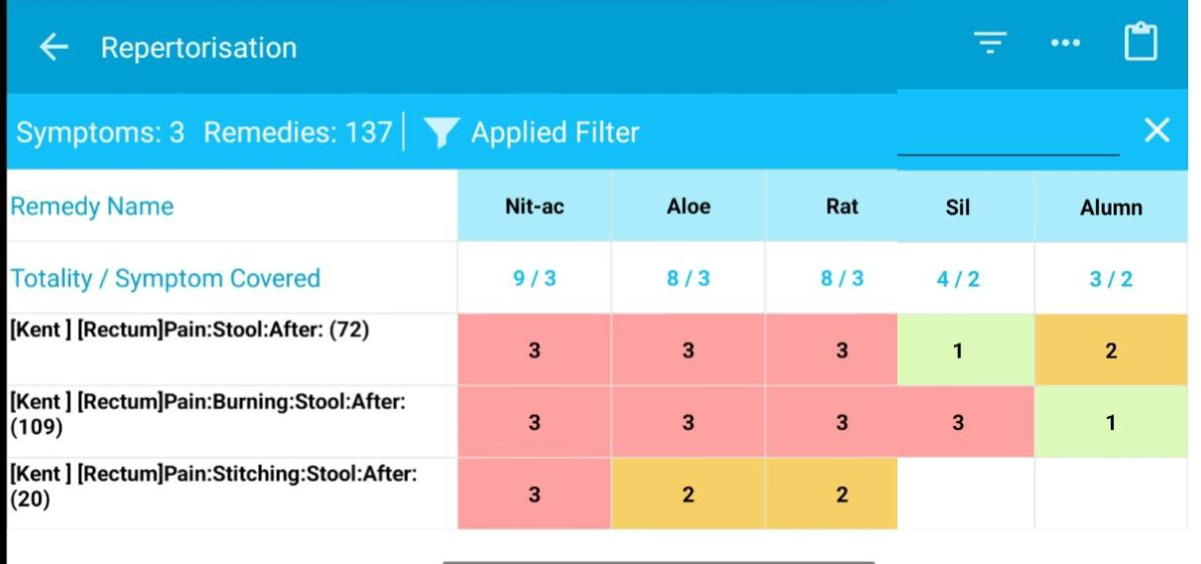

**REMEDY DIFFERENTIATION:**

Nitric acid- in rectal complaints there is bright red bleeding on touch

Aloes: the rectal pain is better by cold application

**AUXILIARY TREATMENT:** Foods toInclude: High-Fiber foods like whole grains, legumes, fruits and leafy vegetables. Foods to Avoid: spicy, fried and processed foods. Hydration: drink at least 2.5 to 3 liters of water per day. Lifestyle modifications: walking (30-24 minutes daily), Yoga: Pawanmuktasana, Malasana; Kegel’s exercise. Avoid long sitting hours. Local hygiene and Sitz bath: sitting in warm water with Epsom salt or antiseptic solutions for 10-15 minutes, twice a day.

**FIRST PRESCRIPTION:** Silicea 30 (3P) + Ratanhia 30 TDS × 15 days

**FOLLOW UPS:**

|  |  |  |
| --- | --- | --- |
| DATE | SYMPTOMS | PRESCRIPTION |
| 1/08/24 | Pain in anal region —> 50%— on and off now | Rx  SIL 30 (2P)  RATANHIA 30 TDS * 15 days |
| 29/08/24 | Pain in anal region —> 80%— on and off now  Constipation- has to strain, soft and hard alternates  Bloating of abdomen  N/C: Heaviness in chest while speaking because of anxiety about her health  Generals- normal  Fasting blood sugar: 130 mg/dL | Rx  SIL 30 (2P)  SL 30 TDS * 15 days |
| 20/09/24 | Pain in anal region —0—  Constipation —0—  Heaviness in chest with palpitations due to anxiety ->>—  Generals- normal | Rx  LYCO 30 (4P)  SL 30 pills TDS * 30 days |

**CASE SUMMARY**

A 58 years old female complains of stitching pain in anus and small lump coming out per rectum while passing stools. She passes hard stools which aggravate her complaints. Desires for sweets is marked and she is quite anxious regarding her health. She was prescribed Ratanhia 30 followed by Silicea 30 along with auxiliary treatment and proper diet, which showed a marked improvement in her complaints.

In Kent’s Repertory (enriched Indian Edition reprinted from 6th American Edition) (Kent, 2010) Chapter Rectum- Rubric- 1. Pain, stool after (Pg.624): Ratanhia +3 and Silicea+. 2. Pain, burning, stool, after a hard (Pg.626): Ratanhia +3 and Silicea+3. 3. Pain, stitching, stool, after (Pg.629): Ratanhia +2

**CONCLUSION**

This study confirms that ano-rectal diseases are influenced by a combination of physical, psychological and lifestyle factors. In chronic dieases the miasmatic approach was considered while prescribing.

This clinical case study also enlightens upon the relationship of remedies in managing the cases of ano-rectal diseases. Ratanhia when followed up with Silicea enhance the healing process and reduces the recurrence rate. They offer a complementary and a curative approach in chronic diseases. Ratanhia effectively controls acute pain and spasms, whereas Silicea ensures deep healing, prevents recurrence, and strengthens the anal tissues.

**ACKNOWLEDGEMENT**

I would like to express my sincere thanks to my prestigious institution Smt. CMP Homeopathic Medical College and my teachers Dr. Mohanbhai Patel, Dr. Asmita Parikh, Dr. Parizad Damania, Dr. Amir Ali Badami, Dr. Pooja Shah, Dr. Anuj Sathe, Dr. Dipika Velkar, Dr. Sumit Goel and Dr. Sanjeev Khanna for their invaluable inputs, timely support, and generous assistance whenever I needed it.

**BIBLIOGRAPHY**

1. BOERICKE, W. (2016). *BOERICKE'S NEW MANUAL OF HOMEOPATHIC MATERIA MEDICA with REPERTORY including Indian Drugs Nosodes, uncommon Rare Remedies, mother tinctures, relationships, sides of body,drug affinities and list of abbreviations.* (Third Revised and Augmented Edition Based on Ninth Edition ed. ed.). New Delhi: B. JAIN PUBLISHERS.
2. Clarke, J. H. (1904). *A clinical repertory to the dictionary of materia medica: Together with repertories causation, temperaments, clinical relationships, natural relationships.* London: The Homeopathic Publishing Company.
3. Kent, J. T. (2010). *REPERTORTY OF THE HOMEOPATHIC MATERIA MEDICA* (ENRICHED INDIAN EDITION REPRINTED FROM SIXTH AMERICAN EDITION ed.). (M. EDITED AND REVISEDBY CLARA LOUISE KENT, Ed.) New Delhi: B. JAIN PUBLISHERS.
4. LOVE, B. A. (2013). *BAILEY AND LOVE'S SHORT PRACTICE OF SURGERY* (26th ed.). (C. J. NORMAN S. WILLIAMS, Ed.) Boca Ranton: CRC Press.