**Intelligent Language Learning System Powered by AI**

Assistant Dr. Suhashini Chaurasia, Department of Computer Science Engineering (Data Science), Abha Gaikwad

Patil College Of Engineering And Technology, Mohgaon, Wardha Road, Nagpur, Maharashtra, India

Pappu Urade1 ,Kavishwar Sahare2, Yash Shende3, Shahil Raut4, Oshin Ramteke5

|  |  |
| --- | --- |
|  | ABSTRACT  The "Intelligent Language Learning System Powered by AI" introduces a state-of-the-art platform designed to redefine the process of language education through advanced artificial intelligence. This innovative system leverages machine learning, natural language processing (NLP), and speech recognition technologies to deliver a personalized, interactive, and adaptive language learning experience. By analyzing individual learning behaviors and progress, the system dynamically tailors lessons and exercises to optimize outcomes for diverse user profiles.  Keywords: Smart AI Language Learning System, Language Education, Artificial Intelligence, Machine Learning |

# INTRODUCTION

In an era of rapid globalization and technological evolution, the demand for effective and scalable language learning solutions has become increasingly urgent. Traditional language education methods, while foundational, often struggle to accommodate the diverse learning styles, paces, and needs of a global audience. The "Intelligent Language Learning System Powered by AI" emerges as a transformative solution, leveraging cutting-edge artificial intelligence technologies to redefine how individuals acquire linguistic skills.

At its core, this system integrates advanced AI components such as machine learning, natural language processing (NLP), and speech recognition to deliver a highly personalized and adaptive learning experience. By continuously analyzing user performance and preferences, the system tailors content and activities to meet individual needs, ensuring optimal engagement and learning efficiency. Features such as real-time pronunciation feedback, contextual grammar assistance, and vocabulary enrichment empower learners to achieve linguistic fluency in a structured yet dynamic environment.

Beyond linguistic accuracy, the system emphasizes the importance of cultural context and conversational for too

fluency. Simulated real-world interactions, idiomatic usage, and cultural nuances are embedded within the learning modules, enabling users to gain practical communication skills. Moreover, the integration of gamification elements—such as rewards, challenges, and interactive exercises—makes the learning process engaging and enjoyable.

Accessibility is a cornerstone of the Intelligent Language Learning System. Designed to function seamlessly across various platforms, including mobile devices, tablets, and desktops, it ensures that users can access their personalized learning experiences anytime and anywhere. Its adaptability extends to support for multiple languages, fostering simultaneous multilingual development and enhancing cognitive flexibility.

This platform also represents a step toward democratizing language education by bridging socio-economic and geographic gaps. By leveraging AI's capabilities, it offers an affordable and inclusive alternative to traditional educational systems. Furthermore, its potential applications span diverse domains, including personal development, academic settings, and professional training, making it a versatile solution for a wide audience.

Furthermore, the system incorporates multilingual support, enabling users to learn multiple languages simultaneously.

**Ⅱ**. LITERATURE REVIEW

Bibauw et al. (2019) emphasize that AI-based teaching tools, such as chatbots, facilitate communication between learners by providing both language input and output. Chatbots enable authentic and meaningful social interactions (Clark, 2018) through various formats, including text, audio, and visual features, while offering clear and effective feedback (Bao, 2019). Akerkar (2014) and Ginsberg (2012) note that AI can make intelligent, informed decisions similar to human reasoning. Additionally, Kim (2018) highlights the accuracy and advanced features of AI applications, making them highly effective for enhancing oral skills, particularly in listening and speaking.

Various studies have explored the influence of AI on different English language skills in second and foreign language contexts, such as writing (Fitria, 2023), reading (Liu, 2021), listening Regarding speaking skills, Suciati et al. (2022) conducted a qualitative study on the impact of the AI-based program Cake on learners' language learning and speaking abilities. Using interviews, observations, and documentation for data collection, they found that AI-based instruction significantly improved learners' overall language abilities and speaking skills. Features such as user-friendliness, accessibility across locations and time, diverse speaking topics, and the ability to assess learners’ language performance contributed to these positive outcomes.

AI has become a powerful teaching tool in language learning and instruction, providing learners with numerous opportunities to improve their language skills (Zhang and Zou, 2020; Sun et al., 2021; Zhang, 2022) and shaping favorable perceptions and attitudes toward AI (Xia et al., 2022). According to Aldosari (2020), AI is a programmed system designed to create intelligent applications for computers and smartphones, capable of performing a variety of tasks with human input. Luckin et al. (2016) suggest that AI contributes to language learning by supporting teaching, group-based learning, and virtual reality experiences.

Ⅲ. Methodology

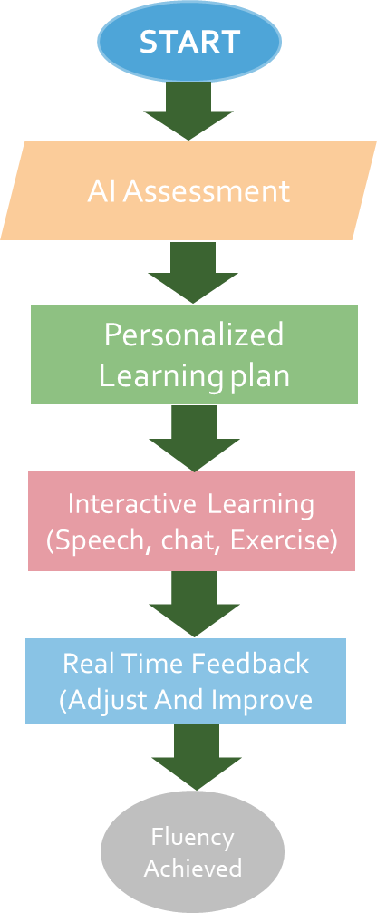

Fig. 3.1. Flowchart for Learning Platform

A. Start:

This is the initiation phase, where the learner begins their journey on the platform. It marks the entry point into the system where the user sets their goals and provides any initial information needed, such as their current language proficiency or learning objectives.

B. AI Assessment:

At this stage, the platform’s AI capabilities come into play to evaluate the learner's abilities. By leveraging natural language processing (NLP) and machine learning, the system conducts an in-depth assessment of the learner's existing language skills, including speaking, reading, writing, and listening.

C. Personalized Learning Plan:

Using the insights gained from the AI assessment, the platform creates a custom-tailored learning plan. This plan adapts to the learner’s unique requirements, focusing on specific areas that need improvement.

D. Interactive Learning (Speech, Chat, Exercise):

At this stage, learners engage in various interactive activities

E. Real-Time Feedback (Adjust and Improve):

As learners progress, the platform provides instant feedback on their performance. This feedback is critical for identifying errors, reinforcing correct usage, and making real-time adjustments to the learning path.

F. Fluency Achieved:

This final stage represents the culmination of the learning process. Here, the learner achieves fluency in the target language, equipped with the skills to communicate effectively in real-world scenarios.

Ⅳ. MODULES



Fig 4.1 Welcome App

As above figure shows the welcome page you’ve shown appears to be the landing screen for a language learning web application named **"SpeakUp"**.

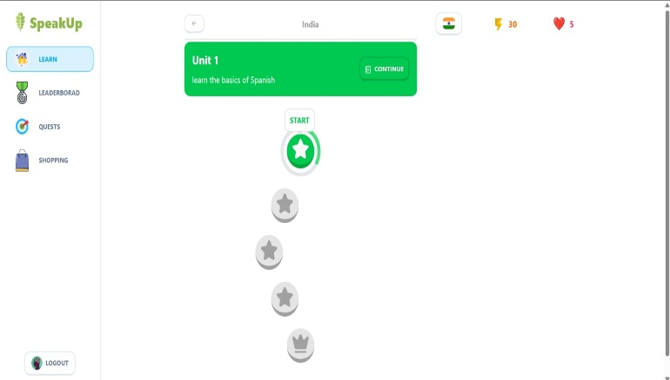

Fig 4.2 Home Page

In the figure 4.2 shows the **home page** of the **SpeakUp** app serves as the main dashboard for users to access learning content and track

their progress.

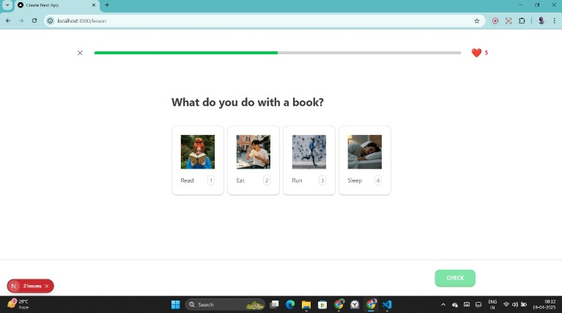

Fig 4.3 Input Page

As above figure shows the input page from the SpeakUp app is an interactive question interface, designed to help users practice vocabulary or comprehension.

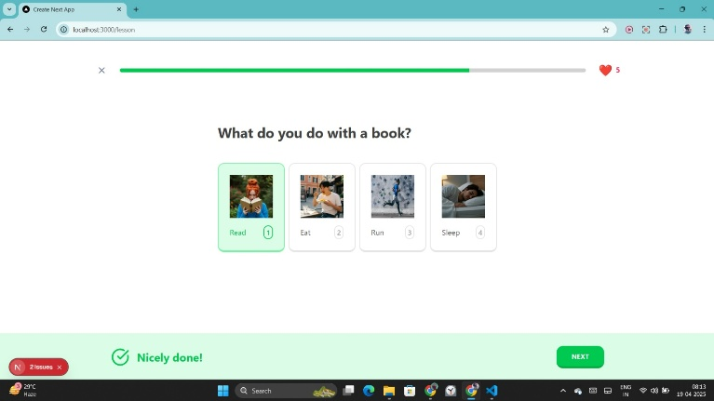

Fig 4.4 Output Page

As above figure shows the output page is a well-designed interactive interface. It asks the question, "What do you do with a book?", presenting four answer options, each represented by an image: Read, Sit, Run, and Sleep. The "Read" option is selected, as shown by a green border around it. Below the question and options, there's a congratulatory message, "Nicely done!" accompanied by a green checkmark, indicating the correct choice was made.

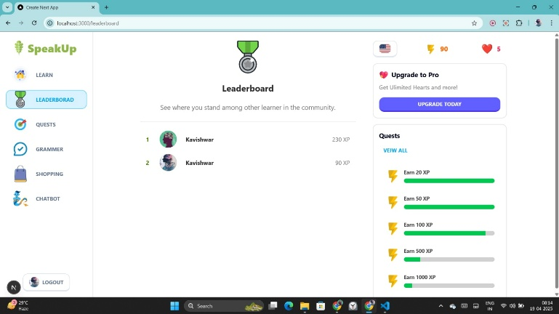

Fig 4.5 Leaderboard Page

As the Leaderboard page on the figure 4.5 shows the showcases user rankings based on XP points, with scores like 230 XP and 80 XP for "Kushdeep." On the right, there's an Upgrade to Pro button and a Quests section listing tasks with XP rewards, including "Earn 20 XP" and "Earn 40 XP." The design combines progress tracking with gamification for a motivating user experience!

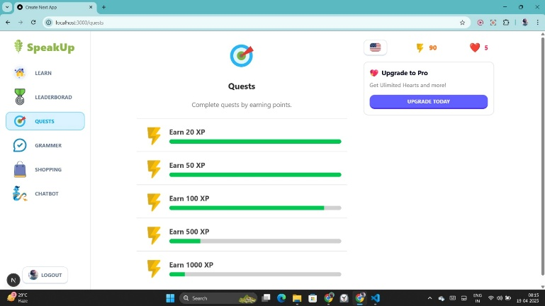

Fig 4.6 Quests Page

In the figure 4.6 shows the "Quests" page on SpeakUp lists tasks users can complete to earn XP, such as Earn 20 XP, 50 XP, 100 XP, 500 XP, and 1000 XP. Each quest features a progress bar showing completion status. There's also an Upgrade to Pro button on the right for enhanced features. The design motivates users with clear goals!

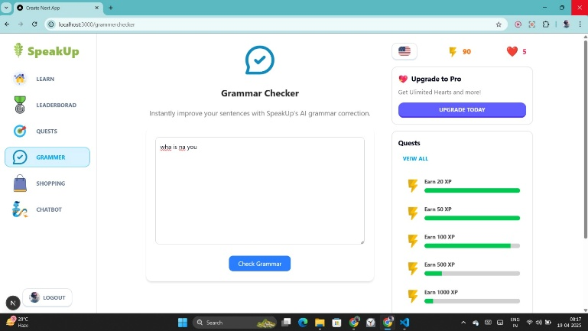

Fig 4.7 Grammar Checker Page

As above figure shows the Grammar Check page on SpeakUp features a text box for users to input sentences and a Check Grammar button to review them. It also has a Quests section on the right for XP progress and an Upgrade to Pro option. The interface promotes learning and goal tracking with a clean design!

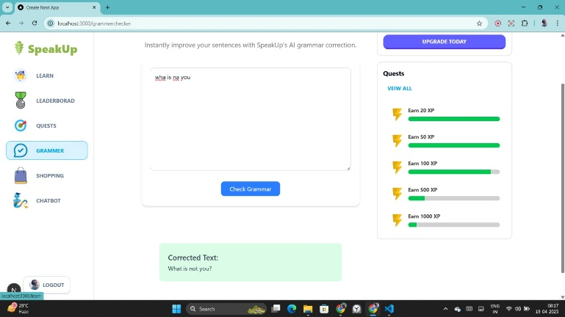

Fig 4.8 Grammar Input Page

The Grammar Input page on SpeakUp lets users input sentences, like "This is to yore", for grammar corrections. It features a "Check Grammar" button below the input box, along with a Quests section on the right to track XP progress and an Upgrade to Pro option. It's simple and user-friendly!

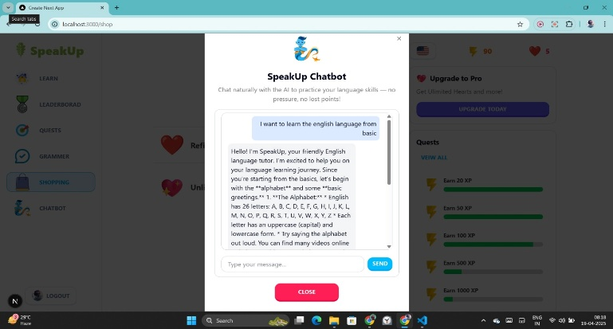

Fig 4.9 Grammar Output Page

In the figure 4.9 shows the Grammar Output page on SpeakUp displays corrected text for sentences like "she is top gen" into phrases such as "What a neat output!". It features a "Check Grammar" button, a Quests section tracking XP rewards, and navigation options on the left. Perfect for quick grammar fixes and progress tracking.

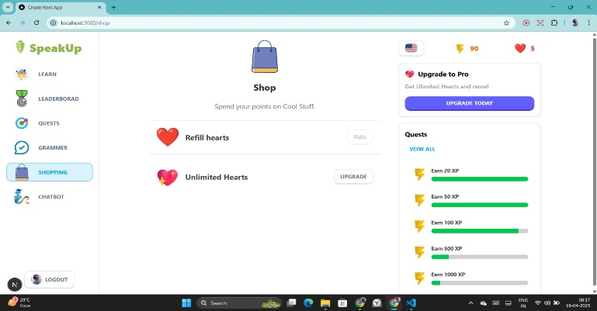

Fig 4.10 Shopping Page

As above figure shows the SpeakUp shopping page allows users to spend points on items like Refill Hearts and Unlimited Hearts. There's also an option to Upgrade to Pro. On the right, a Quests section showcases tasks and progress bars, motivating users to earn XP and enjoy rewards!

Ⅵ. RESULT ANALYSIS



Fig 4.4 Output Page

As above figure shows the output page is a well-designed interactive interface. It asks the question, "What do you do with a book?", presenting four answer options, each represented by an image: Read, Sit, Run, and Sleep. The "Read" option is selected, as shown by a green border around it. Below the question and options, there's a congratulatory message, "Nicely done!" accompanied by a green checkmark, indicating the correct choice was made.



Fig 4.9 Grammar Output Page

As The Grammar Output page on SpeakUp displays corrected text for sentences like "she is top gen" into phrases such as "What a neat output!". It features a "Check Grammar" button, a Quests section tracking XP rewards, and navigation options on the left. Perfect for quick grammar fixes and progress tracking.

V. CONCLUSION

The "AI Base Languages Learning Platform" project stands as a testament to the transformative potential of artificial intelligence in education. By seamlessly combining advanced AI technologies, adaptive learning strategies, and interactive features, this platform redefines how individuals approach language learning. Its ability to assess, personalize, and engage learners ensures a tailored experience catering to diverse linguistic backgrounds and proficiency levels.

The platform bridges traditional gaps in language education by integrating natural language processing, machine learning, and speech recognition. It offers solutions that are not only innovative but also practical, addressing the challenges of accessibility, inclusivity, and engagement. By utilizing tools like real-time feedback and predictive analytics, the platform empowers learners to take control of their language learning journey, fostering growth and confidence.

Ⅶ. REFERENCES

1. MIR MURTAZA, YAMNA AHMED, “AI-Based Personalized E-Learning Systems: Issues, Challenges, And Solutions” (2022). IEEE.
2. M. Vijayakumar1, G. Chellapandiyan, “Language Learning Through AI Technology - LLA (Language Learning Apps) (2024). IRJEM.
3. Li, F.Y., & Yang, F.Q. (2021). Artificial intelligence & higher education. China Educational Technology.
4. Chen, J.L. (2020). AI in foreign language teaching. Journal of Beijing International Studies University.
5. Bax, S. (2003). CALL - past, present, future. System.
6. Chen, J.L., & Jia, Z.X. (2017). IT-based FL learning modes. Technology Enhanced Foreign Language Education.
7. Li, S. (2021). Task-based language teaching in CALL. 2nd Int. Conf. on Education Knowledge & Information Management.
8. Chen, J.L. (2005). Computer-assisted vs. autonomous teaching. China Educational Technology
9. Li, S. (2020). Mobile learning in college English blended teaching. Overseas English.
10. Chen, J.L. (2015). MOOCs & FL teaching in big data era. Technology Enhanced Foreign Language Education.
11. R. Luckin & W. Holmes, "AI in Education,"2016.IJECM.
12. X. Li, "Intelligent Agent-Supported Online Education. IRJMETS.
13. M. Dodigovic, "AI and Second Language Learning: Error Remediation. IJCEM.
14. J Choi & Y. Lee, "Feedback in ESL Writing Class Using AES," SITE Int. Conf., 2010. IJCEM.
15. D. Grimes & M. Warschauer, "Automated Writing Evaluation Case Study," J. Technol. Learn. Assess., 2010. in IRJMETS.
16. M. Warschauer & D. Grimes, "Automated Writing Assessment in Classroom," Pedagogies Int. J., (2008) in JETIR.
17. Z. Li, "Teachers’ Perception in AWE System-Supported ESL Writing Classes," (2021). JETIR.