# Real-Time Object Detection in Dynamic Environments Using Convolutional Neural Networks

**Aditya Dhotkar, Kunal Khare, Shubham Sahani, Prof. Swapnil Gupta**

Department of Computer Science and Engineering, Thakur Shiv Kumar Singh Memorial Engineering College Burhanpur (M.P.)

**ABSTRACT**

Object detection plays a pivotal role in computer vision, facilitating the identification and localization of objects in images and video frames. This technology is integral to various applications, including autonomous driving, security surveillance, medical imaging, and e-commerce. The progression from traditional image processing methods to advanced deep learning approaches has significantly enhanced the accuracy, speed, and scalability of object detection systems. Among the leading frameworks, YOLO (You Only Look Once) has distinguished itself by offering real-time performance alongside high precision. YOLOv8 integrates an optimized architecture, efficient training methodologies, and robust inference capabilities, making it adept at handling complex scenarios characterized by overlapping objects and dynamic backgrounds by employing a single neural network to simultaneously predict bounding boxes and classify objects, YOLOv8 streamlines the detection process, reducing latency and enhancing its suitability for real-time applications. Challenges related to high-quality annotated datasets are mitigated through support for pre-trained models that can be fine-tuned for specific domains, thus minimizing training time and resource expenditure. Furthermore, YOLOv8's versatility across various hardware platforms, including high-performance GPUs and edge devices, along with its integration with cloud solutions, positions it as a scalable option for diverse deployment scenarios.

**INTRODUCTION**

In recent years, advancements in computer vision, particularly in object detection, have significantly transformed the capabilities of intelligent systems across various applications including autonomous vehicles, surveillance, robotics, and healthcare. Traditional object detection methods face challenges in real-time performance, prompting the adoption of deep learning techniques, notably convolutional neural networks (CNNs), which have markedly enhanced both speed and accuracy. This paper focuses on the YOLO (You Only Look Once) model family, emphasizing the latest version, YOLOv8, developed by Ultralytics. YOLOv8 features several architectural innovations such as an anchor-free design, an improved backbone network, and extended functionalities encompassing classification, segmentation, and pose estimation. The study investigates the capabilities, applications, limitations, and future development potentials of YOLOv8 in object detection. By leveraging this state-of-the-art AI model, the research highlights the feasibility of creating intelligent, real-time object recognition systems, underscoring the critical role of effective object detection in advancing computer vision applications.

**OBJECTIVE**

The primary objective is to implement and analyze object detection using YOLOv8, focusing on:

• Achieving real-time detection with high accuracy.

• Understanding its architecture and performance.

• Exploring its application in various fields.

• Demonstrating how it can be trained on custom datasets.

**APPLICATIONS OR SCOPE**

YOLOv8 has a wide range of real-world applications:

• Surveillance: Detecting intruders or abnormal activity.

• Autonomous Vehicles: Recognizing pedestrians, traffic signs, and obstacles.

• Healthcare: Identifying anomalies in medical images.

• Retail & Inventory: Object counting and shelf monitoring.

• Agriculture: Crop and pest detection using drone imagery.

• Edge Computing: YOLOv8 can be deployed on edge devices like Raspberry Pi or Jetson Nano for offline processing.

• Robotics: Integration with real-time robotic vision systems.

**STATE TRANSITION DIAGRAM FOR OBJECT DETECTION**

A **State Transition Diagram** depicts the states of an object detection system and the transitions between these states based on specific events or conditions. It provides a dynamic view of how the system behaves as it processes user input and performs detection tasks.

**• Key States in the Object Detection System**

**1. Idle State:**

* The system is waiting for user input.

**2. Input Validation State:**

* The system is verifying the uploaded file's format and size.
* **Transition:**

▪ Valid input → Proceed to preprocessing.

▪ Invalid input → Return to Idle State.

**3. Preprocessing State:**

* Input data is being resized, normalized, and prepared for detection. o Transition: Completed preprocessing → Detection state.

**4. Detection State:**

* The YOLOv8 model processes the input and detects objects.
* **Transition:** Detection completed → Post-processing state.

**5. Post-Processing State:**

* The system refines results by applying Non-Maximum Suppression (NMS) and filtering low-confidence detections.
* **Transition:** Post-processing completed → Results ready state.

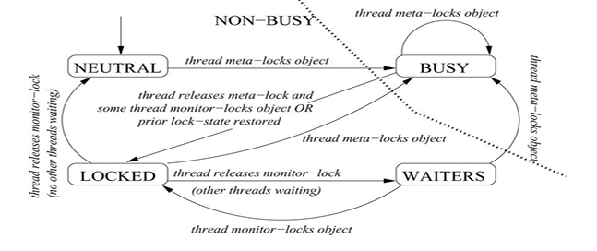

**Fig.1.1** State Transition Diagram for Object Detection

**LIMITATION**

Despite its strengths, YOLOv8 has some limitations:

• Training Data Requirement: Requires large annotated datasets for good performance on custom tasks.

• GPU Dependency: Training and fast inference still rely on GPUs.

• Overlapping Object Detection: Struggles with detecting heavily overlapping or occluded objects.

• Domain Shift: Performance may drop when deployed on data that's very different from the training data.

**RESULT**

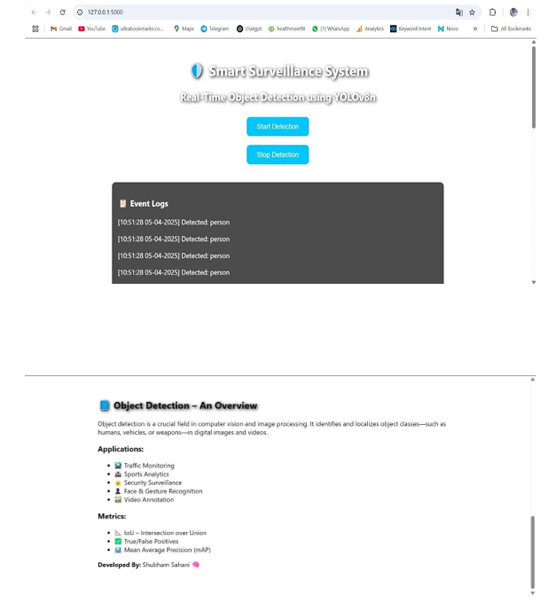

**Fig 1.2** Home page of Object Detection

**CONCLUSION**

Object detection is a cornerstone technology in the field of computer vision, enabling machines to identify and locate objects within images or video streams. Its applications span various domains, including autonomous vehicles, healthcare, security, retail, and industrial automation. By leveraging advancements in deep learning frameworks and architectures like YOLO (You Only Look Once), Faster R-CNN, and SSD, object detection systems have become faster, more accurate, and capable of real- time performance.

**FUTURE SCOPE**

* Integration with edge devices (e.g., drones, Raspberry Pi) for real-time offline detection.
* Application in autonomous vehicles for smarter and safer navigation.
* Use in healthcare for advanced medical image analysis and diagnostics.
* Enhanced smart surveillance systems with behavior recognition.
* Combination with augmented reality (AR) and virtual reality (VR) for immersive experiences.
* Development of lightweight models for faster deployment on mobile platforms.
* Integration with robotic systems for intelligent automation in industries.
* Adoption in agriculture for crop health monitoring using aerial imagery.
* Use in wildlife monitoring for species identification and tracking.
* Enhanced performance through self-supervised or unsupervised learning techniques.

**REFERENCES**

[1]. “A.A. Puntambekar” Software engineering and project management, 2013, Technical Publication.

[2]. "HTML and CSS: Design and Build Websites" by Jon Duckett (2011)

[3]. "PHP and MySQL Web Development" by Luke Welling and Laura Thomson (2016)

[4]. "JavaScript and JQuery: Interactive Front-End Web Development" by Jon Duckett (2014) [5]. "Learning PHP, MySQL & JavaScript: With jQuery, CSS & HTML5" by Robin Nixon (2014)

[6]. "Bootstrap 4 Quick Start: Responsive Web Design and Development Basics for Beginners" by Jacob Lett (2018)

[7]. MySQL in a Nutshell, 2nd Edition by Russell J.T. Dyer, Released April 2008, Publisher(s):O'Reilly Media, Inc.

[8]. Learning MySQL: Get a Handle on Your Data 1st Edition, Kindle Edition by Hugh E. Williams (Author), Seyed M.M. Tahaghoghi (Author)

[9]. MySQL: The Complete Reference (Osborne Complete Reference Series), January 2004 by Vikram Vaswani

[10]. Expert MySQL (Expert's Voice in Databases) Paperback, December 2012 by Charles Bell

[11]. Mastering HTML, CSS & JavaScript Web Publishing Paperback –July 2016 by Laura Lemay (Author), Rafe Colburn (Author), Jennifer Kyrnin (Author)

[12]. Software Engineering: A Practitioner's Approach Paperback – April 2009 by Roger Pressman (Author)

[13]. Software Engineering, Tenth Edition, By Pearson Paperback –May 2017 by Ian Sommerville (Author)

[14] MySQL Explained: Your Step-by-step Guide to Database Design, November 2015 by Andrew Comeau