**INTELLIGENT AND INTERACTIVE**

**TOUCHSCREEN MENU SYSTEM FOR MODERN HOSPITALITY**

**Dr. Indira S P1, Mounashree C S2 , Neha A Killedar3, Rakshitha. K4, Vidyashree K S5**

**1** Associate Professor, Computer Science and Engineering, Jain Institute of Technology, Davanagere, Karnataka, India.

**2,3,4,5** BE Students, Computer Science and Engineering, Jain Institute of Technology, Davanagere, Karnataka, India.

**-------------------------------------------------------------------------------------------------------------------------**

**ABSTRACT**

**The development of a touchscreen digital menu card based on the ATMEGA 328 and Wi-Fi communication technologies is proposed as a new design scheme in this paper for the ordering system used in middle-sized and small hotels. The main advantages are listed as low power consumption, high reliability, and an easy-to-use interface. This method allows anyone to choose the items or order they want from the menu display and place their order using a touchscreen panel that is placed on each table. The order is moved next place which is specified by LCD with the assistance of the Wi-Fi module, finally order billing is provided.**

**Keywords: ATMEGA 328, Touchscreen panel, LCD display, Wi-Fi Module, Raspberry PI, Aurduino processor**

**1. INTRODUCTION**

Many times in the hotel customers were waiting for a waiter to give our order of food. This creates problem when there is rush in hotel especially in festival seasons and generally on weekends. This article avoids problems and tries to give solutions to the problems specified in [1]. Each table in the project will have a touch screen panel. Customers use the interaction to choose their preferred order menus once they arrive at their table [2]. Assuming that the user has chosen menu items 1, 2, 8, 4, and so forth, the user can press the confirm key when finished. Information will then be forwarded to the hotel's kitchen. A computer screen will show all of this information. For this purpose Bluetooth was used at the transmitter (customer table) and receiver table (kitchen side) [3]. So orders will be directly sent to the kitchen and users don’t have to wait for the waiter and the total billed amount directly display to the user [4]. The customer needs a good service, good quality of food consumption, no confusion in placing and receiving an order, quick billing with no errors. All this can be made possible with a new type of system named interactive digital menu card for hotel[5].This paper proposed latest technique for the ordering system used in small and middle sized restaurants by the creation of a interactive digital menu card by ATMEGA 328 and Wi-Fi communication technologies.

**2. REVIEW OF LITERATURE**

**A. Technological Advancements**

It features a touchscreen panel placed on each customer table. The system is designed with multiple transmitter sections (masters) and a single receiver section (slave). Information from various transmitters is transferred to receiver section via a Wi-Fi module, enabling seamless communication and efficient order management.

This system consists of one receiver section and multiple transmitter sections (customer sections). Each customer section (slave) is equipped with an LCD, an ATMEGA328 microcontroller, and a Wi-Fi module transmitter. At the main section, the setup includes a controller, a buzzer, an LCD, a PC, and a Wi-Fi receiver. When a customer takes a seat and places an order using the LCD, items are displayed in image format for easy selection. The input from the touchscreen is transferred to controller through port P1. The analog information is converted to digital by the controller using its built-in ADC (Analog-to-Digital Converter), enabling seamless processing and communication.

The controller receives the input information in digital form and processes it through the user's selection. It then displays the corresponding images on an LCD attached to port P0. Simultaneously, the controller transfers the information to the Wi-Fi module via the transmitter pin. The Wi-Fi module subsequently transmits the data to the receiver section's Wi-Fi module, ensuring efficient communication between the customer and the main system. The receiver section's Wi-Fi module receives the data transmitted by the transmitter section's Wi-Fi module and forwards it to the controller's pin 10. Upon receiving the data, the controller activates port P2, which is connected to a buzzer. The buzzer sounds to indicate that the data has been successfully received. Meanwhile, the controller displays the customer's order details on an LCD connected to its port P1 pins. It also transmits the data to the server, where it is displayed on a PC. The PC interface shows the table number and the items ordered by the customer, facilitating billing and further processing.

Lorenzo, Ariel, et al.'s article introduces ‘ResortXpress,’ a state-of-the-art digital ticket kiosk system that streamlines reservations for resort accommodations and activities in order to increase customer convenience and operational efficiency. The solution aims to provide smooth, intuitive interactions for guests in resort settings through the use of intelligent technologies and cognitive robots [6]. Gbadega, Peter Anuoluwapo, et al. present an innovative system designed to enhance customer satisfaction and accelerate the ordering process. The system leverages RFID technology alongside Wi-Fi modules to establish efficient communication between customers and restaurant staff [7]. By streamlining interactions, it significantly reduces order errors and increases overall service efficiency, offering a more seamless dining experience.

**B. Elevating Service Standards**

Tanmay Bakshi, Bhawani Singh Choudhary, Bhaskar Kumar, and Mishra detail a touch-based system that utilizes Android smartphones to streamline the order placement process. This technology leverages Bluetooth for local connectivity and GSM for remote communication, aiming to enhance operational efficiency and minimize errors in restaurant workflows [8]. Almuqren, Almaha, et al. provide a brief form of the literature on digital forensic investigation techniques for Android smartphones. Their work emphasizes the increasing importance of mobile forensics in cyber security, exploring various methods, challenges, and advancements in the forensic analysis of Android platforms [9].

**3. PROPOSED SYSTEM DESIGN**

Figure 1, figure2 and figure 3 shows the processor architecture and system functionality and functional unit of the system respectively

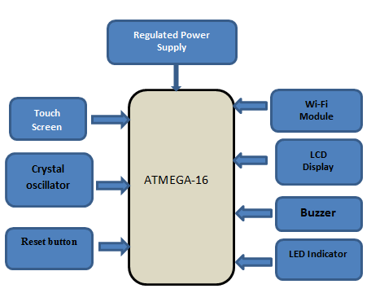

**Figure 1: Processor Architecture of the System**



**Figure 2: Function Flow Diagram of the System**

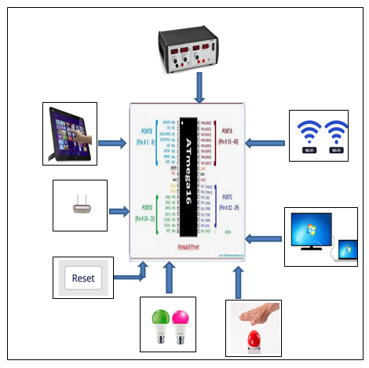

**Figure 3:** **Functional Unit System**

**4. PREREQUISITES**

1. **Hardware Requirements:**

***i*.** *ATMEGA 16:*

A microcontroller is a compact, self-contained computer integrated onto a single chip, encompassing all the essential components of a computer at a much smaller scale. Functionally, a microcontroller serves as a programmable chip designed to control a specific process or system. Typically, microcontrollers are used in embedded systems, where they manage functions within larger systems such as appliances, automobiles, scientific instruments, or computer peripherals. Due to their low-cost design, microcontrollers provide an economical solution, significantly lowering component and design costs for various projects

***ii.*** *TOUCHSCREEN PANEL :*

Touch screen technology has revolutionized display screens across various systems, enabling significant advancements in user interaction. The operation of a touch screen relies on sensors that detect touch inputs. When a user touches a specific point on the screen, a contact is made between the screen's layers, allowing the system to select the option touched by the user. Historically, touch screens were primarily used in mobile phones,

*iii. RFTRANSMITTER MODULE:*

This circuit uses an RF module receiver and transmitter to create a wireless remote control system, enabling the operation of devices from a distance. As the name implies, the RF module relies on radio frequency signals for communication. These signals are transmitted at a specific frequency and baud rate, and the receiver can only receive the signal if it is tuned to the same frequency. The system also incorporates a four-channel encoder/decoder pair. input signals are provided through four switches, and the corresponding outputs are displayed on four LEDs, each representing one of the switches. This setup can be used to design a remote appliance control system. The outputs from the receiver can trigger relays, allowing control of house hold appliances.

*iv HT12E (ENCODER)/HT12D (DECODER) :*

The HT12E is an encoder integrated circuit from the 212 series, commonly used in remote control system applications. It is typically paired with a decoder from the same series for efficient communication, particularly in RF and infrared circuits. The HT12E converts parallel input signals into serial output. It features a 12-bit output, which is divided into 8 address bits and 4 data bits. The HT12D, is a decoder integrated circuit also from the 212 series. This series of decoders is primarily used in remote control systems, such as burglar alarms, car door controllers, and security systems. HT12D is designed to interface with circuits and is paired with corresponding encoders from the 212 series. The selected encoder-decoder pair should be chosen based on the required number of addresses and data format for the application.

**B LCD Display**

1. ***The Liquid Crystal Display:***

One of the most basic and commonly used modules is the 16x2 LCD display. This type of LCD can display 16 characters per line, with two such lines available. Each character on the LCD is displayed in a 5x7 pixel matrix. LCD uses two primary registers: the command register and the data register. These commands are used to control predefined tasks, such as initializing the display, clearing the screen, setting the cursor position, and controlling the display's behavior. Data corresponds to the ASCII values of the characters that will be displayed.

**C Software Requirements**

1. Keil Software
2. Embedded System
3. Flash Magic
4. ***Keil Software:***

Keil is an integrated development environment (IDE) used for writing, compiling, and debugging programs in embedded systems. It supports a range of microcontroller architectures and is widely used in developing firmware for embedded systems. In the Keil IDE, programs are typically written in Embedded C, a specialized version of the C programming language tailored for microcontrollers. Keil provides a suite of tools including code editors, compilers, debuggers, and simulators to streamline the development process and ensure the correct execution of embedded applications.

1. ***Embedded System:***

An embedded system is a specialized computing system designed to perform specific tasks within a larger system. Systems are often resource-constrained, through slow processing power, memory, and storage. They are embedded within devices such as home appliances, vehicles, medical equipment, and more. Embedded systems typically run software that is designed to interface directly with hardware components, and their operation is optimized for the specific task they are built for. Keil software is commonly used to develop the firmware for such systems, providing a development platform for writing and testing code for microcontrollers in embedded applications.

1. ***Flash Magic:***

Flash Magic is a programming tool used to upload the compiled hex file (generated from Keil) to a microcontroller. Once the program has been written and compiled in Keil, the hex file contains the binary code that can be loaded onto the microcontroller for execution. Flash Magic facilitates the transfer of this hex file to the microcontroller’s flash memory over a serial or USB interface. It is particularly useful for programming microcontrollers such as those from the 8051 and ARM families, used in embedded systems. Flash Magic simplifies the programming process, ensuring that the microcontroller is correctly programmed with the necessary code to run the embedded system's functions.

**5. RESULTS AND ANALYSIS**

After the customer is seated, they select the desired item from the menu displayed on the LCD screen. Using the touchscreen interface, the customer makes their selection, which is then sent to the system controller. The controller prompts the customer to specify the required quantity of the selected item. Once the customer inputs the desired quantity, the controller processes the data and transmits it to the kitchen section via an RF module. In the kitchen, the RF receiver captures the transmitted data, and the details, including the item ordered and the quantity, is displayed on an LCD screen for the kitchen staff to prepare the order accordingly.

Below mentioned figures Shows sample snapshots of this project



**Figure 4(a): Main Menu System**

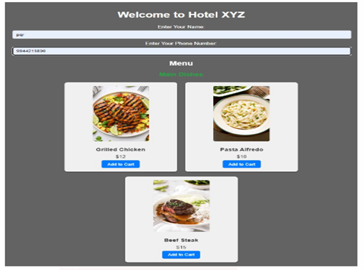

**Figure 4(b): Main Menu System**

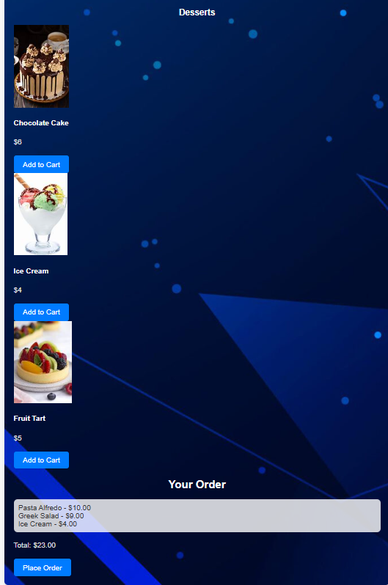

**Figure 5(a): Order Menu System**

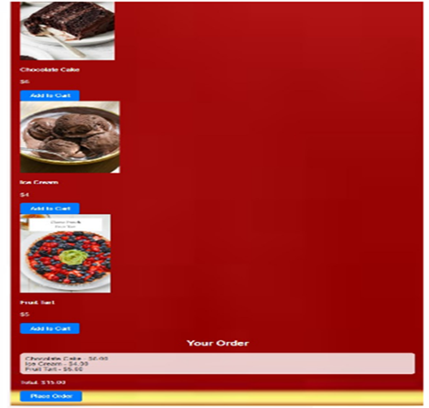

**Figure 5(b): Order Menu System (ice-creams)**

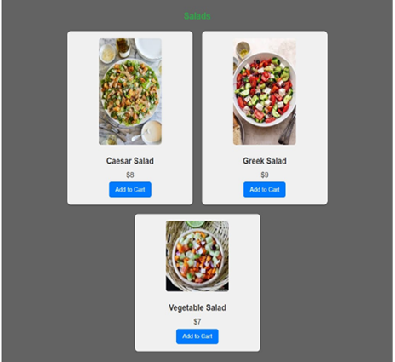

**Figure 5(c): Order Menu System (salads)**

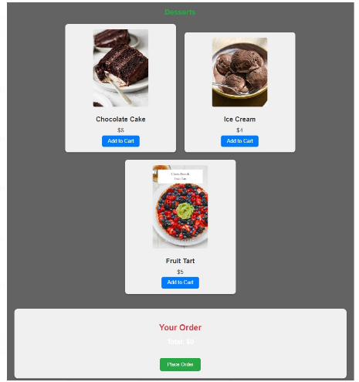

**Figure 5(d): Order Menu System (** Deserts)

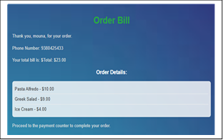

**Figure 6: Order Bill System**

**6. Applications**

Touch screen based wireless ordering project can be used in hotel for customer can give the order immediately. It reduces customer’s time for waiting. So customers don’t have to wait for waiter to take the order. Thus it saves the Time. This project is user friendly and fast.

**7. CONCLUSION**

This article communicates intelligent touchscreen technology through the implementation and complete study of the touchscreen digital menu card for hotel by providing interaction menu system. Implementation technique provides the interfaces of modules ATMEGA 16, Wi- Fi module, etc. with each other and the required coding for it.

**8. REFERENCES**

[1] G.Santosh Kumar, M.Amarnath, “ Touch Screen Based Advanced Menu Ordering System for Restaurants using Raspberry PI” , International Journal of Scientific Engineering and Technology Research, ISSN 2319-8885 Vol.04, Issue.36, Pages: 7709-7712, September 2015.(references)

[2] Ajinkyakumar Jadhav,Amit Bilapatte,Jatin Patil,Snehal Gaherwar, “Development of Wireless Ordering System for Hotel”, International Journal of Emerging Technology and Advanced Engineering, ISSN 2250-2459, ISO 9001:2008 Certified Journal, Volume 5, Issue 1,January 2015.

[3] Zigbee Based Hotel Menu Card and Ordering System, Neha Singh, Mr. Devidas Chikale,Yogita Jagdale, International Journal of Science Engineering and Technology Research (IJSETR), ISSN: 2278 – 7798 Volume 2, Issue 10, October 2013.

[4] D Chen , “ Comparative study of touch screen” · 2022 IEEE explore

[5] S. Abbate, M. Avvenuti, F. Bonatesta, G. Cola, P. Corsini, and A.Vecchio, ǲA “smartphone-based fall detection system”,ǳ Pervasive and Mobile Computing, vol. 8, no. 6, pp. 883-899, Dec. 2012.

[6] Lorenzo, Ariel, et al. "ResortXpress: Digital Ticket Kiosk for Seamless Resort Accommodation and Activity Experiences." , 2024 International Conference on Cognitive Robotics and Intelligent Systems (ICC- ROBINS). IEEE, 2024.

[7] Gbadega, Peter Anuoluwapo, et al. "Design and Implementation of a Smart Restaurant Menu Ordering System Using a WiFi Module and RFID Technology" , 2024 International Conference on Science, Engineering and Business for Driving Sustainable Development Goals (SEB4SDG),IEEE, 2024.

[8] Mishra, Bhaskar Kumar, Bhawani Singh Choudhary, and Tanmay Bakshi. "Touch based digital ordering system on Android using GSM and Bluetooth for restaurants.", 2015 Annual IEEE India Conference (INDICON). IEEE, 2015.

[9] Almuqren, Almaha, et al. "A Systematic Literature Review on Digital Forensic Investigation on Android Devices." Procedia Computer Science 235 (2024): 1332-1352.

[10] S. Liu, “Wi-Fi Energy Detection Testbed (12MTC),” 2023, gitHub repository. [Online]. Available: <https://github.com/liustone99/Wi-Fi-Energy-Detection-Testbed-12MTC>

[11] “Treatment episode data set: discharges (TEDS-D): concatenated, 2006 to 2009.” U.S. Department of Health and Human Services, Substance Abuse and Mental Health Services Administration, Office of Applied Studies, August, 2013, DOI:10.3886/ICPSR30122.v2[12] [Humza Akhtar](https://ieeexplore.ieee.org/author/38068409600); [Ramakrishna Kakarala](https://ieeexplore.ieee.org/author/37326287700) et. al, “A comparative analysis of capacitive touch panel grid designs and interpolation methods”, [2014 IEEE International Conference on Image Processing (ICIP)](https://ieeexplore.ieee.org/xpl/conhome/6992914/proceeding)

[13] [Yeon Hwa Kwak](https://ieeexplore.ieee.org/author/37305853200) et.al., “Comparison of two types of tactile sensing layer in touch screen panel for force sensitive detection”, [2015 IEEE SENSORS](https://ieeexplore.ieee.org/xpl/conhome/7350021/proceeding).

---------------------------------------------------------------------------------------------