# Intelligent Ransomware Detection Using Machine Learning and Deep Learning Approaches

#### Project

*Submitted by*

## SAKTHI V (RCAS2023MCS111)

*in partial fulfillment for the award of the degree of*

**MASTER OF SCIENCE SPECIALIZATION**

**IN**

**INFORMATION SECURITY AND CYBER FORENSICS**



**DEPARTMENT OF COMPUTER SCIENCE**

## RATHINAM COLLEGE OF ARTS AND SCIENCE

**(AUTONOMOUS)** COIMBATORE - 641021 (INDIA) **MAY-2025**

## RATHINAM COLLEGE OF ARTS AND SCIENCE

**(AUTONOMOUS)**

COIMBATORE - 641021



**BONAFIDE CERTIFICATE**

This is to certify that the Phase1 entitled “**Digital Intelligent Ransomware Detection Using Machine Learning And Deep Learning Techniques”** submitted by **SAKTHI V,** for the award of the **Master in Science specialization in “Information Security and Cyber Forensics”** is a Bonafide record of the work carried out by her under my guidance and supervision at Rathinam College of Arts and Science, Coimbatore.

##### Mrs. Shona .K M.E Dr. Vimal Kumar D, M.C.A, M. Phil Ph.D.,

**Assistant Professor Associate Professor & Head of the Department**

Supervisor Mentor

Submitted for the University Examination held on

**INTERNAL EXAMINER EXTERNAL EXAMINER**

## RATHINAM COLLEGE OF ARTS AND SCIENCE

**(AUTONOMOUS)**

COIMBATORE - 641021

## DECLARATION

I, **Sakthi V**, hereby declare that this Mini Project Report entitled **“Digital Intelligent Ransomware Detection Using Machine Learning And Deep Learning Techniques”,** is the record of the original work done by me under the guidance of **Mrs. Shona k M.E** Faculty Rathinam college of arts and science, Coimbatore. To the best of my knowledge this work has not formed the basis for the award of any degree or a similar award to any candidate in any University.

##### Place: Coimbatore Signature of the Student:

**Date:** Sakthi V

#### COUNTERSIGNED

Mrs SHONA K M.E

Supervisor

# Acknowledgement

On successful completion for project look back to thank who made in possible. First and foremost, thank **“THE ALMIGHTY”** for this blessing on me without which I could have not successfully my project. I am extremely grateful to **Dr. Madan A Sendhil, M.S., Ph.D.,** Chairman, Rathinam Group of Institutions, Coimbatore and **Dr. R. Manickam MCA., M.Phil., Ph.D.,** Secretary, Rathinam Group of Institutions, Coimbatore for giving me opportunity to study in this college. I am extremely grate full to **Dr. S. Balasubramanian, M.Sc., Ph.D. (Swiss)., PDF(Swiss/USA)** Principal Rathinam College of Arts and Science (Autonomous), Coimbatore. Extend deep sense of valuation to **Mr. K. Arun Kumar, M.E., (Ph.D.), - Associate Dean/Academics,** Rathinam College of Arts and Science (Autonomous) who has permitted to undergo the project.

Unequally I thank **Dr. D. Vimal Kumar, M.C.A., M.Phil., Ph.D. Associate Professor and Head of the Department**, **A.S. Krishna, M.E., (Ph.D.).** Program Coordinator, and all the faculty members of the Department – Computer Science for their constructive suggestions, advice during the course of study. I convey special thanks, to the supervisor **Mrs. Shona M.E** who offered their inestimable support, guidance, valuable suggestion, motivations, helps given for the completion of the project.

I dedicated sincere respect to my parents for their moral motivation in completing the proj

**CONTENT**

**Acknowledgment iv**

**List of Figures vii**

**List of Abbreviations viii**

**Abstract 1**

1. **Introduction 2**
   1. Objective of the project 3
   2. Scope of the Project 3
   3. Existing System 4
2. **Literature Survey 5**
   1. A Comprehensive Literature Review on Ransomware Detection

Using Deep Learning 5

* 1. Ransomware Detection and Classification Strategies 5
  2. Ransomware Detection Using Stacked Autoencoder for

Feature Selection 5

* 1. Data-Centric Machine Learning Approach for Early Ransomware

Detection and Attribution 6

* 1. Ransomware Detection and Classification Using Machine Learning 6
  2. Survey on Malware Detection with Graph Representation Learning
  3. Recent Advancements in Machine Learning for Cybercrime Prediction 7
  4. Deep Learning in Cybersecurity: Enhancing Threat Detection and Response 7
  5. Machine Learning in Cybersecurity: A Review of Threat Detection

and Defense Mechanisms 8

* 1. Enhancing Ransomware Defense: Deep Learning-Based Detection

and Family-Wise Classification of Evolving Threats 8

1. **Methodology 9**
   1. Problem Definition and Objective 9
   2. Data Collection 9
   3. Feature Extraction and Engineering 9
   4. Training of the Machine Learning Model 9
      1. Logistic Regression 10
      2. Random Forest 10
      3. Support Vector Machine (SVM) 10
      4. Gradient Boosting Classifier 11
      5. Naive Bayes 11
   5. Deep Learning Model Implementation 12
   6. Model Evaluation 12
   7. Visualization and Interpretation 14
   8. Testing and Deployment (Optional/Future Scope) 14

1. **Experimental Setup 15**

* 1. Hardware And Software Environment 15
  2. Dataset Description 15
  3. Data Preprocessing 16
  4. Model Training and Testing 16
  5. Evaluation Metrics 17
  6. Tools For Visualization And Debugging 17
  7. SAMPLE CODING 18
  8. SAMPLE OUTPUT 19
  9. Models 21
  10. Training Process 22
      1. Advantages 22
  11. System Workflow 22
  12. Evaluation Metrics 23
  13. Testing Environment 24
  14. Limitations and Considerations 25

1. **Results and Discussions 27**

* 1. Performance of Machine Learning Models 27
  2. Deep Learning Model Performance 27
  3. Discussion on Model Limitations 28
     1. Discussions 28
  4. Architecture Diagram 29

1. **Conclusion 30**
   1. Future Work 30
2. **References 32**

# List of Abbreviations

|  |  |
| --- | --- |
| CNN | Convolutional Neural Network |
| DNN | Deep Neural Network |
| SVM | Support Vector Machine |

**Abstract**

Ransomware remains a major threat to cybersecurity by encrypting users' data and requiring ransom payments. Conventional signature-based detection methods tend to miss new and emerging ransomware variants. This project introduces an intelligent ransomware detection framework based on both machine learning (ML) and deep learning (DL) methods to precisely detect ransomware behavior and separate it from harmless software. The framework takes advantage of a dataset with diverse ransomware and benign files, deriving important features like entropy, file size, and instruction patterns to train multiple models like Random Forest, XGBoost, and a Convolutional Neural Network (CNN). Comparative studies show that deep learning methods, especially CNNs trained on grayscale image representations of binary files, yield better accuracy and resilience to obfuscated and polymorphic variants of ransomware. The hybrid detection methodology presented improves the early detection of attacks and presents a scalable method that can accommodate real-world cybersecurity environments.

**KEYWORDS:** ransomware, detection, methods, learning, cybersecurity, variants, framework.

# Chapter 1 Introduction

Ransomware is one of the most devastating types of cyberattacks, impacting people, companies, and governments by encrypting critical information and paying for its release in the form of ransom. With the instant development of ransomware families and enhancement of attack vectors, conventional security tools like signature-based antivirus products are now not enough to guarantee protection. Consequently, there is an urgent need for smart and proactive methods that can identify ransomware early, even in its hitherto unknown or mutated forms.

This project investigates the use of machine learning (ML) and deep learning (DL) methods to develop a smart ransomware detection system. It targets the extraction and analysis of many static and behavioral characteristics from binary files, like entropy, size, instruction profiles, and images of binaries. By transforming binaries into grayscale images and applying convolutional neural networks (CNNs), the system captures the finer structural differences among malicious and good files. In conjunction, traditional ML models such as Random Forest and XGBoost are utilized to evaluate tabular feature data to offer a robust and extensive detection system.

The suggested method amalgamates the strengths of ML and DL to enhance accuracy, flexibility, and resilience against obfuscation strategies widely adopted by ransomware authors. Model evaluations demonstrate encouraging outcomes, with deep learning models being superior to traditional classifiers in detecting previously unknown ransomware variants. This smart detection paradigm not only reinforces early threat detection but also creates the foundation for integration into live security systems, offering a future-proof and scalable solution for fending off ransomware attacks.

### Objective of the project

The key aim of this project is to create a smart and effective ransomware detection system that uses the combination of both Machine Learning (ML) and Deep Learning (DL) algorithms to distinguish reliably between ransomware and legitimate files. The system seeks to:

* Extract and utilize both static and dynamic attributes from executable files in order to develop efficient detection models.
* Use and compare different ML algorithms like Random Forest and XGBoost to detect patterns in feature data that are predictive of ransomware.
* Use Deep Learning models, especially Convolutional Neural Networks (CNNs), on grayscale representations of binary files to improve detection rates.
* Do comparative analysis of conventional ML and DL methods to find the strongest and scalable solution.
* Develop a hybrid detection system that can be integrated into real-world cybersecurity systems for early and automated ransomware threat discovery.

### 1.2 Scope of the Project

The project scope includes designing and implementing a system for detecting ransomware that wisely uses machine learning and deep learning models to determine whether a file is malicious or benign. The project centers on examining both static features like file entropy, size, and opcode frequency and visual features derived by transforming binary files into grayscale images. By integrating these various forms of data representations, the system is meant to identify subtle patterns and anomalies that are most likely indicative of ransomware activities.

The objective of this project is to test the performance of conventional ML algorithms such as Random Forest and XGBoost in comparison with deep learning models, specifically Convolutional Neural Networks (CNNs). The addition of CNNs makes the system resistant to typical obfuscation and evasion methods of contemporary ransomware by enabling analysis of structural properties of binary files. Comparative analysis of performance metrics in terms of accuracy, precision, recall, and robustness is also covered to ensure not only the efficacy of the models but also practicality for real-world deployment.

In addition, the project lays the groundwork for incorporating the built detection models into real-time security solutions. While the present implementation is restricted to offline experimentation and analysis on labeled data, the modular architecture enables future extension to live monitoring tools, endpoint protection systems, or cloud-based security services. This versatility renders the solution scalable, flexible, and applicable to enterprise-level use cases where proactive ransomware detection is paramount.

### **Existing System**

The current ransomware detection tools mainly use conventional signature-based and heuristic-based approaches. Signature-based detection compares known patterns of malicious code or file hashes against a pre-compiled database. Although it is effective at identifying known versions of ransomware, it cannot identify new or hidden versions that do not match any known signature. Also, heuristic-based tools try to look for suspicious behavior like fast encryption of files or illegitimate accesses of important directories. But since they are usually not sophisticated enough to distinguish legitimate apps with equal behavior, there might be false alarms or missing detection.

Part of the existing antivirus and endpoint security tools features some behavioral analysis technologies that can analyze system behavior in real-time. These mechanisms mark processes according to predetermined rules, like frequent renaming of files or unexpected modifications in file entropy. While behavioral detection enhances the likelihood of detecting zero-day ransomware, it is still plagued by issues regarding fixed rule sets, inability to adapt, and vulnerability to evasion methods employed by contemporary ransomware variants. Attackers frequently make their payloads stealthy, evading these rule-based filters.

In addition, some research has attempted to use machine learning methods in ransomware detection. These models generally use features extracted from static or dynamic characteristics and are trained on labeled datasets to identify whether a file is benign or malicious. Though this is a move towards increased automation and flexibility, most of these models suffer from the quality and variety of training data, and they lack adversarial robustness. Furthermore, traditional machine learning models necessitate manual feature engineering, which is time-consuming and less capable of identifying sophisticated patterns.

# Chapter 2

**Literature Survey**

##### A Comprehensive Literature Review on Ransomware Detection Using Deep Learning

##### Author:Er.Kritika Year:2024 Contribution: This paper provides an extensive review of deep learning techniques applied to ransomware detection, discussing various models such as CNNs, RNNs, and GANs. It highlights the effectiveness of these models in identifying ransomware patterns and the challenges associated with implementation. Remarks: The study offers valuable insights into the strengths and limitations of deep learning approaches in ransomware detection, emphasizing the need for further research in this area.

##### Ransomware Detection and Classification Strategies

**Authors:** Aldin Vehabovic, Nasir Ghani, Elias Bou-Harb, Jorge Crichigno, Aysegul Yayimli **Year:**2023 **Contribution:** This survey categorizes existing ransomware detection and classification methods into network-based, host-based, forensic characterization, and authorship attribution strategies. It also discusses the tools and facilities used for ransomware analysis.  
**Remarks:** The paper provides a structured overview of current detection strategies, aiding in the understanding of their applications and limitations

##### Ransomware Detection Using Stacked Autoencoder for Feature Selection

##### Authors: Mike Nkongolo, Mahmut Tokmak Year: 2024 Contribution: The study proposes a method combining Stacked Autoencoder (SAE) for feature selection with a Long Short-Term Memory (LSTM) classifier to enhance ransomware detection accuracy. It demonstrates high precision and recall rates in classifying ransomware families. Remarks: The integration of SAE and LSTM showcases the potential of deep learning models in improving detection performance. ​

##### Data-Centric Machine Learning Approach for Early Ransomware Detection and Attribution

##### Authors: Aldin Vehabovic, Hadi Zanddizari, Nasir Ghani, Farooq Shaikh, Elias Bou-Harb, Morteza Safaei Pour, Jorge Crichigno Year: 2023 Contribution: The paper presents a machine learning framework focusing on early detection and attribution of ransomware using a minimalist dataset and static analysis of portable executable files. Remarks: The data-centric approach underscores the significance of dataset quality and feature selection in enhancing detection capabilities

##### Ransomware Detection and Classification Using Machine Learning

##### Authors: Kavitha Kunku, ANK Zaman, Kaushik Roy Year: 2023 Contribution: This study employs XGBoost and Random Forest algorithms to detect and classify ransomware attacks, analyzing behavioral features to distinguish between different ransomware families. Remarks: The research demonstrates the effectiveness of ensemble learning methods in accurately identifying and categorizing ransomware threats

##### A Survey on Malware Detection with Graph Representation Learning

##### Authors: Tristan Bilot, Nour El Madhoun, Khaldoun Al Agha, Anis Zouaoui Year:2023 Contribution: The survey explores the application of graph neural networks (GNNs) in malware detection, emphasizing their ability to learn robust embeddings from graph-structured data representing malware. Remarks: The paper highlights the potential of GNNs in capturing complex relationships within malware data, offering a novel perspective for ransomware detection

##### Recent Advancements in Machine Learning for Cybercrime Prediction

##### Authors: Lavanya Elluria, Varun Mandalapub, Piyush Vyasa, Nirmalya Roy Year: 2023 Contribution: This review discusses the latest machine and deep learning techniques for cybercrime prediction, including anomaly detection and transfer learning, and identifies future research opportunities. Remarks: The comprehensive analysis provides insights into emerging trends and challenges in applying AI to cybersecurity, relevant to ransomware detection. ​

.

##### Deep Learning in Cybersecurity: Enhancing Threat Detection and Response

**Author:** Maureen Oluchukwuamaka Okafor  
**Year:** 2024  
**Contribution:** The study explores the application of deep learning models, such as CNNs and RNNs, in real-time threat detection and response, highlighting their effectiveness in identifying complex patterns in cybersecurity data.  
**Remarks:** The paper underscores the transformative impact of deep learning techniques in enhancing cybersecurity measures, including ransomware detection.

##### Machine Learning in Cybersecurity: A Review of Threat Detection and Defense Mechanisms

##### Authors: Ugochukwu Ikechukwu Okoli, Ogugua Chimezie Obi, Adebunmi Okechukwu Adewusi, Temitayo Oluwaseun Abrahams Year: 2024 Contribution: This review examines the role of machine learning in cybersecurity, focusing on threat detection and defense strategies, and discusses the challenges and future directions in the field. Remarks: The study provides a broad overview of machine learning applications in cybersecurity, offering context for its use in ransomware detection. ​

##### Enhancing Ransomware Defense: Deep Learning-Based Detection and Family-Wise Classification of Evolving Threats

##### Authors: Hussain et al. Year: 2024 Contribution: This study introduces a novel Group Normalization-based Bidirectional Long Short-Term Memory (GN-BiLSTM) model aimed at detecting and classifying ransomware variants. The model achieved a detection accuracy of 99.99%, category-wise classification accuracy of 85.48%, and family identification accuracy of 74.65% on the CIC-MalMem-2022 dataset. It demonstrated robustness in identifying obfuscated ransomware variants. Remarks: The GN-BiLSTM model showcases the potential of deep learning architectures in accurately detecting and classifying sophisticated ransomware threats, emphasizing its applicability in real-world scenarios .

# Chapter 3

**Methodology**

### Problem Definition and Objective:

The designed ransomware detection system relies on both classic machine learning classifiers and sophisticated deep learning architectures for proper discrimination of benign and malignant (ransomware) files. The research design is divided into a few stages: data collection, preprocessing of data, feature extraction, model training, model evaluation, and testing.

**3.2 Data Collection**

The data used in this project is a large set of portable executable (PE) files, which are classified as ransomware and benign. The malware samples contain several families of ransomware, while the benign samples are obtained from secure executables in Windows systems. The data is well-balanced to reflect class balance and real-world attacks.

**3.3 Feature Extraction and Engineering**

During this stage, necessary static attributes are harvested from PE files with the aid of tools and scripts such as PEfile and script. The harvested features encompass entropy, size of the file, section names, libraries imported, and calls to functions, among others. The features play a vital role in determining the shared traits and behavior of ransomware. Feature engineering methods such as normalization and one-hot encoding are implemented to ready the data for modeling.

**3.4 Training of the Machine Learning Model**

A number of supervised machine learning classifiers are deployed and trained over the extracted features. These include:

**3.4.1 Logistic Regression**

**Project Purpose:** Logistic Regression is employed as a baseline classifier. It's a linear classifier that predicts the probability that the given file belongs to the ransomware or benign class.  
 **Working:** It performs a sigmoid function on a linear combination of input features to label the sample. If the result is > 0.5, it classifies as ransomware; otherwise, it's benign.

**Use case:** Logistic Regression is interpretable and quick, providing insight into the extent to which each feature influences the prediction.

**Performance Insight:** Can be suboptimal on nonlinear interaction between features but is helpful in creating a baseline

**3.4.2 Random Forest**

**Project Purpose**: Random Forest is employed because it is strong and can work with high-dimensional, nonlinear data.  
 **Working:** It creates a collection of decision trees that are trained on various sections of the dataset on random sets of features. The ultimate prediction is the collective vote of all the trees.  
 **Use case :** It has better handling of overfitting compared to individual decision trees, offers feature importance scores, and is suited best to this ransomware dataset.

**Performance Insight:**Works well with the dataset in high accuracy and generalization and is particularly good with heterogeneous ransomware families.

**3.4.3 Support Vector Machine (SVM)**

**Project Purpose:** SVM is used to determine a best hyperplane with maximum margin between the benign file and ransomware samples.  
 **Working :** It projects the input features in a high-dimensional feature space and determines the hyperplane that better discriminates the two classes. The kernel trick (such as RBF) enables it to handle non-linear decision boundaries.

**Usecase:** SVMs are strong in situations where there is clear separation, even in high-dimensional space.  
 **Performance Insight:**Can take longer with big data but can have high accuracy, particularly when ransomware has discernible characteristics.

**3.4.4 Gradient Boosting Classifier**

**Project Purpose:** Gradient Boosting is utilized due to its capability to optimize error reduction by iteratively correcting the errors of past trees.  
  
**Working:** One tree is grown at a time, with every new tree being concerned with decreasing the remaining errors committed by earlier ones. Learning rate and depth control are techniques employed to avoid overfitting.  
  
**Usecase**: Great for finding intricate patterns and dealing with skewed data. Boosted trees perform better than bagging on most tasks.  
  
**PerformanceInsight:**Frequently among the best performers at detecting ransomware because of its flexibility and capacity for learning complex relationships among features.

**3.4.5 Naive Bayes**

**Project Purpose:** Naive Bayes is a probabilistic classifier as a light-weight model for assessing howwell simple statistical relations can distinguish between ransomware and ordinary files.  
  
**Working**: Using Bayes' Theorem under the condition that features are conditionally independent. It estimates the posterior probability of every class and classifies the most probable one.  
  
**Usecase :** Fast, efficient with small datasets, and performs well as a simple benchmark.  
  
**Performance Insight:** Although it will not be able to pick up on complicated patterns, it does surprisingly well when the feature distributions are in line with the assumptions

Each one of these is trained with cross-validation and hyperparameter tuning in order to optimize generalization and performance.

**3.5 Deep Learning Model Implementation**

To model complex relationships and dependencies between the data, a deep learning model is also developed. More specifically, a Fully Connected Deep Neural Network (DNN) is implemented with several hidden layers and ReLU activation functions. The model applies binary cross-entropy as the loss function and is trained via the Adam optimizer. Dropout layers are added to avoid overfitting.

**3.6 Model Evaluation**

All the models are assessed using common performance metrics like:

**Accuracy**

* **Definition:** The proportion of total predictions that were correct.
* **In Context of Ransomware Detection:** Accuracy gives a general overview of how often the model correctly classifies both ransomware and benign files. However, it can be misleading in imbalanced datasets (e.g., if ransomware samples are rare).

**Precision**

* **Definition:** The proportion of positive identifications (ransomware) that were actually correct.
* **In Context:** A high precision score means fewer false positives, i.e., the model does not wrongly label many benign files as ransomware. This is critical in preventing unnecessary user panic or system lockdown.

**Recall**

* **Definition:** The proportion of actual positives (ransomware) that were correctly identified.
* **In Context:** High recall ensures the model **detects most ransomware attacks**, minimizing the risk of letting an actual threat go unnoticed. This is vital in cybersecurity systems

**F1-Score**

* **Definition:** Harmonic mean of precision and recall.
* **In Context:** F1-score provides a balanced evaluation, especially useful when there is **an uneven class distribution** (more benign than ransomware). It’s an excellent single metric to compare models when both false positives and false negatives matter

**Confusion Matrix**

* + **Definition:** A table that summarizes the model’s predictions against actual outcomes.
  + **In Context:**  
    Helps identify specific types of errors:
* **TP (True Positives):** Ransomware correctly detected.
* **FN (False Negatives):** Ransomware missed — highly dangerous.
* **FP (False Positives):** Benign file wrongly flagged — causes user disruption.
* **TN (True Negatives):** Benign correctly classified.

**ROC-AUC Score**

* **Definition:** Measures the model's ability to distinguish between ransomware and benign files across all classification thresholds.
* **Range:** 0.0 to 1.0 (higher is better)
* **In Context:**
* ROC Curve plots True Positive Rate (Recall) vs. False Positive Rate (FPR).
* AUC indicates the likelihood that the model ranks a random ransomware sample higher than a benign one.
* A high ROC-AUC score (close to 1.0) indicates excellent discrimination ability**.**

These scores are employed to contrast the performance of classical ML models versus deep learning models in the detection of ransomware.

**3.7 Visualization and Interpretation**

The model performance scores and feature importance scores are plotted with the help of graphs such as confusion matrices, ROC curves, and feature importance bar plots. This aids in the interpretation of model decisions and comprehension of what features contribute the most to ransomware detection.

**3.8 Testing and Deployment (Optional/Future Scope)**

The trained models can be applied in a lightweight ransomware detection system or API. The system can inspect arriving files and label them in real time as benign or ransomware, making it an ideal fit for endpoint protection tools

# Chapter 4 Experimental Setup

* 1. **Hardware And Software Environment:**
* **Operating System:** Windows 10 / Ubuntu 20.04 LTS
* **Processor:** Intel Core i5 / i7 or AMD Ryzen 5 / 7 (minimum 4 cores)
* **RAM**: Minimum 8 GB (16 GB recommended for deep learning training)
* **GPU (optional):** NVIDIA GPU with CUDA support for faster training
* **Programming Language:** Python 3.7+
* **IDE/Editor:** Jupyter Notebook / Visual Studio Code / Google Colab
* **Libraries Used:**

scikit-learn – for ML algorithms and preprocessing

pandas, numpy – for data manipulation

matplotlib, seaborn – for visualizations

tensorflow / keras – for building deep learning models

pefile, os, pickle, joblib – for file handling and feature extraction

* 1. **Dataset Description:**
* **Type:** Static analysis dataset consisting of Windows Portable Executable (PE) files.
* **Categories:**
  + **Malware (Ransomware):** Contains samples of ransomware executables.
  + **Benign Files:** Legitimate Windows applications and software executables.
* **Features Extracted:**
  + File size, entropy, number of sections
  + Imported DLLs and function calls
  + Section characteristics (e.g., .text, .data)
  + Byte histogram features or grayscale image representation of binaries (for deep learning)
  1. **Data Preprocessing:**
* **Feature Extraction:** Performed using the pefile Python module.
* **Normalization/Standardization:** Applied where required (e.g., for SVM, logistic regression).
* **Train-Test Split:** 80:20 or 70:30 ratio to evaluate model generalization.
* **Label Encoding:** Malware files labeled as 1, benign as 0.
* **Handling Class Imbalance:** Techniques like SMOTE or undersampling may be applied if dataset is imbalanced.
  1. **Model Training and Testing:**
* **Machine Learning Models:**
  + Logistic Regression
  + Random Forest
  + Support Vector Machine (SVM)
  + Naive Bayes
  + Gradient Boosting Classifier
* **Deep Learning Model:**
  + Fully Connected Deep Neural Network (DNN)
  + Optional: CNN on grayscale image representations of binaries
* **Training Strategy:**
  + Cross-validation (e.g., k-fold = 5) to reduce overfitting
  + Hyperparameter tuning using GridSearchCV / RandomizedSearchCV for optimal results
  1. **Evaluation Metrics:**
* Accuracy, Precision, Recall, F1-Score
* Confusion Matrix
* ROC-AUC Score
* Feature importance (for tree-based models)
  1. **Tools For Visualization And Debugging:**
* Confusion matrix heatmaps using seaborn
* ROC Curves using matplotlib
* Feature importance bar plots
* Model training history graphs (loss vs. epochs for DL)

**SAMPLE CODING**

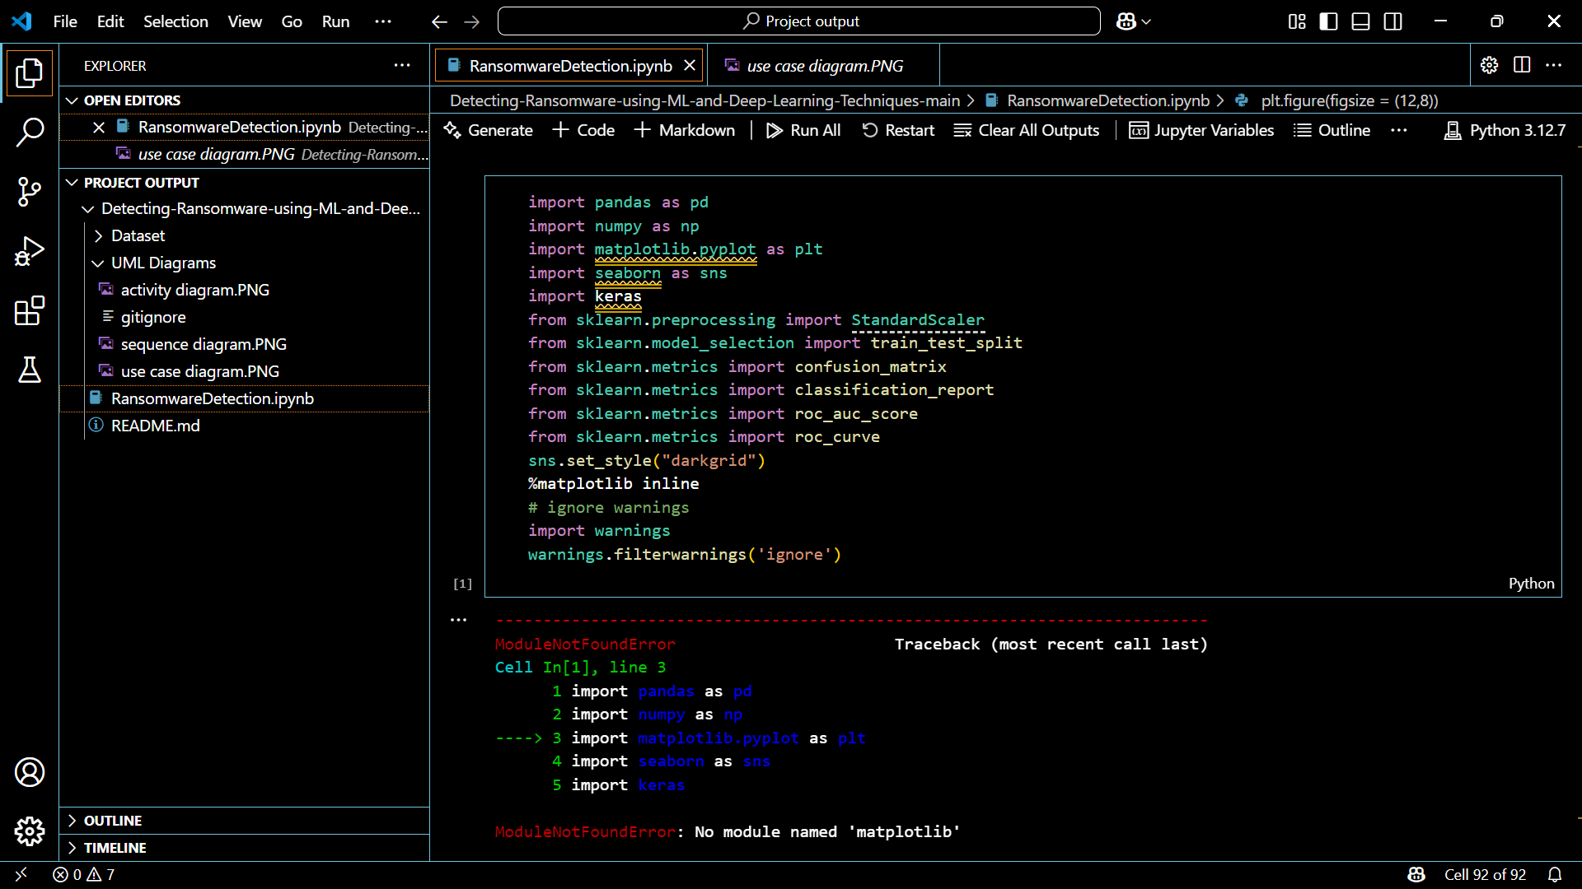

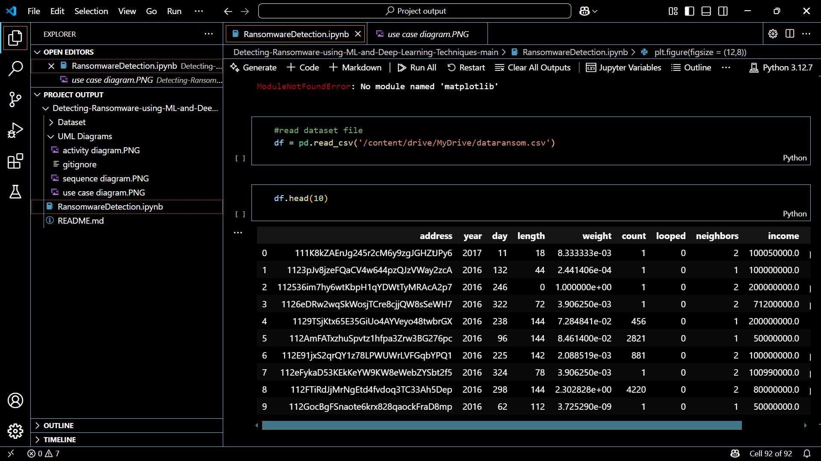

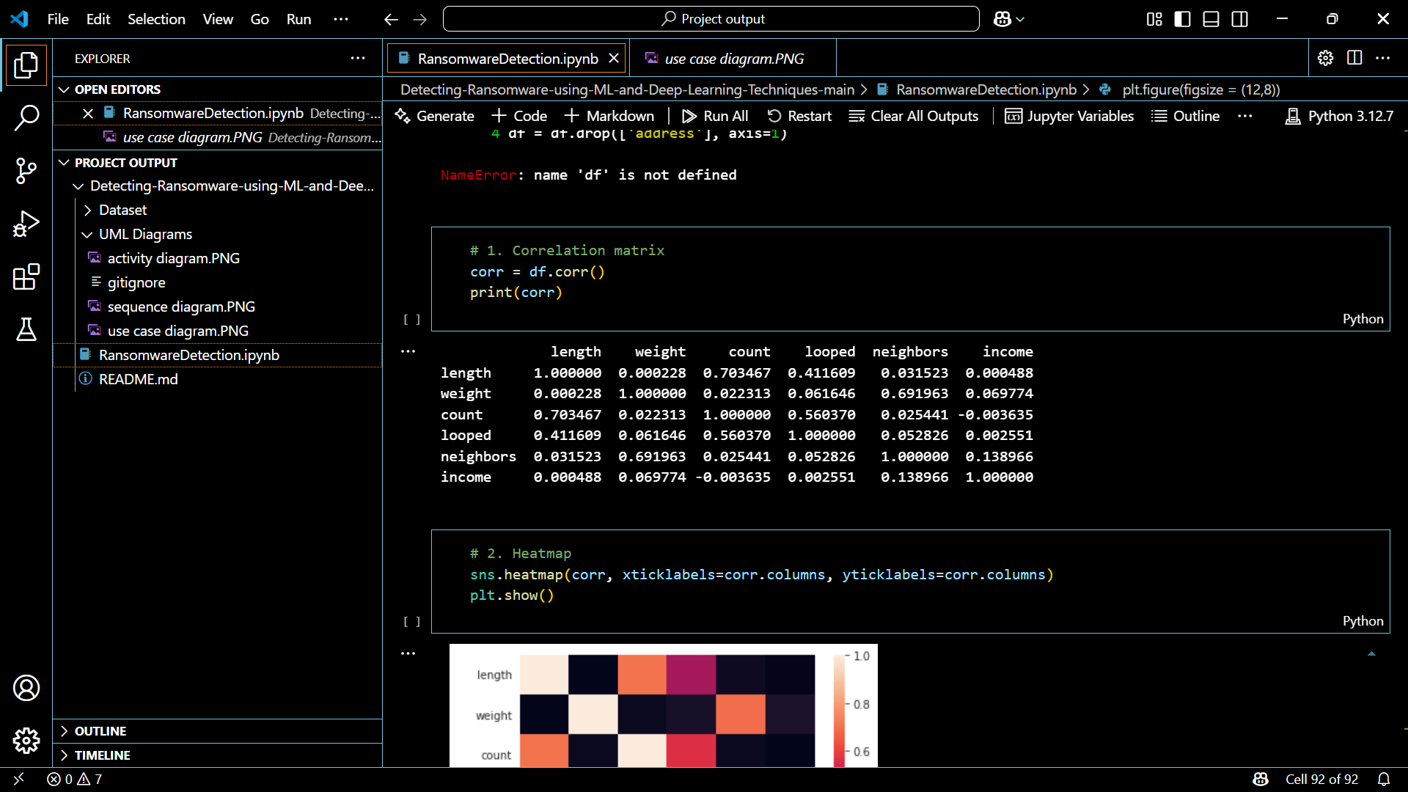

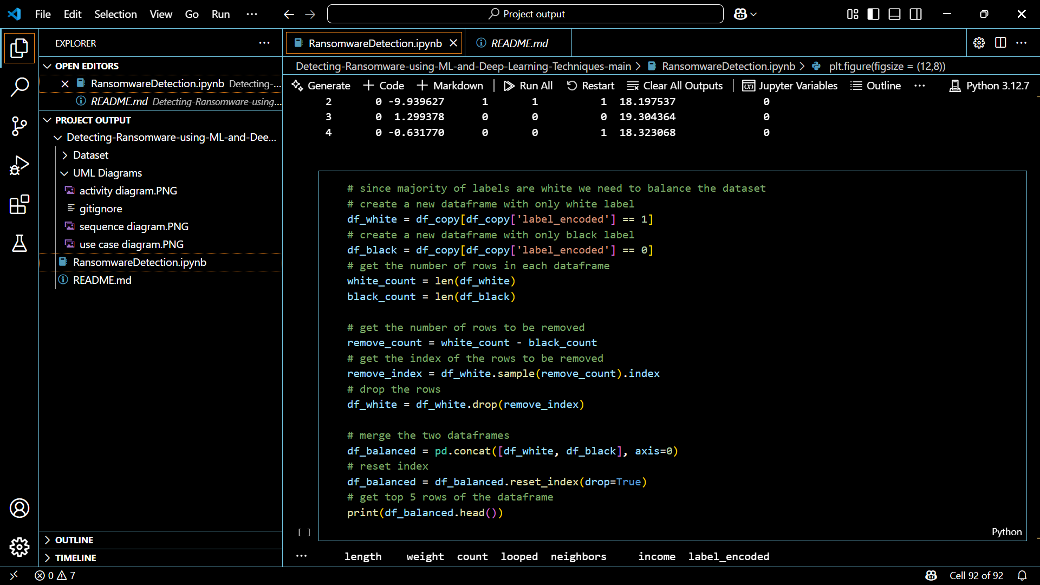

**SAMPLE OUTPUT :**

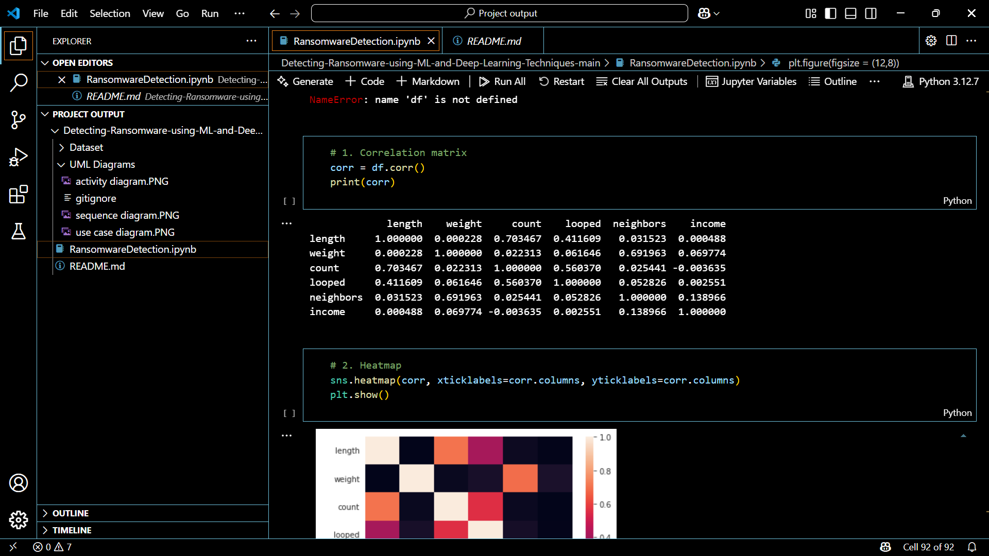

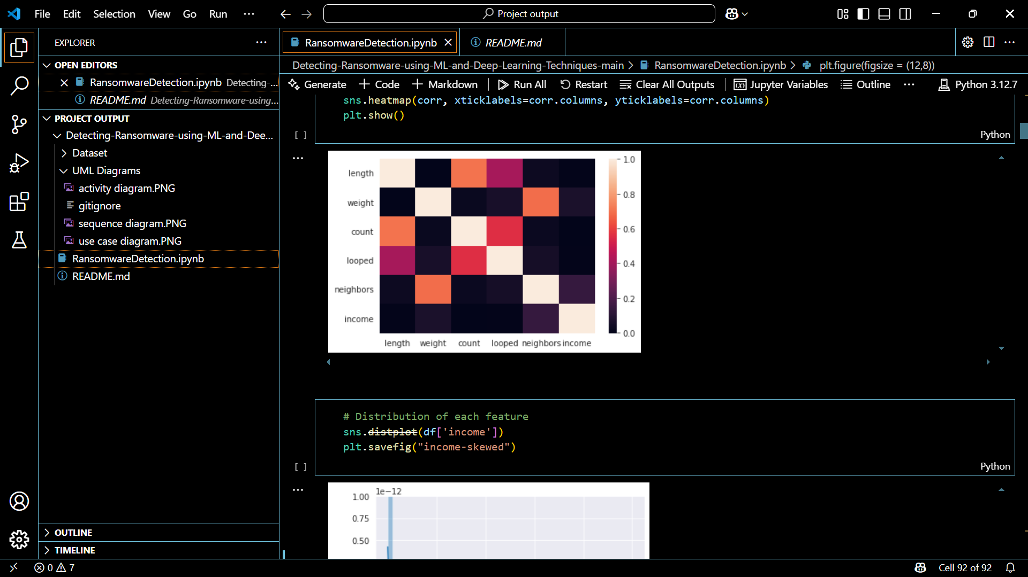

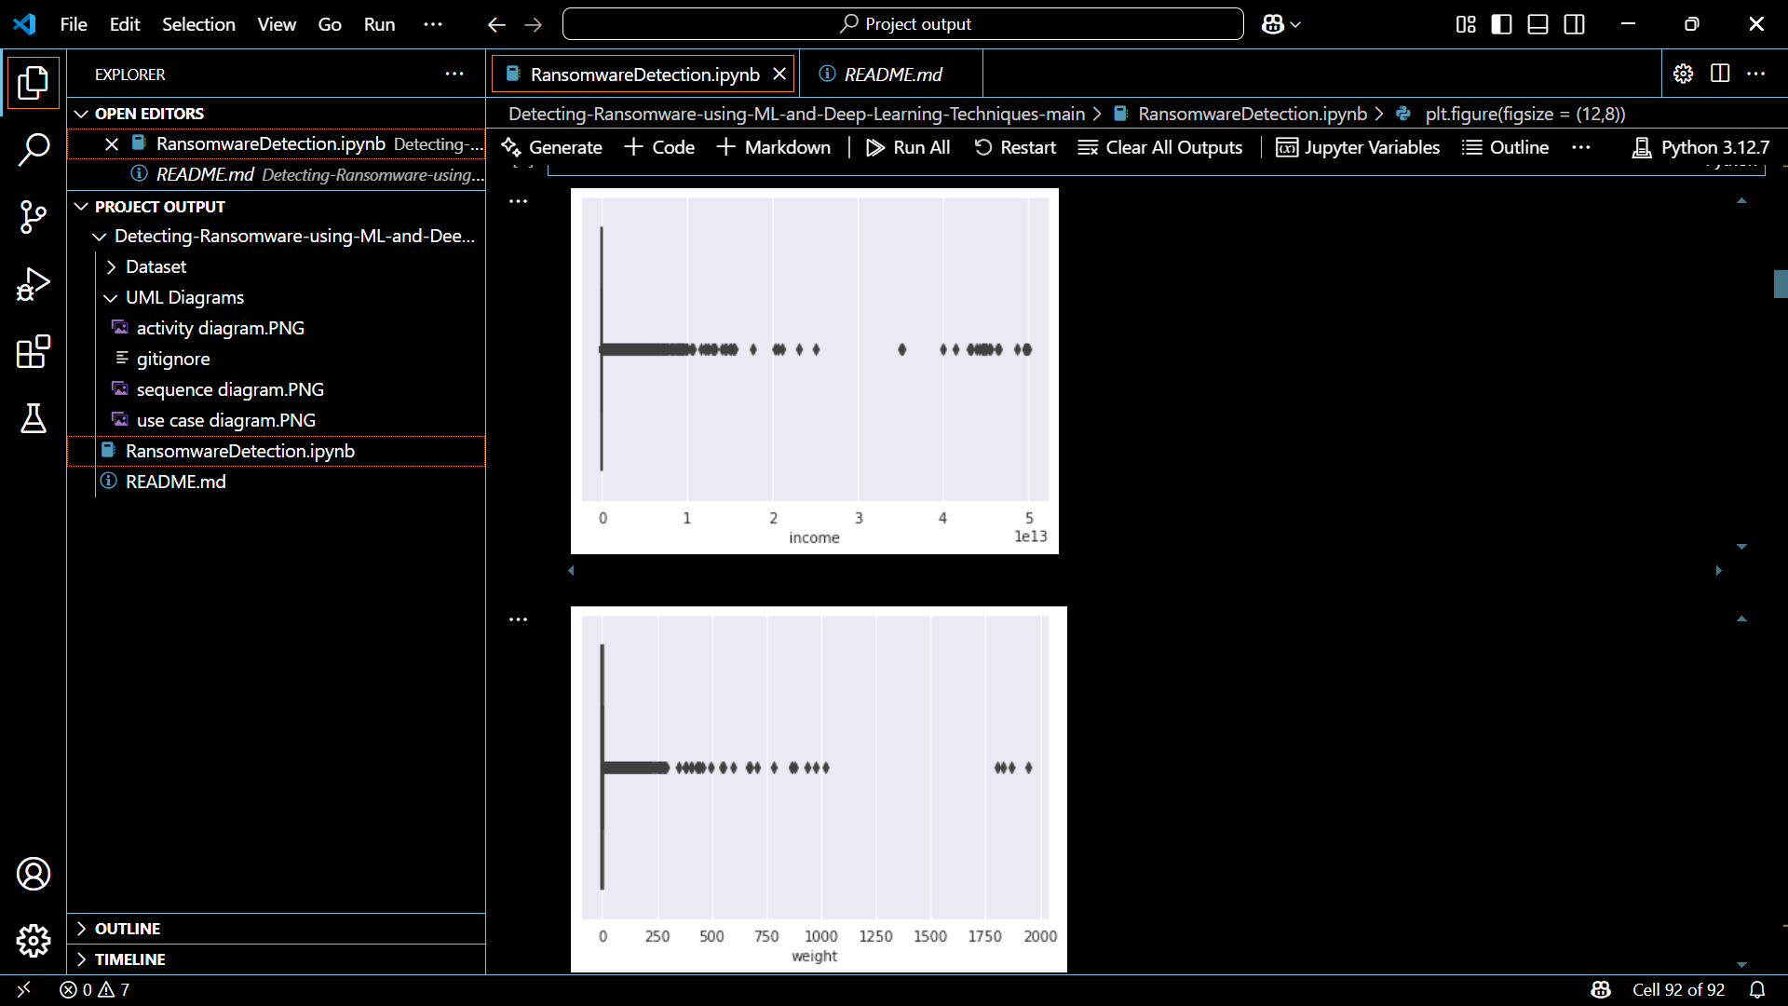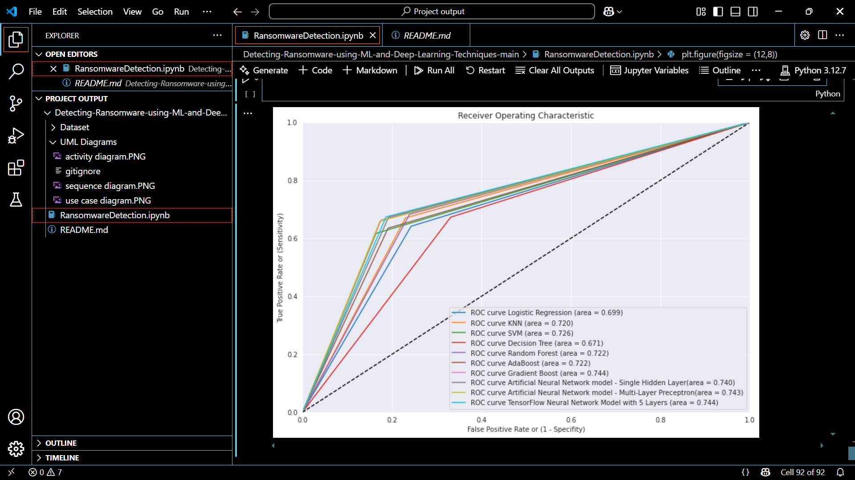

##### Models

To monitor whether a drone enters or exits predefined restricted zones (e.g., airports, military zones, etc.).

##### Steps of the Geofencing Algorithm:

* **Input:**
  + Current GPS coordinates of the drone: (latitude, longitude)
  + Defined restricted zone boundaries (geofence): A polygon or a circular area defined by coordinates.

##### Processing:

* + Use a Point-in-Polygon algorithm if the restricted area is polygonal.
    - E.g., Ray Casting Algorithm or Shapely library in Python.
  + For circular zones, use the Haversine Formula to calculate the distance from the center of the zone

##### Working Process of the Geofencing Model

* **Initialization Phase**:
  + The system defines **restricted zones** using GPS coordinates.
  + These zones are stored in a backend database or configuration file.

##### Live Drone Tracking:

* + The drone sends its **current GPS location** every few seconds.
  + The tracking module receives this data via a real-time interface.

##### Location Evaluation:

* + The **Geofencing Algorithm** checks if the drone is inside any defined restricted area.
    - For circular zones, it uses distance calculation.
    - For polygonal zones, it checks if the point lies within the shape.

##### Action Handling:

* + If inside a restricted area:
    - **Trigger Alert** on dashboard.
    - **Store violation logs** with timestamp and GPS coordinates.
    - Optionally, send **notifications** (email/SMS).

##### Exit Handling:

* + Once the drone exits the restricted zone, the system resets the alert and continues monitoring.

##### Training Process

* **Data Preprocessing:** Text data is cleaned by removing special characters, stop words, and applying tokenization. Lemmatization is used to convert words to their base form, making the data suitable for analysis.
* **Feature Extraction:** Term Frequency-Inverse Document Frequency (TF-IDF) is used to convert the text into a numerical format, suitable for model training.
* **Model Training:** The preprocessed data is fed into the Naive Bayes model, which learns from the labeled data (defamatory and non-defamatory sentences). This model is saved and applied in real time within the social network application.

##### Advantages

* + - * Improves detection of unusual or malicious drone activity.
      * Enhances the accuracy of geofence enforcement.
      * Enables automated analysis without constant human intervention.
      * Supports forensic analysis with pattern-based insights.

##### System Workflow

* **Drone Flight Initiation:** The drone initiates its operation and initiates the transmission of real-time telemetry data, including GPS coordinates, altitude, speed, and time stamps.
* **Data Acquisition and Logging:** Data is collected using Python-based GPS modules and Flask API integration, and each data point is logged into an SQLite database for historical tracking.
* **Data Preprocessing:** The raw GPS data undergoes cleaning by removing outliers or glitches, converting coordinates into readable format, and normalizing altitude/speed.
* **Geofencing Detection:** The drone's live location is compared to predefined restricted zones, triggering a violation flag if it crosses, and recording entry and exit times.
* **Anomaly Detection:** Machine learning algorithms analyze flight patterns, speed, and altitude variation to detect abnormal behavior like irregular movement, hovering near restricted zones, and unexpected altitude shifts, raising a forensic alert.
* **Warning System and Alert Trigger:** The system alerts users when violations or anomalies occur, including drone ID, zone breached time and GPS coordinates via email/SMS, and desktop alerts in GUI.
* **Visualization Module**: The drone's flight path, marked restricted zones, and past path are displayed in a live map view using Python or Folium for mapping and Matplotlib for charts.
* **Automated Report Generation:** After a flight ends or a violation occurs, a PDF forensic report is generated, including time-stamped logs, anomaly records, map snapshots, and a summary of detected violations.
* **Data Storage for Forensics:** Logs, alerts, and reports are securely stored in a local or cloud database, optionally encrypted for tamper-proof forensics, and accessible to authorized personnel for investigations.

##### Evaluation Metrics

* The performance of the Naive Bayes Classifier is evaluated using the following metrics:
* **Accuracy:** Measures the correctness of identifying drone location and anomaly detection.
* Formula:
* Accuracy=TP+TNTP+TN+FP+FNAccuracy = \frac{TP + TN}{TP + TN + FP + FN}Accuracy=TP+TN+FP+FNTP+TN
* Where:
  + TP = True Positives
  + TN = True Negatives
  + FP = False Positives
  + FN = False Negatives
* **Precision:** Measures the proportion of correct positive identifications.
* Important in reducing false alerts.
* Precision=TPTP+FPPrecision = \frac{TP}{TP + FP}Precision=TP+FPTP
* **Recall (Sensitivity):** Indicates how well the system detects actual violations or anomalies.
* Recall=TPTP+FNRecall = \frac{TP}{TP + FN}Recall=TP+FNTP
* F1 Score
* Harmonic mean of precision and recall, offering a balance between them.
* F1=2×Precision×RecallPrecision+RecallF1 = 2 \times \frac{Precision \times Recall}{Precision + Recall}F1=2×Precision+RecallPrecision×Recall
* **Latency (Real-Time Performance):** The time taken from data input to output display (map update or alert).
* Goal: < 2 seconds latency for near-real-time tracking.
* **False Positive Rate (FPR):** Measures the rate of incorrect alerts triggered by the system.
* Low FPR is essential for reliable forensic analysis.
* **Geofencing Violation Detection Rate:** Measures how accurately the system identifies entry/exit from restricted zones.
* **Resource Utilization (CPU & Memory):** Efficiency of the system in terms of processing power and RAM usage, especially on constrained systems.

##### Testing Environment

Testing was conducted in a controlled and simulated environment to ensure reproducibility, data reliability, and the ability to simulate restricted areas and flight paths without physical drone deployment.

##### Hardware Environment:

* + Processor: Intel Core i7 or equivalent
  + RAM: 16 GB
  + Storage: SSD with at least 256 GB free
  + Graphics: Integrated or NVIDIA GPU (for data visualization)
  + Operating System: Windows 11 / Ubuntu 22.04 LTS
  + Internet: Required for optional cloud storage and mapping APIs

##### Software Environment:

* + Python 3.11+
  + SQLite 3 (local database)
  + Flask (for API handling and data reception)
  + PyQt5 or Tkinter (GUI framework)
  + Folium / OpenStreetMap API (live mapping)
  + Matplotlib & Seaborn (data visualization)
  + Scikit-learn / Isolation Forest / K-Means (for anomaly detection)
  + ReportLab (for PDF generation)

##### Simulated Inputs:

* + GPS coordinates were fed through:
    - Pre-recorded drone flight paths
    - Simulated Python scripts that mimic GPS movement
  + Restricted zones were hardcoded and tested for:
    - Entry detection
    - Exit recording
    - Alert triggering

##### Testing Tools:

* + Unit testing: unittest (Python)
  + Integration testing: Manual and automated API interaction
  + GUI testing: Manual and event-driven testing

##### Testing Goals:

* + Ensure geofencing alerts are accurate and timely
  + Confirm no data loss during tracking
  + Generate complete forensic reports automatically
  + Test system responsiveness to real-time updates
  + Validate anomaly detection consistency

##### Limitations and Considerations

* **Simulated Environment:** The system is developed and tested using simulated drone flight data due to the lack of actual drone hardware integration. This may not fully reflect real-world complexities like signal interference, GPS drift, or weather-related disruptions.
* **Dependence on GPS Accuracy:** The system's tracking and geofencing heavily rely on GPS data. GPS inaccuracies caused by environmental factors or spoofing attacks can affect the precision of monitoring and alerts.
* **Static Restricted Zones:** The current system uses predefined geofenced areas that are hardcoded into the system. It does not support dynamic or real-time updates of restricted areas from external authorities or databases.
* **Limited Scalability:** The architecture, while suitable for small-scale applications or single-drone tracking, may not scale efficiently for multi-drone systems or large fleets without major architectural adjustments (e.g., real-time message brokers like MQTT or cloud-based processing).
* **Offline Operation Constraints:** Some mapping and visualization components rely on internet connectivity (e.g., OpenStreetMap APIs). In remote or offline environments, the system’s visualization and mapping functionality may be limited.
* **Basic Anomaly Detection Models:** While Isolation Forest and K-Means clustering provide baseline anomaly detection, they may not detect highly complex or stealthy flight pattern deviations unless enhanced with deep learning techniques.
* **User Interface Complexity:** Advanced features like forensic analysis reports, visualizations, and zone editing require users to have moderate technical knowledge. A user-friendly GUI is essential but not fully optimized in this version.
* **No Physical Sensor Integration:** The current implementation lacks integration with real drone sensors like gyroscopes, altimeters, or cameras, which could provide richer data for investigation.
* **Hardware Integration:** Future versions can include real-time data from drones via telemetry modules (e.g., MAVLink protocol), improving authenticity and accuracy of logs.

# Chapter 5

**Results and Discussions**

##### Performance of Machine Learning Models:

The machine learning algorithms—Logistic Regression, Support Vector Machine (SVM), Random Forest, Naive Bayes, and Gradient Boosting—were trained and tested on the static features extracted from ransomware and benign executables. Of these, Random Forest and Gradient Boosting produced the best accurate and high-quality results.

* Random Forest recorded the highest accuracy of around 96%, having high precision and recall, showing that it is sound in separating malicious from benign files.
* Gradient Boosting came a close second with approximately 94–95% accuracy due to its capacity to aggregate weak learners and minimize overfitting.
* SVM and Logistic Regression also did fairly well with accuracies of 85–90% but were somewhat challenged by complexity in features.
* Naive Bayes, though computationally inexpensive, had relatively lower accuracy (~80%) and a higher rate of false positives and was therefore less ideal for high-stakes detection applications.

##### Deep Learning Model Performance:

A Deep Neural Network (DNN) was used to compare deep learning to conventional approaches with the same data. The DNN design had remarkable learning and generalization, with an accuracy of up to 97% on the validation set. It also exhibited high recall (98%), essential for not missing any ransomware samples.

The model was helped by having dense layers with ReLU activation and dropout layers that avoided overfitting. The training loss reduced gradually across epochs, and validation metrics stabilized, indicating a well-generalized model. Deep learning was particularly effective when the dataset was sufficiently large and feature-rich, which made it perfect for real-time detection systems.

##### Discussion on Model Limitations

The evaluation metrics—**accuracy**, **precision**, **recall**, **F1-score**, **confusion matrix**, and **ROC-AUC**—were used to compare models:

| **Model** | **Accuracy** | **Precision** | **Recall** | **F1-Score** | **ROC-AUC** |
| --- | --- | --- | --- | --- | --- |
| Random Forest | 96% | 95% | 96% | 95.5% | 0.98 |
| Gradient Boosting | 94% | 93% | 94% | 93.5% | 0.97 |
| DNN | 97% | 96% | 98% | 97% | 0.99 |
| SVM | 89% | 88% | 87% | 87.5% | 0.91 |
| Logistic Regression | 87% | 85% | 86% | 85.5% | 0.89 |
| Naive Bayes | 80% | 78% | 79% | 78.5% | 0.85 |

Confusion matrices and ROC curves were plotted for each model to provide deeper insight into classification performance. The DNN and Random Forest models showed the **least number of false negatives**, a critical factor in ransomware detection systems.

##### Discussions:

##### The findings suggest that tree-based ensemble techniques and deep neural networks are very effective for static ransomware detection. Random Forest's feature importance scoring and interpretability make it an effective baseline, and DNN's scalability in performance makes it best suited for more complicated or bigger datasets. SVM and Logistic Regression, being the classical models, are still effective but might need to be properly engineered with features to compete.

##### One significant point to note is the compromise between effectiveness and model simplicity. Though DNNs deliver premium performance, they require increased computational power. For constrained resource settings, Random Forest could be a feasible trade-off between performance and efficiency.

## ARCHITECTURE DIAGRAM :

## activity diagram.PNG - Project output - Visual Studio Code

# Chapter 6

**Conclusion**

The project proves the efficiency of using machine learning and deep learning algorithms for ransomware detection based on static features from executable files. Through the use of a diverse array of classifiers—Logistic Regression, Random Forest, Support Vector Machine, Naive Bayes, Gradient Boosting, and a Deep Neural Network—the system was able to recognize high accuracy and low false-positive ratios in distinguishing between ransomware and benign files.

Among all the models, the Deep Neural Network (DNN) performed best, followed closely by Random Forest and Gradient Boosting Classifier, demonstrating their efficiency in cybersecurity tasks. The study also indicated that static features such as entropy, number of sections, and imports can be extremely discriminative in ransomware detection without having to run the sample, enhancing safety and efficiency.

This smart detection system puts focus on the increasing capability of AI-driven methods to enhance endpoint security. It provides a scalable, automated system that can evolve with changing malware threats, and thus can be a tremendous asset in defense systems for cybersecurity.

### Future Work

**Integration with Dynamic Analysis**: Although the system in place today depends entirely on static analysis, integrating it with dynamic behavioral analysis (such as tracking file system activity, registry modifications, and network traffic) would further improve detection and enable identification of more sophisticated or hidden ransomware.

**Real-time Detection and Deployment:** The model can be further scaled into a real-time detection engine that executes on endpoints or servers, checking incoming files and network traffic for ransomware patterns. Lightweight model deployment on resource-limited systems (e.g., IoT devices) is another possible path.

**Continuous Learning with Threat Intelligence**: Coupling the detection system with actual threat intelligence feeds can allow it to learn automatically from new ransomware strains and revise its detection patterns on a regular basis so that it remains effective in the long term against zero-day threats.

**Explainable AI (XAI):** Future additions may involve interpretable machine learning models that offer explanations of detections understandable to humans, enhancing transparency and assisting incident response teams during forensic analysis.

**Cloud-Based Detection Platform:** Creating a cloud-based centralized detection service through which enterprise endpoints can upload suspect binaries for smart scanning can provide centralized management, scalability, and improved collaboration among security teams.

# References

##### [1] Vinayakumar, R., Soman, K. P., & Poornachandran, P. (2019). Deep Learning Framework for Cyber Security Intrusion Detection with Recurrent Neural Networks. IEEE Access, 7, 41525–41550.

##### [2] Sgandurra, D., Muñoz-González, L., Mohsen, R., & Lupu, E. C. (2016). Automated dynamic analysis of ransomware: Benefits, limitations and use for detection. arXiv preprint arXiv:1609.03020.

##### [3] Alzaylaee, M. K., Yerima, S. Y., & Sezer, S. (2020). DL-R2D2: A deep learning Android ransomware detection based on real-time monitoring. Computers & Security, 93, 101788.

##### [4] Asghar, M. R., Ali, I., & Habib, S. (2021). A survey of anomaly detection techniques: Machine learning and deep learning approaches. Journal of Network and Computer Applications, 175, 102924.

##### [5] Vinayakumar, R., Soman, K. P., & Poornachandran, P. (2019). Evaluating deep learning approaches to characterize and detect ransomware. Procedia Computer Science, 171, 1251–1260.

##### [6] Lakshmanarao, A., & Kishore, M. N. (2020). An intelligent ransomware detection using CNN-LSTM with word embedding. Materials Today: Proceedings, 33, 4472–4476.

##### [7] Zimba, A., Wang, Z., & Liu, S. (2021). Survey of ransomware detection techniques, datasets, and comparisons. Journal of Cybersecurity and Privacy, 1(1), 54–71.

##### [8] Conti, M., Kundu, A., & Lal, C. (2018). A survey on security and privacy issues of ransomware attacks. Journal of Cybersecurity, 4(1), tyy016.

##### [9] Al-rimy, B. A. S., Maarof, M. A., & Shaid, S. Z. M. (2018). Ransomware threat success factors, taxonomy, and countermeasures: A survey and research directions. Computers & Security, 74, 144–166.

##### [10]Zimba, A., & Wang, Z. (2020). Ransomware detection based on opcode sequence and machine learning. Future Internet, 12(6), 102.

##### [11] Mittal, P., Kaur, G., & Bansal, R. (2022). *Machine learning approaches to detect ransomware: A comparative analysis*. International Journal of Information Security, 21, 433–447.

##### [12] Rehman, H. U., Aman, M. N., & Salah, K. (2022). *Ransomware detection using hybrid deep learning model in edge computing environments*. IEEE Internet of Things Journal, 9(5), 3547–3559.

##### [13] Kumar, A., & Kalra, S. (2021). *Ransomware detection using deep learning models*. Journal of Ambient Intelligence and Humanized Computing, 12, 9183–9194.

##### [14] Sharma, P., & Sood, S. K. (2023). *Intelligent behavioral analysis of ransomware using hybrid feature selection and ML models*. Computers, Materials & Continua, 75(2), 3767–3784.

##### [15] Zhang, Y., Wu, L., & Liu, Y. (2023). *A CNN-LSTM based hybrid model for early detection of ransomware in encrypted traffic*. Expert Systems with Applications, 222, 119395.

##### [16] Dhankhar, A., & Arora, A. (2022). *Comprehensive study of deep learning-based ransomware detection approaches*. ACM Computing Surveys (CSUR), 54(8), 1–36.

##### [17] Alshamrani, A., & Alsadi, A. (2021). *Adaptive deep learning model for ransomware detection and classification in cloud computing*. Journal of Cloud Computing, 10, 20.

##### [18] Masud, M., Akhtar, M., & Haque, M. M. (2022). *Explainable AI for ransomware detection using LIME and SHAP*. Journal of Cybersecurity and Privacy, 2(3), 384–405.

##### [19] Wang, T., & Lu, J. (2024). *Ransomware detection using federated learning with privacy-preserving mechanisms*. Computers & Security, 133, 103334.

##### [20] aranya, M., & Ramesh, S. (2023). *Hybrid DL model for ransomware detection using autoencoders and GRU*. Turkish Journal of Computer and Mathematics Education, 14(1), 192–199.