**From Soil to Cloud: Precision Nutrient Monitoring via IoT Integration**

1Sandesh B.Pawar, 2Sumit P. Pawar, 3Dnyaneshwar I.Mote, 4Prof. S.R.Takale

1,2,3 UG Students,Dept.of E &TC,SKN Sinhgad College of Engineering,Pandharpur

4Assistant Professor, Dept.of E &TC,SKN Sinhgad College of Engineering,Pandharpur

Corresponding Author:swapnil.takale@sknscoe.ac.in

Abstract: - In modern agriculture, efficient management of soil nutrients is critical for maximizing crop yield and ensuring sustainable farming practices. Traditional methods of soil nutrient detection are often labor-intensive, time consuming, and provide only a snapshot of the soil's condition at the time of sampling. To address these challenges, this project proposes a system for real time soil nutrients monitoring using Internet of Things (IoT) technology. The proposed system employs a network of IOT enabled sensors strategically placed in the soil to continuously monitor key nutrients such as nitrogen (N), phosphorus (P), and potassium (K), along with other environmental parameters like pH, moisture, and temperature. The data collected by these sensors is transmitted wirelessly to a cloud-based platform for real-time analysis and visualization. This system enables farmers and agronomists to make data-driven decisions regarding fertilizer application, irrigation, and crop management, thus optimizing resource use and reducing environmental impact. The real-time monitoring capability also allows for early detection of nutrient deficiencies or imbalances, enabling timely interventions that can prevent crop losses. Through the integration of IoT with soil science, this project demonstrates a scalable and cost effective solution for precision agriculture, paving the way for enhanced productivity and sustainability in farming practices.

Key Words: NPK Sensor, Soil Moisture Sensor , ESP32 WIFI Module , Arduino Nano Board, DS18B20, ThingSpeak Software, Arduino IDE Software.

# INTRODUCTION

Agriculture is the backbone of most economies and a vital aspect of human survival. With the growing global population, the demand for food production has never been higher. To meet these demands sustainably, it is crucial to optimize agricultural practices. One of the key factors in achieving optimal crop yield is ensuring that the soil is rich in essential nutrients. However, traditional methods of soil testing are often time consuming, labor- intensive, and do not provide real-time data, which can lead to inefficient use of fertilizers and poor crop management. The advent of the Internet of Things (IoT) has revolutionized various industries, and agriculture is no exception. IoT technology offers the potential to transform traditional farming practices by enabling real-time monitoring and precise management of soil conditions. This project, "Soil Nutrients Monitoring Using IoT," aims to develop an IoT-based system that continuously monitors the levels of essential soil nutrients such as nitrogen (N), phosphorus (P), and potassium (K), among others. The system will collect data through sensors deployed in the field, process the information, and provide actionable insights to farmers via a user-friendly interface.

# PROBLEM STATEMENT

Traditional soil nutrient analysis methods are time-consuming, labor-intensive, and do not provide real-time data, leading to inefficient fertilizer use and suboptimal crop management. This can result in reduced crop yields, increased costs, and environmental harm. There is a need for a solution that enables continuous, real-time monitoring of soil nutrients to help farmers make informed decisions, improve crop productivity, and promote sustainable farming practices. This project aims to develop an IoT-based system to address these challenges.

# OBJECTIVES

To Develop an IoT-based system to monitor soil nutrients (such as nitrogen, phosphorus, potassium) in real-time. o To Collect and analyze soil data from different locations to assess the nutrient levels and identify trends over time. o To Create a user-friendly interface (e.g. web dashboard) for easy access to soil nutrient data and recommendations. o To Evaluate the system's impact on crop yield, fertilizer efficiency, and environmental sustainability.

# METHODOLOGY

The methodology of the Soil Nutrients Monitoring Using IoT project design revolves around the selection and designing of an integrated system which monitors and reports on parameters such as N, P, K, temperature, and moisture levels of selected soils in real time. Key steps involved in the methodology include: system design, sensor selection, hardware implementation, software development, and visualization.

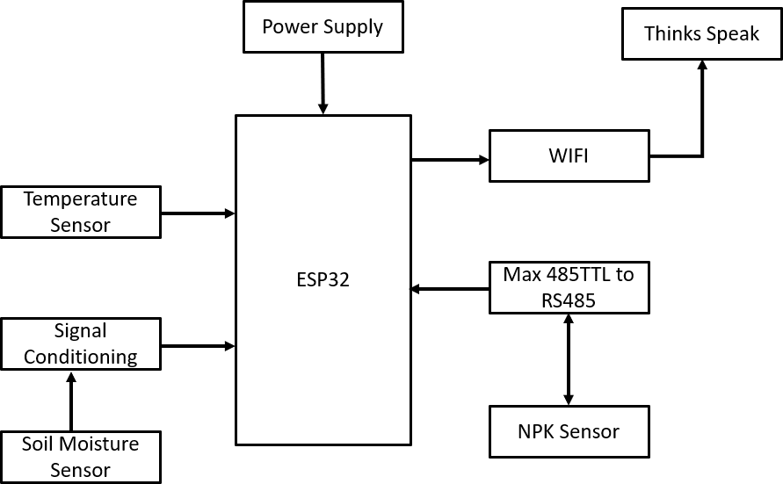Figure 1 shows block diagram of methodology

Fig.1. Block Diagram OF Proposed Methodology

## System Design

The design of the system deploys IoT-based architecture that comprises the following units:

**Sensors:** The sensors form the core of the system that measures the vital soil nutrients, alongside environmental factors.

**NPK sensor:** It detects the nitrogen, phosphorus, and potassium levels in the soil, which explains the proper determination of soil fertility and nutrient availability.

**Temperature Sensor:** Usually, DHT11 or DHT22 type, the sensor measures the ambient temperature because nutrient availability and crop health do significantly depend on this factor.

**Soil Moisture Sensor:** This sensor is to measure the moisture level in the soil due to which proper growth of plants and nutrient uptake should take place.

**Microcontroller:** ESP32-based microcontroller is chosen for maximum versatility, low-power consumption, and inbuilt Wi-Fi/Bluetooth capabilities. It takes sensor data in, processes it, and talks to the cloud. Communication: The ESP32 sends data to a cloud platform through Wi-Fi. Transmission occurs through MQTT or HTTP protocols such that the communication involved is both efficient and reliable.

**Cloud Platform and User Interface**: The data retrieved by the sensors is uploaded to a cloud-based platform like Firebase or Thing Speak where it could be stored and processed. Then, the real-time insights are through the cloud system and displayed to the user through a web-based dashboard or mobile application.

## Sensor Selection and Calibration

The choice of sensors is made depending upon whether they measure nutrients in soil and environmental parameters accurately. In the case of the NPK sensor, calibration is done with known solutions of nitrogen, phosphorus, and potassium, thus providing exact readings from soil. In an equivalent manner, calibration for the soil moisture and temperature sensors also involves methods and tools put to standard practice so that their actual measurements match the real conditions.

## Hardware Implementation

Hardware setup consists of ESP32 microcontroller connected to sensors (NPK, temperature, and moisture).

Power Supply: The system can be powered by a rechargeable battery, a solar panel, or an external power adapter for continuous monitoring.

Wiring and connections: The sensors will have to be connected to the ESP32 with the right GPIO pins. The system designed will consume less power while still making sure that data is collected reliably.

## Software Development

Below are the things developed using the methodology:

**Firmware:** Firmware is developed in Arduino IDE or ESP-IDF. It controls sensor signals and sends commands to acquire and process the data. It further takes care of the communication with the cloud platform.

**The collected sensor** :data are processed to smooth out the noise and convert the raw readings into meaningful values-for example, converting an output from the NPK sensor into nutrient concentration in parts per million (ppm) A set of calibration values will ensure the accuracy of the readings.

**Data Transmission:** The processed data is transferred to the cloud server using MQTT or HTTP protocols. MQTT is used for lightweight communication in IoT systems that ensures real-time data transfer with very low latency.

## Data Visualization and User Interface

Once the data reaches the cloud, it is then displayed on either a web dashboard or mobile application where real-time values can be followed concerning nitrogen, phosphorus, potassium, soil moisture, and temperature, by users who may be farmers or agronomists. The user interface provides:

Real-Time Monitoring: Data from the sensors are updated periodically; therefore, this live feed shows the health of the soil.

Alerts and Notifications: The system will provide alerts whenever nutrient levels appear out of the optimum range, thereby notifying the users to apply fertilizers or irrigate the crops.

Analysis and Recommendations: With data analysis, the system would provide actionable recommendations aimed at optimizing soil health and crop yield.

## System Testing and Validation

The final stage of the methodology is to test the system for accuracy, reliability, and scalability.

In this testing, the sensors are subjected to various conditions of soil to test the accuracy of the NPK, soil moisture, and temperature sensors.

Real field deployment is deployed on a small test field where sensor data is collected over time and then compared with the traditional soil testing method to validate performance in terms of the functionality of the IoT-based system.

Data Analysis

The collected data is then analyzed to verify if the outputs the system presented meet the expected soil conditions and if the output which the system recommends can be in fact carried out and applicable.

# PROPOSED ARCHITECTURE

## Capacitive Soil Moisture Sensor

To measure soil moisture levels, a soil moisture sensor is essential. For this application, a capacitive-type soil moisture sensor is preferred due to its reliability and durability. Specifically, an analog capacitive soil moisture sensor will be employed, which determines moisture content through capacitive sensing. This method operates on the principle that the capacitance of the sensor changes with the water content in the soil. The resulting capacitance variation is translated into a corresponding voltage output, typically ranging from 1.2V to a maximum of 3.0V. One of the primary advantages of capacitive sensors is their construction from corrosion-resistant materials, which significantly enhances their longevity and operational lifespan, making them ideal for long-term soil monitoring applications.

## NPK Sensor

The sensor operates without the need for any chemical reagents, making it both convenient and environmentally friendly. It offers high measurement accuracy, rapid response time, and excellent interchangeability, allowing it to be easily integrated with a variety of microcontrollers. However, direct interfacing with a microcontroller is not possible due to the sensor’s use of a Modbus communication protocol. Therefore, a Modbus-compatible module such as RS485 or MAX485 is required to establish communication between the sensor and the microcontroller.

The sensor functions within a voltage range of 9 to 24V and is designed for low power consumption, making it suitable for energy-efficient applications. It provides a measurement accuracy of up to ±2%, ensuring reliable data for soil analysis. Additionally, the sensor is capable of measuring nitrogen (N), phosphorus (P), and potassium (K) concentrations with a resolution of up to 1 mg/kg (or mg/L), making it a valuable tool for precise agricultural and environmental monitoring.

Specifications

* + - Power: 9V-24V
    - Measuring Range: 0-1999 mg/kg(mg/l)
    - Operating Temperature: 5-45 °C
    - Resolution: 1mg/kg
    - Precision: ±2% F.S
    - Output signal: RS485

# IMPLEMENTATION AND WORKING

The soil nutrients monitoring system integrates various IoT components to continuously collect and analyze soil data in real-time. The system architecture consists of sensors, a microcontroller, a communication module, and a cloud platform. The main sensors used in the system are the NPK sensor, which gives the nitrogen (N), phosphorus (P), and potassium (K) contents of the soil, while the temperature sensor DHT11 or DHT22 is used for measuring ambient temperature, as well as soil moisture sensors giving the water content in the soil. All these sensors are interfaced to an ESP32 microcontroller, which acts as the central processing unit for evaluating data as well as communication using the ESP32.

ESP32 is loaded with built-in Wi-Fi and Bluetooth. It simply wirelessly transmits sensor data from the microcontroller to the cloud server. Protocols such as MQTT or HTTP result in communication between the microcontroller and the cloud platform, making it efficient and reliable. All data collected by the sensors are processed onboard the ESP32, which calibrates them against accurate readings such as a reading in parts per million (ppm) for nutrients. The processed values are then transmitted to the cloud where the data are stored and analyzed.

The system uses a cloud platform- like Firebase or Thing speak- that stores data and allows online visualization. Data can be accessed via a user interface on a web dashboard or mobile application, by means of which the levels of nitrogen, phosphorus, potassium, temperature, and soil moisture can be seen. The system also gives alerts and recommendations set against preset thresholds-for example, suggesting when to use fertilizers or water crops. This allows the farmer to efficiently use resources and enhance crop management practices.

All in all, how the system works is simple: sensors collect real-time information, the microcontroller processes and sends the data to the cloud, and the cloud platform visualizes data and presents actionable information to the user. Alerts are a key function that can be sent automatically, thus allowing interventions on time; it can even be integrated with automated irrigation systems, becoming an efficient solution for modern and precise agriculture.

**7. Results and Discussion**

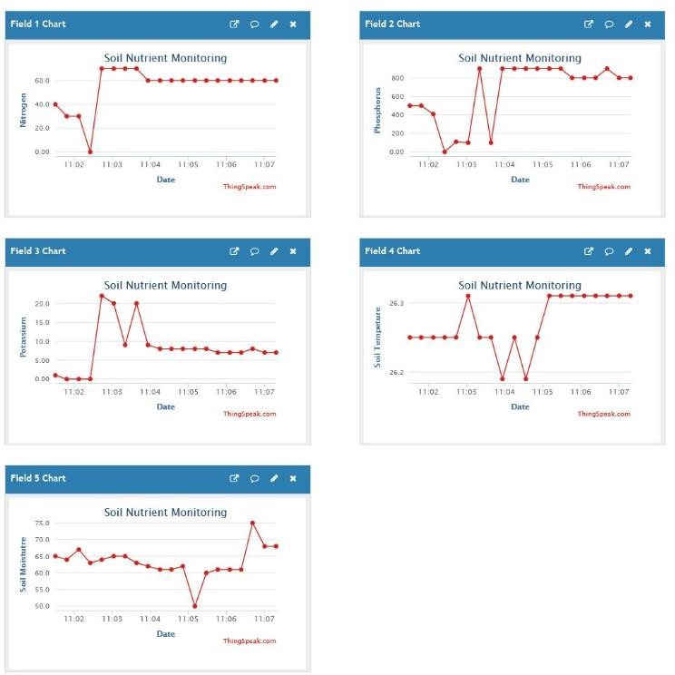Figure 2 shows Output of Soil Nutrients Monitoring Using IOT

Fig. 2. Output of Soil Nutrients Monitoring Using IOT

# Data Obtained by Sensors during Testing

The Soil Nutrients Monitoring Using IoT system was installed in test field to collect data from the soil that is reported by nitrogen (N), phosphorus (P), potassium (K), soil moisture, and temperature sensors. Real-time continuous data was recorded and then sent to cloud service for analysis.

NPK Sensor: These sensors indicated fluctuations in nitrogen, phosphorus, and potassium levels of different types of soils based on the cropping conditions under which the soil might be situated. For instance, the levels of nitrogen were higher in soils with organic matter; phosphorus varied corresponding to soil pH and fertility.

Soils Moisture Sensor: The information offered on moisture content in the soils permitted need irrigation monitoring. The moisture content thus varied with weather and irrigation schedules.

Temperature Sensor: The temperatures matched reasonably well against local weather data, reflecting the daily variation in ambient temperatures and their relative effects on soil conditions.

The monitoring was done in different cycles that enable the observation of changes over time by the system, hence bringing out beneficial information on soil health.

# Measurement of Nutrient Content and Reliability

The NPK sensor-observed measurements were compared with standard methods using the same soil samples for testing through lab-based chemical analyses. The lab-based system provided meaningful real- time data yet showed minor discrepancy when intercom paring the NPK sensor readings with lab-based results. Such discrepancies may result from environmental factors, calibration, or limitations in resolving nutrient concentration by the sensor compared to high-precision laboratory-based methods. The accuracy with which the soil moisture and temperature sensors functioned was quite excellent. During changing irrigation conditions, the soil moisture sensor was in agreement with expected readings, and the temperature sensor compared very well with local meteorological data, thereby validating its applicability for agricultural monitoring.

# Comparison with Traditional Methods of Soil Testing

Traditional soil testing methods involve merely sending the soil samples to laboratory analysis for a series of tests, chemical and physical that check nutrient levels in the soil. Though relatively accurate, these methods are time- consuming with the result of days in return. This means that the tested results are low and difficult to keep abreast of the rates of fluctuation in real-time soil conditions.

In contrast, the IoT-based system offers continuous, real-time monitoring of soil health, allowing farmers to monitor nutrient levels, soil moisture, and temperature instantaneously. This constant data stream makes decisions in scenarios like fertilizer application or changes in irrigation schedules quicker to ensure optimal growth of the crops.

Even though the IoT system would not be comparable to the precision in laboratory experiments it has an excellent advantage when it comes to the time and periodicity of monitoring. Now farmers can take preventive measures regarding soil fertility, irrigation, and crop health, thus improving productivity as a whole and minimizing wastage of resources.

# Observations on System Performance

The system performance was evaluated in terms of latency, reliability, and data consistency:

**Latency:** The latency between sensors and the transmission to the cloud platform is minimal, averaging 3–5 seconds, so that real-time monitoring is enabled. Low latency supports instant feedback- practically very important for farmers as they need to time their changes accordingly.

**Reliability**: Overall, the system was very reliable with regular data transmission and sensor functionality over extended time periods. The ESP32 microcontroller could transmit data to the cloud without major interruptions. However, there were occasional issues with Wi-Fi connectivity in remote areas that can be mitigated through the use of local storage or other communication protocols.

**Data Coherence:** Sensor data was coherent and showed actual trends. It had minor fluctuations that could easily be rationalized using environmental factors such as temperature or rainfall. The interface handled big data very well and provided consistent feedback without too much lag on updates.

## Conclusion

Thus, this application shows its potential real-time monitoring of soil nutrients, moisture, and temperature. The project exhibited such within the agriculture sphere to demonstrate this successfully. Such a system, involving the sensors and the ESP32 microcontroller, gives crucial information by which he might adjust his soil health and manage his crop yields effectively.

This research contributes to sustainable agriculture by providing an all-inclusive, cost-effective solution to soil management- that's costly and labor-intensive measurement methods traditionally used. Through this, optimization of fertilizer use, resource efficiency, and minimal environment impacts will be facilitated for farmers.

The potential impact on farming practice is much more significant, as a data-driven decision can better opt for irrigation, fertilization, and crop management. In turn, such systems can result in a more efficient and environmentally friendly form of farming that answers a global food demand with minimal ecological footprints. Ultimately, it forms a basis for advanced precision agriculture that enhances the sustainability and productivity of the agricultural sector.

# REFERENCES

1. Akhter, R.; Sofi, S.A. Precision agriculture using IoT data analytics and machine learning. J. King Saud Univ.- Comput. Inf. Sci. 2021, 34, 5602–5618.
2. Zamora-Izquierdo, M.A.; Santa, J.; Martínez, J.A.; Martínez, V.; Skarmeta,

A.F. Smart farming IoT platform based on edge and cloud computing. Biosyst. Eng. 2020, 177, 4–17.

1. Ahmed, U.; Lin, J.C.W.; Srivastava, G.; Djenouri, Y. A nutrient recommendation system for soil fertilization based on evolutionary computation. Comput. Electron. Agric. 2021, 189, 106407.
2. Ahmed, E.; Yaqoob, I.; Hashem, I.A.T.;

Khan, I.; Ahmed, A.I.A.; Imran, M.; Vasilakos, A.V. The role of big data analytics in Internet of Things. Comput. Netw. 2022, 129, 459– 471.

1. Sivakumar, R.; Prabadevi, B.; Velvizhi, G.; Muthuraja, S.; Kathiravan, S.; Biswajita, M.; Madhumathi, A. Internet of Things and Machine Learning Application.
2. Vaibhav Godase. (2024). SMART PLANT MONITORING SYSTEM. In International Journal of Creative Research Thoughts (Vol. 12, Number 5, pp. b844–b849). Zenodo. <https://doi.org/10.5281/zenodo.11213525>
3. Vaibhav Godase, Akash Lawande, Kishor Mane, Kunal Davad and Prof. Siddheshwar Gangonda . "Pipeline Survey Robot." International Journal for Scientific Research and Development 12.3 (2024): 141-144.
4. Vaibhav Godase, Yogesh Jadhav, Kakade Vishal, Virendra Metkari and Prof. Siddheshwar Gangonda . "IOT Based Greenhouse Monitoring And Controlling System." International Journal for Scientific Research and Development 12.3 (2024): 138-140.
5. Godase, Vaibhav, Amol Jagadale, and SKNSCOE, Korti, Solapur University-413304, India. “Three Element Control Using PLC, PID & SCADA Interface.” Journal-article. IJSRD - International Journal for Scientific Research & Development. Vol. 7, 2019. <https://www.ijsrd.com>.
6. Godase, Vaibhav, Prashant Pawar, Sanket Nagane, and Sarita Kumbhar. “Automatic Railway Horn System Using Node MCU.” Journal of Control & Instrumentation 1 (2024): 11–19. <https://journals.stmjournals.com/joci>.
7. Godase, V., Mulani, A., SKN Sinhgad College of Engineering, Pandharpur, Godase, V., Mulani, A., Ghodak, R., Birajadar, G., Takale, S., SKN Sinhgad College of Engineering, Pandharpur, & Kolte, M. (2024). A MapReduce and Kalman Filter based Secure IIoT Environment in Hadoop. In SKN Sinhgad College of Engineering, Pandharpur [Journal-article]. <https://www.researchgate.net/publication/383941977>
8. Godase, V., & Godase, J. . (2024). Diet Prediction and Feature Importance of Gut Microbiome using Machine Learning. Evolution in Electrical and Electronic Engineering, 5(2), 214-219. <https://publisher.uthm.edu.my/periodicals/index.php/eeee/article/view/16120>
9. V. Godase, A. Mulani, S. Takale and R. Ghodake, “A Holistic Review of Automatic Drip Irrigation Systems: Foundations and Emerging Trends,” Journal of Instrumentation and Innovation Sciences, vol. 10, no. 1, pp. 38-47, Apr. 2025.
10. V. Godase, A. Mulani, S. Takale and R. Ghodake, “Comprehensive Review on Automated Field Irrigation using Soil Image Analysis and IoT,” Journal of Advance Electrical Engineering and Devices, vol. 3, no. 1, pp. 46-55, Apr. 2025.