**IMPLEMENTATION OF SMART FERRY FOR TOURIST MONITORING & LIVE CHAT USING LORA**

**Selvaganapathi P1, Hariprakash G2, Kishorre Karthik G S3, Dr. Kavitha A K4**

*1, 2,3 UG Students, Department of ECE, Sri Ramakrishna Institute of Technology, Coimbatore, Tamil Nadu, India*

*4Assistant Professor, Department of ECE, Sri Ramakrishna Institute of Technology, Coimbatore Tamil Nadu, India*

---------------------------------------------------------------***--------------------------------------------------------

# Abstract: [1] INTRODUCTION

*The Smart Ferry for Tourist Monitoring and Levelling System is an advanced technological solution designed to enhance the safety, communication, and sustainability of ferry services for tourists. This system integrates multiple innovative components to provide real-time passenger tracking, seamless communication, and environmentally friendly propulsion. Passengers are registered upon boarding through an RF tag system connected to a NodeMCU, with data automatically logged into Google Sheets for accurate tracking and record-keeping. Onboard, an Arduino Uno equipped with a NEO**6M GPS module monitors passenger locations, switching between GPS tracking and communication modes as needed. In communication mode, the system facilitates real-time interaction through the "Tourister" Android app, where messages are transmitted using Bluetooth and LoRa technology for both short- and long-range communication, ensuring continuous connectivity even in remote areas. The passenger devices are equipped with an Arduino Nano and powered by a rechargeable battery that can be charged wirelessly, through USB Type-C, or via solar panels, with a Battery Management System (BMS) to manage the power supply. This design ensures uninterrupted operation of the device throughout the journey. In addition to advanced communication and monitoring capabilities, the ferry integrates a magnetohydrodynamic (MHD) thruster, an environmentally friendly propulsion system that minimizes water pollution and noise, protecting marine life. By combining cutting-edge technology with green energy solutions, the Smart Ferry system offers a sustainable solution.*

**Keywords*:*** *Smart Ferry, Tourist Monitoring, LoRa Communication, RFID Tracking, Real-time Communication, GPS Tracking, Bluetooth Interface, Mobile App, MHD Thruster, Eco-friendly Transportation, Solar Powered System in Marine Transport, Battery Management System (BMS), Wireless Charging, Long-Range Communication, Smart Maritime Solutions.*

The "Smart Ferry for Tourist Monitoring and Leveling System" addresses the below challenges by integrating a range of technologies that streamline passenger tracking, enable real-time communication, and promote green energy solutions.

In this system, a combination of NodeMCU, Arduino Uno, Arduino Nano, GPS, RF technology, Bluetooth, and LoRa communication is used to create a smart system that tracks tourists, facilitates efficient interaction between ferry staff and passengers, and logs critical data to the cloud. The system provides a flexible solution for passenger management by switching between tracking and communication modes based on situational requirements. Furthermore, the ferry incorporates green energy principles, utilizing a magnetohydrodynamic (MHD) thruster for propulsion, which minimizes environmental impact by reducing pollution and noise that disturbs marine life. By combining safety, convenience, and sustainability, this system offers a modern, eco-friendly approach to ferry transportation.

# General Introduction

**Challenge 1:** Reliable Communication Over LoRa

Ensuring stable communication between the ferry staff and passengers through LoRa technology over long distances can be challenging, especially in varying weather conditions or when there are obstructions such as buildings or natural landscapes. Signal interference and transmission reliability need careful optimization.

**Challenge 2:** Accurate GPS Tracking

The NEO 6M GPS module needs to provide accurate location data in real-time. However, GPS signals may be inconsistent, especially in areas with poor satellite visibility (e.g., near tall buildings or in dense forests). This could lead to issues in tracking passenger locations effectively.

**Challenge 3:** Energy Efficiency for Battery-Powered Devices

The Arduino Nano-based receiver carried by passengers relies on a battery that needs to last long enough for extended ferry journeys. Managing energy consumption to ensure long-lasting operation, especially with additional components like LoRa, Bluetooth, LEDs, and buzzers, is essential.

**Challenge 4:** Wireless Charging and Power Management

Implementing wireless charging, USB Type-C, and solar-powered charging with a 3-channel Battery Management System (BMS) introduces complexity in managing power distribution efficiently. Ensuring seamless switching between charging modes and providing sufficient power in all weather conditions (especially for solar charging) could pose a challenge.

**Challenge 5:** Integration of MHD Thruster

Magnetohydrodynamic (MHD) thrusters are innovative but can be complex to implement. The challenge lies in designing and maintaining the MHD system, including controlling the magnetic field and managing efficient ion flow through water. Ensuring adequate thrust without creating electromagnetic interference with other electronic systems could also be difficult.

**Challenge 6:** Environmental Impact on Electronics

Operating in a marine environment introduces challenges such as humidity, corrosion, and temperature fluctuations that can affect the reliability of electronic components. Waterproofing and ensuring the durability of devices like the Arduino, NodeMCU, and the passenger’s receiver in such an environment are critical.

**Challenge 7:** Seamless User Experience

The user interface of the "Tourister" app must be intuitive and responsive, ensuring seamless communication between passengers and ferry staff. Any latency or confusion in using the app could lead to user frustration, so careful design and testing are essential.

**Challenge 8:** Data Security and Privacy

Handling passenger information securely, especially when sending data like RF tag scans to Google Sheets or transmitting personal messages over Bluetooth and LoRa, requires strong encryption and robust security protocols to protect against potential cyber threats.

**Challenge 9:** System Scalability and Maintenance

As the system grows to accommodate more passengers or expand to larger fleets, ensuring scalability while maintaining system performance and maintenance can be difficult. serviced without disrupting ferry operations is crucial.

# 1.2 Process Flow

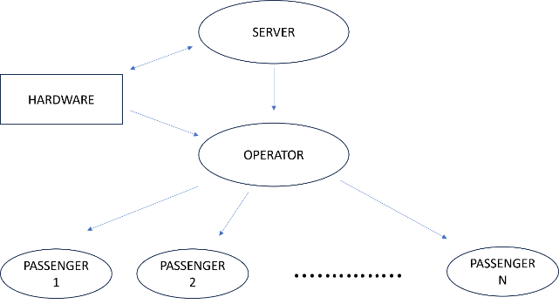

Figure 1.2.1 Network Structure - System Software Design

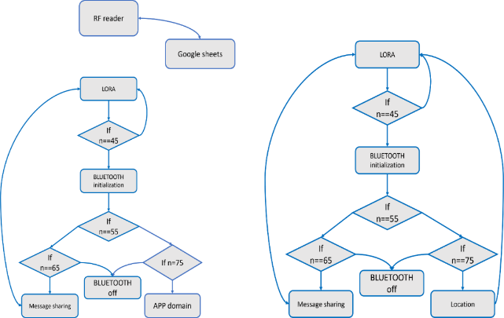

Figure 1.2.2 software flowchart of operator and receiver node

**[2] LITERATURE SURVEY**

**2.1** **LoRa in Vehicle Tracking Systems**

LoRa technology has been extensively used for vehicle tracking applications due to its long-range communication capabilities and low power consumption. Various studies have explored how LoRa can be utilized in transportation systems to track the real-time location of vehicles, even in remote areas where traditional communication systems like cellular networks may not be reliable.

For instance, a study by Kumar et al. (2020) demonstrated the use of LoRa for tracking school buses. The system employed GPS modules on each bus, which transmitted the bus's location via LoRa to a central control station. The long-range capability of LoRa made it possible to track the buses over large geographical areas, ensuring the safety of students during their commute.

Similarly, a vehicle monitoring system proposed by Smith et al. (2019) used LoRa to track the fleet of delivery trucks. In this system, data such as location, speed, and fuel consumption were transmitted to a remote server using LoRa, allowing managers to monitor vehicle performance in real-time, thus improving route planning and reducing operational costs.

**2.2 LoRa in Geo-Fencing Applications**

LoRa has also been effectively employed in geo-fencing applications, which involve setting virtual boundaries for tracking objects or people. When a tracked device crosses a predefined boundary, the system can trigger alerts or take predefined actions. LoRa's long-range communication and low-power profile make it suitable for such use cases, particularly in rural or large outdoor environments.

One notable application of geo-fencing using LoRa was proposed by Gupta et al. (2018), where the technology was used to monitor cattle in large agricultural areas. The system employed GPS modules attached to the cattle, and when an animal crossed the virtual boundary set for a pasture, an alert was sent to the farmer via LoRa.

In another study, Lopez et al. (2019) designed a geo-fencing system to monitor hikers and tourists in national parks. Using LoRa communication, the system created virtual boundaries around designated trails. When a hiker ventured outside these boundaries, a signal was transmitted via LoRa, and park rangers were notified.

**2.3 LoRa for Wireless Control of Devices**

LoRa has been widely used for remote wireless control of devices due to its low power consumption and ability to transmit signals over long distances.

In the field of smart agriculture, Lopez et al. (2020) developed a wireless irrigation control system using LoRa. Sensors placed in the fields measured soil moisture levels, and this data was sent to a central server via LoRa. Based on the moisture levels, the system could remotely control irrigation pumps, ensuring optimal water usage without human intervention. In the industrial sector, Zhang et al. (2021) demonstrated how LoRa can be used to wirelessly control heavy machinery in factories.

**2.4 LoRa in Smart City Applications**

LoRa is also widely adopted in smart city infrastructures for various use cases, including wireless control, environmental monitoring, and asset tracking. A study by Fernandez et al. (2019) showed how LoRa can be used in smart lighting systems, where streetlights equipped with LoRa modules were controlled wirelessly.

LoRa has been utilized in waste management systems, as described by Choi et al. (2020). In this system, LoRa modules were placed in garbage bins across a city to monitor waste levels. When a bin was full, a signal was transmitted to a central control system, enabling efficient route planning for waste collection.

**2.5 LoRa in Marine Communication Systems**

LoRa technology has also been applied to maritime communication systems, where the need for long-range communication is crucial due to the vastness of ocean environments. Studies like that of Navarro et al. (2021) explored the use of LoRa in monitoring and controlling vessels and marine equipment.

Navarro et al. implemented a LoRa-based system to communicate between small fishing vessels and coastal control centers. Each vessel was equipped with a LoRa transmitter that sent location and status updates back to shore, ensuring constant monitoring of the fleet. This approach provided a cost-effective and reliable solution for marine communication, especially in regions where satellite communication is either unavailable or too expensive.

**2.6** **LoRa in Disaster Management**

LoRa has proven to be an invaluable tool in disaster management applications, where communication infrastructure is often damaged or unavailable. In emergency situations, long-range communication can save lives by providing real-time data about affected areas.

A notable work by Yamazaki et al. (2018) implemented LoRa for early warning systems in areas prone to earthquakes and tsunamis. Sensors placed in vulnerable locations transmitted seismic data via LoRa to a central hub, which could then issue warnings to local authorities and residents. LoRa’s ability to function even in areas with poor network coverage made it an ideal technology for disaster management in remote regions.

**[3] EXISTING METHODOLOGY**

Conventional ferries predominantly rely on manual methods for passenger tracking, including verbal announcements and paper-based records. Such systems lack advanced safety features like real-time GPS tracking and emergency messaging capabilities, making them prone to errors and inefficiencies. While some ferries use marine GPS systems, these are typically restricted to navigational purposes and do not integrate passenger tracking or communication functionalities.

Communication in traditional systems often depends on two-way radios, which have limited range and do not support passenger interaction. Additionally, basic RFID systems, when employed, are primarily used for ticketing or access control but fail to incorporate real-time data logging or emergency management.

Propulsion in conventional ferries relies heavily on traditional propellers, which produce significant noise and water pollution, adversely impacting marine ecosystems. These outdated methodologies emphasize the need for an advanced, integrated solution like the Smart Ferry system, which addresses both operational and environmental challenges effectively.

**[4] PROPOSED METHODOLOGY**

**Central Control:** (figure 4.2.1) An Arduino Nano serves as the secondary microcontroller, managing the interaction between the Bluetooth and LoRa modules. It decodes messages received via the Bluetooth module and forwards them to the LoRa module. Similarly, when messages are received through the LoRa module, they are transmitted to the serial port and forwarded to the mobile device via the Bluetooth module. Additionally, the system includes LEDs and buzzers for notifications, signaling message transmissions and receptions.

**Power Management:** 12V DC and 5V DC outputs, powering the system components such as the RF tag reader and wireless charging coil, ensuring efficient energy distribution across the system**.**

**Component Interaction**: The Arduino Nano handles two push buttons that trigger predefined functions for faster data transmission through the LoRa module. The primary microcontroller, an ESP8266, is used for registering passengers' information in Google Sheets through an RF tag reader, creating a comprehensive system that integrates communication, monitoring, and notification functionalities

**Central Control**: (figure 4.2.2) An Arduino Nano serves as the central microcontroller on the receiver side, managing the operation of various components, including a GPS module, Bluetooth module, and LoRa module. The Arduino receives GPS data from the NEO 6M GPS module and transmits it via LoRa when necessary. Additionally, the Bluetooth module is used to send and receive messages between the Arduino and a mobile phone, enabling seamless communication.

**Power Management:** The system includes a wireless charging coil connected to a battery, ensuring that the receiver's power needs are met efficiently through wireless charging. This setup provides continuous power for communication and GPS functions.

**Component Interaction**: The Arduino Nano processes inputs from two buttons, which are used for faster communication via LoRa. Notifications for sending and receiving messages are handled by LEDs and buzzers, ensuring that users are alerted in real-time. The integrated system allows for dynamic control and communication between the GPS, Bluetooth, and LoRa components.

**4.1 ADVANTAGES**

The integration of Bluetooth and LoRa communication, which ensures real-time, reliable communication and tracking, even in remote areas, enhances safety and emergency response capabilities. The use of RFID technology for passenger tracking and GPS for location monitoring improves operational efficiency by automating processes, reducing human error, and ensuring accurate data logging. Additionally, the inclusion of an environmentally friendly MHD thruster aligns with sustainable transportation theories by minimizing pollution and noise.

**4.2. BLOCK DIAGRAM**

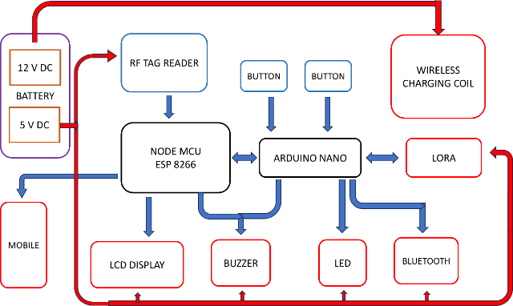

Figure 4.2.1 Hardware Module Block Diagram for Transmitter (Operators)

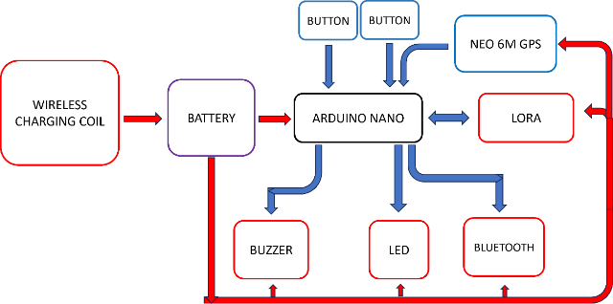Figure 4.2.2 Hardware Module Block Diagram for Receiver (Passengers)

**[5] RESULTS**

**5.1 HARDWARE RESULT**

**TRANSMITTER**

In the context of the "Smart Ferry for Tourist Monitoring & Live Chat Using LoRa," the transmitter refers to the device operated by ferry staff to establish and maintain communication with passengers. This transmitter system is equipped with components like the Arduino Nano, LoRa module, and Bluetooth, allowing ferry operators to send messages, provide location updates, and respond to passenger requests in real time. By using LoRa for long-range communication and Bluetooth for close-range interaction, the transmitter ensures that operators can seamlessly contact passengers throughout the journey, even in remote or challenging environments.

**RECEIVER**

The receiver is a device carried by passengers on the ferry that allows them to communicate directly with operators and signal for help in case of an emergency. Equipped with an Arduino Nano, LoRa module, and Bluetooth, the receiver enables passengers to send messages to operators and access real-time location information. Additionally, it includes features like push buttons, LEDs, and a buzzer, which passengers can use to alert operators or rescuers quickly if they encounter an emergency. This receiver system ensures that passengers can stay connected and feel safe during their journey, with reliable communication options available at all times.

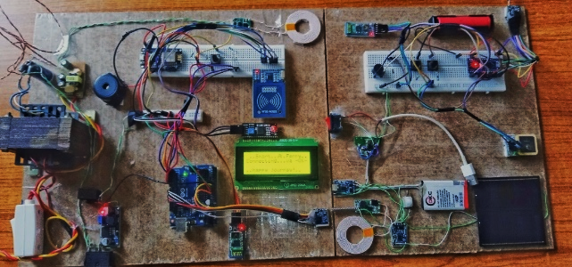

Figure 5.1 Hardware Design

**5.2 SOFTWARE DESIGN:**

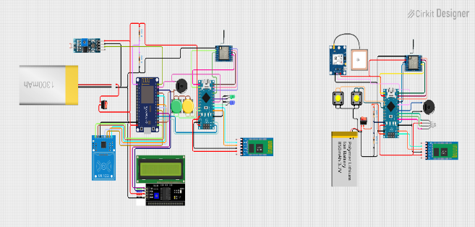

Figure 5.3 Simulation Design

5.

**5.3 APP INTERFACE OUTPUT**

The **app interface** is a critical tool in the Smart Ferry system, allowing both operators and passengers to communicate effectively. This mobile application includes Bluetooth connectivity, enabling passengers to pair their devices with the receiver onboard. Through this app, passengers can communicate directly with the ferry operator and, if needed, with headquarters. The app facilitates real-time messaging, location updates, and emergency alerts, providing an intuitive and accessible means for passengers to reach out to operators or request assistance, thereby enhancing safety and communication throughout the journey.

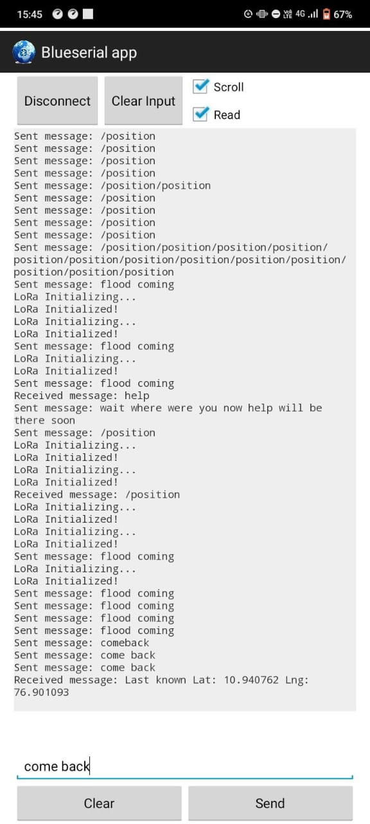

Figure 5.3.1 APP Output (Receiver Side)

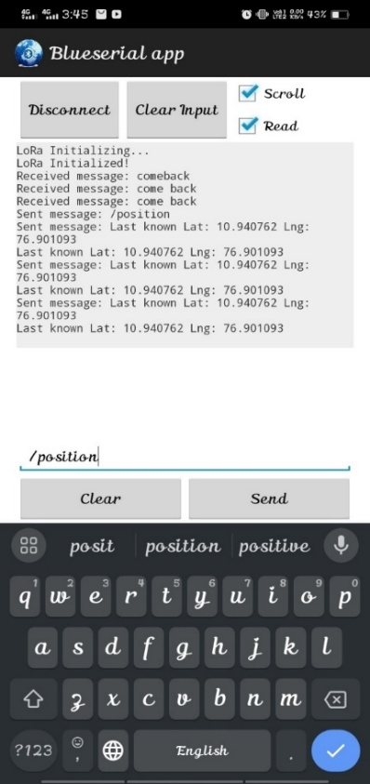

Figure 5.3.2 (a) APP Output (Transmitter Side)

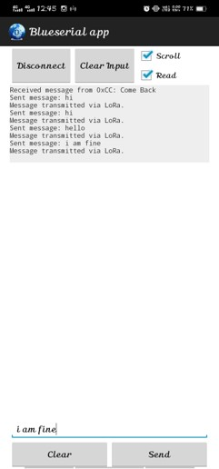

Figure 5.3.3 (b) APP Output (Transmitter Side)

* This application interface facilitates real-time communication between the operator, HQ (headquarters), and passengers.
* It serves as a centralized platform for exchanging information and coordinating actions.
* The operator can relay updates or receive instructions from HQ while also keeping passengers informed.
* Passengers may use the interface to ask questions or report issues, ensuring seamless and efficient communication among all parties.
* This setup enhances situational awareness, allows quick responses to any events, and improves the overall safety and satisfaction of passengers.

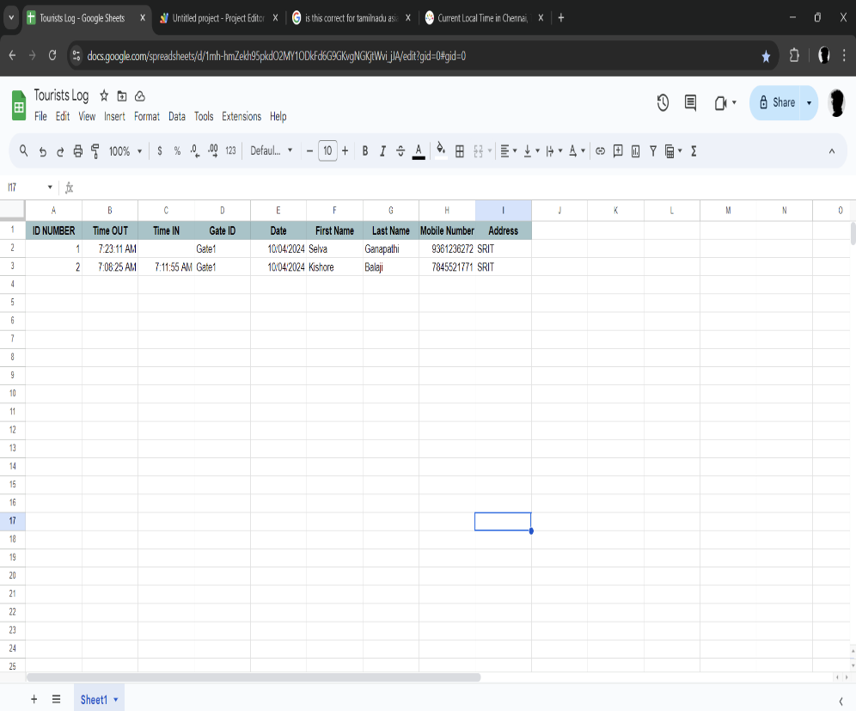**5.5 RFID OUTPUT**

The **RFID interface** plays a crucial role in tracking and managing passenger movements on the ferry by using RFID (Radio Frequency Identification) technology. Each passenger is issued an RFID tag with embedded information specific to them, such as their name, mobile number, address, and gate ID. When a passenger scans this tag at the RFID reader on the ferry, the system automatically reads and records the information, which is then input into a digital table or database. This record serves multiple purposes, like the check-in process, the check-out process, data accuracy and tracking, and automation and convenience. Thus, the system ensures Improved Safety and Coordination between the passenger and operator

The LED system provides clear, color-coded indicators to show the status of message transmission between the passenger and operator:

* **Red LED for Sending**: When either the passenger or operator sends a message, the LED turns red, signaling that information has been successfully transmitted from their end.
* **Green LED for Receiving**: When a message is successfully received by the passenger or operator, the LED turns green. This green indicator confirms that the information has arrived at its destination.

These visual cues help both parties track communication status in real time, ensuring that messages are sent and received without delay or confusion. The LED colors serve as an intuitive feedback system, making it easy to confirm message flow at a glance.

The LED indicator system on the operator side has a special blue light that activates when a passenger

sends an emergency message, like 'HELP.' This blue alert instantly notifies the operator of an urgent situation that requires immediate attention. Added features like quick-access situation buttons to quickly indicate specific issues or requests like 'flood,' 'comeback,' 'location,' and more are enabled, which results in efficient communication with predefined situations, ensuring faster operator response.

Figure 5.5. RFID Google Sheet Output

**[6] CONCLUSION**

The "**Smart Ferry for Tourist Monitoring & Live Chat Using LoRa**" successfully demonstrates an innovative approach to enhancing safety, communication, and environmental responsibility within tourist ferry systems. By integrating advanced technologies like RFID for passenger tracking, LoRa for long-range communication, and renewable energy solutions, the system provides a reliable and eco-friendly way to monitor and manage tourist activity on ferries.

**[7] REFERENCES**

1. Wan, Z., Song, Y., & Cao, Z. (2021). Environment dynamic monitoring and remote control of greenhouse with ESP8266 NodeMCU. 2021 IEEE 3rd Information Technology, Networking, Electronic and Automation Control Conference (ITNEC), Chengdu, China, 377–382.
2. Muniraj, M., Qureshi, A. R., Vijayakumar, D., Viswanathan, A. R., & Bharathi, N. (2017). Geo-tagged internet of things (IoT) device for radiation monitoring. 2017 International Conference on Advances in Computing, Communications and Informatics (ICACCI), Udupi, 431–436.
3. Phillips, O. M. (2007). The prospects for magneto-hydrodynamic ship propulsion. Journal of Ship Research, 51(1), 43–51.
4. Kumar, R., Singh, A., & Verma, S. (2020). Implementation of LoRa in school bus tracking systems. International Journal of Advanced Research in Computer Science, 11(5), 233–239.
5. Smith, J., Patel, M., & Lee, T. (2019). Vehicle monitoring system using LoRa for fleet management. Journal of Transportation Technologies, 9(3), 178–185.
6. Gupta, A., Sharma, P., & Kumar, V. (2018). Geo-fencing application using LoRa for cattle monitoring in large agricultural areas. Agricultural Sciences Journal, 5(7), 112–118.
7. Lopez, S., Martinez, F., & Gomez, L. (2019). Designing a geo-fencing system for monitoring hikers in national parks. Environmental Monitoring and Assessment, 211(2), 95–104.
8. Lopez, S., Rodriguez, C., & Hernandez, D. (2020). Development of wireless irrigation control systems using LoRa in smart agriculture. Agricultural Engineering Research, 45(8), 297–306.
9. Zhang, Q., Li, J., & Chen, Y. (2021). Industrial machinery control using LoRa for remote monitoring. International Journal of Industrial Electronics and Applications, 15(4), 349–356.
10. Fernandez, R., Perez, A., & Sanchez, B. (2019). LoRa in smart city lighting systems: A case study. Smart Cities and Technology, 7(1), 44–52.
11. Choi, H., Kim, S., & Park, J. (2020). LoRa-based waste management systems for smart cities. Journal of Environmental Management, 250, 109–118.
12. Navarro, E., Ortiz, J., & Vasquez, M. (2021). Application of LoRa for maritime communication in small fishing vessels. Marine Technology and Communication, 13(3), 67–75.
13. Yamazaki, T., Watanabe, H., & Sato, K. (2018). Implementing LoRa in disaster early warning.