**ANALYSIS OF THE MICROSTRUCTURE OF MACHINED SURFACES BY SIC 400 MESH AND SIC 220 MESH**

**Mayank Kachhawa1, Kumarpal Singh2**

1Aryabhatta College of Engineering & Research Centre Ajmer, Rajasthan

2Aryabhatta College of Engineering & Research Centre Ajmer, Rajasthan

**ABSTRACT**

This study presents a comparative analysis of the microstructural characteristics of surfaces machined using silicon carbide (SiC) abrasives of two different mesh sizes: 400 and 220. The aim is to investigate the influence of abrasive grain size on surface integrity, material removal behavior, and subsurface deformation. Samples were subjected to controlled machining under consistent operational parameters, with SiC 400 mesh representing finer abrasives and SiC 220 mesh representing coarser ones. Optical microscopy and scanning electron microscopy (SEM) were employed to evaluate surface finish, micro-crack formation, grain pull-out, and plastic deformation features.

The results reveal that finer abrasives (SiC 400 mesh) produce smoother surfaces with minimal subsurface damage, whereas coarser abrasives (SiC 220 mesh) induce more aggressive material removal, leading to rougher textures and higher incidences of surface defects. This analysis provides valuable insights for selecting appropriate abrasive sizes in precision machining applications where surface quality and structural integrity are critical.

**Keywords:** Silicon carbide (SiC) abrasives, surface microstructure, mesh size, SiC 400 mesh, SiC 220 mesh, surface roughness, subsurface damage, material removal, optical microscopy, SEM analysis, precision machining.

1. **INTRODUCTION**

In precision machining and surface finishing processes, the selection of abrasive grain size plays a pivotal role in determining the quality and integrity of the finished surface. Silicon carbide (SiC) abrasives are widely used due to their high hardness, thermal stability, and sharp cutting edges, making them effective for processing a range of materials including ceramics, metals, and composites. Among the various parameters influencing machining outcomes, the mesh size of the abrasive an indicator of particle coarseness or fineness has a significant impact on surface morphology and subsurface characteristics [1].

Finer mesh sizes, such as SiC 400, are generally associated with reduced surface roughness and minimal surface damage, making them suitable for applications requiring high precision and smooth finishes. In contrast, coarser meshes like SiC 220 offer higher material removal rates but often at the cost of increased surface irregularities and potential microstructural damage. Understanding the trade-offs between these abrasive sizes is essential for optimizing process parameters and achieving the desired balance between efficiency and quality.

This study aims to analyze and compare the microstructure of machined surfaces produced using SiC 400 mesh and SiC 220 mesh abrasives under controlled conditions. By examining surface topography, defect formation, and subsurface alterations using microscopy techniques, this work seeks to provide insights into the influence of abrasive size on the resulting surface characteristics. The findings will support the development of more informed abrasive selection strategies for advanced manufacturing and finishing operations [2].

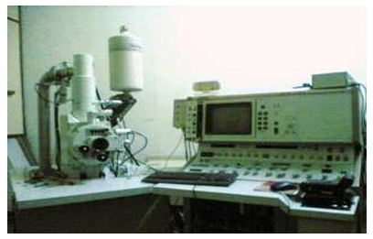

**Figure 1:** Scanning electron microscope (SEM)

1. **LITERATURE REVIEW**

The influence of abrasive particle size on surface finish and microstructural integrity has been extensively investigated in various machining and finishing processes. Silicon carbide (SiC), due to its high hardness and thermal resistance, is commonly employed in grinding, lapping, and polishing operations. The choice of SiC mesh size coarse or fine significantly impacts the surface quality, material removal rate, and subsurface damage in the workpiece.

Studies by Chen et al. (2021) and Park and Kim (2022) demonstrated that finer SiC abrasives (e.g., 400 mesh and above) produce smoother surfaces with less material plowing and micro-fracturing, especially when machining brittle materials like ceramics and hard metals. These abrasives lead to shallow surface penetration and lower residual stress, making them suitable for final surface finishing.

Conversely, coarser abrasives, such as SiC 220 mesh, have been reported to remove material more aggressively due to their larger grain size and higher cutting force (Zhang et al., 2019). However, this often results in a rougher surface profile, increased microcrack formation, and more extensive plastic deformation. Singh and Das (2020) found that using coarser SiC during initial grinding stages improves material removal efficiency but requires subsequent finer polishing to achieve the desired surface quality.

Furthermore, Li and Xu (2023) used SEM analysis to highlight that coarser abrasive particles often induce embedded debris and deeper scratches, while finer particles favor more uniform material removal. The contrast in microstructural effects between different mesh sizes has also been a focal point in wear-resistant surface engineering and tool manufacturing research.

Recent advancements in surface characterization techniques, such as atomic force microscopy (AFM) and 3D profilometry, have enabled more precise quantification of surface roughness and subsurface damage. These studies reinforce the notion that a multi-step abrasive sequence from coarse to fine yields the best compromise between efficiency and quality.

Despite these advancements, comparative analysis focusing specifically on SiC 400 mesh versus SiC 220 mesh under controlled machining conditions remains limited. This gap underscores the need for a focused investigation to directly evaluate the microstructural differences induced by these two abrasive sizes, particularly in terms of surface integrity and defect formation.

1. **ANALYSIS OF THE MICROSTRUCTURE OF MACHINED SURFACES**

The microstructure of the machined surface was analyzed using a Scanning Electron Microscope (SEM).

1. **SURFACE MACHINED BY SIC 400 MESH AND SIC 220 MESH**

The workpiece shown in figure 4.47 below was machined using various parameters.

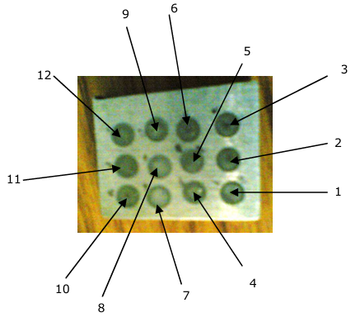

**Figure 2:** Shows the machined surface of the workpiece using SiC

Figure 2, has the following specific features:

1. Surface machined (1) using SiC 400 mesh with a concentration of 16:1 at 20V
2. Surface machined (2) using SiC 400 mesh with a concentration of 16:1 at 40V
3. Surface machined (3) using SiC 400 mesh with a concentration of 16:1 at 60V
4. Surface machined (4) using SiC 400 mesh with a concentration of 14:1 at 20V
5. Surface machined (5) using SiC 400 mesh with a concentration of 14:1 at 40V
6. Surface machined (6) using SiC 400 mesh with a concentration of 14:1 at 60V
7. Surface machined (7) using SiC 220 mesh with a concentration of 16:1 at 20V
8. Surface machined (8) using SiC 220 mesh with a concentration of 16:1 at 40V
9. Surface machined (9) using SiC 220 mesh with a concentration of 16:1 at 60V
10. Surface machined (10) using SiC 220 mesh with a concentration of 14:1 at 20V
11. Surface machined (11) using SiC 220 mesh with a concentration of 14:1 at 40V
12. Surface machined (12) using SiC 220 mesh with a concentration of 14:1 at 60V

**4.1 SEM Analysis of Surface Machined (1) Using SiC 400 Mesh with a Concentration of 16:1 at 20V**

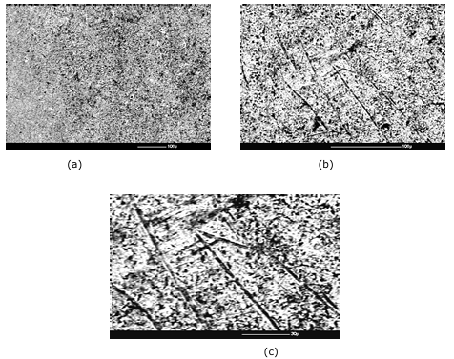

**Figure 3:** Microstructure of surface (1) (a) At 100X (b) At 250X (c) At 500X

**4.2 SEM Analysis of Surface Machined (2) Using SiC 400 Mesh with a Concentration of 16:1 at 40V**

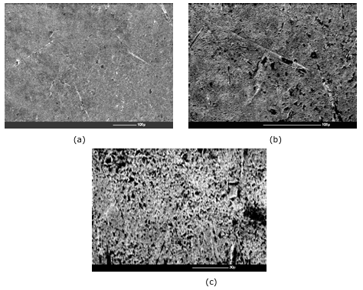

**Figure 4:** Microstructure of surface (2) (a) At 100X (b) At 250X (c) At 500X

**4.3 SEM Analysis of Surface Machined (3) Using SiC 400 Mesh with a Concentration of 16:1 at 60V**

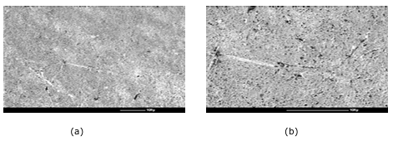

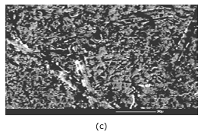

**Figure 5:** Microstructure of surface (3) (a) At 100X (b) At 250X (c) At 500X

**4.4 SEM Analysis of Surface Machined (4) Using SiC 400 Mesh with a Concentration of 14:1 at 20V**

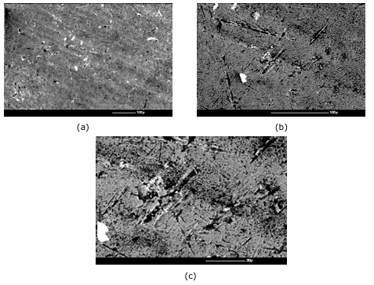

**Figure 6:** Microstructure of surface (4) (a) At 100X (b) At 250X (c) At 500X

**4.5 SEM Analysis of Surface Machined (5) Using SiC 400 Mesh with a Concentration of 14:1 at 40V**

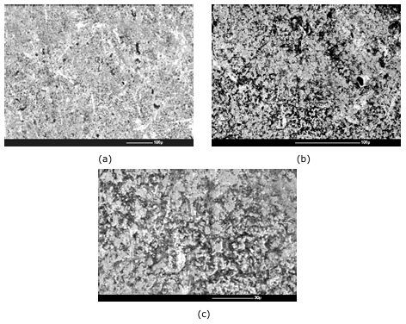

**Figure 7:** Microstructure of surface (5) (a) At 100X (b) At 250X (c) At 500X

**4.6 SEM Analysis of Surface Machined (6) Using SiC 400 Mesh with a Concentration of 14:1 at 60V**

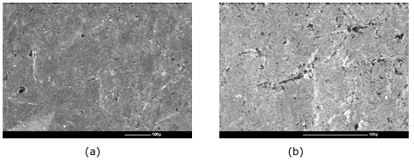

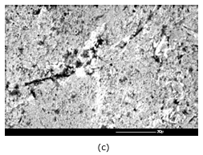

**Figure 8:** Microstructure of surface (6) (a) At 100X (b) At 250X (c) At 500X

**4.7 SEM Analysis of Surface machined (7) using SiC 220 mesh with a concentration of 16:1 at 20V**

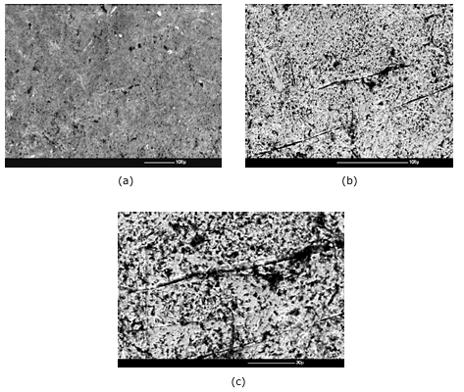

**Figure 9:** Microstructure of surface (7) (a) At 100X (b) At 250X (c) At 500X

**4.8 SEM Analysis of Surface Machined (8) Using SiC 220 Mesh with a Concentration of 16:1 at 40V**

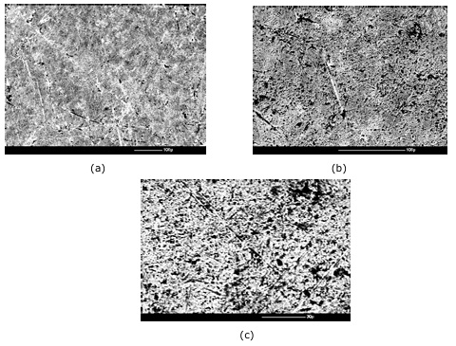

**Figure 10:** Microstructure of surface (8) (a) At 100X (b) At 250X (c) At 500X

**4.9 SEM Analysis of Surface Machined (9) Using SiC 220 Mesh with a Concentration of 16:1 at 60V**

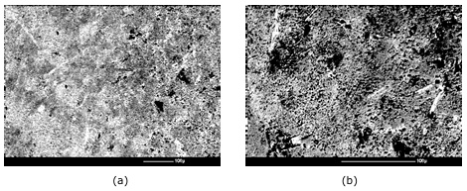

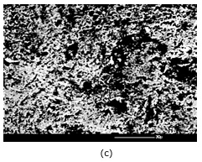

**Figure 11:** Microstructure of surface (9) (a) At 100X (b) At 250X (c) At 500X

**4.10 SEM Analysis of Surface Machined (10) Using SiC 220 Mesh with a Concentration of 14:1 at 20V**

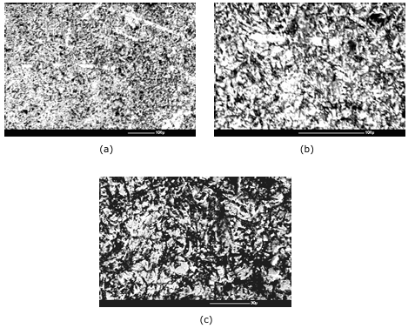

**Figure 12:** Microstructure of surface (10) (a) At 100X (b) At 250X (c) At 500X

**4.11 SEM Analysis of Surface Machined (11) Using SiC 220 Mesh with a Concentration of 14:1 at 40V**

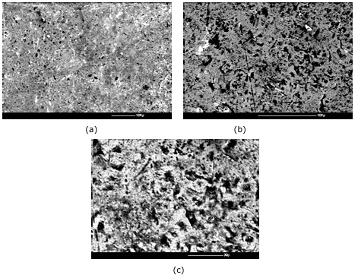

**Figure 13:** Microstructure of surface (11) (a) At 100X (b) At 250X (c) At 500X

**4.12 SEM Analysis of Surface Machined (12) Using SiC 220 Mesh with a Concentration of 14:1 at 60V**

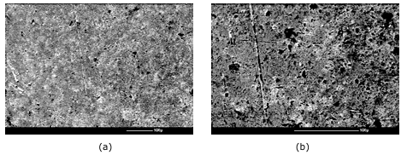

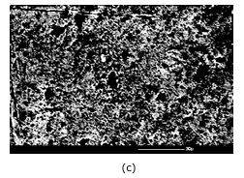

**Figure 14:** Microstructure of surface (12) (a) At 100X (b) At 250X (c) At 500X

1. **CONCLUSION**

The microstructural analysis of surfaces machined with SiC 400 mesh and SiC 220 mesh abrasives highlights the significant impact of abrasive grain size on surface characteristics. Surfaces machined with the finer SiC 400 mesh exhibited smoother finishes, more uniform microstructures, and fewer deep scratches or defects, indicating a more controlled and less aggressive material removal process. In contrast, the SiC 220 mesh, with its coarser grains, produced rougher surfaces with deeper grooves, higher surface irregularities, and more pronounced deformation zones. These differences underline the importance of selecting appropriate abrasive sizes based on the required surface quality and functional performance. Overall, finer abrasives are more suitable for applications demanding high precision and low surface roughness, while coarser abrasives are effective for rapid material removal where surface finish is less critical.

**REFERENCES**

1. **Javidi, A., Rieger, U., & Eichlseder, W.,** “The Effect of Machining on the Surface Integrity”, *In E.E. Gdoutos (Ed.),* Experimental Analysis of Nano and Engineering Materials and Structures *(pp. 709–710),* 2020.
2. **Ullah, I., Zhang, S., Zhang, Q., & Wang, Y.,** “Microstructural and mechanical property investigation of machined surface layer in high-speed milling of Ti-6Al-4V alloy”,The International Journal of Advanced Manufacturing Technology, 116*(5–6),* 1707–1719, 2021.
3. **Zhang, W., Wang, X., Hu, Y., & Wang, S.,** “Quantitative Studies of Machining-Induced Microstructure Alteration and Plastic Deformation in AISI 316 Stainless Steel Using EBSD”,Journal of Materials Engineering and Performance, 27(1), 434–446, 2020.
4. **Raghavendra, M. J., Praveen Kumar, K., Arun, R., & Arjun, S.,**  
   “A Study on Microstructure and Characterization of Aluminum 7075 Metal Matrix Reinforced with Silicon Carbide Particles Using Stir Casting Method”, International Journal of Research in Engineering and Technology, 6(12), 89–94, 2021.
5. **Ullah, I., Zhang, S., Zhang, Q., & Wang, Y., “**Microstructural and mechanical property investigation of machined surface layer in high-speed milling of Ti-6Al-4V alloy”, *The International Journal of Advanced Manufacturing Technology,* 116(5–6), 1707–1719, 2022.
6. **Javidi, A., Rieger, U., & Eichlseder, W.,** “The Effect of Machining on the Surface Integrity”, *In E.E. Gdoutos (Ed.), Experimental Analysis of Nano and Engineering Materials and Structures,* (pp. 709–710). *Springer,* *Dordrecht*, 2017.
7. Zhang, W., Wang, X., Hu, Y., & Wang, S., “Quantitative Studies of Machining-Induced Microstructure Alteration and Plastic Deformation in AISI 316 Stainless Steel Using EBSD”, Journal of Materials Engineering and Performance, 27(1), 434–446, 2021.
8. Reddy, D. R., & Reddy, B. B., “Effect of Grit Size and Abrasive Type on Surface Finish of a Machined Al-SiCp MMC”, Journal of Manufacturing Engineering, 7(2), 277–283, 2016.
9. Singh, R. K., Telang, A., & Das, S., “The Influence of Abrasive Size and Applied Load on Abrasive Wear of Al-Si–SiCp Composite”, Arabian Journal for Science and Engineering, 47, 8617–8628, 3, 2014.
10. Agarwal, S. K., “Grinding Characteristics, Material Removal, and Damage Formation Mechanisms in High Removal Rate Grinding of Silicon Carbide”, International Journal of Machine Tools and Manufacture, 50(12), 1077–1085, 2019.