**Rice Leaf Disease Detection using Deep Learning and Model Ensembling Techniques**

**Abstract:**  
  
Rice is a common staple crop in rural areas where farmers face a critical threat of food insecurity, disease surveillance can significantly reduce loss of crop yield and extend the lifecycle of the farm. In this study, a novel deep learning and ensemble learning method is proposed for real-time disease detection of rice leaves. Pre-trained convolutional neural network models of ResNet152V2, DenseNet169, InceptionV3 and MobileNetV2 are evaluated to detect disease patterns presented in rice leaves with classification accuracy of 97. 5%, 97%, 97% and 96%, respectively. Using a stacking-based ensemble learning method, the best-performing models of these models are combined to obtain a meta-model accuracy of 99. 9%. A model of the proposed model classifies diseases observed in the rice leaf to ten categories. It is then trained and evaluated against a rice disease dataset and with performance metrics like accuracy and F1-score. A mobile application is then developed for real-time disease detection by which farmers can easily use this method for early intervention and crop management; hence promoting precision agriculture by a robust solution that significantly improves the crop yield and food security.

**Keywords:**

*Rice Disease Detection, Ensemble Learning, ResNet152V2, InceptionV3, MobileNetV2, DenseNet169, Stacking, Transfer Learning, Disease Classification, Feature Extraction*

**Introduction:**

One of the world’s main staple foods, rice is cultivated for more than half of the world’s population. With the increasing number of diseases and pests that affect rice plants, rice production threatens the global food security and sustainability. In order to successfully detect the disease in time, conventional methods employ manual observation and can result in slow, labor-intensive, and inaccurate disease detection. To address these problems, this work proposes a novel approach to early detection of rice diseases based on deep learning and ensemble learning models. We show that pre-trained convolutional neural networks exhibiting disease-specific features are used to identify disease-specific diseases from the image of rice leaves. Then, to further improve predictive ability and stability of our model, we employ a stacking-based ensemble strategy. This technique uses the strengths of multiple models in an ensemble and builds a meta-classifier of the learned features resulting from the stacking. Experimental results from the proposed approach show that ensemble methods with deep learning techniques exhibit highly accurate classification performance. These approaches and their application in large scale agriculture can provide highly accurate classification results. Thus, our paper shows the importance of intelligent, AI-driven solutions in the field of precision agriculture, which will play a major role to provide effective, efficient, and sustainable rice farming. Rice farming is a complicated farming process affecting many factors including humidity, rainfall, soil composition, and climate. Rice fields frequently come into contact with a wide variety of bacteria and fungi due to their natural water requirements. This provides suitable environments for bacteria, fungi, and other organisms to flourish and infect rice. Rice diseases are becoming more frequent in recent years, and they pose a threat to rice crops. Different types of rice diseases, both parasitic and non-parasitic, are equally likely to occur and can range from mild to severe. In some cases, a rice plant may be lost due to serious illness or adverse effects, even causing damage exceeding 20% to as high as 100%.

The different diseases are:

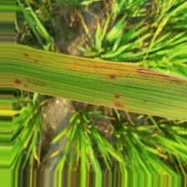 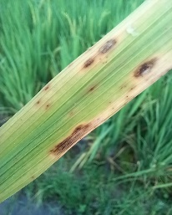 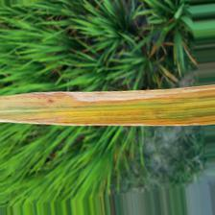

Fig-1: Brown Spot Fig-2: Leaf Blast Fig-3: Bacterial Leaf Blight 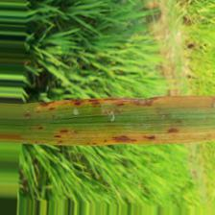 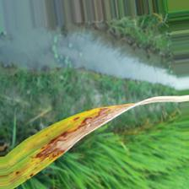 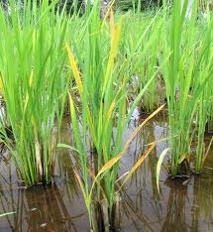

Fig-4: Narrow Brown Leaf Spot Fig-5: Leaf Scald Fig-6: Tungro

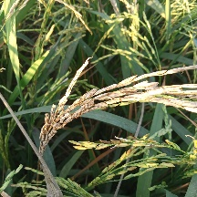 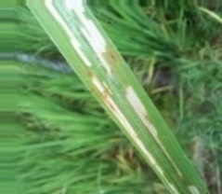 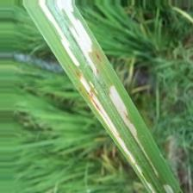

Fig-7: Neck Blast Fig-8: Rice Hispa Fig-9: Sheath Blight

Each of the nine rice diseases considered in this study exhibits distinct visual symptoms and patterns, which can be used for accurate identification. A brief overview of their characteristics is provided below:

* **Brown Spot**: Caused by *Bipolaris oryzae*, it appears as dark brown, circular to oval-shaped lesions on the surface of rice leaves.
* **Leaf Blast**: Triggered by *Magnaporthe oryzae*, this disease is marked by spindle-shaped lesions with grayish-green centers and dark brown edges.
* **Bacterial Blight**: Characterized by elongated lesions near the leaf tips and edges, which transition from white to yellow and eventually gray due to secondary fungal infection.
* **Narrow Brown Leaf Spot**: Caused by *Cercospora oryzae*, this disease forms thin, linear brown streaks. It thrives in hot and humid climates, reducing photosynthesis efficiency and crop yield.
* **Leaf Scald**: Caused by *Microdochium oryzae*, it presents as water-soaked lesions with wavy margins that eventually turn reddish-brown.
* **Tungro**: Associated with stress conditions, Tungro manifests as irregular brown to reddish-brown lesions on both leaves and leaf sheaths.
* **Neck Blast**: Also caused by *Magnaporthe oryzae*, this disease affects the neck region of the rice panicle, producing dark brown to black lesions that can lead to panicle breakage.
* **Rice Hispa**: Caused by an infestation of a metallic blue-green beetle that feeds on leaves, creating parallel white streaks across the leaf surface.
* **Sheath Blight**: Caused by *Rhizoctonia solani*, this disease features oval or irregular, water-soaked spots on the leaf sheaths, which can expand and coalesce over time.

Monitoring rice diseases is crucial for early detection, effective treatment, and preventing crop losses. This research presents an automated method using deep learning to accurately predict and classify nine rice diseases based on visual symptoms, providing a reliable tool for AI-driven agricultural disease management.

**Related Work:**

Simhadri and Kondaveeti (2023) [1] developed a rice leaf disease detection system using transfer learning with models like VGG16, InceptionV3, and MobileNetV2. The approach achieved around 96% accuracy, effectively addressing small dataset challenges. They recommended expanding datasets, enabling real-time detection, integrating IoT, and adopting explainable AI for future work.

Deng et al. (2021) [2] proposed a fully automated system for rice disease diagnosis using deep learning models such as DenseNet121 and ResNet50. The system achieved over 95% accuracy, significantly reducing the need for manual diagnosis. Future recommendations included dataset expansion, real-time applications, severity estimation, explainability, and cross-crop generalization.

Islam and Richhariya (2024) [3] introduced a hybrid ensemble model combining ResNet152V2, DenseNet121, InceptionNetV2, and MobileNetV2 for rice leaf disease classification. The model achieved 96.8% accuracy, outperforming individual models in precision and robustness. Future work suggested includes data augmentation, model explainability, lightweight architectures, and broader performance evaluation.

Bijoy et al. (2024) [4] proposed a novel deep CNN model for rice leaf disease detection, utilizing an enhanced dataset with diverse and annotated images. Using models like AlexNet, MobileNet, ResNet50, DenseNet121, and ShuffleNet, their approach achieved 98.3% accuracy. Future directions included explainable AI, robustness testing, lightweight models, and real-world field validation to support sustainable agriculture.

Ahad et al. (2023) [5] conducted a comparative study of CNN architectures—DenseNet121, EfficientNetB7, XceptionV3, MobileNetV2, and ResNet101—for rice disease classification. The study evaluated each model’s accuracy, aiming to identify the most effective architecture for automated detection. Future work focused on exploring additional models, expanding datasets, optimizing performance, and enabling real-time deployment.

Raval and Chaki (2024) [6] proposed an ensemble transfer learning approach combined with explainable AI for leaf disease detection. Using MobileNetV3 and EfficientNetB0, the model achieved 98% accuracy while providing visual explanations to enhance interpretability. Future work includes cross-crop generalization, real-time deployment, severity prediction, and edge computing integration.

Altabaji et al. (2024) [7] conducted a comparative study of Transfer Learning, LeafNet, and a Modified LeafNet for rice leaf disease classification. The Modified LeafNet achieved the highest accuracy of 97.1%, highlighting the benefits of model customization.

Sethy et al. (2020) [8] proposed a hybrid approach combining deep feature extraction using ResNet50 with classification via Support Vector Machine (SVM) for rice leaf disease detection. The method achieved 95.6% accuracy, demonstrating the effectiveness of integrating deep learning with traditional classifiers. Future work includes dataset expansion, mobile integration, and real-time monitoring.

Latif et al. (2022) [9] developed an improved CNN model for rice disease detection, aiming to reduce overfitting and enhance generalization. Using dCNN and VGG19, the model achieved over 90% accuracy in some cases, outperforming baseline models. Future recommendations include ensemble learning, edge deployment, multi-modal approaches, and large-scale dataset expansion.

Krishnamoorthy et al. (2021) [10] utilized deep neural networks with transfer learning, employing models like ResNetV2, Inception, and CNN for rice leaf disease prediction. Their approach achieved 97.3% accuracy, proving effective for limited agricultural datasets. Future work suggested includes real-time deployment, lightweight models, and severity analysis.

**Methodology:**

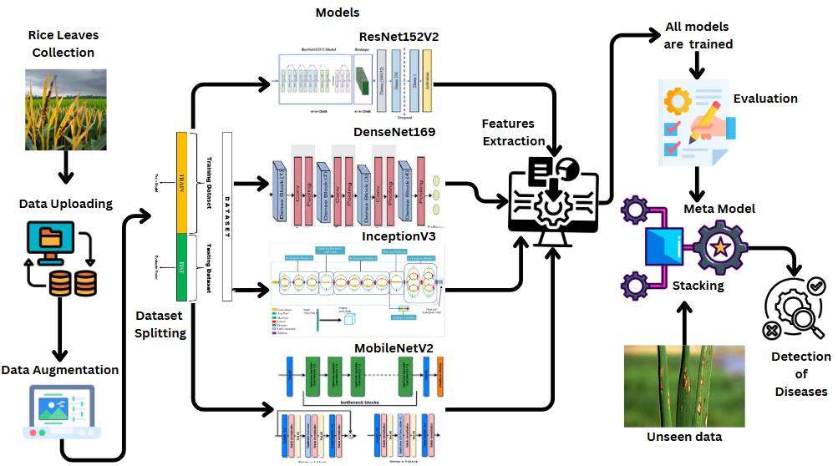

Fig 10: Flow of Proposed Methodology

**1.Dataset:**

The dataset used in this study was sourced from Kaggle.com, a platform known for hosting machine learning datasets and competitions. It contains annotated images of nine rice leaf diseases—such as Narrow Brown Spot, Hispa, Neck Blast, and Leaf Scald—used to train and validate deep learning models for automatic disease detection. The images, showcasing various visual symptoms, were carefully selected and cleaned to ensure quality. This dataset supports research in precision agriculture by aiding in the development of intelligent systems for early disease detection and effective crop management.



Fig 11: Dataset Illustration

### 2. Image Preprocessing:

### Image pre-processing is necessary for improving image quality and optimizing inputs for deep learning. models. All images in this research were resized to 256×256 pixels to provide uniformity and compatibility with neural networks and maintain important features. JPEG and PNG images were decoded into pixel matrices using TensorFlow utilities to make them ready for model training. The pixel values were normalized to the [0, 1] range using Keras preprocessing tools, which helps in faster convergence and better model performance. The dataset was then divided into training (80%), validation (10%), and testing (10%) sets to provide reliable evaluation and better generalization. All these steps together improve feature extraction, eliminate noise, and enhance the accuracy of rice disease detection.

### 3. Pre-Trained Models:

### DenseNet169

DenseNet169, being a deeper version of DenseNet121, is utilized as part of the base components of the hybrid model. Pre-trained on the ImageNet dataset, it has the advantage of dense connectivity—where each layer takes input from all the previous layers—enabling better gradient flow as well as efficient reuse of features. With include_top=False, the top classification layer is eliminated, so that DenseNet169 can now be utilized as a feature extractor alone. Also, setting trainable=False will freeze pre-trained weights during training. Input image of (256, 256, 3) is passed through the convolutional as well as pooling layers of DenseNet169, followed by batch normalization as well as flattening into one-dimensional feature vector.

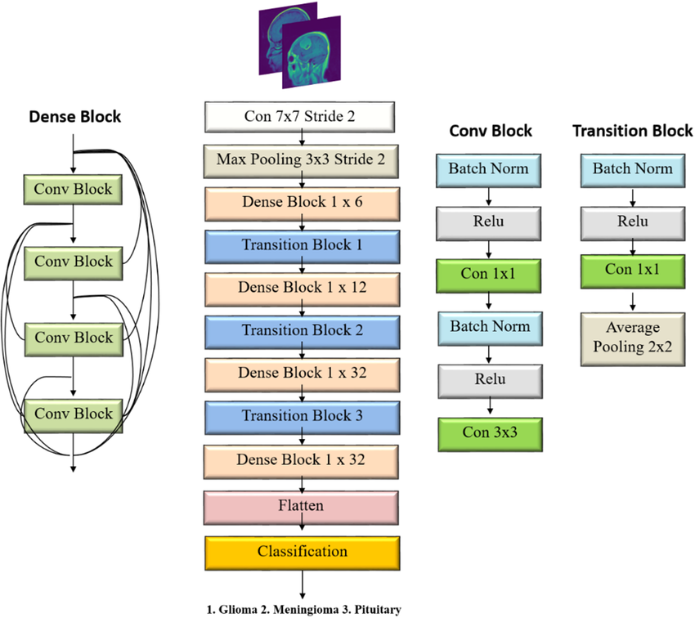

Fig 12: Architecture of DenseNet169

### InceptionV3

InceptionV3 is integrated into the architecture to contribute its multi-scale feature extraction capabilities. Known for its inception modules, this model processes image features using multiple convolutional kernels in parallel, allowing it to capture both fine-grained and global patterns. Like the other models, include_top=False is used to discard the original classification head, and trainable=False freezes the pre-trained weights. After processing the input, InceptionV3 outputs a feature map, which is batch-normalized and flattened for fusion with features from the other models.

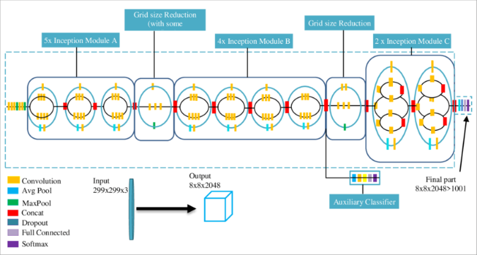

Fig 13: Architecture of InceptionV3

### MobileNetV2

MobileNetV2 brings efficiency to the hybrid system with its lightweight design, using **depthwise separable convolutions** and **inverted residual blocks.** Despite being computationally efficient, it effectively extracts detailed features from input images. By setting include_top=False, the top classifier is removed, and trainable=False ensures the base weights remain unchanged. The model processes the (256, 256, 3) input image, and the extracted features are normalized and flattened before integration into the ensemble.

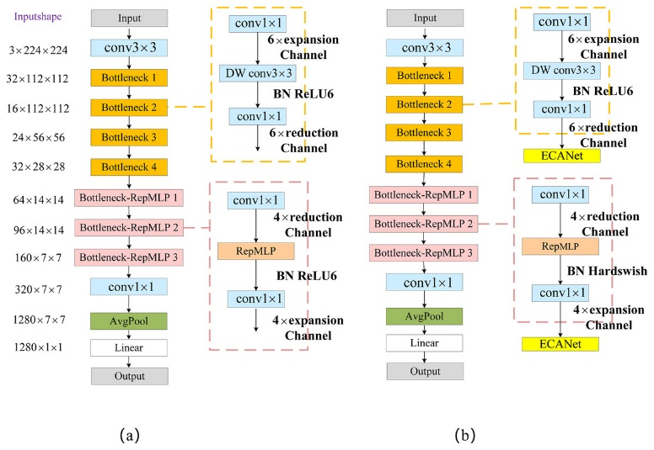

Fig 14: Architecture of MobileNetV2

### ResNet152V2

ResNet152V2 is a very deep architecture that utilizes **residual connections** to overcome vanishing gradient issues. Its depth allows it to extract complex hierarchical features from rice leaf images. As with the other models, include_top=False and trainable=False are applied. The image passes through residual blocks, and the final feature maps are batch-normalized and flattened.

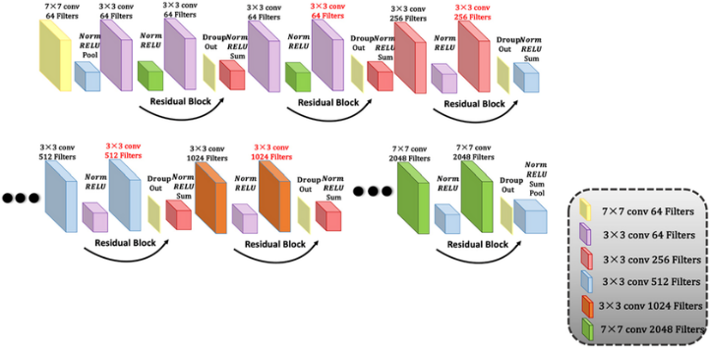

Fig 15: Architecture of ResNet152V2

**Feature Extraction**

Unifying the input image 256x256, 256x256, and 3 was used to aggregate all four models, DenseNet169, InceptionV3, MobileNetV2, and ResNet152V2. Each model independently processed the input image and obtained feature vectors that blended all model’s strengths—dense connectivity of DenseNet169, multi-scale filters of InceptionV3, efficiency of MobileNetV2, and deep residual learning of ResNet152V2. The feature vectors obtained from all four models were flattened and concatenated to form a feature representation. As a result, combining features from different features sources allowed the model to understand the input data better and thus better identify specific and subtle diseases in rice leaf images. Adaptation first trained using fully connected (dense) layers, first consisting of 512 neurons undergoing ReLU activation, was then batch normalized, followed by second dense layer consisting of 256 neurons with ReLU activation. Finally the final layer consisting of 10 neurons representing one of the nine disease categories (including a healthy class) was generated in a Softmax activation function to generate probability distributions for classification. The class with the highest probability of training was chosen as the model’s prediction.

**Stacking Ensemble Learning** :

The stacking process in this study involved multiple stages aimed at enhancing classification performance. First, features were extracted from the preprocessed rice leaf images using two powerful deep learning models: DenseNet169 and InceptionV3. These models generated feature vectors, which were then combined into a single, comprehensive representation by concatenating their outputs. This unified feature vector served as the input for the meta-model—a fully connected neural network designed to perform the final classification. The meta-model architecture included dense layers with ReLU activation functions to capture complex patterns, batch normalization layers to ensure stable and efficient training, and dropout layers to reduce the risk of overfitting. Finally, a Softmax layer was used at the output to assign probabilities to each class, enabling accurate prediction of the disease category.

**Prediction Process** :

The classification process of a new image of rice leaf was performed in a multi-step pipeline. The raw image was first preprocessed by resizing and normalizing to account for the size of the input image in order to get a suitable feature vector of the image, the preprocessed image was then fed into two pre-trained deep learning models (DenseNet169 and InceptionV3) for extraction of high-level feature vectors, all the feature vectors of this image were then comma-separated to form a comprehensive feature vector of this image, and finally fed into a trained meta model for final classification which would predict the corresponding rice disease category.

**Results and Discussion:**

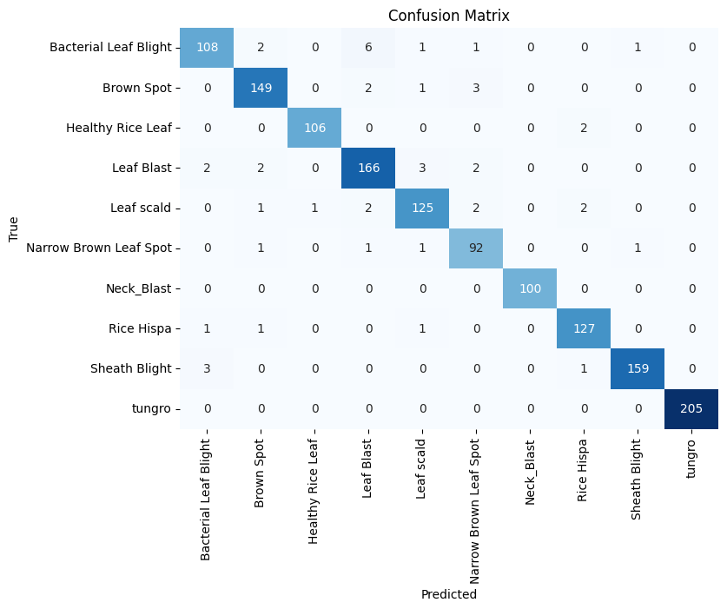**DenseNet169:**

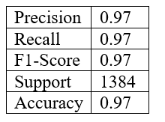

Fig 16: Confusion Matrix

DenseNet169 model achieved excellent results with 97% accuracy, and precision, recall, and F1-score all at 0.97. The confusion matrix shows high classification accuracy across all 10 categories, with classes like Tungro, Sheath Blight, and Leaf Blast identified almost perfectly. Minor misclassifications occurred between similar diseases, such as Bacterial Leaf Blight and Leaf Blast, but had minimal impact on overall performance.

**MobileNetV2:**

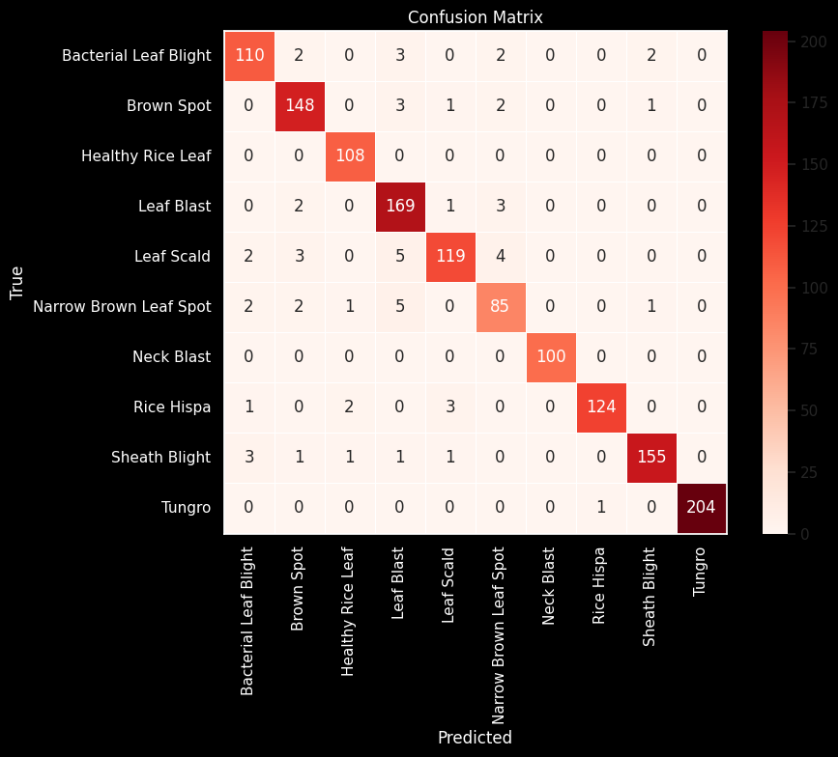 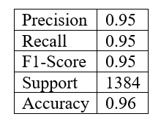

Fig 17: Confusion Matrix

MobileNetV2 model achieved a strong overall accuracy of 96%, with precision, recall, and F1-score all at 0.95. As shown in the confusion matrix, most classes were accurately predicted, with high performance in categories such as Tungro, Sheath Blight, and Leaf Blast. While a few misclassifications occurred—mainly between Leaf Scald, Narrow Brown Leaf Spot, and Leaf Blast—they were relatively limited and did not significantly affect the model’s reliability. These results indicate that the model performs well across diverse rice diseases and is suitable for practical deployment in agricultural settings

**InceptionV3**

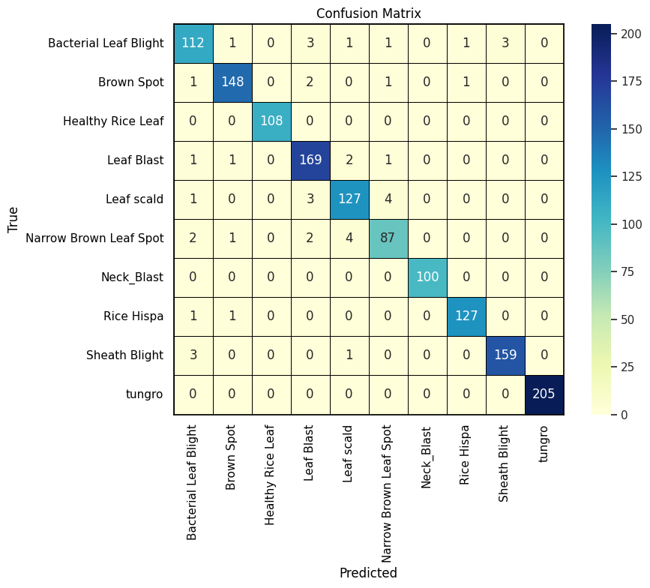 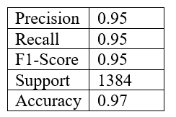

Fig 18: Confusion Matrix

InceptionV3 model attained an overall accuracy of 97%, with precision, recall, and F1-score each recorded at 0.95. The confusion matrix shows that the model accurately classified most samples across all 10 disease categories. Minor misclassifications were noted between visually similar diseases like Leaf Scald and Leaf Blast, but these had a limited impact on the model's overall effectiveness.

**Resnet152V2:**

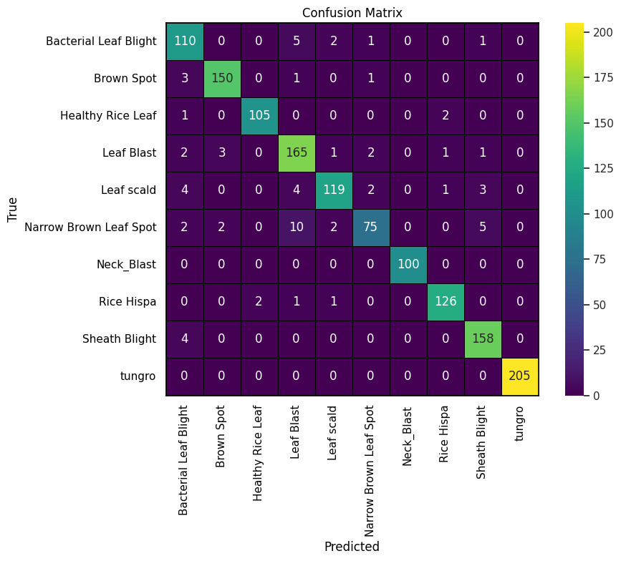 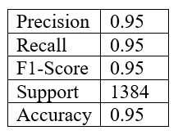

Fig 19: Confusion Matrix

ResNet152V2 model achieved an overall accuracy of 95%, with precision, recall, and F1-score all at 0.95, indicating balanced and reliable performance. The confusion matrix shows strong classification accuracy across most classes. While there were some misclassifications—mainly involving Leaf Scald and Narrow Brown Leaf Spot—the model generally maintained high prediction consistency.

**Meta Model:**

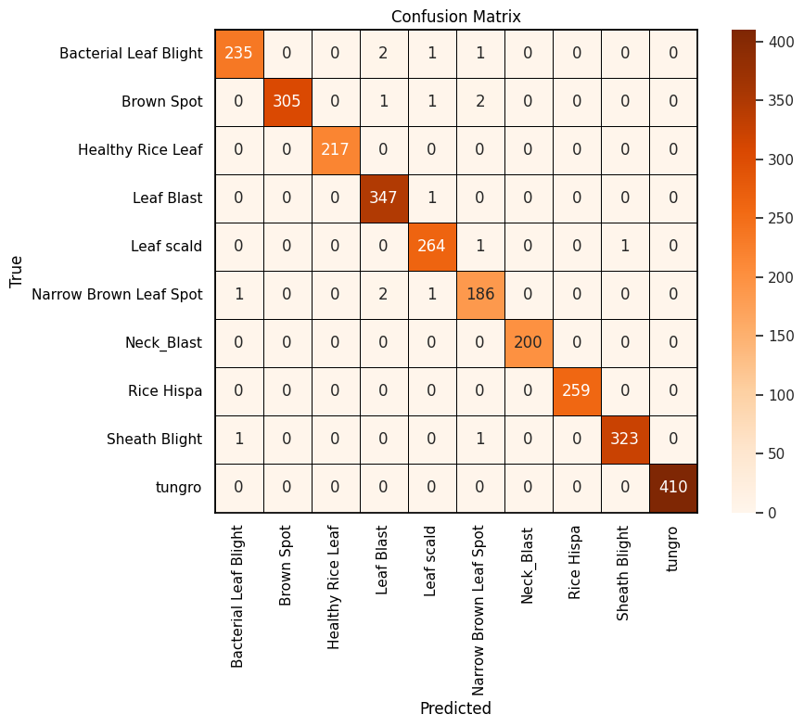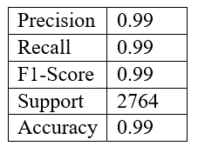

Fig 20: Confusion Matrix

Meta model delivered exceptional performance, achieving 99% accuracy, along with precision, recall, and F1-score of 0.99. The confusion matrix reveals that nearly all samples across the 10 disease categories were correctly classified, demonstrating the model’s high reliability. Critical diseases such as Tungro, Sheath Blight, and Leaf Blast were identified with near-perfect precision, showcasing the model’s strong ability to distinguish subtle visual patterns.

**Model Comparison:**

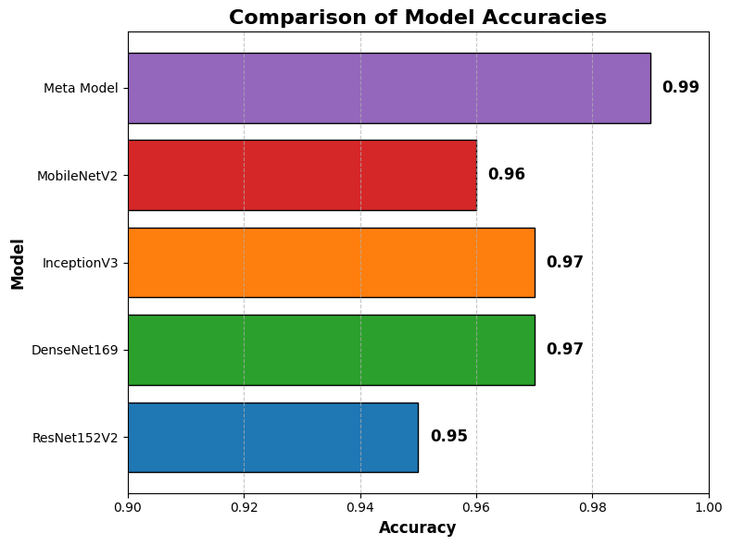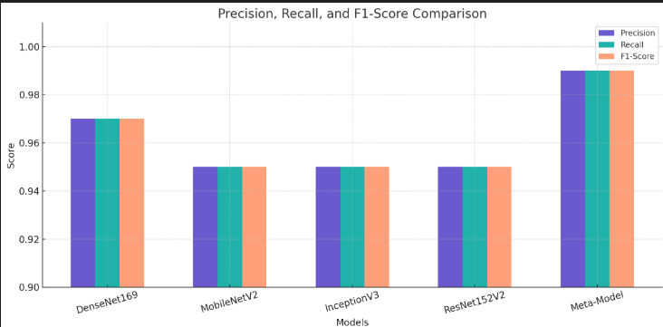

Fig 21: Models’ Comparison

To evaluate model effectiveness for rice disease classification, four deep learning architectures—DenseNet169, InceptionV3, MobileNetV2, and ResNet152V2—were trained and compared using precision, recall, F1-score, and accuracy. DenseNet169 achieved the best results with 97% accuracy and strong metric scores, closely followed by InceptionV3. MobileNetV2 and ResNet152V2 showed slightly lower performance (95–96% accuracy) but remain viable for resource-constrained deployments. Based on performance, DenseNet169 and InceptionV3 were selected for a stacking ensemble, where their feature vectors were combined and passed to a meta-model. This ensemble achieved 99% across all evaluation metrics, surpassing individual models and highlighting the effectiveness of ensemble learning in enhancing disease detection accuracy. The meta-model’s high performance underscores its potential for real-world use in precision agriculture.

**Conclusion:**

This research effectively showcases the potential of a deep learning ensemble method for precise identification of rice leaf diseases. By integrating the capabilities of several pre-trained models—DenseNet169, InceptionV3, MobileNetV2, and ResNet152V2—through a stacking ensemble framework, the developed meta-model achieved a remarkable classification accuracy of 99%, surpassing the performance of the individual models. These findings highlight the strength of ensemble learning in improving the accuracy and resilience of automated crop disease detection systems. Despite these encouraging results, there remains room for future enhancement. For instance, increasing the diversity of the dataset by including various environmental conditions, different stages of disease progression, and multiple rice species could improve the model’s ability to generalize across real-world scenarios. Secondly, investigating lightweight model architectures and applying optimization techniques could enable efficient deployment on resource-constrained devices, allowing real-time disease detection in field environments. Additionally, incorporating complementary data modalities—such as hyperspectral or thermal imagery—may further improve diagnostic accuracy. Finally, integrating explainable AI (XAI) methods to interpret model predictions would increase user trust and facilitate the practical adoption of this technology by farmers and agricultural professionals.

**References:**

[1] Ahmed, K., Shahidi, T. R., Alam, S. M. I., & Momen, S. (2019, December). Rice leaf disease detection using machine learning techniques. In 2019 International Conference on Sustainable Technologies for Industry 4.0 (STI) (pp. 1-5). IEEE.

[2] Simhadri, C. G., & Kondaveeti, H. K. (2023). Automatic recognition of rice leaf diseases using transfer learning. Agronomy, 13(4), 961.

[3] Raval, H., & Chaki, J. (2024). Ensemble transfer learning meets explainable AI: A deep learning approach for leaf disease detection. Ecological Informatics, 84, 102925.

[4] Deng, R., Tao, M., Xing, H., Yang, X., Liu, C., Liao, K., & Qi, L. (2021). Automatic diagnosis of rice diseases using deep learning. Frontiers in plant science, 12, 701038.

[5] Islam, N., & Richhariya, P. (2024). Deep Learning-Based Classification of Rice Leaf Diseases Using Hybrid Ensemble Models. International Journal of Innovations in Science, Engineering And Management, 34-41.

[6] Altabaji, W. I., Umair, M., Tan, W. H., Foo, Y. L., & Ooi, C. P. (2024). Comparative Analysis of Transfer Learning, LeafNet, and Modified LeafNet Models for Accurate Rice Leaf Diseases Classification. IEEE Access.

[7] Bijoy, M. H., Hasan, N., Biswas, M., Mazumdar, S., Jimenez, A., Ahmed, F., ... & Momen, S. (2024). Towards Sustainable Agriculture: A Novel Approach for Rice Leaf Disease Detection Using dCNN and Enhanced Dataset. IEEE Access.

[8] Sethy, P. K., Barpanda, N. K., Rath, A. K., & Behera, S. K. (2020). Deep feature based rice leaf disease identification using support vector machine. Computers and Electronics in Agriculture, 175, 105527

[9] Ahad, M. T., Li, Y., Song, B., & Bhuiyan, T. (2023). Comparison of CNN-based deep learning architectures for rice diseases classification. Artificial Intelligence in Agriculture, 9, 22-35.

[10] Latif, G., Abdelhamid, S. E., Mallouhy, R. E., Alghazo, J., & Kazimi, Z. A. (2022). Deep learning utilization in agriculture: Detection of rice plant diseases using an improved CNN model. Plants, 11(17), 2230.

[11] Upadhyay, S. K., & Kumar, A. (2022). A novel approach for rice plant diseases classification with deep convolutional neural network. International Journal of Information Technology, 14(1), 185-199.

[12] Dogra, R., Rani, S., Singh, A., Albahar, M. A., Barrera, A. E., & Alkhayyat, A. (2023). Deep learning model for detection of brown spot rice leaf disease with smart agriculture. Computers and Electrical Engineering, 109, 108659.

[13] Lu, Y., Yi, S., Zeng, N., Liu, Y., & Zhang, Y. (2017). Identification of rice diseases using deep convolutional neural networks. Neurocomputing, 267, 378-384.

[14] Ibrahim, A. W. S., & Atya, D. B. (2022). Detection of diseases in rice leaf using deep learning and machine learning techniques. Webology, 19(1), 1493-1503.

[15] Krishnamoorthy, N., Prasad, L. N., Kumar, C. P., Subedi, B., Abraha, H. B., & Sathishkumar, V. E. (2021). Rice leaf diseases prediction using deep neural networks with transfer learning. Environmental Research, 198, 111275.