**Handover in Wireless Networks and its Strategies in Channel Estimation**

1Mahendra Vasuniya, 2Prof. Divyanshu Bagh

1M.Tech Scholar, 2Assistant Professor

1,2Dept. of Electronics and Communication Engg., LNCT(Bhopal) Indore Campus, Indore

***Abstract:-* Wireless communication is undergoing a paradigm shift with emergence of high performance machine learning (ML) computing and internet of things (IoT). The demand for bandwidth has significantly risen due to multimedia applications and high speed data transfer. However, with increasing number of cellular users, the challenge is to effectively manage the limited spectrum allotment for wireless communication while maintaining satisfactory quality of service. Hence, different multiplexing techniques have been used to effectively use the available bandwidth. Recently, the concept of automatic fallback in receivers are gaining popularity due to high mobility in vehicular networks and IoT. Automatic fallback and handover mechanisms often utilize the channel state information (CSI) of the radio and can switch between technologies to provide the best available quality of service for particular spatial and temporal channel conditions. With the advent of machine learning and deep learning methods, estimating the channel state information has become computationally efficient and feasible thereby improving the performance metrics of the system. This paper presents a comprehensive review on the need for cognitive systems with CSI availability, handover mechanisms in wireless networks and different strategies involved in estimating the channel state information for wireless networks.**

***Keywords: Wireless Networks, Handover, Channel State Information (CSI), Cognitive Networks, Machine Learning (ML).***

**I. INTRODUCTION**

Wireless communications beyond 5G has emerged as new paradigm with enormous new possibilities such as metaverse, digital clones, large scale automation and internet of things to name a few [1]. However, all these new age concepts critically depend on the bandwidth availability and spectrum management in wireless networks. As bandwidth is limited, hence, effectively using the bandwidth is critically important to cater to the following needs [2]:

1. Increasing number of users.
2. Increased bandwidth requirement owing to multimedia data transfer.
3. Need for high data rates.
4. Limited available bandwidth.

The problem becomes even more critical with the necessity of internet of things (IoT) and fog computing networks where multiple devices are connected over internet and send data to a centralized server [3]. The IoT framework is depicted in figure 1.

There are several applications of IoT such as:

1. Manufacturing and automation.
2. Climate monitoring.
3. Communications and robotics.
4. Defense
5. Medical applications etc.

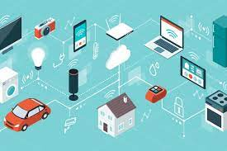

**Fig.1 The IoT framework**

The IoT framework has its own set of limitations in the sense that that is a lot of device cluttering in the near 2.4GHz Industrial scientific and medical (ISM) band. IoT based networks can be further classified as [4]:

1. Cellular based IoT
2. Device to Device based IoT.

Figure 2 depicts the D2D and Cellular based IoT models.

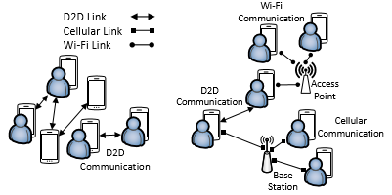

**Fig.2 Standalone and Network assisted IoT.**

Another variant of the IoT framework is the fog computing architecture for last mile connectivity. Fog infrastructure supports heterogeneous devices, such as end devices, edge devices, access points, and switches. Fog servers are considered to be micro data centres by inheriting cloud services at the network edges [5]. The fog computing architecture is depicted in figure 3.

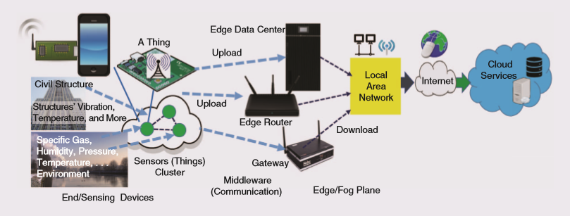

**Fig.3The fog architecture**

**II. NEED FOR FALLBACK AND HANDOVER.**

The need for fallback and handover stems from the fact that different modulation

techniques perform differently for different channel environments [6]. While frequencies can be re-used over distances, yet the conditions for frequency reuse factor needs to be considered. Figure 4 depicts the scenario for frequency re-use.

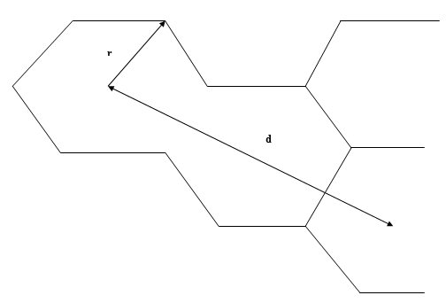

**Fig.4Re-Using Frequencies in geographically distant regions.**

The frequency ‘f’ can be reused at a cell site ‘d’ km away for a cell with radius ‘r’ keeping in mind the reuse factor:

$q=\frac{d}{r}$ (1)

Here,

q is the re-use factor.

r is the cell radius.

d is the distance of re-use.

Typically, in wide area networks and metropolitan area networks, if multiple IoT clusters are connected to a single Cloud Server in a cell, then such a cell is called a Macro Cell [8].Macro cells may have a large number of IoT devices (IoTDs) connected. The scenario of such IoT clusters is depicted in figure 5.

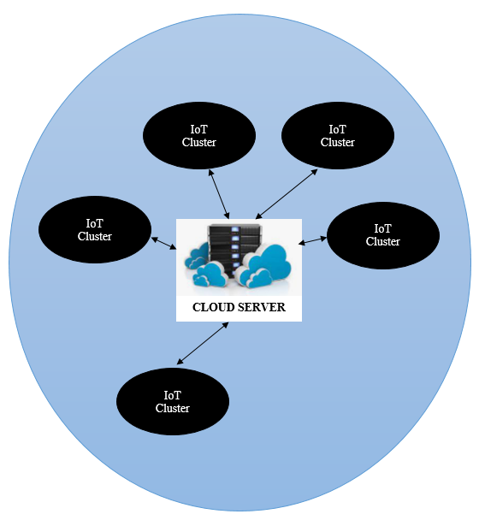

**Fig.5IoT clusters connected over cloud.**

The major constrains of IoT and fog based networks are [9]:

1. Devices are resource constrained.
2. Number of devices are exceedingly large.
3. Networks can be used for extremely time critical applications with latency causing seriousrepercussions.

Thus, selecting an appropriate multiplexing technique is necessary to address the following issues [10]:

1. Lesser Bit Errors.
2. Low or acceptable limits of outage.
3. Acceptable latencies.
4. Effective spectrum management.

The major multiplexing techniques which are employed are [11]:

1. FDM
2. TDM
3. OFDM
4. NOMA

In FDM: Different users have different frequencies.In TDM: Different users have different times slots.In OFDM: Different users have different orthogonal frequencies.In NOMA: Different uses have different power levels. In NOMA, different uses may have SAME time slot and frequency, but the power level should be different. Figure 6 depicts the spectrum of FDM, OFDM and NOMA.

**Table 1. Comparison of OFDM and NOMA**

|  |  |  |
| --- | --- | --- |
| **OFDM** | **NOMA** | **Reference** |
| Signals separated in Frequency Domain | Signals Separated in Power Domain | Cai et al., "Modulation and Multiple Access for 5G Networks, IEEE 2017 [12]. |
| Condition of Orthogonality Necessary | No need of orthogonality | Cai et al., "Modulation and Multiple Access for 5G Networks, IEEE 2017. |
| Lower Throughput (Mbps) | Higher Throughput (Mbps) | Nain et al., User Selection with optimal power allocation in Downlink NOMA, IEEE 2017 [13] |
| Lower Sum Rate (Bits/s/Hz)  (Spectral efficiency ‘ȵ’) | Higher Sum Rate (Bits/s/Hz)  (Spectral efficiency ‘ȵ’) | D Tse & P Viswanath, Fundamentals of Wireless Communication, 2004 (Book) [14]. |
| Receiver Design less complex | Receiver design based on interference cancellation much more complex | Guerreiro et al., "On the Receiver Design for Nonlinear NOMA-OFDM Systems, IEEE 2020 [15] |
| OFDM is less susceptible to path loss and multipath fading compared to NOMA | NOMA is highly susceptible to path loss in case of fading channels and may result in poor quality of service | A Al Khansa et al., Performance analysis of Power-Domain NOMA and NOMA-2000 on AWGN and Rayleigh fading channels, Journal of Physical Communication, Elsevier 2020 [16].e |

OFDM and NOMA often exhibit similar SNR-BER characteristics. A typical cellular system generally has the capability of adaptive fallback or automatic fallback [17]. In such cases, there can be a switching from one of the technologies to another parallel or co-existing technology in case of changes in system parameters such as Bit Error Rate (BER) etc.NOMA and OFDM can be shown to co-exist in case they can share similar bandwidth parameters and have a comparative BER performance over the SNR range chosen so that automatic fallback or handover is not a problem. Thus two major fallback or handover mechanisms are commonplace which are:

1. OFDM-NOMA
2. Cellular-Device to Device-Wifi

**III. MULTIPATH PROPAGATION AND SYSTEM OUTAGE**

The main objective of handover is to maintain a satisfactory quality of service metric.The outage of the system is measure of the quality of service of the systems. The outage means the chance of unacceptable quality of service. The outage primarily depends on the signal to noise ratio and the bit error rate of the system. The system outage often is represented in terms of the complementary cumulative distribution function or the CCDF. The need for using a probabilistic model for the description of the outage of the system is due to the fact that neither the BER no the SNR of the system can be used to ascertain the outage since both are subjective performance metrics [18]. In general, it is shown that the outage is a function of the signal to noise plus interference ratio, the distance and the channel fading effects. The outage in terms of absolute parameters q( $λ)$ is given by [23]:

$q\left(λ\right)=exp\left\{-\frac{{2π}^{2}}{\sin\left(\frac{2π}{η}\right)}R_{k}^{2}{SINR}_{k}^{2/η}λ\right\}$ (2)

Here,

$K_{k}=C_{k}R_{k}^{2}{SNR}_{k}^{2/η}$ is a constant depending on system and channel parameters

SINR represents the signal to noise plus interference ratio

R is the distance

$λ_{j}$ is the device density in a network

$σ_{kj}$ is the shadowing factor

$q\left(λ\right)$ is the absolute outage

Mathematically, the CCDF analysis of outage is given by [24]:

$ccdf\left(x\right)=1-cdf(x)$ (3)

Here,

ccdf denotes the complementary cumulative density function of the D2D Networks system

cdf denotes the cumulative density function of the network.

x denotes a random variable.

**IV. MACHINE LEARNING ASSISTED HANDOVER**

The enhancements in chip fabrication and computational power have made it possible to analyze copious amount of data at real time and on miniaturized systems on chip (SoCs) [19]. Machine learning (ML) models can be have the capability of analyzing large and complex data sets practically infeasible with conventional statistical models [20]. Machine learning models can be classified as [21]:

1. Unsupervised Learning: In this approach, the data set is not labelled or categorized prior to training a model. This typically is the most crude form of training wherein the least amount of apriori information is available regarding the data sets [22].
2. Supervised Learning: In this approach, the data is labelled or categorized or clustered prior to the training process. This is typically possible in case the apriori information us available regarding the data set under consideration.
3. Semi-Supervised Learning: This approach is a combination of the above mentioned supervised and unsupervised approaches. The data is demarcated in two categories. In one category, some amount of the data is labelled or categorized. This is generally not the larger chunk of the data. In the other category, a larger chunk of data is unlabeled and hence the data is a mixture of both labelled and unlabeled data groups.

Often, another sub-categorization made is the reinforcement learning which the type of learning in which the aim is to adjust the training parameters so as to maximize the rewards in certain circumstances. They may also possess categorically classified targets prior to training. Typically, some paradigms separate out machine learning and deep learning. In case of deep learning, the number of hidden layers are multiple and no separate feature extraction is done, and the data is directly fed to the neural network [23].

Machin Leaning and Deep Learning based techniques can be used to estimate the channel state information through several training parameters such as:

1. Channel Gain
2. Fading effects
3. Shadowing parameters

Thus, the correlation among the independent variables and target variable can be estimated through the training process.

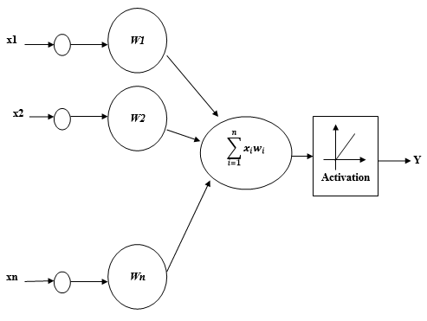

**Fig.6 Neural Network Model**

The neural network model is the most effective training model used for pattern recognition for deep learning models and is depicted in figure 14.The mathematical relationship between the various parameters is given by:

$y=f(\sum_{i=1}^{i=n}{X_{i}W_{i}+Ɵ)}$ (4)

Here,

X represents the inputs

Y represents the output

W represents the weights

Activation represents the behavior of the neural network while decision making

The model can be trained with time spaced input-target data corresponding to the channel to attain the updated CSI.

Moreover, by estimating the channel response, the design of equalizers can also be done [24]. The equalization mechanism can be used to mitigate the negative effects of noise and distortions in the channel. Such a mechanism is depicted in figure 1

**Conclusion: This paper presents a comprehensive review on the currents trends in wireless networks pertaining to modulation techniques, handover mechanisms and automatic fallback, fading effective and channel sensing through latest machine learning and deep learning algorithms for cognitive networks. Moreover, internet of things (IoT), fog computing, device to device networks and their co-existence in underlay cellular networks have also been discussed. Channel sensing mechanisms through channel sensing and estimation of channel state information (CSI) for the design of equalization mechanisms have also been cited and discussed in detail. Moreover, the significant and noteworthy contributions in the domain have also been presented with the approach used, novelty of perspective and findings. The findings of the paper indicate that stochastic and big data analytics methods can be explored to design optimal handover and equalization methods for future generation wireless networks aiming high data rates, low error rate and outage to maintain satisfactory quality of service (QoS)**

**References**

1. J. Thompson et al., "5G wireless communication systems: prospects and challenges [Guest Editorial]," in IEEE Communications Magazine, vol. 52, no. 2, pp. 62-64, February 2014, doi: 10.1109/MCOM.2014.6736744.
2. M. A. M. Albreem, "5G wireless communication systems: Vision and challenges," 2015 International Conference on Computer, Communications, and Control Technology (I4CT), 2015, pp. 493-497, doi: 10.1109/I4CT.2015.7219627.
3. J. M. Khurpade, D. Rao and P. D. Sanghavi, "A Survey on IOT and 5G Network," 2018 International Conference on Smart City and Emerging Technology (ICSCET), 2018, pp. 1-3, doi: 10.1109/ICSCET.2018.8537340.
4. J. H. Anajemba, Y. Tang, J. A. Ansere and C. Iwendi, "Performance Analysis of D2D Energy Efficient IoT Networks with Relay-Assisted Underlaying Technique," IECON 2018 - 44th Annual Conference of the IEEE Industrial Electronics Society, 2018, pp. 3864-3869, doi: 10.1109/IECON.2018.8591373.
5. M. Aazam, S. Zeadally and K. A. Harras, "Fog Computing Architecture, Evaluation, and Future Research Directions," in IEEE Communications Magazine, vol. 56, no. 5, pp. 46-52, May 2018, doi: 10.1109/MCOM.2018.1700707.
6. Ş. Sönmez, I. Shayea, S. A. Khan and A. Alhammadi, "Handover Management for Next-Generation Wireless Networks: A Brief Overview," 2020 IEEE Microwave Theory and Techniques in Wireless Communications (MTTW), 2020, pp. 35-40, doi: 10.1109/MTTW51045.2020.9245065.
7. T. D. Novlan, R. K. Ganti, A. Ghosh and J. G. Andrews, "Analytical Evaluation of Fractional Frequency Reuse for Heterogeneous Cellular Networks," in IEEE Transactions on Communications, vol. 60, no. 7, pp. 2029-2039, July 2012, doi: 10.1109/TCOMM.2012.061112.110477.
8. H. Zhang, X. Wen, B. Wang, W. Zheng and Y. Sun, "A Novel Handover Mechanism Between Femtocell and Macrocell for LTE Based Networks," 2010 Second International Conference on Communication Software and Networks, 2010, pp. 228-231, doi: 10.1109/ICCSN.2010.91.
9. M. Yannuzzi, R. Milito, R. Serral-Gracià, D. Montero and M. Nemirovsky, "Key ingredients in an IoT recipe: Fog Computing, Cloud computing, and more Fog Computing," 2014 IEEE 19th International Workshop on Computer Aided Modeling and Design of Communication Links and Networks (CAMAD), 2014, pp. 325-329, doi: 10.1109/CAMAD.2014.7033259.
10. A. Alrawais, A. Alhothaily, C. Hu and X. Cheng, "Fog Computing for the Internet of Things: Security and Privacy Issues," in IEEE Internet Computing, vol. 21, no. 2, pp. 34-42, Mar.-Apr. 2017, doi: 10.1109/MIC.2017.37.
11. S. Han et al., "Artificial-Intelligence-Enabled Air Interface for 6G: Solutions, Challenges, and Standardization Impacts," in IEEE Communications Magazine, vol. 58, no. 10, pp. 73-79, October 2020, doi: 10.1109/MCOM.001.2000218.
12. Y. Cai, Z. Qin, F. Cui, G. Y. Li and J. A. McCann, "Modulation and Multiple Access for 5G Networks," in IEEE Communications Surveys & Tutorials, vol. 20, no. 1, pp. 629-646, Firstquarter 2018, doi: 10.1109/COMST.2017.2766698.
13. G. Nain, S. S. Das and A. Chatterjee, "Low Complexity User Selection With Optimal Power Allocation in Downlink NOMA," in IEEE Wireless Communications Letters, vol. 7, no. 2, pp. 158-161, April 2018, doi: 10.1109/LWC.2017.2762303.
14. D Tse & P Viswanath, Fundamentals of Wireless Communication, 2004 (Book)
15. J. Guerreiro, R. Dinis, P. Montezuma and M. Campos, "On the Receiver Design for Nonlinear NOMA-OFDM Systems," 2020 IEEE 91st Vehicular Technology Conference (VTC2020-Spring), 2020, pp. 1-6, doi: 10.1109/VTC2020-Spring48590.2020.9129559.
16. A Al Khansa, X Chen, Y Yin, G Gui, H Sari., Performance analysis of Power-Domain NOMA and NOMA-2000 on AWGN and Rayleigh fading channels, Journal of Physical Communication, Elsevier 2020, vol.43, 101185.
17. H. Yoo, M. Lee, T. H. Hong and Y. S. Cho, "A Preamble Design Technique for Efficient Handover in IEEE 802.16 OFDM-Based Mobile Mesh Networks," in IEEE Transactions on Vehicular Technology, vol. 62, no. 1, pp. 460-465, Jan. 2013, doi: 10.1109/TVT.2012.2220990.
18. D. Zhang, Y. Zhou, X. Lan, Y. Zhang and X. Fu, "AHT: Application-Based Handover Triggering for Saving Energy in Cellular Networks," 2018 15th Annual IEEE International Conference on Sensing, Communication, and Networking (SECON), 2018, pp. 1-9, doi: 10.1109/SAHCN.2018.8397106.
19. M. Schmidt, D. Block and U. Meier, "Wireless interference identification with convolutional neural networks," 2017 IEEE 15th International Conference on Industrial Informatics (INDIN), 2017, pp. 180-185, doi: 10.1109/INDIN.2017.8104767.
20. S. Skaria, A. Al-Hourani, M. Lech and R. J. Evans, "Hand-Gesture Recognition Using Two-Antenna Doppler Radar With Deep Convolutional Neural Networks," in IEEE Sensors Journal, vol. 19, no. 8, pp. 3041-3048, 15 April15, 2019, doi: 10.1109/JSEN.2019.2892073.
21. S Cohen, “The basics of machine learning: strategies and techniques”, Artificial Intelligence and Deep Learning, Elsevier 2021, pp.13-40.
22. VK Ayyadevara, “Basics of Machine Learning”, Pro Machine Learning Algorithms, Spreinger 2020, pp 1-15.
23. Y. Sun, C. Wang, H. Cai, C. Zhao, Y. Wu and Y. Chen, "Deep Learning Based Equalizer for MIMO-OFDM Systems with Insufficient Cyclic Prefix," 2021 IEEE 92nd Vehicular Technology Conference (VTC2020-Fall), 2020, pp. 1-5, doi: 10.1109/VTC2020-Fall49728.2020.9348509.
24. H. Yazdani, A. Vosoughi and X. Gong, "Achievable Rates of Opportunistic Cognitive Radio Systems Using Reconfigurable Antennas With Imperfect Sensing and Channel Estimation," in IEEE Transactions on Cognitive Communications and Networking, vol. 7, no. 3, pp. 802-817, Sept. 2022, doi: 10.1109/TCCN.2021.3056691.