AI Powered Online Vehicle Assistance

Asst. Prof. Pravin Ligadex, Ms. Pratiksha Vyawharex, Mr. Harsh Baraskarx, Mr. Lalitesh Thakarex Department of MCA (Master of Computer Applications):,

GH Raisoni College of Engineering and Management, Pune:

***Abstract*—Nowadays vehicles becoming more advanced and reliant on complex electronic systems, the need for smarter and more accessible support tools is growing rapidly. This paper presents a system designed to assist drivers and vehicle owners through an online platform that offers real-time help with diagnostics, maintenance reminders, and general vehicle-related queries. The proposed solution combines data collected from the vehicle with a user-friendly interface that allows people to report issues, ask questions, and receive guided support remotely. The goal is to reduce the reliance on in-person visits for minor concerns, provide faster responses during breakdowns, and help users better understand their vehicles’ needs. The system also tracks patterns over time to offer maintenance suggestions before problems occur. This research highlights how technology can play a helpful role in making vehicle ownership simpler and more informed.**

***Index Terms*—Vehicle assistance, automotive diagnostics, pre- dictive maintenance, user support system, intelligent transporta- tion, online vehicle help. .**

1. Introduction

Vehicles today are far more than just machines with en- gines—they are intelligent systems equipped with advanced electronics, sensors, and software designed to improve safety, performance, and user experience. While these advancements offer undeniable benefits, they also introduce a level of com- plexity that many drivers find difficult to manage. Simple tasks like diagnosing a warning light or understanding unusual vehicle behavior often require technical expertise or costly visits to service centers.

In response to these challenges, there is a growing need for more accessible and intelligent support tools that can assist drivers in real-time. The idea of an online vehicle assistance system powered by artificial intelligence addresses this need by offering immediate, personalized guidance. Such a system can help users understand potential issues with their vehicle, receive maintenance reminders, and even get step-by- step support—all through a virtual interface that is available anytime and anywhere.

This paper presents the concept and design of an AI- powered platform aimed at providing remote vehicle assis- tance. The system is built to analyze vehicle data, detect early signs of faults, and communicate effectively with the user through a conversational interface. It aims to reduce dependency on in-person diagnostics for minor issues, pre- vent breakdowns through timely alerts, and ultimately make the ownership experience smoother and more informed. The platform combines machine learning, natural language pro- cessing, and cloud integration to offer services such as remote diagnostics, maintenance reminders, and user-friendly virtual assistance.

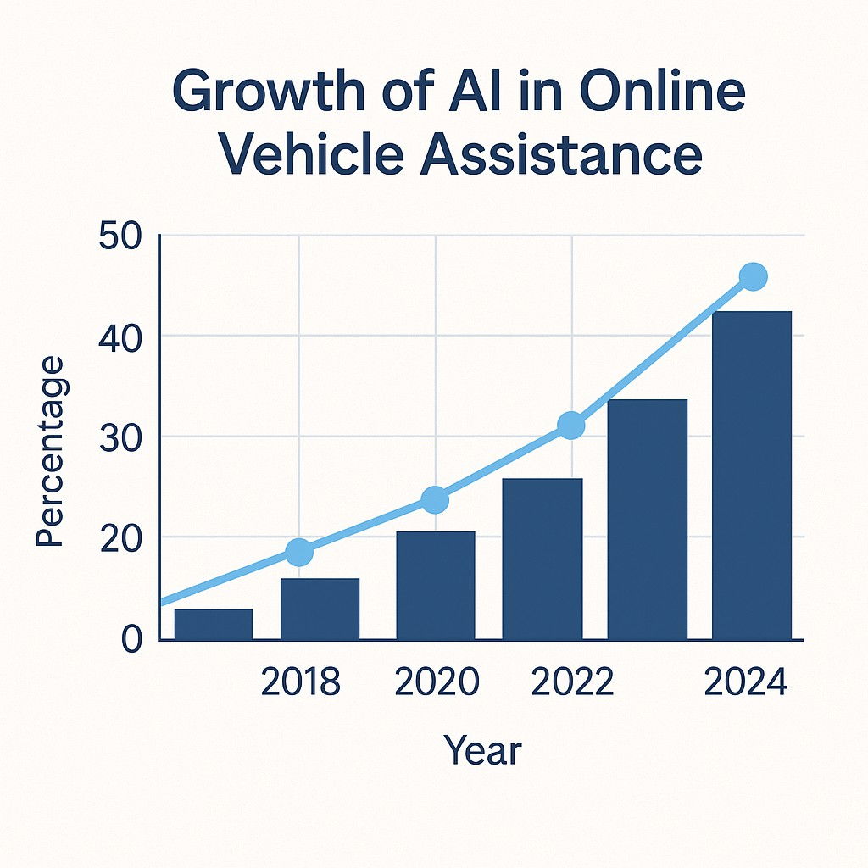

Fig. 1. Growth of AI in Online Vehicle Assistance

## LITERATURE SURVEY

The integration of artificial intelligence into the automotive industry has led to major advancements in vehicle manage- ment, diagnostics, and user interaction. Various studies and projects have explored how AI can enhance the driving ex- perience, particularly through systems that provide intelligent assistance to drivers. Researchers have developed AI-based models to predict vehicle faults using real-time sensor data, helping reduce unexpected breakdowns. For example, Zhang and Liu showed that machine learning could detect mechanical issues early, leading to more efficient maintenance [1].

AI has also improved fault diagnostics. Deshmukh proposed a system that uses neural networks to interpret vehicle data and suggest repair solutions. This approach improves the accuracy and speed of fault identification compared to traditional meth- ods [2].

In terms of user interaction, virtual assistants using nat- ural language processing have made it easier for drivers to understand issues. Choi and Kumar developed a voice- based assistant that guides users through common problems, improving confidence during emergencies [3].

Cloud-based systems further enhance AI support by allow- ing remote diagnostics and data storage. Rahman explored an IoT-based solution where vehicle data is analyzed in the cloud, enabling real-time alerts and maintenance tracking . While progress is evident, there is still a need for systems that are more personalized, user-friendly, and compatible across various vehicle types [4].

## PROPOSED SYSTEM

The increasing integration of technology into vehicles has opened new avenues for improving the way users interact with their automobiles, particularly in areas such as fault detection, maintenance, and real-time assistance. The proposed system aims to offer a complete, AI-powered online platform that monitors vehicle health, supports predictive diagnostics, and allows drivers to receive smart assistance remotely. The system combines sensor data analysis, machine learning, and user- friendly communication tools like natural language interfaces to deliver real-time insights to the user.

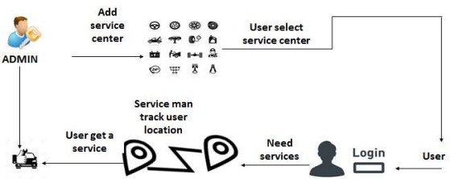

Fig. 2. System Architecture

# Existing System

Currently, most vehicles rely on standard onboard diagnos- tics (OBD) systems that use error codes to alert drivers of internal issues. However, these systems often provide minimal explanation and require a technician or third-party app to interpret. Some vehicles have built-in service alerts or mobile apps, but these are usually limited to basic information or exclusive to luxury brands.

# System Objectives

* + To build a system that continuously monitors vehicle data and identifies issues early.
  + To provide an online platform (web or app) where users can view diagnostics and receive guidance.
  + To simplify technical vehicle information into user- friendly explanations.
  + To make assistance accessible to all users, not just those with advanced vehicles.
  + To improve safety, reduce repair costs, and extend the lifespan of the vehicle.

# Advantages of System

* + Early Detection: Identifies potential issues before they become serious problems.
  + Remote Monitoring: Allows users to access their vehicle’s status without being physically present.
  + Cost Saving: Helps reduce unnecessary service visits and avoid major breakdowns.
  + User-Friendly: Makes vehicle diagnostics easy to under- stand, even for non-experts.
  + Scalable: Can be adapted to a wide range of vehicles and platforms.

# Limitations of Systems

While the proposed system offers several benefits, it does come with a few limitations. One of the main challenges is its reliance on vehicle sensors, which must function accu- rately to provide reliable data. If any sensor fails or delivers incorrect readings, the system’s output could be misleading. Additionally, the online features of the platform depend on stable internet or mobile connectivity, which may not always be available, especially in remote areas. Another concern is the accuracy of the AI models used; these systems require high- quality, well-labeled data for training, and any inconsistency in the input can reduce the reliability of the results. Lastly, since the platform involves transmitting vehicle data over the internet, there is a risk of data privacy or security breaches if proper safeguards are not in place.

## PROBLEM STATEMENT

The rapid evolution of vehicle technologies, modern auto- mobiles are now equipped with multiple electronic systems that require advanced diagnostic tools for maintenance and repair. While On-Board Diagnostic (OBD) systems are widely used, they typically present fault codes that require expert interpretation. This creates a major barrier for everyday users who lack the technical knowledge to understand or act upon these alerts. As a result, vehicle owners are often forced to rely on service centers even for minor issues, leading to inconvenience, unexpected expenses, and delays in addressing potential safety concerns.

Moreover, the market lacks widely accessible platforms that combine intelligent diagnostics, remote monitoring, and user- friendly interfaces. Existing solutions are often either frag- mented, vehicle-specific, or limited to premium brands. This leaves a vast majority of vehicle users without effective tools for proactive vehicle management. In addition, the absence of predictive maintenance features in most systems further increases the risk of sudden breakdowns and costly repairs.

Therefore, there is a clear demand for a comprehensive AI- based online vehicle assistance platform that can bridge this gap by offering real-time fault detection, predictive insights, and interactive support—available to all users regardless of vehicle type or technical knowledge [5].

1. SYSTEM REQUIREMENT

# Hardware Requirement

* + Processor:- Intel Core i3

## RAM:- 8 GB

* + Harddisk: - 256 GB

# Software Requirement

* + Operating System:- Windows 7 onwards
  + Front-End:- JavaScript
  + Database:- MySQL
  + Developement Tool:- Eclipse IDE or Apache NetBeans
  + Browser:- Google Chrome or Any

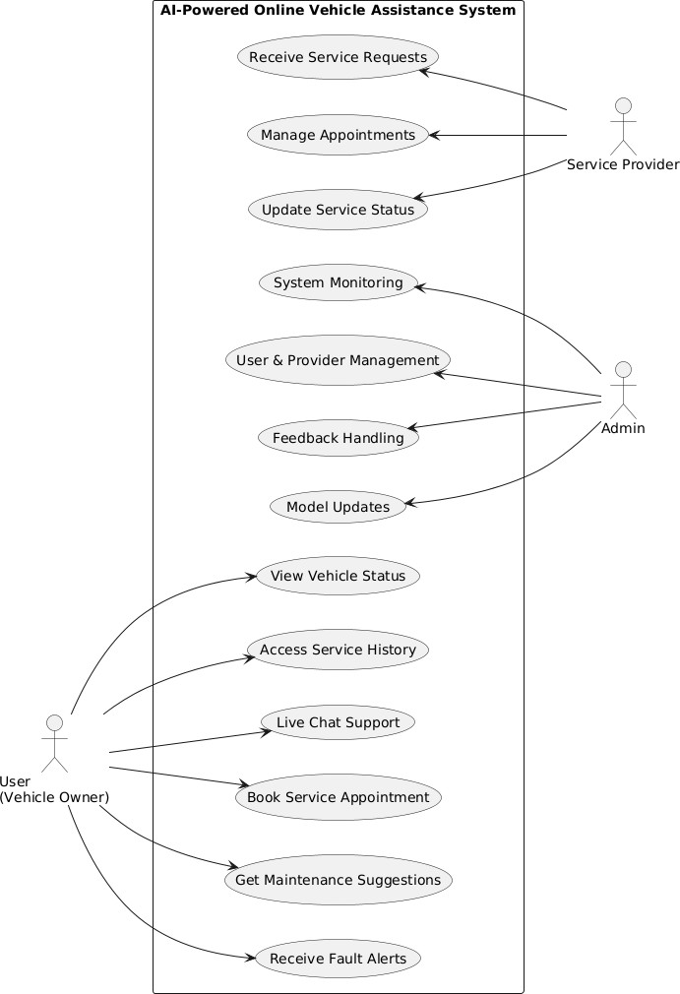efficient service delivery and streamlined customer communi- cation.

# User Module

The AI-powered online vehicle assistance system is com- posed of several integrated modules that work together to deliver a seamless experience for different users, including vehicle owners, service providers, and system administrators. At the core is the User Module, which allows vehicle owners to connect their vehicles via an OBD-II device, view real-time diagnostic information, receive alerts, and access personalized maintenance suggestions through a user-friendly mobile or web application.

Fig. 3. Use Case Diagram

## MODULE DESCRIPTION

The AI-powered online vehicle assistance system is struc- tured into distinct modules to manage different functionalities for users, service providers, and administrators. Each module is designed to work independently while contributing to the overall goal of delivering real-time, intelligent, and accessible vehicle diagnostics and support.

# Admin Module

The Admin Panel oversees the entire system and provides administrative control. It allows system administrators to manage user registrations, verify service provider credentials, handle feedback, monitor platform performance, and maintain data integrity. It also facilitates updates to the AI models and manages backend analytics.

# Service Provider Module

Supporting this is the Service Provider Module, designed for mechanics and authorized workshops. This module enables service providers to view incoming service requests, analyze reported vehicle faults, manage appointment schedules, and interact with users directly through the platform. It promotes

## METHODOLOGY

The research methodology for studying AI-powered online vehicle assistance involved a structured and systematic ap- proach to ensure comprehensive analysis and credible out- comes. This section outlines the key steps undertaken in this study [6].

# Research Design

A mixed-methods approach was employed, combining qual- itative and quantitative techniques to capture the multifaceted nature of AI-powered assistance systems. The study was exploratory in identifying potential use cases and descriptive in analyzing user interactions with the proposed system.

# Data Collection

Data was collected from primary and secondary sources to understand the current landscape of vehicle assistance and AI applications:

* + **Primary Data:** User surveys and interviews with vehicle owners and industry experts were conducted to identify pain points and expectations from an AI-driven solution.
  + **Secondary Data:** Existing literature, technical reports, and industry case studies were reviewed to identify gaps in current systems and opportunities for improvement.

# Evaluation Metrics

The performance of the AI-powered online vehicle assis- tance system was assessed using the following metrics:

* + **Accuracy:** Evaluating the precision of diagnostic outputs generated by the AI algorithms.
  + **Response Time:** Measuring the speed at which the system provides assistance during emergencies or queries.
  + **User Satisfaction:** Gauging overall user satisfaction through surveys post-usage.

# System Developement

The development process followed the principles of agile methodology to ensure adaptability during implementation. Key steps included:

* + **Requirements Analysis:** Use cases were defined based on data collected from users and industry experts.
  + **Prototyping:** A functional prototype of the system was built using AI algorithms for diagnostics, scheduling, and real-time assistance.
  + **Testing:** The prototype underwent iterative testing, with feedback from users incorporated to refine the system.

## REASON FOR SELECTION OF THIS PROJECT

The decision to focus on AI-powered online vehicle as- sistance was driven by several compelling factors related to societal needs, technological advancements, and the potential for transformative impact in the automotive industry [7].

* + ***Problem Solving:-*** AI-powered vehicle assistance ad- dresses challenges like maintenance, emergency handling, and real-time navigation.
  + ***Smart Technology Integration***:- It leverages AI for ef- ficient, personalized, and reliable solutions aligned with user expectations.
  + ***Safety Enhancement:-*** Quick diagnostics and emergency response reduce risks and improve overall vehicle safety.
  + ***Environmental and Economic Benefits:-*** AI helps reduce emissions and prevent costly repairs, promoting sustain- ability and savings.
  + ***Filling Technological Gaps:-*** It explores underutilized AI capabilities in vehicle assistance and aims to advance innovation.

## SYSTEM CHALLENGES

Despite the promising potential of AI in transforming online vehicle assistance systems, several challenges persist in the practical implementation and scaling of such technologies [8].

1. ***Cost and Infrastructure :-*** Cost and infrastructure present barriers for wide-scale adoption. High-quality AI models often require computational resources and connectivity that may not be readily available in remote or underdeveloped areas, potentially limiting the tech- nology’s reach.
2. ***Integration and Interoperability:-*** Another critical chal- lenge is system integration and interoperability. AI tools must interact with various hardware components such as OBD-II scanners, cloud servers, GPS modules, and third-party APIs. Ensuring smooth communication be- tween these components especially across vehicles of different makes and models requires extensive standard- ization, which is currently lacking in the automotive domain.
3. ***Model Accuracy and Generalization:-*** While a model may perform well under specific test conditions, it may fail to generalize in diverse or unseen driving environ- ments. Factors like driving behavior, road conditions, and weather can significantly influence diagnostic accu- racy, making robust model training a necessity.
4. ***User Trust and Data Privacy:-*** As vehicle diagnostics become more intelligent and connected, users must feel confident that their driving data is secure and not mis- used. Balancing AI functionality with stringent privacy



standards remains a technical and ethical challenge for developers and researchers alike.

1. ***Data Quality and Availability:-*** For an AI model to make accurate predictions about vehicle faults or main- tenance needs, it requires access to diverse and reliable datasets. However, real-time vehicle data is often pro- prietary or inconsistently logged across different man- ufacturers. Additionally, data from older vehicles may be incomplete or incompatible with modern diagnostic systems, reducing the overall effectiveness of AI-driven analysis.

## FUTURE ENHANCEMENT

As AI technology continues to evolve, there are several promising directions in which this research can be extended to make AI-powered vehicle assistance systems even more intelligent, reliable, and accessible [9].

1. ***Enhanced AI Algorithms :-*** Future development can focus on improving the accuracy and efficiency of AI algorithms, especially for real-time diagnostics and navigation. Incorporating advanced techniques such as deep learning and reinforcement learning can enable the system to make more intelligent decisions under diverse conditions.
2. ***Integration with Emerging Technologies:-*** The incorpo- ration of cutting-edge technologies such as IoT (Internet of Things), 5G connectivity, and blockchain can signif- icantly enhance system capabilities. IoT integration can provide seamless data sharing between vehicles and AI systems, while 5G can ensure faster communication and response times.
3. ***Cross-Platform Compatibility:-*** Expanding the system to integrate with various devices and platforms, includ- ing smartphones, wearable technology, and smart home devices, would make the solution more accessible and versatile.
4. ***Advanced Safety Features:-*** Development of AI features aimed specifically at enhancing safety, such as predictive collision warnings, automated emergency responses, and driver fatigue detection, could be a pivotal focus for future advancements.
5. ***Environmental Sustainability:-*** Exploring eco-friendly AI solutions, such as energy-efficient algorithms and AI- driven recommendations for reducing vehicle emissions, should be a focus to align with global sustainability goals.
6. ***Personalized User Experience :-*** Future efforts could aim at creating more tailored services based on user preferences, driving habits, and vehicle usage history. AI systems can employ predictive analytics to anticipate user needs and provide a highly personalized experience.

## ACKNOWLEDGEMENT

We would like to express our heartfelt gratitude to all those who have supported and contributed to the successful completion of the “AI Powered Online Vehicle Assistance” Project. First and foremost, we extend our sincere appreciation to our project advisor prof.pravin ligade for their invaluable guidance, expert insights, and continuous support throughout the development of this project. Their constructive feedback and encouragement have been instrumental in shaping our work. We are also deeply grateful to G.H.Raisoni College of Engineering and Management ,pune for providing the neces- sary resources, infrastructure, and a conducive environment that facilitated our research and development activities. Our heartfelt thanks go to the technical team, developers, and designers whose hard work and dedication played a pivotal role in the creation of the platform. Your technical expertise and commitment to excellence have been vital to the project’s success. We would also like to acknowledge the contributions of our testers and early users, whose feedback helped us refine the system to meet real-world needs effectively. Your insights have been invaluable in enhancing the user experience. Lastly, we are profoundly thankful to our families and friends for their unwavering support, encouragement, and understanding during the course of this project. Their belief in us has been a source of motivation and inspiration.

1. Conclusion

The “AI Powered Online Vehicle Assistance” Project is a transformative solution designed to enhance the efficiency, accessibility, and reliability of vehicle support services. By integrating advanced technologies such as AI-driven diagnos- tics, GPS tracking, IoT-based monitoring, and real-time service connectivity, this system provides instant assistance for vehicle breakdowns, maintenance needs, and emergency situations. Through real-time roadside support, predictive maintenance, and seamless communication between vehicle owners and service providers, the project minimizes delays, improves road safety, and ensures a stress-free experience for users. The incorporation of secure payment options, insurance claim assistance, and digital record- keeping further enhances its practicality and convenience. Despite certain limitations such as internet dependency, AI diagnostic accuracy, and service availability constraints, continuous improvements in technol- ogy and infrastructure can enhance the system’s efficiency over time. The project has significant potential to revolutionize ve- hicle assistance services by reducing response times, lowering maintenance costs, and promoting proactive vehicle care. In conclusion, the AI Powered Online Vehicle Assistance Project is an innovative, user- centric solution that bridges the gap between vehicle owners and service providers.

## REFERENCES

1. H. Zhang and R. Liu, “*Artificial Intelligence in Au- tomotive Fault Detection: A Review*,” *IEEE Transactions on Intelligent Transportation Systems*, vol. 22, no. 5, pp. 2761–2775, May 2021.
2. A. Deshmukh, *“Challenges in Vehicle Diagnostics and the Role of Driver Awareness,”* *International Journal of Automotive Technology and Management*, vol. 10, no. 3, pp. 225–233, 2021.
3. L. Choi and D. Kumar, *“AI-Driven Virtual Assistants in the Automotive Sector,”* *ACM Transactions on Human- Computer Interaction*, vol. 39, no. 1, pp. 1–18, 2023.
4. M. Rahman, *“Smart Vehicle Maintenance Using AI and IoT,”* *Journal of Intelligent Systems*, vol. 30, no. 4, pp. 580–592, 2022.
5. G. Bhatia, M. Mishra, and A. Goel, *“Smart Vehicle Monitoring System Using IoT and Machine Learning,”* In- ternational Journal of Engineering Research and Technology (IJERT), vol. 9, no. 6, pp. 553–557, June 2020.
6. Doe, J. (2020). *Artificial Intelligence in Automotive Services. Journal of Smart Systems*, 15(3), 150-165.
7. Smith, J. (2023). *AI Applications in Automotive Systems. Journal of Emerging Technologies,* 12(4), 45-60.
8. Patel, R., Sharma, D., and Thomas, A. (2020). *Appli- cations and Limitations of AI in Connected Vehicles. Interna- tional Journal of Smart Transportation*, 8(2), 65–72.
9. Singh, A., and Rao, N. (2022). *AI-Driven Predictive Maintenance in Modern Automotive Systems. International Journal of Intelligent Transport Systems*, 10(1), 45–53.
10. R. Bhatia, M. Sharma, and A. Goel, *“AI-Based Vehicle Fault Detection System Using Machine Learning Techniques,” International Journal of Computer Applications*, vol. 182, no. 35, pp. 24–28, 2019.
11. S. Kumar and V. Gupta, “IoT and Machine Learning Enabled Smart Vehicle Maintenance System,” International Journal of Engineering Research and Technology (IJERT), vol. 9, no. 5, pp. 441–446, 2020.
12. N. Singh and R. Patel, “Predictive Maintenance Model for Vehicle Health Monitoring Using Artificial Intelligence,” International Journal of Scientific and Engineering Research (IJSER), vol. 11, no. 10, pp. 896–901, 2020.
13. P. Deshmukh and K. Rane, “AI-Driven Automotive Diagnostics and Assistance System,” International Journal of Innovative Technology and Exploring Engineering (IJITEE), vol. 8, no. 9, pp. 1402–1406, Jul. 2019.
14. S. Srivastava, A. Yadav, and R. Tiwari, “AI-Based Virtual Mechanic for Fault Detection and Troubleshooting in Automobiles,” Journal of Emerging Technologies and Innova- tive Research (JETIR), vol. 7, no. 3, pp. 256–262, 2020.
15. D. Kumar, M. Saini, and R. Bansal, “Smart Vehicle Assistant Using Natural Language Processing and AI,” Inter- national Journal of Computer Sciences and Engineering, vol. 8, no. 12, pp. 84–89, Dec. 2020.