**Consumer Behavior and Satisfaction in Internet Banking: A Review with Reference to Madhya Pradesh**

**Anushka Jain1, Dr. Swapna Pillai2, Dr. Harsh Sharma3**

1Research Scholar, IPER, Bhopal

2Professor, Department of Commerce, BSSS, Bhopal

3Professor, IPER, Bhopal

**Abstract**

The speedy advancement of internet generation has transformed conventional banking practices into greater flexible and user-pleasant digital services. This evaluate paper explores consumer behavior and pride toward internet banking, with special reference to selected districts of Madhya Pradesh. The study highlights key factors influencing patron adoption, which includes ease of use, trust, perceived risk, and digital literacy. It also discusses dimensions of customer pride, along with carrier nice, usability, security, and customer service. Through a assessment of latest research and available data, the paper identifies gaps in the existing literature, particularly concerning rural client stories and agree with-building mechanisms. The findings advise that even as net banking adoption is growing in urban areas of Madhya Pradesh, rural districts nonetheless face demanding situations associated with infrastructure and focus. The overview concludes by using emphasizing the want for localized strategies to enhance patron pleasure and promote inclusive digital banking offerings.

**Keywords:** Internet Banking, Consumer Behavior, Customer Satisfaction, Madhya Pradesh, Digital Banking Adoption

**1. Introduction**

In the previous few many years, the growth of internet banking has changed the manner human beings get entry to monetary services. The comfort of banking from home or on a cell tool has attracted a wide range of clients across India. Madhya Pradesh, being a mix of urban and rural areas, shows an thrilling sample in how human beings adopt and feel glad with internet banking offerings. This assessment paper objectives to recognize patron conduct and delight with internet banking, specializing in studies and insights associated with Madhya Pradesh. It highlights the elements that have an effect on clients' use of internet banking and identifies regions wherein service providers can improve consumer revel in.

**2. Internet Banking: An Overview**

Internet banking, also known as online banking, refers to the use of the internet to carry out banking sports like checking account balances, moving cash, paying payments, and making use of for loans. It gets rid of the want for physical visits to the financial institution, saving both effort and time for customers.

Despite its advantages, internet banking also provides challenges, inclusive of worries over security, technical difficulties, and the shortage of private interplay that some customers price. Especially in semi-urban and rural elements of Madhya Pradesh, low virtual literacy and negative internet infrastructure can limit get admission to these offerings.

|  |  |  |
| --- | --- | --- |
| **Features** | **Traditional Banking** | **Internet Banking** |
| **Accessibility** | Limited to bank hours | 24/7 availability |
| **Physical presence** | Required | Not required |
| **Transaction Speed** | Moderate to slow | Fast |
| **Personal Interaction** | Face-to-face | Virtual only |
| **Risk Factors** | Less cyber risk, more paperwork | Cybersecurity risks |

**Table 1: Comparison of Traditional vs Internet Banking**

**Conceptual Framework**

**Visual Diagram**

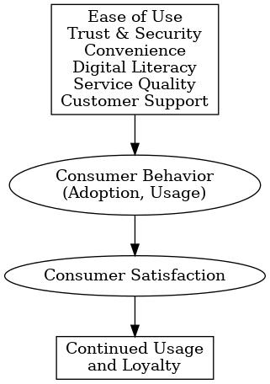

**Explanation:**

* Factors like ease of use, trust, and service quality **influence** how consumers behave towards internet banking (whether they adopt and use it frequently).
* Consumer behavior **directly impacts** their **satisfaction**.
* Higher satisfaction leads to **continued usage**, **positive word-of-mouth**, and **loyalty**.

**3. Consumer Behavior in Internet Banking**

Consumer behavior in net banking is inspired via more than one factors. Some primary elements include:

• **Ease of Use**: Platforms that are easy and person-friendly encourage better adoption.

• **Trust and Security**: Consumers have to experience that their personal and financial facts is secure.

• **Convenience**: Ability to transact at any time with out status in queues.

• **Awareness and Digital Literacy**: Knowledge approximately the usage of internet banking affects adoption, particularly in rural areas.

• **Socio-Demographic Factors**: Age, gender, training, earnings level, and occupation play crucial roles.

Different studies have shown that more youthful and more knowledgeable individuals are much more likely to adopt internet banking. Meanwhile, rural consumers regularly hesitate because of accept as true with issues and absence of familiarity with era.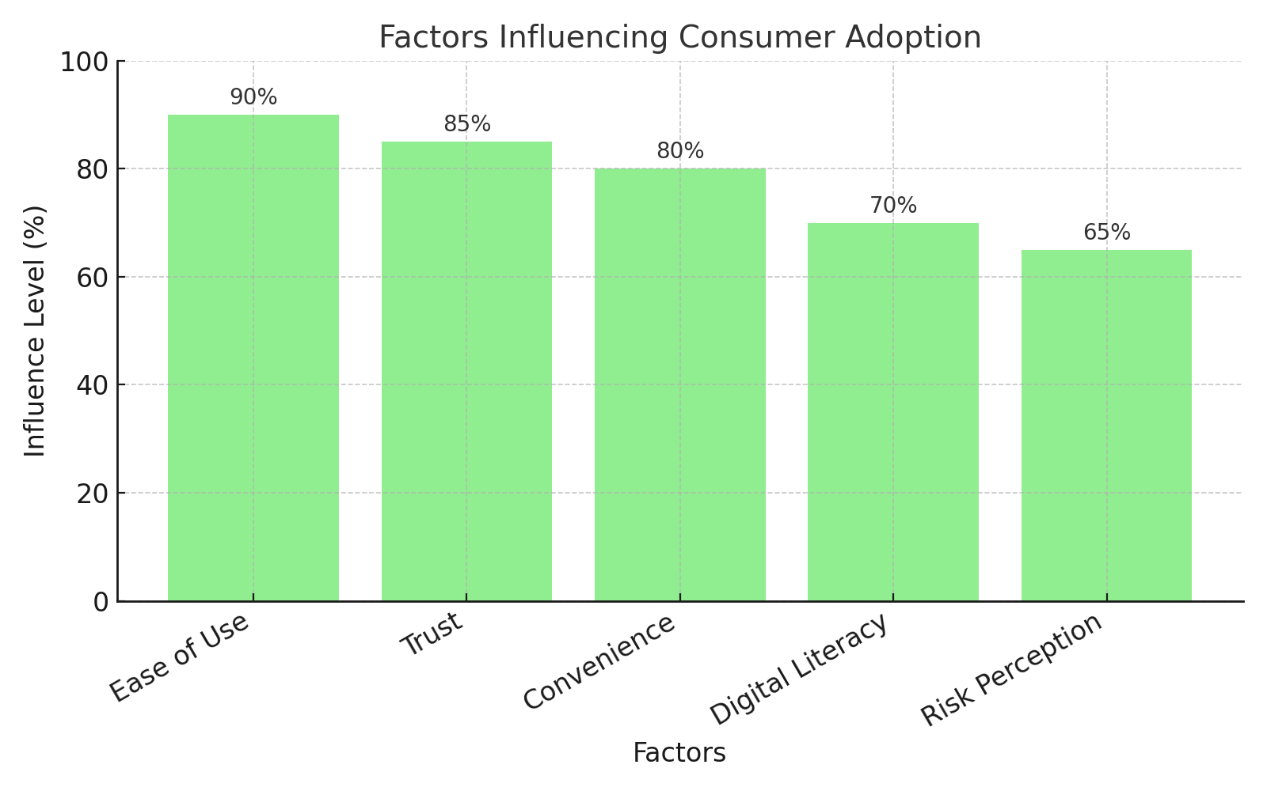

# **Graph 1: Factors Influencing Consumer Adoption**

|  |  |  |
| --- | --- | --- |
| **Demographic Variable** | **Higher Usage Group** | **Lower Usage Group** |
| **Age** | 20–40 years | Above 50 years |
| **Education** | Graduates and above | Primary education level |
| **Income** | Middle and high income | Low income |
| **Location** | Urban and semi-urban areas | Rural areas |

**Table 2: Demographic Variables vs Internet Banking Usage Trends**

**4. Consumer Satisfaction in Internet Banking**

Consumer satisfaction depends on how well the service meets their expectations. In internet banking, the main areas that influence satisfaction are:

* **Service Quality**: Speed and reliability of online services.
* **Website/App Usability**: Easy navigation, clear instructions, and attractive design.
* **Security Measures**: Availability of features like OTPs, encryption, and fraud detection.
* **Customer Support**: Quick resolution of complaints or technical issues.
* **Customization**: Personalized services and recommendations.

However, dissatisfaction may occur due to server downtimes, technical glitches, security breaches, or complicated interfaces.

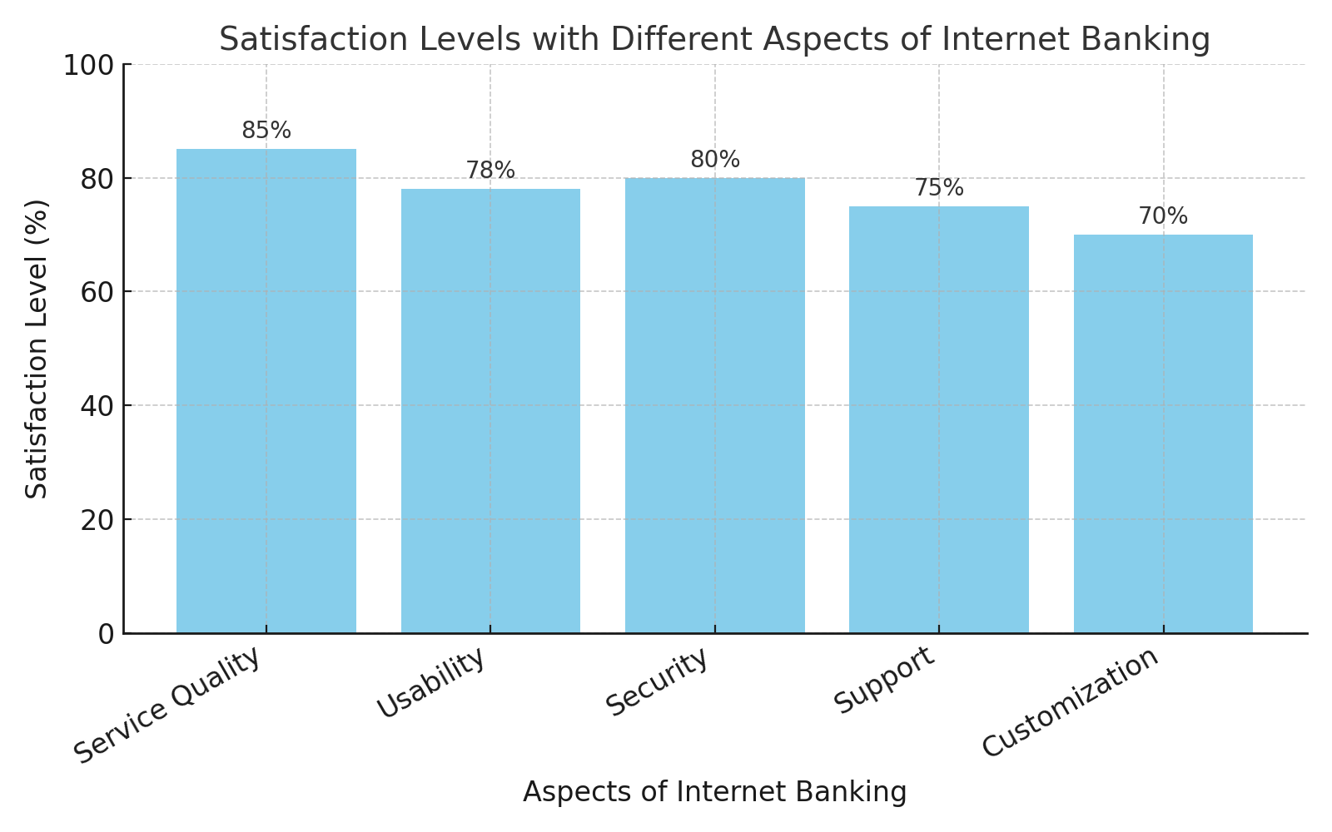

# **Graph 2: Satisfaction Levels with Different Aspects of Internet Banking**

**5. Studies and Findings from Madhya Pradesh**

Several studies conducted in Madhya Pradesh reveal mixed results regarding internet banking usage:

* Urban consumers in cities like Bhopal and Indore show high adoption rates due to better internet infrastructure and awareness.
* In rural districts, despite increasing mobile penetration, internet banking adoption remains low because of trust issues and lack of digital skills.
* Awareness programs and improved banking apps designed in regional languages have started bridging the gap, but challenges remain.

### **Summary of Reviewed Studies**

| **Study** | **Country / Region** | **Focus Area** | **Key Findings** |
| --- | --- | --- | --- |
| Sharma (2023) | Indore, Madhya Pradesh | Impact of internet banking service quality on customer satisfaction | Identified five key service quality dimensions—website ease of use, comfort, accessibility, confidence, and responsiveness—that positively influence customer satisfaction. |
| Shailender & Tomar (2023) | Chhindwara, Madhya Pradesh | Customer perceptions of e-banking services in rural areas | Found significant differences in customer satisfaction between public and private sector banks, with public banks facing more challenges in service delivery. |
| Devi Ahilya University (2018) | Indore, Madhya Pradesh | Customer perception toward internet banking | Revealed that education level and type of employment significantly affect customer satisfaction, while age and gender do not. |
| Khan & Mahapatra (2008) | India | Service quality evaluation in internet banking | Identified seven quality dimensions, with customers most satisfied with reliability, accessibility, privacy/security, responsiveness, and fulfillment, but least satisfied with user-friendliness. |
| Bashir & Madhavaiah (2015) | India | Consumer attitude and behavioral intention towards internet banking adoption | Demonstrated that perceived usefulness, ease of use, trust, and enjoyment are direct determinants of attitude towards internet banking, influencing behavioral intentions. |
| Chhabra (2018) | Punjab & Chandigarh, India | Service quality's impact on trust, satisfaction, and loyalty in internet banking | Found that efficiency, reliability, responsiveness, and website design significantly influence customer trust and satisfaction, leading to loyalty. |
| Sardana & Bajpai (2020) | Delhi, India | E-banking service quality and customer satisfaction | Identified trust and privacy as the most critical factors influencing e-banking service quality perceptions. |
| Kamboj & Singh (2018) | India | Customer satisfaction with digital banking and demographic factors | Highlighted that slow internet speed and lack of security features are major concerns, affecting customer satisfaction across different demographics. |
| Fozia (2017) | India | Comparative study on customer satisfaction in internet banking | Emphasized the importance of multiple regression analysis in understanding overall customer satisfaction in internet banking. |
| Ashoka et al. (2017) | Rural India | Consumer perception and satisfaction towards internet and mobile banking | Noted challenges in internet and mobile banking adoption in rural areas, with concerns over security and accessibility affecting satisfaction. |

**6. Gaps Identified in Literature**

While there have been numerous studies on internet banking at the national level, gaps remain when it comes to focused research in Madhya Pradesh. The main gaps are:

* Lack of studies comparing rural and urban consumer experiences in depth.
* Limited research on the impact of language barriers in internet banking.
* Few studies addressing trust-building strategies for first-time users in rural areas.
* Need for gender-specific analysis, as women's adoption patterns differ.

These gaps open opportunities for further research to create better, more inclusive banking platforms.

**7. Conclusion**

Internet banking has transformed the manner banking offerings are accessed, but patron behavior and pleasure levels vary broadly based on demographic and nearby factors. In Madhya Pradesh, whilst city areas show encouraging symptoms of adoption, rural districts nonetheless lag in the back of because of multiple boundaries. Banks want to awareness on enhancing digital literacy, enhancing trust via higher security measures, and providing offerings which might be easy to use throughout numerous consumer agencies. Future studies that specialize in rural-city comparisons and particular client needs can assist form higher banking techniques.

**8. References**

1. Sharma, G. (2023). Internet banking service quality and its impact on customer satisfaction in Indore district of Madhya Pradesh. *Academia.edu*.
2. Shailender, & Tomar, A. (2023). Exploring customer perceptions of e-banking services in rural Madhya Pradesh: A comparative analysis of public and private sector banks in Chhindwara district. *Well Testing Journal*, 32, 31–36.
3. Devi Ahilya University. (2018). Study of customer perception toward internet banking in Indore. *Research Review International Journal of Multidisciplinary*, 3(1).
4. Khan, M. S., & Mahapatra, S. S. (2008). Service quality evaluation in internet banking: An empirical study in India. *International Journal of Indian Culture and Business Management*, 2(1), 30–46.
5. Bashir, I., & Madhavaiah, C. (2015). Consumer attitude and behavioural intention towards internet banking adoption in India. *Journal of Indian Business Research*, 7(1), 67–102.
6. Chhabra, K. (2018). Does service quality matter in the context of internet banking? A perceptual analysis of India’s internet banking customer’s perception regarding service quality, trust, satisfaction, and loyalty. *Journal of Commerce and Accounting Research*, 7(3), 52–60.
7. Sardana, S., & Bajpai, V. N. (2020). E-banking service quality and customer satisfaction: An exploratory study on India. *International Journal of Services and Operations Management*, 36(2), 223–247.
8. Kamboj, N., & Singh, G. (2018). Customer satisfaction with digital banking in India: Exploring the mediating role of demographic factors. *Indian Journal of Computer Science*, 3(2).
9. Fozia, D. (2017). Analyzing customer satisfaction of internet banking: A comparative study in India. *Global Journal of Management and Business Research*, 17(C3), 5–8.
10. Ashoka, M. L., Rakesh, T. S., & Madhushree, S. (2017). Consumer perception and satisfaction towards internet banking and mobile banking with reference to nationalized banks in rural India. *International Journal of Asian Business and Information Management*, 8(4), 29–40.