**CLOUD-BASED MICRO WIND TURBINE FOR EMERGENCY POWER GENERATION**

**Dr.B.Tharani1, Jayakrishnan T2, Natarajaperumal N H3, Dharshan C4, ,Sarveswaran A5**

*1 Professor, 2 Student, Department of Electrical and Electronics Engineering*

*Sri Shakthi Institute of Engineering and Technology, Coimbatore, Tamil Nadu, India.*

*Email:* [*tharani@siet.ac.in*](mailto:tharani@siet.ac.in)*,* [*jayakrishnant21eee@srishakthi.ac.in*](mailto:jayakrishnant21eee@srishakthi.ac.in)

**ABSTRACT**

During emergency response and off-grid conditions, providing power to the necessary devices remains a significant problem. This report suggests a micro wind turbine cloud-integrated system for emergency power generation, where the system may be simply attached (e.g., clipped on a backpack) to collect the energy from winds. The system consists of an integrated wind turbine with a DC generator, regulation circuitry of power, and a lithium-ion battery for the storage of power. An IoT module interfaces the turbine to a cloud platform, allowing power output and battery status to be monitored in real time. Leveraging the Internet of Things (IoT) in a smart energy grid context allows the envisioned micro turbine to be remotely supervised and controlled, offering resilience and flexibility in energy supply. We explain the system architecture and operation principles, then model the turbine's performance for different wind conditions. Test results for the prototype illustrate the turbine's capacity to power small electronics (like smartphones and LED lights) with wind velocities as low as 3–5 m/s, with better efficiencies at higher wind velocities. The cloud integration offers useful data for maximizing utilization and maintenance. Discussion entails the incorporation of such micro-generation devices into contemporary IoT-based smart grids for improved emergency response, comparing the approach with conventional portable power sources. The research demonstrates that an IoT-enabled portable wind turbine is an effective off-grid power solution that supports existing smart grid infrastructure during emergencies.

**Keywords:** Micro Wind Turbine, Emergency Power Generation, IoT Integration, Smart Grid, Cloud Monitoring

1. **INTRODUCTION**

Reliable off-grid power is essential during natural disasters, remote expeditions, and emergencies when traditional electricity is unavailable. For instance, portable renewable generators in disaster relief and military operations can lessen dependence on diesel fuel. Conventional backup options like gasoline or diesel generators come with fuel logistics issues and emissions, while battery power banks eventually run out and solar panels rely on sunlight. Wind energy is a plentiful renewable source available at any time where there is sufficient airflow. A compact wind turbine can offer a steady off-grid power supply to keep vital devices like communication tools and medical equipment running when other methods fail.

Recent developments in smart grids and the Internet of Things (IoT) have led to more adaptive energy systems. IoT-enabled smart grids use distributed sensors and connected devices to monitor and control energy in real time, enhancing efficiency. Even with a small wind turbine, IoT connectivity can provide significant benefits. Researchers have shown that real-time monitoring of wind turbines through IoT and cloud platforms can verify performance and optimize generation. Mobile wind turbine units have also been developed for emergency situations, like a trailer-based turbine for rural disaster areas. However, this paper focuses on a lightweight, backpack-mounted micro-scale wind turbine designed to charge personal devices. By linking the turbine to a cloud-based IoT platform, we aim to merge local renewable energy generation with modern smart grid management. The paper will describe the system's design, architecture, operational concept, prototype testing, and insights for future improvement within smart grids.

1. **SYSTEM ARCHITECTURE**

The micro wind turbine system effectively converts wind energy into electrical power and supports IoT-based monitoring. The overall setup comprises two main parts: the energy generation and storage subsystem and the IoT communication and control subsystem. The system includes lightweight, high-lift turbine blades on a compact rotor, designed for portability and durability, produced using 3D printing. A small brushless DC motor acts as a generator, converting the wind-induced motion into variable AC electricity, which is later rectified into DC for use. Due to fluctuating wind speeds affecting generator voltage, a voltage regulator maintains a stable output suitable for charging devices. A buck-boost converter ensures a consistent 5 V DC output for USB charging. Any surplus energy is stored in a rechargeable Li-ion battery pack made from 18650 cells, designed with a battery management system for safe operation. This battery not only stores excess energy generated during high winds but also provides a stable power supply in less windy conditions. The prototype battery has a 2600 mAh capacity at 3. 7 V, delivering a boosted output of 5 V when needed. At the heart of the IoT system is an ESP32 microcontroller, noted for its low power consumption and built-in Wi-Fi capabilities. This microcontroller continuously monitors the system's electrical parameters, such as generator output and battery status, while also reading available environmental data. Although a wind speed sensor could be included, the current design estimates wind speed based on generator output to keep hardware requirements low. The ESP32 also features an LCD display, offering real-time information on power output, battery level, and charging status, which is useful in remote locations.

Cloud connectivity is a key feature of this system. Through the ESP32’s Wi-Fi, data is sent to a cloud server, specifically using AWS IoT core services for device messaging and monitoring. The microcontroller publishes telemetry data regularly, providing updates on power output, cumulative energy, and battery level. This information can be viewed on a cloud dashboard, enabling remote monitoring of the turbine’s performance. Secure communication is facilitated via the MQTT protocol over TLS, with the device authenticated to the cloud service. The cloud platform can transmit commands back to the microcontroller for adjustments, such as control over the turbine’s operations during extreme wind conditions. The system’s components are housed within a portable design. A custom 3D-printed frame allows the turbine to easily attach to various structures like backpacks or tent poles. The entire unit emphasizes lightweight, weather-resistant construction, with essential elements protected within waterproof housing. Its compact size, roughly 15–20 cm in rotor diameter and weighing around 1–1. 5 kg including the battery, makes it manageable for a single user to deploy quickly. In conclusion, this micro wind turbine system integrates energy harvesting, power management, and IoT communication efficiently. The combined hardware and software are designed for effective wind energy capture and storage while providing real-time data to the cloud. The architecture offers scalability and flexibility, allowing for additional sensors and broader applications within smart grid frameworks or emergency management systems.

1. **PROPOSED SYSTEM**

The proposed system is an IoT-enabled microgeneration unit designed to provide emergency power and connect with smart grid systems. It operates in three main stages: power generation and charging, data acquisition and cloud reporting, and user interaction and control. During power generation, a turbine spins in the wind, activating a DC generator that produces electricity. This raw power is converted through a rectifier and regulator to charge a connected battery and/or power a USB device. The system prioritizes charging devices while sending extra power to the battery. If the wind is weak, the battery supplies energy to maintain an uninterrupted power supply, essential for emergencies, such as powering a satellite phone during a rescue. The regulator prevents battery overcharging, and a battery management system (BMS) protects against over-discharge to ensure safety and battery health. The local control logic, managed by the ESP32, follows a simple energy flow algorithm to adjust charging based on battery status and available wind power.

In the data acquisition stage, the ESP32 collects data on generator output and battery status multiple times per second. This data is processed to track energy generated and consumed, average power output, and runtime. Updates are sent to the cloud every minute, including essential metrics like timestamp, wind turbine RPM, generator voltage, and battery level. In the cloud, AWS IoT manages the data, which is then displayed on a real-time dashboard, allowing operators to monitor multiple units remotely and predict maintenance needs based on performance trends. For user interaction, the system is designed for ease of use. Users need only to place the turbine in a windy area and connect their device. The local LCD shows messages about the turbine's performance. Authorized users can log into the cloud dashboard to check system status. Additionally, it could provide data to emergency management systems to inform resource deployment. While the current version doesn’t allow remote control, future versions may include features for dynamic configuration.

Overall, this system combines a wind turbine's functionality with IoT cloud connectivity, making it a significant advancement in emergency power solutions and the potential development of smart microgrids. It aims to support localized energy needs effectively, especially in emergency situations. The next section will present results from testing the system and how it compares to traditional energy solutions..

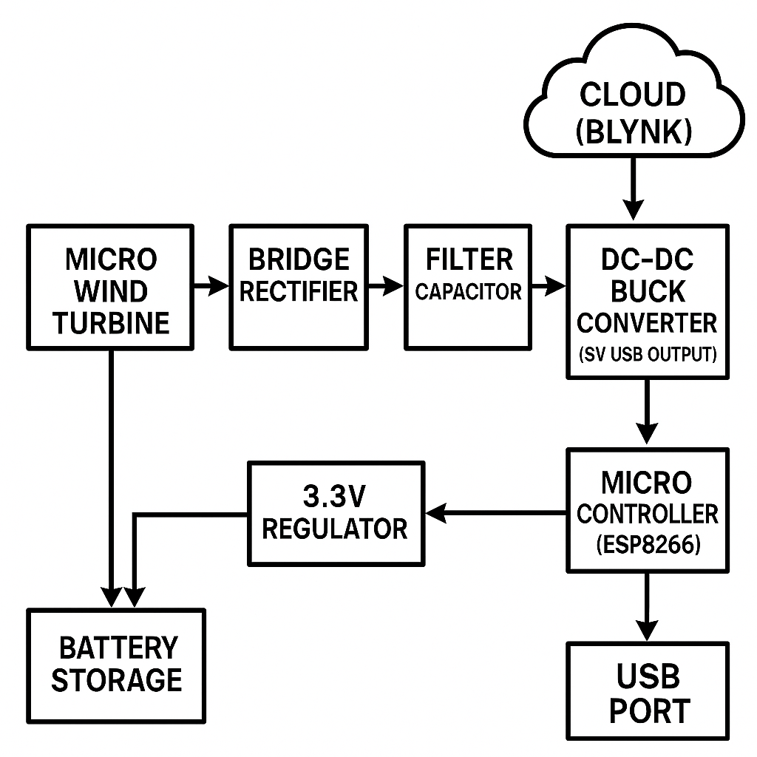

**Figure 1:** Block Diagram

1. **RESULTS AND DISCUSSION**

We developed a working prototype of a cloud-integrated micro wind turbine and tested its performance under different conditions. The results show it can be used for emergency power generation, highlighting the benefits of IoT connectivity and the challenges of micro-scale wind energy. The prototype was assembled following a specific design, with 3D-printed turbine blades attached to a hub linked to a DC generator. It was mounted on a collapsible tripod for ease of deployment. The electronics were housed at the turbine's base, making the total weight about 1. 2 kg and costing under $100 to build, making it affordable. For indoor tests, we initially used an electric fan to create controlled wind. The turbine started rotating at wind speeds around 3 m/s, generating about 4–5 V DC without load. When charging a smartphone, it provided roughly 1–1. 5 W of power. As wind speed increased to 5 m/s, the current output rose to about 3 W. At the highest tested wind speed of around 8 m/s, the turbine reached 5 W output, matching expectations for its scale. This power output can keep small electronics operational. For example, it generated around 3 Watt of energy in an hour at about 5 m/s, capable of charging a typical smartphone battery in about 4 hours under favorable conditions. Outdoors, we tested the turbine in natural wind on a moderately windy day. The setup included attaching it to a backpack frame about 1. 5 m off the ground. Even winds below 3 m/s allowed for occasional power generation. At higher wind speeds of 4–5 m/s, the turbine reliably charged a smartphone, accumulating about 8 Watt over three hours. This variability mimics real-world conditions, with the battery regulating power delivery. We found that minor adjustments to the turbine’s height and orientation affected its performance significantly.

The IoT aspect was crucial, as real-time data was transmitted to the AWS cloud. We observed power spikes during wind gusts, allowing us to track energy production accurately. Remote monitoring can help users ensure the turbine operates well, providing valuable data for potential issues. While we did not implement advanced optimization algorithms, the collected data could support future improvements for better efficiency.

Comparing our wind turbine to other portable power solutions, we noted advantages over solar chargers, such as functionality in cloudy or nighttime conditions. Unlike fuel generators, our turbine operates silently and uses renewable energy but struggles to match their continuous power output. Our micro turbine is designed for personal devices, emphasizing portability and IoT connectivity, although it produces less power than some commercial portable solutions. Despite challenges like low-wind energy production and device stability, our project confirmed the micro wind turbine effectively charges devices and provides real-time data. Overall, these results illustrate the potential for IoT-enabled microgeneration, showing how small renewable sources can fit into a larger smart energy ecosystem. This integration could enhance resource management in emergencies and provide valuable insights for off-grid users and energy researchers.

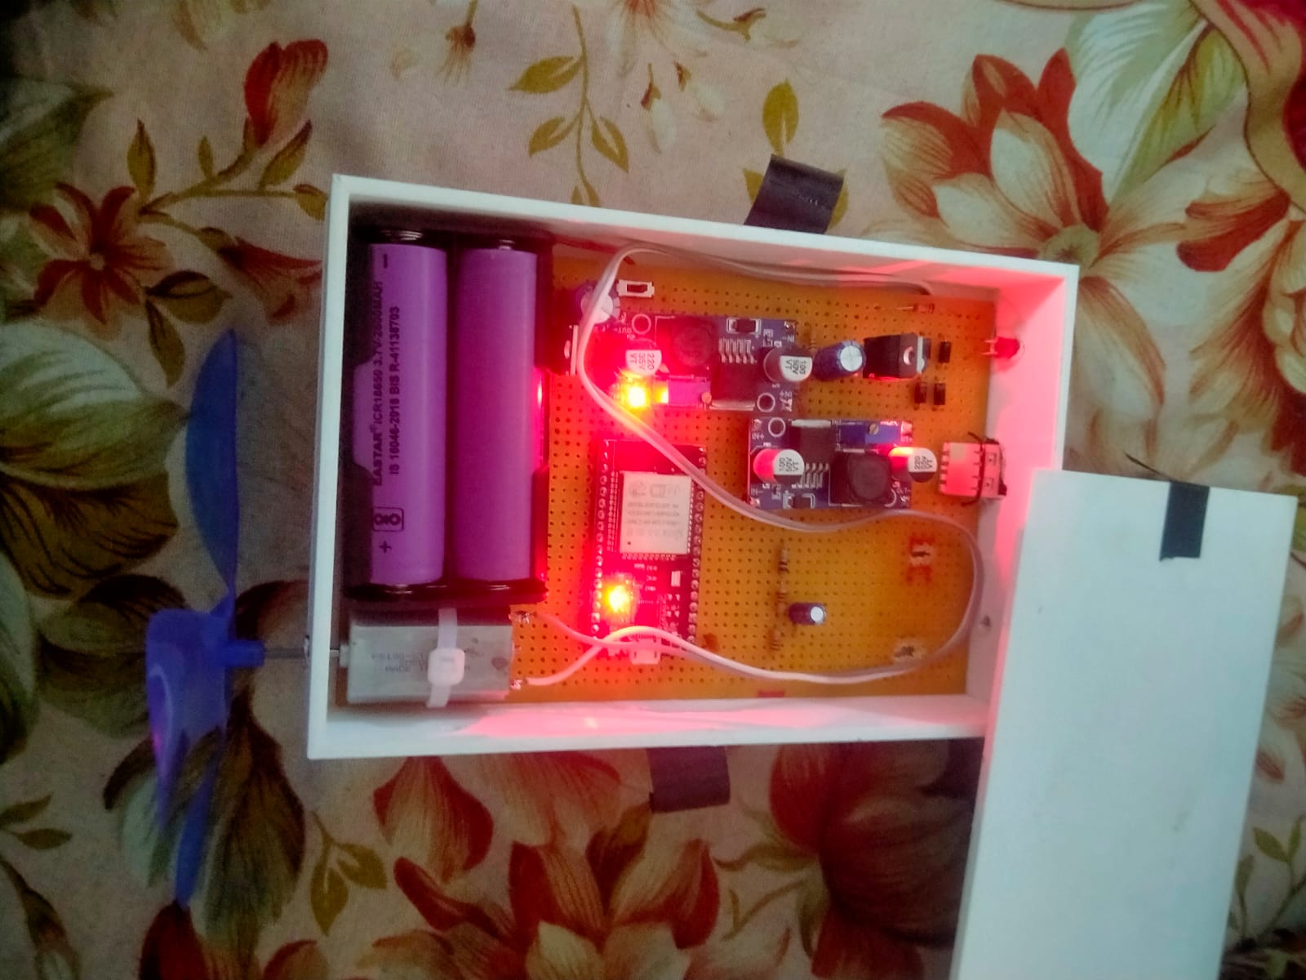

**Figure 2:** Hardware Model

1. **CONCLUSION**

We have presented a cloud-integrated micro wind turbine system designed for emergency power generation in off-grid situations. This system combines a portable wind turbine, efficient power electronics, on-board IoT communication, and cloud-based monitoring to generate small-scale power for devices while providing real-time performance insights. Testing showed that the turbine starts generating power at about 3 m/s wind speed, producing a few watts in moderate wind, which is sufficient for charging phones, radios, LED lights, and other essential electronics during emergencies. A battery ensures energy is saved for uses even during calm periods, enhancing reliability. Field tests confirmed that devices could be charged overnight when wind was available, highlighting the system's effectiveness when solar options were inadequate.

The IoT integration adds value by allowing remote monitoring through a cloud platform. Users can track energy generation and usage and resolve issues in real time. In multiple turbine scenarios, data aggregation aligns with smart grid management principles. This setup lays the groundwork for future improvements like remote control, predictive maintenance alerts, and integration with larger energy systems. The project illustrates that small-scale renewable technologies can contribute meaningfully to smart energy ecosystems, even backpack-sized turbines. The cloud-integrated micro wind turbine demonstrates a viable merge of renewable energy and IoT connectivity at a small scale, offering avenues for future enhancements. These include improving turbine efficiency, developing hybrid systems, and creating standardized interfaces for integrating with local grids. The project shows promise for a decentralized and resilient energy future by enabling individuals to generate and monitor their power, contributing to democratized energy production within an IoT-enabled smart grid.

1. **REFERENCES**
2. U.S. Department of Energy, “Compact Wind Turbines Could Support Disaster Relief and Military Missions,” Office of Energy Efficiency & Renewable Energy (EERE), Aug. 2019. *[Online]. Available: energy.gov*
3. “IoT Remote Monitoring of a Wind Turbine Backed Up by Electrical Grid,” *Proceedings of the International Conference on Renewable Energy and IoT*, 2020.
4. G. Erdemir, A. E. Kuzucuoğlu, and F. A. Selçuk, “A mobile wind turbine design for emergencies in rural areas,” *Renewable Energy*, vol. 166, pp. 9–19, 2020.
5. T. Sebastian, A. Gupta, and M. R. Algrain, “IoT-based Wind Energy System Monitoring for Maximum Power Extraction,” *IEEE Intl. Conference on IoT*, 2022.