## ALONE ONLINE: THE PARADOX OF DIGITAL CONNECTION

**PAVENTHAN S, Student III Year (Computer Science), Rathinam College of Arts and Science, Coimbatore -21, paventhanp08@gmail.com**

[Abinesh1530@gmail.com](mailto:Abinesh1530@gmail.com)

**Ganapathiram N, Assistant Professor, Department of Computer Science, Rathinam College of Arts and Science,**

Coimbatore – 21, Tamil Nadu, India

# ABSTRACT

While the digital age promises seamless global connectivity, it has given rise to a profound contradiction—digital loneliness. This paper explores how individuals experience emotional isolation despite being constantly connected through social platforms, messaging apps, and AI-based interactions. By examining the psychological, technological, and societal dimensions of this paradox, the study sheds light on how algorithm-driven engagement can replace meaningful human contact. It further investigates whether artificial companions and online communities truly fill the void or merely simulate social presence. With a focus on human-computer interaction, emotional AI, and social media behavior, this paper aims to understand the real cost of our digital togetherness and propose strategies for healthier online relationships.

Keywords: Digital loneliness, Emotional AI, Online isolation, Hyperconnectivity, Social simulation, Virtual presence

# INTRODUCTION

We live in an age where communication is instant and ubiquitous. From video calls across continents to AI chatbots offering emotional support, technology has revolutionized human interaction. Yet, paradoxically, studies show a rise in reported feelings of loneliness—especially among the digitally native generation. Digital loneliness emerges not from a lack of communication, but from a lack of *connection*. As we curate identities for likes and hearts, the depth of real companionship seems to vanish. This paper questions whether the networks that connect us are also the ones making us feel more alone.

# 2. LITERATURE SURVEY

1. Turkle’s Theory of Networked Solitude

Sherry Turkle’s Alone Together* describes how we are “alone even when together,” emphasizing that digital tools can simulate but not substitute emotional intimacy.

2. Social Media Fatigue Studies

Researchers report that heavy social media users often experience anxiety, FOMO (Fear of Missing Out), and a paradoxical sense of exclusion from real-life connection.

3. AI Companionship (e.g., Replika AI)

Though emotionally intelligent chatbots can offer temporary comfort, prolonged dependence may lead to emotional dissociation from human relationships.

4. Digital Detox Research

Numerous case studies reveal that disconnection from digital platforms leads to improved mood, better sleep, and stronger face-to-face relationships.

5. Youth and Virtual Identity Crisis

Adolescents especially struggle with balancing their real selves and their digital personas, often feeling isolated when their online image fails to reflect their inner reality.

# 3. PROPOSED SYSTEM

A conceptual model, D-LENS (Digital Loneliness Evaluation & Nurturing System), is proposed. D-LENS is a mobile-based AI tool aimed at identifying and mitigating digital loneliness. The system collects user behavior data (social app usage, interaction frequency, sleep patterns), cross-references it with self-assessed mental health scores, and provides personalized emotional well-being feedback.

KEY FEATURES:

• Sentiment Monitoring: Analyzes user mood from messages and social posts.

• Connection Quality Meter: Tracks meaningful vs. superficial digital interactions.

• Mindful Nudges: Prompts for offline engagement or digital detox breaks.

• Companion Bot (Optional): Provides conversation and emotional support but encourages human interaction.

• Community Circles: Suggests real-life group meetups and support groups based on location.

# 4. SOFTWARE IMPLEMENTATIONS

Developed in Android Studio, the D-LENS app integrates with Firebase for data storage and user authentication. Sentiment analysis is powered by Hugging Face transformers. Emotional behavior is mapped using TensorFlow models trained on conversational data. API integrations allow synchronization with major social platforms (Meta, WhatsApp, Instagram) for behavioral insights.

# 5. MODULE DESCRIPTION

5.1 User Profiling and Data Sync

User signs up, grants permission to track app usage and social interactions.

5.2 Emotional Mapping Engine

Analyzes tone, word choice, and communication patterns to infer emotional state.

5.3 Feedback Interface

Generates reports on emotional trends and suggests actions (e.g., call a friend, take a walk).

5.4 Human-in-the-Loop Support

Option to connect with mental health counselors for critical cases.

5.5 Privacy and Consent

Ensures all data is encrypted and users have full control over what is shared or stored.

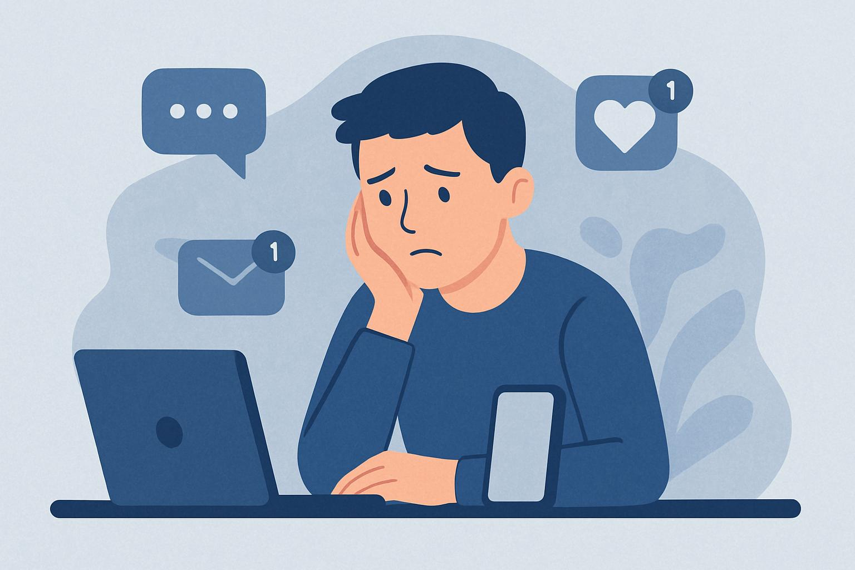

# 6. CONCLUSION

As we drift through digital spaces, chasing connection, we often find ourselves echoing into voids of artificial warmth. *Alone Online* reveals that despite the promise of togetherness, emotional distance persists. True connection requires authenticity, presence, and vulnerability—qualities algorithms cannot fully replicate. While AI can support mental health, it should not replace human touch. A conscious reevaluation of our digital habits, coupled with tech designed for emotional depth, is the key to reconnecting in the age of simulation.

# REFERENCES

1. Turkle, S. (2011). *Alone Together: Why We Expect More from Technology and Less from Each Other*. Basic Books.

2. Hunt, M. G., Marx, R., Lipson, C., & Young, J. (2018). No more FOMO: Limiting social media decreases loneliness and depression. *Journal of Social and Clinical Psychology*, 37(10), 751–768.

3. Orben, A., & Przybylski, A. K. (2019). The association between adolescent well-being and digital technology use. *Nature Human Behaviour*, 3, 173–182.

4. Twenge, J. M., Spitzberg, B. H., & Campbell, W. K. (2019). Less in-person social interaction with peers among U.S. adolescents in the 21st century and links to loneliness. *Journal of Social and Personal Relationships*, 36(6), 1892–1913.

5. Replika AI. (2023). Your AI Friend. Available at: <https://replika.ai>

6. Shensa, A., Sidani, J. E., Lin, L. Y., Bowman, N. D., & Primack, B. A. (2016). Social media use and perceived emotional support among US young adults. *Journal of Community Health*, 41(3), 541–549.

7. Center for Humane Technology. (2020). The Social Dilemma [Documentary]. Netflix.

8. Lanchester, J. (2017). You Are the Product. *London Review of Books*, 39(16), 3–10.

9. Goleman, D. (1995). *Emotional Intelligence: Why It Can Matter More Than IQ*. Bantam Books.

# ACKNOWLEDGMENT

This project is the outcome of research and development under the Department of Computer Science, Rathinam College of Arts and Science. The author expresses sincere gratitude to the department faculty and technical staff for their support and feedback during the project..

# AUTHOR BIOGRAPHY

# PAVENTHAN S is a final-year B.Sc. Computer Science student at Rathinam College of Arts and Science, with interests in artificial intelligence, emotional computing, and human-centered technology. His recent work explores the intersection of empathy and AI through emotionally intelligent systems. He can be reached at paventhanp08@gmail.com. [abinesh1530@gmail.com](mailto:abinesh1530@gmail.com).