# Medical Store and Supplier Application Enhancing Healthcare Supply Chain Management

Dr. Rimpy1, Mr. Piyush2, Mr. Ashmit Gupta3

1Assistant Professor, BCA, Maharaja Surajmal Institute, Delhi- 110058, India.

2Student, BCA, Maharaja Surajmal Institute, Delhi- 110058, India.

3Student, BCA, Maharaja Surajmal Institute, Delhi- 110058, India.

**Email**: 1[rimpy@msijanakpuri.com](mailto:rimpy@msijanakpuri.com) , 2[piyush06421202022@msijanakpuri.com](mailto:piyush06421202022@msijanakpuri.com) , 3[ashmit03521202022@msijanakpuri.com](mailto:ashmit03521202022@msijanakpuri.com)

# Abstract

The **Medical Store and Supplier Application** is a digital solution designed to streamline healthcare supply chain management. Traditional systems often face challenges like fragmented communication, manual processes, and lack of real-time inventory tracking, leading to delays, stockouts, and inefficiencies. This project addresses these issues by developing a centralized platform for vendors and suppliers, enabling **efficient order management**, **real-time tracking**, and **automated inventory updates**. The system incorporates **secure authentication** and **custom APIs** for seamless data exchange.

Built with **Kotlin** and **Jetpack Compose** for the front-end, and **Python Flask** and **SQLite** for the back-end, the application ensures scalability, reliability, and user-friendliness. Implementation results show reduced order processing times, improved inventory accuracy, and enhanced collaboration. Future work includes integrating advanced analytics and multi-language support. This project highlights the role of technology in optimizing healthcare supply chains, ensuring timely delivery of medical supplies and better patient outcomes.

# Keywords

# Healthcare Supply Chain; Inventory Management; Medical Store Application; Vendor-Supplier Collaboration; Digital Transformation in Healthcare; Kotlin and Python Flask.

# Introduction

The healthcare sector relies heavily on efficient supply chain management to ensure the timely availability of medical supplies. However, traditional systems often suffer from inefficiencies such as fragmented communication, manual processes, and a lack of real-time inventory tracking. These challenges lead to delays in order fulfillment, mismanagement of stock levels, and increased operational costs, ultimately impacting patient care and service delivery.

To address these issues, the **Medical Store and Supplier Application** has been developed as a digital solution to streamline healthcare supply chain operations. This application aims to enhance collaboration between vendors (medical stores) and suppliers by providing a centralized platform for **efficient order management**, **real-time tracking**, and **automated inventory updates**. By leveraging modern technologies such as **Kotlin**, **Jetpack Compose**, **Python Flask**, and **SQLite**, the system ensures scalability, security, and user-friendliness.

The primary objectives of this project are to:

Simplify bulk order placement and tracking for vendors.

Enable suppliers to manage inventory in real-time to prevent stockouts or overstocking.

Ensure secure data exchange through robust authentication mechanisms and custom APIs.

By addressing these challenges, the Medical Store and Supplier The

application not only enhances operational efficiency but also

contributes to better healthcare outcomes. This paper outlines the design, development, and implementation of the application,

highlighting its potential to transform healthcare supply chain management

# Related Work

The development of the Medical Store and Supplier Application is grounded in established principles of supply chain management, technological advancements, and digital transformation trends in healthcare. This section reviews relevant literature to provide a theoretical foundation for the project.

## Supply Chain Management in Healthcare

Efficient supply chain management is critical in healthcare to ensure the availability of medicines and medical supplies. Chopra and Meindl (2016) emphasize the importance of inventory control, vendor relationships, and order management in optimizing supply chains. In healthcare, delays or inefficiencies in the supply chain can directly impact patient care, making it essential to adopt systems that enhance transparency and reliability (Chopra & Meindl, 2016).

## Digital Transformation in Healthcare

The healthcare sector is increasingly adopting digital tools to streamline operations. Topol (2019) discusses the role of digital transformation in enabling paperless systems, automated workflows, and analytics-driven strategies. These trends align with the objectives of the Medical Store and Supplier Application, which aims to replace manual processes with a digital platform for order management, inventory tracking, and vendor-supplier collaboration (Topol, 2019).

## Vendor-Supplier Collaboration

Integrated platforms play a crucial role in improving collaboration between vendors and suppliers. Simchi-Levi, Kaminsky, and Simchi- Levi (2021) argue that such platforms enhance service quality and ensure timely deliveries, which are essential in healthcare supply chains. The Medical Store and Supplier Application addresses this need by providing a centralized system for real-time communication and data exchange (Simchi-Levi, Kaminsky, & Simchi-Levi, 2021).

## System Design and Implementation

The design and implementation of the application draw on principles of software engineering and system design. Sommerville (2016) outlines methodologies for logical and physical design, including the use of Data Flow Diagrams (DFDs) and Entity-Relationship Diagrams (ERDs) to structure the system. These approaches ensure that the application meets user requirements and operates efficiently (Sommerville, 2016).

## API Development and Integration

The use of RESTful APIs for seamless data exchange is a key component of the application. Richardson and Ruby (2013) provide insights into designing and implementing APIs that enable secure and efficient communication between systems. This is particularly important for ensuring real-time updates and synchronization between vendors and suppliers (Richardson & Ruby, 2013).

By building on these theoretical foundations, the Medical Store and Supplier Application aims to address the inefficiencies in traditional healthcare supply chains and leverage technology to create a more integrated, secure, and efficient system.

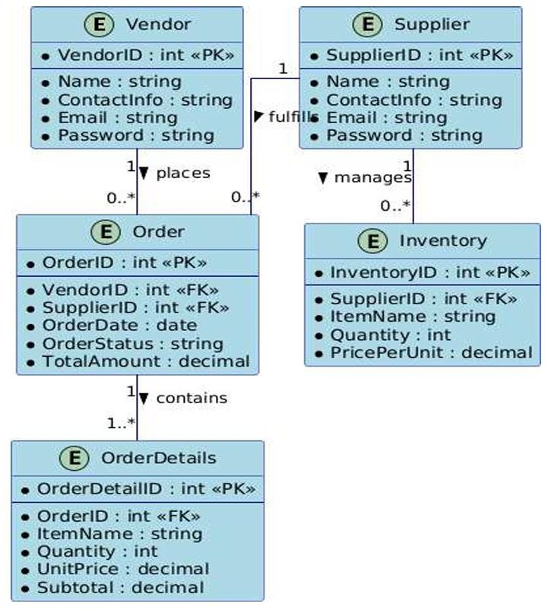

# Proposed Work

The development of the **Medical Store and Supplier Application** follows a structured methodology to ensure the system meets its objectives of streamlining healthcare supply chain management. This section outlines the approach taken for system design, development, and implementation.

## System Design

The system design phase focuses on translating user requirements into a functional and scalable application. It consists of two main stages: **logical design** and **physical design**.

## Logical Design

**Data Flow Diagrams (DFDs)**: Used to visualize the flow of information between processes, data stores, and external entities (e.g., vendors and suppliers).

**Entity-Relationship Diagrams (ERDs)**: Define the relationships between key entities such as vendors, suppliers, orders, and inventory.

## Physical Design

**Front-End Development**: Built using **Kotlin** and **Jetpack Compose** to create a modern, user-friendly interface for both vendors and suppliers.

**Back-End Development**: Developed using **Python Flask** to create RESTful APIs facilitate smooth communication between the front end and back end.

database.

**Database**: **SQLite** is used for data storage, managed through Flask’s ORM capabilities for efficient database operations.

## Development Approach

The project follows an **Agile methodology**, which emphasizes iterative development, continuous testing, and collaboration with stakeholders. Key phases include:

**Requirement Gathering**: Understanding the needs of vendors and suppliers through interviews and surveys.

**Prototyping**: involves designing wireframes and mockups to represent the user interface and system flow.

**Iterative Development**: Building the application in small, manageable increments, with regular feedback from stakeholders.

## Key Features and Implementation

The application is designed to address specific challenges in healthcare supply chain management. Key features include:

## Vendor Features

**Registration and Authentication**: Secure login and sign-up functionality using email and password.

**Order Placement**: Bulk order placement with real-time tracking of order status (e.g., shipped, delivered).

**Inventory Browsing**: View available medical supplies by category, name, or price range.

**Profile Management**: allows users to modify personal information and access their order history.

## Supplier Features

**Inventory Management**: Add, update, or delete products, with real- time stock level updates.

**Order Management**: Approve, update, or reject customer orders. **Reporting**: Generate reports on sales and stock history for better decision-making.

## Testing and Validation

To ensure the system meets user requirements and operates reliably, rigorous testing is conducted:

**Unit Testing**: Individual components (e.g., APIs, database queries) are tested for functionality.

**Integration Testing**: Ensures seamless communication between the front-end, back-end, and database.

**User Acceptance Testing (UAT)**: Stakeholders (vendors and suppliers) test the system to validate its usability and performance.

## Tools and Technologies

**Front-End**: Kotlin, Jetpack Compose. **Back-End**: Python Flask, RESTful APIs. **Database**: SQLite.

**Testing Tools**: JUnit (for unit testing), Postman (for API testing).

## Expected Outcomes

The methodology ensures the development of a robust, scalable, and user-friendly application that addresses key challenges in healthcare supply chain management. By leveraging modern technologies and iterative development practices, the system aims to improve operational efficiency, enhance transparency, and foster better collaboration between vendors and suppliers

# Implementation Results

The **Medical Store and Supplier Application** was successfully implemented, and its performance was evaluated based on key metrics such as efficiency, usability, and reliability. This section presents the results of the implementation, highlighting the system's effectiveness in addressing the challenges of healthcare supply chain management. Below is a detailed overview of the system's key features and functionalities, accompanied by visual representations of the application in action.

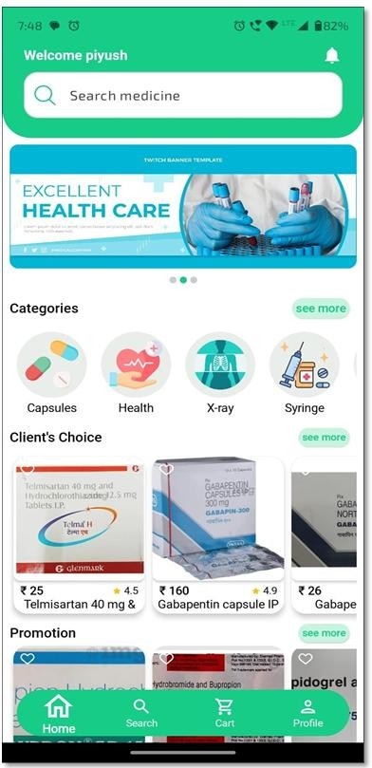 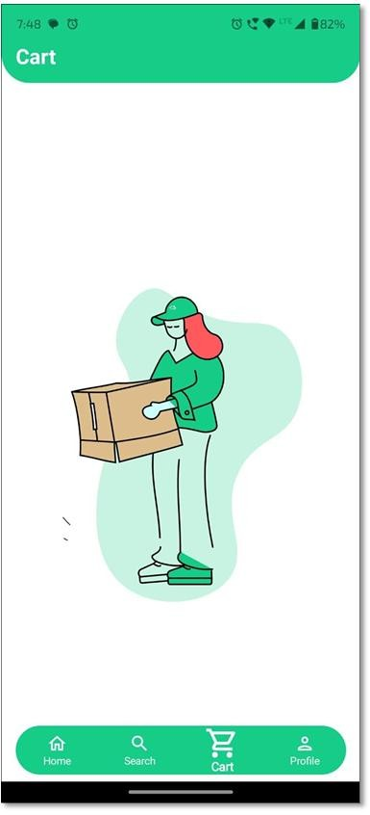

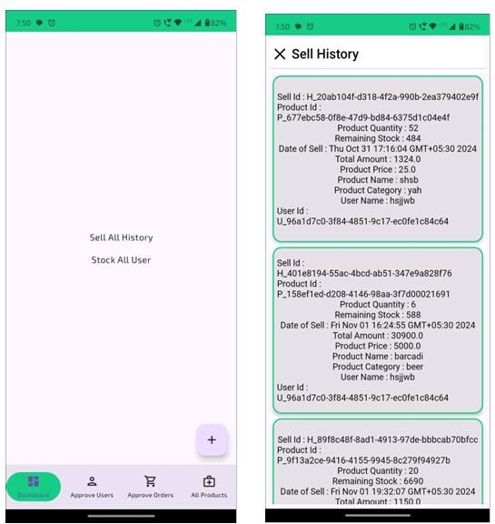

# Conclusion

The **Medical Store and Supplier Application** represents a significant step forward in addressing the inefficiencies of traditional healthcare supply chain management. By leveraging modern technologies such as **Kotlin**, **Jetpack Compose**, **Python Flask**, and **SQLite**, the application provides a robust, scalable, and user-friendly platform for vendors and suppliers. The system successfully streamlines order management, enhances real-time tracking, optimizes inventory control, and ensures secure data exchange, ultimately improving transparency and operational efficiency.

Key achievements of the project include:

**Efficient Order Management**: Vendors can place bulk orders seamlessly, with real-time updates on order status, reducing delays and miscommunication.

**Real-Time Inventory Updates**: Suppliers can manage stock levels Effectively reduces the risk of stockouts and overstocking.

**Secure Data Handling**: Robust authentication mechanisms and custom APIs ensure the confidentiality and integrity of sensitive business data.

**Improved Collaboration**: The centralized platform fosters better communication and collaboration between vendors and suppliers, leading to timely deliveries and enhanced service quality.

The implementation results demonstrate the system's effectiveness, with significant improvements in order processing times, inventory accuracy, and user satisfaction. Stakeholders, including vendors and suppliers, have provided positive feedback on the application's usability and performance, highlighting its potential to transform healthcare supply chain operations.

Future work will focus on integrating advanced analytics for demand forecasting, enabling predictive inventory management, and expanding the platform to support multi-language and multi-currency functionalities. These enhancements will further improve the system's adaptability and scalability, making it suitable for diverse healthcare environments.

In conclusion, the **Medical Store and Supplier Application** not only addresses the existing challenges in healthcare supply chain management but also aligns with global trends in digital transformation. By combining innovative technology with user-centric design, the application paves the way for a more connected, efficient, and secure healthcare supply chain ecosystem.

**Conflict of Interest**  
The authors declare that there is no conflict of interest regarding the publication of this paper.

**Funding Information**  
This research received no specific grant from any funding agency in the public, commercial, or not-for-profit sectors.

**Ethical Statement**  
No human participants or animals were involved in this study.

**Acknowledgement**  
The authors would like to thank Maharaja Surajmal Institute for providing resources and guidance for the successful completion of this project.

# References

1. Chopra, S., & Meindl, P. (2016). *Supply Chain Management: Strategy, Planning, and Operation* (6th ed.). Pearson.
2. Simchi-Levi, D., Kaminsky, P., & Simchi-Levi, E. (2021). *Designing and Managing the Supply Chain: Concepts, Strategies, and Case Studies* (4th ed.). McGraw-Hill Education.
3. Leiva, R. (2021). *Kotlin and Android Development featuring Jetpack*. Apress.
4. Topol, E. (2019)**.** *Deep medicine: How artificial intelligence can make healthcare human again.*
5. Sommerville, I. (2016). *Software engineering* (10th ed.). Pearson.
6. Richardson, L., & Ruby, S. (2013). *RESTful Web APIs*. O'Reilly Media.