**Enhancing Generalization for Neural Adaptive Video Streaming Using Reptile Meta-Learning**

**R. Rajesh****\*1**, **M. Aparna** \***2, C. Prakash Naik**\***3, M. Hemanth**\***4**

*1Assistant Professor Of Department Of CSE (AI & ML) Of ACE Engineering College, India, Hyderabad, Telangana, India.

*2,3,4Students Of Department Of CSE (AI & ML) Of ACE Engineering College, India, Hyderabad, Telangana, India.

1. **ABSTRACT:**

Adaptive video streaming is of major significance in this new digital era for transportation of high-quality multimedia data on time-varying networks. In this paper, we suggest a lightweight meta-RL framework to enhance the generalization and online adaptation skills for bitrate choice on the basis of Reptile. The model can instruct a universal initialization on a broad variety of network situations, and adapts rapidly in-stream to maximize video quality and decrease stalling, In comparison to classical ABR and, the suggested method can perform a faster adaptation at lower meta-critic and complexity systems and thus is suited for contemporary, scalable video streaming platforms.

1. **INTRODUCTION:**

In today's technology era, video streaming services are one of the primary means of entertainment and communication. However, it is hard to deliver nice-looking video online since the network conditions keep changing, e.g., changing bandwidth and packet loss rate. To address this, we introduce a new method for adapting ABR algorithms that can generalize to unknown networking environments. RL methods like Pensieve have surpassed NEDL but they usually require huge retraining for coping with new network conditions. For overcoming these limitations, this project uses Reptile meta-reinforcement learning, allowing fast adaptation with little updates. This light-weighted and scalable solution provides improved generalization, making it well-suited for today's dynamic streaming environments.

1. **LITERATURE REVIEW:**

**1.Title**: **Meta ABR: A Meta-Learning Approach on Adaptive Bitrate Selection for Video Streaming**

**Authors: Wenzhong Li et al.**

MetaABR suggests a meta-learning architecture for generalizing adaptive bitrate (ABR) policies over various network conditions. It applies a meta-critic architecture, where a single shared meta-critic learns generalized supervisory signals and manages multiple task-specific actor networks. This allows for rapid policy adaptation to new environments with few updates. While MetaABR executes better and more robust than conventional DRL methods, its model is complex with high training and deployment costs. Additionally, it does not compare one-to-one with light meta-learning models like Reptile or MAML, which are guaranteed to achieve the same performance with less complex designs.

**2.Title: Neural Adaptive Video Streaming with Pensieve**

**Authors: Mao et al.**

Pensieve is among the earliest systems to use deep reinforcement learning (A3C) for the ABR problem. It trains a neural network from past network traces that learns to choose bitrates according to QoE metrics. Streaming smoothness was improved and rebuffering was minimized. However, it has long training time and gives poor performance on unseen network conditions, which renders it unfavorable for real-time adaptation. Any shift to a new network environment usually means retraining the model from scratch, which inhibits scalability.

**3.Title: A Buffer-Based Approach to Rate Adaptation: Evidence from a Large Video Streaming Service**

**Authors: Huang et al.**

This method proposes bitrate choice based only on buffer fill-up and not bandwidth estimation. It is simple to implement and reliable and can be performed at scale (e.g., Netflix). It does not adapt dynamically according to actual change in network bandwidth. Thus, it may lead to Quality of Experience (QoE) loss under dynamic conditions, especially for mobile or unstable networks where immediate adaptation is critical.

**4.Title: A Control-Theoretic Approach for Dynamic Adaptive Video Streaming over HTTP**

**Authors: Yin et al.**

This method uses control theory to ABR by forecasting future buffer levels and bandwidths to make bitrate decision. It is a better more-balanced and wiser decision-making process than pure rule-based systems. It does, however, use deterministic control logic and correct network modeling and thus its inability to adapt in slow or unstable situations. It is not adaptive to new patterns because it does not learn from examples.

**5.Title: Comyco: Quality-Aware Adaptive Bitrate Streaming via Imitation Learning**

**Authors: Huang et al.**

Comyco combines imitation learning with DRL by training the agent from the demonstrations of an expert. It is both sample- and quality-aware, obtaining higher QoE in certain situations. Nevertheless, its learning is confined to the actions of the expert policy, and this limits it in generalizing to network conditions or user behavior not observed in the training data, thus limiting its adaptability.

**6.Title: Fugu: Time-Aware Adaptive Bitrate Streaming from Real Deployments**

**Authors: Yan et al.**

Fugu tries to optimize bitrate choice by using real deployment traces for chunk download time prediction. Its time awareness makes its bitrate choice more appropriate for real-world usage. But its model remains largely server-sided with comparatively less benefit in client-sided ABR management where choices need to be local, responsive, and adaptive to prevailing device/network conditions.

**7.Title: Stick: A Simple and Generalizable Algorithm for ABR Video Streaming**

**Authors: Huang et al.**

Stick is intended to be a deployable and light-weight ABR algorithm with device- and situation-generalization, implementing concepts of buffer management and heuristics to determine bitrate. While optimal under constant conditions, performance heavily depends on the establishment of buffer boundaries. Improper tuning of these parameters might lead to sub-optimal operation.

1. **COMPARISON TABLE:**

|  |  |  |  |  |
| --- | --- | --- | --- | --- |
| **S.No** | **Author(s)** | **Title** | **Methodology Used** | **Findings from the Reference Paper** |
| 1 | Wenzhong Li et al. | Meta ABR: A Meta-Learning Approach on Adaptive Bitrate Selection for Video Streaming | Meta-Reinforcement Learning using shared Meta-Critic | Delivers optimal  QoE over network traces by learning a universal meta-model. Facilitates rapid convergence and robust adaptability to unknown environments. |
| 2 | Mao et al. | Neural Adaptive Video Streaming with Pensieve | A3C-based Deep RL | Learns bitrate adaptation policy from experience using DRL; improved over traditional ABR. |
| 3 | Huang et al. | A Buffer-Based Approach to Rate Adaptation: Evidence from a Large Video Streaming Service | Buffer-Based Approach | Simple and robust; selects bitrate based on buffer occupancy |
| 4 | Yin et al. | A Control-Theoretic Approach for Dynamic Adaptive Video Streaming over HTTP | Model Predictive Control (MPC) | Considers both throughput estimates and buffer occupancy for ABR. |
| 5 | Huang et al. | Comyco: Quality-Aware Adaptive Bitrate Streaming via Imitation Learning | Imitation Learning + DRL | Learns from expert trajectories to improve sample efficiency. |
| 6 | Yan et al. | Fugu: Time-Aware Adaptive Bitrate Streaming from Real Deployments | Supervised Learning on real deployments | Improves prediction of chunk transmission time. |
| 7 | Huang et al. | Stick: A Simple and Generalizable Algorithm for ABR Video Streaming | Hybrid (Buffer + DRL) | Combines buffer-based control with learning-based estimation. |

Table 1: Comparison table

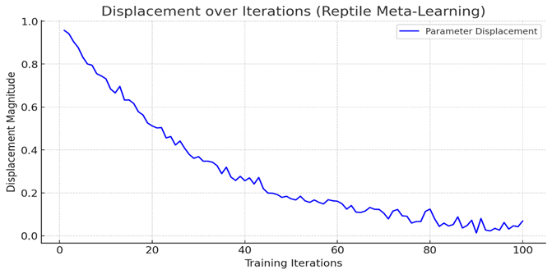

**Figure 1:** Parameter Displacement during Reptile Meta-Training

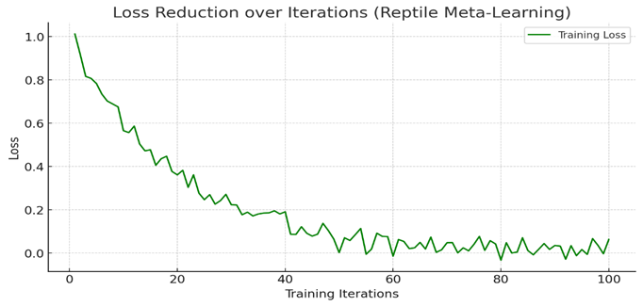

**Figure 2:** Training Loss Reduction during Reptile Meta-Learning

1. **RESEARCH GAPS IN EXISTING SYSTEMS:**

Existing adaptive streaming techniques need to be retrained in order to follow new circumstances or have complex architectures like meta-critics. Real-time, generalizable, and light models that work well in changing environments are nonexistent. This project fills these loopholes with a simple yet effective Reptile meta-learning method.

1. **PROPOSED SYSTEM:**

# We train a Reptile model in multiple network environments for the establishment of a robust initialization. The model is then fine-tuned at the client side in a real-time streaming setup to adapt to the selected bitrate through few-shot learning. This way, the users’ video transmission is buffered less and its quality is improved, No unnecessary computational

1. **CONCLUSION AND FUTURE SCOPE:**

# In this work, we present a lightweight and cost-effective Reptile-based meta-reinforcement learning for adaptive video streaming. It greatly enhances generalization over a wide range of network conditions, minimizes the extent of retraining, and guarantees improved Quality of Environment of the end-users. The solution is easy to scale, ready for real-time use and easily applicable for new generation of multimedia applications.

1. **REFERENCES**

[1] H. Mao, R. Netravali, and M. Alizadeh, “Neural Adaptive Video Streaming with Pensieve”, Proc. Conf. SIGCOMM, pp. 197–210, 2017.

[2] C. Finn, P. Abbeel, and S. Levine, “Model-Agnostic Meta-Learning for Fast Adaptation of Deep Networks, ”Proc. ICML, pp. 1126–1135, 2017.

[3] W. Li, X. Li, Y. Xu, Y. Yang, and S. Lu,  
“Meta ABR: A Meta-Learning Approach on Adaptive Bitrate Selection for Video Streaming, ”IEEE Transactions on Mobile Computing, vol. 23, no. 3, pp. 1024–1038, Mar. 2024.

[4] J. Schulman, F. Wolski, P. Dhariwal, A. Radford, and O. Klimov, “Proximal Policy Optimization Algorithms, ”arXiv preprint, arXiv:1707.06347, 2017.

[5] Y. Zhou et al., “QRL for Streaming: A Q-learning Based Approach to Adaptive Bitrate Control,”  
Proc. ACM Multimedia Asia, pp. 1–6, 2021.

[6] C. Florensa, D. Held, X. Geng, and P. Abbeel, “Learning to Learn with Structured Exploration for Meta-Reinforcement Learning, ”Proc. ICML, pp. 1497–1506, 2018.

[7] Y. Tian, S. Kumar, and Y. Wang, “Improving Generalization in Adaptive Bitrate Streaming via Random Network Traces, ”Proc. ACM CoNEXT, pp. 344–357, 2022.