**Collaborative Student Project Monitoring and Management Tool**

**Abhijna1, Deeksha C A2, Dhanyasri M3, Harshitha M4, Dr Rajashekar M B5**

1Computer Science & Engineering, GSSS Institute Of Engineering and Technology for Women, Mysuru, Karnataka, India

2Computer Science & Engineering, GSSS Institute Of Engineering and Technology for Women, Mysuru, Karnataka, India

3Computer Science & Engineering, GSSS Institute Of Engineering and Technology for Women, Mysuru, Karnataka, India

4Computer Science & Engineering, GSSS Institute Of Engineering and Technology for Women, Mysuru, Karnataka, India

5 Associate Professor, Computer Science & Engineering, GSSS Institute Of Engineering and Technology for Women, Mysuru, Karnataka, India

**ABSTRACT**

The Collaborative Student Project Monitoring and Management Tool is a web-based platform designed to streamline and automate the project management process in academic institutions. It addresses challenges such as communication gaps, deadline tracking, and manual documentation by offering role-based access for students, guides, and coordinators. Students can form groups, propose topics, upload deliverables, and track progress, while guides and coordinators can review submissions, provide evaluations, and manage project workflows. Integrated features like real-time notifications, resource sharing, evaluation uploads, and dashboards enhance collaboration and accountability. The system reduces administrative workload, ensures timely feedback, and maintains transparency in grading and documentation. With a user-friendly interface and robust architecture, it supports scalability, data integrity, and accessibility, making it a comprehensive solution for efficient academic project management.

Keywords: Project Management, Student Portal, Academic Automation, Web Application, Role-Based Access, Django

1. **INTRODUCTION**

Managing academic projects efficiently has become increasingly important in higher education, especially in engineering and technology-driven courses.[1] With the growing complexity of project-based learning, institutions face challenges in coordinating students, tracking deliverables, and ensuring timely evaluations.[2] Traditional, manual approaches often lead to communication breakdowns, delays, and inefficient data handling. These limitations highlight the need for digital transformation in project monitoring and evaluation.[1]

In response, web-based systems have gained prominence for their ability to simplify project workflows, promote accountability, and support collaboration across multiple stakeholders.[3] They offer centralized control, real-time updates, and role-specific access, making them ideal for academic environments.

Current research emphasizes the value of automation and digitization in academic project management.[3] Many studies focus on integrating cloud platforms, dashboards, and notification systems to enhance transparency and performance tracking. Additionally, the use of role-based architecture and secure data management has become a standard for maintaining academic integrity and user accessibility.[4]

This project introduces a *Collaborative Student Project Monitoring and Management Tool* designed to modernize how institutions manage student projects. It provides a scalable, user-friendly solution that enhances communication, streamlines documentation, and ensures efficient evaluation processes.[4] This tool addresses a critical need in academia by bridging the gap between students, faculty, and administrators through technology-driven solutions.[3]

1. **METHODOLOGY**

The development of the *Collaborative Student Project Monitoring and Management Tool* involved a structured and systematic methodology to ensure the creation of an efficient, scalable, and user-friendly web-based application.[2] This section outlines the methods and processes followed in the research and development phases, including system design, technology stack selection, data flow modeling, and implementation strategy.[3] The goal was to automate student project tracking and evaluation while ensuring role-based accessibility for students, guides, and coordinators.

**2.1 System Design and Architecture**

The system follows a role-based, modular architecture that supports three primary user roles—student, guide, and coordinator. Each role has access to specific modules relevant to their functions.[5] The design began with requirement gathering and was followed by use case modeling, schema design, and flow chart development.

A relational database was modeled to establish relationships between users, project groups, submissions, and evaluations.[6] Django, a Python-based web framework, was selected for backend development due to its rapid development capabilities and robust security features. HTML, CSS, Bootstrap, and JavaScript were used for frontend design to ensure a responsive and accessible user interface.

**2.2 Development Process and Technologies Used**

The development followed the Agile methodology, enabling iterative design, feedback, and testing cycles. The system was built using:

* **Django (Python):** For backend logic, user authentication, URL routing, and ORM-based database interactions.
* **HTML/CSS/Bootstrap:** For designing responsive layouts and intuitive navigation.
* **JavaScript:** For client-side interactivity and dynamic updates.
* **MySQL:** As the database management system to store user, project, and evaluation data securely.

The project was developed in multiple phases:

* **Phase 1:** Designing the database schema and setting up authentication and user roles.
* **Phase 2:** Implementing student dashboards with project upload, team creation, and status tracking.
* **Phase 3:** Building guide and coordinator dashboards for evaluation and project monitoring.
* **Phase 4:** Testing and deployment on a local server environment.
  1. **Functional Modules**
* A**uthentication Module:** Secure login for students, guides, and coordinators.
* **Group Management Module:** Enables students to form and manage project teams.
* **Submission Module:** Allows students to upload deliverables and receive feedback.
* **Evaluation Module:** Guides upload evaluation sheets and feedback.
* **Notification System:** Sends real-time alerts and updates for deadlines and submissions.
* **Admin Panel:** Provides coordinators with access to assign guides and track all ongoing projects.

1. **MODELING AND ANALYSIS**

The *Collaborative Student Project Monitoring and Management Tool* is developed using a modular and layered architecture model. It incorporates client-server interaction with Django as the backend framework and a MySQL database for structured data storage. Each module of the system was analyzed based on functionality, usability, and performance during development and testing.

The system includes three core user models:

* **Student**: Can form groups, upload project reports, and track progress.
* **Guide**: Can view assigned groups, provide feedback, and upload evaluation sheets.
* **Coordinator**: Manages faculty-student assignments, modifies groups, and oversees submission tracking.

.

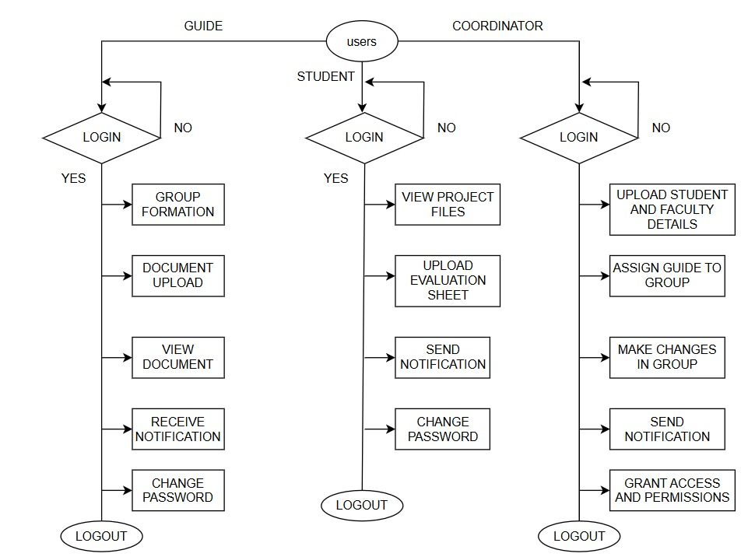

**Figure 1:** The flow chart depicting the role-based architecture and functionalities

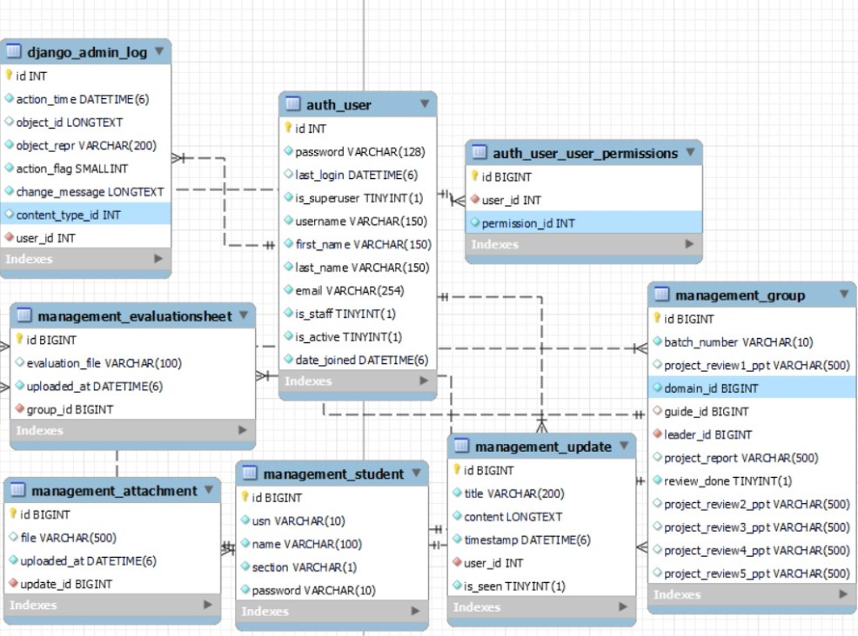

**Figure 2:** Schema diagram representing the database.

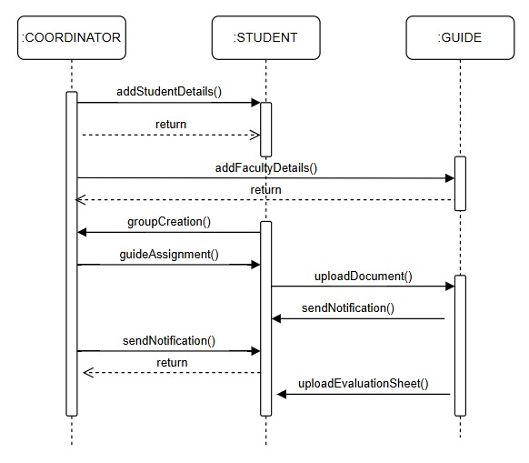

**Figure 3:** System Sequence Diagram

**System Components and Interaction:**

* **Frontend**: Built using HTML, CSS, Bootstrap, and JavaScript for responsive UI.
* **Backend**: Powered by Django to handle logic, user authentication, and routing.
* **Database**: MySQL used to manage users, submissions, groups, evaluations, and notifications.

A schema diagram and flowchart were designed to map the relationships and interactions between users and features, ensuring smooth data flow and access control throughout the platform.

1. **RESULTS AND DISCUSSION**

The implementation of the system achieved the core objectives set at the beginning of the project. After deployment and testing, the following results were observed:

* **Role-Based Access Control**: Students, guides, and coordinators accessed only their relevant modules, ensuring secure interaction.
* **Real-Time Project Tracking**: Coordinators and guides could monitor submissions and evaluations live through their dashboards.
* **Error Reduction**: The paperless submission and validation process helped minimize common submission mistakes.
* **Improved Communication**: Notification and feedback systems allowed for timely updates and responses among users.
* **User-Friendly Interface**: The use of Bootstrap and clear navigation resulted in positive usability feedback from testers.

These outcomes confirm that the tool offers a reliable, scalable, and efficient platform for managing student academic projects in a collaborative environment.

1. **CONCLUSION**

The *Collaborative Student Project Monitoring and Management Tool* successfully addresses the inefficiencies in traditional academic project handling. Through automation and centralized management, it allows students, guides, and coordinators to work in a synchronized and transparent environment. The system eliminates paperwork, simplifies communication, and enables real-time monitoring of submissions and evaluations. Its scalable design ensures it can be adopted by educational institutions of various sizes to improve project management practices. Future work may involve integrating analytics dashboards and mobile access for broader usability.

1. **ACKNOWLEDGEMENTS**

We express our sincere gratitude to our project guide, **Dr. Rajashekar M B**, for his valuable support and guidance. We also thank the faculty and staff of the **Department of Computer Science & Engineering**, GSSSIETW, for their continuous encouragement. Our heartfelt thanks to our families and peers for their support throughout this project.

1. **REFERENCES**
2. Django Software Foundation. 'The Django Web Framework.' https://www.djangoproject.com
3. Bootstrap Documentation. 'Front-End Toolkit.' https://getbootstrap.com
4. MySQL Documentation. 'MySQL Reference Manual.' https://dev.mysql.com
5. Nisha Soms et al. 'Student Project Management System,' International Journal of Emerging Trends in Engineering Research, 2021.
6. Abu Bakar, Marini et al. 'Learning Management System Technologies and Software Solutions for Online Teaching,' IGI Global, 2011.
7. TRACE Project Research Paper. 'Final Year Supervision Management System for Project Monitoring,' 2009.