**ANALYSIS OF SURFACE ROUGHESS AND TOOL WEAR RATE FOR TURNING PARAMETERS USING TAGUCHI OPTIMIZATION TECHNIQUE**

**Ms. Shilpa Anil Wagh , Dr. V. S. Aher.**

1P.G. Research Scholar, Mechanical Design Engineering, Amrutvahini College Of Engineering, Sangamner, Maharashtra, India.

2Professor, Mechanical Engineering Department, Amrutvahini college of Engineering, Sangamner ,Maharashtra ,India.

**ABSTRACT:**

The study aims to determine the effectiveness of vegetable and synthetic oils in improving machining performance, particularly in small-scale industries where cost constraints and environmental regulations are significant concerns. The input parameters of Cutting Speed, Depth of Cut, Feed rate and Fluid Flow rate is optimized using Taguchi analysis method. Preliminary results suggest that both types of oils offer unique advantages in terms of lubrication properties, with the choice of lubricant potentially influencing tool wear and surface quality. This investigation provides valuable insights into optimizing machining processes while promoting sustainable manufacturing practices in small-scale operations. The experimental setup involves the use of a lathe machine where the turning process is conducted under varying lubrication conditions—vegetable oil and synthetic oil, each delivered in minimal quantities through the MQL system. Tool life is assessed by measuring the wear and deterioration of the cutting tool over a specified number of machining cycles, while surface finish is evaluated through roughness measurements using a Talysurf.

**Keywords:** Minimum Quantity Lubrication, Surface Roughness, Tool Wear Rate

1. **INTRODUCTION :**

Turning is one of the most common of metal cutting operations. In turning, a work piece is rotated about its axis as single-point cutting tools are fed into it, shearing away unwanted material and creating the desired part. Turning can occur on both external and internal surfaces to produce an axially-symmetrical contoured part. The two basic requirements for turning are a means of holding the work while it rotates and a means of holding cutting tools and moving them to the work. The work may be held on one or by both its ends. Turning can produce long chips that may interfere with the work in progress. The right cutting tools and proper lubrication are used to control chip formation.

Green manufacturing is a modern manufacturing strategy. It is imperative for the 21st centuries manufacturing industry. Its ultimate goal is to reduce and to minimize the environmental impact and also the proper resource consumption during a product life cycle. In the area of manufacturing, machining plays an important role. The machining processes have an important place in the traditional production industry. But during the machining process, the cutting fluid is the main sources of environmental pollution. Many industrial practices show that an optimal selection for cutting fluid is an effective way to reduce the production cost. The selection of cutting fluid in machining was examined. The cutting fluids applied in machining processes basically have three characteristics. These are Cooling Effect, Lubrication Effect, Taking away formed chip from the cutting zone. Many industrial practices show that making an optimal selection for cutting fluid is an effective way to reduce the production cost. This also helps to minimize the environmental pollution which is generated by cutting fluid. By optimizing cutting oil consumption organizations can reduce production cost, waste disposal costs, increase productivity of cutting oil and to improve workplace safety and health. Reduction of environmental pollution has been the main concern in the present day metal cutting industry.

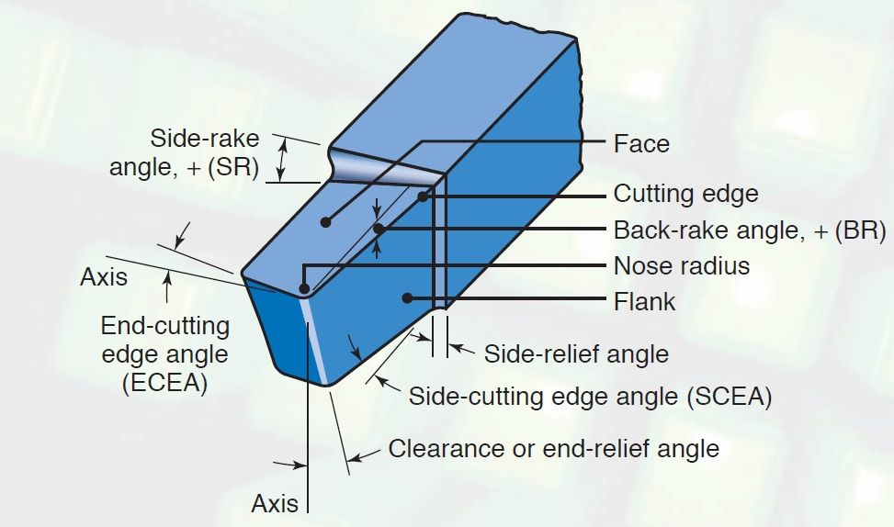

**Figure 1** Single Point Cutting Tool

The High speed tool is used here for following reasons: High working hardness, High wear resistance, excellent toughness, Compressive strength, High retention of hardness and red hardness, Strength to prevent breakage on the cutting edge. The cutting part consists of the working surfaces. It includes the top surface (face), along which the chip formed in the machining process comes off; and the side relief and end relief surfaces, which face the machined surface of the work piece. In order to increase its strength, the tool point is given a cutting edge that is circular (with a radius of 0.5-2 mm) or is in the form of a transitional cutting edge (0.5-3 mm long).

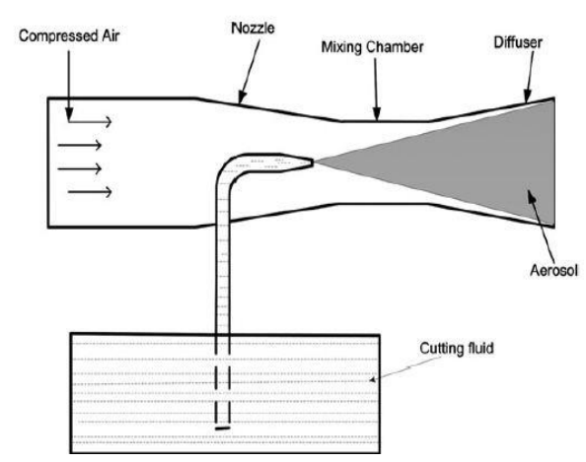

**Figure 2** Working Principle of MQL

MQL is the process of applying minute amounts of high quality lubricant directly to the cutting tool/work piece interface instead of using traditional flood coolants. MQL minimizes your environmental impact by significantly reducing fluid usage and eliminating the need for coolant treatment and disposal. These near-dry machining benefits are multiplied further when using 100% biodegradable lubricants which are formulated from renewable plant-based oils. When considering these facts along with the performance benefits of biodegradable lubricants and MQL, it becomes obvious that this is the future of metal cutting fluid. The lubricant is sprayed with the help of external supply system which can be one or more nozzles. The amount of coolant used in MQL is about 3-4 order magnitude less than the amount commonly used in flood cooling condition. For example up to 10 liters of coolant is used in flood coolant type lubrication system.

1. **OBJECTIVES :**
2. To identify the surface roughness and tool wear rate for varying cutting speed, depth of cut, feed rate under dry and wet lubrication condition.
3. To study the effect of cutting parameters on surface roughness and tool wear using edible oil as coolant.
4. To analyse the processing parameter for best surface finish and tool wear rate for varying cutting speed, depth of cut and feed rate using Taguchi Analysis and Anova methodology.
5. To minimize the coolant quantity for best surface finish and tool wear and to reduce the cost of coolant consumption.
6. To analyse the environmental benefits and economic feasibility of using vegetable oils as compared to synthetic oils in the MQL setup considering biodegradability, toxicity, cost of operation, and coolant disposal.

1. **METHODOLOGY :**

**Figure 3** Methodology of Research Work

Green manufacturers try to make products that have a lower environmental impact than other products. Manufacturing industries related to machining can reduce their environmental impact by making green products. The objective factors of the decision making green products arises due to the problem of cutting fluid selection for Green Manufacturing is a complex multi-objective decision making problems. The objective factors of the decision making problems for traditional cutting fluid selection Environmental Impact should be considered, where E means to minimize the environmental impact. Ecological Impact: Exhaust Gas emission, solid waste generated and waste water incurred by the use of hazardous waste water incurred by the use of hazardous waste cutting fluid. Impact of occupational health and safety and sanitation management: Toxicities of additives, decreasing action of mineral, oil etc.

1. **EXPERIMENTAL METHODS AND MATERIALS :**
   1. ***Cutting Tool :***

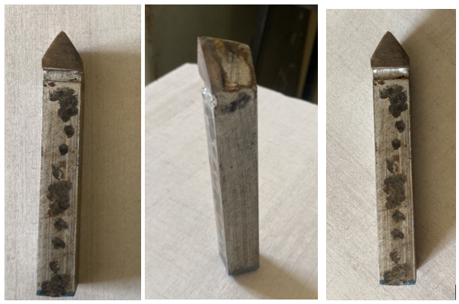

**Figure 4** Carbide Tip Cutting Tool

Tungsten carbide is the most commonly used carbide material in cutting tools, but there are several other types of carbide, each with their unique properties and applications. By understanding the differences between these carbide materials, you can make an informed decision and achieve optimal results. Carbide Tip Cutting tool provide prominent characteristics as follows-

* 1. ***Lathe Attachments :***

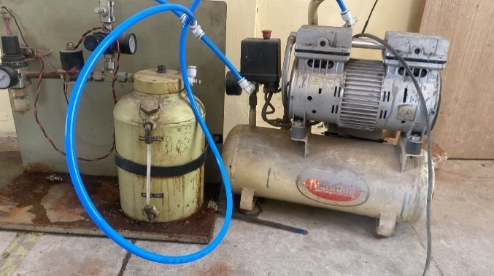

**Figure 5.** Attachment of Pump, Stand and Compressor

* 1. ***Specimen :***

The material selected here is made of Mild Steel EN8 Grade. The term Mild Steel applies to all low carbon Steel that does not contain any alloying elements in its makeup and has a carbon content that does not exceed 0.25%. The term “Mild” is used to cover a wide range of specifications and forms for a variety of Steel.

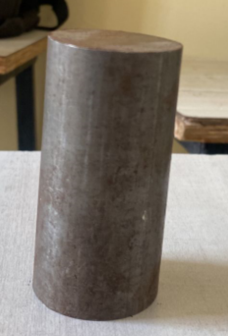

**Figure 6.** Working Specimen

* 1. ***Cutting Parameters :***

There are three factors and three design level. The factors are now assign with the values in the table 1

**Table 1.** Cutting Parameters for Dry Condition

|  |  |  |  |
| --- | --- | --- | --- |
| **Level** | **Spindle Speed (RPM)** | **Depth of Cut (mm)** | **Feed rate (mm/rev)** |
| 1 | 120 | 0.25 | 15.07 |
| 2 | 140 | 0.5 | 17.25 |
| 3 | 160 | 0.75 | 19.48 |

* 1. ***L9 Array and surface Roughness with Tool Wear Rate :***

**Table 2.** Orthogonal AL9 Array with Input and Output Parameters

|  |  |  |  |  |  |
| --- | --- | --- | --- | --- | --- |
| **Trail No.** | **Spindle Speed** | **Depth of Cut** | **Feed rate** | **Surface Roughness**  **(Ra μm)** | **Tool Wear Rate** |
|  | 120 | 0.25 | 15.07 | 1.674 | 0.18 |
|  | 120 | 0.5 | 17.25 | 1.71 | 0.2 |
|  | 120 | 0.75 | 19.4 | 1.853 | 0.19 |
|  | 140 | 0.25 | 17.25 | 1.479 | 0.21 |
|  | 140 | 0.5 | 19.4 | 2.512 | 0.12 |
|  | 140 | 0.75 | 15.07 | 2.755 | 0.21 |
|  | 160 | 0.25 | 19.4 | 2.502 | 0.17 |
|  | 160 | 0.5 | 15.07 | 2.822 | 0.19 |
|  | 160 | 0.75 | 17.25 | 2.973 | 0.16 |

* 1. ***Signal to Noise Ratio :***

**Table 3.** Multi Criteria S/n Ratio for Dry Condition

|  |  |  |  |
| --- | --- | --- | --- |
| **Trial** | **Surface R.** | **TWR** | **S/n Ratio** |
|  | 1.674 | 0.18 | -1.51473 |
|  | 1.71 | 0.2 | -1.70863 |
|  | 1.853 | 0.19 | -2.39263 |
|  | 1.479 | 0.21 | -0.47575 |
|  | 2.512 | 0.12 | -4.99999 |
|  | 2.755 | 0.21 | -5.81729 |
|  | 2.502 | 0.17 | -4.97545 |
|  | 2.822 | 0.19 | -6.02048 |
|  | 2.973 | 0.16 | -6.46616 |

**Table 4** Optimized Parameter as per S/N Ratio SR and TWR

|  |  |  |
| --- | --- | --- |
| **Level** | **S/N ratio Parameter** | **Value** |
| Spindle Speed | Level 1 | 120 Rpm |
| Depth of Cut | Level 2 | 0.5 mm |
| Feed Rate | Level 3 | 19.48 mm/rev |

Table 5. **Analysis of Variance for Dry Condition**

|  |  |  |  |  |  |
| --- | --- | --- | --- | --- | --- |
| **SSource** | **DF** | **Adj SS** | **Adj MS** | **F-Value** | **P-Value** |
| Regression | 3 | 33.464 | 11.1547 | 6.89 | 0.032 |
| Spindle Speed | 1 | 23.3883 | 23.3883 | 14.45 | 0.013 |
| Depth of Cut | 1 | 9.9077 | 9.9077 | 6.12 | 0.056 |
| Feed Rate | 1 | 0.168 | 0.168 | 0.1 | 0.76 |
| Error | 5 | 8.0904 | 1.6181 |  |  |
| Total | 8 | 41.5544 |  |  |  |

1. **RESULT AND DISCUSSIONS :**

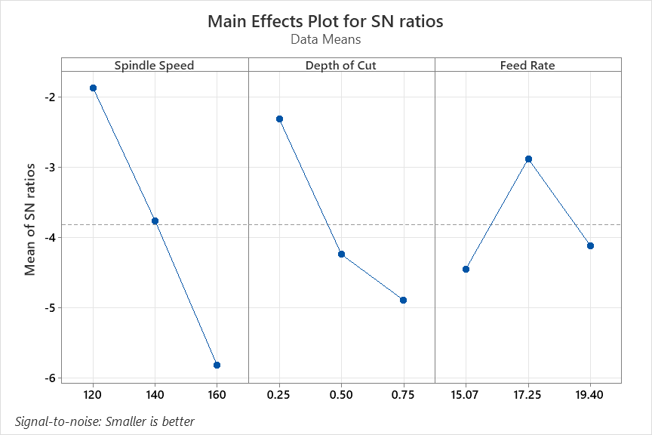

**Figure 7.** Effect analysis of Cutting Parameters on Surface Roughness and Tool Wear

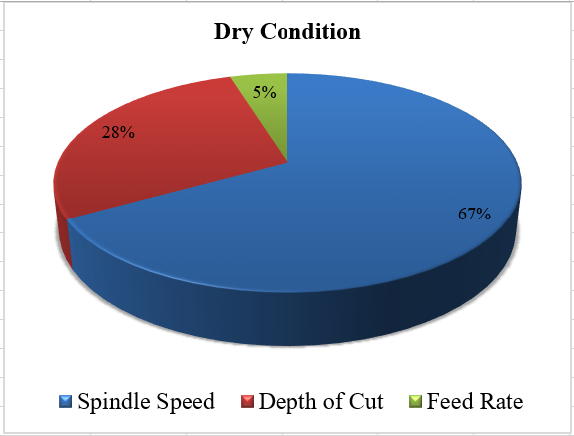

**Figure 8.** Contribution of Cutting Parameters on Surface Roughness and Tool Wear

* The Surface roughness and tool wear rate has been measured for dry and wet conditions. The cutting parameters of Spindle speed, Depth of cut and feed rate were same as that of dry and wet on the contrast the wet condition was added with one more input factor of Fluid Flow Rate**.** The Figure 7.3, explains the effect of cutting parameters and fluid flow on SR of workpiece and TWR of tool.
* The values determined during the experimentation are converted to Signal to Noise ratio for smaller the better the criteria. Hence smaller the S/n ratio better the results are achieved.
* ANOVA is the analysis of variance to determine the effect on each input parameter on the output of the experimental analysis. As there are nine different trials with varying cutting parameters like spindle speed, depth of cut, feed rate and fluid flow rate, there are certain changes in the output of surface roughness as well as tool wear rate
* As evident in the figure 7 and figure 8, spindle speed plays the most significant parameter for achieving the low SR and TWR. If the figure 8, is closely observed the second most significant parameter is the depth of cut. The Minimum quantity lubrication can be achieved using the taguchi analysis technique for surface roughness and tool wear rate of material.

1. **CONCLUSION**

* EN8 Mild steel is the material which is being selected for turning trails which is done on CNC lathe machine. Single Point Cutting tool is used for CNC lathe turning.
* Orthogonal L9 array is formed and nine different trials have been carried out making the as constant parameter and varying spindle speed, the depth of cut and feed rate and fluid flow rate.
* The Tool wear rate and surface roughness is calculated for each parameter along with the mean process levels. The measured values of SR and TWR are transfer to Signal to Noise ratio for lower the better criteria.

1. **REFERENCES**
2. Sachin Agarwal and Nilesh Patil, “Experimental study of non-edible vegetable oil as a cutting fluid in machining of M2 Steel using MQL”, Procedia Manufacturing, Elsevier Publication, 2020.
3. N.R. Dhar, M. Kamruzzaman, Mahiuddin Ahmed, “Effect of minimum quantity lubrication (MQL) on tool wear and surface roughness in turning AISI-4340 steel”, Journal of Materials Processing Technology, Elsevier Publication, 2006.
4. Nilesh C. Ghuge, Dattaraya D. Palande, “The Emergence of MQL with Vegetable Oil as a Green Manufacturing Technique: A Review”, Samriddhi Volume 14, Issue 1, 2022.
5. W.L.R. Fernandoa, N. Sarmilana, K.C. Wickramasinghea, H.M.C.M. Herathb, G.I.P. Perera, “Experimental investigation of Minimum Quantity Lubrication (MQL) of coconut oil based Metal Working Fluid”, Materials Today: Proceedings, Elsevier Publication, 2020.
6. Ms. Madhuriya jadhav, Dr. Sachin Agrawal, “Comparative experimental analysis of non-edible vegetable oil as cutting fluid - a review”, International Research Journal of Engineering and Technology, 2024.
7. Balwan Singh, Dr. Tushar Gupta, “Performance evaluation of non-edible oils blends as cutting fluid in turning operation of mild steel”, Journal of Emerging Technologies and Innovative Research, 2023.
8. M. Zeeshan Siddique, “Parametric Analysis of Tool Wear, Surface Roughness and Energy Consumption during Turning of Inconel 718 under Dry, Wet and MQL Conditions”, Journal of Machines, MDPI, 2020.
9. Havva Demirpolat, “Comparison of Tool Wear, Surface Roughness, Cutting Forces, Tool Tip Temperature, and Chip Shape during Sustainable Turning of Bearing Steel”, Journal of Materials, MDPI, 2023.
10. M. Balamurugan, Sivakumar Subramani, Venkatasudhahar Murugesan, “Spray characteristics of non-edible oils in MQL systems for improved material machining”, Revista Materia, 2024.
11. Bogdan Arsene, “MQL-Assisted Hard Turning of AISI D2 Steel with Corn Oil: Analysis of Surface Roughness, Tool Wear, and Manufacturing Costs”, Journal of Metals, MDPI, 2021.
12. Ali, S.M; Dhar, N.R & Dey, S.K, “Effect Of Minimum Quantity Lubrication (Mql) On Cutting Performance In Turning Medium Carbon Steel By Uncoated Carbide Insert At Different Speed-Feed Combinations”, Advances in Production Engineering & Management, 2011.
13. Tamboli Mubashir Chand, Kartik Raju Daswani, Mohammed Taquee, “Design and Fabrication of Minimum Quantity Lubrication (MQL) Setup”, International Journal of Innovative Science and Research Technology, 2017.