**SECURITY DOCKER ECOSYSTEMS: AUTOMATED AUDITS AND MITIGATION FRAMEWORK BASED ON CIS**

**Dharani Priya S1, Krishna A.S.2**

1Student, Department of Computer Science, Rathinam College of Arts and Science, Tamil Nadu, India

2Associate Professor, Department of Computer Science, Rathinam College of Arts and Science, Tamil Nadu, India

**ABSTRACT**

Security Docker Ecosystems is a computerized auditing and mitigation system designed specifically for containerized environments. The project utilizes the Docker Security tool and maps its checks to the Center for Internet Security (CIS) Docker in order to verify compliance and increase container security. The system performs thorough analysis of Docker hosts and containers and reports misconfigurations, vulnerabilities, and departures from best practices. It streamlines important tasks like environment scanning, compliance scoring, logging, and reporting, thus minimizing manual overhead and enhancing audit accuracy. With modularity and scalability in mind, the system facilitates simple integration with CI/CD pipelines and future security modules. Simplifying the process of security auditing and encouraging adherence to CIS standards, this framework enables DevSecOps teams, system administrators, and cybersecurity professionals to ensure secure and resilient Docker-based infrastructures.

**Key words:Docker Security, CIS, Automated Audits, Vulnerability Mitigation, Compliance Automation.**

1. **INTRODUCTION**

With today's more containerized IT environments, organizations increasingly depend upon Docker to deploy and manage applications because it is portable, flexible, and scalable. But with this accelerated adoption of containerization comes new security risks that legacy security models are too often unprepared to manage. With evolving cyber threats and misconfigurations now being the top reason containers get breached, there is a greater need than ever before for an automated and end-to-end auditing framework. In response to this, Security Docker Ecosystems: Automated Audits and Mitigation Framework Based on CIS has been created. This project aims to improve the security posture of Docker-based systems by incorporating automated audit functionality with best-practice as defined by the Center for Internet Security (CIS). In contrast to traditional approaches that depend on manual auditing or disjointed tools, this framework integrates different security checks, reporting capabilities, and mitigation methods into a single, automated system. It enables DevSecOps teams, system administrators, and security experts to actively scan and remediate Docker vulnerabilities proactively.

Utilizing tools such as Docker Security in combination with bespoke shell scripts, the framework continuously monitors and audits Docker containers and hosts. It includes features such as rule checks, real-time report generation, misconfiguration alerts, and potential risk categorization. Additionally, the project is capable of integration with container orchestration platforms and supports convenient customization for organization-specific compliance policies. Through an emphasis on automation, modularity, and usability, the Security Docker Ecosystem framework reduces the labor-intensive burden of Docker security assessments. Its scalable design and comprehensive reporting make it appropriate for large-scale production environments as well as individual developers looking to implement secure container practices. In the end, this project provides a pragmatic and efficient solution to enhance container security, minimize operational risk, and meet compliance standards in contemporary DevOps pipelines.

* 1. **Objective of the project**

The goal of this project is to create an automated security auditing and mitigation tool for Docker environments. It is designed to improve container security by identifying misconfigurations, vulnerabilities, and compliance deviations according to the CIS Docker security. The project emphasizes automating the auditing process to minimize manual effort and provide consistent, reliable security checks on different platforms. In addition, it aims to use automated or guided remediation mechanisms to effectively handle the issues detected. Through ongoing monitoring and imposing security best practices, the project enables organizations to have a solid and secure Docker environment, reducing possible threats and enhancing overall system resilience.

* 1. **Scope of the project**

The scope of this project is to design, develop, and deploy an automated security auditing and mitigation framework specifically for Docker ecosystems. With containerization technologies such as Docker becoming the backbone of modern software development and deployment, securing these environments has become an essential requirement. This project meets the increasing need for automated tools that are capable of detecting vulnerabilities, enforcing security best practices, and minimizing the risks inherent in misconfigured Docker instances.The project uses industry-standard benchmarks, mostly the CIS Docker security, to scan Docker hosts and containers for security compliance. It emphasizes auditing configurations, identifying deviations from best practices, and automatically proposing or applying corrective measures where necessary. The project aligns lightweight scripting and containerization methods with the need to preserve high performance and portability in a wide range of Linux-based operating systems, cloud setups, and hybrid infrastructure.Through offering automated scanning, comprehensive reporting, and remediation recommendations, the project is envisioned to reduce the role of human error, take less time, and enhance the organization's security operations that implement Docker. It facilitates proactive security risk management and aids continuous compliance without affecting operational efficiency to a notable extent. The target audience for this system consists of DevOps engineers, cybersecurity experts, IT administrators, and organizations with a significant dependence on containerized applications. In the future, the project can be scaled up to include support for Kubernetes clusters, add AI-based anomaly detection, and provide real-time security monitoring features, thereby increasing its scope and utility in the changing landscape of container security.

1.3**Existing System**

In the field of containerized application security, there are many scripts and tools available to remedy Docker-related weaknesses, such as the well-known Docker Security, individual shell script options, and hand-typed configuration checklists. These tools are, however, usually broken and need cybersecurity experts to run and interpret results manually, which is inefficient and susceptible to misconfiguration.The systems today do not have an automated remediation capability, leaving it to the user to interpret and implement security hardening recommendations. There is no single framework that integrates auditing, real-time monitoring, reporting, and remediation into a single process. This fragmented implementation results in sluggishness in determining misconfigurations, implementing the fixes, and producing compliance reports.Another deficiency in the current solutions is they are not portable and scalable. Although some software tools are configured for simple security audits, it is not highly optimized for consolidation across large or enterprise Docker infrastructure. Most of these tools also rely heavily on particular host configurations, and deployment in diverse environments is therefore complicated and prone to errors.Additionally, the lack of customization, reporting standardization, and enforcement of security policy restricts further the use of existing systems.Furthermore, as organizations embrace microservices and container orchestration at scale, the inability to manage and secure these environments as a whole heightens the threat of security breaches.

1. **LITERATURE SURVEY**

**1.NIST Best Practices for Container Hardening (2022)**

Suggests practices such as reducing privileges and network segmentation to harden containers.

**Remark:** Extensive practices recommended, yet too much hardening could affect performance.

**2.Clair by CoreOS (2023)**

Conducts static scanning of security images for identified vulnerabilities.

**Remark:** Reliable for image scanning but needs ongoing database updates to remain effective.

**3.Gartner Report on Container Security (2023)**

Emphasizes the importance of automated and scalable container security tools.

**Remark:** Emphasizes that automation makes security better but introduces integration and resource management issues.

**4.Anchore Engine (2022)**

An open-source Docker security image scan the security vulnerabilities and policy compliance.

Note: Policy-based but requires extensive configuration for varied environments.

**5.Sysdig Falco (2023)**

A behavioral activity monitoring tool to catch abnormal activity in containers.

Note: Great for runtime security, but it is required to tune rules for individual environments.

**6.Twistlock by Palo Alto Networks (2023)**

A full stack cloud-native security platform for containers and serverless applications.

**Remark:** Highly effective but costly and usually overkill for small infrastructures.

**7. Aqua Security Research (2022)**

Container vulnerability research report identifying prevalent vulnerabilities such as privilege escalation and unscanned images.

**Remark:** Illustrates the fact that a significant root of breaches is disregarding basic steps in container hardening.

**8.Harbor by CNCF (2023)**

Cloud-native registry scanning Docker images for vulnerability prior to deployment.

**Remark:** Assists enforcing vulnerability scanning but depends on out-of-band CVE feeds.

1. **METHODOLOGY**

The approach in this project targets the development of an automated audit and mitigation tool for Docker environment hardening through CIS.The initial work on this project was identifying requirements through learning about typical security vulnerabilities in Docker and correlating them with best practices in the industry. The project created a modular system by utilizing automation utilities like Docker Security and in-house shell scripts to undertake continuous audits and impose security practices. The scripts were created with the help of shell scripting for lightweight automation and had Docker APIs integrated to facilitate hassle-free interaction with Docker hosts. The framework was containerized by using Docker itself to provide portability and a consistent performance environment across various platforms such as Linux and Termux. Implementation was done by initializing local test environments, executing automated scans, identifying misconfigurations, and performing mitigation steps. Intensive testing, such as unit testing and system verification, was carried out to ensure effectiveness and reliability. Then, elaborate reporting mechanisms were integrated to reflect clear information on vulnerabilities and corrective measures. Continuous improvement and feedback were envisaged to ensure the framework stays current with emerging security threats.

* 1. **System Design and Architecture**

1. Core Framework

* Uses Docker for Security as the core auditing engine.
* Queries Docker hosts for vulnerabilities against CIS security benchmarks.

2. Automation Layer

* Developed based on shell scripting to automate security audit and mitigation processes.
* Handles scheduling of audits, results parsing, and execution of fixes.

3. Containerized Deployment

* The framework is fully containerized for simple deployment.
* Provides platform independence across Linux-based systems and Termux environments.

4. Reporting Module

* Fetches results of audits and produces detailed user reports.
* Supports human-readable reports for improved readability of vulnerabilities.

5. Logging and Monitoring

* Remembers all the steps and output for audit and traceability needs.
* Assists tracking security posture throughout time.

6. Feedback and Updates

* Has an integrated feedback to incorporate new benchmarks and security standards.
* Eases continuous improvement based on inputs from users and changing threats.

7. Scalability and Extensibility

* Modular architecture enables simple expansion (e.g., cloud security scanning, AI-based threat detection).
* Efficiently scales from single-node installations to enterprise installations.

1. **RESULTS AND DISCUSSION**

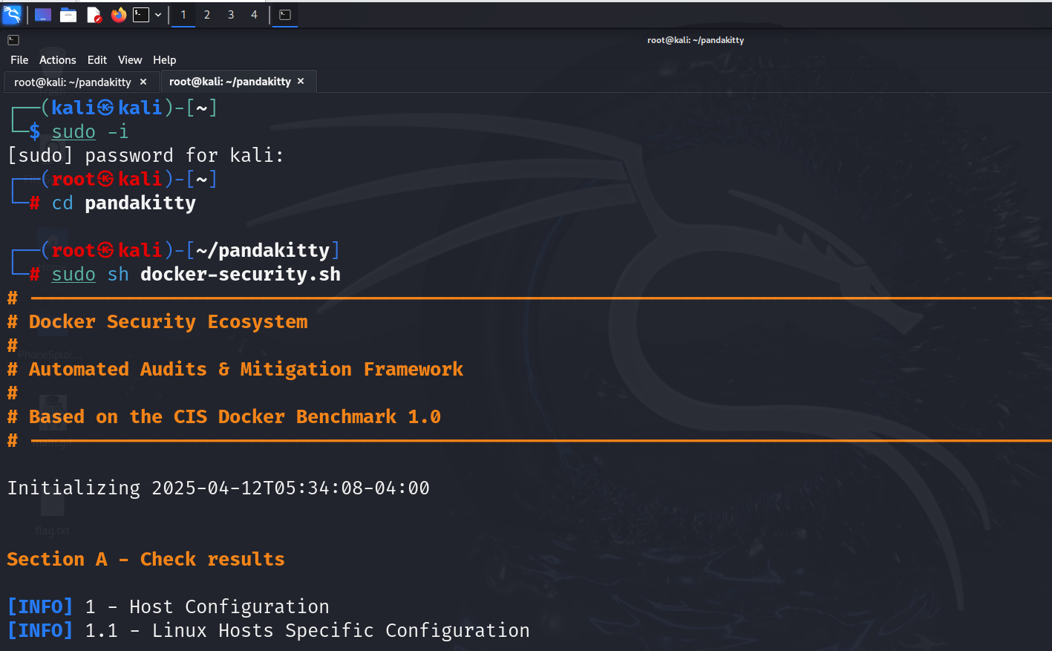

**Figure:1**

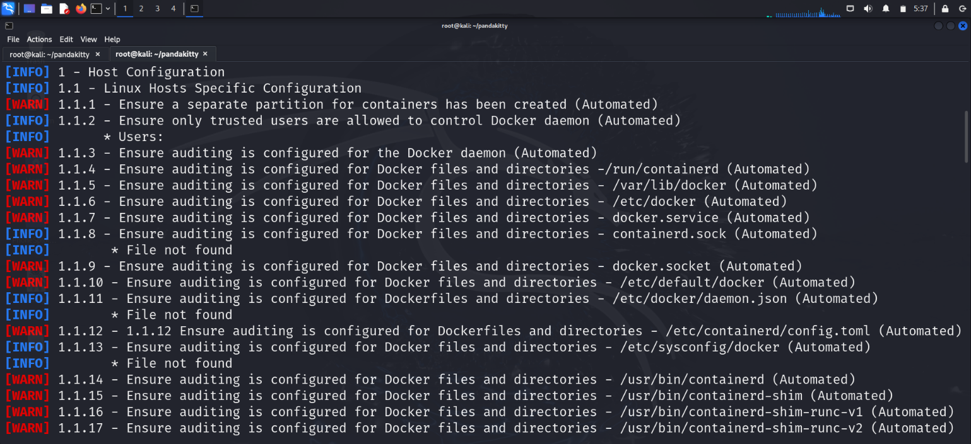 **Figure: 2**

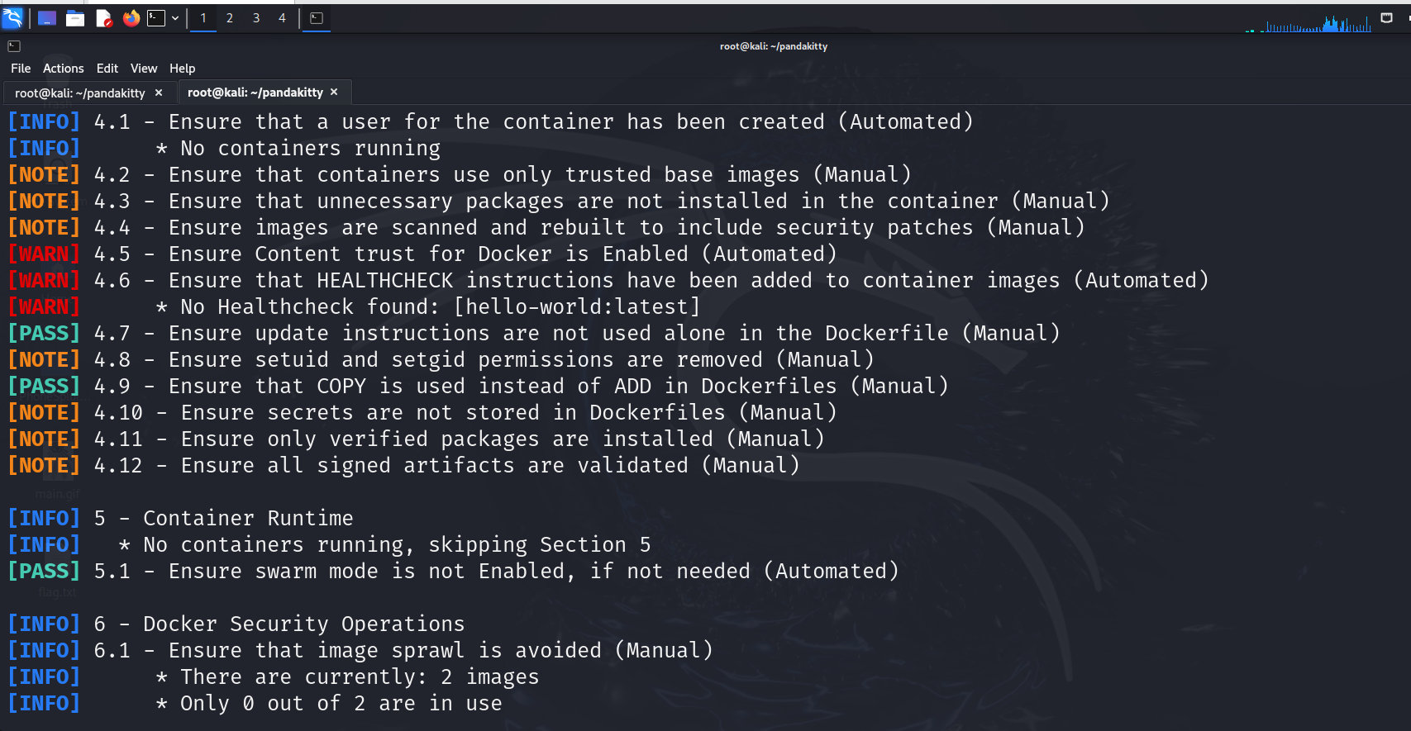

**Figure: 3**

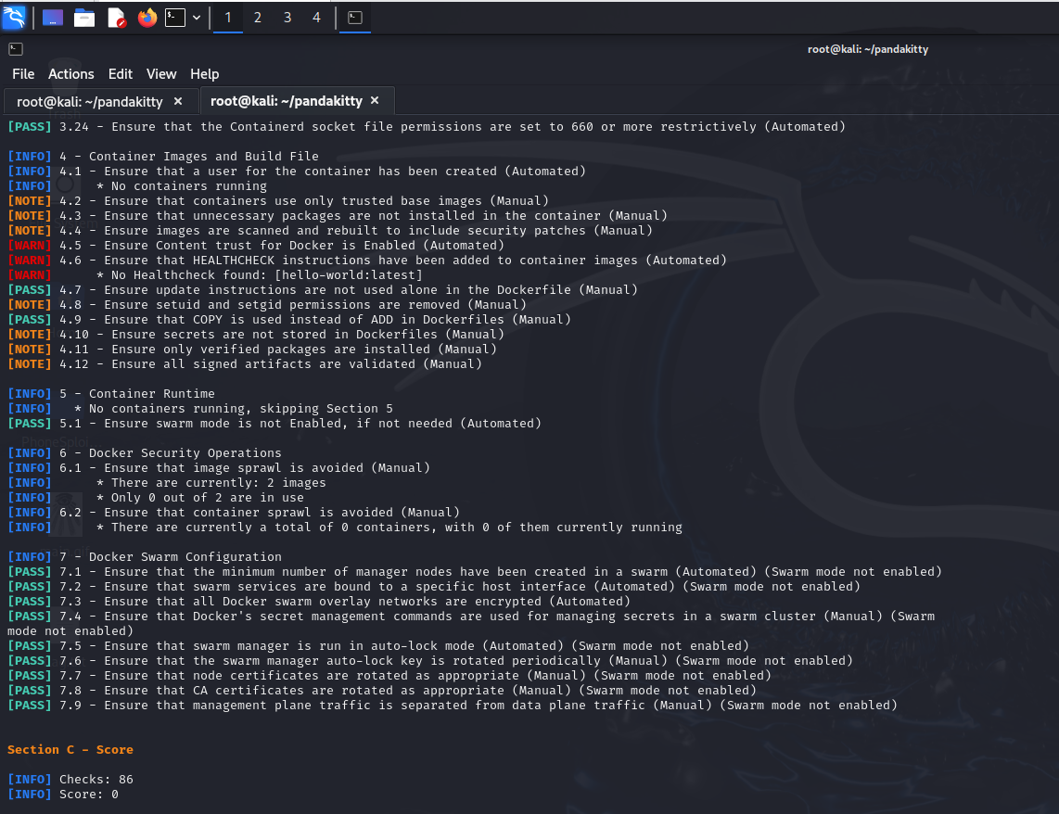

**Figure: 4**

**4.1Efficiency Improvement:**Security audits automated saved a lot of time relative to manual inspections, rendering regular security upkeep more feasible.

**4.2 Reliability:**Results were reliable and correct in varying test environments, reflecting the framework's cross-platform support and reliability.

**4.3 Usability:**Containerized deployment via Docker made it easy to install and deploy, even for non-technical users.

**4.4 Limitations:**

* Manual verification was necessary for some vulnerabilities following automatic discovery.
* The current framework is host-level security, and future releases can benefit from the addition of containerized application security.

**4.5 Future Enhancements:**

1. Integration with CI/CD Pipelines

Embed security audits directly into DevOps pipelines (e.g., Jenkins, GitLab CI) ensuring containers are validated prior to deployment.

2. Role-Based Access Control (RBAC) Dashboard

Create a role-based user-friendly dashboard for user management, audit log viewing, and mitigation step control according to role (e.g., Admin, Auditor, Developer).

3. Cloud-Native Security Modules

Add security checks specific to cloud environments such as AWS ECS, Azure Container Instances, and Google Kubernetes Engine to go beyond local Docker environments.

4. Zero Trust Architecture Support

Enforce zero trust policies at the container level to improve isolation and mitigate risks of lateral movement within containerized environments.

5. Vulnerability Intelligence Feed Integration

Utilize external threat intelligence (e.g., CVE databases, MITRE ATT&CK) to refresh the framework in real-time for new Docker-related vulnerabilities.

6. Incident Response Automation

Integrate response modules that perform pre-defined actions (e.g., stopping a container, alerting) upon detection of critical vulnerabilities.

7. Mobile App Companion

Create a lightweight mobile app to monitor audit outcomes, receive alerts, and initiate scans from Android/iOS devices.

8. Machine Learning-Based Risk Scoring

Use ML models to attribute risk scores to containers based on discovered vulnerabilities, patterns of behavior, and system activity.

1. **REFERENCES**
2. Andress, Jason. The Basics of Information Security: Understanding the Fundamentals of InfoSec in Theory and Practice. 4th ed., Syngress, 2022.
3. Cole, Eric. Advanced Persistent Threat: Understanding the Danger and How to Protect Your Organization. 2nd ed., Syngress, 2020.
4. Erickson, Jon. Hacking: The Art of Exploitation. 3rd ed., No Starch Press, 2023.
5. Krawetz, Neal. Introduction to Network Security: Theory and Practice. Updated Online Resource, Cengage Learning, 2021.
6. McClure, Stuart, Scambray, Joel, and Kurtz, George. Hacking Exposed: Network Security Secrets and Solutions. 8th ed., McGraw-Hill, 2020.
7. Nmap Development Team. Nmap Network Scanning: The Official Nmap Project Guide to Network Discovery and Security Scanning. Insecure.Org, Online Documentation, 2023.
8. Perrin, Chad. Security Power Tools. O'Reilly Media, Online Articles, 2021.
9. Skoudis, Ed. Counter Hack Reloaded: A Step-by-Step Guide to Computer Attacks and Effective Defenses. 3rd ed., Prentice Hall, 2021.
10. National Institute of Standards and Technology (NIST). Cybersecurity Framework. Online Publication, 2022.
11. OWASP Foundation. OWASP Top 10: The Ten Most Critical Web Application Security Risks. Online Report, 2023.
12. Mitre Corporation. Common Vulnerabilities and Exposures (CVE) Database. Online Repository, 2023.
13. CERT Coordination Center (CERT/CC). Incident Response and Threat Intelligence Reports. Online Resource, 2023.